Supplementary information

Contents

Fig. S1 │Target area in Osaka Bay, Japan
Fig. S2 │Study flow of methodological framework and analysis
Fig. S3 │Study flow of methodological framework and analysis
Fig. S4 │Five inundation projections used in the stated preference experiment

Table S1│Mean and standard deviation of the socioeconomic attributes among two categories of samples
Table S2│Averages of expected values (standard deviations) of economic loss over zip-code areas

Web survey format

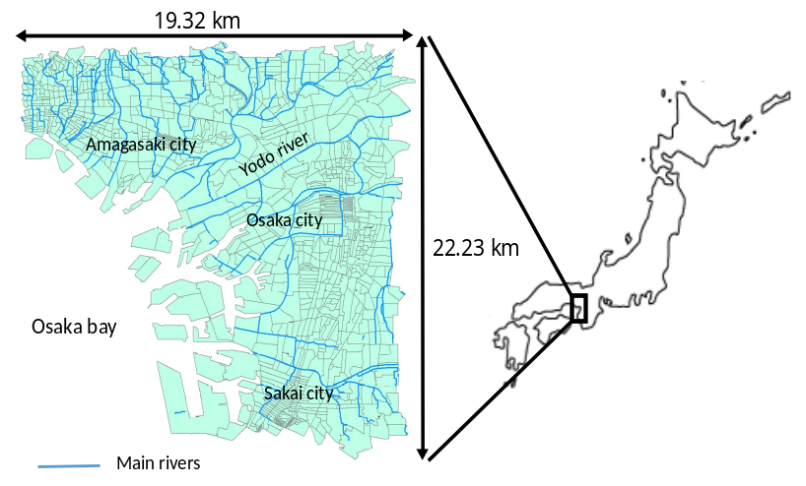

Fig. S1│Target area in Osaka Bay, Japan

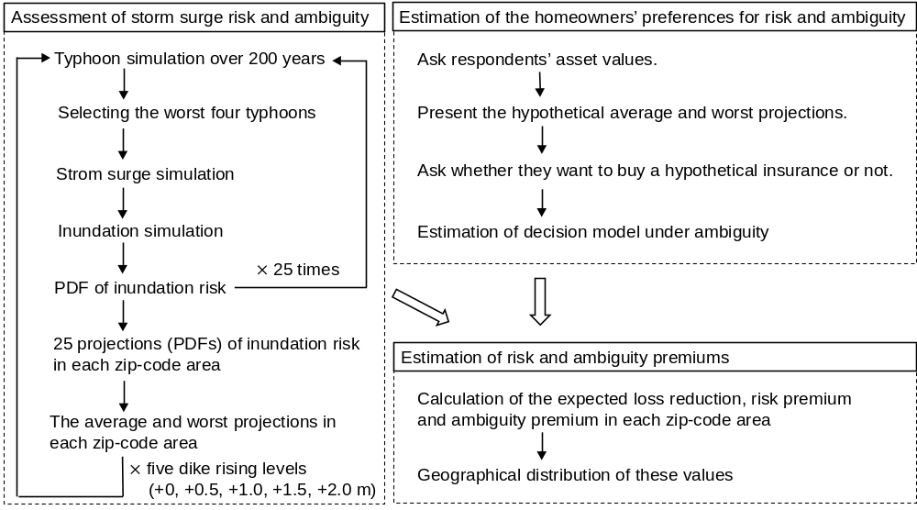
Fig. S2 │Study flow of methodological framework and analysis

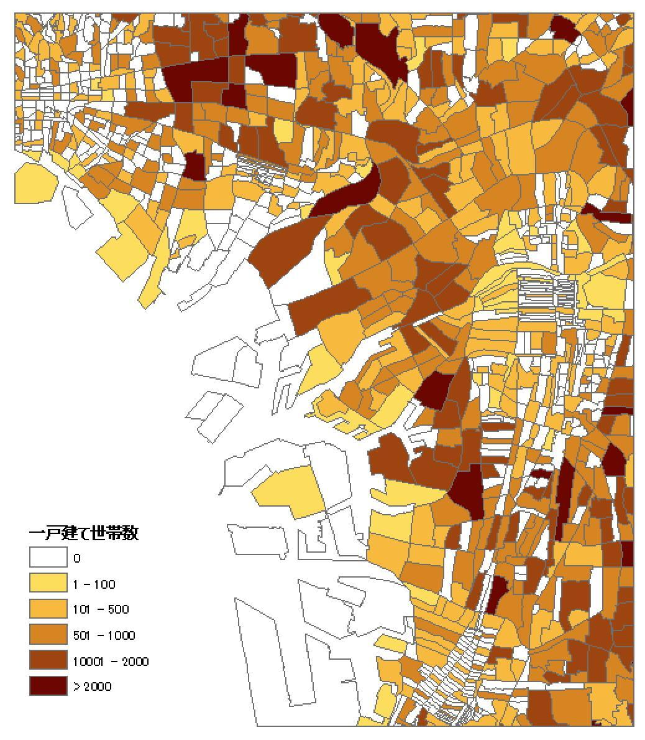
The number of households
Fig. S3 │Study flow of methodological framework and analysis

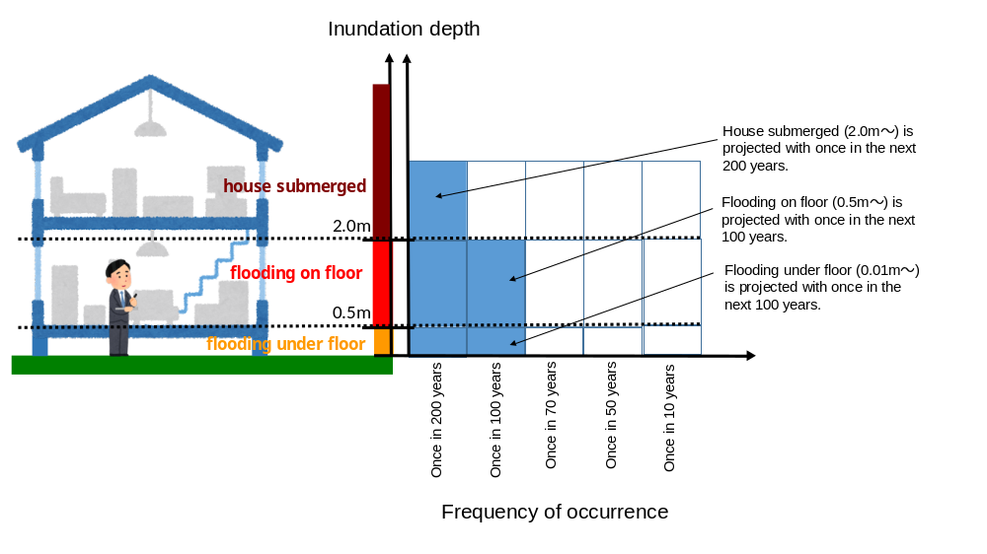
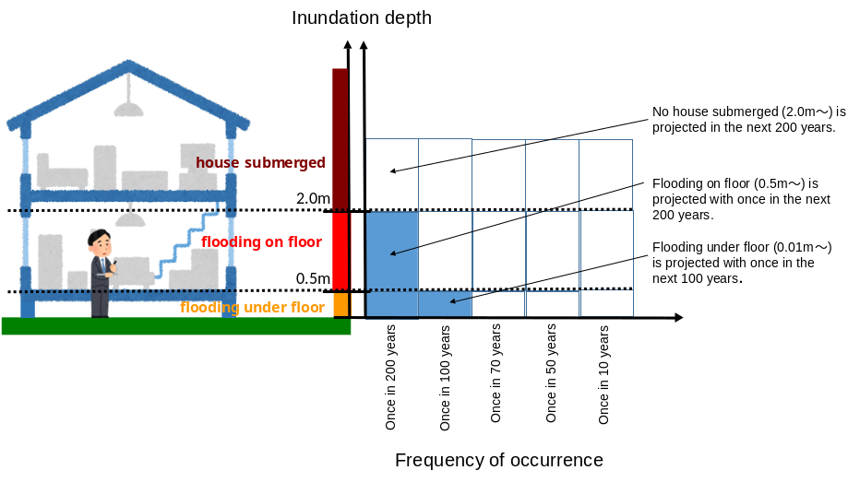
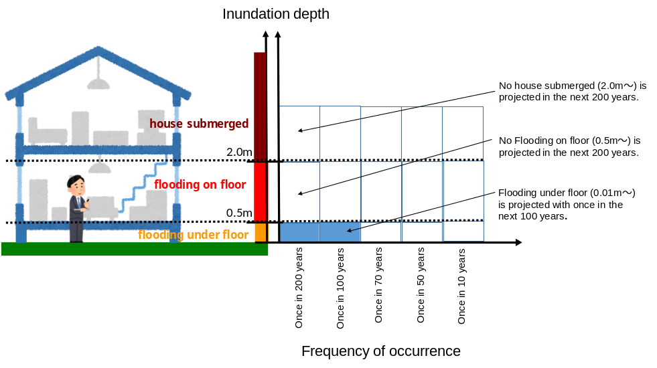
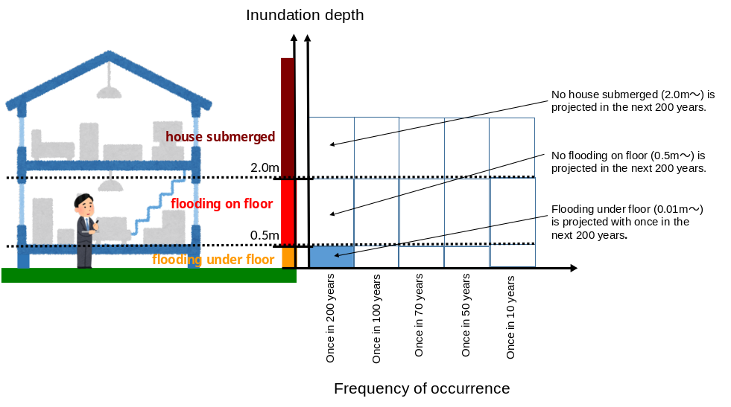
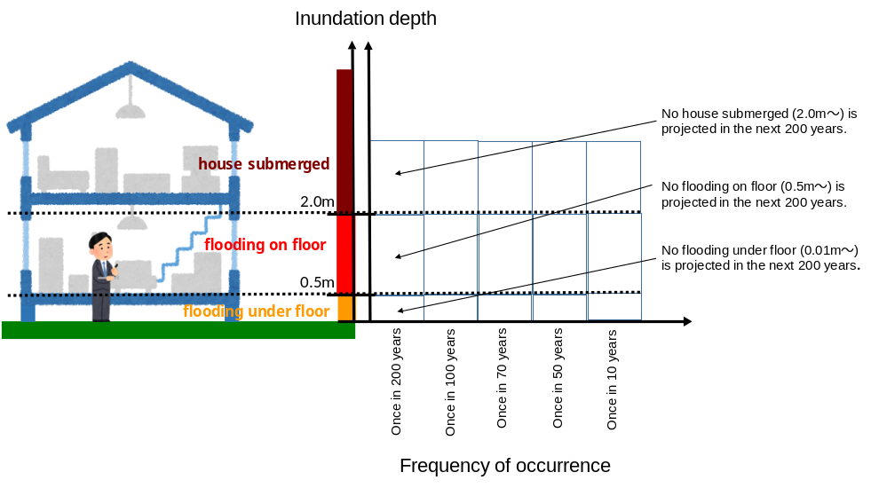

Fig. S4 │Five inundation projections used in the stated preference experiment: two of them are randomly chosen, then the less serious one is set as the “average projection” and the other is set as the “worst projection.”

Table S1│Mean and standard deviation of the socioeconomic attributes among two categories of samples
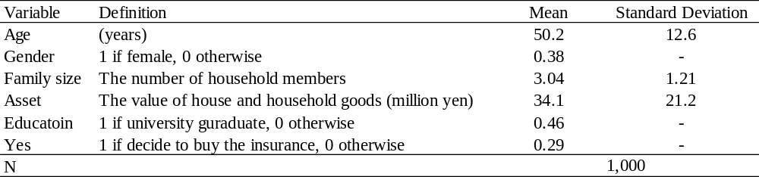

Table S2│Averages of expected values (standard deviations) of economic loss over zip-code areas
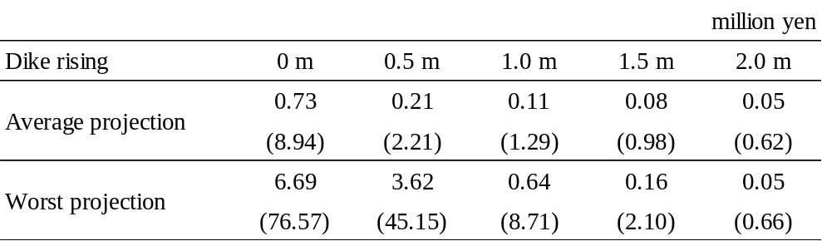

Web survey format

[The original version was written in Japanese.]

The purpose of this survey is to find out what you think about storm surge disasters.

“A storm surge” is a phenomenon in which sea water is blown in, causing the sea level to rise. It is caused by a drop in atmospheric pressure due to a typhoon or developed low pressure system, which sucks up the sea level and causes it to rise, or by strong winds blowing from offshore toward the coast. When the sea level rises above the levee due to a storm surge, the seawater floods and causes flooding damage to residential areas.

- Mechanism of Storm Surge
Typhoons and low pressure systems
There are three main factors that contribute to the occurrence of storm surges.
1. Sucking up of sea level due to atmospheric pressure drop
Since the central pressure of a typhoon or cyclone is lower than that of the surrounding area, the air near the center sucks up the sea surface, resulting in a rise in sea level.
2. Wind blowing seawater to shore
When strong winds from a typhoon blow toward the coast, seawater is blown toward the coast, causing the sea level near the coast to rise abnormally.
3. Sea level rise due to waves
When large waves are constantly rushing toward the shore, they cannot return rapidly to the sea, and large amounts of seawater accumulate close to the shore, causing the sea level to rise. The bigger the wave, the bigger the rise in sea level.

- Major storm surge disasters in Japan
Major storm surge disasters
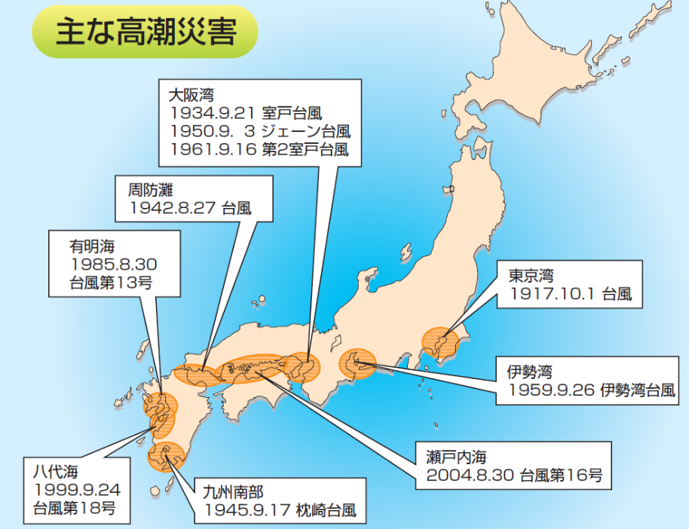

Osaka Bay
Typhoon Muroto
Typhoon Jane
Typhoon Muroto II

Suou Nada
Typhoon
Ariake sea
Tokyo Bay
Typhoon 13
Typhoon

Ise bay
Typhoon Ise
Yatsushiro sea
Setouchi sea
Typhoon 16
Sothern Kyusyu
Typhoon Makurazaki
Typhoon 18

- Recent cases of storm surge disasters in Japan
When a typhoon or a well-developed low pressure system approach, the tide level may rise significantly. This is a storm surge, and it can cause flooding of houses in coastal areas.
Typhoon-induced storm surges reaching elevations of around 2.5 meters have killed people along the Yatsushiro Sea coast in 2009 and the Setouchi Sea coast in 2014.

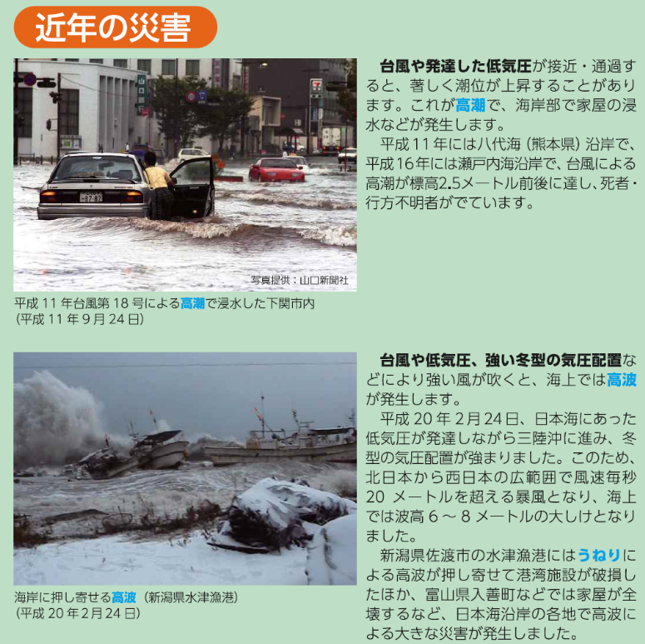
When strong winds blow due to typhoons, low pressure systems, or strong winter pressure systems, storm surges occur at sea.
On February 24, 2018, a low pressure system in the Sea of Japan developed and advanced off the coast of Sanriku, strengthening the winter-type pressure system. As a result, winds exceeded 20 meters per second over a wide area from northern to western Japan, and there was heavy sea breeze with waves 6 to 8 meters high.
The storm surges damaged fishing port facilities at the Mizutu fishing harbor in Sado City, Niigata Prefecture, and houses were completely destroyed in Irizen Town, Toyama Prefecture.

1. Please answer the following questions about your house and household goods.

1-1
Suppose that your house has been damaged by storm surge flooding and needs to be rebuilt. How much do you think it would cost to rebuild your house to the same level as your current house?

1 million yen 2 million yen 3 million yen 4 million yen 5 million yen
6 million yen 7 million yen 8 million yen 9 million yen 10 million yen
11 million yen 12 million yen 13 million yen 14 million yen 15 million yen
16 million yen 17 million yen 18 million yen 19 million yen 20 million yen
21 million yen 22 million yen 23 million yen 24 million yen 25 million yen
26 million yen 27 million yen 28 million yen 29 million yen 30 million yen
31 million yen 32 million yen 33 million yen 34 million yen 35 million yen
36 million yen 37 million yen 38 million yen 39 million yen 40 million yen
41 million yen 42 million yen 43 million yen 44 million yen 45 million yen
46 million yen 47 million yen 48 million yen 49 million yen 50 million yen

Over 50 million yen _____________million yen

1-2
Suppose that all of the household goods in your house have been damaged by storm surge flooding and need to be replaced. How much do you think it would cost to buy new household goods of the same level as your current ones?

1 million yen 2 million yen 3 million yen 4 million yen 5 million yen
6 million yen 7 million yen 8 million yen 9 million yen 10 million yen
11 million yen 12 million yen 13 million yen 14 million yen 15 million yen
16 million yen 17 million yen 18 million yen 19 million yen 20 million yen
21 million yen 22 million yen 23 million yen 24 million yen 25 million yen
26 million yen 27 million yen 28 million yen 29 million yen 30 million yen

Over 30 million yen _____________million yen

2. The following questions ask you how you would judge when presented with information about the probabilities of occurrence of a storm surge disaster.

Currently, the height of storm surges is projected by typhoon simulations using the latest scientific methods. However, due to uncertainties that are not fully understood by current science, there are variations in the projections as shown in the figure below. The thick blue curve shows the average case, and the thick red curve shows the worst case.

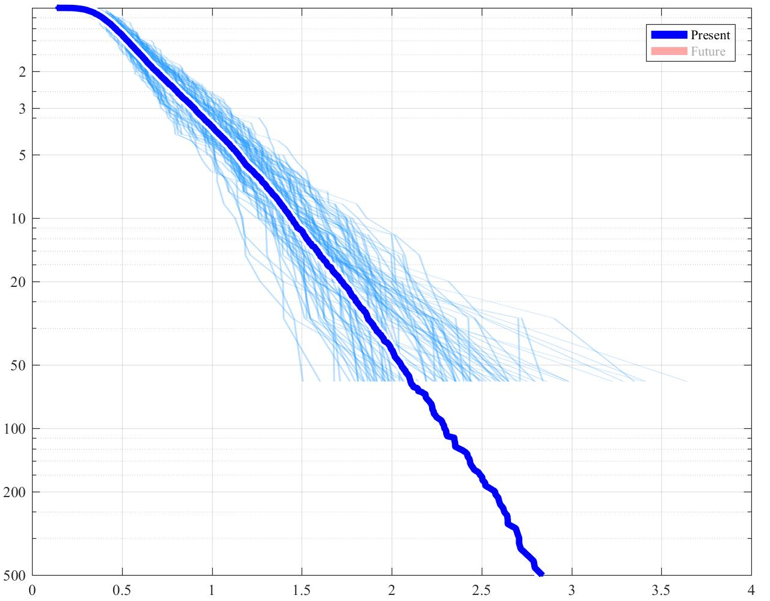
Annual maximum high of storm surge (m)
Annual probability of occurrence
The worst case
The average case
0.2%
0.5%
1%
2%
5%
10%
20%

50%

Suppose that the risks of storm surge damage to your house are projected to be as follows.
- Your home is at risk of flooding from storm surge.
- Typhoon simulations using the latest scientific methods have projected the distribution of the probability of your house being flooded by storm surge.
- However, there is uncertainty in the projected probability of flooding of your house.
- You now have the following projections A and B for the average and worst case of the typhoon simulation, respectively.
In the average one among 25 projections of inundation risk from typhoon simulation, the inundation risk of your house was projected as the following figure.
Average projection

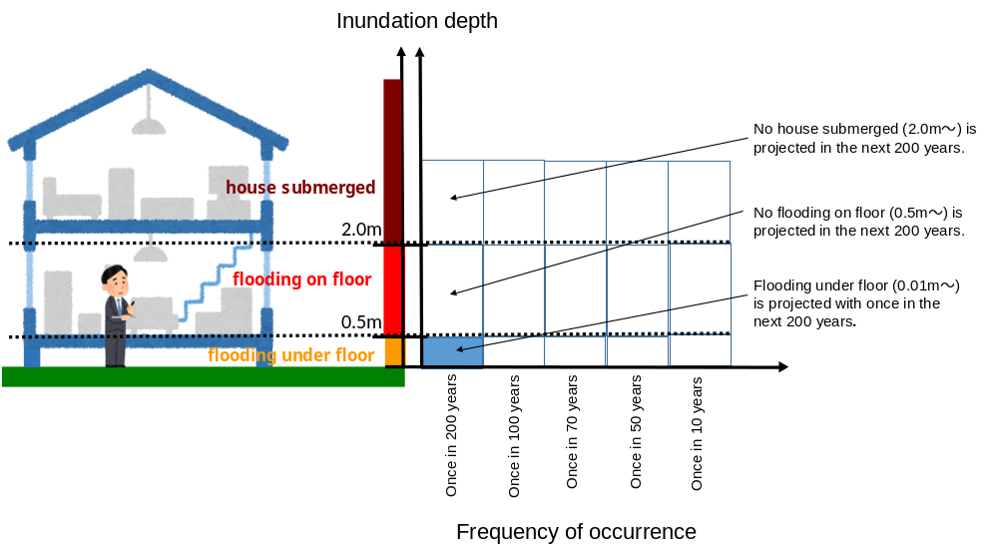

In the worst one among 25 projections of inundation risk from typhoon simulation, the inundation risk of your house was projected as the following figure.
Worst projection

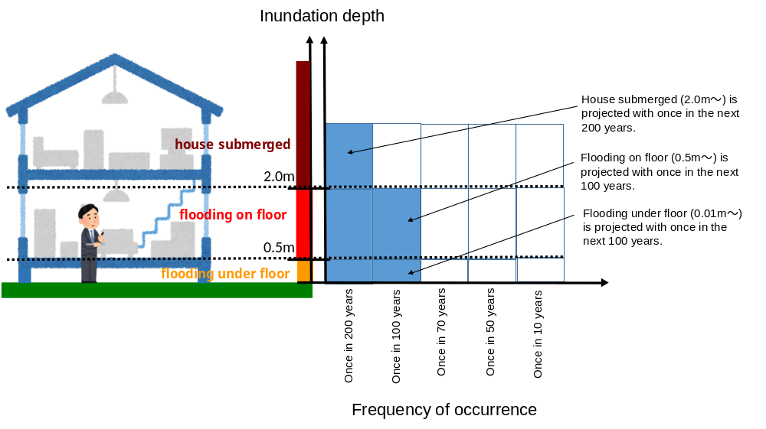

[The average and worst projections were randomly selected form the five projections shown in Fig. S4]
Suppose the following hypothetical situation.

- If your house gets flooded under floor (inundation depth is below 0.5m) from storm surge, your economic loss is AAA yen (1% of your asset value).
- If your house gets flooded on floor (inundation depth is 0.5m－2.0m) from storm surge, your economic loss is BBB yen (50% of your asset value).
- If your house gets submerged (inundation depth is over 2.0m) from storm surge, your economic loss is CCC yen (100% of your asset value).
- You do not have any insurance for compensating economic loss from storm surge.

[The amounts of economic losses (AAA, BBB, and CCC) due to storm surge inundation were automatically calculated on the web system and presented to the respondents.]

2-1
Suppose that the government sells a new insurance which covers all losses due to storm surge floods with full compensation of house restoring cost and households’ assets back, and that the insurance will be contracted once in a year. Do you like to buy this new insurance policy with the annual fee of XXX yen?

1. Yes, I’d like to buy the insurance with annual fee of XXX yen.
2. No, I’d not like to buy the insurance

2-2
Why did you choose not to buy the insurance? Please choose one of the following options as your reason.

1. The insurance fee is too expensive

2. I cannot understand the question

3. I cannot accept the hypothetical scenarios

4. Other reasons ( )

[The amount of insurance fee (XXX yen/year) was automatically calculated and presented to the respondents according to the following formula: their estimated household asset value×0.001%, 0.005%, 0.01%, 0.05%, 0.1%, 0.5%, and 1%]

3. Please tell us about yourself.

3-1 What is your age?

( ) years old

3-2 What is your gender?

1. Male 2. Female

3-3 Please indicate the number of family members living with you (the number including you).

( )

3-4 What is your last educational background?

1. Junior high school 2. High school 3. Technical college 4. Vocational school

5. Junior college 6. University 7. Graduate School 8. Others ( )

3-5 Please tell us about difficulty of the content of this survey.

1. Very difficult 2. Difficult 3. A little difficult 4. Neutral

5. A little easy 6. Easy 7. Very easy

3-6 If you have any comments about this survey, please let us know.

( )

Thank you very much for your cooperation.

