Supplementary material on
Climate-driven inequalities in dengue transmission between rural and urban populations in western India
Avik Kumar Sam^{1,2,*}, Akshay Kumar¹, Ipsita Pal Bhowmick³, Kalpana Baruah⁴, Harish C. Phuleria^{1,2,5,*}
- Environmental Science and Engineering Department, Indian Institute of Technology Bombay, Mumbai, India
- National Disease Modelling Consortium, Indian Institute of Technology Bombay, Mumbai, India
- Indian Council of Medical Research – Regional Medical Research Centre, Dibrugarh, India
- National Center for Vector Borne Disease Control, Ministry of Health and Family Welfare, India
- Center in Climate Studies, Indian Institute of Technology Bombay, Mumbai, India

* Corresponding Authors: Avik Kumar Sam; avik.sam@iitb.ac.in, Harish C. Phuleria; phuleria@iitb.ac.in

Appendix 1
- Land use / Land cover (LULC)
Pune City is located in UTM Zone 43, and its coordinates are 148 and 47 in Landsat satellite images. Landsat 8 OLI_TIRS satellite image of 2013-04-06 was directly acquired from USGS Earth Explorer (Link: https://earthexplorer.usgs.gov/) for the urban study area. Sentinel 2A satellite images are downloaded from Copernicus Data Space Ecosystem (https://browser.-dataspace.copernicus.eu/).
  - Classification using Support Vector Machine method
Multiple studies have reported that Support Vector Machine (SVM) provides better accuracy than other classification methods (Srivastava et al., 2012; Yousefi et al., 2022); therefore, in the present study, the SVM method was used to delineate LULC for all periods. The SVM is a powerful supervised ML model suitable for both classification and regression tasks (Arfa & Minaei, 2024; Cortes & Vapnik, 1995).
Preprocessing of satellite imagery included atmospheric correction, geometric rectification, and image enhancement to ensure radiometric and spatial accuracy. Training samples for each LULC class were collected from high-resolution reference imagery, ensuring that they represented the spectral and spatial variability of each class. The SVM classifier was implemented with a radial basis function (RBF) kernel, which effectively separates non-linear class boundaries by mapping input features into a higher-dimensional space. The optimal penalty parameter (C) and kernel width (γ) were determined through neighbourhood search and cross-validation to maximise classification accuracy. Post-classification filtering was applied to reduce salt-and-pepper noise, and the final classification was validated using an independent set of ground truth points. Accuracy was assessed through confusion matrix statistics and the Kappa coefficient.

Table S1 List of satellite data with their specifications.
Data Used | Path/Row | Date of Acquisition | Spectral Resolution | Spatial Resolution (m) | Swath (km)
Landsat 8 | 147/47 | 27-03-2013 | Band 1 (0.433 – 0.453) | 30 | 185
Landsat 8 | 147/47 | 27-03-2013 | Band 2 (0.450 – 0.515) |  | 185
Landsat 8 | 147/47 | 27-03-2013 | Band 3 (0.525 – 0.600) |  | 185
Landsat 8 | 147/47 | 27-03-2013 | Band 4 (0.630 – 0.680) |  | 185
Landsat 8 | 147/47 | 27-03-2013 | Band 5 (0.845 – 0.885) |  | 185
Landsat 8 | 147/47 | 27-03-2013 | Band 6 (1.560 – 1.660) |  | 185
Landsat 8 | 147/47 | 27-03-2013 | Band 7 (2.100 – 2.300) |  | 185
Landsat 8 | 147/47 | 27-03-2013 | Band 8 (0.500 – 0.680) | 15 | 185
Landsat 8 | 147/47 | 27-03-2013 | Band 9 (1.360 – 1.390) | 30 | 185
Landsat 8 | 147/47 | 27-03-2013 | Band 10 (10.60 – 11.19) | 100 (resampled to 30) | 185
Landsat 8 | 147/47 | 27-03-2013 | Band 11 (11.50 – 12.51) | 100 (resampled to 30) | 185
Sentinel 2A |  |  | Band 1 (0.443) | 60 | 290
Sentinel 2A |  |  | Band 2 (0.490) | 10 | 290
Sentinel 2A |  |  | Band 3 (0.560) | 10 | 290
Sentinel 2A |  |  | Band 4 (0.665) | 10 | 290
Sentinel 2A |  |  | Band 5 (0.705) | 20 | 290
Sentinel 2A |  |  | Band 6 (0.740) | 20 | 290
Sentinel 2A |  |  | Band 7 (0.783) | 20 | 290
Sentinel 2A |  |  | Band 8 (0.842) | 10 | 290
Sentinel 2A |  |  | Band 8A (0.865) | 20 | 290
Sentinel 2A |  |  | Band 9 (0.945) | 60 | 290
Sentinel 2A |  |  | Band 10 (1.375) | 60 | 290
Sentinel 2A |  |  | Band 11 (1.610) | 20 | 290
Sentinel 2A |  |  | Band 12 (2.190) | 20 | 290

1.2 Accuracy Estimation
Accuracy entails the systematic evaluation of a map in relation to reference information using consistent rules to ensure reliable comparisons (Ganguly et al., 2017). The accuracy of the classified images was assessed using error matrices (overall, user’s and producer’s accuracies) and Kappa statistics. A total of 125 random points were generated using “create accuracy assessment points” via a stratified random sampling method.
The confusion matrix is generated to check the accuracy of classified images of all periods. Overall accuracy indicates the proportion of correct predictions made by the model relative to the total number of predictions (Arfa and Minaei, 2024). Although this metric provides a brief overview of the model’s performance, it may not offer an accurate assessment in cases involving imbalanced class distributions within the dataset. The total corrected prediction is calculated by Equation 1.
$$\begin{aligned}Overall Accuracy=\frac{\sum_{i=1}^{n}{\left(C_{ii}\right)}}{\sum_{i=1}^{n}{\sum_{j=1}^{n}{\left(C_{ij}\right)}}} \#Eq. 1\end{aligned}$$
where $C_{ii}$ represents the diagonal elements (ie correct classification), $C_{ij}$ represents the aspects of the confusion matrix.
Producer’s accuracy measures the proportion of correctly classified reference (ground truth) pixels for a specific class on the map, indicating the classifier’s effectiveness in capturing that class and indicates omission error when the accuracy is low. It is calculated by equation 2.
$$\begin{aligned}Producer Accuracy \left(for class i\right)=\frac{\left(C_{ii}\right)}{\sum_{j=1}^{n}{\left(C_{ij}\right)}} \#Eq. 2\end{aligned}$$
where $C_{ii}$ are the diagonal elements, and $\sum_{j=1}^{n}{\left(C_{ij}\right)}$ are the elements of the confusion matrix.
User’s accuracy represents the proportion of map pixels classified as a specific class that genuinely belong to that class. This measure indicates the reliability of the classification for map users and highlights commission errors when the accuracy is low. It is calculated by Equation 3.
$$\begin{aligned}User^{'}s Accuracy \left(for class i\right)=\frac{\left(C_{ii}\right)}{\sum_{j=1}^{n}{\left(C_{ji}\right)} } \#Eq. 3\end{aligned}$$
Where C_{ii} represents the diagonal elements, $\sum_{j=1}^{n}{\left(C_{ji}\right)}$ are the elements of the confusion matrix.
The Kappa coefficient measures the agreement between predicted and actual classifications. It also considers the chance that agreement could happen randomly (Equation 4)
$$\begin{aligned}K=\frac{P_{o}-P_{e}}{1-P_{e}} \#Eq. 4\end{aligned}$$
Where P_{o} represents the observed agreement or overall accuracy, and P_{e} signifies the expected agreement that occurs by chance, a value determined through the use of the confusion matrix. 1.3 Results
The spatial distribution of land use and land cover (LULC) changes over three different periods, spanning the years 2013, 2018, and 2023, within the city of Pune and its adjacent areas is shown in Figure S9. Delineation of LULC classes was undertaken employing the SVM classification algorithm, which is recognised for its robustness in processing high-dimensional data and limited training samples. Landsat 8 satellite images from April 2013, along with Sentinel-2A satellite images from February 2018 and February 2023, were used to delineate various LULC classes. These classes include water bodies, vegetation, rangeland, cropland, barren land, and settlement areas (Figure S9a-c).
Built-up lands encompass all artificial structures, including urban, rural, and industrial settlements. These areas are scattered throughout the study region. Major densely populated urban regions within PMC include Camp, Shivanagar, Deccan and Swaragate. In the northwest, within PCMC, significant locations include Pimri, Chinchwad, Nigdi and Wakad alongside rapidly expanding peripheral zones such as Hadapsar, Kharadi, and Pashan. In 2013, the total area of settlements was 355.53 km², which comprised 20.15% of the study area. By 2018, this area had expanded to 436.25 km², and by 2023, it had reached 505.89 km², accounting for 24.73% and 28.68% of the total study area, respectively (Table S-2). This considerable growth in settlement area from 355.53 km² (20.15%) in 2013 to 505.89 km² (28.68%) in 2023 underscores a sustained trend of urban expansion, likely attributed to factors including population growth, industrialisation, and advancements in infrastructure. Agricultural lands in the study area are categorised into cropland and fallow land. In 2013, these lands covered an area of 478.88 km2 (27.15%), representing 27.15% of the total area. By 2018, it had increased to 591.82 km² (33.55%), and further expanded to 595.84 km² (33.78%) by 2023. This trend indicates a shift towards intensified agricultural use, possibly replacing former rangelands (Table S-2).
Table S2 Areal statistics of LU/LC classes during April 2013, February 2018 and February 2023.
 | 2013 |  | 2018 |  | 2023
Class | Area | % | Area | % | Area | %
Waterbodies | 13.37 | 0.76 | 21.05 | 1.19 | 21.25 | 1.2
Vegetation | 8.7 | 0.49 | 77.12 | 4.37 | 74.1 | 4.2
Rangeland | 906.05 | 51.36 | 632.65 | 35.86 | 560.14 | 31.75
Cropland | 478.88 | 27.15 | 591.82 | 33.55 | 595.84 | 33.78
Barren land | 1.46 | 0.08 | 5.12 | 0.29 | 6.78 | 0.38
Settlement | 355.53 | 20.15 | 436.25 | 24.73 | 505.89 | 28.68
Total | 1764 | 100 | 1764 | 100 | 1764 | 100
Of particular significance is the substantial decline in rangeland, which decreased from 906.05 km² (51.36%) in 2013 to 560.14 km² (31.75%) in 2023. This reduction suggests a conversion of rangeland areas to cropland or their development for settlement purposes. Vegetation cover underwent a substantial increase from 8.70 km² (0.49%) in 2013 to 77.12 km² (4.37%) in 2018, followed by a slight reduction to 74.10 km² (4.20%) in 2023. This trend could be attributed to afforestation, urban landscaping activities, or seasonal variations in classification methodologies. Waterbodies comprise areas with surface water, either impounded in the form of ponds, lakes and reservoirs or flowing as streams, rivers, canals, etc. In the study area, the area of waterbodies nearly doubled from 13.37 km² (0.76%) in 2013 to 21.25 km² (1.20%) in 2023, potentially due to reservoir expansion or improved mapping accuracy. Barren land consistently classified as a minor category throughout the study period, with an increase from 1.46 km² (0.08%) in 2013 to 6.78 km² (0.38%) in 2023. This change may be attributed to factors such as construction activities or land degradation.
The accuracy assessment of the LULC classification was conducted by selecting 125 random sample points from the classified LULC map and comparing them with the high-resolution Google Earth images (Table S-3). Results indicate that the overall accuracy of the classified LULC map prepared for 2013, 2018, and 2023 is 89.6%, 89.6%, and 88% respectively. Furthermore, the Kappa accuracy is 86.1%, 86.9%, and 84.8% for the subsequent years. Additionally, slope was extracted from the Cartosat Digital Elevation Model (32 m spatial resolution), downloaded from Bhuvan (https://bhuvan-app3.nrsc.gov.in/data/download/index.php). The collated slope measurements varied between 0-55°.
Table S3 Accuracy assessment of LULC classified map over Pune city for 2013, 2018, and 2023.
 |  | 2013 |  |  | 2018 |  |  | 2023
LULC Classes | Producer Accuracy (%) |  | User Accuracy (%) | Producer Accuracy (%) |  | User Accuracy (%) | Producer Accuracy (%) |  | User Accuracy (%)
Settlement | 90.5 |  | 95 | 89.3 |  | 100 | 96.4 |  | 93.1
Rangeland | 88.5 |  | 93.9 | 100 |  | 88.9 | 82.9 |  | 90.6
Waterbody | 100 |  | 100 | 100 |  | 100 | 90.9 |  | 100
Vegetation | 100 |  | 100 | 62.5 |  | 100 | 81.8 |  | 90
Cropland | 80.8 |  | 77.8 | 100 |  | 82.4 | 87.1 |  | 79.4
Barrenland | 100 |  | 66.7 | 81.8 |  | 90 | 88.9 |  | 80
Overall accuracy (%) | 89.6 |  |  | 91.2 |  |  |  |  | 88
Kappa Accuracy (%) | 86.1 |  |  | 89 |  |  |  |  | 84.8

Appendix 2
  - Weather data
    - Seasonal classification and El-Nino anomalies
We have divided the months into seasons according to the Indian Meteorological Department’s classification for Pune district (IMD, 2005), which is as follows: December – February (Winter), March – May (Summer), June – September (Monsoon) and October – November (Post-monsoon) (IMD, 2005). Furthermore, we collated the anomalies in monthly sea surface temperatures observed for the Niño 3.4 region, which is typically defined as the El Niño-Southern Oscillation (ENSO), from the NOAA Climate Prediction Centre (NOAA Climate Prediction Center, 2024). The monthly variations in the weather variables observed across urban and rural Pune are presented in the supplementary figures (Figures S4 and S5, respectively).
  - Description of the SaTScan modelling framework and the hypothesis testing
SaTScan utilises a cylindrical scanning window, which is derived by multiplying the spatial base area (spatial resolution) by the temporal height (temporal resolution), and systematically spans the data, assessing various locations, spatial sizes, and temporal intervals to estimate the expected case counts. For each cylindrical window, a likelihood ratio is calculated, which measures the difference in observed and expected cases (Aboushady et al., 2025) The window with the maximum likelihood ratio is the most probable cluster, while its statistical significance is measured through a Monte Carlo Simulation using 9999 replications, which randomly permutes time labels to generate a reference distribution under the null hypothesis.
The null hypothesis assumed that there was no space-time interaction in the distribution of dengue cases across Pune, or that any observed space-time clustering was due to chance. Under the alternative hypothesis, it was assumed that a space-time interaction, or non-random clustering of dengue cases, exists in both space and time. Using the p-value, the null hypothesis was rejected, while the alternative hypothesis was accepted. Such clusters, which did not occur by chance and imply the occurrence of a probable outbreak, were reported in the present study.

Appendix 3

Detailed results from spatial analyses in urban Pune
During the monsoon months of June – August 2016, a relatively stronger cluster (LLR = 114.4; expected cases = 3; observed cases = 54) was observed that covered only 12-unit km² neighbourhoods in the western city boundaries. In October, three secondary clusters were observed, which were concentrated in the central regions. The most significant of these occurred between October and November 2016, spanning 14-unit km² neighbourhoods, with 180 reported cases compared to 39 expected cases and an LLR of 136.9. In the eastern periphery of the city boundaries, a large cluster was observed between January and February 2017, with a LLR of 22.5, and again between November and December 2021, which had a LLR of 35.1. In the northern Pimpri-Chinchwad region, we observed additional six clusters suggesting temporal recurrence, which were spread between August – October 2012 (LLR = 28.8; expected cases = 16, observed cases = 54), May – July 2015 (LLR = 40.9; expected cases = 33, observed cases = 97), October – November 2018 (LLR = 84.1; expected cases = 350, observed cases = 161), September – October 2021 (LLR = 15.8; expected cases = 49, observed cases = 93), and August – October 2022 (LLR = 74.7; expected cases = 288, observed cases = 516). Previously, SaTScan was used to identify possible clusters in Thailand (Rotejanaprasert et al., 2024), Brazil (Romero Canal et al., 2018), Australia (Naish & Tong, 2014), Mexico (Dong et al., 2022), and in India (Joshua et al., 2020; Valson & Soman, 2017). We also performed the SaTScan analysis for rural Pune, which is provided as Figure S3.

Diagnostics for the Bayesian hierarchical models
The trace plots (provided as supplementary Figures S6, S7, and S8) exhibit a horizontal fuzzy caterpillar pattern, indicating good mixing with no obvious trends or drifts. This suggests that the sampler has converged and the posterior is adequately explored. This is also indicated by the R-hat statistic, also known as the potential scale reduction factor, which equals 1.0. The Effective Sample Size was also greater than 400, indicating a high degree of independence from the posterior distribution. Together, these diagnostics demonstrated that the sampler achieved efficient exploration of the posterior sampling space with minimal issues. We also observed a CBI of 0.61, which suggested a moderately strong ability to assign higher environmental suitability to observed dengue presence locations relative to the background considered, thus confirming the effectiveness of the model in capturing meaningful spatiotemporal variations in relative environmental suitability. Overall, the results highlight the robustness of the model for a reliable spatiotemporal assessment of dengue risk in urban Pune, providing valuable insights for targeted intervention measures and an efficient surveillance system.
References:
Aboushady, A. T., Mansour, F., El Maghraby, M., Teixeira, B., Cunha, S., Dantas, M. M., Nawwar, A., Hegazy, A., & Chen-Xu, J. (2025). The use of SatScan software to map spatiotemporal trends and detect disease clusters: a systematic review. Communications Medicine, 5(1), 1–8. https://doi.org/10.1038/S43856-024-00699-1;SUBJMETA=174,308,478,692,700;KWRD=EPIDEMIOLOGY,PUBLIC+HEALTH
Arfa, A., & Minaei, M. (2024). Utilizing multitemporal indices and spectral bands of Sentinel-2 to enhance land use and land cover classification with random forest and support vector machine. Advances in Space Research, 74(11), 5580–5590.
Cortes, C., & Vapnik, V. (1995). Support-vector networks. Machine Learning, 20(3), 273–297. https://doi.org/10.1007/BF00994018
Dong, B., Khan, L., Smith, M., Trevino, J., Zhao, B., Hamer, G. L., Lopez-Lemus, U. A., Molina, A. A., Lubinda, J., Nguyen, U. S. D. T., & Haque, U. (2022). Spatio-temporal dynamics of three diseases caused by Aedes-borne arboviruses in Mexico. Communications Medicine, 2(1), 1–11. https://doi.org/10.1038/S43856-022-00192-7;SUBJMETA=174,2514,255,308,692,699;KWRD=EPIDEMIOLOGY,VIRAL+INFECTION
Joshua, V., Kanagasabai, K., Sabarinathan, R., Ravi, M., Kirubakaran, B., Ramachandran, V., Shete, V., Gowri, A., & Murhekar, M. (2020). Space time analysis of dengue fever diagnosed through a network of laboratories in India from 2014-2017. Journal of Vector Borne Diseases, 57(3), 221–225. https://doi.org/10.4103/0972-9062.311774
Naish, S., & Tong, S. (2014). Hot spot detection and spatio-temporal dynamics of dengue in queensland, Australia. International Archives of the Photogrammetry, Remote Sensing and Spatial Information Sciences - ISPRS Archives, XL–8(1), 197–204. https://doi.org/10.5194/ISPRSARCHIVES-XL-8-197-2014
NOAA Climate Prediction Center. (2024). Niño 3.4 SST Anomalies. https://www.cpc.ncep.noaa.gov/products/analysis_monitoring/ensostuff/ONI_v5.php
Romero Canal, M., Regina da Silva Ferreira, E., Fernanda Estofolete, C., Martiniano Dias, A., Tukasan, C., Carolina Bertoque, A., Dantas Muniz, V., Lacerda Nogueira, M., Santos da Silva, N., Canal, R. M., Silva Ferreira, da E., & Dias, M. A. (2018). Spatiotemporal-based clusters as a method for dengue surveillance. Revista Panamericana de Salud Pública, 41, e162. https://doi.org/10.26633/RPSP.2017.162
Rotejanaprasert, C., Chinpong, K., Lawson, A. B., & Maude, R. J. (2024). Comparative evaluation of spatiotemporal methods for effective dengue cluster detection with a case study of national surveillance data in Thailand. Scientific Reports, 14(1), 1–16. https://doi.org/10.1038/S41598-024-82212-1;SUBJMETA=1538,459,478,692,700;KWRD=DISEASE+PREVENTION,HEALTH+POLICY,PUBLIC+HEALTH
Srivastava, P. K., Han, D., Rico-Ramirez, M. A., Bray, M., & Islam, T. (2012). Selection of classification techniques for land use/land cover change investigation. Advances in Space Research, 50(9), 1250–1265.
Valson, J. S., & Soman, B. (2017). Spatiotemporal clustering of dengue cases in Thiruvananthapuram district, Kerala. Indian Journal of Public Health, 61(2), 74–80. https://doi.org/10.4103/IJPH.IJPH_26_16
Yousefi, S., Mirzaee, S., Almohamad, H., Al Dughairi, A. A., Gomez, C., Siamian, N., & Abdo, H. G. (2022). Image classification and land cover mapping using Sentinel-2 imagery: Optimization of SVM parameters. Land, 11(7), 993.

Supplementary Figures:
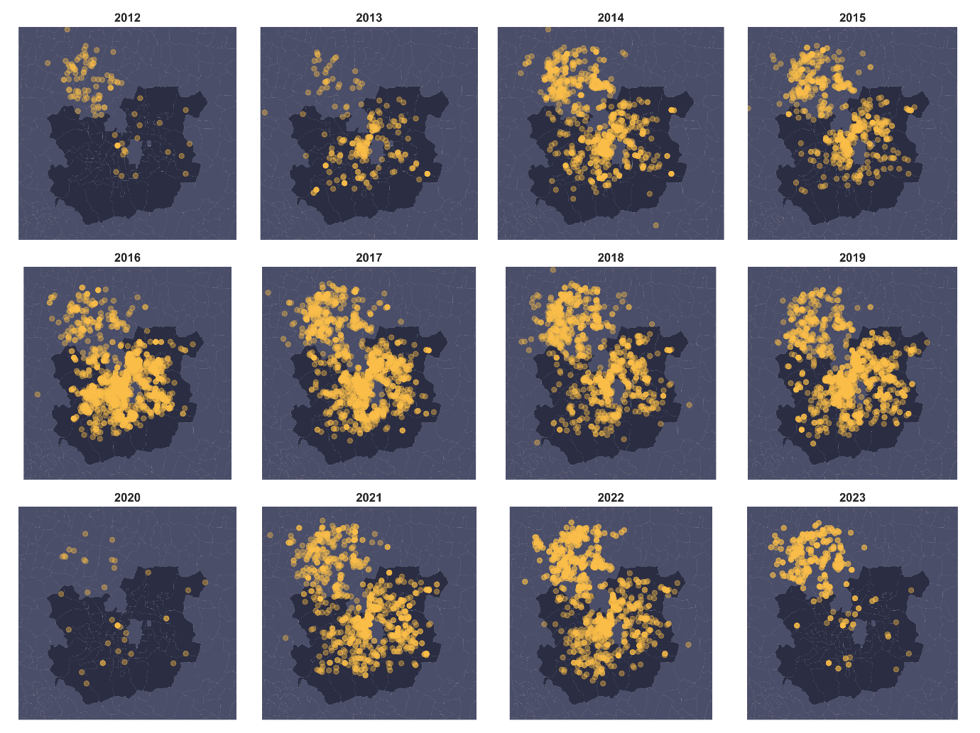
Figure S1: Georeferenced dengue cases reported in urban Pune across the years.

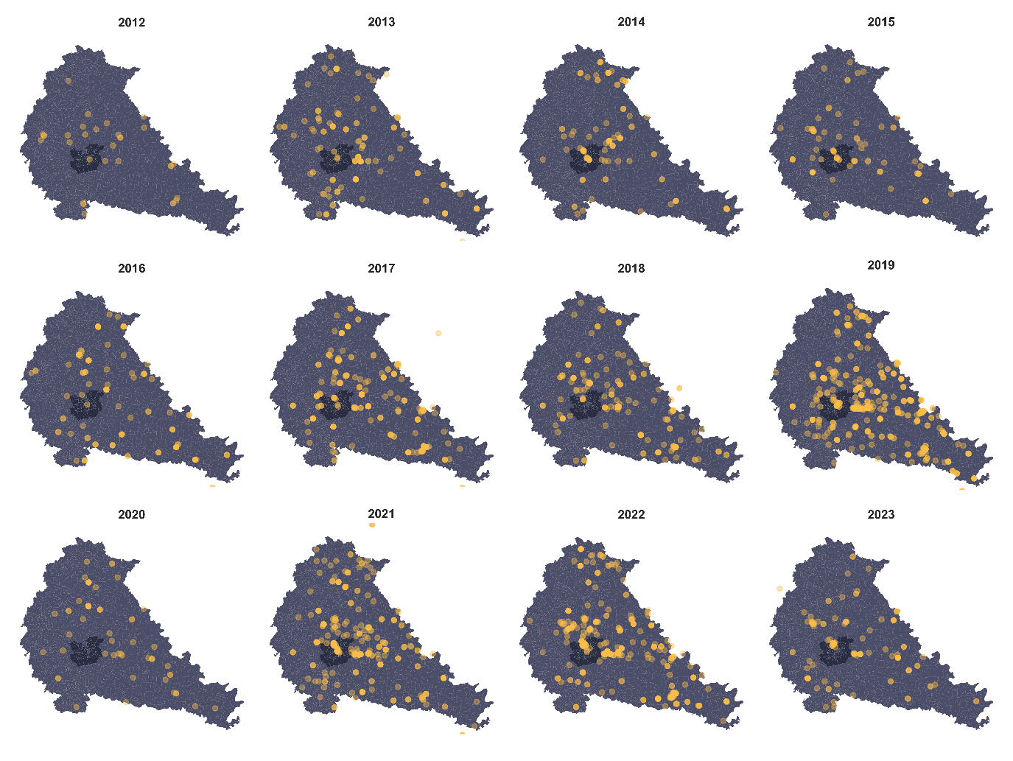
Figure S2: Georeferenced dengue cases reported in rural Pune across the years

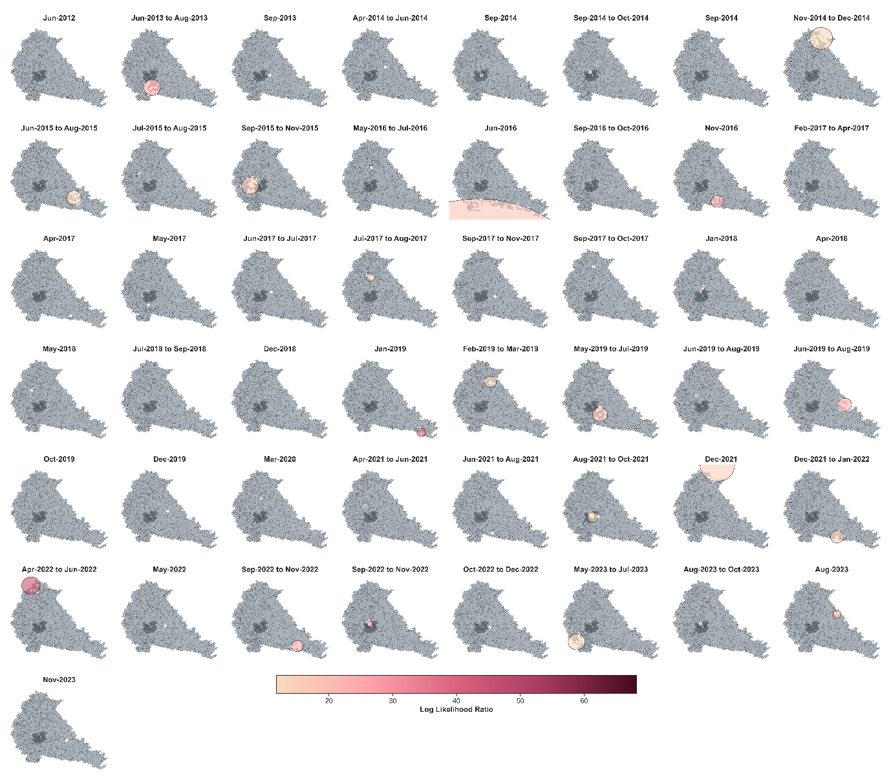
Figure S3 Significant clusters (p-value < 0.05) observed in rural Pune using the Space-Time Permutation Model developed through SaTScan.
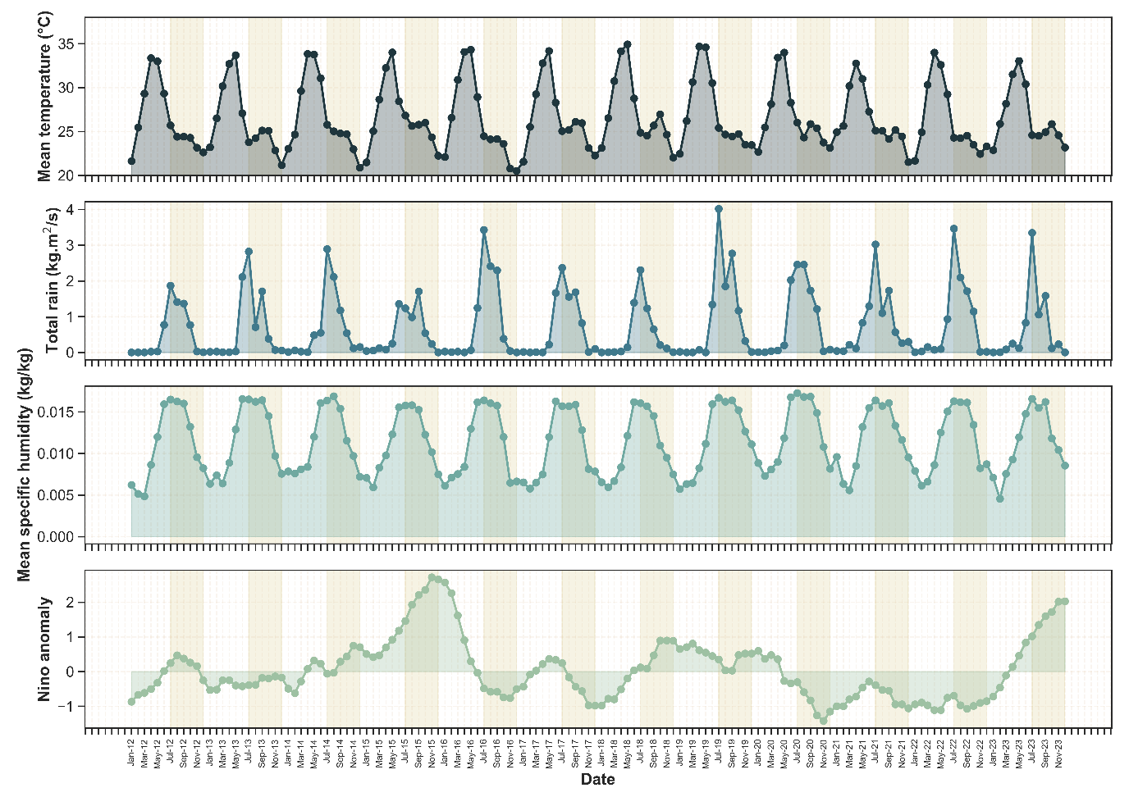
Figure S4: Monthly variations in the meteorological variables in urban Pune.
The shaded region represents the monsoon and post-monsoon months of July-November.

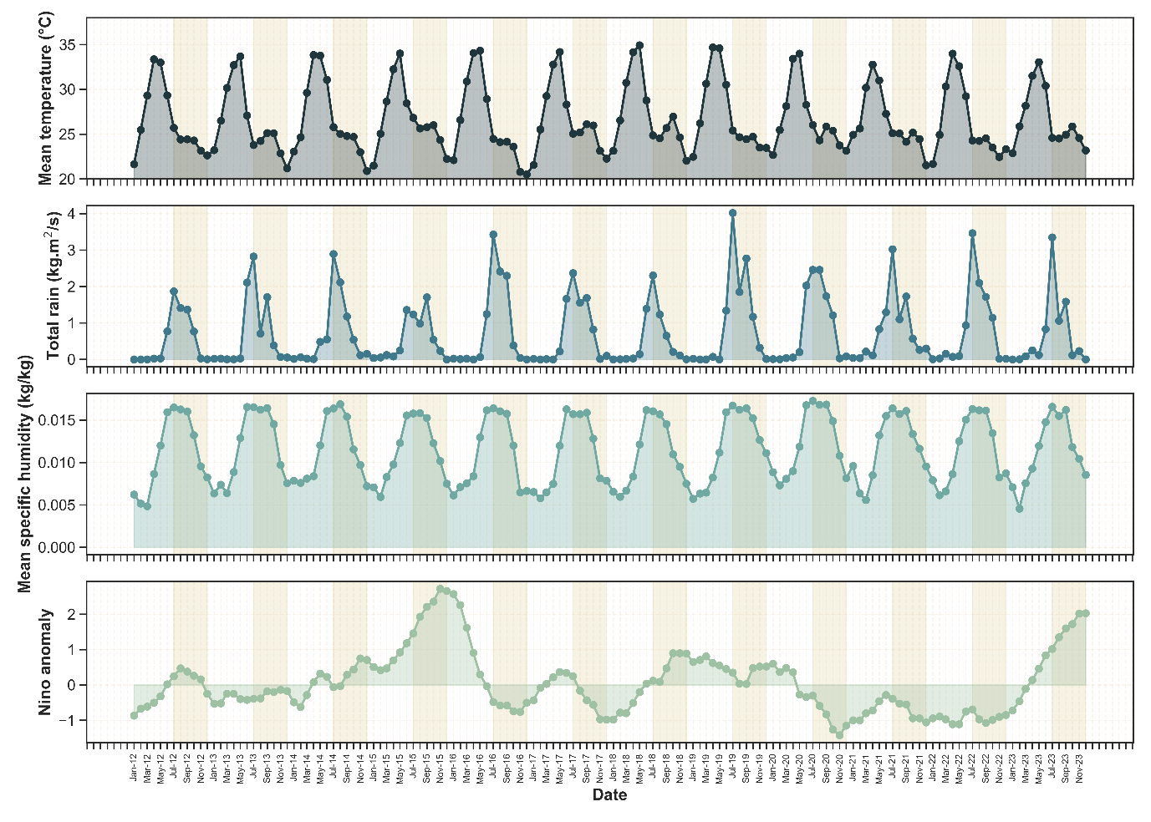
Figure S5: Monthly variations in the meteorological variables in rural Pune.
The shaded region represents the monsoon and post-monsoon months of July-November.
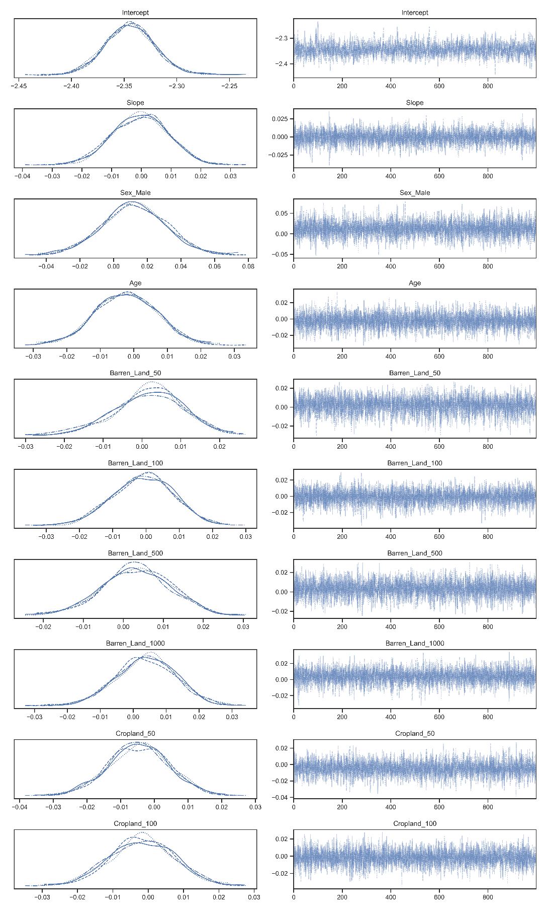
Figure S6 Trace plot 1
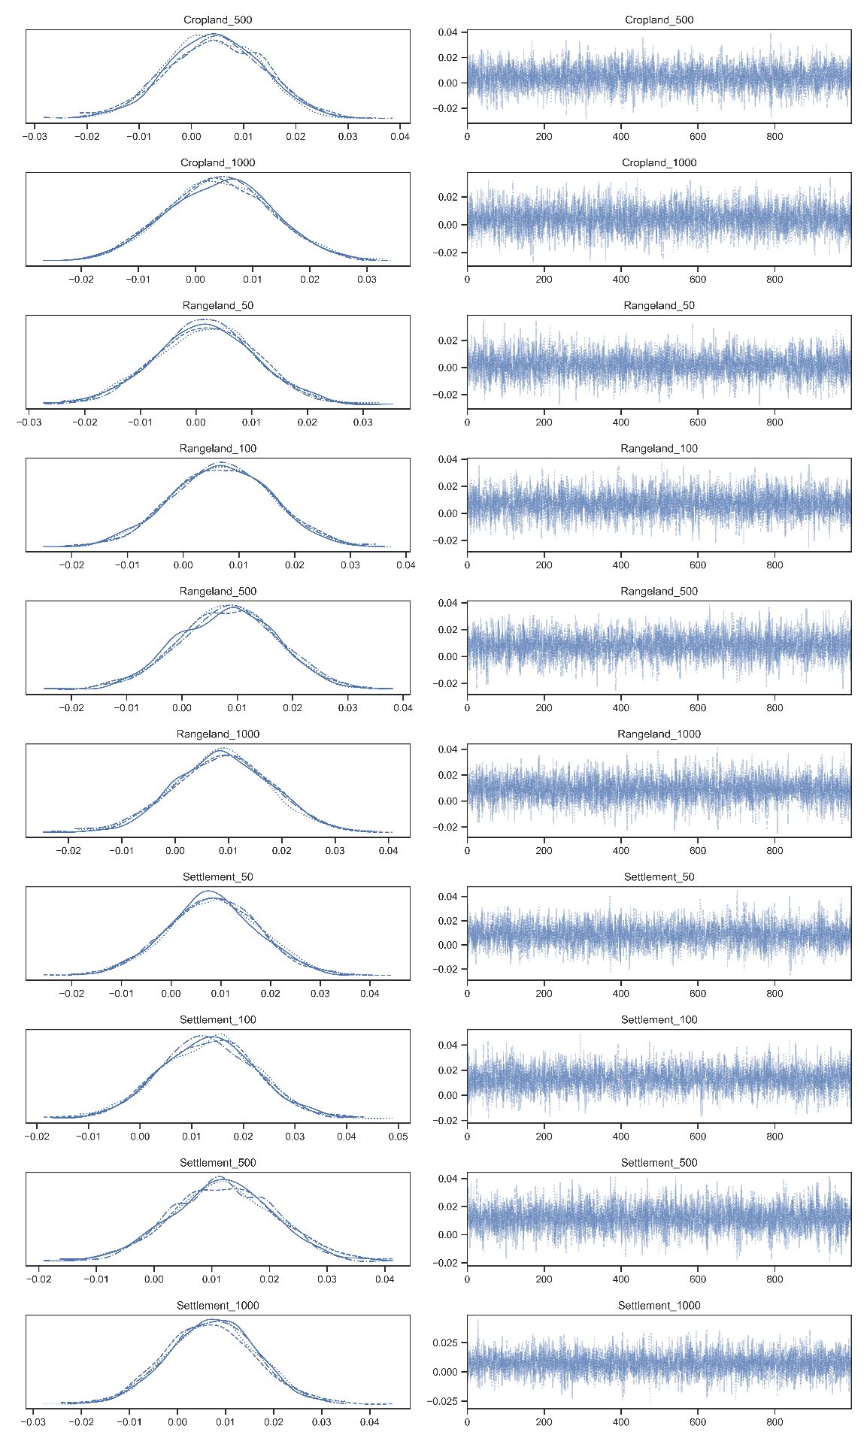
Figure S7 Trace plot 2

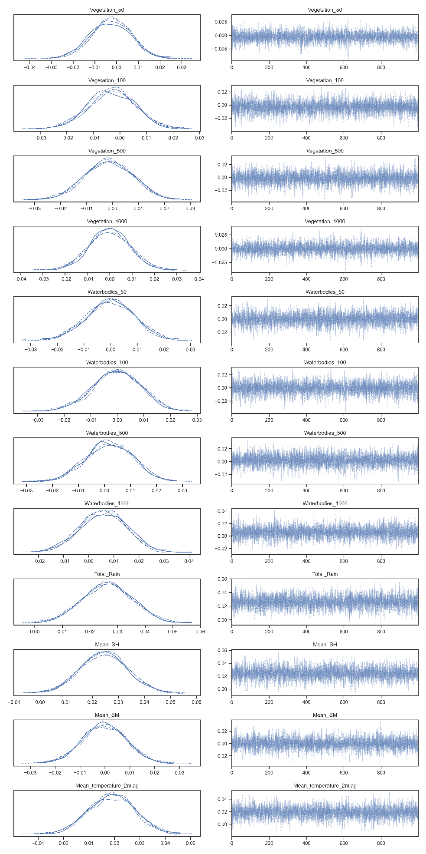
Figure S8 Trace plot 3

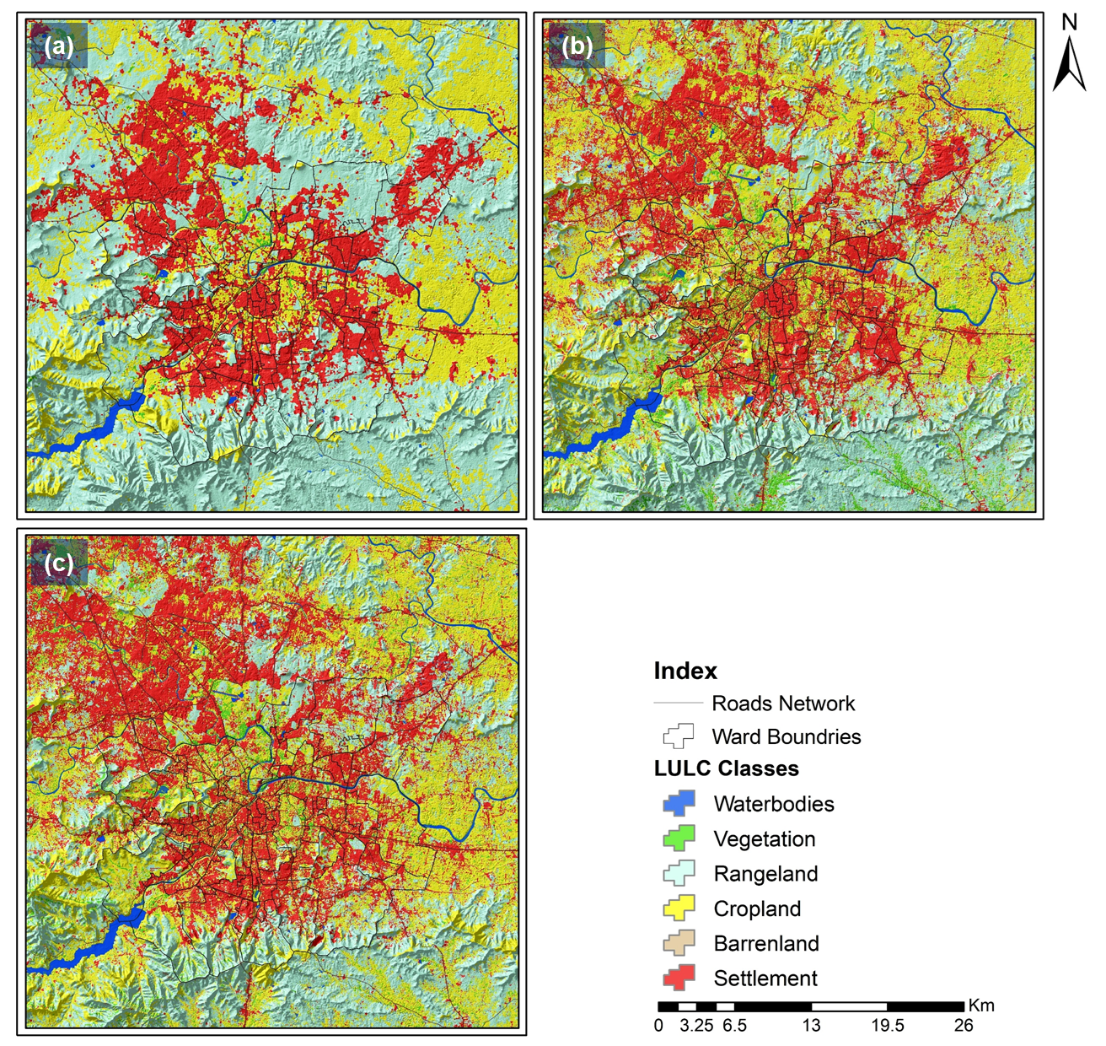
Figure S9 Delineated land use/land cover (LU/LC) map developed for the period (a) 2013, (b) 2018, and (c) 2023.

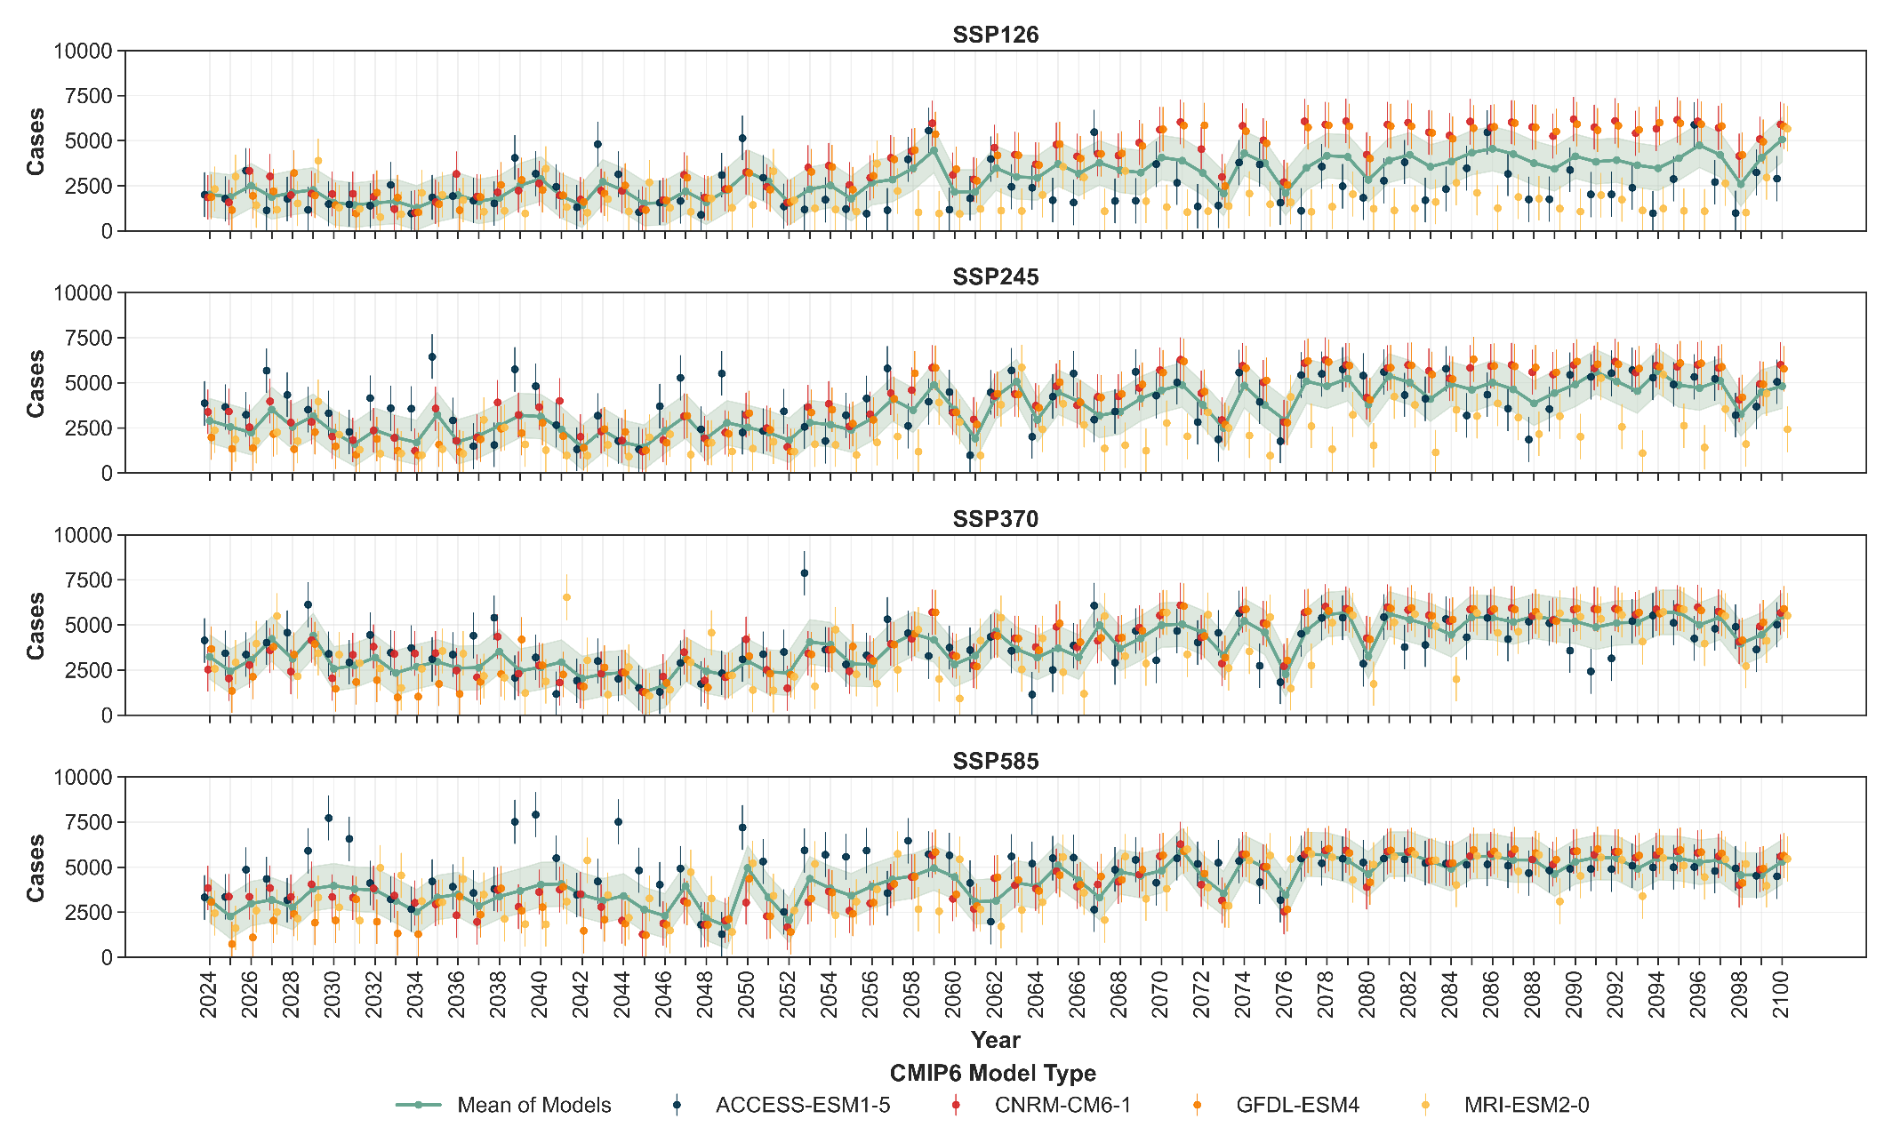
Figure S9 Annual dengue predictions in urban Pune obtained using the projections from four CMIP-6 models.
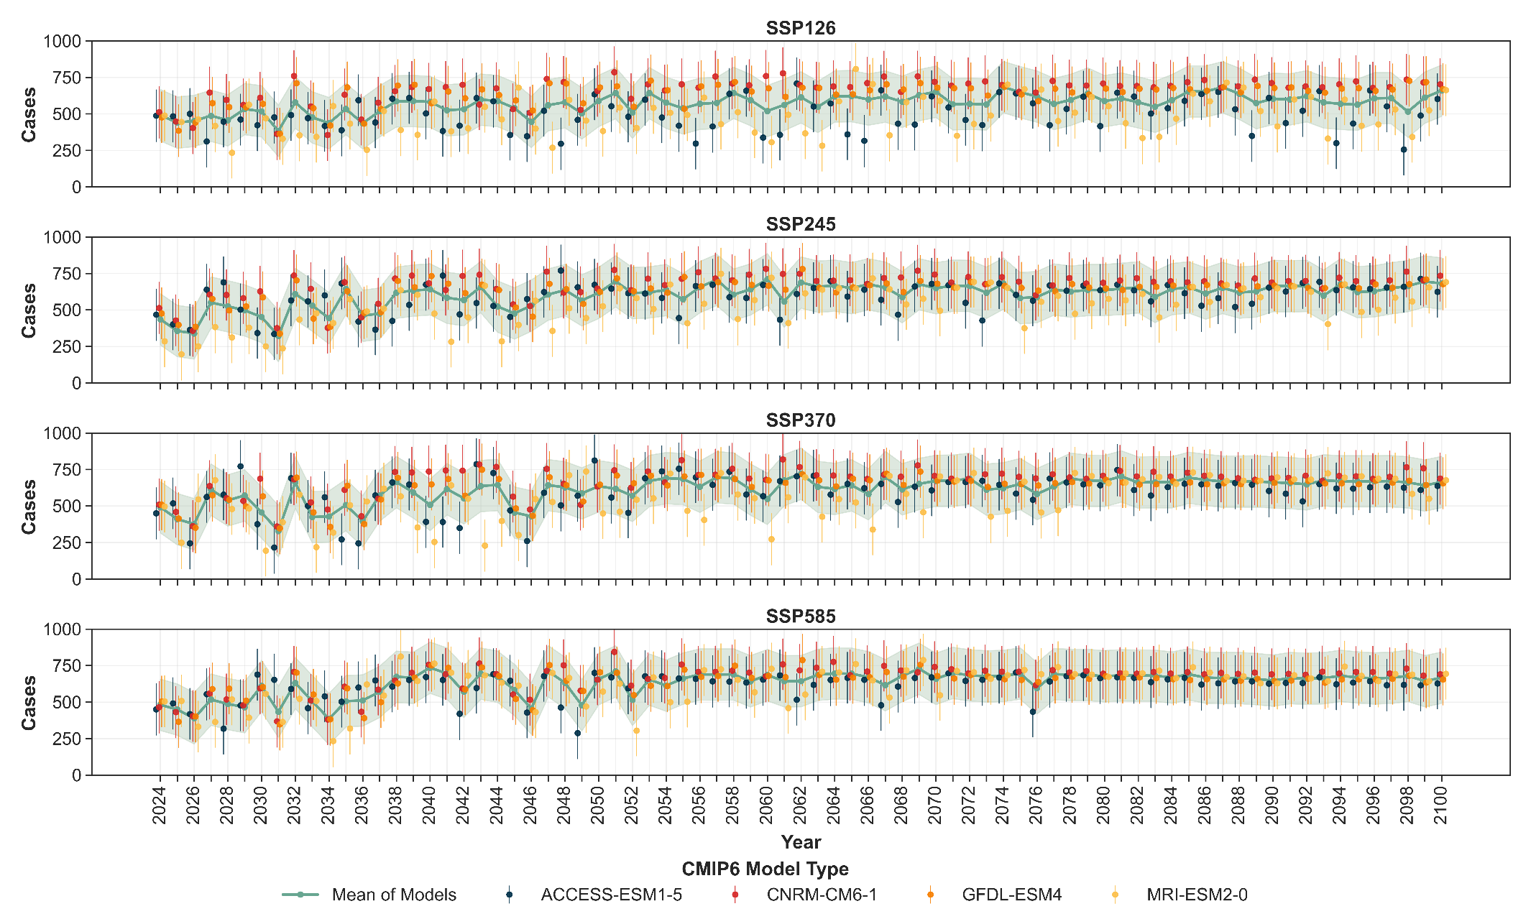
Figure S10 Annual dengue predictions in rural Pune obtained using the projections from four CMIP-6 models.

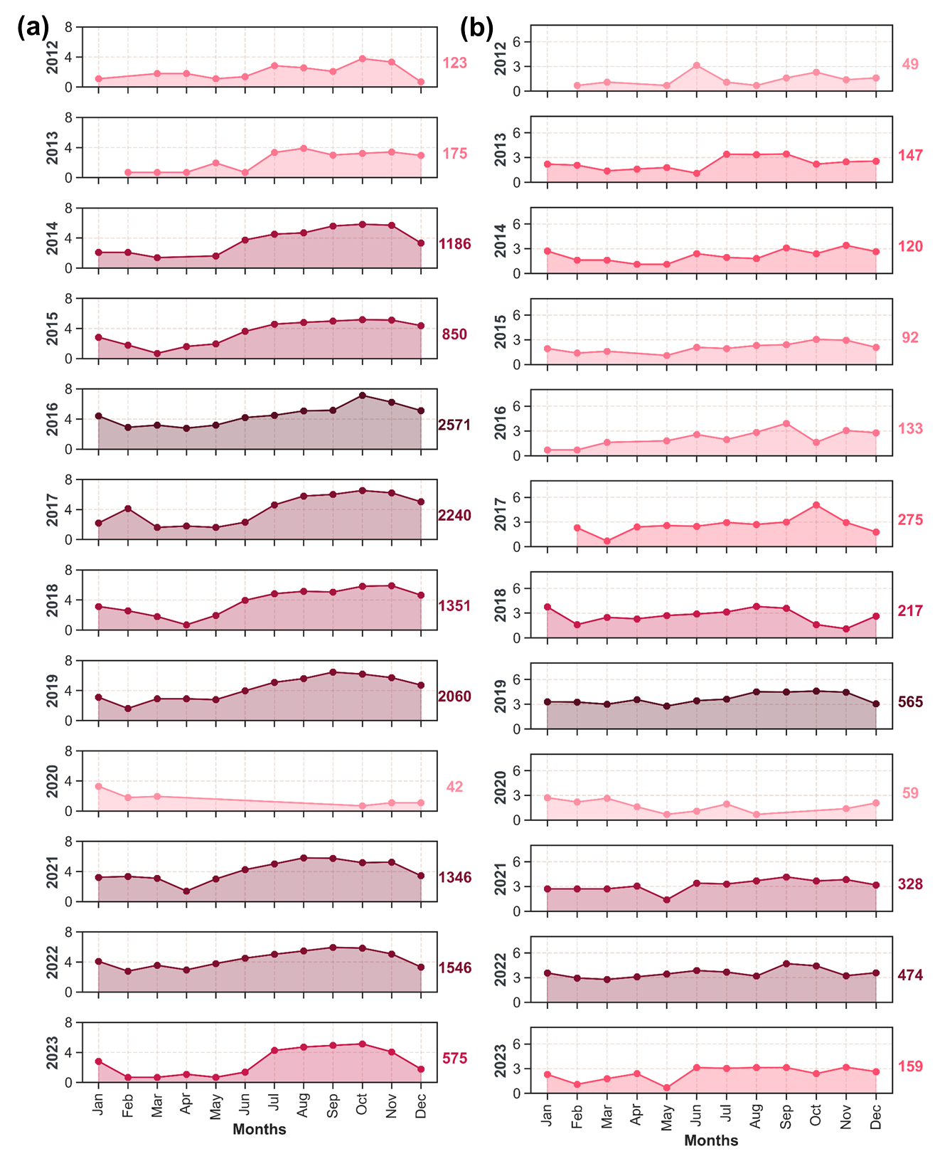
Figure S11 Monthly variations observed in the reported case counts in (a) urban and (b) rural Pune. The cases on the y axes for the particular year are represented in natural logarithm (y_{log} = log (y_{actual} + 1)). The numbers on the right axis show the total actual cases.

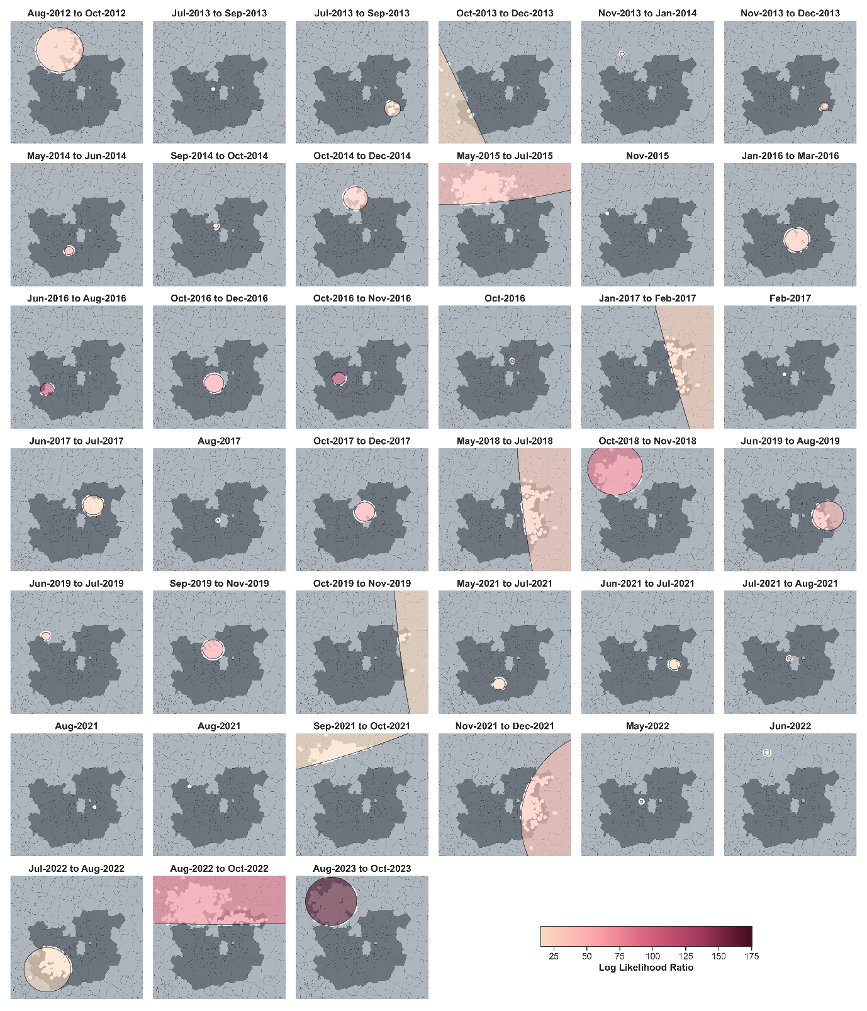Figure S12 Significant clusters (p-value < 0.05) observed in urban Pune using the Space-Time Permutation Model developed through SaTScan.

