Appendix
Fig. S1 Elevation and study area distribution in Jiangsu Province
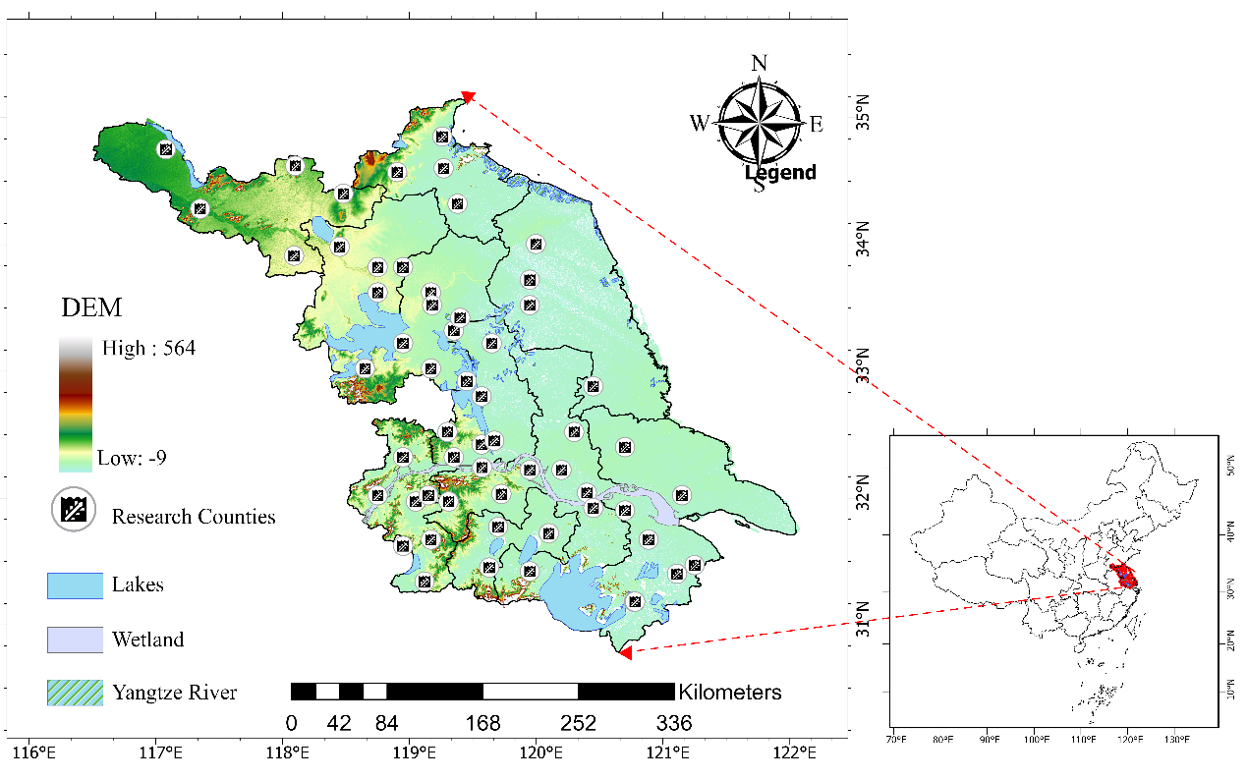

Fig. S2 Optimal marginal distribution fitting of compound extreme events in Jiangsu Province (1994-2020)
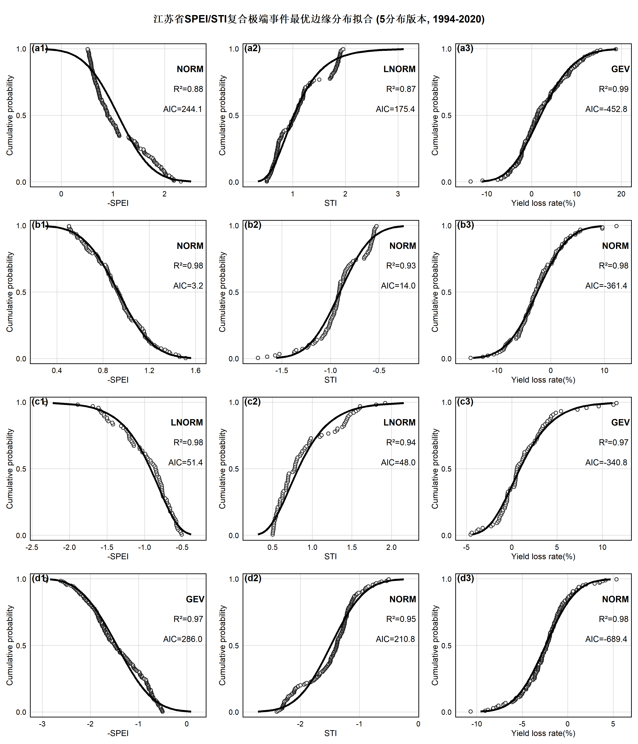

Fig. S3 Joint probability distribution of SPEI-STI compound extreme events based on vine copula
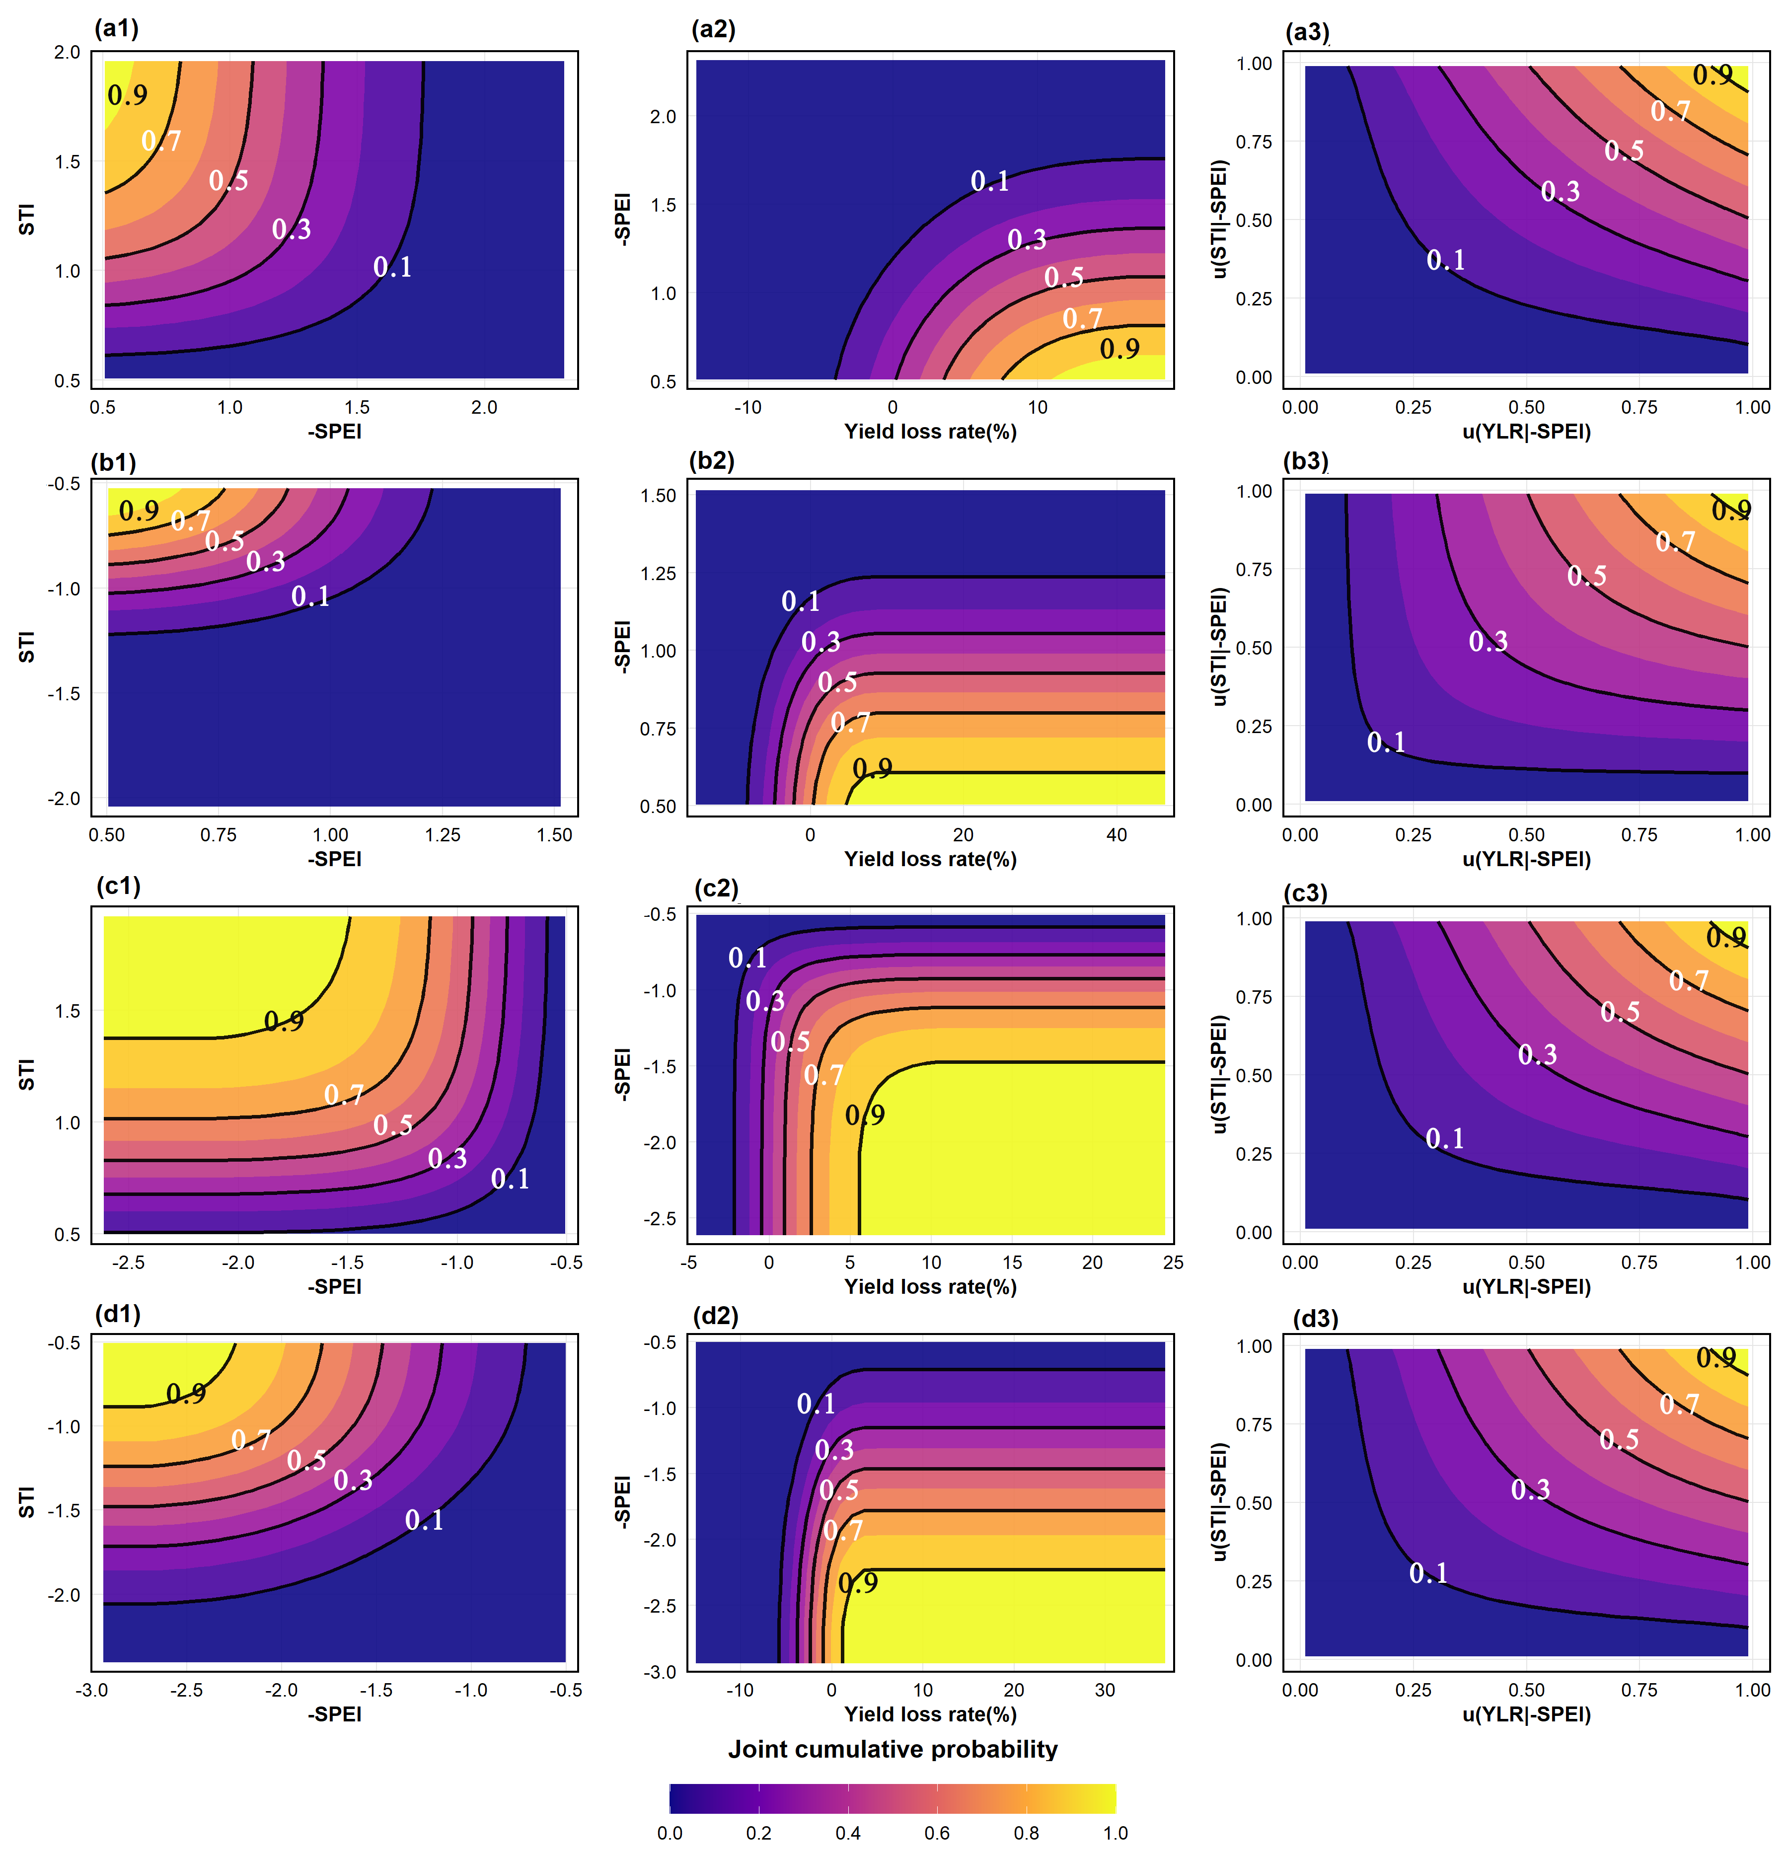

Table S1 Classification definitions of extreme precipitation and temperature events
Extreme moisture condition categories | SPEI | Extreme temperature condition categories | STI
Severe wet (SW) | 1.5 ≤ SPEI | Severe hot (SH) | 1.5 ≤ STI
Moderate wet (MW) | 1.0 ≤ SPEI < 1.5 | Moderate hot (MH) | 1.0 ≤ STI < 1.5
Light wet (LW) | 0.5 ≤ SPEI < 1.0 | Light hot (LH) | 0.5 ≤ STI < 1.0
No water stress | -0.5 < SPEI < 0.5 | No temperature stress | -0.5 < STI < 0.5
Light drought (LD) | -1.0 < SPEI ≤ -0.5 | Light cold (LC) | -1.0 < STI ≤ -0.5
Moderate drought (MD) | -1.5 < SPEI ≤ -1.0 | Moderate cold (MC) | -1.5 < STI ≤ -1.0
Severe drought (SD) | SPEI ≤ -1.5 | Severe cold (SC) | STI ≤ -1.5

Table S2 Candidate copula functions and their parameter ranges
Copula | $$C\left(μν\right)$$ | Parameter
Frank | $$-\frac{1}{θ}ln\left[1+\frac{\left(e^{-θμ}-1\right)\left(e^{-θν}-1\right)}{e^{-θ}-1}\right]$$ | $$θ∈R$$
Gumbel | $$exp\{-{\left[{\left(-lnμ\right)}^{θ}+{\left(-lnν\right)}^{θ}\right]}^{1/θ}\}$$ | $$θ∈\left[1,∞\right]$$
Gaussian | $$Φ_{ρ}\left(Φ^{-1}\left(μ\right),Φ^{-1}\left(ν\right)\right)$$ | $$ρ∈\left[-1,1\right]$$
Student’s t | $$t_{ν,ρ}\left(t_{ν}^{-1}\left(μ\right),t_{ν}^{-1}\left(ν\right)\right)$$ | $$ρ∈\left[-1,1\right],ν>0$$
BB1 (Joe-Clayton) | $${\left[1+({\left({\left(u^{-θ}-1\right)}^{δ}+{\left(v^{-δ}-1\right)}^{δ}\right)}^{1/δ}\right]}^{-1/θ}$$ | $$θ≥1,δ>0$$
Rotated Clayton | $$u+v-1+{\left[({\left(1-u\right)}^{-θ}+{\left(1-v\right)}^{-θ}-1\right]}^{-1/θ}$$ | $$θ∈\left[0,∞\right]$$

