Additional file 1
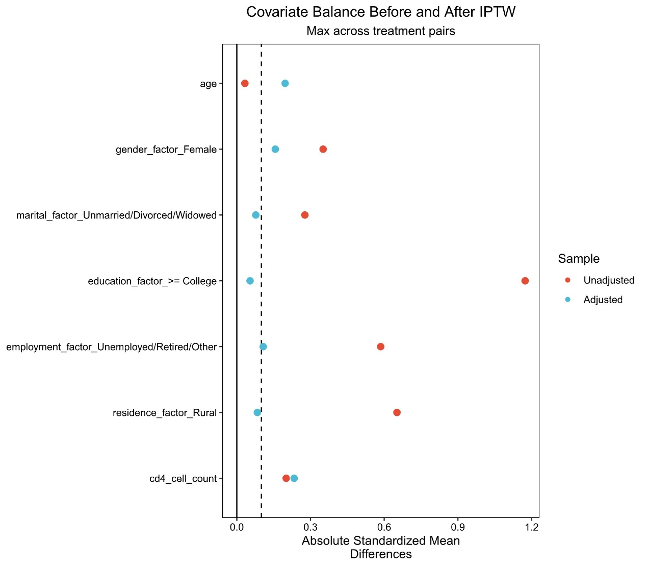
Supplementary Figure S1. Love plot demonstrating covariate balance before and after Inverse Probability of Treatment Weighting (IPTW).
Note: Standardized mean differences (SMD) for all covariates were successfully reduced to < 0.1 in the weighted pseudo-population, confirming the elimination of baseline socioeconomic confounding biases.

Supplementary Table S1. Baseline Characteristics After Inverse Probability of Treatment Weighting (IPTW)
Characteristic | Overall  (N = 710)¹ | National Free  (N = 495)¹ | Resident  (N = 133)¹ | Urban Employee  (N = 82)¹ | p-value²
Age (Years), Mean (SD) | 45 (13) | 45 (12) | 44 (13) | 47 (14) | 0.79
Gender, n (unweighted) (%) |  |  |  |  | 0.53
Male | 426 (63%) | 280 (60%) | 86 (60%) | 60 (67%)
Female | 284 (37%) | 215 (40%) | 47 (40%) | 22 (33%)
Marital Status, n (unweighted) (%) |  |  |  |  | 0.82
Married/Cohabiting | 351 (50%) | 255 (49%) | 65 (49%) | 31 (53%)
Unmarried/Divorced/Widowed | 359 (50%) | 240 (51%) | 68 (51%) | 51 (47%)
Education Level, n (unweighted) (%) |  |  |  |  | 0.91
<= High School | 482 (68%) | 351 (68%) | 107 (69%) | 24 (67%)
>= College | 228 (32%) | 144 (32%) | 26 (31%) | 58 (33%)
Employment Status, n (unweighted) (%) |  |  |  |  | 0.74
Employed | 397 (58%) | 266 (56%) | 67 (57%) | 64 (61%)
Unemployed/Retired/Other | 313 (42%) | 229 (44%) | 66 (43%) | 18 (39%)
Residence, n (unweighted) (%) |  |  |  |  | 0.85
Urban | 557 (79%) | 382 (79%) | 96 (78%) | 79 (81%)
Rural | 153 (21%) | 113 (21%) | 37 (22%) | 3 (19%)
CD4 Cell Count, Mean (SD) | 657 (338) | 627 (276) | 648 (351) | 697 (380) | 0.84
¹Data are presented as unweighted sample sizes (n) and weighted percentages (%). P-values are derived from the weighted pseudo-population to confirm covariate balance.
²Design-based KruskalWallis test; Pearson's X^2: Rao & Scott adjustment

