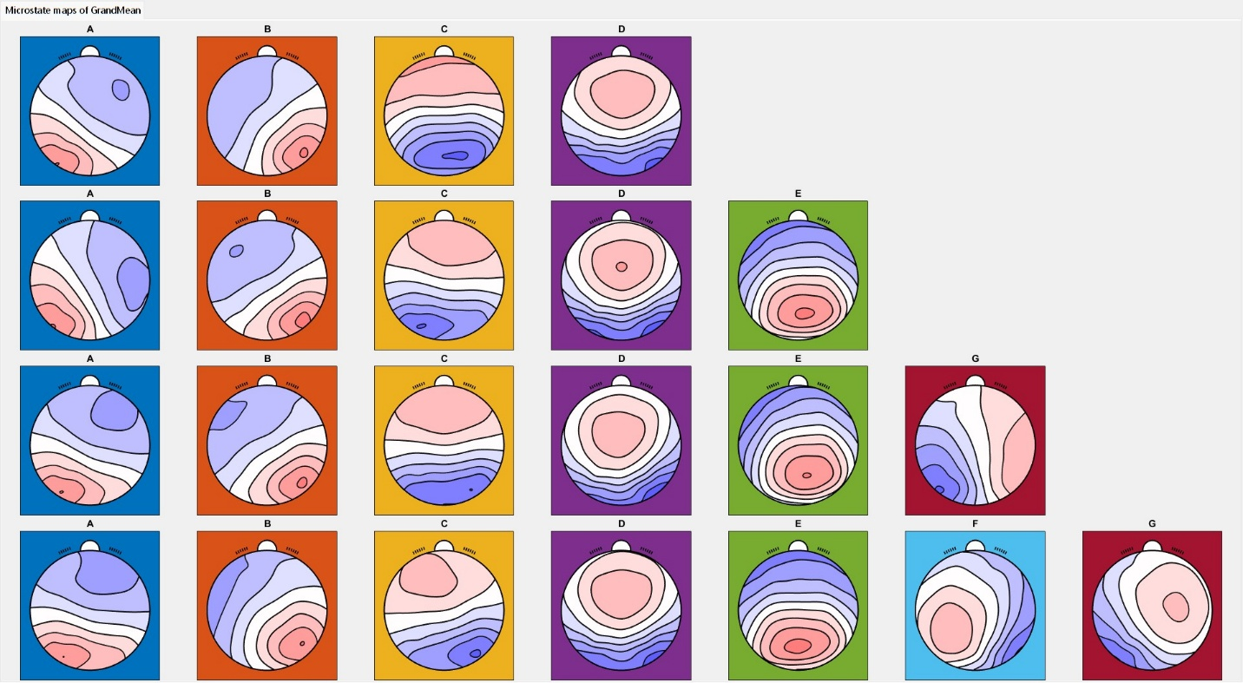
Supplementary Figure 1. Grand mean maps in the second dataset. Each set of maps was compared with the published metamaps for consistency among studies and datasets.

Supplementary Table 1. Welch’s and Bayesian Student’s t test on EEG microstate parameters across datasets
Dataset 1 | Group | t | p | BF10 | Cohen's d | Lower | Upper
MeanDuration_A | CTL vs Subclinical | 3.555 | < .001 | 9.443 | 0.78 | 0.276 | 1.277
MeanDuration_B | CTL vs Subclinical | 1.762 | 0.087 | 0.891 | 0.424 | -0.064 | 0.908
MeanDuration_C | CTL vs Subclinical | 2.335 | 0.024 | 1.311 | 0.519 | 0.029 | 1.004
MeanDuration_D | CTL vs Subclinical | 1.16 | 0.254 | 0.415 | 0.273 | -0.208 | 0.752
MeanDuration_E | CTL vs Subclinical | 1.72 | 0.095 | 0.909 | 0.421 | -0.068 | 0.904
MeanDuration_G | CTL vs Subclinical | 3.201 | 0.003 | 8.217 | 0.737 | 0.231 | 1.235
MeanOccurrence_A | CTL vs Subclinical | -0.547 | 0.588 | 0.286 | -0.135 | -0.611 | 0.343
MeanOccurrence_B | CTL vs Subclinical | -1.63 | 0.112 | 0.733 | -0.392 | -0.873 | 0.096
MeanOccurrence_C | CTL vs Subclinical | -1.376 | 0.18 | 0.766 | -0.36 | -0.843 | 0.128
MeanOccurrence_D | CTL vs Subclinical | -1.917 | 0.064 | 1.494 | -0.482 | -0.969 | 0.013
MeanOccurrence_E | CTL vs Subclinical | -0.662 | 0.513 | 0.306 | -0.164 | -0.641 | 0.315
MeanOccurrence_G | CTL vs Subclinical | -0.66 | 0.514 | 0.305 | -0.164 | -0.64 | 0.315
Coverage_A | CTL vs Subclinical | 0.793 | 0.433 | 0.316 | 0.187 | -0.292 | 0.663
Coverage_B | CTL vs Subclinical | -0.553 | 0.584 | 0.281 | -0.131 | -0.607 | 0.346
Coverage_C | CTL vs Subclinical | 0.106 | 0.916 | 0.25 | 0.026 | -0.451 | 0.501
Coverage_D | CTL vs Subclinical | -0.869 | 0.392 | 0.357 | -0.217 | -0.694 | 0.264
Coverage_E | CTL vs Subclinical | 0.336 | 0.739 | 0.264 | 0.085 | -0.392 | 0.561
Coverage_G | CTL vs Subclinical | 0.284 | 0.778 | 0.258 | 0.07 | -0.407 | 0.546
MeanDuration_A | CTL vs MDD | 2.353 | 0.023 | 1.771 | 0.537 | 0.053 | 1.016
MeanDuration_B | CTL vs MDD | 1.762 | 0.085 | 0.73 | 0.4 | -0.078 | 0.873
MeanDuration_C | CTL vs MDD | 0.543 | 0.591 | 0.288 | 0.137 | -0.333 | 0.605
MeanDuration_D | CTL vs MDD | 1.744 | 0.088 | 0.671 | 0.389 | -0.087 | 0.862
MeanDuration_E | CTL vs MDD | 2.1 | 0.042 | 1.175 | 0.479 | -0.003 | 0.955
MeanDuration_G | CTL vs MDD | 2.21 | 0.033 | 1.961 | 0.528 | 0.042 | 1.008
MeanOccurrence_A | CTL vs MDD | -0.68 | 0.5 | 0.288 | -0.153 | -0.622 | 0.316
MeanOccurrence_B | CTL vs MDD | -1.463 | 0.153 | 0.679 | -0.359 | -0.832 | 0.12
MeanOccurrence_C | CTL vs MDD | -1.831 | 0.075 | 1.04 | -0.439 | -0.914 | 0.043
MeanOccurrence_D | CTL vs MDD | -1.594 | 0.119 | 0.705 | -0.378 | -0.851 | 0.1
MeanOccurrence_E | CTL vs MDD | -0.489 | 0.628 | 0.274 | -0.119 | -0.587 | 0.351
MeanOccurrence_G | CTL vs MDD | -0.817 | 0.419 | 0.324 | -0.193 | -0.662 | 0.278
Coverage_A | CTL vs MDD | 0.454 | 0.652 | 0.263 | 0.101 | -0.368 | 0.569
Coverage_B | CTL vs MDD | -0.486 | 0.629 | 0.266 | -0.108 | -0.576 | 0.361
Coverage_C | CTL vs MDD | -0.622 | 0.538 | 0.296 | -0.153 | -0.621 | 0.318
Coverage_D | CTL vs MDD | -0.172 | 0.864 | 0.248 | -0.037 | -0.505 | 0.431
Coverage_E | CTL vs MDD | 0.847 | 0.402 | 0.323 | 0.196 | -0.275 | 0.665
Coverage_G | CTL vs MDD | 0.075 | 0.94 | 0.246 | 0.017 | -0.451 | 0.485
Dataset 2 | Group | t | p | BF10 | Cohen's d | Lower | Upper
MeanDuration_A | CTL vs mild D | 0.332 | 0.741 | 0.295 | 0.093 | -0.462 | 0.647
MeanDuration_B | CTL vs mild D | -0.344 | 0.733 | 0.295 | -0.095 | -0.649 | 0.46
MeanDuration_C | CTL vs mild D | -1.655 | 0.105 | 0.718 | -0.447 | -1.007 | 0.118
MeanDuration_D | CTL vs mild D | -0.883 | 0.382 | 0.369 | -0.238 | -0.794 | 0.319
MeanDuration_E | CTL vs mild D | -0.912 | 0.366 | 0.379 | -0.248 | -0.804 | 0.309
MeanDuration_G | CTL vs mild D | 1.215 | 0.23 | 0.49 | 0.336 | -0.224 | 0.892
MeanOccurrence_A | CTL vs mild D | 1.059 | 0.295 | 0.419 | 0.288 | -0.271 | 0.844
MeanOccurrence_B | CTL vs mild D | 0.942 | 0.351 | 0.4 | 0.263 | -0.295 | 0.818
MeanOccurrence_C | CTL vs mild D | -0.719 | 0.475 | 0.346 | -0.201 | -0.756 | 0.356
MeanOccurrence_D | CTL vs mild D | -0.056 | 0.955 | 0.283 | -0.016 | -0.57 | 0.538
MeanOccurrence_E | CTL vs mild D | 0.075 | 0.941 | 0.283 | 0.021 | -0.534 | 0.575
MeanOccurrence_G | CTL vs mild D | 1.79 | 0.08 | 0.931 | 0.496 | -0.07 | 1.056
Coverage_A | CTL vs mild D | 1.17 | 0.248 | 0.472 | 0.324 | -0.236 | 0.88
Coverage_B | CTL vs mild D | 0.581 | 0.564 | 0.322 | 0.162 | -0.394 | 0.716
Coverage_C | CTL vs mild D | -1.545 | 0.129 | 0.669 | -0.424 | -0.982 | 0.139
Coverage_D | CTL vs mild D | -0.268 | 0.79 | 0.291 | -0.075 | -0.629 | 0.479
Coverage_E | CTL vs mild D | -0.334 | 0.74 | 0.294 | -0.092 | -0.646 | 0.463
Coverage_G | CTL vs mild D | 2.266 | 0.028 | 1.987 | 0.632 | 0.061 | 1.197
Dataset 3 | Group | t | p | BF10 | Cohen's d | Lower | Upper
MeanDuration_A | CTL vs Subclinical | 1.029 | 0.309 | 0.422 | 0.278 | -0.263 | 0.822
MeanDuration_B | CTL vs Subclinical | 0.648 | 0.52 | 0.327 | 0.276 | -0.365 | 0.716
MeanDuration_C | CTL vs Subclinical | -0.226 | 0.822 | 0.282 | 0.275 | -0.601 | 0.477
MeanDuration_D | CTL vs Subclinical | 0.577 | 0.567 | 0.316 | 0.276 | -0.383 | 0.697
MeanDuration_E | CTL vs Subclinical | 0.95 | 0.347 | 0.401 | 0.277 | -0.282 | 0.802
MeanDuration_G | CTL vs Subclinical | 1.451 | 0.153 | 0.629 | 0.28 | -0.153 | 0.938
MeanOccurrence_A | CTL vs Subclinical | -0.143 | 0.887 | 0.279 | 0.275 | -0.578 | 0.5
MeanOccurrence_B | CTL vs Subclinical | -0.762 | 0.449 | 0.351 | 0.277 | -0.749 | 0.333
MeanOccurrence_C | CTL vs Subclinical | -1.556 | 0.126 | 0.731 | 0.281 | -0.97 | 0.122
MeanOccurrence_D | CTL vs Subclinical | -0.535 | 0.595 | 0.31 | 0.276 | -0.685 | 0.395
MeanOccurrence_E | CTL vs Subclinical | 0.38 | 0.705 | 0.294 | 0.276 | -0.435 | 0.644
MeanOccurrence_G | CTL vs Subclinical | 0.141 | 0.888 | 0.279 | 0.275 | -0.501 | 0.578
Coverage_A | CTL vs Subclinical | 0.225 | 0.823 | 0.282 | 0.275 | -0.478 | 0.601
Coverage_B | CTL vs Subclinical | -0.208 | 0.836 | 0.281 | 0.275 | -0.596 | 0.483
Coverage_C | CTL vs Subclinical | -0.725 | 0.472 | 0.343 | 0.276 | -0.739 | 0.342
Coverage_D | CTL vs Subclinical | -0.008 | 0.993 | 0.276 | 0.275 | -0.542 | 0.537
Coverage_E | CTL vs Subclinical | 0.555 | 0.582 | 0.315 | 0.276 | -0.388 | 0.693
Coverage_G | CTL vs Subclinical | 0.608 | 0.546 | 0.321 | 0.276 | -0.375 | 0.706
P values are not corrected for multiple testing.

