Figure 1C
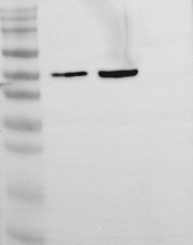 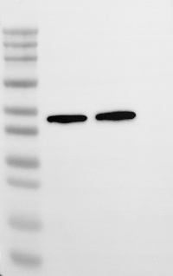
GSS β-actin
Figure 1F
GSH β-actin
Figure 1G
GSH β-actin
Figure 2C
GSH Grx1 β-actin
Figure 3A
STAT3 STAT3 GSH STAT3

Figure 3B
p-STAT3 STAT3 β-actin
Figure 3D
Mem. p-STAT3 STAT3 β-actin
Cyto. p-STAT3 STAT3 β-actin
Nuc. p-STAT3 STAT3 Histone H3

Figure 4A
p-STAT3 STAT3 Grx1 β-actin

Figure 4H
RORγ β-actin

