Influence of Vertical Baffles on the Motion of Gas and Particles in Gas-Solid Fluidized Beds
Zhiqiang Maª, Xiuxun Hao^{b}, Fei Gaoª, Junling Fan^{b,}*, Pan Zhang^{b}, Guanghui Chen^{a,}**
ªCollege of Chemical Engineering and Key Laboratory of Multiphase Flow Reaction and Separation Engineering of Shandong Province, Qingdao University of Science and Technology, Qingdao 266042, China
^{b}College of Electromechanical Engineering, Qingdao University of Science and Technology, Qingdao 266069, China
*Corresponding author: Tel./fax: +86 532 84022957. E-mail: keda2973@163.com (J. Fan)
**Corresponding author: Tel./fax: +86 532 84022957. E-mail: guanghui@qust.edu.cn (G. Chen)

In all four fluidized bed configurations, bubbles exhibit similar interaction behaviors upon contacting the walls of the heat exchange tubes. These bubble-wall interactions can be categorized into the following three typical types:
- Bubble Breakage:
As illustrated in Fig. A1, a large bubble rises and its upper surface first comes into contact with the top wall of a heat exchange tube. Upon further upward movement, the bubble surface is sliced by the tube wall, resulting in the breakup of the large bubble into several smaller bubble segments. These fragments partially adhere to the tube wall and continue ascending in the form of unsealed, smaller bubbles.
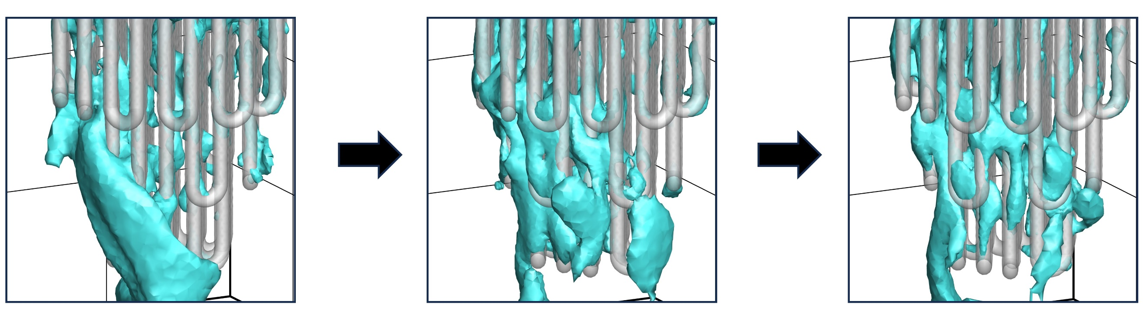
Fig. A1. The bubble breaks upon contact with the top of the heat exchange tube.
- Bubble Penetration:
As shown in Fig. A2, a large bubble rising within the bed is compressed upon encountering the top of a heat exchange tube. The bubble undergoes surface deformation and is subsequently punctured. As it continues to rise, the tube penetrates the lower portion of the bubble, eventually passing through the entire bubble volume.
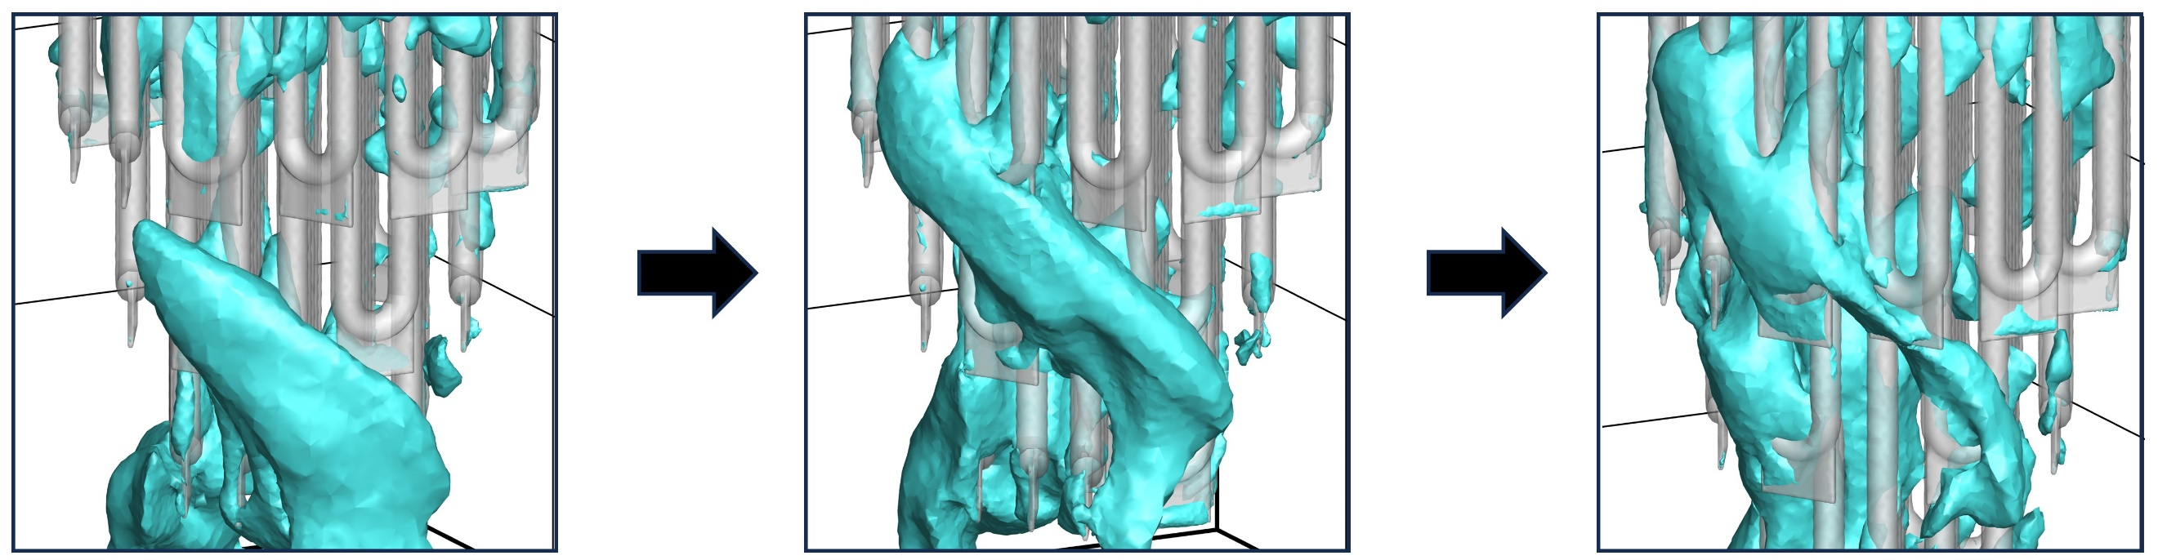
Fig. A2. Bubble penetration by the heat exchanger tube.
- Bubble “Short Circuit”:
As highlighted by the red circle in Fig. A3, a portion of the bubble remains in contact with the wall of the heat exchange tube, forming an open channel. Over time, the spatial position of the bubble remains largely unchanged, but its volume gradually decreases. Close observation reveals that the gas escapes through this opening, adhering to the wall and moving upward along the heat exchange tube, thereby forming a short-circuiting gas path.
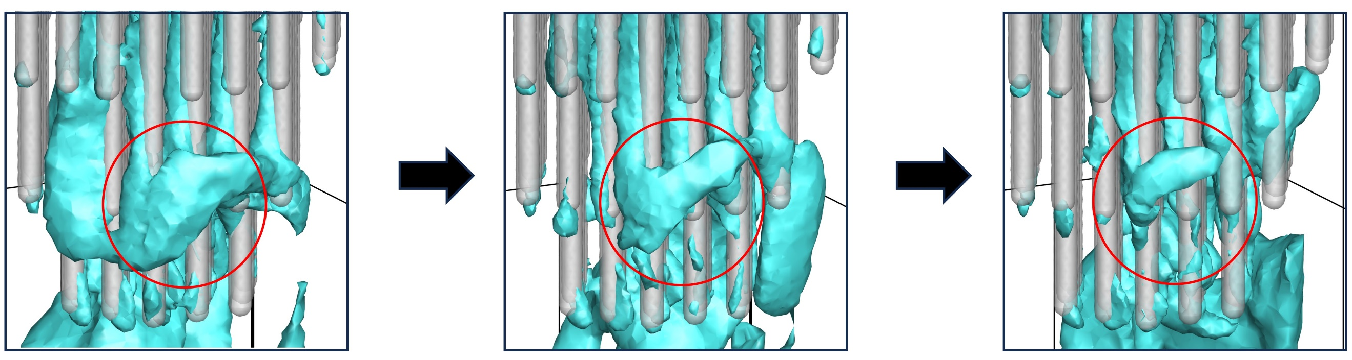
Fig. A3. "short-circuiting" behavior of bubbles.
- Wall-Adhering Deformation:
As shown in Fig. A4, when a bubble comes into contact with the side wall of a heat exchange tube and adheres to its surface, the bubble continues to rise while its interface becomes partially unsealed. Due to relative motion within the internal gas and the influence of wall shear, the bubble surface undergoes deformation along the contour of the heat exchange tube. As a result, bubbles in this state typically appear as elongated, strip-like structures attached to the wall.
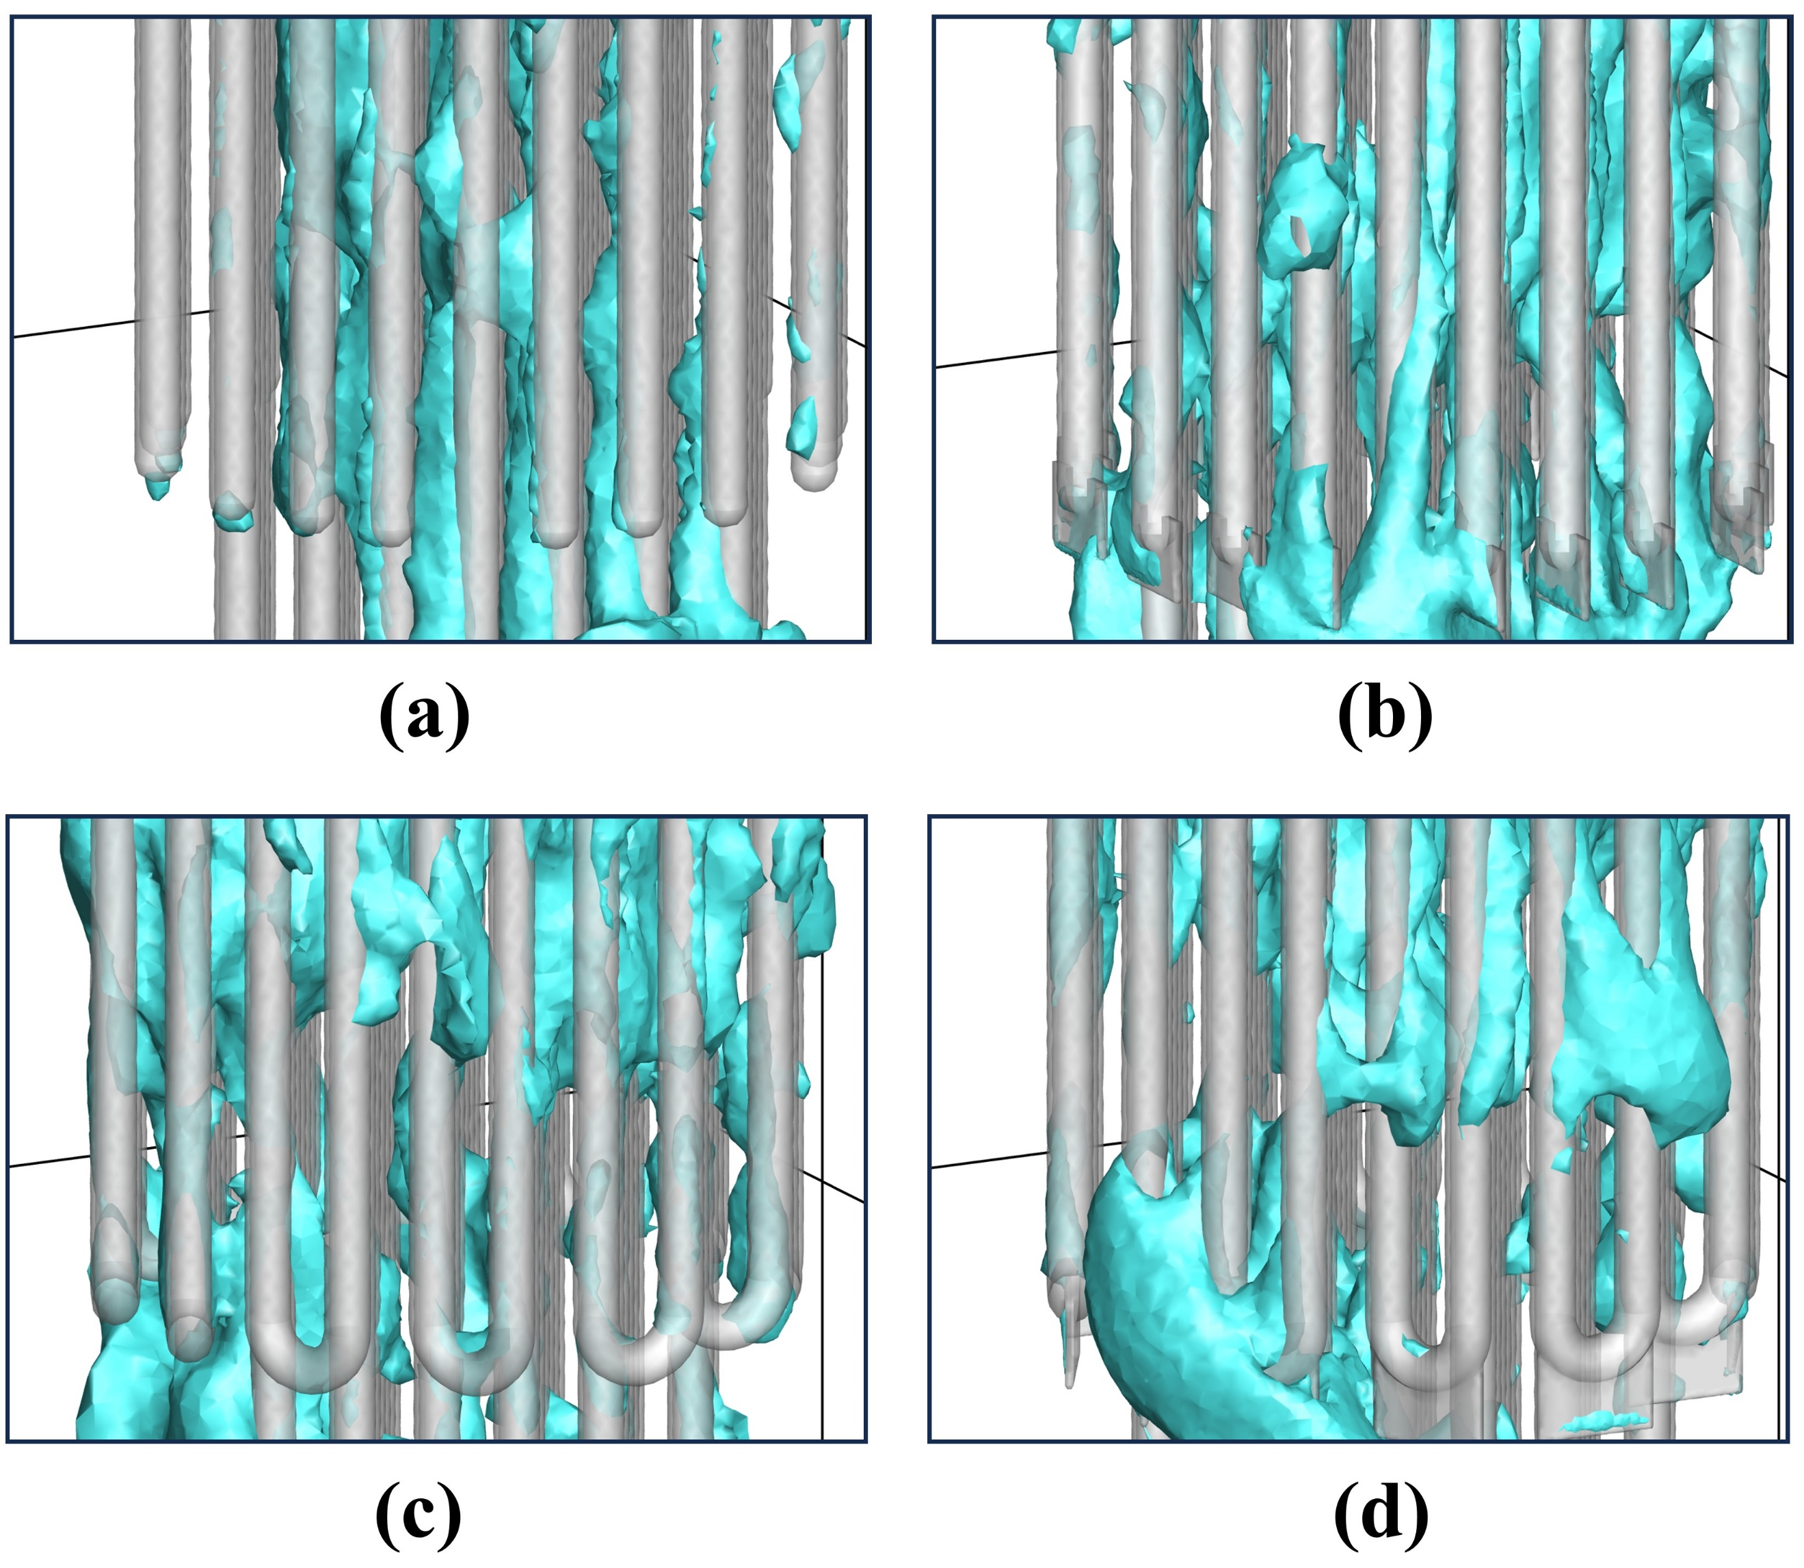
Fig. A4. The bubble's along-the-wall deformation behavior after contacting side wall of the heat exchange tube: (a) Case 1; (b) Case 2; (c) Case 3; (d) Case 4.
Among the four types of bubble behaviors described above, wall-adhering deformation is the most prevalent; nearly all bubbles in contact with heat exchange tube surfaces exhibit this behavior. The other three behaviors - bubble breakage, penetration, and short-circuiting - are not mutually exclusive. Upon contact with the tube wall, a bubble may experience any of these three behaviors individually, in combination, or even simultaneously. Notably, short-circuiting can be regarded as a special case of wall-adhering deformation in which the bubble remains nearly stationary while gas escapes along the wall. The occurrence of wall-to-wall motion, wall-adhering deformation, and short-circuiting stems from the fact that the resistance imposed by the tube wall on the bubble is lower than that exerted by the surrounding particles, making the wall a preferred path for bubble evolution. Bubble breakage reduces the average bubble diameter and thereby increases the total interfacial area. Likewise, both short-circuiting and wall-adhering deformation transform spherical bubbles into elongated, strip-like forms, significantly increasing their aspect ratio and surface area. Therefore, bubble breakage, short-circuiting, and wall-adhering deformation all contribute to enhancing the bubble surface area, which in turn improves gas-solid contact and promotes mass transfer efficiency within the fluidized bed.

