Supplemental Information

1. Detailed Description of Tribometer and Auto-Loading Platform
Each sample was tested with an individual “station” comprised of two perpendicular 100-gram load cells (Phidgets) mounted to a compliant titanium flexure. Custom-made ball holders capable of holding 3 counterfaces are central to the high-throughput workflow. Ball holders use a central magnet to allow for tool-less manipulation with the robotic arm and to stay affixed to the end of a station. A custom end effector comprised of a PEEK spring block with a magnetic center is attached to the end of the robotic arm to give compliance. The applied normal force of each station is controlled via a ball-bearing stage (Optosigma TADC-251C) driven by a nema 8 non-captive stepper motor (Moons LN081S-E03006-100-S-050) with 6 mm of travel and a lead screw pitch of 0.6096 mm per rotation. The load cell signals are conditioned using a custom dual-channel load cell amplifier board based on the Analog Devices AD8428 instrument amplifier, giving ~±5 mV peak-to-peak unfiltered noise (~±1 mN). Six stations are mounted to a common Y and Z ±12.5 mm cross-roller bearing stage (Optosigma TADC-651S25UU) that have each been modified to accommodate an identical nema 8 non-captive motor. All eight stepper motors are controlled using Applied Motion STF06-IP stepper motor controllers with 20,000 steps per revolution (~0.03 µm per step) and outfitted with individual limit switches for homing and over-loading protection. Bidirectional sliding motion is provided by a ball-screw X stage (Parker Hannifin) with a lead screw pitch of 5 mm per rotation driven by a nema 23 step-servo motor (Applied Motion TSM23Q-2AG) capable of 0.25-µm position accuracy. The tribometer is controlled using a custom MATLAB user interface with data acquired at 1000 Hz using a National Instrument USB-6343 multifunctional data acquisition card.
The ball reloading system is controlled via a programmable logic controller (BRX series). A Meca500 robotic arm places a used ball holder from the ball holder platen into the machine. A x-y stage (Parker Hannifin) moves the torque driver (Mountz) and engages the hex drive onto a silver coated set screw (to avoid galling) that holds a single counterface. A pair of linear actuators of different sizes (Faulhaber, 1 N and 6 N max force) pinch the counterface, followed by the torque driver disengaging the set screw using three rotations. The captured counterface is moved to an unloading position and dropped into a container. A brass ball holder slide that (1) drops a new ball to be captured by the linear actuators and (2) holds the ball holder down while the torque driver disengages is moved into position. The captured clean counterface is moved to the bottom of the ball holder and the torque driver tightens to 8 cN-m, followed by the x-y stages disengaging the driver and moving it out of position. This process is repeated for all three used ball holders until loaded (the robotic arm spins the holder between loads), followed by the robotic arm swapping out the fully loaded ball holder to the next used one on the platen.

2. Detailed Description of Testing Time and Operator Time
Calculations are based on the following set of assumptions and the experimental details in section 3 for the dry N₂ and lab air experiments: (1) The tribometer being used is the tribometer shown in Figure 3 and uses a platter of 24 ball holders that each hold three balls and a sample stage that holds 24 coated substrates (4 per head, 6 heads), (2) The human operator must interact with the tester and either rotate the ball holder between tests as well as change the ball holder every three tests (if not automated) and physically change the ball holder platter and the sample stage (for serial and automated methods). (3) A human operator works 8 hours a day, any operation that falls outside of work hours would be required to happen the following business day for testing to continue, (4) All ball holders for the entire 448 sample set and samples are assumed to be preloaded and are already in the glovebox. Here, we are not accounting for the time to prepare samples or to transfer samples in/out of a glovebox, (5) All software is pre-configured for testing and the time to run the software is not considered, and (6) Operator times to interface with the tribometers are adjusted based on environment because dry N₂ tests are assumed to be in a glove box and lab air tests are not in a glovebox and the tester is easily accessible. Conservative times are given in this work, with the time to rotate a single head in lab air assumed to be 35 seconds and 50 seconds in dry N₂. Times for changing of the sample stages/ball holder platens are assumed to take 30 seconds in lab air and 45 seconds in dry N₂.

3. Sputter gun arrangements showing elements of the source-substrate geometry.

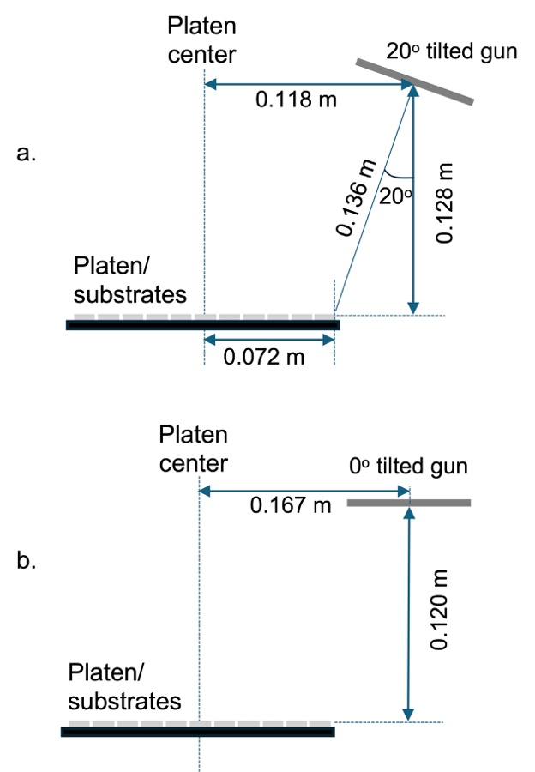
FIG. A1. Schematics showing the source-sample geometries for sputter guns oriented at a.) 20º tilt and b.) 0º tilt. These side views show a plane containing the center points of a sputter source and substrate platen. Substrates are not shown to scale although their top surface is used as a reference for included dimensions.

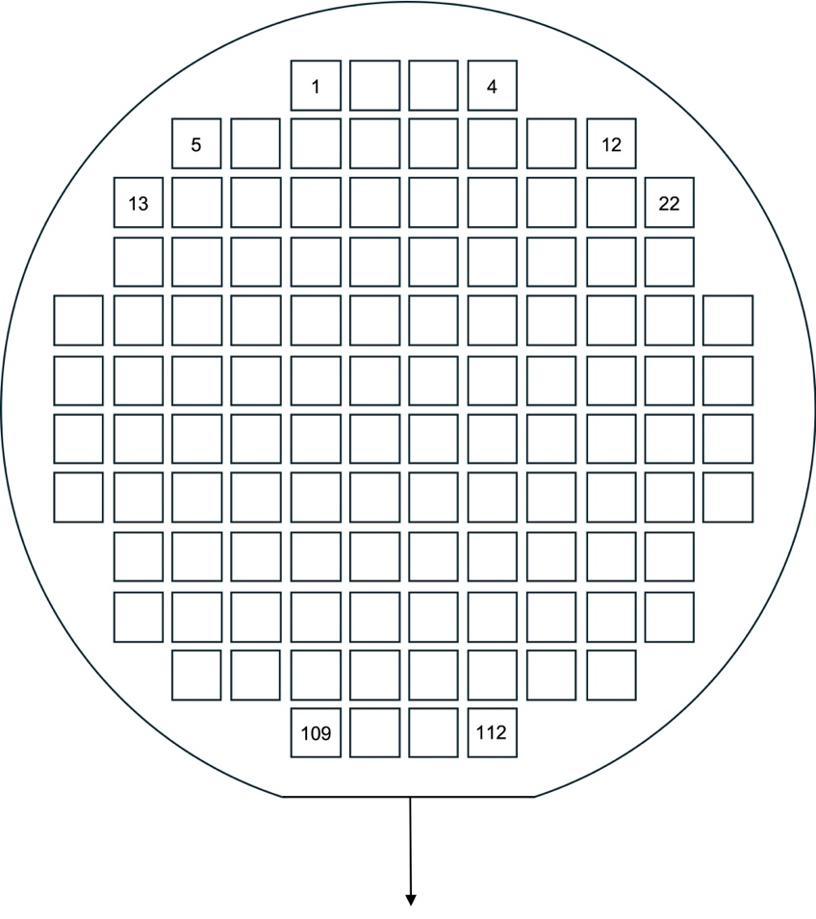
FIG. A2. Plan view, top-down drawing of the substrate fixture showing positions for 112 samples. The arrow points along a plane bisecting the center points of Pt and Au sputter sources.

