Plasma Heparan Sulfate Structural Variation and Phenotypic Heterogeneity in Pediatric Acute Respiratory Distress Syndrome
*Colin J. Sallee, MD, MS¹; Aline B. Maddux, MD, MSCS²; Joseph A. Hippensteel, MD, MS³; Daniela Markovic, MS⁴; Zhangjie Wang, PhD⁵; Jian Liu, PhD⁶; Kaori Oshima, PhD⁷; Robert P. Richter, MD, MS⁸; Andreas Schwingshackl, MD, PhD¹; Peter M. Mourani, MD⁹; David Elashoff, PhD⁴; Eric P. Schmidt, MD⁷; Anil Sapru, MD, MAS¹
¹Department of Pediatrics, Division of Pediatric Critical Care Medicine, David Geffen School of Medicine at University of California Los Angeles and Mattel Children's Hospital, Los Angeles, CA, USA
²Department of Pediatrics, Section of Pediatric Critical Care, University of Colorado School of Medicine and Children's Hospital Colorado, Aurora, CO, United States
³Department of Medicine, Division of Pulmonary Sciences and Critical Care Medicine, University of Colorado Anschutz Medical Campus, Aurora, CO, USA
⁴Departments of Medicine and Computational Biology, David Geffen School of Medicine at University of California Los Angeles, Los Angeles, CA, USA
⁵Glycan Therapeutics, Raleigh, NC, USA
⁶Division of Chemical Biology and Medicinal Chemistry, Eshelman School of Pharmacy, University of North Carolina at Chapel Hill, Chapel Hill, NC, USA
⁷Department of Medicine, Division of Pulmonary and Critical Care Medicine, Harvard Medical School and Massachusetts General Hospital, Boston, MA, USA
⁸Department of Pediatrics, Division of Pediatric Critical Care Medicine, University of Alabama at Birmingham Heersink School of Medicine, Birmingham, AL, USA
⁹Department of Pediatrics, Division of Pediatric Critical Care Medicine, University of Michigan Medical School, Ann Arbor, MI, USA
*Corresponding Author:
Colin J. Sallee, MD, MS
10833 Le Conte Ave 12-358 MDCC
Los Angeles, CA 90095
csallee@mednet.ucla.edu

TABLE OF CONTENTS:

SUPPLEMENTAL METHODS:
Molecular Measurements……………………………………………………………Page 3-4
Statistical Analysis…………………………………………………………………...Page 4

SUPPLEMENTAL RESULTS:
Sensitivity Analyses………………………………………………………………….Page 5
e-Figure 1……………………………………………………………………………....Page 6
e-Figure 2……………………………………………………………………………....Page 7
e-Figure 3……………………………………………………………………………....Page 8
e-Figure 4……………………………………………………………………………....Page 9
e-Figure 5……………………………………………………………………………....Page 10
e-Table 1……………………………………………………………………………......Page 11
e-Table 2……………………………………………………………………………......Page 12
e-Table 3……………………………………………………………………………......Page 13

SUPPLEMENTAL REFERENCES..................................................................................Page 14

METHODS:
Molecular Measurements:
Whole blood was collected in an EDTA tube, placed immediately on ice after collection, and centrifuged at 2500 g for 10 min at 4°C to separate plasma. The plasma was aliquoted and stored at -80°C until analysis. Plasma was analyzed from the first collection after enrollment in the study. The full panel of biological markers measured in this study are presented in e-Table 1.
Protein and Proteoglycan Biomarkers.
We measured protein biomarkers associated with innate immune and endothelial activation using two Luminex multiplex panels (Luminex, R&D Systems, Minneapolis, MN): a 5-plex high performance, high sensitivity human cytokine panel and an 11-plex human discovery assay at the Immune Assessment Core (IAC) at UCLA. Measured analytes from plasma include interleukin (IL)-1β, -6, -8, -10, tumor necrosis factor-α (TNF-α), angiopoietin(Ang)-1, -2, endocan, soluble tumor necrosis factor receptor II (TNFRII), soluble intercellular adhesion molecule-1 (ICAM-1), soluble vascular cell adhesion molecule (VCAM-1]), soluble thrombomodulin (TM), von-Willebrand factor (vWF). We included markers of alveolar-epithelial injury surfactant protein D (SPD) and soluble receptor for advanced glycation end products (RAGE) to contrast the innate immune activation endothelial markers. Our selection of biomarkers was guided by prior adult and pediatric ARDS studies, particularly the canonical markers identifying hyper- and hypo-inflammatory subphenotypes.¹⁻⁵ We further measured a commonly employed marker of endothelial glycocalyx (eGCX) shedding in sydecan-1, a main HS proteoglycan.⁶ Each sample underwent duplicate runs with an intra-assay coefficient of variation <5% and a standard curve R² > 95% for each analyte.
Quantification and Structural Characterization of Glycosaminoglycans using High-Performance Liquid Chromatography-Tandem Mass Spectrometry (HPLC-MS/MS).
Across the cohort, HPLC-MS/MS measurements for HS-TriS, HS-2S, and HS-2SNS were below the limit of detection (LOD) in 6, 3, and 1 patient(s), respectively. For these cases, values were imputed as one-half of the minimum observed value for the corresponding marker (minimum/2). At the time of the initial analysis, the HPLC-MS/MS method was unable to distinguish between CS-2S4S and HS-2S6S disaccharide subtypes. These analytes were below the LOD in more than 20% of patients (11/46) and were therefore excluded from further analysis. CS-2S, CS-4S6S, and CS-TriS were also undetectable across the entire cohort and were similarly removed. Finally, the HPLC-MS/MS method used was insensitive to 3-O-sulfation of the glucosamine (GlcNAc) residues of heparan sulfate (HS), a rare GlcNAc modification that has been implicated in the regulation of microvascular thrombosis.⁷
Heparanase (HPSE) Activity.
The enzymatic activity of HPSE was assessed using 20 μL of human plasma in a total reaction volume of 100 μL using a novel HPLC-MS/MS-based method we have developed (publication under peer review). The reaction mixture consisted of 20 μL plasma, 0.2 nM dekaparin solution, and 73 μL enzymatic buffer composed of 50 mM sodium acetate (pH 5.0) and 0.15 mM sodium chloride. The reaction was incubated at 37°C for 1 hour. Following incubation, enzymatic activity was terminated by heat denaturation. ¹³C-labeled GlcNS6S-GlcA (glucuronic acid) recovery calibrant was injected into the mixture as an internal standard, and the reaction mixture was passed through a 30 kDa molecular weight cut-off Amicon® Ultra-0.5 centrifugal filter to separate disaccharides from plasma proteins. The filtrate was vacuum-dried, reconstituted in double-distilled water. Samples were then subjected to HPLC-MS/MS analysis to quantify GlcNS6S-GlcA levels relative to the amount of ¹³C-labeled GlcNS6S-GlcA calibrant. The HPSE activity assay utilizes a specific HS disaccharide readout that is not common to native HS and is thus not impacted by endogenous circulating HS levels.
Statistical Analysis:
Categorical variables were summarized with frequency (%) and compared with chi-square or Fisher’s exact tests, where appropriate. Continuous variables were presented using median and interquartile range (IQR) and evaluated with non-parametric rank-order Spearman correlation. Comparisons between 2 groups were conducted using nonparametric Wilcoxon rank-sum tests, while comparisons involving >2 groups were analyzed using Kruskal-Wallis tests followed by post-hoc Dunn’s tests for multiple comparisons.
Principal Component Analysis:
Biomarker concentrations were natural (ln(x)) log-transformed to address right skewness and standardized (mean = 0, standard deviation = 1) to enable comparisons across assays. Retained principal components (PCs) were interpreted as candidate biological axes and were based upon a combination of scree plots (eigenvalue >1.0 using the Kaiser-Guttman rule) and permutation testing. To assess the statistical significance of principal components, 1,000 permutation iterations were conducted. For each iteration, values within each variable were randomly permuted independently to disrupt the multivariate correlation structure while preserving the marginal distribution of each variable. PCA was recomputed for each permuted dataset to generate an empirical null distribution of eigenvalues. Observed eigenvalues were compared to their corresponding null distributions, and components were considered statistically significant if the observed eigenvalue exceeded the 95th percentile of the permutation-derived distribution.
Mahalanobis distance was calculated in the two-dimensional space defined by PC1 and PC2 to quantify multivariate deviation from the sample distribution. This metric incorporates the variance-covariance structure of the PC scores, providing a standardized measure of distance from the multivariate centroid. Observations (patients) with squared Mahalanobis distances exceeding the 97.5th percentile of the chi-square distribution (2 degrees of freedom) were flagged as potential multivariate outliers.
Regression Analyses:
Due to the relatively small sample size and to avoid reliance on strict parametric assumptions we employed bootstrap resampling methods, where appropriate, to generate bias-corrected 95% confidence intervals. This approach provides more robust inference under distributional uncertainty. In addition, we assessed the influence of individual observations using Cook’s distance (4/n criterion) and difference in beta (DFBETA) statistics (2/√n criterion) to identify points that could disproportionately affect model estimates. Analyses were evaluated both with and without influential observations to ensure the stability and robustness of the findings.

RESULTS:
Sensitivity Analyses for Principal Component Analysis (PCA); Regression and HPSE analyses:
Across model specifications, two patients previously contained in Cluster 3 in our earlier investigations⁸, were consistently identified as potentially influential based on Mahalanobis distance criteria for PCA and Cook’s distance and DFBETA criteria for regression analyses. Sensitivity analyses excluding these observations yielded substantively similar results in the PCA analyses and analyses of sulfation enrichment across children with and without PARDS, suggesting that our findings were robust to potential influential data points. However, in exploratory analyses using our novel HPSE activity assay, observed associations were sensitive to their inclusion. These two observations had the highest circulating total HS concentrations, yet exhibited the sixth and eighth lowest HPSE activity in the entire cohort. Indeed, after exclusion of these patients, increasing higher HPSE activity exhibited a robust linear association with total HS levels (β per log-HPSE increase = 0.22, 95% CI 0.10, 0.34, p=0.014).

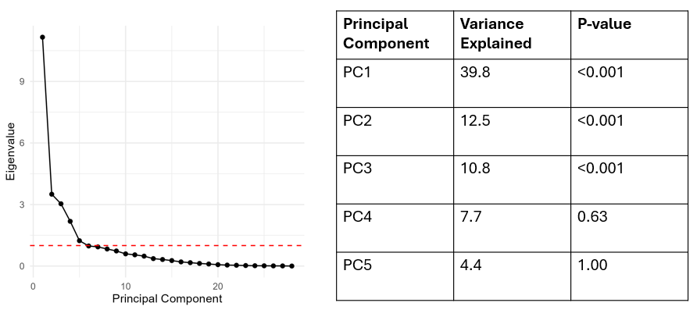
e-Figure 1. Scree plot showing the eigenvalues of the principal components (PC). The Kaiser-Guttman criterion was applied to identify components to retain, with the dashed red line indicating the eigenvalue threshold of 1. Permutation testing was then performed to determine whether the variance explained by each PC exceeded that expected by chance. Based on these analyses, PC1, PC2, and PC3 were retained for further analysis in the main dataset.

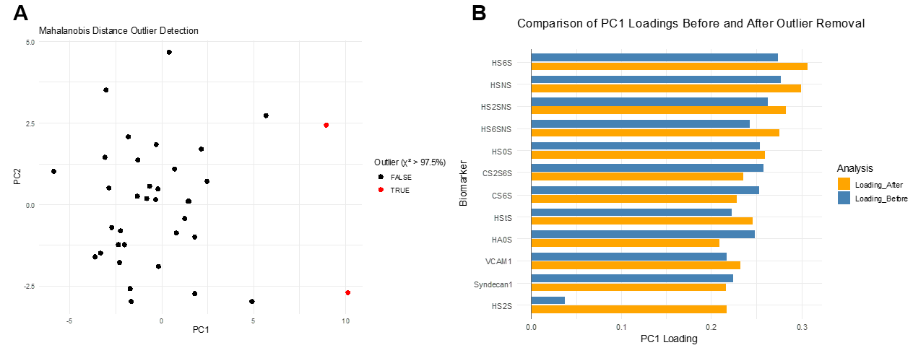
e-Figure 2. (A) Mahalanobis distance. Mahalanobis distance-based outlier detection identified two samples (highlighted in red) as outliers in the two-dimensional principal component (PC) space. (B) Comparison of PC1 loadings before and after outlier removal. Figure demonstrates that the loading coefficients remain largely unchanged after outlier removal. In both cases, 6-O- and N-sulfated HS subtypes were the primary contributors to the variance captured by PC1.

e-Figure 3. (A) PC Loadings Heatmap (PARDS and no PARDS). Biomarker loadings across PC1, PC2, and PC3. (B) PCA Biplot (PARDS and no PARDS). PCA biplot of PC1 (Dim1, “glycocalyx axis”) and PC2 (Dim 2, “inflammatory axis”) across children with (black dots) and without PARDS (grey dots). Arrows represent variables with the highest loading coefficients for a given PC. PCA = principal component analysis; PC = principal component; PARDS = pediatric acute respiratory distress syndrome.

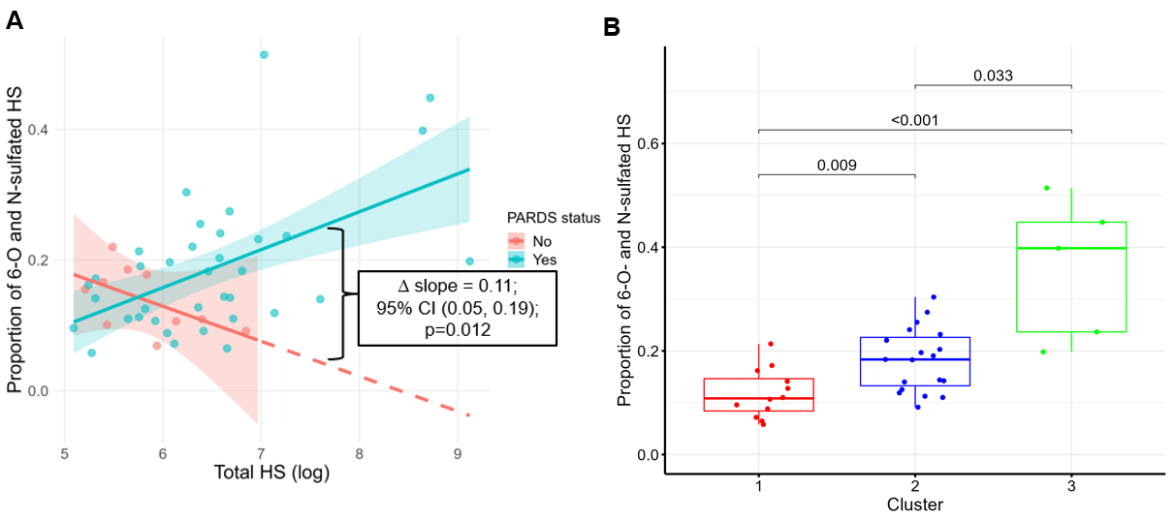
e-Figure 4. (A) Proportion of 6-O- and N-sulfated HS and total HS by PARDS status. Among children with PARDS, higher total HS levels were associated with increased proportion of 6-O- and N-sulfated HS subtypes whereas the opposite pattern was observed in non-PARDS. A linear model including the interaction term: Proportion 6-O- and N-sulfated HS ~ Total HS * PARDS status demonstrated that the slopes differed significantly between groups (interaction p=0.012). (B) Proportion of 6-O- and N-sulfated HS subtypes by PARDS clusters. Proportion of 6-O- and N-sulfated HS subtypes increased stepwise across PARD clusters. p<0.05 was statistically significant. HS = heparan sulfate; PARDS = pediatric acute respiratory distress syndrome.

e-Figure 5. HPSE activity in PARDS vs. no PARDS. HPSE activity was higher in children with PARDS compared with those without PARDS, although this difference did not reach statistical significance. Children with PARDS exhibited more than a 10-fold greater variance in HPSE activity relative to non-PARDS patients (Brown-Forsythe test, p=0.002). HPSE = heparanase-1; PARDS = pediatric acute respiratory distress syndrome.

e-Table 1: List of Biomarkers
Glycosaminoglycans |  | Proteoglycans | Inflammation | Endothelial Activation | Epithelial Injury
HS Disaccharide Subtypes  TriS_{HS}  NS6S_{HS}  NS2S_{HS}  NS_{HS}  2S6S_{HS}  2S_{HS}  6S_{HS}  0S_{HS} | HS Disaccharide Structure  △UA2S(1,4)GlcNS6S  △UA(1,4)GlcNS6S  △UA2S(1,4)GlcNS  △UA(1,4)GlcNS  △UA2S(1,4)GlcNAc6S  △UA2S(1,4)GlcNAc  △UA(1,4)GlcNAc6S  △UA(1,4)GlcNAc | Endocan  Syndecan-1 | IL-1β  IL-6  IL-8  IL-10  TNF-α  TNFR-II | Ang-1  Ang-2  ICAM-1  TM  VCAM-1  vWF | RAGE  SPD
CS Disaccharide Subtypes  TriS_{CS}  2S4S_{CS}  2S6S_{CS}  4S6S_{CS}  2S_{CS}  4S_{CS}  6S_{CS}  0S_{CS} | CS Disaccharide Structure  △UA2S(1,3)GalNAc4S6S  △UA2S(1,3)GalNAc4S  △UA2S(1,3)GalNAc6S  △UA(1,3)GalNAc4S6S  △UA2S(1,3)GalNAc  △UA(1,3)GalNAc4S  △UA(1,3)GalNAc6S  △UA(1,3)GalNAc
HA Disaccharide  0S_{HA} | HA Disaccharide Structure  △UA(1,3)GlcNAc
HS = heparan sulfate; CS = chondroitin sulfate; HA = hyaluronic acid (hyaluronan); UA = uronic acid; GlcNAc = N-acetyl glucosamine; GalNAc = N-acetyl galactosamine; Ang-1 = angiopoietin-1; Ang-2 = angiopoetin-2; ICAM-1= intercellular adhesion molecule-1; IL- = interleukin-; RAGE, receptor for advanced glycation end-products; SPD = surfactant protein D; TM = thrombomodulin; TNF-α = tumor necrosis factor-alpha; TNFRII = tumor necrosis factor receptor II; VCAM, vascular cell adhesion molecule-1; vWF, von Willebrand factor; 0S HS/CS = non-sulfated HS/CS disaccharide subtype. HA is non-sulfated.

e-Table 2: Cohort Characteristics

Variables | PARDS (n=36) | No PARDS (n=10)
Demographics  Age, year  Female sex | 9.3 (0.19-13.7)  16 (44.4) | 6.7 (1.9-10.4)  4 (40)
Comorbidities  Chronic pulmonary disease  Neurologic disease  Immunocompromise | 10 (36)  10 (36)  7 (19.4) | 2 (20)  2 (20)  0 (0)
Timing of plasma collection  Days from intubation | 4.6 (3.4-5.6) | 4.3 (3.1-5.3)
PARDS Cause  Direct (e.g., pneumonia)  Indirect (e.g., sepsis)  Unspecified | 23 (63.9)  9 (25.0)  4 (11.1) | NA
Illness Severity and Organ Dysfunction Indices  PRISM-III  OSI  PELOD-2  Non-pulmonary PELOD-2 | 4 (0-10)  8.3 (5.4-13)  6.9 (2.2-16)  1.1 (0.54-2.8) | 5.5 (0, 11)  1.9 (1.8-4.4)  10.7 (2.2-12.9)  2.8 (0.55-3.5)
Clinical Outcomes  28-day ventilator-free days  28-day PICU-free days | 20.5 (16.7-22.7)  15.9 (12.4-20.0) | 21.0 (19.1-22.4)  13.7 (12.3-21.3)

e-Table 3: Association between PCs and 28-day VFDs and PFDs.
Principal Component | 28-day VFD  β (95% CI) | 28-day PFD  β (95% CI)
PC1 | -0.33 (95% CI -0.64, -0.02), p=0.037 | -0.29 (95% CI -0.63, 0.04), p=0.088
PC2 | -0.25 (95% CI -0.56, 0.05), p=0.105 | -0.12 (95% CI -0.45, 0.21), p=0.469
PC3 | -0.28 (95% CI -0.59, 0.02), p=0.074 | -0.13 (95% CI -0.47, 0.20), p=0.427
Standardized regression coefficients (β) with 95% confidence intervals (CIs), with β representing the change in the response variable in standard deviation units [SD]) associated with a 1 SD change in PC score. P<0.05 was statistically significant. VFD = ventilator-free day; PFD = PICU-free days; PC = principal component

REFERENCES:

1. Calfee CS, Delucchi K, Parsons PE, et al. Subphenotypes in acute respiratory distress syndrome: latent class analysis of data from two randomised controlled trials. Lancet Respir Med. Aug 2014;2(8):611-20. doi:10.1016/S2213-2600(14)70097-9
2. Calfee CS, Janz DR, Bernard GR, et al. Distinct molecular phenotypes of direct vs indirect ARDS in single-center and multicenter studies. Chest. Jun 2015;147(6):1539-1548. doi:10.1378/chest.14-2454
3. Zinter MS, Spicer A, Orwoll BO, et al. Plasma angiopoietin-2 outperforms other markers of endothelial injury in prognosticating pediatric ARDS mortality. American journal of physiology Lung cellular and molecular physiology. Feb 2016;310(3):L224-L231. doi:10.1152/ajplung.00336.2015
4. Yehya N, Zinter MS, Thompson JM, et al. Identification of molecular subphenotypes in two cohorts of paediatric ARDS. Thorax. Oct 9 2023;doi:10.1136/thorax-2023-220130
5. Lim MJ, Whitney JE, Sallee CJ, et al. Plasma Soluble Intercellular Adhesion Molecule-1 Has a Central Role in Biomarker Network Analysis and Is Associated With Poor Outcomes in Two Distinct Pediatric Cohorts of Acute Respiratory Distress Syndrome and Acute Respiratory Failure. Crit Care Med. Jul 1 2025;53(7):e1457-e1469. doi:10.1097/CCM.0000000000006719
6. Murphy LS, Wickersham N, McNeil JB, et al. Endothelial glycocalyx degradation is more severe in patients with non-pulmonary sepsis compared to pulmonary sepsis and associates with risk of ARDS and other organ dysfunction. Ann Intensive Care. Oct 06 2017;7(1):102. doi:10.1186/s13613-017-0325-y
7. Xu D, Esko JD. Demystifying heparan sulfate-protein interactions. Annu Rev Biochem. 2014;83:129-57. doi:10.1146/annurev-biochem-060713-035314
8. Sallee CJ, Maddux AB, Hippensteel JA, et al. Circulating Heparan Sulfate Profiles in Pediatric Acute Respiratory Distress Syndrome. Shock. Oct 1 2024;62(4):496-504. doi:10.1097/SHK.0000000000002421

