Seeing herself in science: Broadening participation in biology through promoting student familiarity with scientists

Appendix S1: Supplemental information

Appendix S2 includes:
Table S1. The ten self-efficacy related questions we asked the student population.
Table S2. The five science career commitment related questions we asked the student population.
Table S3. The reported differences of having a scientific role model across gender dimensions and the effect on self-efficacy.
Table S4. The reported differences across gender and having a scientific role model across gender and the effect on science career commitment.
Figure S1: Science self-efficacy among undergraduate biology students across gender groupings (male, female) incorporating whether students had a scientist they personally identified with that matched their gender identity (Yes or No).
Figure S2: Self-reported science self-efficacy among undergraduate biology students across reasons why students personally identified with a scientist based either on gender, experienced gender marginalization, no reason, no scientist personally identified with, popularity or notoriety in the science community, or shared interests across student male/female gender.
Figure S3: Self-reported science career commitment among undergraduate biology students across reasons why students personally identified with a scientist based either on gender, experienced gender marginalization, no reason, no scientist personally identified with, popularity or notoriety in the science community, or shared interests across student male/female gender.

Table S1. The ten self-efficacy related questions we asked the student population. These questions were included to allow students to rate their scientific abilities on a Likert Scale of 1-5 from not confident to extremely confident.
Please rate these statements on the following scale: Presently, I am confident I can...
Discuss scientific concepts with my friends or family.
Read the scientific literature (current papers, written by scientists, in scientific journals).
Make an argument using scientific evidence.
Present scientific results in writing or orally.
Understand the science content of this course.
Think critically about scientific findings I read about in the media.
Determine what is -- and what is not -- valid scientific evidence.
Pose questions that can be addressed by collecting and evaluating scientific evidence.
Understand scientific processes behind important scientific issues in the media.
Use scientific thinking to solve problems outside of this course.

Table S2. The five science career commitment related questions we asked the student population. These questions were included to allow students to rate the following statements on a Likert Scale of 1-5 from strongly disagree to strongly agree.
Please indicate how much you agree with the following statements.
I intend to work in a job related to science.
I will work as hard as necessary to achieve a career in science.
I feel that I am on a definite career path in science.
I definitely want a career for myself in science.
Science is the ideal field of study for my life.

Table S3. The reported differences of having a scientific role model across gender dimensions and the effect on self-efficacy. Sum Sq = Sums of squares, Df = degrees of freedom, F stat = F statistic.
Self-Efficacy | Sum Sq | Df | F value | P value
Gender | 0.011 | 1 | 0.103 | 0.748
Match Gender | 0.378 | 1 | 3.554 | 0.059
Match Gender ✕ Gender | 0.011 | 1 | 0.101 | 0.751
Residuals | 139.585 | 1311

Table S4. The reported differences across gender and having a scientific role model across gender and the effect on science career commitment. Sum Sq = Sums of squares, Df = degrees of freedom, F value = F statistic.
Science Career Commitment | Sum Sq | Df | F value | P value
Gender | 0.002 | 1 | 0.022 | 0.88
Match Gender | 0.379 | 1 | 4.983 | 0.026
Match Gender ✕ Gender | 0.440 | 1 | 5.785 | 0.016
Residuals | 99.700 | 1312

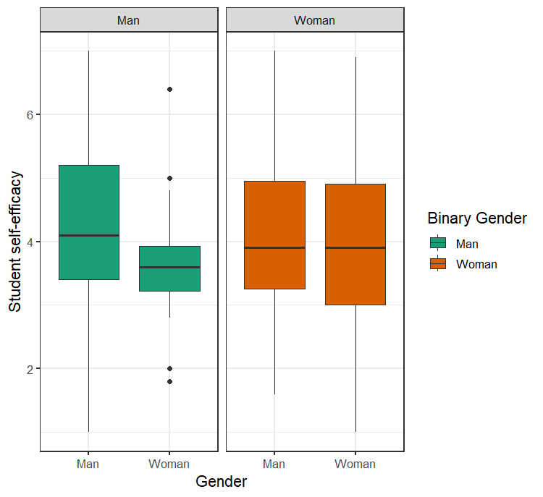
Figure S1: Science self-efficacy among undergraduate biology students across gender groupings (male, female) incorporating whether students had a scientist they personally identified with that matched their gender identity (Yes or No).

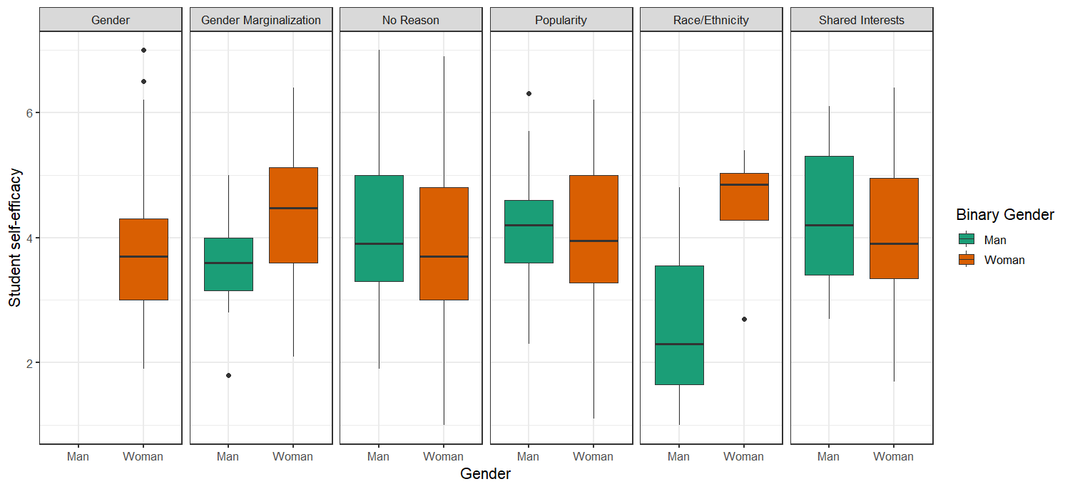
Figure S2: Self-reported science self-efficacy among undergraduate biology students across reasons why students personally identified with a scientist based either on gender, experienced gender marginalization, no reason, no scientist personally identified with, popularity or notoriety in the science community, or shared interests across student male/female gender.

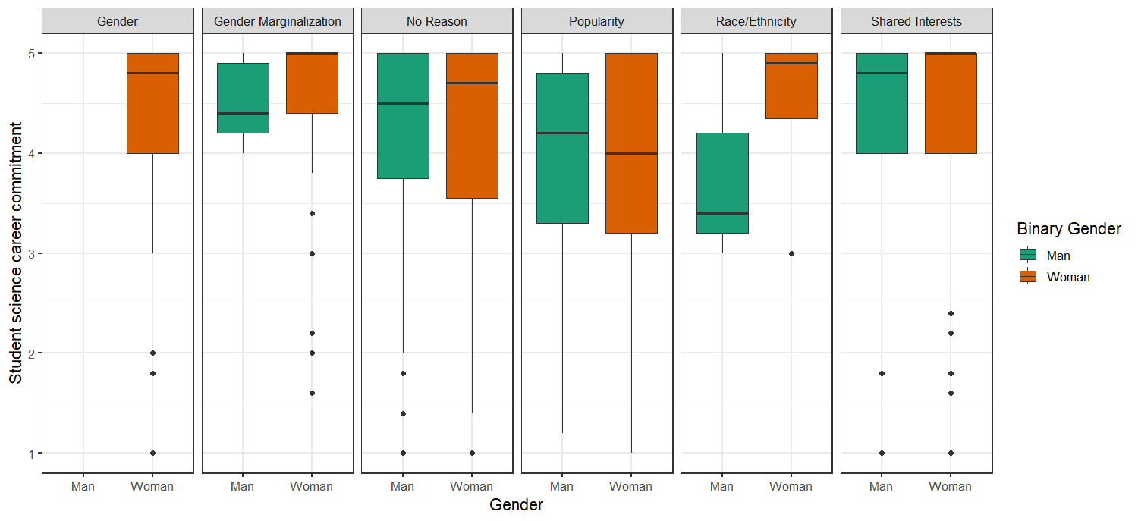
Figure S3: Self-reported science career commitment among undergraduate biology students across reasons why students personally identified with a scientist based either on gender, experienced gender marginalization, no reason, no scientist personally identified with, popularity or notoriety in the science community, or shared interests across student male/female gender.

