SUPPORTING INFORMATION FOR:

Citterio, C., Golinucci, N., Rinaldi L, Rocco M.V. Carbon footprint of electricity: a systematic methodological and quantitative review. Journal of Industrial Ecology.
This supporting information provides additional details on data sources, harmonization procedures, and robustness checks adopted in the article. It includes extended results on electricity generation emissions, methodological notes on harmonization across databases, and a comparison of EXIOBASE footprints by commodity and activity. Further sections report national carbon intensities, treatment of monetary databases, and a worked example of company-level electricity footprints. These materials support the reproducibility of the analysis and illustrate the implications of methodological choices for reported emission factors.

Table of contents
1. Electricity generation emissions 2
2. Data harmonization 3
3. EXIOBASE footprint by commodity vs by activity 5
4. Country generation carbon intensity 6
5. Monetary databases 9
6. Example of company electricity CF 9

1. Electricity generation emissions
The data presented in the introduction to support the statements regarding the relevance of electricity in calculating climate impact were calculated using MARIO software. The results of Table 1 are obtained aggregating different electricity activities and measuring its weight over the rest of GHG emissions. Another interesting metric that can be easily obtained by manipulation of SUTs is the weight of emissions related to electricity generation on the total footprint of commodities. Figure 1 shows the results for EXIOBASE Monetary SUT 2015 v3.8.2 [1] and EXIOBASE Hybrid SUT 2011[2]. Even though the shares span from 0 to 100%, the inter-quartile range is concentrated between 3.9% and 21.1%, and 6.6% and 27.0% respectively. The outliers ranging all the way to almost 100% are mainly the commodity electricity itself.
IEA data: N2O and CH4 are provided in gCO2eq/kWh according to IPCC Ar6 report. They are converted back into g of the substance and then AR5 factors are used for final comparison

Table 1: The percentage shows, for three MRIO databases, how much of total GHG emissions are generated by the production of electricity
EEIO database | Share of GHG emissions for electricity production over total
EXIOBASE Monetary SUT 2015 v3.8.2 | 26.6%
EXIOBASE Hybrid SUT 2011 v3.3.18 | 26.8%
EXIOBASE Hybrid SUT 2020 (Nowcasted) | 25.1%
FIGARO-E3 | 30.8%

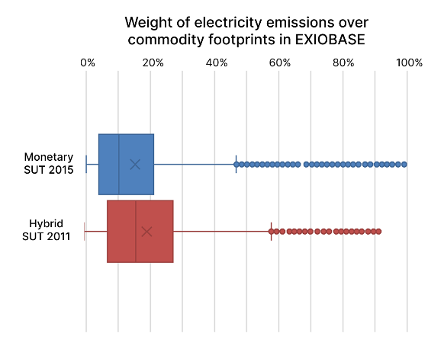
Figure 1: Weight of electricity emissions over commodity footprints in EXIOBASE, comparison of Monetary and Hybrid SUTs for 2015

2. Data harmonization
Cross-source data comparison required harmonization along two principal dimensions: passing from various GHG accounting to a standardized GWP100 as defined by IPCC AR5 and having a common classification of generation technologies.
Table 2 presents the factors by which accounts for each source have been multiplied in order to have the same GWP100. In EXIOBASE, satellite accounts report gas flows in grams of substance, therefore AR5 characterization factors have been directly used. IEA reports CH4 and N2O values as CO2-equivalent but through IPCC AR6 characterization factors, so a re-scaling was needed. Other sources report directly grams of CO2-equivalent.

Table 2: Multiplication factors to reach harmonized climatic impact (if not specified, coefficient of 1 for CO2eq)
Data source | CO₂ | N₂O | CH₄ | HFCs | SF6 | CO | Fgas
Exiobase 3.10.1 | 1 | 264.8 | 29.7 | 1 | 23506 | 4.1
Exiobase hybrid 3.8 | 1 | 264.8 | 29.7 |  |  | 4.1
GLORIA | 1 | 264.8 | 29.7 | 1 | 23506 | 4.1
IEA | 1 | 1.0067 | 0.9707

Table 3 shows how classifications of technologies for electricity generation from different sources have been harmonized into common categories. For IEA the technology “Biofuels” has been excluded because its CO2 emissions are of biogenic origin [3].

Table 3: Harmonization of electricity generation technologies categories from different sources
 | Exiobase | Electricity Maps | IEA | Ecoinvent | NREL | IPCC | ENTSO-E
Coal | Production of electricity by coal | Coal | Coal peat and oil shale | Coal | Coal | Coal | Fossil Brown coal/Lignite; Hard coal; Peat
Biomass and waste | Production of electricity by biomass and waste | Biomass | Non-renewable wastes | Biomass; Waste |  | Biomass dedicated | Biomass; Waste
Geothermal | Production of electricity by Geothermal | Geothermal |  | Geothermal |  | Geothermal | Geothermal
Hydroelectric | Production of electricity by hydro | Hydro |  | Hydroelectric |  | Hydropower | Hydro run of river and pundage; water reservoir
Natural Gas | Production of electricity by gas | Gas | Natural gas | Natural Gas; Industrial gasses | Natural gas | Gas - Combined Cycle | Fossil gas
Nec | Production of electricity nec | Unknown |  |  |  |  | Other
Nuclear | Production of electricity by nuclear |  |  | Nuclear | Nuclear | Nuclear | Nuclear
Oil | Production of electricity by petroleum and other oil derivatives | Oil | Oil | Petroleum products |  |  | Fossil oil; oil shale
Solar | Production of electricity by solar photovoltaic; Production of electricity by solar thermal | Solar |  | Photovoltaics | Solar photovoltaics; Concentrating solar power | Solar PV – Utility; Concentrated solar power | Solar
Ocean | Production of electricity by tide, wave, ocean |  |  |  |  | Ocean - Wave & Tidal | Marine
Wind | Production of electricity by wind | Wind |  | Wind | Wind | Wind | Wind onshore, offshore

Boxplots
To visualize effectively the distribution of data by technology, boxplots are used to provide a clear way for evaluating consistency across data sources. Boxplots are also a valuable tool for assessing whether a data point from an additional source is comparable. The boxplots in Figure 1 in the main manuscript and in Figure 2 here, present wiskers reaching over and below 1.5 times the inter-quartile range (IQR) while the dashed line is the average and the solid line the median.
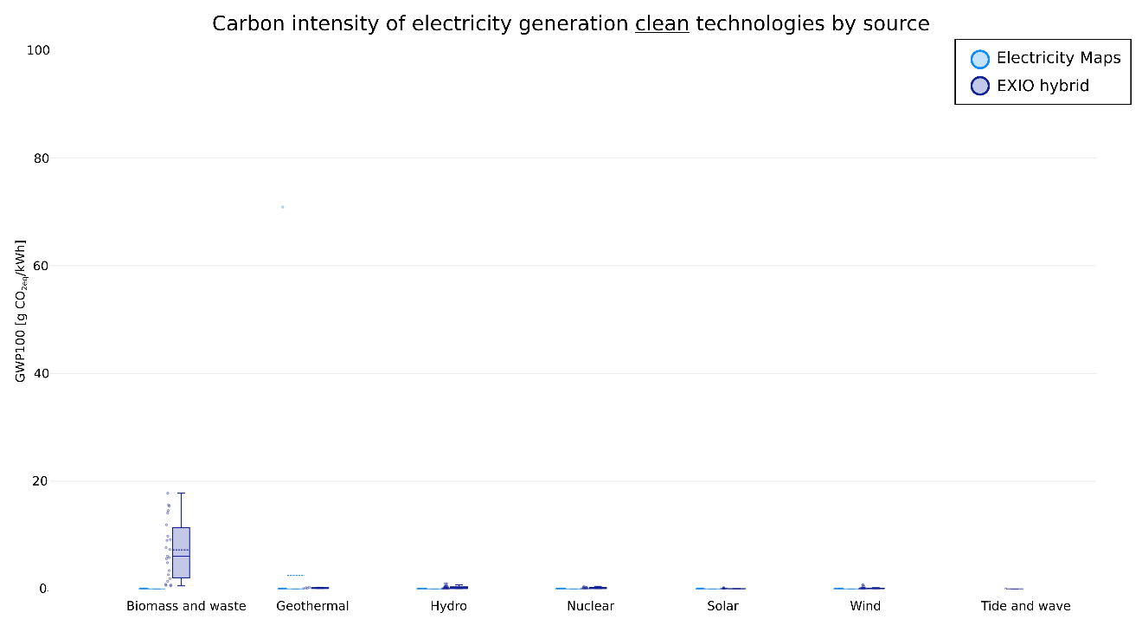
Figure 2: Carbon intensity of electricity generation, focusing on clean technologies, for Electricity Maps and EXIOBASE hybrid SUT (only sources that report this indicator)

3. EXIOBASE footprint by commodity vs by activity
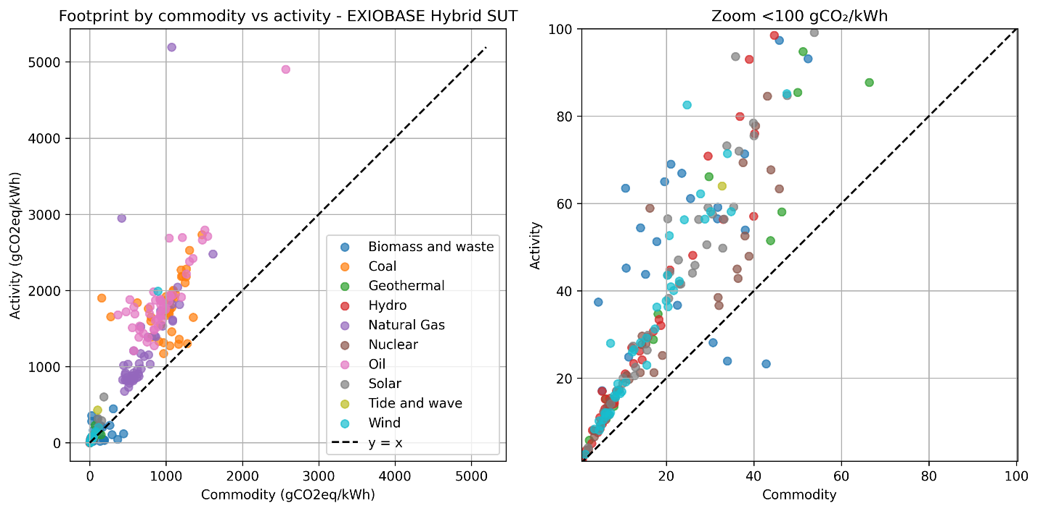
- (b)
Figure 3a. Carbon footprint of electricity generation technologies of EXIOBASE Hybrid SUT (2011), on horizontal axis by commodity and on vertical axis by activity. Figure b. Zoom

When discussing footprints obtained from IOTs or SUTs, it is essential to specify whether they refer to an activity or a commodity. Carbon intensity is only defined for activities due to the fact that satellite accounts are measured for activity outputs, and only afterwards allocated to commodities. The results for footprints instead are distinct and different because, for activities, footprints depend on direct accounts and on the use of inputs from other activities (Leontief matrix [4]) that have their own direct accounts; for commodity footprints, the “make” matrix is involved, which describes, according to the industry-based assumption [5] used in MARIO [6], the mix of commodities each activity produces for one unit of output. Therefore, if electricity from a specific source is produced not only by the corresponding activity but also as a by-product of another activity that has a lower footprint, the total footprint by commodity will result lower than the footprint by activity. Cogeneration is modelled in this way, by including in the “market share” of electricity commodities a portion from “Steam and hot water supply”, in order to describe the activation of heat production when electricity is demanded from technologies that include CHP plants. This is the case for coal, natural gas and oil, where the IQRs of activity and commodity footprints don’t even overlap; for other surces the tendency is of having higher values by activity. The only exception is biomass and waste, where the market share of the commodity “Electricity by biomass and waste” also includes waste incineration, which has a higher footprint than the electricity production activity.

4. Country generation carbon intensity
Data on electricity generation shares by different technologies for EU27 countries is available on ENTSO-E transparency platform [7]. It provides temporally detailed information but is reported to have some missing data or discrepancies for some countries [8]. In order to justify the use of this data source, we here perform a comparison with generation shares provided by the think tank EMBER [9]. The categorization follows EMBER aggregation, which is less granular than the one used in our work. The comparison shown here is for year 2021.. Figure 4 presents for each country stacked bars representing generation shares by technology, on the left ENTSO-E and on the right EMBER. There are significant discrepancies only for the categories “other” and “other fossil”, as can be expected since here fall all the situations of uncertainty in reporting. In Figure 5 the same data is reported detailing technologies on the horizontal axis, having in blue ENTSO-E and in red EMBER. We can see biggest discrepancies in between sources for Wind energy in Ireland and for Bioenergy, Other and Solar for Netherlands.
ENTSO-E does not provide the required data for Malta, while Luxemburg is merged with Germany. Therefore, national grid EFs are not reported for the two small countries and the weight of Luxemburg on Germany production is deemed small enough to be ignored.

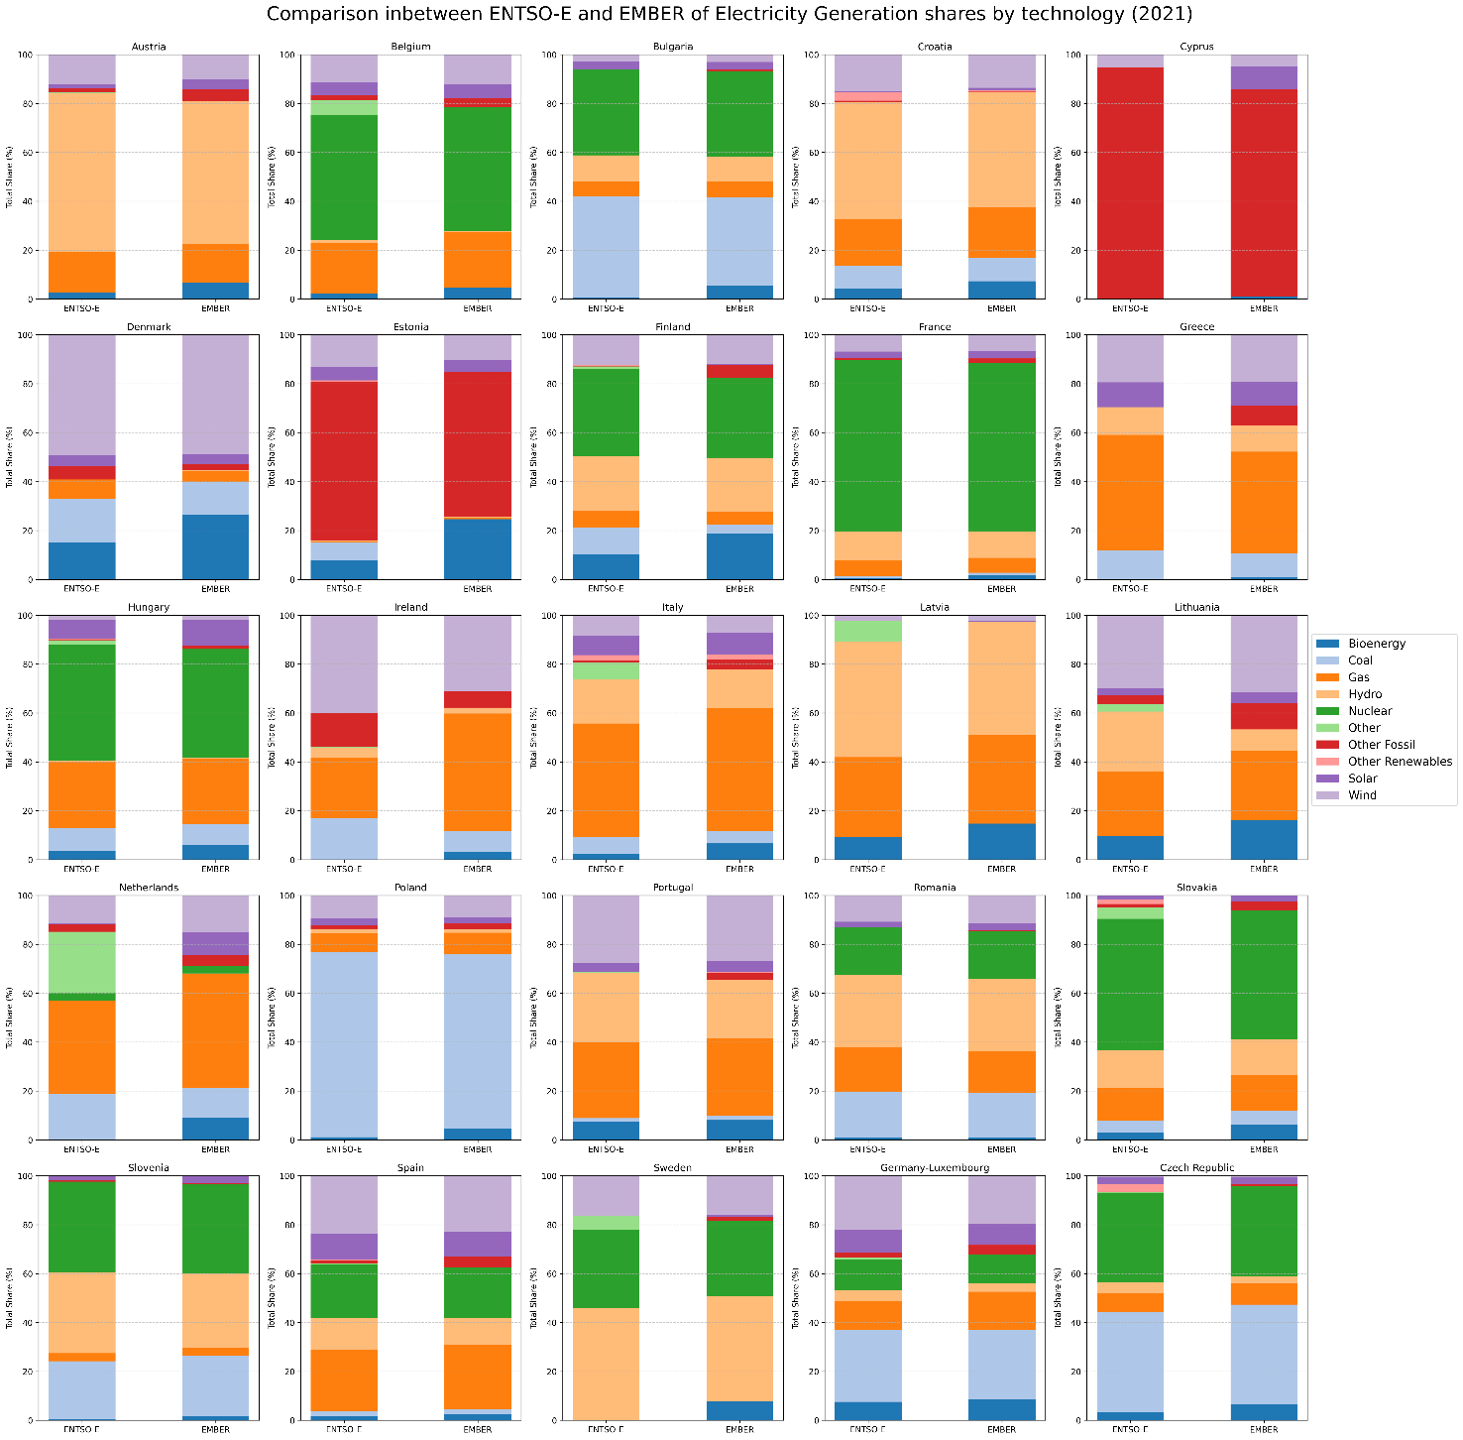
Figure 4. Comparison between ENTSO-E and EMBER electricity generation shares by technology for the year 2021

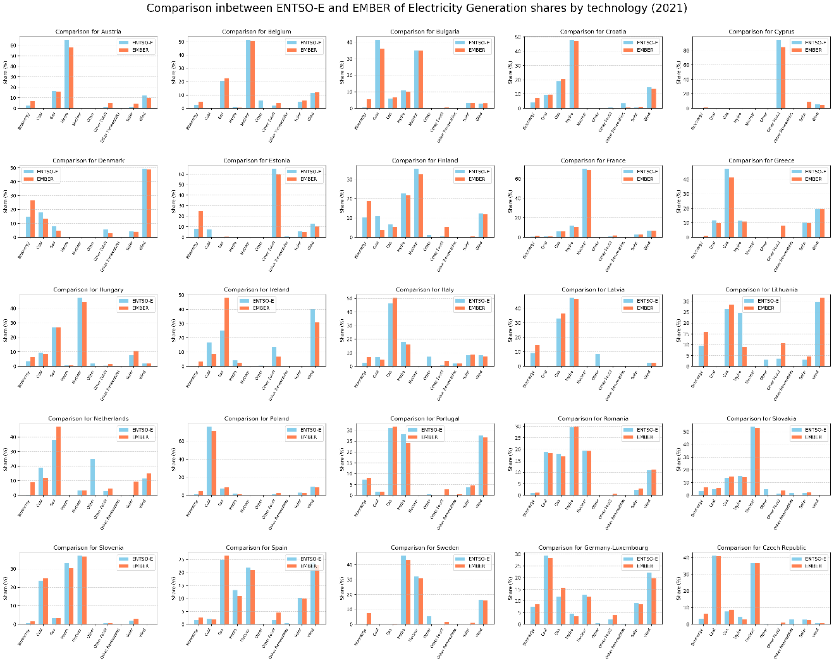
Figure 5. Comparison technology by technology between ENTSO-E and EMBER electricity generation shares for the year 2021

We here detail how the CIs and CFs for national electricity grid of EU27 and US for the year 2021 were computed.
For sources where technology detail is higher (e.g. IEA distinction of Biofuels and Waste, aggregated together as “Biomass and waste”), the value of EF has been averaged in order to obtain the factor for the generation of the general category (e.g.“Biomass and waste”).
The national value for CI is not computed using IPCC coefficients because it only provides values for Coal and Natural Gas.
For sources that miss the CF for a specific technology (e.g. NREL biomass and waste, IPCC oil), the corresponding CF from Electricity Maps is used. This is done because Electricity maps has CFs for all technologies and considered countries and from the boxplots it is highlighted that its values always fall inside the range of other sources.
ENTSO-E has the generation category “Other” but only Exiobase and Electricity Maps report the corresponding EFs. For the computation of national EFs from other sources, for the “Nec” category the value is obtained as an average of other sources, through the formula in Equation 1 and 2, where G_{Nec} is the generation from “Other” technologies and where CI_{no Nec} is the CI computed for all technologies except “other” (and corresponding for CF).
$$CI=\frac{CI_{noNec}}{1-G_{Nec}}$$ | (Eq. 1)
$$CF=\frac{CF_{noNec}}{1-G_{Nec}}$$ | (Eq. 2)

5. Monetary databases
The considered databases in monetary units are EMERGINGC[10], EORA26 [11][NO_PRINTED_FORM]EXIOBASE v3.10.1 [12] , GLORIA [13] and GTAP in WIOD version[14]. In OR2 is a complete table deepening the characteristics of each considered source.
EXIOBASE is provided in current EUR, while other databases in current USD :to obtain homogeneus values we therefore consider the change EURUSD, using the average for the adequate year, extracted from [15].
The newest version of EXIOBASE 3.10.1 provides data for 2023, however its values of CF for Electricity generation activity or Electricity commodity (aggregating the distinct activities, distribution and transmission) are suspiciously low, around two orders of magnitude, compared to those of previous years. For this reason, only year 2017 is considered for this data source.

6. Example of company electricity CF
To concretely illustrate the consequences of discrepancies in CFs, we compute total GHG emissions related to electricity consumption for an hypothetical company using the factors presented in the article. Let’s assume a company uses 10MWh of electricity in one year. According to average electricity bills for 2023, considering only the material cost of energy and transmission and distribution fees, excluding other feed and taxes (what we could consider a basic price) the price of electricity is set by GTAP database at 0.16€/kWh. Therefore, the hypotetical company would pay 1600 EUR for electricity in 2023. Multiplying these two quantities for the respective monetary or physical CFs, we obtain the results in Figure 6.

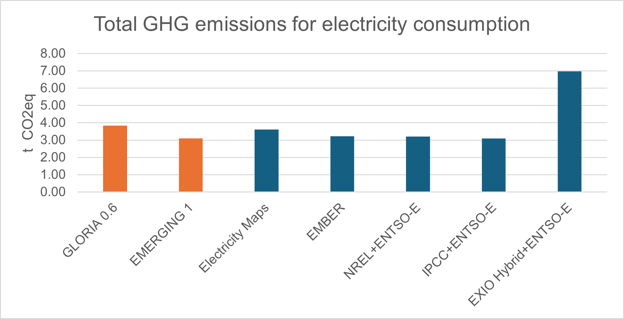
Figure 6: GHG emissions related to the consumption of 1 MWh of electricity or 1600 EUR (basic price) in Italy in 2023

