Supplementary Results
Supplementary Table 1
Single-Sensor ICC and 64-Sensor Mean Reliability for STP and ITC Across Paradigms and Frequency Bands
Paradigm | Trial Type | Frequency Band | r (ITC) | r(64) (ITC) | r (STP) | r(64) (STP)
PS | All | Low | .474 | .983 | .788 | .996
 |  | Beta | .293 | .964 | .660 | .992
 |  | Gamma | .232 | .951 | .519 | .986
OB | Targets | Low | .479 | .983 | .747 | .995
 |  | Beta | .244 | .954 | .588 | .989
 |  | Gamma | .186 | .936 | .468 | .983
 | Standard | Low | .533 | .986 | .788 | .996
 |  | Beta | .345 | .971 | .629 | .991
 |  | Gamma | .277 | .961 | .476 | .983
Note. r = mean single-sensor intraclass correlation coefficient ICC(2,1) averaged across 20 ms time bins. r(64) = reliability of the 64-sensor grand average estimated using Falconer and Mackay’s (1996) formula: r(64) = 64r / [1 + 63r] (p. 143, eq. 8.15). PS = paired stimuli; OB = oddball; STP = single-trial power; ITC = inter-trial coherence.

Supplementary Table 2
Clinical and Demographic Characteristics of the Cross-Sectional Sample.
Characteristic | Biotype-1  N = 515 | Biotype-2  N = 512 | Biotype-3  N = 538 | p-value
Age, M (SD) | 37.7 (12.5) | 39.0 (11.6) | 35.8 (12.3) | <0.001
Sex, n (% male) | 306 (60%) | 221 (43%) | 275 (51%) | <0.001
PANSS Total | 63 (19) | 66 (19) | 59 (19) | <0.001
Positive | 16 (6) | 17 (6) | 14 (6) | <0.001
Negative | 15 (6) | 16 (6) | 14 (6) | <0.001
General | 32 (9) | 33 (10) | 30 (10) | <0.001
Montgomery-Åsberg Depression Scale | 12 (10) | 11 (10) | 11 (10) | >0.9
Young Mania Rating Scale | 8 (7) | 9 (8) | 7 (7) | 0.008
Birchwood Social Functioning Scale | 121 (24) | 119 (24) | 128 (24) | <0.001
BACS Composite | −1.80 (1.22) | −2.11 (1.22) | −0.62 (1.13) | <0.001
Note. Values are mean (SD). p-values from Kruskal-Wallis rank sum test. Age and sex derived from the full analysis sample (n = 1,565 psychosis cases). Subjects included had usable EEG data from both paired-stimulus and oddball paradigms.

Supplementary Table 3
Additional Clinical Characteristics of the Cross-Sectional Sample.
Characteristic | Biotype-1  N = 515 | Biotype-2  N = 512 | Biotype-3  N = 538 | p-value
Illness Duration, M years (SD) | 19 (13) | 19 (12) | 17 (12) | 0.002
Medication Status (%) |  |  |  | 0.337
Not Medicated | 6.0% | 4.2% | 6.0%
Medicated | 94% | 96% | 94%
Medication Count, M (SD) | 4.8 (3.3) | 5.0 (3.5) | 4.6 (3.0) | 0.296
Psychotropic Count, M (SD) | 2.9 (1.6) | 2.9 (1.6) | 2.8 (1.6) | >0.9
Psychotropics (%) |  |  |  | 0.274
Off | 9.7% | 9.6% | 12.3%
On | 90% | 90% | 88%
Antipsychotics (%) |  |  |  | <0.001
Off | 19% | 18% | 29%
On | 81% | 82% | 71%
1st Generation |  |  |  | 0.051
Off | 88% | 87% | 92%
On | 12% | 13% | 8.4%
2nd Generation |  |  |  | 0.005
Off | 27% | 27% | 35%
On | 73% | 73% | 65%
Antidepressants (%) |  |  |  | 0.813
Off | 54% | 56% | 54%
On | 46% | 44% | 46%
Tricyclics |  |  |  | 0.593
Off | 99% | 98% | 98%
On | 1.4% | 2.2% | 2.0%
SSRIs |  |  |  | >0.9
Off | 70% | 69% | 70%
On | 30% | 31% | 30%
Other Antidepressants |  |  |  | 0.528
Off | 79% | 81% | 80%
On | 21% | 19% | 20%
Mood Stabilizers (%) |  |  |  | 0.006
Off | 57% | 58% | 49%
On | 43% | 42% | 51%
Lithium |  |  |  | 0.182
Off | 88% | 84% | 85%
On | 12% | 16% | 15%
Anticonvulsants |  |  |  | 0.003
Off | 66% | 71% | 61%
On | 34% | 29% | 39%
Anxiolytics/Sedatives/Hypnotics (%) |  |  |  | 0.471
Off | 78% | 75% | 78%
On | 22% | 25% | 22%
Anticholinergics (%) |  |  |  | 0.004
Off | 86% | 84% | 91%
On | 14% | 16% | 9.5%
Stimulants (%) |  |  |  | 0.070
Off | 95% | 95% | 92%
On | 4.7% | 4.9% | 7.6%
CPZ Equivalent Dose, M (SD) | 541 (804) | 548 (805) | 450 (724) | 0.070
Note. Values are mean (SD) unless indicated as (%). p-values from Kruskal-Wallis rank sum test or Pearson’s chi-squared test. CPZ = chlorpromazine. Subjects included had usable EEG data from both paired-stimulus and oddball paradigms.

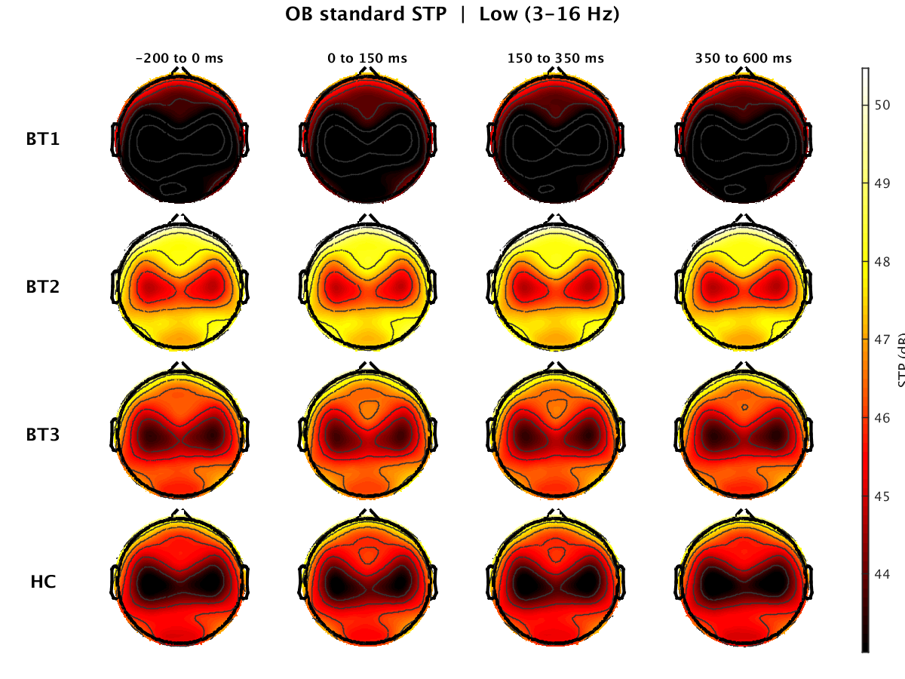
Supplementary Figure 1. OB Standard STP Low Band (3–16 Hz). Scalp topographies of single-trial power in the low frequency band (3–16 Hz) during Oddball Standards for BT1, BT2, BT3, and HC at −200 to 0, 0 to 150, 150 to 350, and 350 to 600 ms.
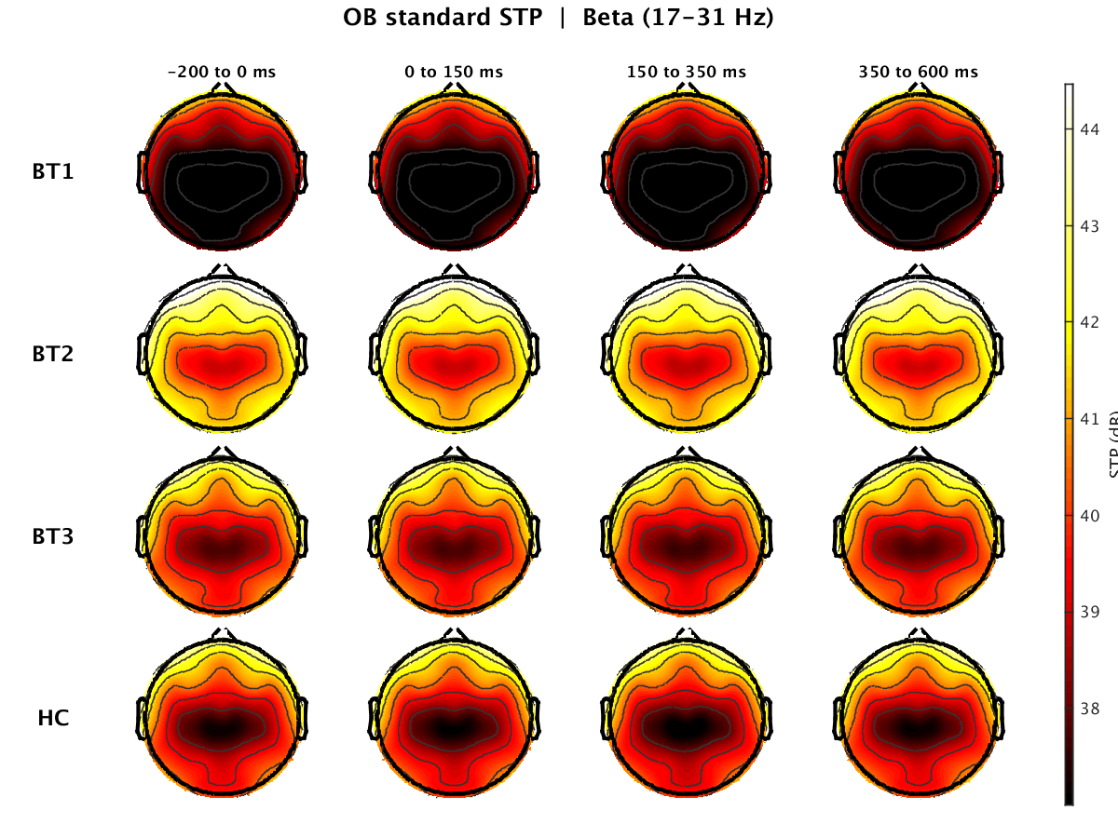
Supplementary Figure 2. OB Standard STP Beta Band (17–31 Hz). Scalp topographies of single-trial power in the beta band (17–31 Hz) during Oddball Standards for BT1, BT2, BT3, and HC at −200 to 0, 0 to 150, 150 to 350, and 350 to 600 ms
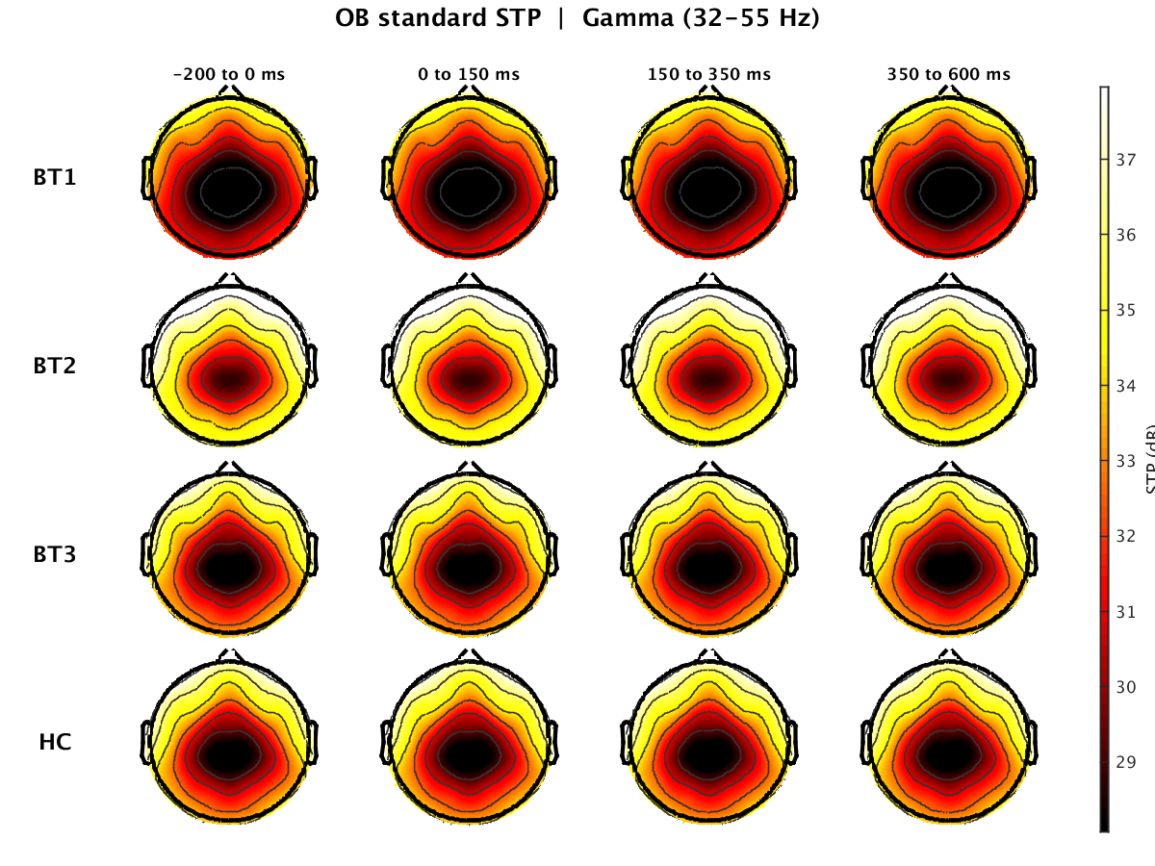
Supplementary Figure 3. OB Standard STP Gamma Band (32–55 Hz). Scalp topographies of single-trial power in the gamma band (32–55 Hz) during Oddball Standards for BT1, BT2, BT3, and HC at −200 to 0, 0 to 150, 150 to 350, and 350 to 600 ms.
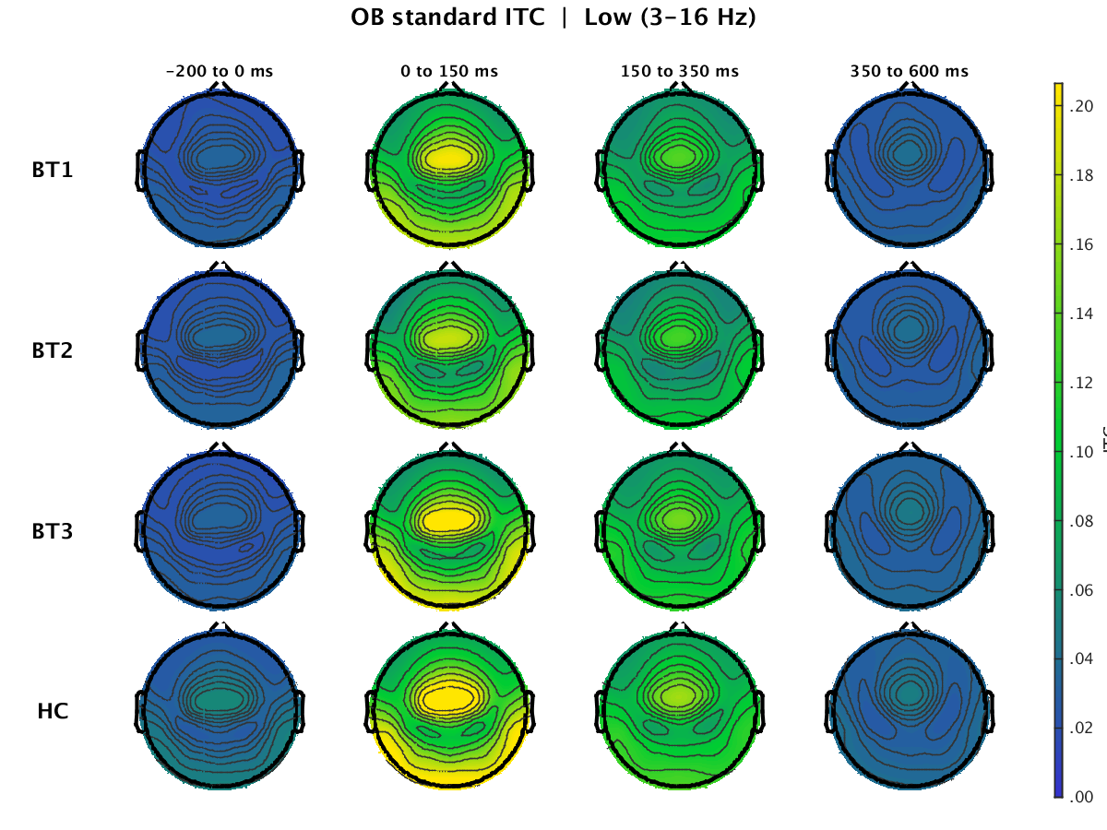
Supplementary Figure 4. OB Standard ITC Low Band (3–16 Hz). Scalp topographies of inter-trial coherence in the low frequency band (3–16 Hz) during Oddball Standards for BT1, BT2, BT3, and HC at −200 to 0, 0 to 150, 150 to 350, and 350 to 600 ms.
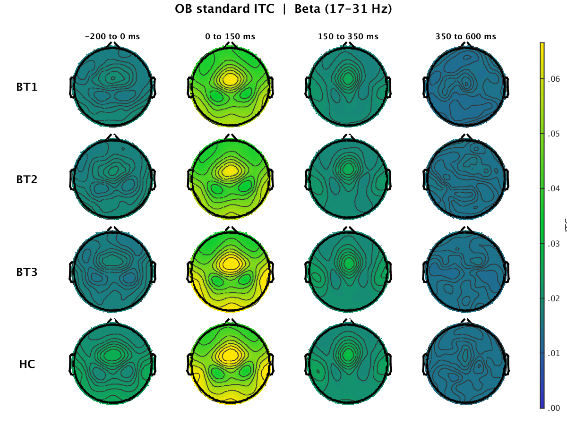
Supplementary Figure 5. OB Standard ITC Beta Band (17–31 Hz). Scalp topographies of inter-trial coherence in the beta band (17–31 Hz) during Oddball Standards for BT1, BT2, BT3, and HC at −200 to 0, 0 to 150, 150 to 350, and 350 to 600 ms.
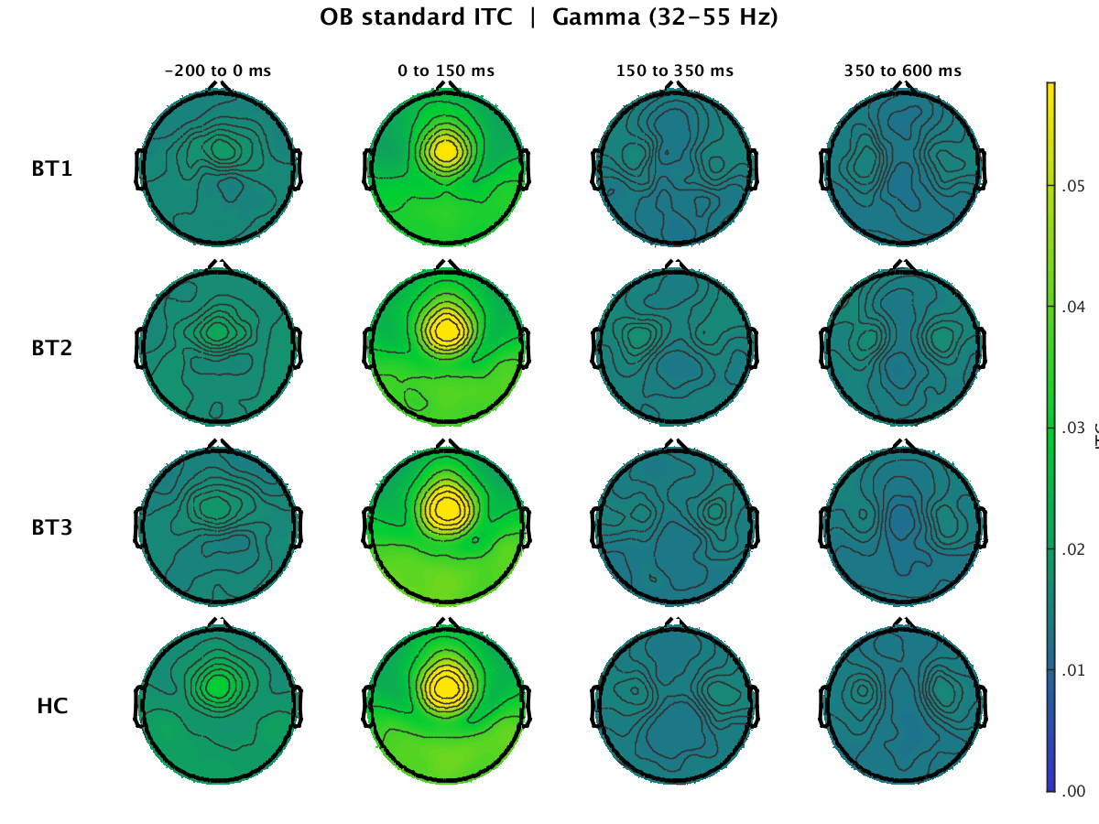
Supplementary Figure 6. OB Standard ITC Gamma Band (32–55 Hz). Scalp topographies of inter-trial coherence in the gamma band (32–55 Hz) during Oddball Standards for BT1, BT2, BT3, and HC at −200 to 0, 0 to 150, 150 to 350, and 350 to 600 ms.
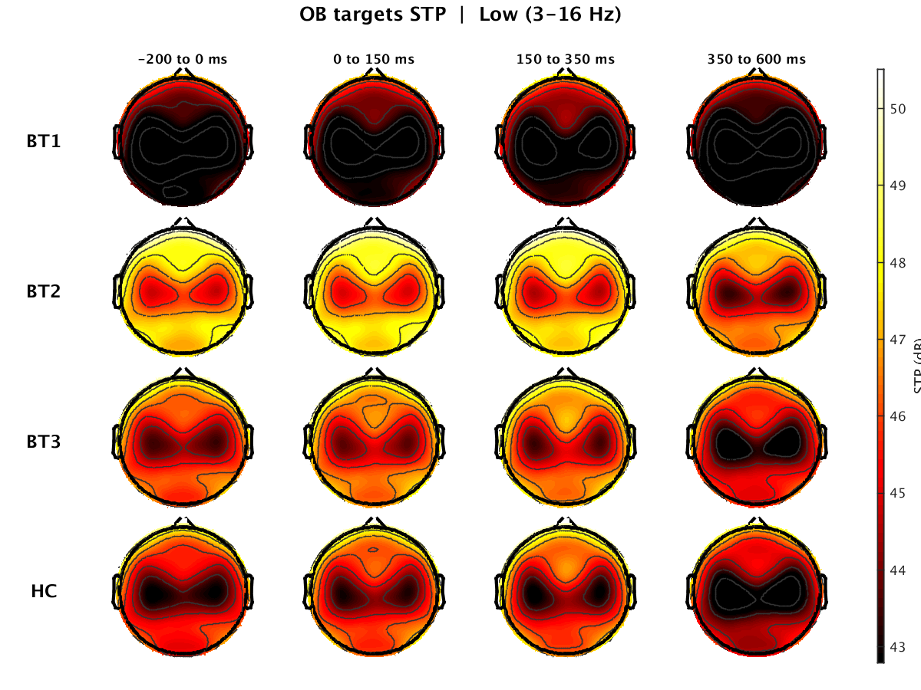
Supplementary Figure 7. OB Target STP Low Band (3–16 Hz). Scalp topographies of single-trial power in the low frequency band (3–16 Hz) during Oddball Targets for BT1, BT2, BT3, and HC at −200 to 0, 0 to 150, 150 to 350, and 350 to 600 ms.
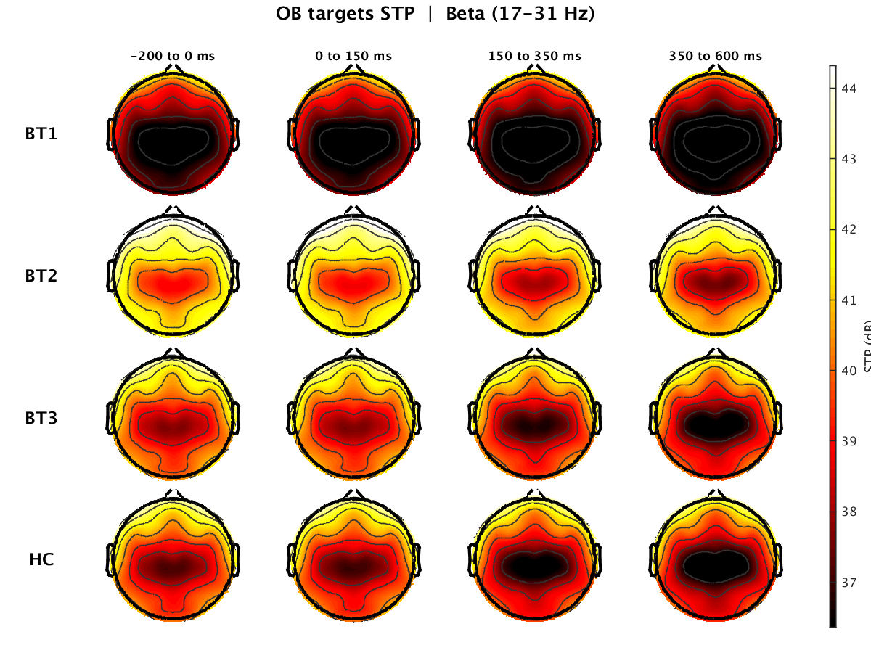
Supplementary Figure 8. OB Target STP Beta Band (17–31 Hz). Scalp topographies of single-trial power in the beta band (17–31 Hz) during Oddball Targets for BT1, BT2, BT3, and HC at −200 to 0, 0 to 150, 150 to 350, and 350 to 600 ms.
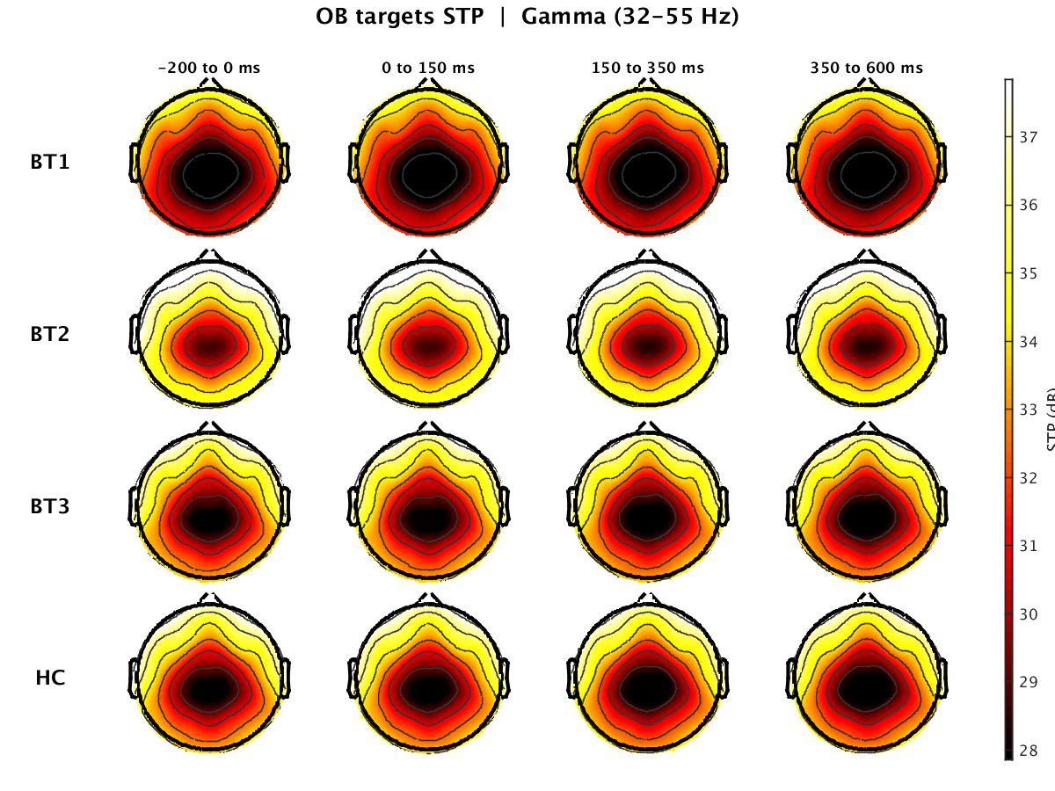
Supplementary Figure 9. OB Target STP Gamma Band (32–55 Hz). Scalp topographies of single-trial power in the gamma band (32–55 Hz) during Oddball Targets for BT1, BT2, BT3, and HC at −200 to 0, 0 to 150, 150 to 350, and 350 to 600 ms.
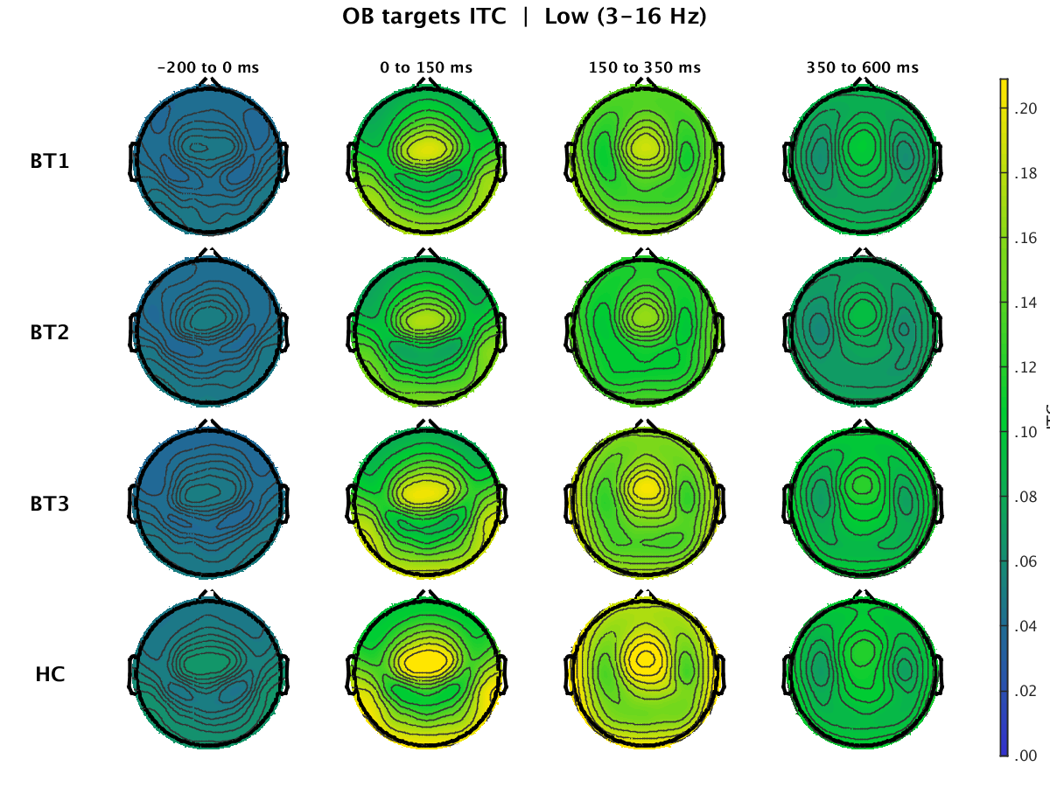
Supplementary Figure 10. OB Target ITC Low Band (3–16 Hz). Scalp topographies of inter-trial coherence in the low frequency band (3–16 Hz) during Oddball Targets for BT1, BT2, BT3, and HC at −200 to 0, 0 to 150, 150 to 350, and 350 to 600 ms.
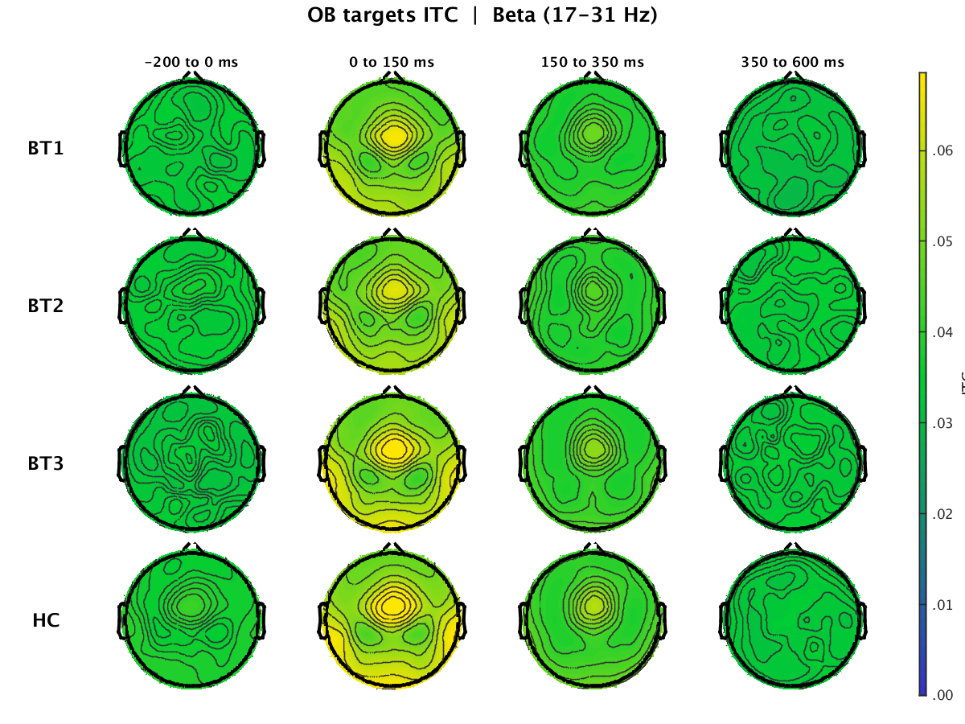
Supplementary Figure 11. OB Target ITC Beta Band (17–31 Hz). Scalp topographies of inter-trial coherence in the beta band (17–31 Hz) during Oddball Targets for BT1, BT2, BT3, and HC at −200 to 0, 0 to 150, 150 to 350, and 350 to 600 ms.
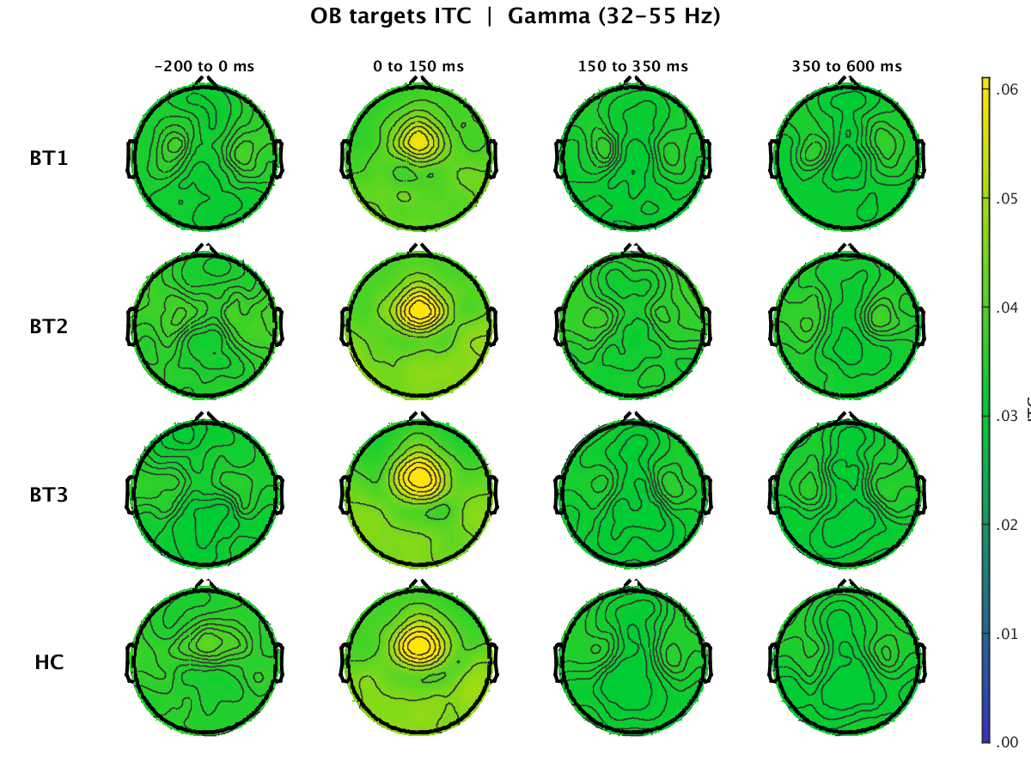
Supplementary Figure 12. OB Target ITC Gamma Band (32–55 Hz). Scalp topographies of inter-trial coherence in the gamma band (32–55 Hz) during Oddball Targets for BT1, BT2, BT3, and HC at −200 to 0, 0 to 150, 150 to 350, and 350 to 600 ms.
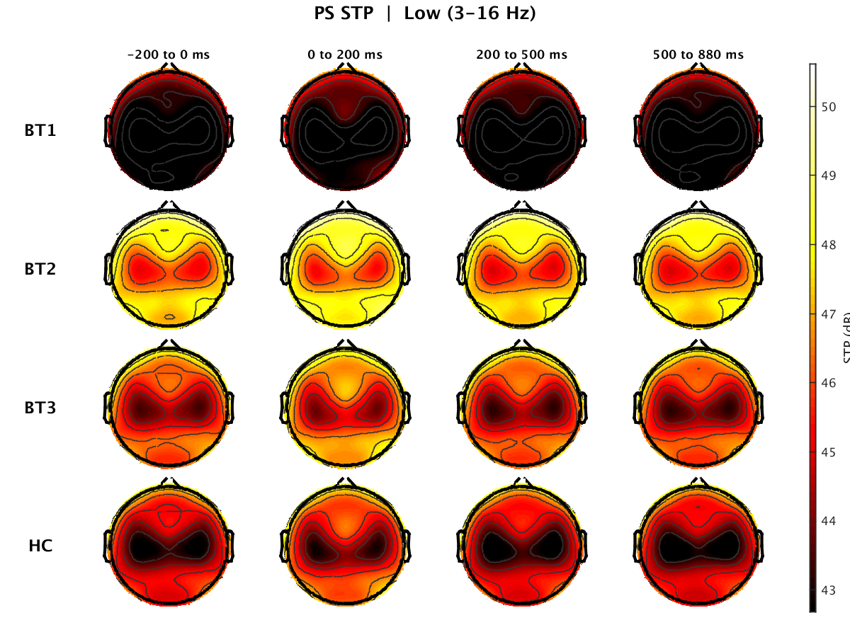
Supplementary Figure 13. Paired-Stimulus STP Low Band (3–16 Hz). Scalp topographies of single-trial power in the low frequency band (3–16 Hz) during the Paired-Stimulus paradigm for BT1, BT2, BT3, and HC at −200 to 0, 0 to 200, and 500 to 880 ms.
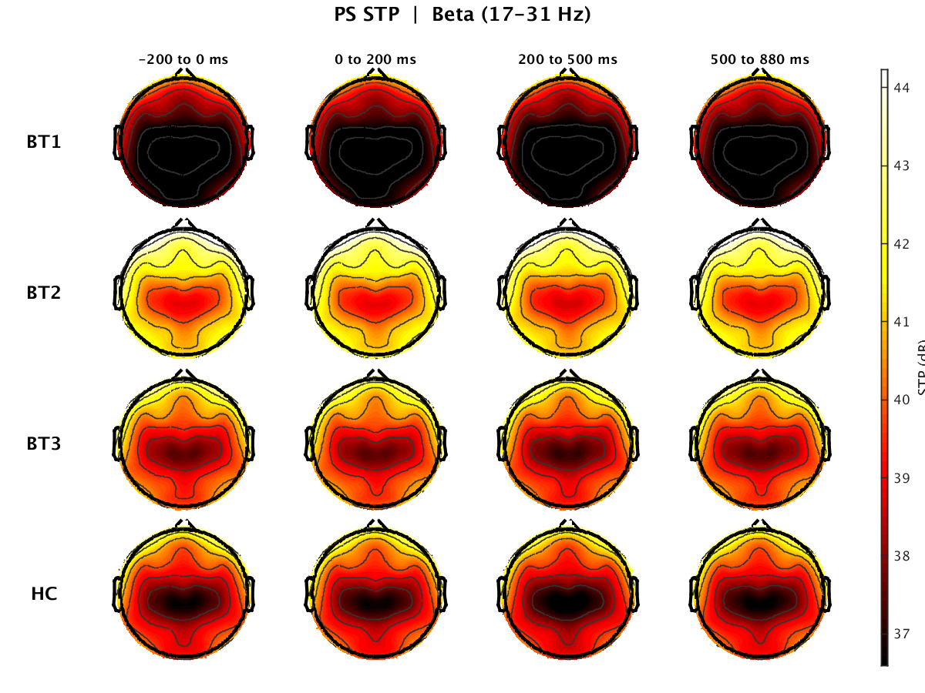
Supplementary Figure 14. Paired-Stimulus STP Beta Band (17–31 Hz). Scalp topographies of single-trial power in the beta band (17–31 Hz) during the Paired-Stimulus paradigm for BT1, BT2, BT3, and HC at −200 to 0, 0 to 200, and 500 to 880 ms.
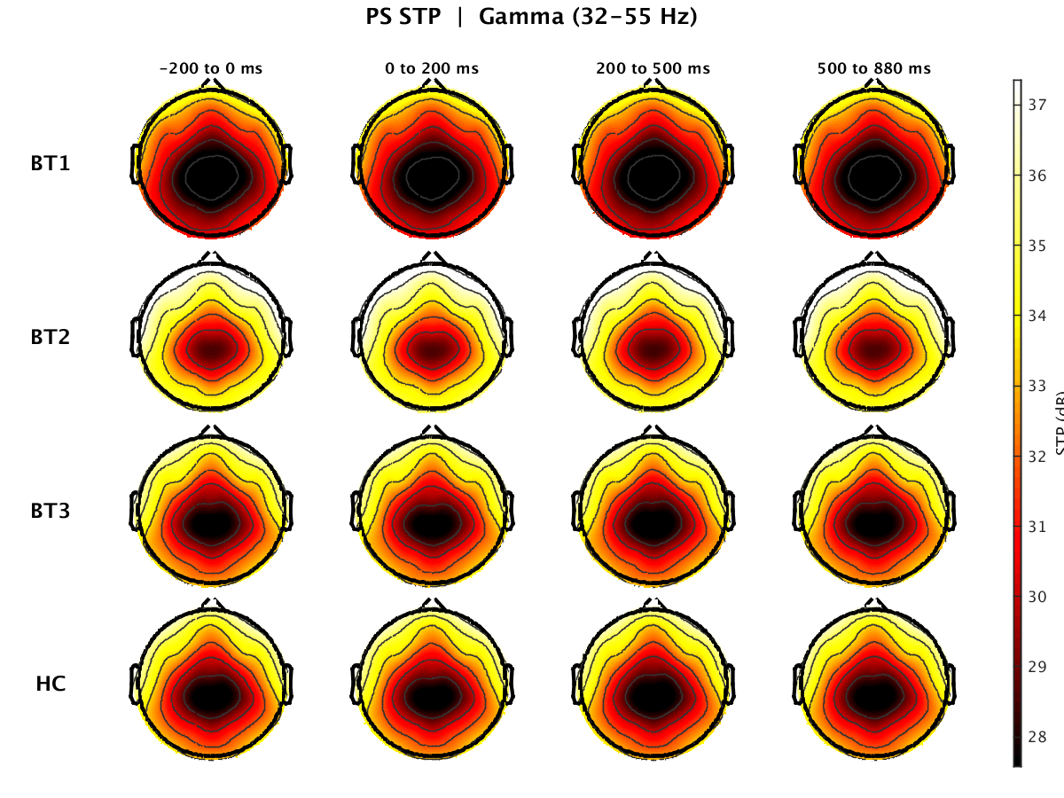
Supplementary Figure 15. Paired-Stimulus STP Gamma Band (32–55 Hz). Scalp topographies of single-trial power in the gamma band (32–55 Hz) during the Paired-Stimulus paradigm for BT1, BT2, BT3, and HC at −200 to 0, 0 to 200, and 500 to 880 ms.
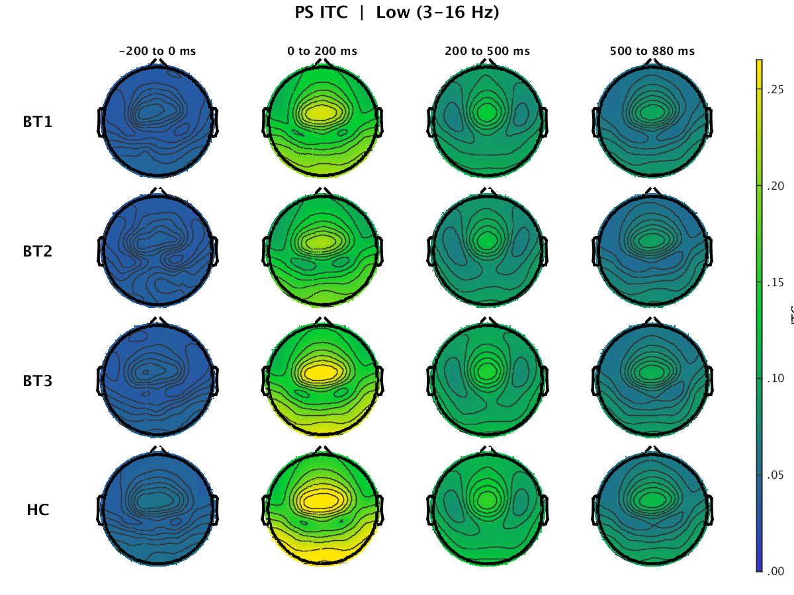
Supplementary Figure 16. Paired-Stimulus ITC Low Band (3–16 Hz). Scalp topographies of inter-trial coherence in the low frequency band (3–16 Hz) during the Paired-Stimulus paradigm for BT1, BT2, BT3, and HC at −200 to 0, 0 to 200, and 500 to 880 ms.
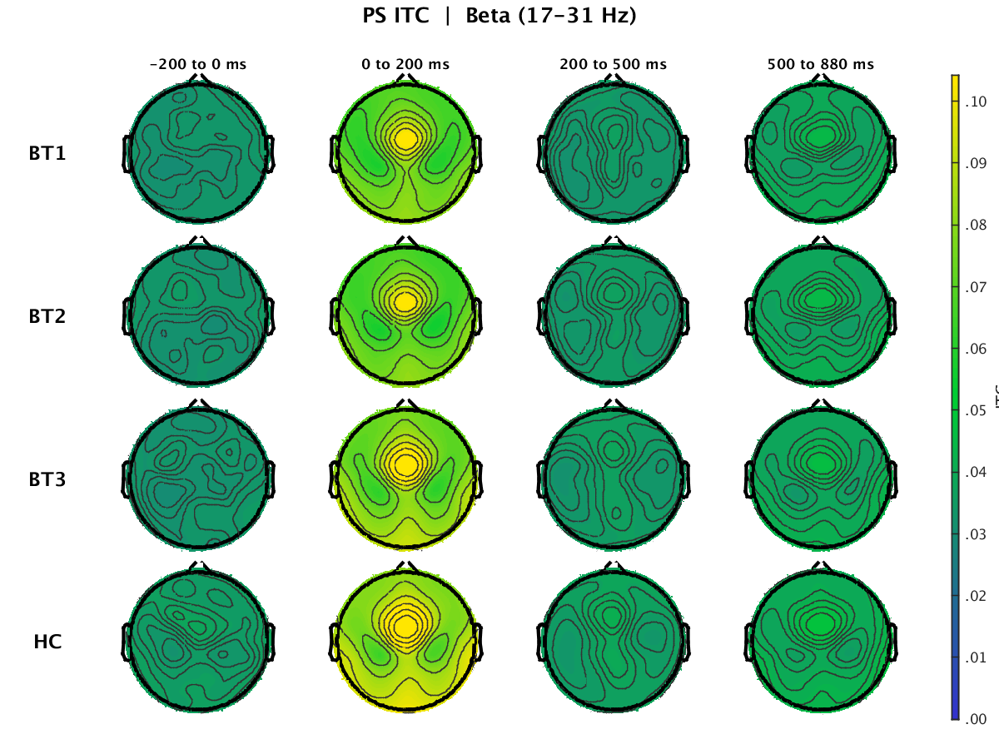
Supplementary Figure 17. Paired-Stimulus ITC Beta Band (17–31 Hz). Scalp topographies of inter-trial coherence in the beta band (17–31 Hz) during the Paired-Stimulus paradigm for BT1, BT2, BT3, and HC at −200 to 0, 0 to 200, and 500 to 880 ms.
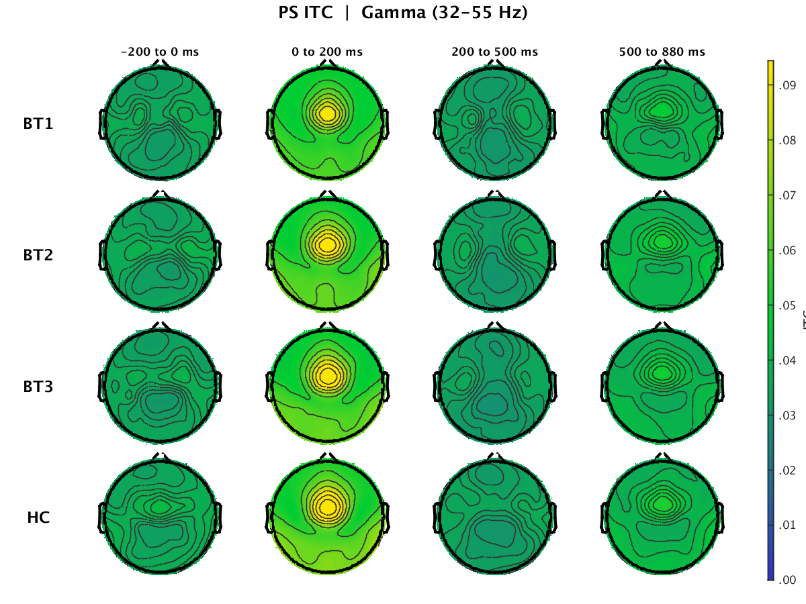
Supplementary Figure 18. Paired-Stimulus ITC Gamma Band (32–55 Hz). Scalp topographies of inter-trial coherence in the gamma band (32–55 Hz) during the Paired-Stimulus paradigm for BT1, BT2, BT3, and HC at −200 to 0, 0 to 200, and 500 to 880 ms.

