Supplementary Results: DSM Diagnostic Group Comparisons
These analyses examined STP and ITC patterns across DSM psychosis diagnoses, schizophrenia (SZ, n=568), schizoaffective (SADP, n=435), bipolar I with psychosis (BP, n=418), and in comparison, healthy persons (HC, n=717). These analyses used features defined empirically from DSM-significant ANOVA windows (qFDR < .01, ≥3 contiguous 20 ms bins), yielding 7 features: 6 low-frequency ITC windows and 1 beta-band STP window. Glass’s Δ is referenced to the HC standard deviation.

Supplementary Results: DSM Diagnostic Group Analyses

Single-Trial Power (STP)
Across both tasks and all trial types (paired-stimuli, oddball standards, and oddball targets), only one STP window reached the significance threshold for DSM groups: paired-stimuli beta-band STP across almost the entire epoch (−195 to 865 ms). Despite this reaching significance in the ANOVA, effect sizes were modest. Glass’s Δ relative to HC ranged from −0.04 (SZ) to +0.16 (BP). Low-frequency and gamma-band STP showed no significant windows under any condition.

Inter-Trial Coherence (ITC)
Low-frequency ITC was the primary domain of DSM group differentiation, with 6 of the 7 features derived from significant ITC windows. All showed a consistent pattern of graded reduction across psychosis diagnoses compared to healthy persons, with SZ showing the largest deficits. The strongest effects were observed for paired-stimuli low ITC (25–385 ms; Glass’s Δ: SZ = −0.60, SADP = −0.50, BP = −0.30) and oddball target low ITC (126–585 ms; Δ: SZ = −0.58, SADP = −0.47, BP = −0.23). Smaller but effects were observed for oddball target low ITC (5–66 ms; Δ: SZ = −0.45, SADP = −0.30, BP = −0.35) and oddball standard low ITC (206–324 ms; Δ: SZ = −0.44, SADP = −0.32, BP = −0.19). Two additional windows showed weaker effects: oddball standard low ITC (405–545 ms; Δ: SZ = −0.23, SADP = −0.30, BP = −0.04) and a late paired-stimuli low ITC window (705–785 ms; Δ: SZ = −0.28, SADP = −0.10, BP = −0.05). Beta- and gamma-band ITC showed no significant DSM group differences.

Linear Discriminant Analysis
Linear discriminant analysis was performed using the 7 DSM significant time–frequency features identified from the ANOVA analyses. The overall discriminant model was significant (Wilks’ Λ = .880, χ²(21) = 272.06, p < .001). Sequential tests indicated that Functions 2 and 3 each provided significant additional discrimination beyond the preceding function (Functions 2–3: Wilks’ Λ = .978, χ²(12) = 47.82, p < .001; Function 3: Wilks’ Λ = .990, χ²(5) = 20.69, p = .001). Function 1 accounted for 83.1% of group discrimination variance (eigenvalue = .111; canonical r = .316), Function 2 for an additional 9.6% (eigenvalue = .013; canonical r = .113), and Function 3 for 7.3% (eigenvalue = .010; canonical r = .098).
Function 1 (83.1% of variance) captured across-trial temporal consistency, driven by four low-frequency ITC windows loading negatively: paired-stimuli low ITC (25–385 ms; r = −.800), oddball target low ITC (126–585 ms; r = −.758), oddball target low ITC (5–66 ms; r = −.630), and oddball standard low ITC (206–324 ms; r = −.616; see Supplementary Table 1). All three psychosis groups scored positively on this function, reflecting reduced ITC relative to HC, in a graded pattern from most to least impaired: SZ (+0.41), SADP (+0.19), BP (−0.03), HC (−0.42). Function 2 (9.6%) contrasted late oddball standard low ITC (405–545 ms; r = +.523) against early oddball target low ITC (5–66 ms; r = −.585), with BP showing the highest centroid (+0.21) and all other groups near zero (SADP = −0.13, SZ = −0.00, HC = −0.05). Function 3 (7.3%) was dominated by paired-stimuli beta STP (r = −.626) and a late paired-stimuli ITC window (705–785 ms; r = −.471). Across all three functions, group separation was modest; 3D Euclidean centroid distances were largest between SZ and BP (d = 0.45) and SZ and HC (d = 0.36), intermediate between SADP and BP (d = 0.35) and SADP and HC (d = 0.28), and smallest between BP and HC (d = 0.26) and SZ and SADP (d = 0.10; Supplementary Figure 1).
Supplementary Table 1
Task | Band | Measure | Time window (ms) | Function 1 | Function 2 | Function 3 | M (SD)
 |  |  |  |  |  |  | SZ | SADP | BP | HC
Paired stimuli | Low | ITC | 25 to 385 | −.800* | +.079 | +.207 | 0.14 (0.07) | 0.14 (0.07) | 0.16 (0.07) | 0.18 (0.07)
Oddball targets | Low | ITC | 126 to 585 | −.758* | +.211 | +.062 | 0.11 (0.05) | 0.11 (0.05) | 0.13 (0.05) | 0.14 (0.05)
Oddball targets | Low | ITC | 5 to 66 | −.630* | −.585 | +.081 | 0.10 (0.06) | 0.11 (0.06) | 0.11 (0.06) | 0.13 (0.08)
Oddball standards | Low | ITC | 206 to 324 | −.616* | +.056 | −.044 | 0.08 (0.04) | 0.09 (0.05) | 0.10 (0.05) | 0.11 (0.06)
Oddball standards | Low | ITC | 405 to 545 | −.367 | +.523* | +.327 | 0.03 (0.02) | 0.03 (0.02) | 0.03 (0.02) | 0.03 (0.02)
Paired stimuli | Low | ITC | 705 to 785 | −.339 | +.057 | −.471* | 0.05 (0.03) | 0.06 (0.03) | 0.06 (0.03) | 0.06 (0.03)
Paired stimuli | Beta | STP | −195 to 865 | −.017 | +.311 | −.626* | 40.47 (2.79) | 40.83 (2.68) | 40.99 (2.87) | 40.59 (2.52)
Structure Matrix and Group Means for DSM-Significant EEG Time–Frequency Features in Linear Discriminant Analysis. Note. Structure matrix showing correlations between EEG time–frequency features and the canonical discriminant functions derived from DSM diagnostic group comparisons (schizophrenia, schizoaffective, bipolar with psychosis, healthy persons). Asterisks (*) denote the function with the largest absolute loading for each feature. M (SD) values reflect group means and standard deviations from each significant time–frequency cluster. STP = single-trial power; ITC = inter–trial coherence; SZ = schizophrenia; SADP = schizoaffective disorder; BP = bipolar I disorder with psychosis; HC = healthy persons.

Supplementary Figure 1
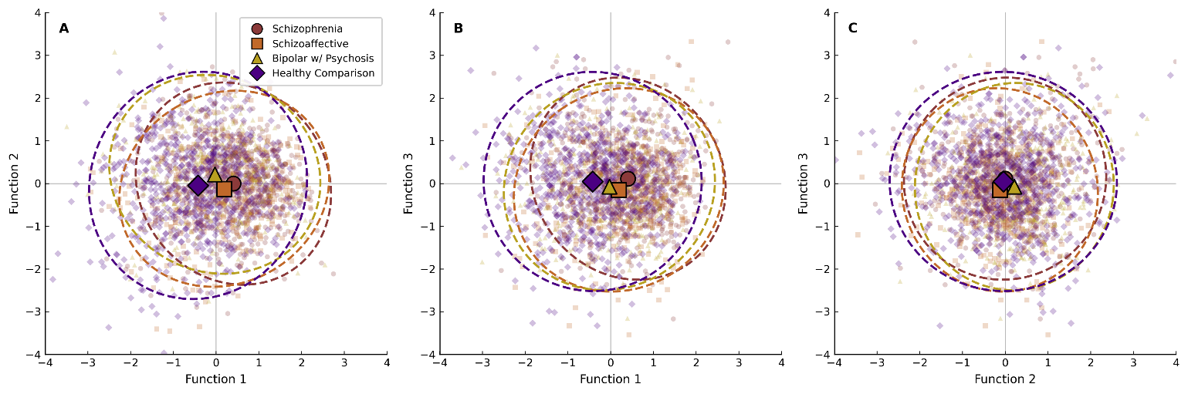
Linear Discriminant Analysis of EEG Time–Frequency Features Across DSM Psychosis Diagnoses and Healthy Persons. Note. Each point represents one participant positioned according to their overall EEG response profile, with axes reflecting weighted combinations of the 7 DSM-significant neural features. Markers indicate group centroids; ellipses indicate one standard deviation of each group’s distribution.

Supplementary Figure 2
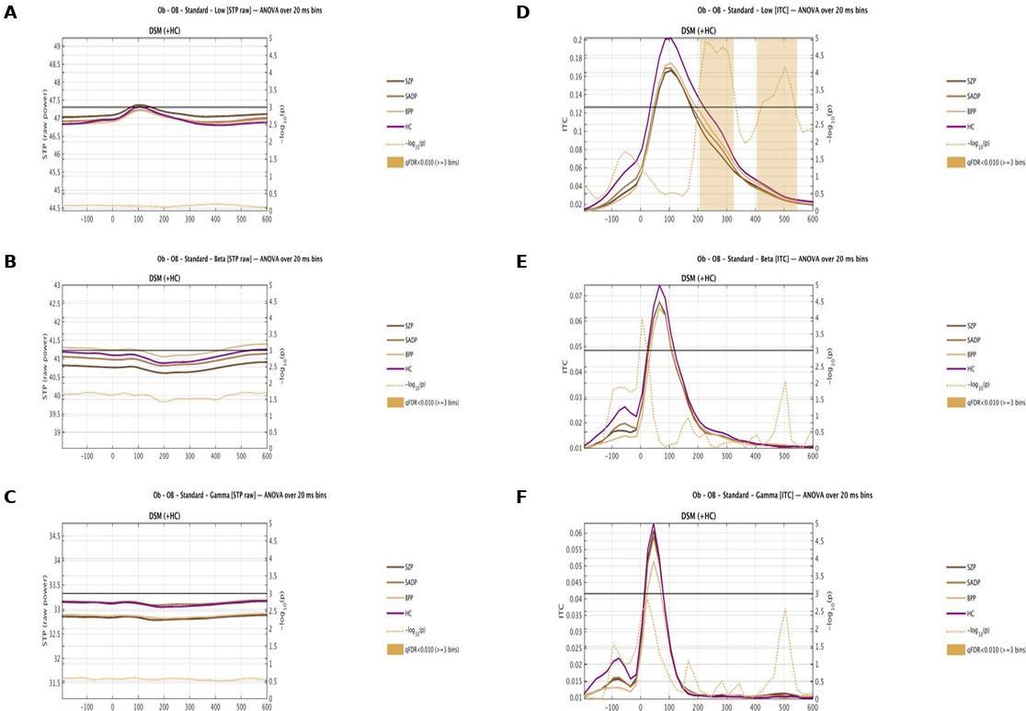
Oddball Standard trials raw single-trial power (Left Column, A-C) and inter-trial coherence (Right Column, D-F). Note. Group-average waveforms (~3–55 Hz) for DSM groups schizophrenia (SZP), schizoaffective (SADP), bipolar I with psychosis (BPP), and healthy comparison (HC) participants across the −200 to 600 ms epoch. Shaded regions indicate time bins surviving cluster-corrected ANOVA thresholds (qFDR < .01, ≥3 contiguous bins); the dotted trace shows −log10(p) values across time.

Supplementary Figure 3
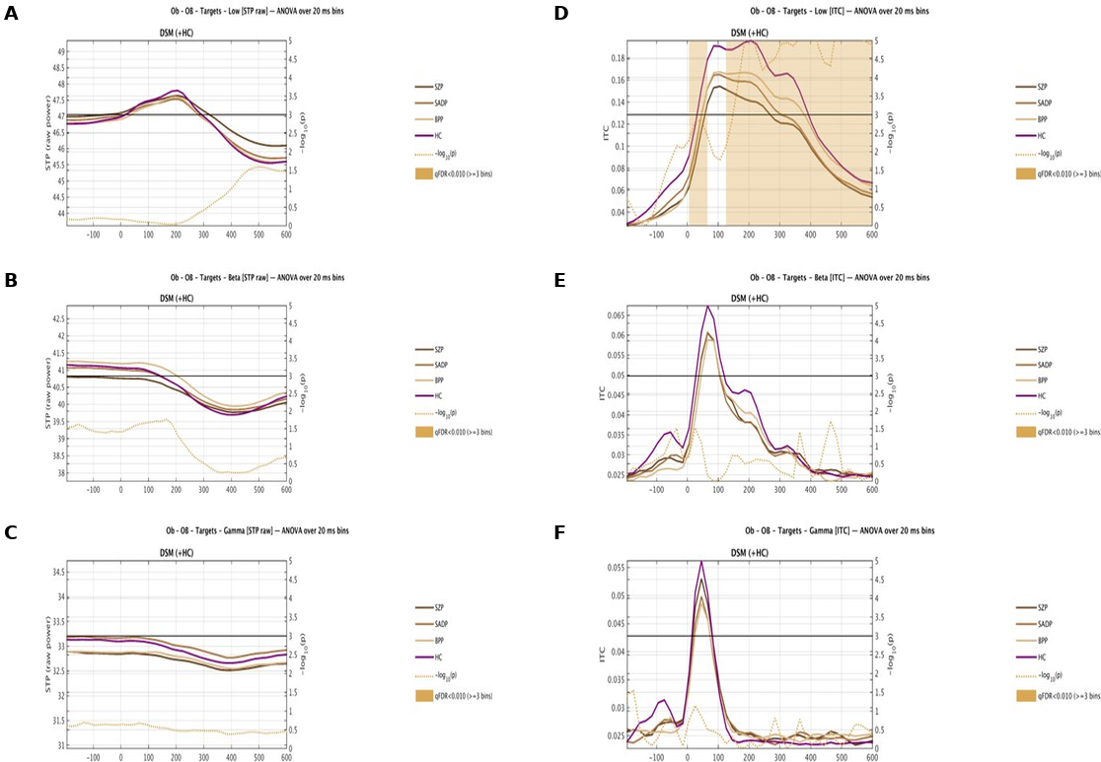
Oddball Target trials raw single-trial power (Left Column, A-C) and inter-trial coherence (Right Column, D-F). Note. Group-average waveforms (~3–55 Hz) for DSM groups schizophrenia (SZP), schizoaffective (SADP), bipolar I with psychosis (BPP), and healthy comparison (HC) participants across the −200 to 600 ms epoch. Shaded regions indicate time bins surviving cluster-corrected ANOVA thresholds (qFDR < .01, ≥3 contiguous bins); the dotted trace shows −log10(p) values across time.

Supplementary Figure 4
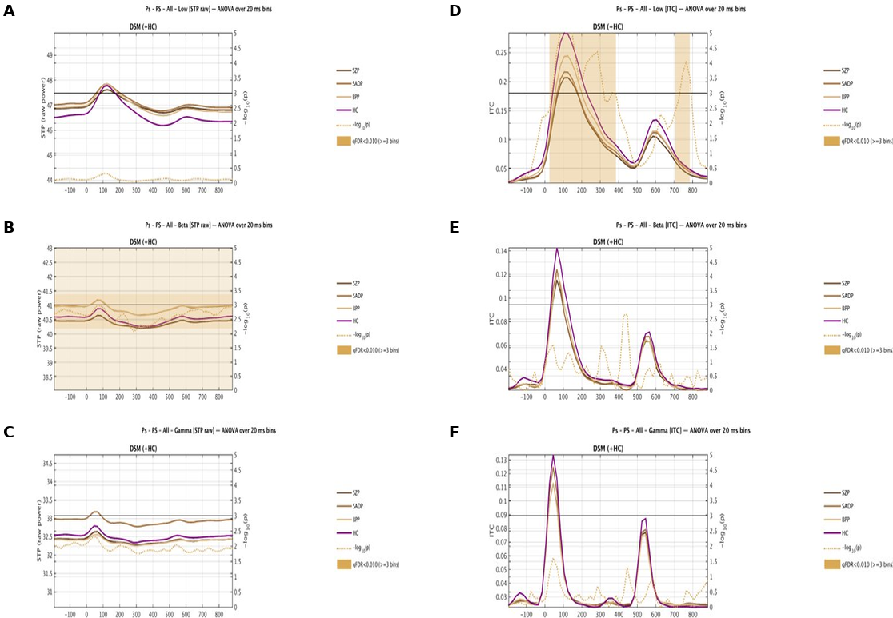
Paired-Stimulus raw single-trial power (Left Column, A-C) and inter-trial coherence (Right Column, D-F). Note. Group-average waveforms (~3–55 Hz) for DSM groups schizophrenia (SZP), schizoaffective (SADP), bipolar I with psychosis (BPP), and healthy comparison (HC) participants across the −200 to 880 ms epoch time-locked to S1 onset. Shaded regions indicate time bins surviving cluster-corrected ANOVA thresholds (qFDR < .01, ≥3 contiguous bins); the dotted trace shows −log10(p) values across time.

