Supplementary information for

ASD Toddlers Exhibit Impaired Development of Neural Systems
That Respond to and Guide Mother-Child Interactions

Authors: Yaqiong Xiao^{1*}, Teresa H. Wen¹, Lauren Kupis², Lisa Eyler^{3,4}, Disha Goel¹, Michael V. Lombardo^{5,6}, Karen Pierce^{1*} and Eric Courchesne^{1*}

Affiliations:
¹ Autism Center of Excellence, Department of Neurosciences, University of California, San Diego, La Jolla, CA, USA
² Department of Psychology, University of Miami, Coral Gables, FL, USA
³ Department of Psychiatry, University of California, San Diego, 9500 Gilman Drive, La Jolla, CA 92161, USA
⁴ VISN 22 Mental Illness Research, Education, and Clinical Center, VA San Diego Healthcare System, San Diego, CA, USA
⁵ Laboratory for Autism and Neurodevelopmental Disorders, Center for Neuroscience and Cognitive Systems @UniTn, Istituto Italiano di Tecnologia, Rovereto, Italy
⁶ Autism Research Centre, Department of Psychiatry, University of Cambridge, Cambridge, CB2 8AH, United Kingdom

*Correspondence to:
Eric Courchesne at ecourchesne1949@gmail.com
Yaqiong Xiao at y9xiao@health.ucsd.edu

Karen Pierce at kpierce@health.ucsd.edu
Supplementary Table 1
Sample sizes and total scans of each language paradigm in toddlers and adults
 | Toddlers |  | Adults  Sample size (N)  (total scans)
 | TD  Sample size (N)  (total scans) | ASD  Sample size (N)  (total scans) | Adults  Sample size (N)  (total scans)
Story language | 23  (26) | 31  (33) | 13  (18)
Karen language | 28  33 | 36  (40) | 12  (12)
Motherese | 25  (29) | 37  (39) | 8  (11)

Abbreviations: ASD, autism spectrum disorder; TD, typical development.
Total scans include initial and retest scans.

Supplementary Fig. 2
Estimated coefficients from mixed effects models of ROI activation predicted by social and communication scores across subjects and three language paradigms
ROI | Model Output
ROI | Variables | Estimate | Standard error | p-value | R²_{m}
Left temporal | Communication scores | 0.00037 | 0.00016 | 0.021* | 0.07
Left temporal | Social scores | 5e-04 | 0.00018 | 0.009** | 0.082
Right temporal | Communication scores | 0.00081 | 0.00032 | 0.013* | 0.097
Right temporal | Social scores | 0.00117 | 0.00037 | 0.002** | 0.126

Coef, R²_{m} indicates marginal squared R, i.e., the proportion of the total variance explained by the fixed effects. Asterisks indicate significant effects after correcting for multiple comparisons using FDR method. * p < 0.05, ** p <.005.

Supplementary Table 3
Characteristics at MRI scan or outcome | ASD  (N = 41) | TD  (N = 30) | p value  (TD vs. ASD)
Demographics
Sex (M/F) | 35/6 | 18/12 | .06ª
Age at MRI scan, months | 28.8 (9.7) | 23.7 (6) | .003^{b}
Age at clinical tests, months | 28.9 (8.4) | 26.3 (8.1) | .19^{b}
ADOS (module T, 1, or 2) score
mean (SD)
ADOS SA | 12.9 (4.1) | 2.7 (1.5) | <.001^{b}
ADOS RRB | 5.3 (2.1) | 1.2 (1.2) | <.001^{b}
ADOS Total | 18.2 (5.4) | 3.9 (1.8) | <.001^{b}
Mullen T score

mean (SD)
Visual reception | 38.6 (12.7) | 54.3 (11.6) | <.001^{b}
Fine motor | 40 (11.9) | 50 (8.2) | <.001^{b}
Receptive language | 32.3 (14.8) | 48.2 (11.5) | <.001^{b}
Expressive language | 33.1 (16.1) | 43.8 (12.2) | .002^{b}
Early Learning Composite | 74.1 (22) | 98.4 (16.6) | <.001^{b}
Vineland standard score

Mean ( SD
Communication | 82.9 (16.6) | 97.2 (11.9) | <.001^{b}
Daily living | 86.4 (11.8) | 97.5 (12.2) | .001^{b}
Socialization | 83 (12.6) | 98.6 (10.3) | <.001^{b}
Motor skills | 92.08 (10.9) | 97.9 (10.8) | .31^{b}
Adaptive behavior composite | 82.4 (11.5) | 96.8 (10.9) | <.001^{b}
Demographic information and clinical test scores for ASD and TD toddlers
Values for age and all clinical test scores are presented as mean (SD).
Abbreviations: ASD, autism spectrum disorder; TD, typical development; ADOS, Autism Diagnostic Observation Schedule; SA, social affect; RRB, restricted and repetitive behavior.
ªPearson’s chi-squared test.
^{b}Welch’s t test.
Supplementary Table 4
Head motion for each language paradigm in toddlers (ASD and TD groups) and adults

 | Toddlers |  |  | Adults (mm) | Adults vs. TD toddlers | Adults vs. ASD toddlers
 | ASD (mm) | TD  (mm) | TD vs. ASD | Adults (mm) | Adults vs. TD toddlers | Adults vs. ASD toddlers
Story language | 0.073 (0.036) | 0.072 (0.039) | t = 0.09  p = 0.92 | 0.075 (0.019) | t = 0.4  p = 0.7 | t = 0.33  p = .74
Karen language | 0.089 (0.049) | 0.076 (0.033) | t = 1.33  p = 0.19 | 0.081 (0.04) | t = 0.38  p = 0.71 | t = -0.56  p = .58
Motherese | 0.086 (0.046) | 0.066 (0.026) | t = 2.2*  p = 0.031 | 0.074 (0.03) | t = 0.76  p = 0.46 | t = -1.0  p = .33
Head motion parameters (quantified via mean framewise displacement) for ASD, TD, and adults are presented as mean (SD). * p < 0.01.
Abbreviations: ASD, autism spectrum disorder; TD, typical development.

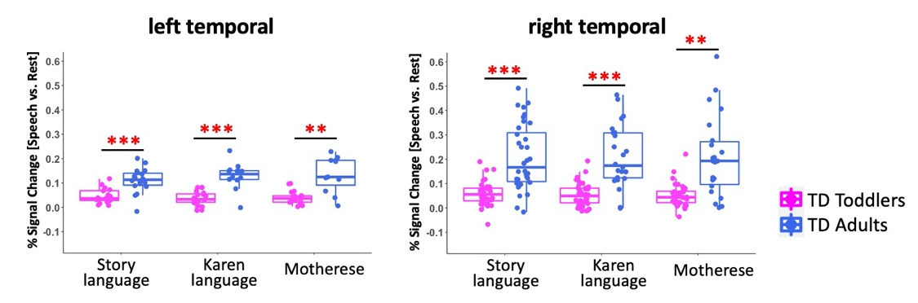

Supplementary Fig. 1
Group differences between typically developing (TD) toddlers and TD adults in percent signal changes
For all language paradigms, percent signal changes in TD toddlers are significantly less than TD adults. The boxes show interquartile range (IQR; first quartile, Q1; third quartile, Q3); the vertical line inside the box represents the median; the whiskers indicate Q1 – (1.5 × IQR) or Q3 + (1.5 × IQR). The red asterisks indicate significant group differences between TD toddlers and TD adults. ** p < .05, *** p <.001.

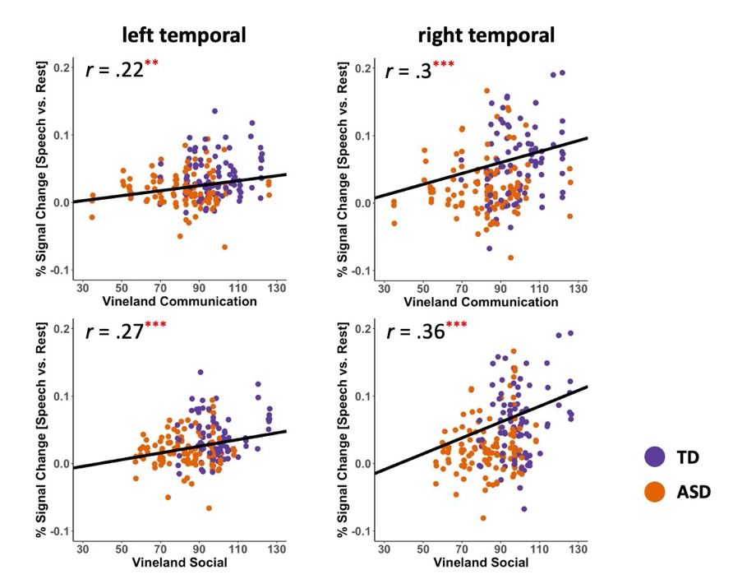

Supplementary Fig. 2
Scatterplots showing significant correlations of brain response to language stimuli with a child’s social and communication abilities
The black line in each scatterplot represents model fits across all subjects (i.e., ASD and TD toddlers) and three language paradigms (i.e., Story language, Karen language, and Motherese). The r values indicate Pearson’s correlation coefficients (for estimated coefficients from mixed effects models, see Supplementary Table S2). ** p < .005, *** p < .001.

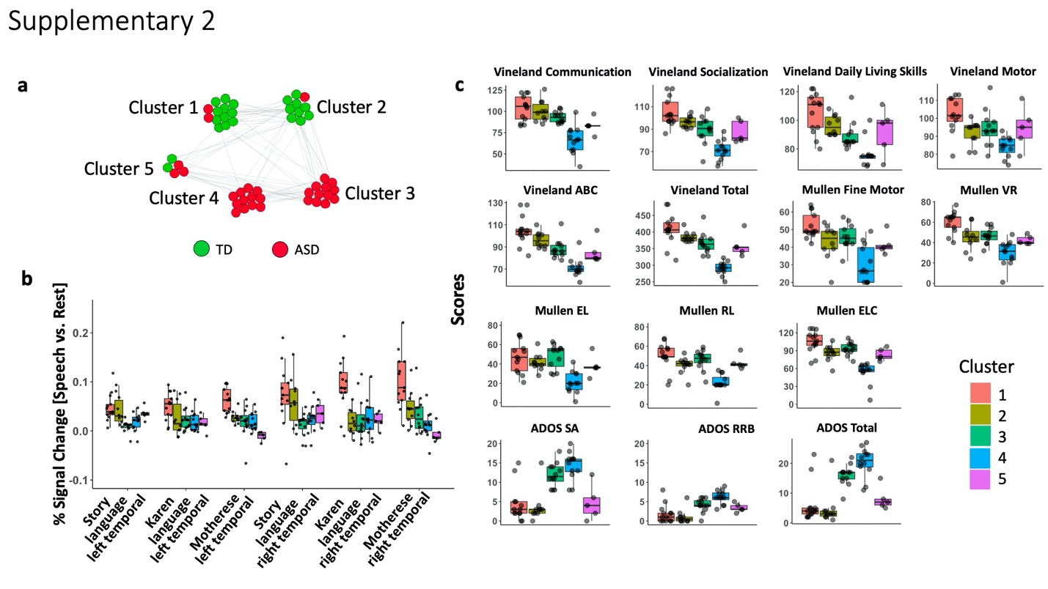
Supplementary Fig. 3
TD and ASD subgroups with distinct fMRI-clinical patterns
a, Similarity Network Fusion and Louvain algorithm revealed 5 fMRI-clinical distinct subgroups (green: TD; red: ASD), including two TD clusters (Clusters 1 and 2), two ASD clusters (Clusters 3 and 4), and one mixed cluster (Cluster 5) of 2 TD and 3 ASD toddlers. b, A trend of reduced brain activation to three language paradigms in ASD clusters as compared to TD clusters. c, Severe symptoms and social and language deficits in ASD toddlers but Cluster 4 appears to be more severe and have a poorer prognosis as compared to Cluster 3. The boxes show interquartile range (IQR; first quartile, Q1; third quartile, Q3); the vertical line inside the box represents the median; the whiskers indicate Q1 – (1.5 × IQR) or Q3 + (1.5 × IQR).
Abbreviations: ASD, autism spectrum disorder; TD, typical development; ABC, adaptive behavior composite; VR, visual reception; EL, expressive language; RL, expressive language; ELC, early learning composite; ADOS, Autism Diagnostic Observation Schedule; SA, social affect; RRB, restricted and repetitive behavior.

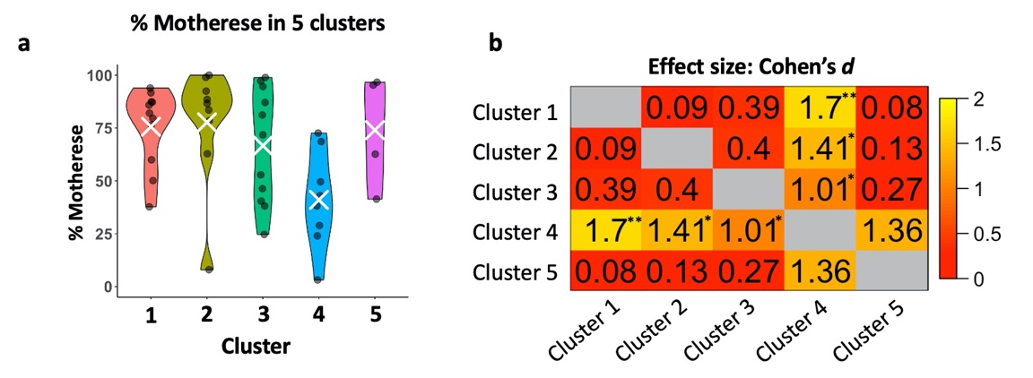
Supplementary Fig. 4
Preference for motherese vs. computer “techno” images and sounds in 5 clusters
a, Toddlers in TD clusters (Clusters 1 and 2) had significantly higher percentage fixation towards motherese versus computer “techno” sounds than ASD toddlers (Clusters 4). The white cross indicates group mean. b, The heatmap matrix shows standardized effect sizes (Cohen’s d) for each pairwise group comparison between clusters. Cohen’s d value is shown in each cell and the standard effect size is also indicated by the color of the cell. The asterisk indicates significant results of two-sample t-tests. *p <.05, **p < .005.

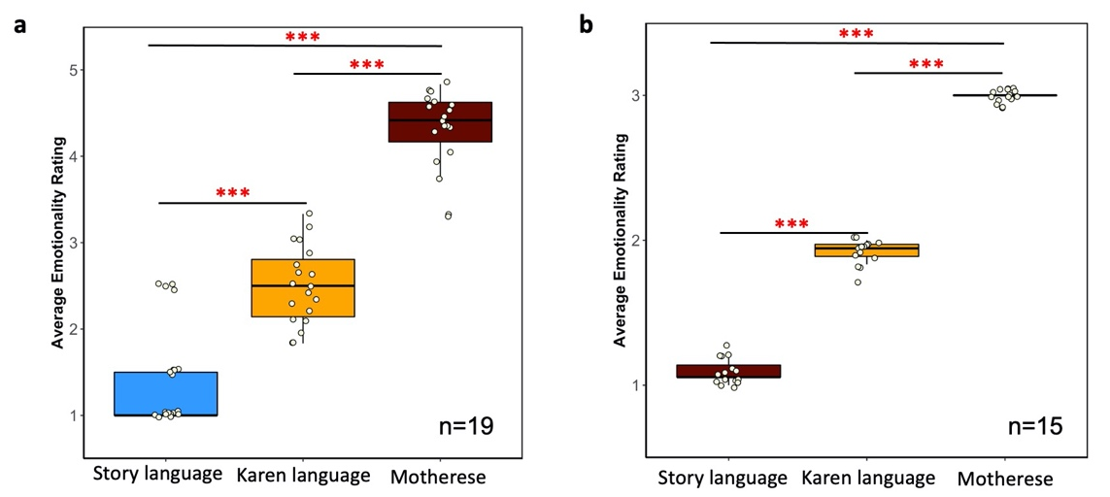
Supplementary Fig. 5
Average emotionality rating for each language paradigm in two computer-based surveys
a, In survey 1, ratings on each story or phrases were collected from a group of typical adults (n=19). b, In Survey 2, a group of adults (n=15) rated 18 trials, each containing a Story language segment, a Karen language segment, and a Motherese segment. Both surveys showed significant differences in levels of emotionality between three language paradigms: the Story language paradigm had the least levels of emotionality, followed by Karen language, while the Motherese speech had the most amount of emotional salience. The boxes show interquartile range (IQR; first quartile, Q1; third quartile, Q3); the vertical line inside the box represents the median; the whiskers indicate Q1 – (1.5 × IQR) or Q3 + (1.5 × IQR). The red asterisks indicate significant differences between language paradigms. *** p < .001.

