Table S1: The amino acid sequence of ChBp and ChBp-I2.
Name | Seqeunce
ChBp | TGWVKDNGSWYYLNLSGYML
ChBp-I | TGWVKDNGSWYYLNLSGYMLYHANNSTDT

Table S2: The primer used for amplification of CBDs in this study
Name | Seqeunce (5’-3’)
CBD-A-F | ccatggcgattgaaacaggctggca
CBD-A-R | aagcttatactgtaatcaagccatc
CBD-B-F | ccatgggtacttggcaaggaaaacag
CBD-B-R | aagcttaatttttcgccatgtagccacca
CBD-C-F | ccatggctgttacattttttata
CBD-C-R | aagcttacacttgttcttctctattattaa
CBD-D-F | ccatggaaactgtcggttggaagaaaat
CBD-D-R | aagcttactatactcgttctccatcact

Table S3: The primer used for q-PCR analysis in this study.
Name | Forward | Reverse
16S | GGCAATGGACGGAAGTCTGA | GTTAGCCGTCCCTTTCTGGT
dnaK | CTCGTATCCCTGCCGTTGTTGAAG | ACATCACCAGTAATCACACCACCTTG
galE | ATAAAGCTGTCGGAGAATCC | CCATATACAGTCGCACTTGA
pstB | ACTTCAGCCTTAGACCCTAT | GGATTGGTAAACACGTCAAC
RS00165 | GAGCAACAAGCGACCATGATTGAAG | CCACCTAAGCAAGCCACGACAC
RS00225 | TTCAGAGTCGTGTCGGAAAGAATAAGG | ATCGATTCCTAAGTCTTCAGCAGCTC
RS00360 | ATCAGACTGTGGTAGTTGTTGCTCATC | TCTCTAACTCACACTCAATCACTTGGC
RS00725 | AACATCCTCTGCCTTGATTG | AGAATGGGATAGAGTGTGGA
RS00985 | ATCGAACAAACGGTATCGAA | ATCTCCAACAACTATGCGAC
RS01330 | GGACTTGGAATTGCCATCCTTTCAAC | AGCGATAACCTCACCACCAACATTC
RS01390 | GCTACGGTACAACTCTTGGTAACTCTC | CGTCTTCACGAACACCTGGAACTG
RS03095 | GCCTTTAGCGTAATAGCAGTTCAAACC | CAAGGGCAACAACGATACCAACAAC
RS03195 | ATGCAGTCATGGTGAAAGATGTAAACG | TTGCTGGGATACGGAATAAGATTGGTC
RS03560 | AATCATAGTGGAACGCTTGT | TACTGGGACAAAAATCCCTG
RS03590 | ATGCCGTTATTAGCAAAAGC | AGGTTCAAAGCCATCGTAAT
RS04100 | ATCAGGACTTGGAGAATTGGCAGAAG | AGCATGACCGACTACTGTTGAACG
RS07605 | ACTGATGAAGAAGGTGACGATGTGAC | CCAGGTGCTTGTCCAAGTTCGG
RS08730 | GCCAAAAGTAATGCTATGGAG | CAACATTTCTGTTTGAGCCT
RS08990 | GATTTGTTGGGAATTTCAGCGGATACG | AATCACGAATCACAGTAGCAGTACGAG
RS08995 | TATTTGGTTCTAGCGCTGTT | TATAGCCCAAGGTGTACTGA
RS09050 | TTCATCCATCGTATTCACCC | ACGATAGGCGATAACTTCTG
RS09060 | GCCCAGGATACGGACTTTATCTTGC | ACGATGATAATGGTCTTGCCGAGTTC
RS09065-R | AGCGATAATCAAATCAGGCT | AGTCCGCCTCCGCTTAGATACC
RS10045 | GCTAACGATTGGAAAGAAGC | TAAGGCCCATACTCTTCAGT
RS10075 | TGCCGTCACTAGAAATCAAATTAAGCG | TCTCCATCTCTGCGTATCCCAAGG
RS10655 | GCTATGGGAACGCCTGGTATGC | ATGTTCTTGTCACAGCCACCGATAG

Figure S1: Purification of the choline binding domain of LytA (A), CbpD (D) and LytC (C). The deduced proteins were marked with black arrow.
Figure S2: Quantification of the up-regulated (A) and down-regulated (B) genes under choline binding domain of LytA (A), CbpD (D) and LytC (C) at different concerntations.
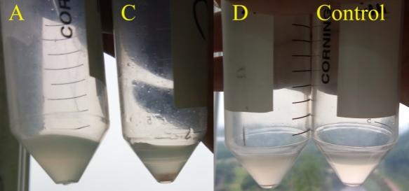
Figure S3: Autolysis of pneumococcal cells under CBD-A, CBD-C and CBD-D. The cells were incubated in mediums containing CBD-A, CBD-C and CBD-D (100μg/mL) for 2h, then the mediums were placed at room temperature for 10h. autolysis was only detected at the control group, cell aggregate was detected at CBD-C group.

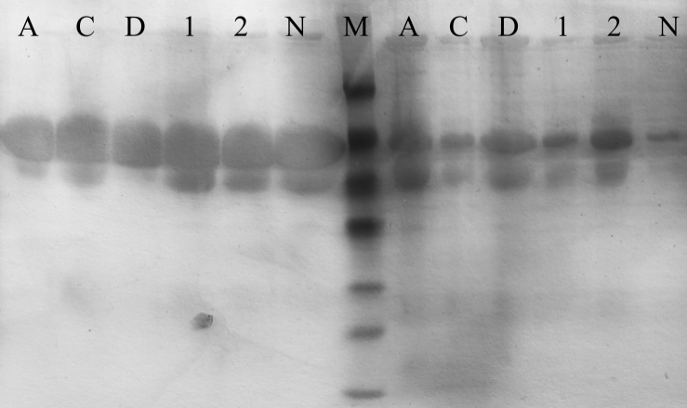
Figure S4: Detection of extracellular protein, after being precipitated by TCA, soluble (left) and insoluble protein (right, dissolved by 8M urea) of were detected by SDS-Page.

