Do all freshwater ponds have similar chemical traits? Evidence on water-quality characteristics and their potential to support harmful cyanotoxins
Morolake M. Fatunmbi¹, Debabrata Sahoo^{2*}, Sarah A. White¹, Amy E. Scaroni³, Dawoon Jeong², Calvin B. Sawyer⁴
¹Department of Plant and Environmental Science, Clemson University, Clemson, SC, 29634, USA.
²Department of Agricultural Sciences, Clemson University, and South Carolina Water Resources Center, Clemson University, Pendleton, SC 29670. USA.
³Department of Forestry and Environmental Conservation, Clemson University, Baruch Institute of Coastal Ecology and Forest Science, Georgetown, SC, 29440, USA
⁴Department of Agricultural Sciences, Clemson University, Clemson, SC, 29634, USA.

*Correspondence Address:
Dr. Debabrata Sahoo, PE, PH
Department of Agricultural Sciences, Clemson University, and South Carolina Water Resources Center, Clemson University, 509 Westinghouse Road, Pendleton, SC 29670, USA. Tel: +1-803-404-4340; Email: dsahoo@clemson.edu.

Supplementary table 1: Descriptive statistics of water quality parameters by pond type (These parameters are represented in a table rather than boxplot for better visualization)
S/n | Parameters | Pond types | Mean±SD | Median(IQR) | Min - Max
1 | Ammonium-N (mg/L) | Irrigation | 0.15±0.26 | 0.05(0.07) | 0.01– 1.19
1 | Ammonium-N (mg/L) | Livestock | 0.26±0.71 | 0.04(0.04) | 0.00 – 3.20
1 | Ammonium-N (mg/L) | Recreation | 0.16±0.47 | 0.04(0.04) | 0.01 – 2.14
1 | Ammonium-N (mg/L) | Stormwater | 0.08±0.13 | 0.04(0.04) | 0.00 – 0.64
2 | Nitrate+Nitrite-N (mg/L) | Irrigation | 3.00±7.80 | 0.04(2.85) | 0.00 – 50.47
2 | Nitrate+Nitrite-N (mg/L) | Livestock | 0.01±0.03 | 0.00(0.00) | 0.00 – 0.16
2 | Nitrate+Nitrite-N (mg/L) | Recreation | 0.01±0.15 | 0.00(0.00) | 0.00 – 0.63
2 | Nitrate+Nitrite-N (mg/L) | Stormwater | 0.14±0.32 | 0.00(0.01) | 0.00 – 1.30
3 | SRP (mg/L) | Irrigation | 0.24±1.06 | 0.01(0.04) | 0.00 – 7.32
3 | SRP (mg/L) | Livestock | 0.10±0.21 | 0.01(0.03) | 0.01 – 0.86
3 | SRP (mg/L) | Recreation | 0.01±0.01 | 0.01(0.02) | 0.00 – 0.03
3 | SRP (mg/L) | Stormwater | 0.04±0.06 | 0.02(0.02) | 0.00 – 0.20
4 | Microcystin (µg/L) | Irrigation | 1.51±8.23 | 0.11(0.12) | 0.01 – 56.90
4 | Microcystin (µg/L) | Livestock | 23.0±91.3 | 0.43(2.37) | 0.05 – 544.90
4 | Microcystin (µg/L) | Recreation | 0.19±0.22 | 0.14(0.13) | 0.04 – 1.21
4 | Microcystin (µg/L) | Stormwater | 0.15±0.10 | 0.17(0.13) | 0.03 – 0.24
5 | Phycocyanin (µg/L) | Irrigation | 8.03±11.57 | 2.45(9.59) | 0.17 – 53.03
5 | Phycocyanin (µg/L) | Livestock | 28.52±52.28 | 5.55(29.85) | 0.19 – 274.25
5 | Phycocyanin (µg/L) | Recreation | 5.63±6.83 | 2.77(6.75) | 0.02 – 24.98
5 | Phycocyanin (µg/L) | Stormwater | 4.01±7.66 | 1.81(2.64) | 0.06 – 40.65
SRP: Soluble reactive phosphorus
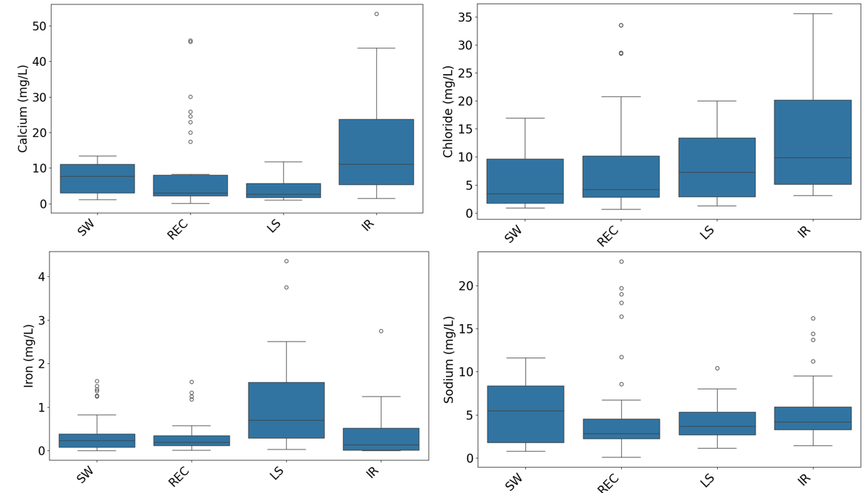
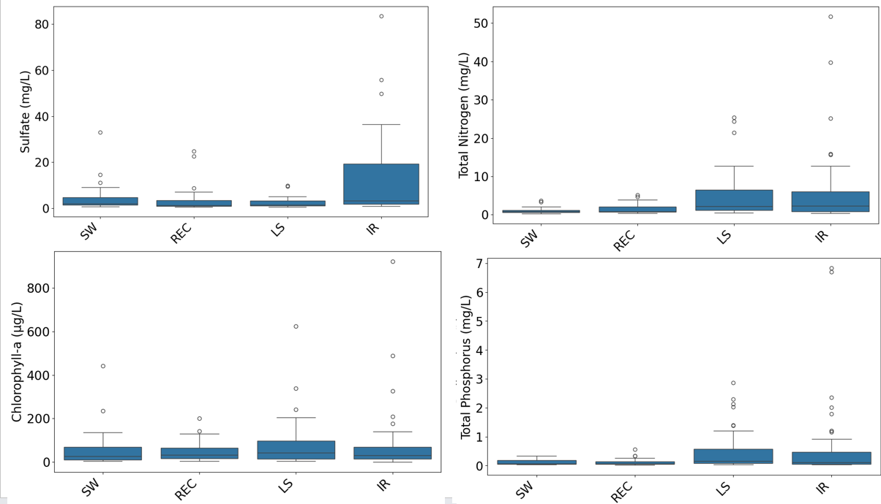
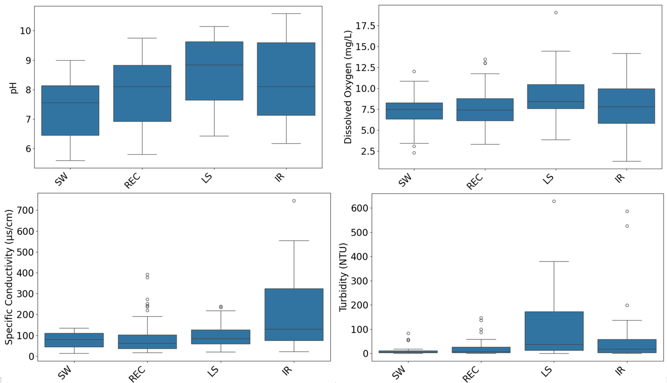
Supplementary figure 1: Boxplots showing the distribution of selected water quality parameters (calcium, chloride, iron, sodium, sulfate, total nitrogen, chlorophyll-a, total phosphorus, pH, dissolved oxygen, specific conductivity, and turbidity) across four pond types: Stormwater (SW), Recreation (REC), Livestock (LS), and Irrigation (IR).

