Supplementary Information
Gen2: Building a Reviewer-Defensible Benchmark for Binding Hypothesis Triage in Cryptic Pocket Discovery
Author: Hoosdally Shakeel

Contents
• Supplementary Methods S1. Benchmark ontology, row-status definitions, and pooled-eligibility rules
• Supplementary Table S1. Benchmark role definitions and pooled-eligibility rules
• Supplementary Table S2. Full slice-level admissibility matrix for the current Gen2 panel
• Supplementary Table S3. PTP1B evidence table and bounded same-series triage structure
• Supplementary Table S4. TP53 Y220C evidence-tier table and calibration-only justification
• Supplementary Table S5. KRAS G12D evidence-tier table and restricted-slice justification
• Supplementary Table S6. CK2 falsification logic table
• Supplementary Table S7. Candidate mature-slice expansion table
• Supplementary Figure S1. TP53 Y220C evidence-tier schematic
• Supplementary Figure S2. KRAS G12D evidence-tier schematic

Supplementary Information overview
This Supplementary Information provides the supporting benchmark-construction material for the main manuscript. Its purpose is to make the current Gen2 panel more transparent without shifting the paper away from decision-carrying main-text figures and tables. The supplement therefore expands the benchmark ontology, row-status logic, slice-level admissibility structure, and restricted-use assignments that underlie the present checkpoint. It also records the bounded evidence tiers for PTP1B, TP53 Y220C, KRAS G12D, CK2, and the current mature-slice expansion candidates. Consistent with the main manuscript, these materials are intended to clarify admissibility, restriction, and non-pooled status rather than to introduce a pooled benchmark claim.

Supplementary Methods S1. Benchmark ontology, row-status definitions, and pooled-eligibility rules

S1.1. Benchmark ontology
The Gen2 benchmark program used a bounded slice-role ontology to distinguish between systems that could support benchmark interpretation and systems that could only support restricted or non-pooled use. Each candidate slice was assigned one role before pooled scoring was considered. The allowed roles were: included benchmark slice, limited calibration slice, limited comparator slice, controlled mature-slice buildout, falsification or failure-mode slice, and excluded slice. This role system was used to prevent heterogeneous cases from being treated as automatically comparable simply because they involved plausible ligand-pocket hypotheses. In practical terms, the ontology separated slices that could in principle contribute to later benchmark scoring from slices that were retained only for calibration, comparator, buildout, or rejection logic.
An included benchmark slice was defined as a slice with sufficiently resolved row identities, comparator structure, and evidential maturity to support benchmark interpretation under the locked rules. A limited calibration slice was defined as a slice that could support bounded positive-control or calibration use, but not pooled scoring. A limited comparator slice was defined as a slice that could support restricted anchor-versus-weaker-comparator interpretation without full benchmark promotion. A controlled mature-slice buildout was defined as a candidate expansion slice with credible benchmark potential, but not yet promoted into the active pooled panel. A falsification or failure-mode slice was defined as a slice retained to test rejection behavior under mechanistic contradiction or failure logic rather than to expand benchmark breadth. An excluded slice was defined as a slice that did not contribute to benchmark evaluation under the current checkpoint rules.

S1.2. Row-status definitions
The basic unit of analysis in the benchmark program was one ligand-target-site hypothesis per row. Each row therefore recorded a specific claim rather than a target-level narrative. To make row handling auditable, every row was assigned an explicit status.
An evaluable row was a row with sufficiently resolved ligand identity, target context, proposed site, evidence class, and benchmark role to permit interpretation under the active rules. An unevaluated row was a row retained in the benchmark infrastructure but not admitted to pooled interpretation because a required condition remained unmet. A provisional row was a row supported only partially, such that inclusion would have overstated the evidential base. An excluded row was a row judged not to belong in the slice under the current evidence. A restricted row was a row that could support only bounded use, for example inside a calibration or limited-comparator slice, but not pooled scoring. These row-status assignments were used to ensure that benchmark assembly proceeded through explicit admission or restriction decisions rather than through informal narrative carryover from the literature.

S1.3. Rules for pooled eligibility
Pooled benchmark interpretation was permitted only when both slice-level and row-level conditions were satisfied. A slice could be considered for pooled use only if its role allowed pooled interpretation. A row could be considered for pooled use only if ligand identity, target state, proposed site, comparator logic, and evidence class were all sufficiently resolved to support cross-slice comparison. Rows with unresolved identity, ambiguous site assignment, incomplete comparator structure, or explicitly restricted slice roles remained inside the benchmark infrastructure but outside pooled scoring.
Under this system, pooled eligibility was treated as an evidential property rather than as an administrative default. A slice did not become pooled-eligible merely because it had been curated or because it contained a plausible positive ligand. Likewise, a row did not become pooled-eligible merely because it could be named or because some supporting literature existed. Pooled eligibility required that the benchmark question, comparator structure, and evidential maturity be strong enough to justify comparison against other rows and other slices under fixed rules.

S1.4. Restricted-use categories
Some slices were intentionally retained in restricted-use categories. This was done when the available evidence supported a scientifically useful but narrower role than pooled benchmarking. For example, a slice could be retained as calibration-only when it contained a bounded positive anchor but lacked the comparator structure needed for a fuller benchmark question. A slice could be retained as a limited comparator slice when it contained a strong anchor and a weaker comparator but lacked an explicit negative or equivalent benchmark-complete structure. A slice could be retained as falsification material when its main value lay in testing whether the framework rejected a mechanistically contradictory hypothesis. Restricted-use assignment was therefore not a placeholder for unfinished work alone. It was a deliberate benchmark decision designed to preserve evidential discipline.

S1.5. Failure-mode handling
Failure-mode slices were handled separately from pooled benchmark scoring. Their purpose was not to enlarge the benchmark panel or to provide ordinary negative rows, but to test whether the framework could reject weakly supported or contradictory hypotheses under fixed criteria. These slices were therefore admissible as scientifically informative material without being treated as pooled benchmark evidence. This distinction was important because rejection behavior is part of benchmark logic, but not every rejection case is suitable for inclusion in pooled performance summaries.

S1.6. Checkpoint logic
At each checkpoint, the benchmark program was interpreted according to the currently locked slice roles and row statuses rather than according to the most optimistic historical state reached during curation. This rule prevented the benchmark from drifting back toward earlier provisional interpretations once stricter restrictions had been imposed. As a result, the operative benchmark state at any given point was the preserved checkpoint state, not the most expansive intermediate state observed during development. This checkpoint logic was central to the present manuscript because it defined what the active panel could and could not support at the time of writing.

S1.7. Reporting rule
The benchmark program was reported under a rule that prioritized admissibility decisions over apparent panel breadth. Main benchmark claims were therefore tied to slice role, row status, and pooled eligibility, rather than to raw counts of curated targets or ligands. Under this rule, a blocked pooled benchmark could still represent a successful benchmark-construction outcome if the blocked state arose from explicit evidential discipline rather than from incomplete workflow execution. This reporting logic was used throughout the manuscript and underlies the distinction between benchmark-like, calibration-only, restricted-comparator, falsification, and non-promoted material.

Supplementary Table S1. Benchmark role definitions and pooled-eligibility rules
Definitions of the slice-role classes used in the Gen2 benchmark program, together with their allowed uses and pooled-scoring status. This table provides the ontology used to distinguish benchmark slices from calibration, restricted-comparator, buildout, falsification, and excluded material. It is intended to clarify admissibility logic rather than to report benchmark performance.
Benchmark role | Definition | Allowed use | Not allowed | Pooled-metric eligible
Included benchmark slice | Slice with sufficiently resolved row identities, comparator structure, and evidential maturity to support benchmark interpretation under the locked rules | Benchmark interpretation, cross-slice comparison, pooled scoring if row-level criteria are also met | Use beyond the locked benchmark question or retrospective rule changes | Yes, if row-level criteria are also satisfied
Limited calibration slice | Slice that supports bounded positive-control or calibration use but lacks the structure needed for full benchmark promotion | Calibration, bounded anchor use, restricted interpretation | Pooled scoring, broad performance claims, use as a full benchmark slice | No
Limited comparator slice | Slice that supports a restricted anchor-versus-weaker-comparator question but lacks a full benchmark-complete structure | Restricted comparator analysis, bounded slice-level interpretation | Pooled scoring, broad specificity claims, use as a mature benchmark slice | No
Controlled mature-slice buildout | Candidate expansion slice with credible benchmark potential but not yet promoted into the active pooled panel | Structured buildout, comparator definition, benchmark-planning use | Active pooled benchmarking, claim as current benchmark evidence | No
Falsification or failure-mode slice | Slice retained to test rejection behavior under mechanistic contradiction or failure logic rather than to expand benchmark breadth | Failure-mode analysis, rejection-behavior assessment, bounded framework interpretation | Counting as ordinary pooled benchmark evidence or as a conventional negative row by default | No
Excluded slice | Slice not admissible for benchmark interpretation under the current checkpoint rules | Documentation of exclusion status only | Any benchmark, calibration, or pooled use | No
Note: Pooled eligibility requires both an admissible slice role and sufficiently resolved row-level criteria, including ligand identity, target context, proposed site, comparator structure, and evidence class.

Supplementary Table S2. Full slice-level admissibility matrix for the current Gen2 panel
Expanded slice-level matrix summarizing the current Gen2 panel, including anchor logic, comparator structure, falsification or exclusion logic, pooled eligibility, and bounded interpretive role. This table complements the main-text cross-case synthesis by showing why individual slices are restricted, non-pooled, or non-promoted. It summarizes admissibility structure rather than quantitative benchmark outcomes.
Slice | Biological/task class | Current role | Strongest anchor or defining evidence | Comparator structure | Explicit negative or falsification logic | Pooled-metric eligible | Key evidential bottleneck | Bounded interpretive use
PTP1B | Allosteric phosphatase slice | Minimal same-series benchmark-like slice at the slice-definition level; not pooled-promoted at the preserved checkpoint | FRJ as anchor positive from the same allosteric series | BB3 as weaker same-series comparator | Compound 4 as explicit same-series negative | No | Preserved-checkpoint row-readiness and mapping constraints | Same-series allosteric triage interpretation only
TP53 Y220C | Mutant cavity slice | Limited positive-only calibration slice | PhiKan083 as anchor positive with direct mutant-cavity support | PK7088 as weaker comparator with caution | No explicit negative; MB710 excluded | No | Absence of explicit negative and incomplete benchmark-complete comparator structure | Positive-only calibration use
KRAS G12D | Mutant cryptic-pocket slice | Restricted anchor-plus-weaker-comparator slice | MRTX1133 as strong anchor | TH-Z835 as weaker comparator with caution | No explicit negative; no third ligand included | No | Lack of benchmark-complete comparator structure and non-pooled role restriction | Restricted anchor-versus-weaker-comparator interpretation
CK2 | Wrong-hypothesis / competing-site autopsy | Falsification slice | Defining evidence is the rejection logic rather than a positive anchor | Not used as a graded positive-comparator slice | Competing-site / occupancy-conflict falsification logic | No | Mechanistically informative only as rejection material | Failure-mode and rejection-behavior interpretation
HIF-2α | Controlled mature-slice buildout candidate | Policy-closed mature-slice buildout | Mature cavity rationale with PT2385 / belzutifan anchor logic | Weaker-versus-stronger comparator logic is available | Not active because of policy closure | No | Policy closure at current checkpoint | Buildout planning only
MEK1 | Candidate mature expansion slice | Non-promoted expansion candidate | Type III allosteric anchor logic available | ATP-site comparator structure is available | Not active because slice not yet promoted | No | Not yet integrated into active benchmark panel | Expansion candidate only
AKT1 reserve | Reserve expansion candidate | Reserve candidate only | Reserve allosteric benchmark potential | Comparator structure not yet promoted | Not active because slice remains reserve | No | Baseline and slice-definition not yet fixed to active-panel standard | Reserve expansion planning only
Note: This table summarizes admissibility at the slice level rather than row-level quantitative outcomes. “Pooled-metric eligible” indicates whether a slice was admissible for pooled benchmark interpretation at the preserved checkpoint, not whether it contained scientifically interesting ligand-pocket hypotheses.

Supplementary Table S3. PTP1B evidence table and bounded same-series triage structure
Evidence-tier summary for the PTP1B slice, including the anchor positive, weaker same-series comparator, and explicit same-series negative. This table documents why PTP1B is the closest current approximation to a minimal benchmark-like triage unit. Its scope is deliberately bounded to a same-series allosteric problem and should not be interpreted as a broad allosteric benchmark.
Ligand | Assigned role in slice | Evidence status | Evidence basis | Benchmark function | Key limitation | Included in pooled metrics
FRJ | Anchor positive | Strong positive anchor | Same-series allosteric positive with supporting benchmark role assignment | Represents the clearest positive ligand in the bounded PTP1B triage question | Same-series scope only; does not establish multi-scaffold breadth | No
BB3 | Weaker positive comparator | Positive with weaker support than FRJ | Same-series comparator retained to preserve graded within-series discrimination | Tests whether Gen2 preserves a weaker-but-plausible comparator distinct from the anchor | Not intended as a co-equal anchor or as an independent benchmark expansion case | No
Compound 4 | Explicit same-series negative | Explicitly tested weak/inactive comparator | Biochemical inactivity / weakness and no-effect cellular behavior in the same discovery series | Tests whether Gen2 rejects a same-series compound that should not be advanced | No direct structural confirmation of site binding | No
Note: The PTP1B slice is bounded as a same-series allosteric triage problem. Its value lies in the presence of an anchor positive, a weaker same-series comparator, and an explicitly tested same-series negative, not in broad allosteric or multi-scaffold coverage.

Supplementary Table S4. TP53 Y220C evidence-tier table and calibration-only justification
Evidence-tier summary for the TP53 Y220C slice, including the anchor positive, weaker comparator retained under caution, and excluded candidate. This table documents why TP53 Y220C is admissible only as a limited positive-only calibration slice. It is included to clarify restricted-use logic rather than to support pooled benchmark promotion.
Ligand | Assigned status in slice | Evidence tier | Evidence basis | Allowed benchmark use | Reason not pooled-promoted
PhiKan083 | Anchor positive | Direct anchor | Direct mutant-cavity support with source-verified anchor status | Positive-only calibration anchor | Slice lacks an explicit negative and does not support a full benchmark discrimination task
PK7088 | Weaker comparator with caution | Indirect / weaker comparator | Real support retained, but weaker than the anchor and not treated as co-equal evidence | Restricted comparator within calibration-only interpretation | Comparator support is weaker and insufficient to upgrade the slice to pooled benchmark status
MB710 | Excluded | Unresolved / insufficient | Not retained as an admissible slice component under the current evidence state | None | Excluded from the slice because the evidence state does not support benchmark use
Note: TP53 Y220C is retained only as a limited positive-only calibration slice. The slice contains one anchor positive and one weaker comparator under caution, but no explicit negative and no benchmark-complete comparator structure sufficient for pooled promotion.

Supplementary Table S5. KRAS G12D evidence-tier table and restricted-slice justification
Evidence-tier summary for the KRAS G12D slice, including the strong anchor, weaker comparator retained under caution, and the deliberate absence of a forced third ligand. This table explains why KRAS G12D remains a restricted anchor-plus-weaker-comparator slice rather than a pooled-evaluable benchmark slice. It clarifies bounded admissibility rather than benchmark performance.
Ligand | Assigned status in slice | Evidence tier | Evidence basis | Allowed benchmark use | Reason not pooled-promoted
MRTX1133 | Strong anchor | Direct anchor | Direct KRAS G12D anchor with benchmark-relevant support | Anchor for a restricted slice | Slice lacks an explicit negative and does not support a benchmark-complete pooled discrimination task
TH-Z835 | Weaker comparator with caution | Weaker comparator | Retained as a weaker comparator under explicit caution | Restricted anchor-versus-weaker-comparator interpretation | Comparator support is weaker than the anchor and insufficient for pooled benchmark promotion
No third ligand included | Not included | Not applicable | No additional ligand was forced into the slice without adequate support | None | Deliberate exclusion to avoid inflating slice breadth beyond the available evidence
Note: KRAS G12D is retained only as a restricted anchor-plus-weaker-comparator slice. The slice contains a strong anchor and a weaker comparator, but no explicit negative and no third ligand added merely to enlarge the apparent panel. The resulting role is therefore bounded and non-pooled.

Supplementary Table S6. CK2 falsification logic table
Structured summary of the CK2 wrong-hypothesis case, including the claimed non-canonical interpretation, the competing-site or occupancy-conflict logic, and the resulting rejection role. This table shows why CK2 is informative as falsification material rather than as pooled benchmark evidence. Its purpose is to document failure-mode coverage and rejection behavior under fixed rules.
Element | Current interpretation | Evidential role | Allowed benchmark use | Reason not pooled-promoted
Claimed hypothesis | Plausible non-canonical or allosteric-like CK2 binding hypothesis | Starting claim under evaluation | Entry point for failure-mode analysis only | Not treated as accepted benchmark evidence
Positive-anchor status | Not used as a positive benchmark anchor | No positive-anchor role assigned | None | The slice is not organized as a positive benchmark case
Comparator structure | Not used as a graded positive-versus-weaker-comparator slice | Not applicable | None | The slice does not support conventional comparator-based benchmark interpretation
Rejection logic | Competing-site or occupancy-conflict falsification logic | Core mechanistic evidence | Falsification and rejection-behavior assessment | The slice is informative because it is rejected, not because it expands pooled benchmark breadth
Final slice role | Falsification slice | Failure-mode coverage | Rejection-behavior interpretation only | Not admissible as pooled benchmark evidence
Note: CK2 is retained as falsification material rather than as a conventional benchmark slice. Its value lies in showing that Gen2 can reject a plausible but mechanistically contradictory hypothesis under fixed rules. It is therefore informative for failure-mode coverage, but not for pooled scoring.

Supplementary Table S7. Candidate mature-slice expansion table
Summary of candidate expansion slices and the missing benchmark functions they could add to the current panel. This table explains why HIF-2α and MEK1 are the strongest current strengthening options and why AKT1 remains a reserve candidate. It is included as benchmark-expansion logic and does not indicate current promotion into the active pooled panel.
Candidate slice | Candidate role | Missing benchmark function it could add | Strongest anchor logic | Comparator structure | Current reason not promoted | Bounded current use
HIF-2α | Controlled mature-slice buildout candidate | Adds a non-kinase internal-cavity case with stronger mature-slice potential | PT2385 and belzutifan provide the main positive-anchor logic | Weaker-versus-stronger comparator logic is available within the PAS-B cavity series | Policy-closed at the current checkpoint; not active in holdout or pooled metrics | Mature-slice buildout planning only
MEK1 | Candidate mature expansion slice | Adds a cleaner type III allosteric versus ATP-site discrimination problem | Type III allosteric anchor logic is available | ATP-site comparator structure is available | Not yet promoted into the active benchmark panel | Expansion candidate only
AKT1 reserve | Reserve expansion candidate | Could add an additional allosteric kinase case if baseline and comparator logic are fixed cleanly | Reserve allosteric-anchor logic exists | Comparator structure is not yet promoted to active-panel standard | Baseline choice and slice definition not yet locked to promotion standard | Reserve planning only
Note: This table is provided to show how the current panel could be strengthened by adding missing benchmark functions rather than by increasing target count alone. At the present checkpoint, none of these candidates is part of the active pooled benchmark panel.

Supplementary Figure S1. TP53 Y220C evidence-tier schematic
Evidence-tier schematic for the TP53 Y220C slice. PhiKan083 is retained as the anchor positive, PK7088 as a weaker comparator under caution, and MB710 is excluded from the admissible slice definition. The figure supports the conclusion that TP53 Y220C is usable only as a limited positive-only calibration slice and not as pooled benchmark material.
Supplementary Figure S1. TP53 Y220C evidence-tier schematic
Legend: Evidence-tier schematic for the TP53 Y220C slice. PhiKan083 is retained as the anchor positive, PK7088 as a weaker comparator under caution, and MB710 is excluded from the admissible slice definition. The figure supports the conclusion that TP53 Y220C is usable only as a limited positive-only calibration slice and not as pooled benchmark material.

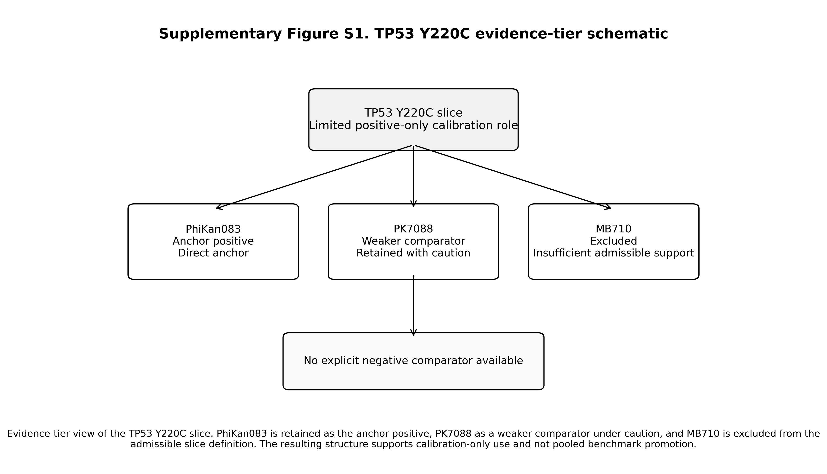

Supplementary Figure S2. KRAS G12D evidence-tier schematic
Evidence-tier schematic for the KRAS G12D slice. MRTX1133 is retained as the strong anchor, TH-Z835 as a weaker comparator under caution, and no third ligand is included in the slice. The figure supports the conclusion that KRAS G12D is usable only as a restricted anchor-plus-weaker-comparator slice and not as pooled benchmark material.

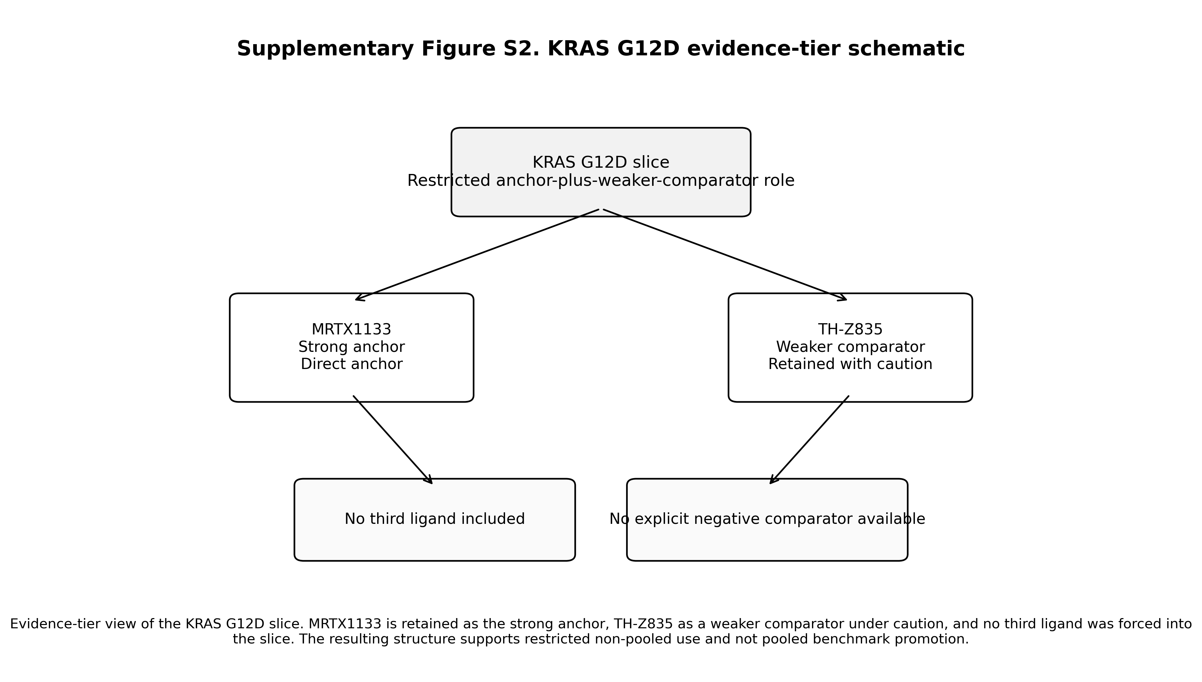
Supplementary Figure S2. KRAS G12D evidence-tier schematic
Legend: Evidence-tier schematic for the KRAS G12D slice. MRTX1133 is retained as the strong anchor, TH-Z835 as a weaker comparator under caution, and no third ligand is included in the slice. The figure supports the conclusion that KRAS G12D is usable only as a restricted anchor-plus-weaker-comparator slice and not as pooled benchmark material.
.

