Supplementary Materials
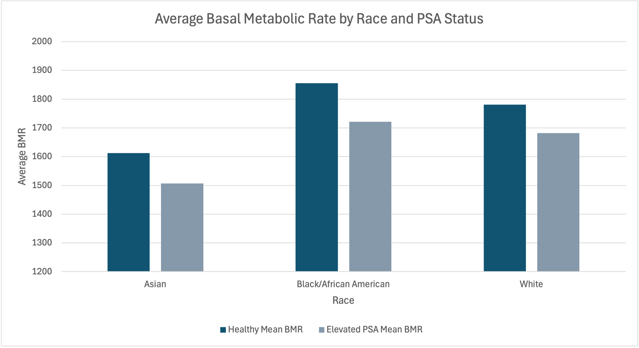
Figure S1. Mean Basal Metabolic Rate (BMR) Among Healthy Men and Men with Elevated PSA Levels by Race
Mean BMR values are shown for healthy participants and those with elevated PSA across five racial groups.

Variable | Category | Healthy (n = 5,368) | Elevated PSA (n = 9,220) | Total (n = 14,588)
Age, years
Age, years | 50-55 | 981 (18.3%) | 1,384 (15.0%) | 2, 365 (16.2%)
Age, years | 56-60 | 1,337 (24.9%) | 2,082 (22.6%) | 3,419(23.4%)
Age, years | 61-65 | 1,443 (26.9%) | 2,819 (30.6%) | 4,262 (29.2%)
Age, years | 66-70 | 1,372 (25.5%) | 2,935 (31.8%) | 4,307 (29.4%)
Age, years | Not Available | 235 (4.4%) | 0 (0.00%) | 235 (1.6%)
BMI, kg/m²
BMI, kg/m² | <18.5 (underweight) | 28 (0.5%) | 46 (0.5%) | 74 (0.5%)
BMI, kg/m² | 18.5-24.9 (Normal) | 978 (18.2%) | 1,804 (19.6%) | 2,782 (19.1%)
BMI, kg/m² | 25.0–29.9 (Overweight) | 1,869 (34.8%) | 3,987 (43.2%) | 5,856 (40.1%)
BMI, kg/m² | 30-34.9 (Obese Class I) | 1,282 (23.9%) | 2,134 (23.1%) | 3,416 (23.4%)
BMI, kg/m² | 35.0-39.9 (Obese Class II) | 623 (11.6%) | 773 (8.4%) | 1,396 (9.6%)
BMI, kg/m² | ≥ 40 (Obese Class III) | 401 (7.4%) | 372 (4.0%) | 773 (5.2%)
BMI, kg/m² | Not Available | 187 (3.6%) | 104 (1.2%) | 291 (2.1%)
Race | White / Caucasian | 3,198 (59.6%) | 6,432 (69.7%) | 9,630 (65.9%)
Race | Black / African American | 955 (17.8%) | 1,327 (14.4%) | 2,282 (15.6%)
Race | Asian | 141 (2.6%) | 143 (1.6%) | 284 (1.9%)
Race | American Indian or Alaska Native | 66 (1.2%) | 52 (0.6%) | 118 (0.8%)
Race | Middle Eastern or North African | 21 (0.4%) | 56 (0.6%) | 77 (0.5%)
Race | Other | 987 (18.4%) | 1,210 (13.1%) | 2,197 (15.3%)
Table S1. Demographic characteristics including age, body mass index (BMI), and race among healthy males and males with elevated PSA aged 50–70 years.

Race | Healthy Participant Count | Elevated PSA Participant Count | Healthy Record Count | Elevated PSA Record Count
Asian | 25 | 22 | 9580 | 10035
Black/African American | 38 | 53 | 17185 | 37939
White | 302 | 722 | 229991 | 719441
Table S2. Participant and Record Counts

