Supplementary Materials

Supplementary Figure S1. Mother-Child Neural Synchrony: Real versus Surrogate Data Distributions (Beta)
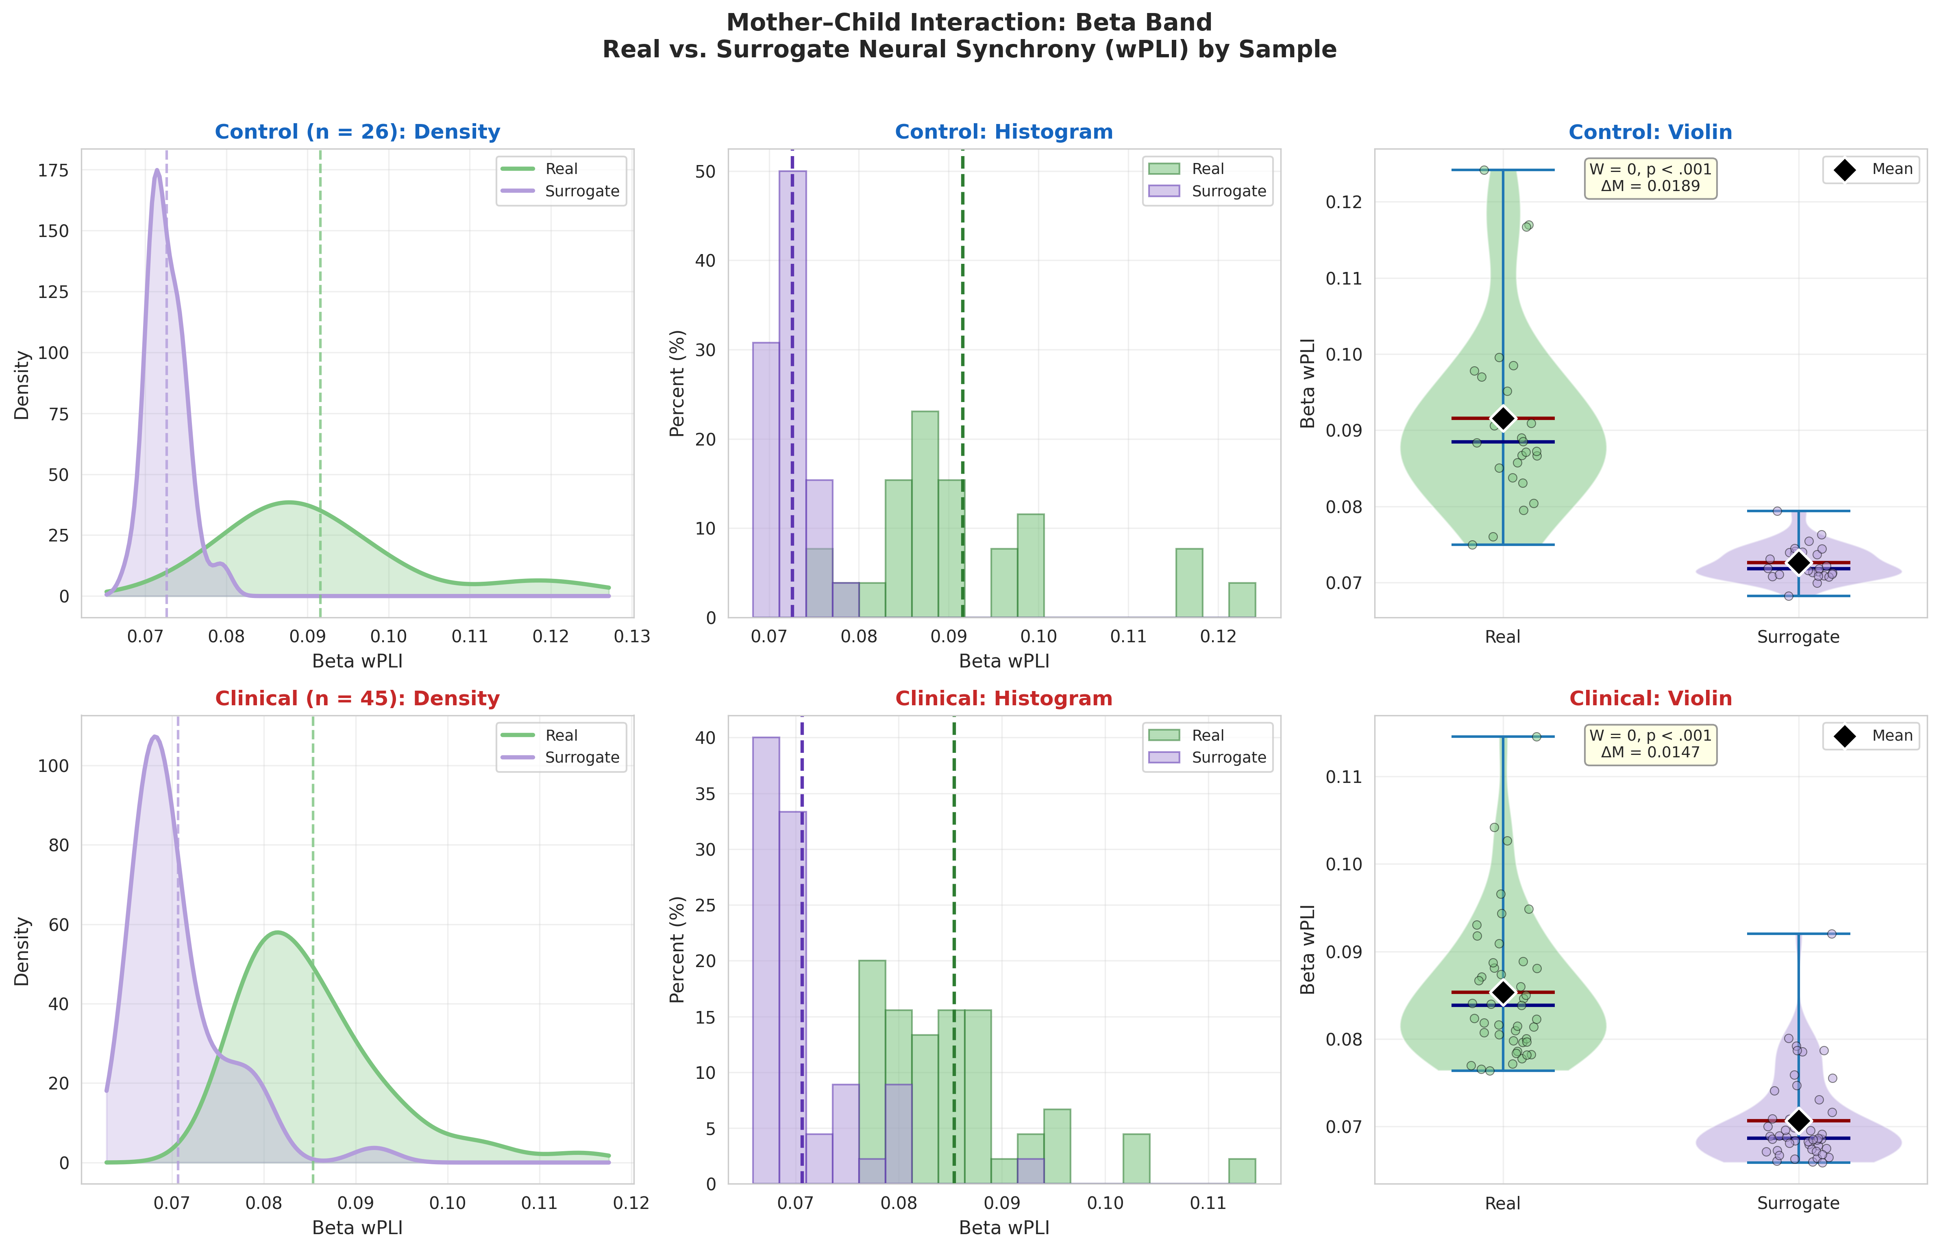
Supplementary Figure S1. Mother–child beta band (13–30 Hz) real vs. surrogate neural synchrony distributions. Top row: control families; bottom row: clinical families. Left: kernel density estimates of real (green) vs. surrogate (purple) wPLI values, with dashed lines at group means. Center: overlapping histograms with common bin widths. Right: violin plots with individual data points, means (black diamonds), and medians (blue lines). Wilcoxon signed-rank test statistics and mean differences (ΔM) are annotated.

Supplementary Figure S2. Mother-Child Neural Synchrony: Real versus Surrogate Data Distributions (Alpha)
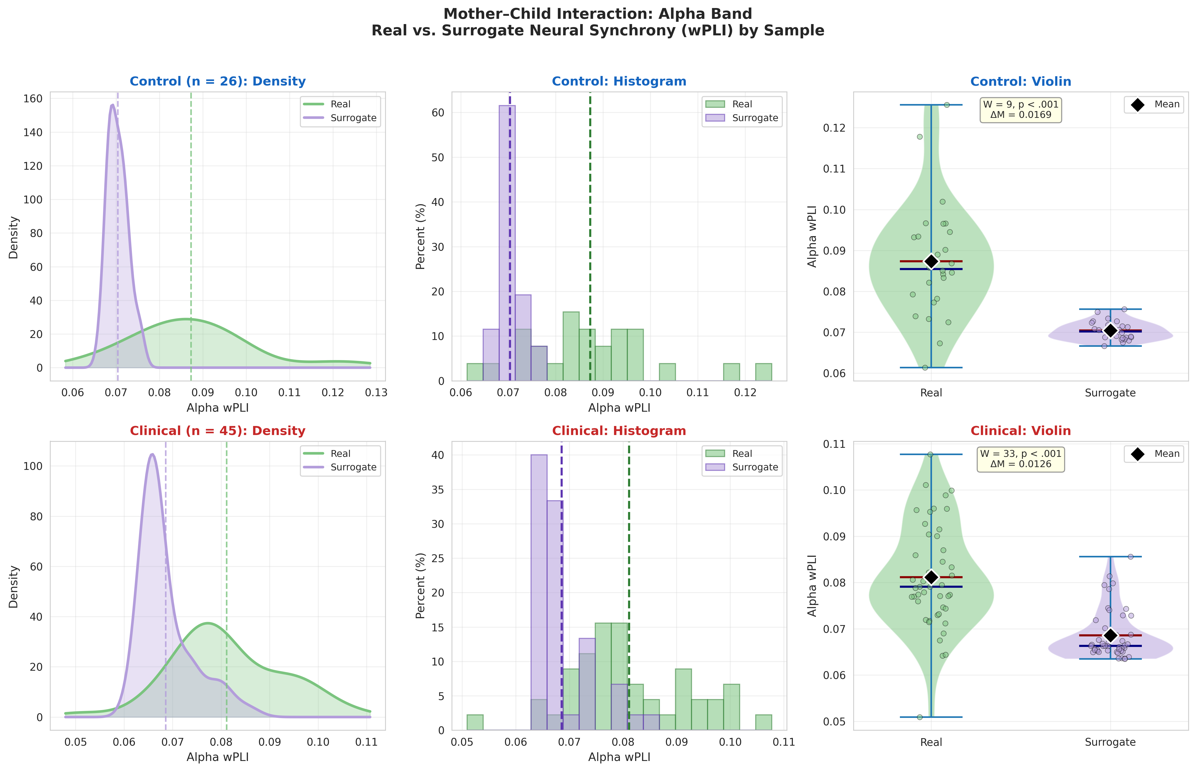
Supplementary Figure S2. Mother–child alpha band (8–12 Hz) real vs. surrogate neural synchrony distributions. Top row: control families; bottom row: clinical families. Left: kernel density estimates of real (green) vs. surrogate (purple) wPLI values, with dashed lines at group means. Center: overlapping histograms with common bin widths. Right: violin plots with individual data points, means (black diamonds), and medians (blue lines). Wilcoxon signed-rank test statistics and mean differences (ΔM) are annotated.

Supplementary Figure S3. Father-Child Neural Synchrony: Real versus Surrogate Data Distributions (Beta)
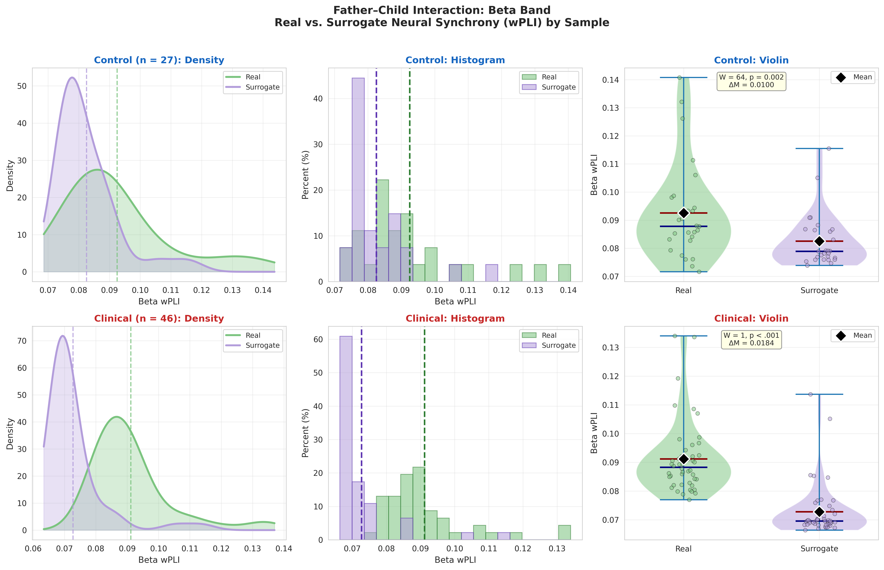
Supplementary Figure S3. Father–child beta band (13–30 Hz) real vs. surrogate neural synchrony distributions. Top row: control families; bottom row: clinical families. Left: kernel density estimates of real (green) vs. surrogate (purple) wPLI values, with dashed lines at group means. Center: overlapping histograms with common bin widths. Right: violin plots with individual data points, means (black diamonds), and medians (blue lines). Wilcoxon signed-rank test statistics and mean differences (ΔM) are annotated.

Supplementary Figure S4. Father-Child Neural Synchrony: Real versus Surrogate Data Distributions (Alpha)
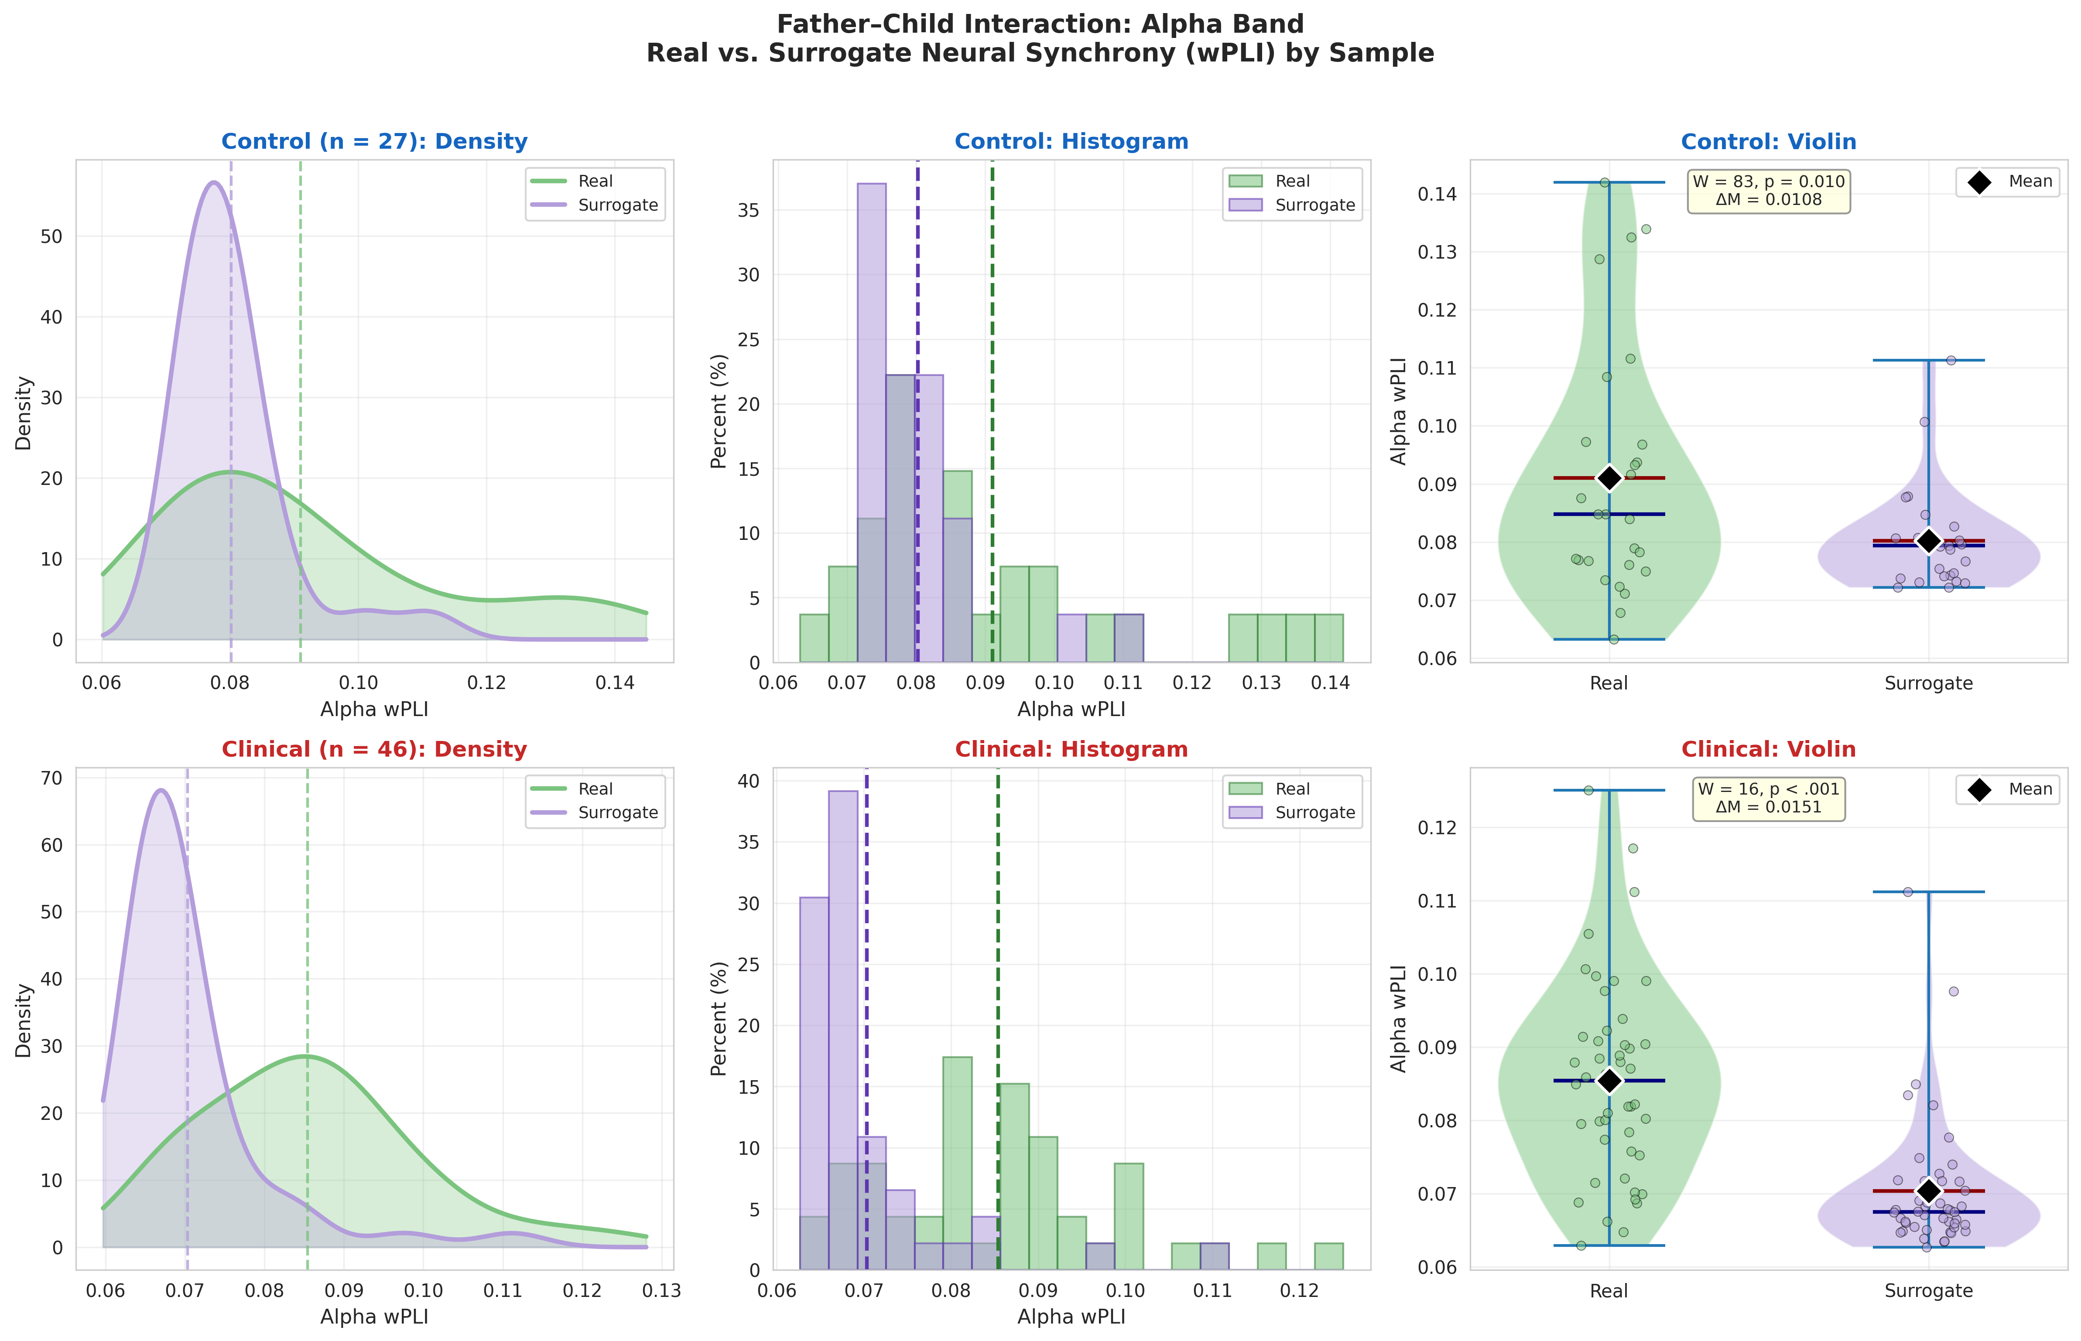
Supplementary Figure S4. Father–child alpha band (8–12 Hz) real vs. surrogate neural synchrony distributions. Top row: control families; bottom row: clinical families. Left: kernel density estimates of real (green) vs. surrogate (purple) wPLI values, with dashed lines at group means. Center: overlapping histograms with common bin widths. Right: violin plots with individual data points, means (black diamonds), and medians (blue lines). Wilcoxon signed-rank test statistics and mean differences (ΔM) are annotated.

Supplementary Figure S5. Alpha Band Synchrony Patterns
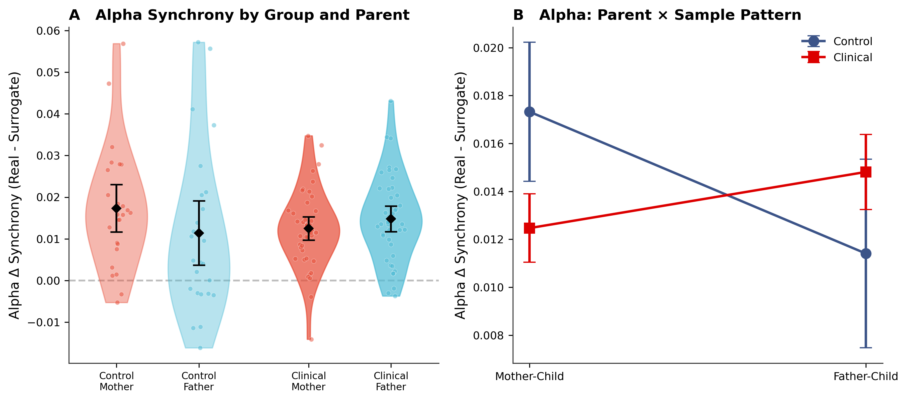
Supplementary Figure S5. Alpha band synchrony patterns from the main text analyses. (A) Alpha Δ synchrony by group and parent. (B) Alpha Parent × Child Anxiety interaction pattern. Unlike beta synchrony, alpha did not show a significant crossover interaction, but rather a trend in the same direction (F(1,66) = 3.06, p = .085, η²p = .044, 90% CI [.000, .089]), suggesting similar reorganization under family stress.

Supplementary Analysis 1: Maternal Psychopathology as Grouping Variable - ANOVA
To assess whether the crossover interaction pattern generalized beyond child anxiety status, we repeated the primary analyses using Maternal Diagnosis as the between-subjects factor. Among the 30 diagnosed mothers, diagnoses comprised generalized anxiety disorder (n = 8), anxiety disorder NOS (n = 9), major depressive disorder (n = 5), OCD (n = 1), PTSD (n = 1), and comorbid conditions (n = 6). All diagnosed mothers were drawn from the clinical sample; the undiagnosed group comprised all 28 control families together with 19 clinical families in which the mother carried no psychiatric diagnosis (final n: undiagnosed = 41, diagnosed = 27).
A 2 × 2 mixed ANOVA with Parent (mother–child, father–child) as the within-subjects factor and Mother Diagnosed (undiagnosed, diagnosed) as the between-subjects factor revealed no significant main effects in either frequency band. In the alpha band (8–12 Hz), neither the main effect of Mother Diagnosed (F(1,66) = 0.44, p = .510, η²p = .007, 90% CI [.000, .013]) nor the main effect of Parent (F(1,66) = 0.09, p = .762, η²p = .001, 90% CI [.000, .003]) were significant, and the Parent × Mother Diagnosed interaction likewise did not reach significance (F(1,66) = 3.25, p = .076, η²p = .047, 90% CI [.000, .094]).
In the beta band (13–30 Hz), the main effects of Mother Diagnosed (F(1,66) = 0.91, p = .344, η²p = .014, 90% CI [.000, .027]) and Parent (F(1,66) = 0.09, p = .760, η²p = .001, 90% CI [.000, .003]) were again non-significant, whereas the Parent × Mother Diagnosed interaction was significant (F(1,66) = 9.61, p = .003, η²p = .127, 90% CI [.027, .252]), replicating the crossover pattern observed in the primary child-anxiety analyses.
Decomposition of the beta-band interaction revealed a dissociation between groups. Among undiagnosed mothers, mother–child synchrony exceeded father–child synchrony (Wilcoxon signed-rank test: W = 270, p = .037, r_{rb} = 0.37, 95% CI [0.06, 0.67]). The pattern reversed among diagnosed mothers, for whom father–child synchrony significantly exceeded mother–child synchrony (W = 66, p = .002, r_{rb} = 0.65, 95% CI [0.31, 0.89]). A between-group comparison of the mother-minus-father difference score confirmed that this reversal was statistically robust (Welch's t = 3.40, p = .001, d = 0.75, 95% CI [0.25, 1.25]) (See Supplementary Table S1, Supplementary Figure S6).

Supplementary Table S1. Mixed ANOVA: Parent × Mother Diagnosed
Alpha band (8–12 Hz):
Effect | F(1,66) | P | η²p | 90% CI
Mother Diagnosed | 0.44 | .510 | .007 | [.000, .013]
Parent | 0.09 | .762 | .00 | [.00, .00]
Parent × Mother Diagnosed | 3.25 | .076 | .047 | [.000, .094]

Beta band (13–30 Hz):
Effect | F(1,66) | P | η²p | 90% CI
Mother Diagnosed | 0.91 | .344 | .014 | [.000, .027]
Parent | 0.09 | .760 | .001 | [.000, .003]
Parent × Mother Diagnosed | 9.61 | .003** | .127 | [.027, .252]

Supplementary Table S1. Mixed ANOVA: Parent × Mother Diagnosed. 2×2 mixed ANOVAs on Δ synchrony (real minus surrogate) with Parent (mother–child, father–child) as within-subjects factor and Mother Diagnosed (undiagnosed, diagnosed) as between-subjects factor. N = 68 families.

Supplementary Figure S6. Mixed ANOVA: Parent × Mother Diagnosed
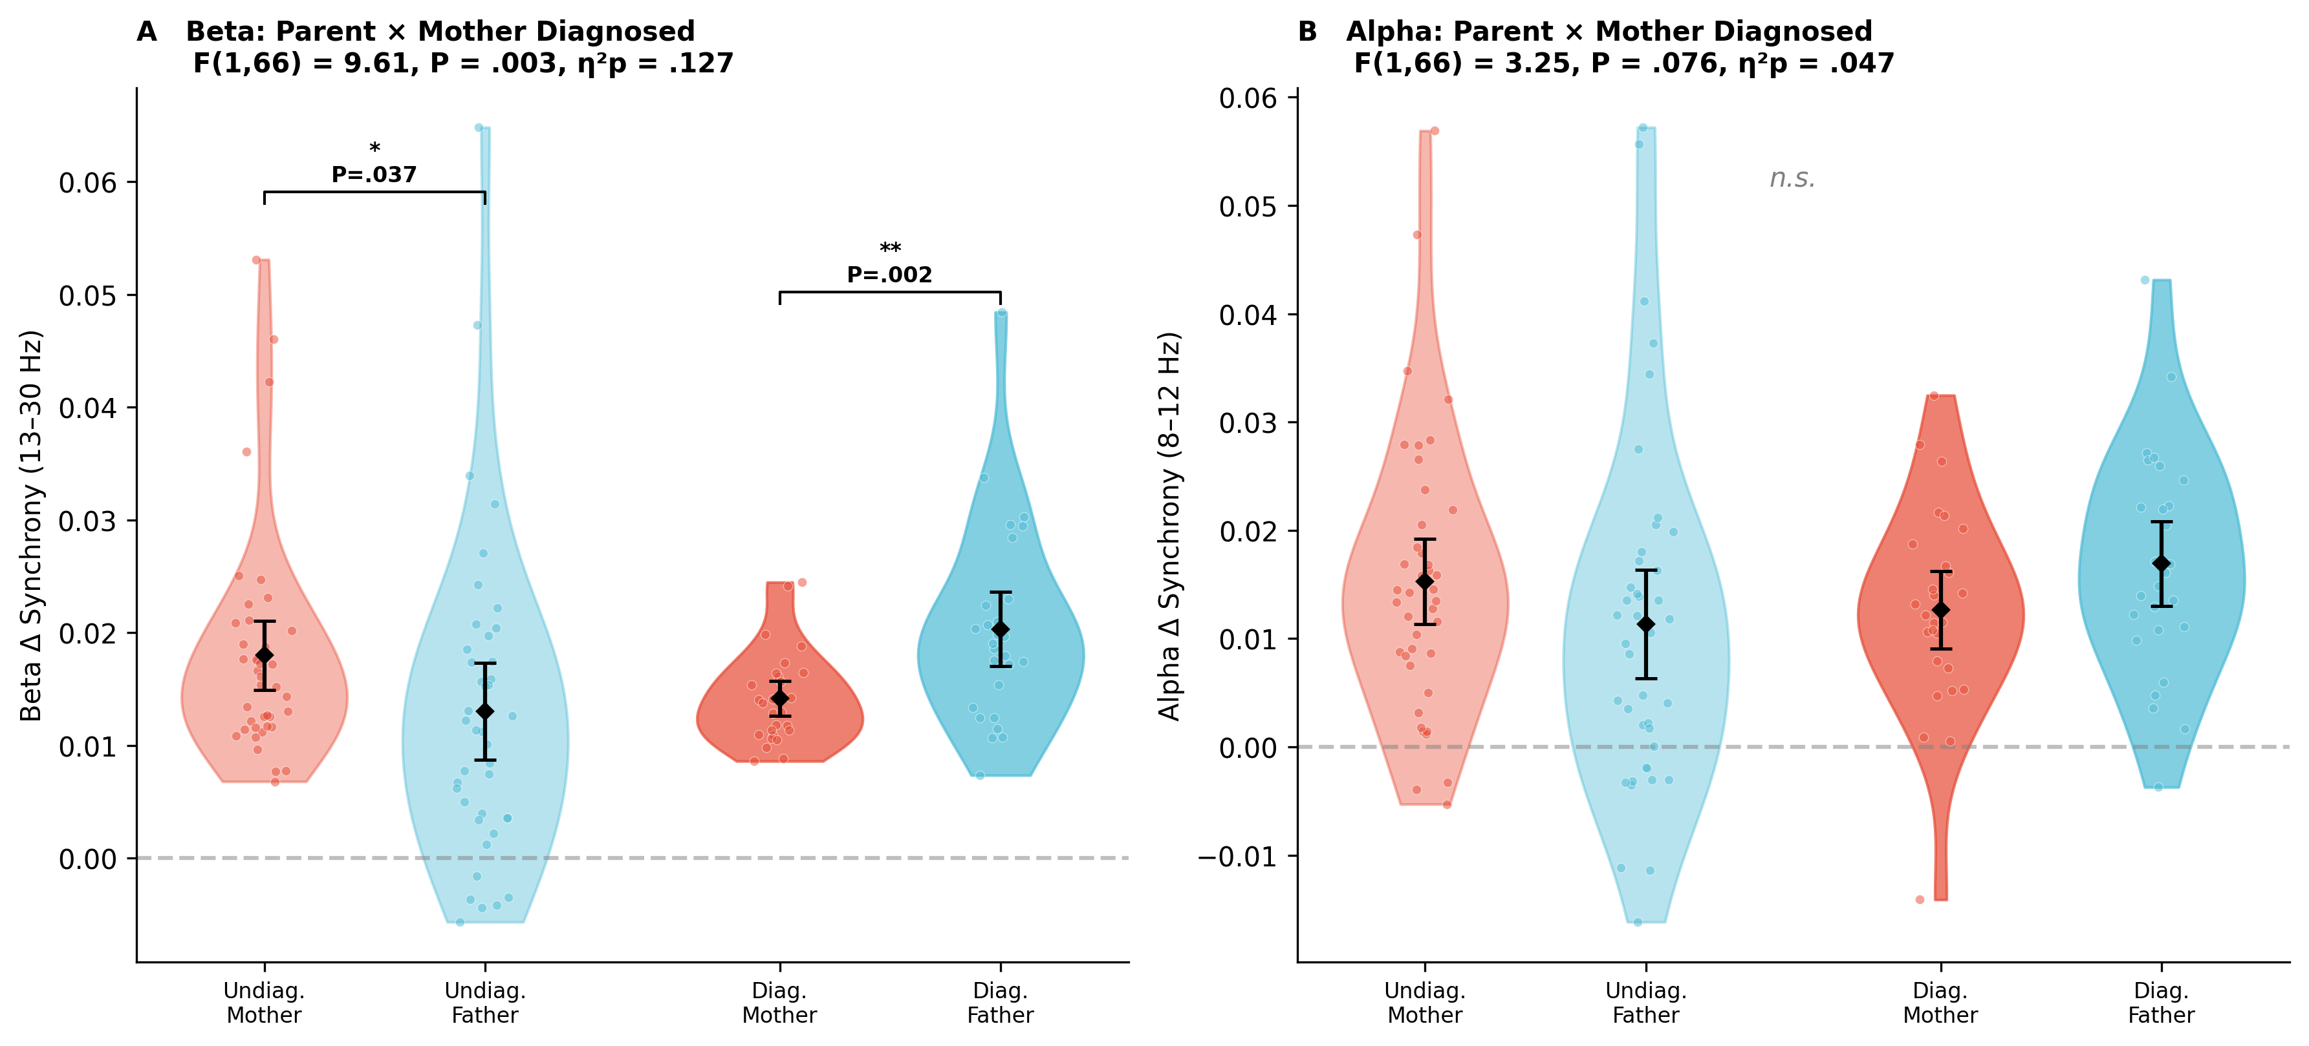
Supplementary Figure S6. Inter-brain synchrony as a function of Parent and Mother Diagnosed. (A) Beta Δ synchrony showing significant crossover interaction (P = .003): mother–child synchrony exceeds father–child synchrony in undiagnosed families (*P = .037), while father–child exceeds mother–child in diagnosed families (**P = .002). (B) Alpha Δ synchrony showing a marginal interaction in the same direction (P = .076). Diamonds indicate means; error bars represent 95% CIs.

Supplementary Analysis 2: Hierarchical Regression Analyses with Maternal Diagnosis as Predictor
To examine the predictive value of maternal psychiatric diagnosis and parenting quality for beta-band neural synchrony, we conducted separate three-step hierarchical regressions for mother–child and father–child Δ synchrony (N = 65).
Mother–child beta synchrony. Entering maternal diagnosis in Step 1 did not significantly predict mother–child synchrony (R² = .038, FΔ(1,63) = 2.49, p = .120; β = −0.0034, SE = 0.0022, t = −1.58, p = .120, 95% CI [−0.008, 0.001]). Adding maternal and paternal parenting quality in Step 2 did not produce a significant increment (R² = .114, ΔR² = .076, FΔ(2,61) = 2.61, p = .082), and no individual predictor reached significance in this step. The addition of the three two-way interaction terms in Step 3 yielded a significant increment (R² = .234, ΔR² = .120, FΔ(3,58) = 3.04, p = .036), and the full model was significant (F(6,58) = 2.96, p = .014). Within this final model, maternal parenting (β = 0.0693, SE = 0.0272, t = 2.55, p = .014, 95% CI [0.015, 0.124]) and paternal parenting (β = 0.0632, SE = 0.0303, t = 2.09, p = .041, 95% CI [0.003, 0.124]) each contributed significant positive effects, alongside a significant negative maternal × paternal parenting interaction (β = −0.0230, SE = 0.0091, t = −2.52, p = .015, 95% CI [−0.041, −0.005]). The diagnosis × parenting interaction terms were non-significant (both p > .54, for full model see Supplementary Table S2).
Father–child beta synchrony. In Step 1, maternal diagnosis significantly predicted father–child synchrony (R² = .069, FΔ(1,63) = 4.65, p = .035; β = 0.0068, SE = 0.0031, t = 2.16, p = .035, 95% CI [0.001, 0.013]), indicating that families of diagnosed mothers showed greater father–child synchrony. The addition of parenting variables in Step 2 produced a significant increment (R² = .180, ΔR² = .111, FΔ(2,61) = 4.12, p = .021), within which paternal parenting emerged as a significant predictor (β = 0.0140, SE = 0.0058, t = 2.40, p = .019, 95% CI [0.002, 0.026]) while maternal diagnosis was reduced to a trend (p = .086). The Step 3 increment did not reach significance (R² = .265, ΔR² = .085, FΔ(3,58) = 2.25, p = .092), yet the full model remained significant (F(6,58) = 3.49, p = .005). In the final model, maternal parenting (β = 0.0960, SE = 0.0394, t = 2.44, p = .018, 95% CI [0.017, 0.175]) and paternal parenting (β = 0.1252, SE = 0.0439, t = 2.85, p = .006, 95% CI [0.037, 0.213]) were both significant positive predictors, and the maternal × paternal parenting interaction was again significant and negative (β = −0.0330, SE = 0.0132, t = −2.50, p = .015, 95% CI [−0.060, −0.007]). Maternal diagnosis and the diagnosis × parenting interaction terms were non-significant in the final step (all p > .13, for full model see Supplementary Table S2).

Supplementary Table S2. Hierarchical Regression: Mother Diagnosed as Step 1 Predictor
DV: Mother–Child Beta Δ Synchrony (N = 65)

Step 1: R² = .038, ΔR² = .038, FΔ(1,63) = 2.49, P = .120
Variable | β | SE | t | P | 95% CI
Constant | 0.0178 | 0.0013 | 13.26 | <.001*** | [0.015, 0.020]
Mother Diagnosed | −0.0034 | 0.0022 | −1.58 | .120 | [−0.008, 0.001]

Step 2: R² = .114, ΔR² = .076, FΔ(2,61) = 2.61, P = .082
Variable | β | SE | t | P | 95% CI
Constant | 0.0308 | 0.0154 | 2.00 | .050 | [0.000, 0.062]
Mother Diagnosed | −0.0025 | 0.0021 | −1.19 | .240 | [−0.007, 0.002]
Maternal Parenting | 0.0020 | 0.0019 | 1.05 | .298 | [−0.002, 0.006]
Paternal Parenting | −0.0066 | 0.0041 | −1.62 | .110 | [−0.015, 0.002]

Step 3 (Final model): R² = .234, ΔR² = .120, FΔ(3,58) = 3.04, P = .036; Full model: F(6,58) = 2.96, P = .014
Variable | β | SE | t | P | 95% CI
Constant | −0.1743 | 0.0912 | −1.91 | .061 | [−0.357, 0.008]
Mother Diagnosed | −0.0189 | 0.0323 | −0.59 | .560 | [−0.084, 0.046]
Maternal Parenting | 0.0693 | 0.0272 | 2.55 | .014* | [0.015, 0.124]
Paternal Parenting | 0.0632 | 0.0303 | 2.09 | .041* | [0.003, 0.124]
Dx × Maternal Parenting | 0.0004 | 0.0040 | 0.10 | .922 | [−0.008, 0.008]
Dx × Paternal Parenting | 0.0052 | 0.0085 | 0.60 | .548 | [−0.012, 0.022]
Maternal × Paternal Parenting | −0.0230 | 0.0091 | −2.52 | .015* | [−0.041, −0.005]

DV: Father–Child Beta Δ Synchrony (N = 65)

Step 1: R² = .069, ΔR² = .069, FΔ(1,63) = 4.65, P = .035
Variable | β | SE | t | P | 95% CI
Constant | 0.0130 | 0.0019 | 6.66 | <.001*** | [0.009, 0.017]
Mother Diagnosed | 0.0068 | 0.0031 | 2.16 | .035* | [0.001, 0.013]

Step 2: R² = .180, ΔR² = .111, FΔ(2,61) = 4.12, P = .021
Variable | β | SE | t | P | 95% CI
Constant | −0.0216 | 0.0219 | −0.99 | .328 | [−0.066, 0.022]
Mother Diagnosed | 0.0053 | 0.0030 | 1.74 | .086 | [−0.001, 0.011]
Maternal Parenting | −0.0021 | 0.0027 | −0.78 | .441 | [−0.008, 0.003]
Paternal Parenting | 0.0140 | 0.0058 | 2.40 | .019* | [0.002, 0.026]

Step 3 (Final model): R² = .265, ΔR² = .085, FΔ(3,58) = 2.25, P = .092; Full model: F(6,58) = 3.49, P = .005
Variable | β | SE | t | P | 95% CI
Constant | −0.3537 | 0.1322 | −2.68 | .010** | [−0.618, −0.089]
Mother Diagnosed | 0.0705 | 0.0467 | 1.51 | .137 | [−0.023, 0.164]
Maternal Parenting | 0.0960 | 0.0394 | 2.44 | .018* | [0.017, 0.175]
Paternal Parenting | 0.1252 | 0.0439 | 2.85 | .006** | [0.037, 0.213]
Dx × Maternal Parenting | −0.0022 | 0.0058 | −0.37 | .713 | [−0.014, 0.010]
Dx × Paternal Parenting | −0.0190 | 0.0124 | −1.53 | .130 | [−0.044, 0.006]
Maternal × Paternal Parenting | −0.0330 | 0.0132 | −2.50 | .015* | [−0.060, −0.007]

Supplementary Table S2. Hierarchical Regression: Mother Diagnosed as Step 1 Predictor. Hierarchical regression with Mother Diagnosed (0 = undiagnosed, 1 = diagnosed) entered at Step 1, Maternal and paternal parenting quality (CIB composites) at Step 2, and all two-way interactions at Step 3. *P < .05; **P < .01; ***P < .001.

Supplementary Figure S7. Cross-parental Modulation of Neural Synchrony (Mother Diagnosed analyses)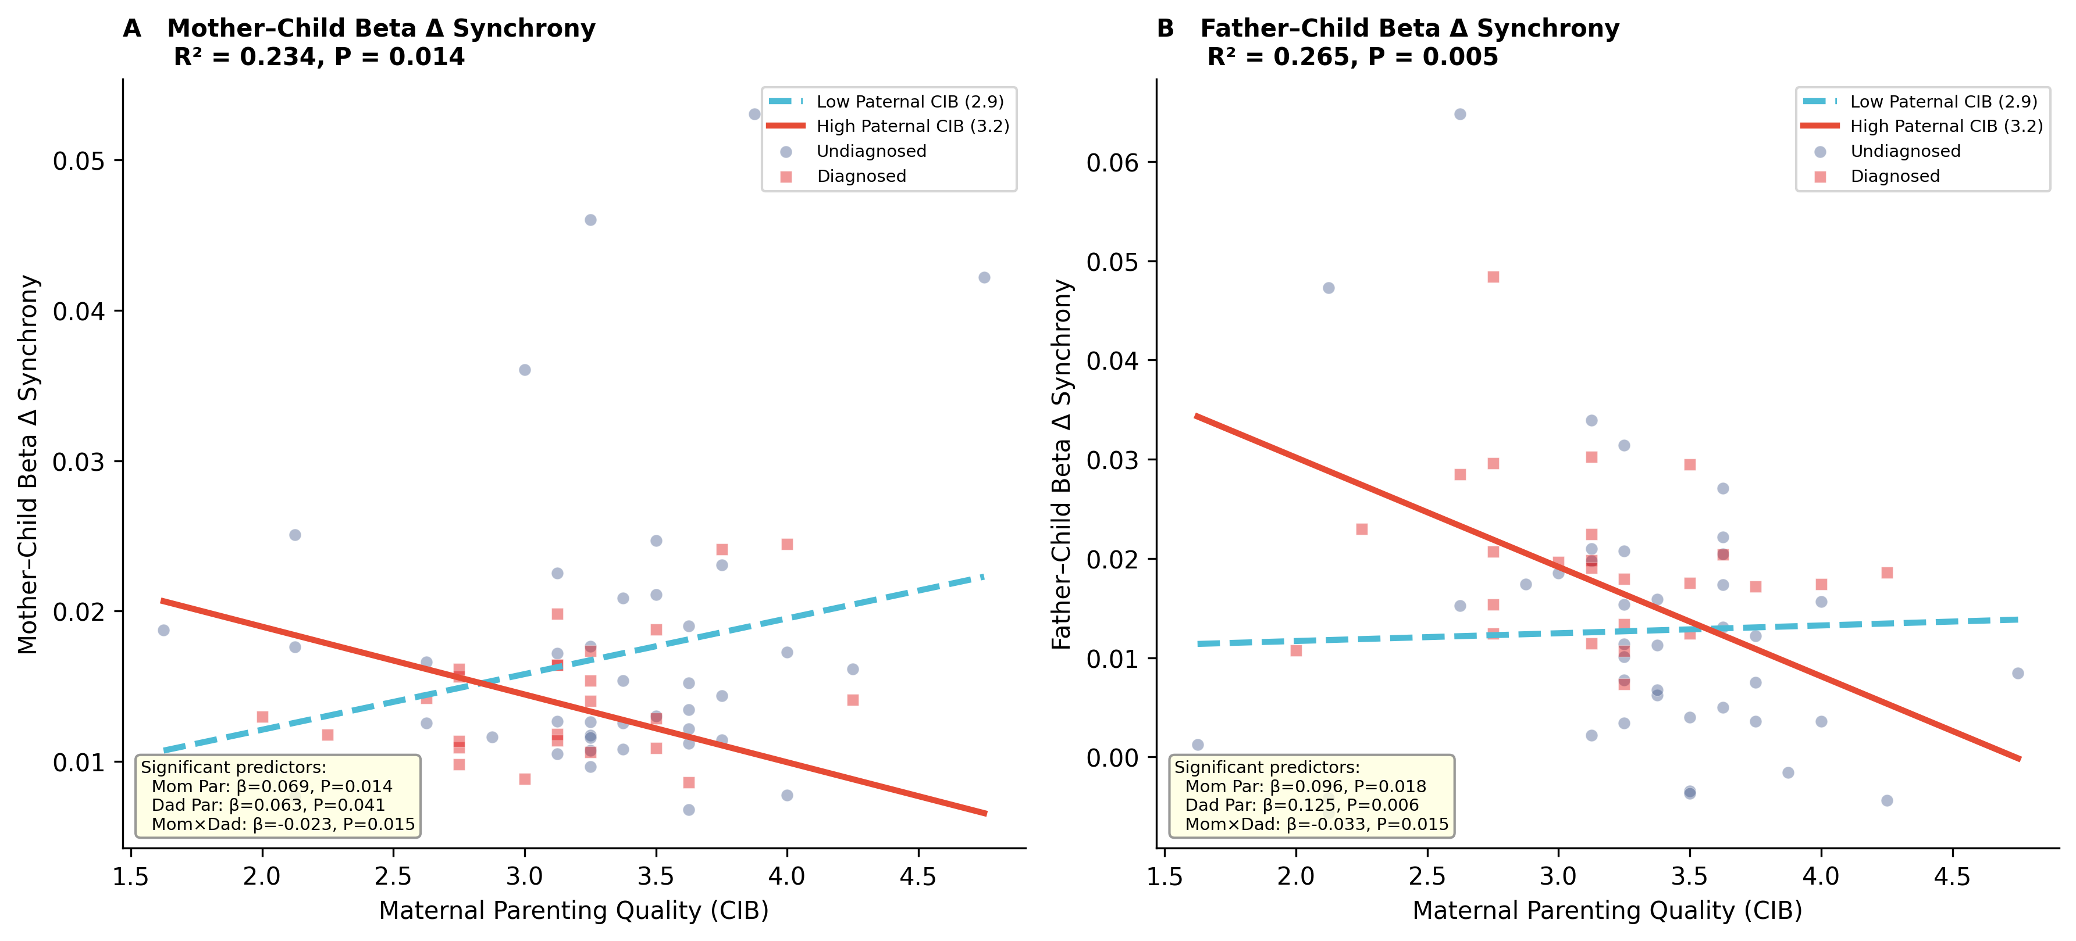
Supplementary Figure S7. Cross-parental modulation of neural synchrony (Mother Diagnosed analyses). (A) Mother–child beta Δ synchrony as a function of Maternal parenting quality, stratified by paternal parenting quality (median split). The significant Maternal × Paternal Parenting interaction (P = .015) indicates cross-parental modulation. (B) Father–child beta Δ synchrony showing the same cross-parental pattern (P = .015). Circles = undiagnosed mothers; squares = diagnosed mothers. Significant predictors from the full model are annotated in each panel.
These supplementary analyses confirm that the crossover interaction pattern and cross-parental brain–behavior modulation are not solely driven by Child Anxiety but also emerge when families are grouped by Maternal psychopathological diagnosis, consistent with a family systems interpretation in which Maternal mental health shapes the distribution of neural synchrony across parental subsystems.

Supplementary Analysis 3: Omnibus 2×2×2 Mixed ANOVA
To provide a unified statistical test incorporating both the validation of genuine inter-brain synchrony and the differential balance across parents and clinical groups, we conducted a 2×2×2 mixed-design repeated-measures ANOVA with Parent (mother–child, father–child) and Data Type (real dyads, surrogate data) as within-subjects factors and Child Anxiety (clinical, control) as a between-subjects factor. Data were available for N = 68 families where both parent–child dyads provided valid EEG data (25 control, 43 clinical).
Alpha Rhythm Synchrony. The main effect of Data Type was highly significant (F(1,66) = 145.21, P < 0.001, η²p = 0.68, 90% CI [0.57, 0.76]), confirming robust inter-brain synchrony beyond chance levels. Real dyads exhibited significantly higher alpha synchrony (M = 0.085, SD = 0.015) compared to surrogate controls (M = 0.071, SD = 0.007). The main effect of Child Anxiety was significant (F(1,66) = 15.80, P < 0.001, η²p = 0.19, 90% CI [0.07, 0.32]), with control dyads showing higher overall synchrony. A main effect of Parent emerged (F(1,66) = 6.59, P = 0.012, η²p = 0.09, 90% CI [0.01, 0.21]), with father–child dyads showing higher synchrony than mother–child dyads. No two-way or three-way interactions reached significance (all P > 0.08; see Supplementary Table S3).
Beta Rhythm Synchrony. Beta synchrony demonstrated even stronger evidence of genuine neural coupling. The main effect of Data Type was highly significant (F(1,66) = 209.03, P < 0.001, η²p = 0.75, 90% CI [0.67, 0.82]), with real dyads showing higher synchrony (M = 0.090, SD = 0.013) than surrogate controls (M = 0.074, SD = 0.008). Significant main effects emerged for Child Anxiety (F(1,66) = 12.25, P < 0.001, η²p = 0.15, 90% CI [0.04, 0.28]) and Parent (F(1,66) = 9.56, P = 0.003, η²p = 0.12, 90% CI [0.03, 0.25]). Critically, a significant three-way Parent × Data Type × Child Anxiety interaction emerged (F(1,66) = 6.11, P = 0.016, η²p = 0.085, 90% CI [0.01, 0.20]), indicating that parent-specific beta synchrony mechanisms differ fundamentally between clinical and typically developing populations. This three-way interaction subsumes and contextualizes the Parent × Child Anxiety interaction reported in the main text (see Supplementary Figure 8).

Supplementary Table S3. Omnibus 2×2×2 Mixed ANOVA Results
Alpha band (8–12 Hz):
Effect | F(1,66) | P | η²p | 90% CI
Data Type | 145.21 | <.001*** | .68 | [.57, .76]
Child Anxiety | 15.80 | <.001*** | .19 | [.07, .32]
Parent | 6.59 | .012* | .09 | [.01, .21]
Parent × Child Anxiety | 2.19 | .144 | .03 | [.00, .06]
Data Type × Child Anxiety | 0.10 | .751 | .00 | [.00, .00]
Parent × Data Type | 0.09 | .762 | .00 | [.00, .00]
Parent × Data Type × Child Anxiety | 3.06 | .085 | .04 | [.00, .09]

Beta band (13–30 Hz):
Effect | F(1,66) | P | η²p | 90% CI
Data Type | 209.03 | <.001*** | .76 | [.67, .82]
Child Anxiety | 12.25 | <.001*** | .16 | [.04, .28]
Parent | 9.56 | .003** | .13 | [.03, .25]
Parent × Child Anxiety | 0.78 | .381 | .01 | [.00, .02]
Data Type × Child Anxiety | 0.71 | .401 | .01 | [.00, .02]
Parent × Data Type | 0.10 | .754 | .00 | [.00, .00]
Parent × Data Type × Child Anxiety | 6.11 | .016* | .08 | [.01, .20]

Supplementary Table S3. Omnibus 2×2×2 Mixed ANOVA Results. 2×2×2 mixed-design repeated-measures ANOVA with Parent (mother–child, father–child) and Data Type (real, surrogate) as within-subjects factors and Child Anxiety (clinical, control) as between-subjects factor. N = 68 families. 90% CIs reported for η²p following standard practice for partial eta-squared. *P < .05; **P < .01; ***P < .001.

Supplementary Figure S8. Omnibus 2×2×2 Mixed ANOVA Results

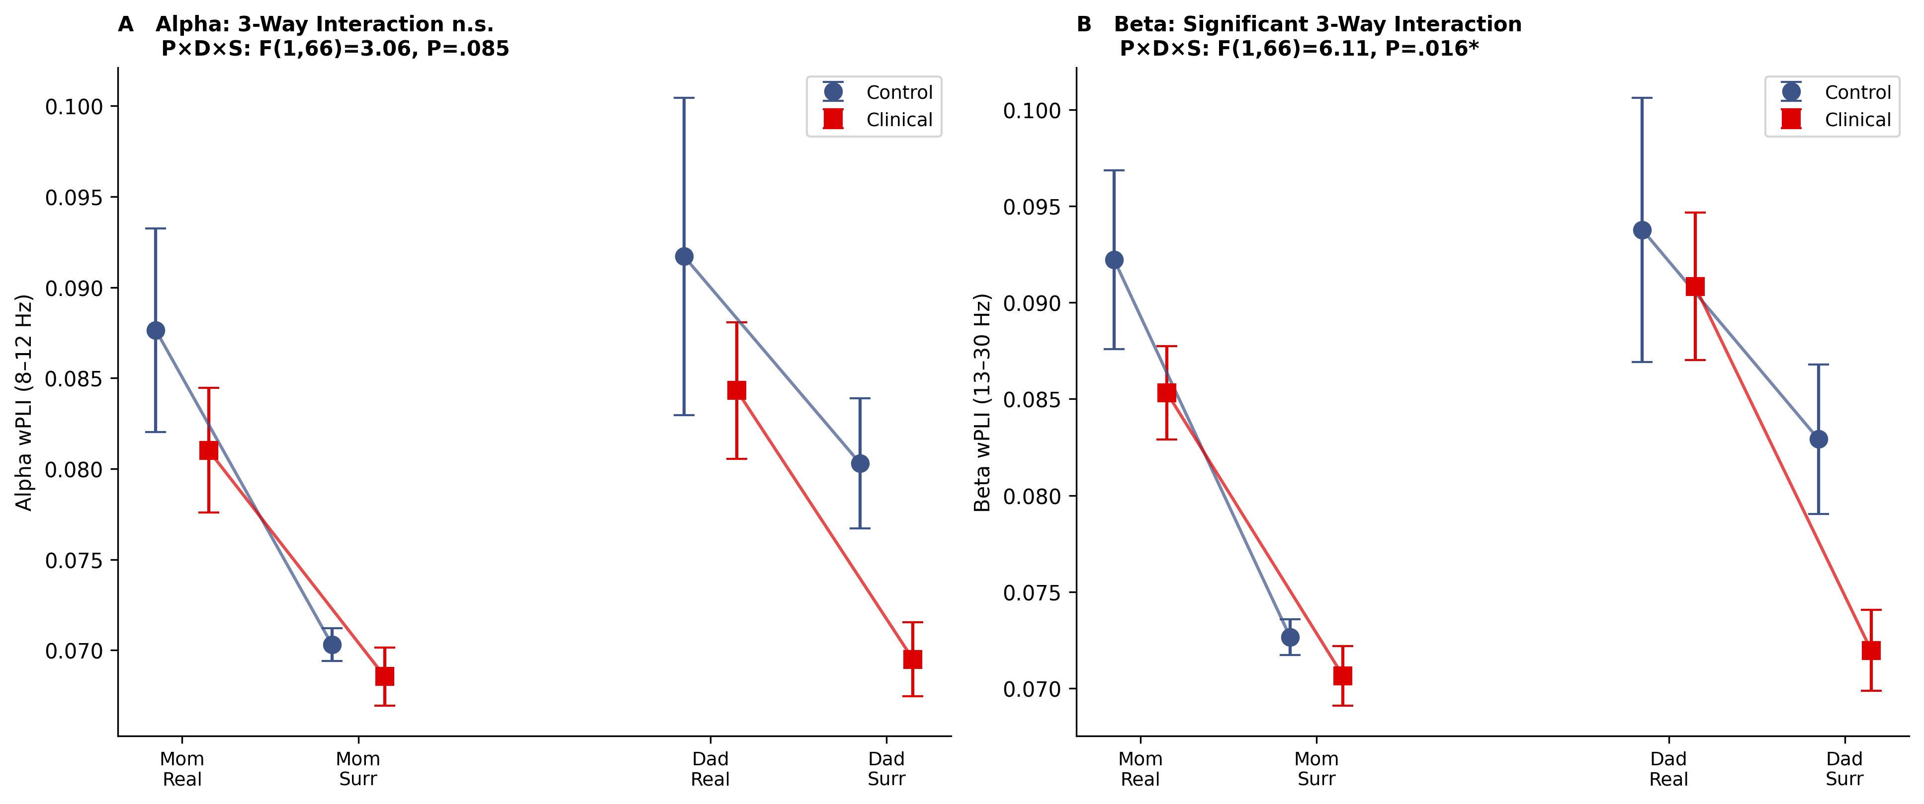
Supplementary Figure S8. Omnibus 2×2×2 mixed ANOVA results. (A) Alpha band synchrony showing real versus surrogate values for mother–child and father–child dyads by Child Anxiety group. The three-way interaction was marginal (P > .12). (B) Beta band synchrony showing the significant three-way Parent × Data Type × Child Anxiety interaction (P = .016), which subsumes the crossover pattern reported in the main text. Error bars represent 95% CIs.

Supplementary Sensitivity Analysis (S SA): Full Sample Without Outlier Exclusions
To assess the robustness of the primary findings, all analyses from Sections 2.1–2.2 were repeated on the full sample prior to applying the 2.5 SD outlier exclusion criterion. This sensitivity analysis includes 3 additional families in mother–child analyses and 2 additional families in father–child analyses that were excluded from the primary analyses due to extreme beta Δ synchrony values exceeding 2.5 SD above the group mean (z-scores ranging from 2.05 to 4.69).

S SA 1. Validation of Inter-Brain Synchrony (Full Sample)
All four validation tests confirmed robust inter-brain synchrony above surrogate levels (all p_{(FDR)}) < .001), with effect sizes comparable to the primary analysis.
Mother–child alpha (N = 74): Real M = 0.085, SD = 0.015; Surrogate M = 0.069, SD = 0.005; W = 2707, z = 7.11, p_{(FDR)} < .001, r_{rb} = 0.95, 95% CI [0.88, 1.00].
Mother–child beta (N = 74): Real M = 0.089, SD = 0.012; Surrogate M = 0.071, SD = 0.004; W = 2775, z = 7.47, p_{(FDR)} < .001, r_{rb} = 1.00, 95% CI [1.00, 1.00].
Father–child alpha (N = 75): Real M = 0.088, SD = 0.018; Surrogate M = 0.074, SD = 0.010; W = 2651, z = 6.47, p_{(FDR)} < .001, r_{rb} = 0.86, 95% CI [0.74, 0.95].
Father–child beta (N = 75): Real M = 0.093, SD = 0.017; Surrogate M = 0.076, SD = 0.010; W = 2772, z = 7.11, p_{(FDR)} < .001, r_{rb} = 0.95, 95% CI [0.88, 0.99].

S SA2. Mixed ANOVAs: Parent × Child Anxiety (Full Sample)
With the full sample (N = 72 families with complete data for both dyads; 27 control, 45 clinical), the 2×2 mixed ANOVAs were conducted with Parent (mother–child, father–child) as a within-subjects factor and Child Anxiety (control, clinical) as a between-subjects factor.
Alpha band: No significant effects emerged: Parent (F(1,70) = 0.13, P = .720, η²p = .002, 90% CI [.000, .048]), Child Anxiety (F(1,70) = 0.09, P = .760, η²p = .001, 90% CI [.000, .043]), nor their interaction (F(1,70) = 2.04, P = .158, η²p = .028, 90% CI [.000, .116]).
Beta band: The critical Parent × Child Anxiety interaction remained significant (F(1,70) = 6.11, P = .016, η²p = .080, 90% CI [.008, .193]), with no significant main effects of Parent (F(1,70) = 0.01, P = .926, η²p < .001, 90% CI [.000, .011]) or Child Anxiety (F(1,70) = 0.27, P = .604, η²p = .004, 90% CI [.000, .059]).

Supplementary Sensitivity Analysis - Table S-SA1. Mixed ANOVA results for alpha and beta Δ synchrony
Alpha Δ
Effect | F(1,70) | P | η²p | 90% CI
Parent Interaction (P) | 0.13 | .720 | .002 | [.000, .048]
Child Anxiety (S) | 0.09 | .760 | .001 | [.000, .043]
P × S | 2.04 | .158 | .028 | [.000, .116]

Beta Δ
Effect | F(1,70) | P | η²p | 90% CI
Parent Interaction (P) | 0.01 | .926 | <.001 | [.000, .011]
Child Anxiety (S) | 0.27 | .604 | .004 | [.000, .059]
P × S | 6.11* | .016 | .080 | [.008, .193]

Supplementary Sensitivity Analysis - Table S-SA1. Mixed ANOVA results for alpha and beta Δ synchrony (full sample, N = 72).

S SA3. Beta Band Interaction Decomposition (Full Sample)
Between-group comparison: The mother-minus-father Δ synchrony balance score was compared between Child Anxiety groups using a Mann-Whitney U test, as Shapiro-Wilk tests indicated significant non-normality in the control group (W = 0.90, P = .015; clinical: W = 0.98, P = .657). Control families showed a more positive balance (Mdn = 0.012) than clinical families (Mdn = −0.003), and this difference was highly significant: U = 309, z = 3.47, P < .001, r_{rb} = −0.49, 95% CI [−0.67, −0.26] (Supplementary Figure S-SA3).
Within-sample Wilcoxon signed-rank tests: FDR-corrected across the two comparisons (N = 72; 27 control, 45 clinical; Supplementary Figure S-SA2):
Control families (n = 27): Mother–child beta Δ synchrony (M = 0.021, SD = 0.015) was significantly greater than father–child (M = 0.013, SD = 0.022); W = 275, z = 2.07, p_{(FDR)} = .039, r_{rb} = 0.46, 95% CI [0.04, 0.83].
Clinical families (n = 45): Father–child beta Δ synchrony (M = 0.020, SD = 0.012) was significantly greater than mother–child (M = 0.016, SD = 0.009); W = 282, z = −2.66, p_{(FDR)} = .014, r_{rb} = −0.46, 95% CI [−0.73, −0.14].
All key findings were replicated in the full sample without outlier exclusions (see S SA4. Comparison of Primary and Full-Sample Results). The Parent × Child Anxiety interaction on beta Δ synchrony remained significant (P = .016), and the double dissociation pattern was confirmed: in control families, mother–child synchrony exceeded father–child synchrony (p_{(FDR)} = .039); in clinical families, this pattern reversed (p_{(FDR)} = .014). The between-group comparison of the mother-minus-father balance score was highly significant using the Mann-Whitney U test (P < .001), which was adopted because of the non-normal distribution of control-group difference scores (driven by extreme values in the unexcluded families) violated the assumptions of parametric tests. Effect sizes were therefore attenuated relative to the primary analysis (η²p = .080 vs. .161), because of the influence of statistical outliers on parametric effect size estimates. Notably, the direction and significance of all findings were preserved, confirming the robustness of the results reported in the main analyses.

S SA4. Comparison of Primary and Full-Sample Results
Supplementary Sensitivity Analysis - Table S-SA2. Comparison of key statistics.
Statistic | Primary (N = 68; n = 25, 43) | Full sample (N = 72; n = 27, 45)
ANOVA P × Child Anxiety | F(1,66) = 12.68, P < .001 | F(1,70) = 6.11, P = .016
η²p [90% CI] | .161 [.05, .29] | .080 [.008, .193]
Between-group test | Welch’s t(29.9) = 2.98, P = .006 | Mann-Whitney U = 309, P < .001
Between-group effect size | d = 0.81 [−1.34, −0.27] | r_{rb} = −0.49 [−0.67, −0.26]
Control: Mom > Dad | r_{rb} = 0.53 [0.13, 0.88], p_{(FDR)} = .019 | r_{rb} = 0.46 [0.04, 0.83], p_{(FDR)} = .039
Clinical: Dad > Mom | r_{rb} = −0.49 [−0.76, −0.18], p_{(FDR)} = .008 | r_{rb} = −0.46 [−0.73, −0.14], p_{(FDR)} = .014

Supplementary Sensitivity Analysis - Table S-SA2. Primary analysis used Welch’s t-test for the between-group comparison (Shapiro-Wilk normality confirmed, both P > .13). Full-sample analysis used the Mann-Whitney U test due to significant non-normality in the control group (Shapiro-Wilk p = .015). Effect sizes are Cohen’s d (primary; 95% CI from noncentral t-distribution) and rank-biserial r_{rb} (full sample; 95% CI analytic). Within-sample r_{rb} 95% CIs were obtained via bias-corrected bootstrap (10,000 iterations). 90% CIs are reported for η²p, following convention for ANOVA effect sizes.

Supplementary Sensitivity Analysis Figure S-SA1
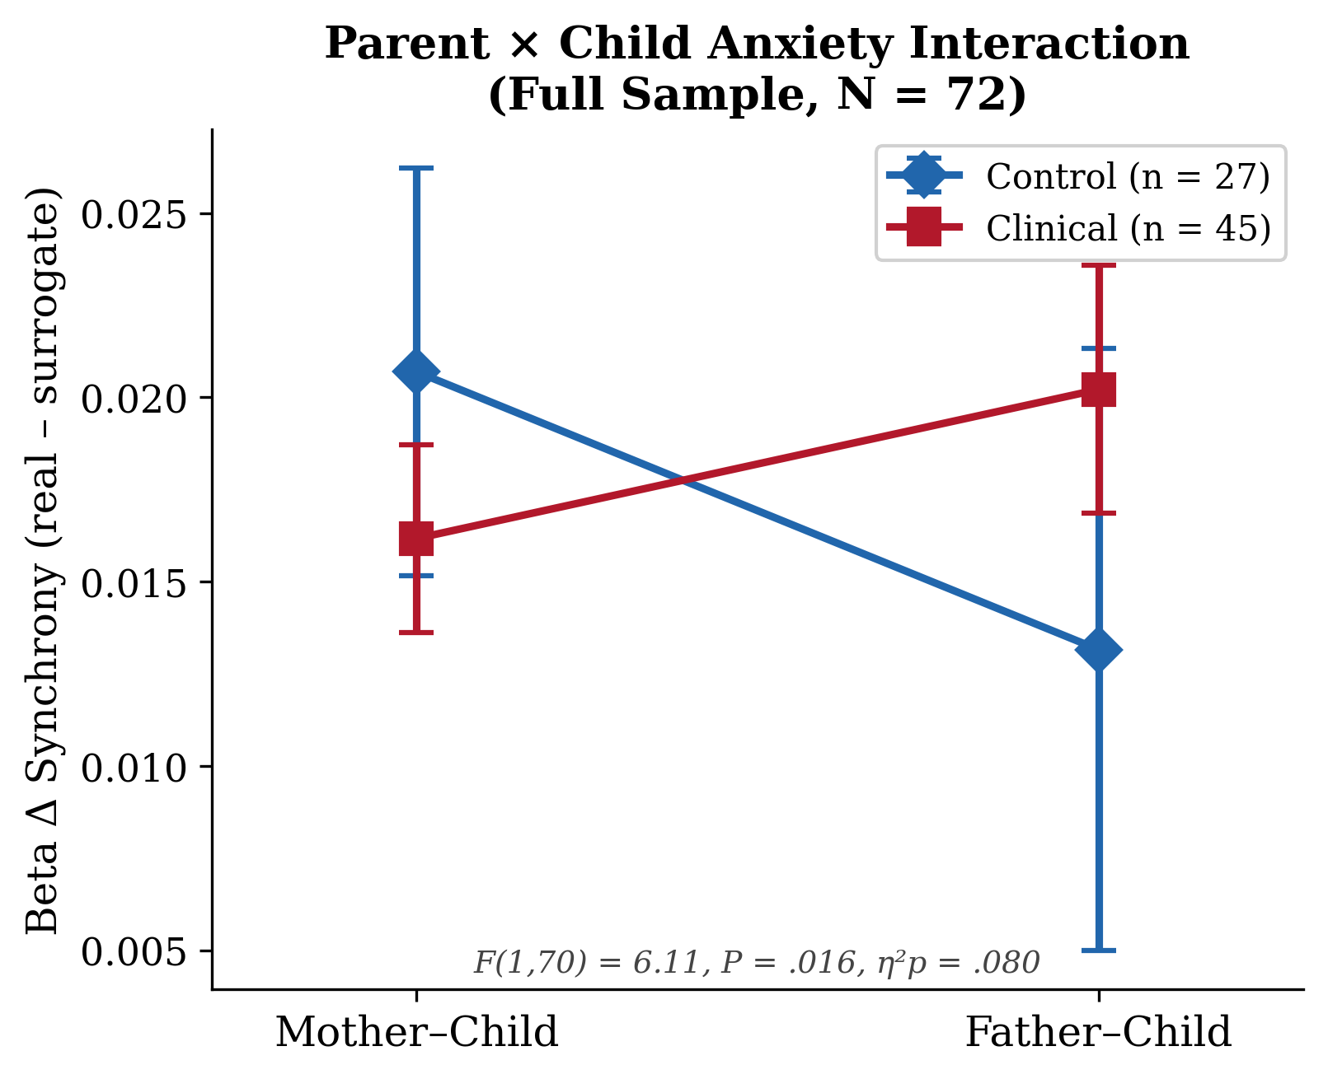
Supplementary Sensitivity Analysis Figure S-SA1. Crossover interaction plot for beta Δ synchrony in the full sample (N = 72). Diamonds represent group means ± 95% CIs. In control families, mother–child synchrony exceeds father–child synchrony; in clinical families, this pattern reverses. The Parent × Child Anxiety interaction remained significant (F(1,70) = 6.11, p = .016, η²p = .080).

Supplementary Sensitivity Analysis Figure S-SA2
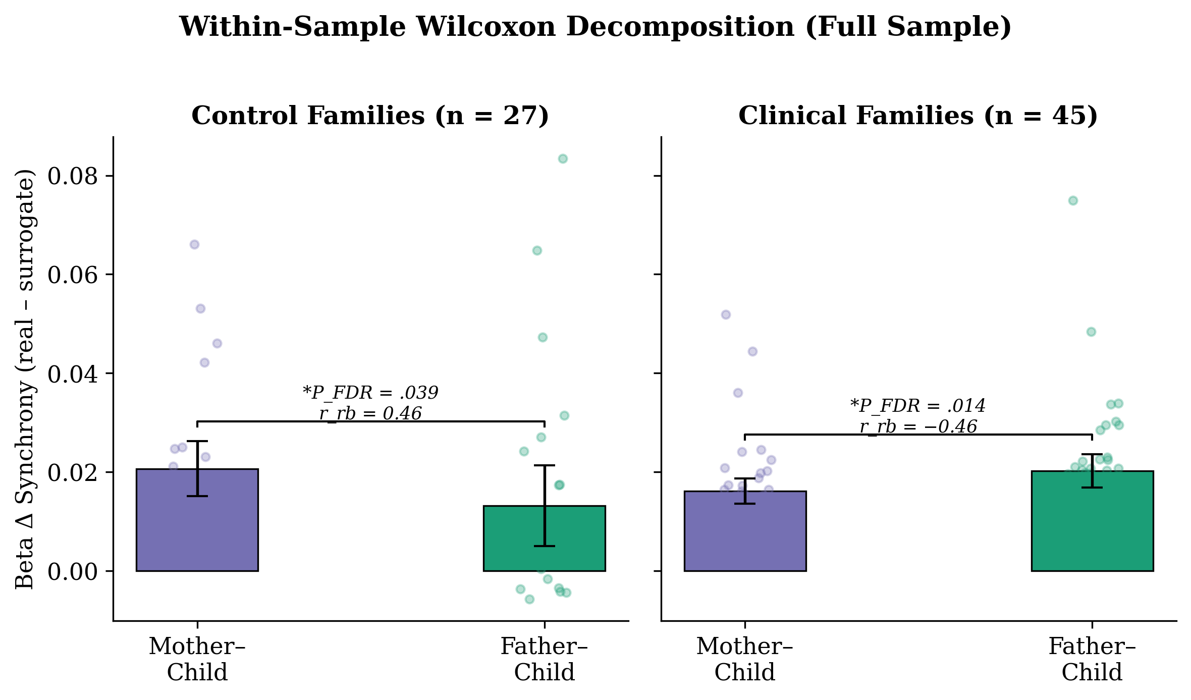
Supplementary Sensitivity Analysis Figure S-SA2. Within-sample Wilcoxon decomposition of the beta Δ synchrony interaction in the full sample. Bars represent group means ± 95% CIs; individual data points shown in the background. Control families: mothers > fathers (p_{(FDR)} = .039, r_{rb} = 0.46). Clinical families: fathers > mothers (p_{(FDR)} = .014, r_{rb} = −0.46).

Supplementary Sensitivity Analysis Figure S-SA3
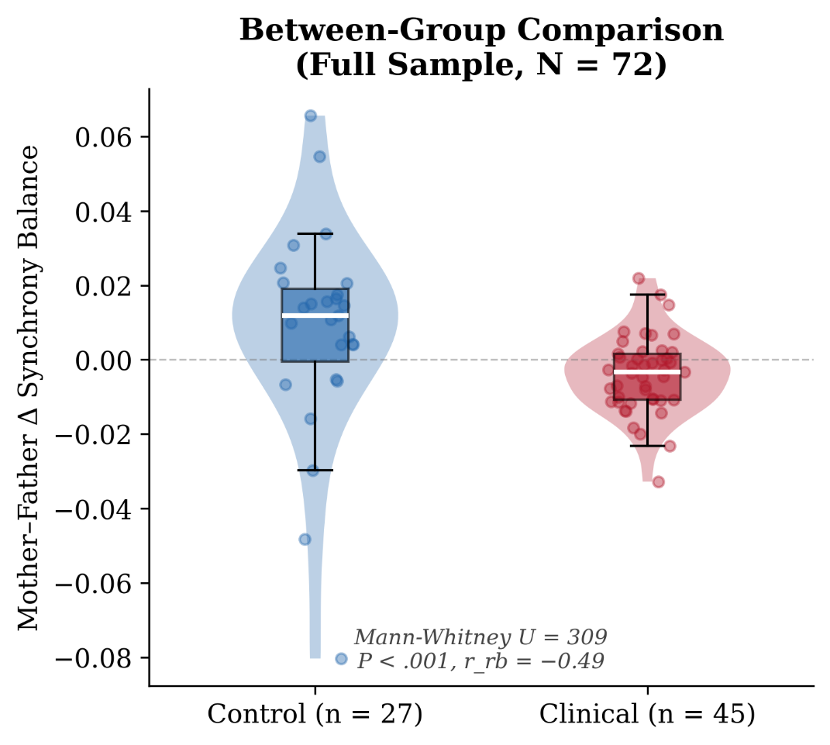
Supplementary Sensitivity Analysis Figure S-SA3. Between-group comparison of the mother-minus-father Δ synchrony balance score in the full sample (N = 72). Violin plots show the distribution; box plots show median and IQR; individual data points overlaid. Positive values indicate mother-child greater synchrony; negative values indicate father-child greater synchrony. The dashed line marks zero (equal balance). Mann-Whitney U = 309, P < .001, r_{rb} = −0.49.

