Supplementary Figure S1. Flowchart of patient selection.

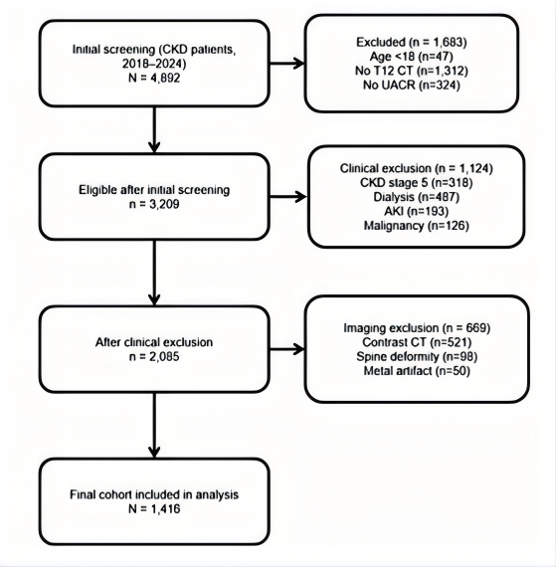

Supplementary Table S1. Sensitivity Analysis: Association between Visceral Fat Density and SMI-defined Sarcopenia

Models | Variables | Odds Ratio (95% CI) | P-value
Model 1 (Crude) | Visceral fat density (HU) | 1.241 (1.131 - 1.369) | <0.001
Model 2 (Adjusted for eGFR) | Visceral fat density (HU) | 1.129 (1.114 - 1.228) | <0.001
Model 3 (Adjusted for eGFR, UACR stages) | Visceral fat density (HU) | 1.116 (1.097 - 1.135) | 0.002
Notes: SMI, skeletal muscle index; CI, confidence interval; eGFR, estimated glomerular filtration rate; HU, Hounsfield units; UACR, urinary albumin-to-creatinine ratio.
In this sensitivity analysis, the dependent variable (sarcopenia) was re-defined according to the skeletal muscle index (SMI) at the T12 level. Binary logistic regression was performed to predict SMI-defined sarcopenia. Model 1 is an unadjusted crude model. Model 2 is adjusted for eGFR. Model 3 is further adjusted for eGFR and UACR stages (A1-A3).

