Supplementary files
- Analytical performance of the RLEP qPCR
The performance of the RLEP qPCR assay was evaluated across multiple runs to assess its reproducibility and analytical sensitivity. For each run, the amplification efficiency (as determined using the Bio-Rad CFX96 Real-Time PCR System thermocycler) was approximately 90%, with an R² value consistently close to 1 and a y-intercept around 40, indicating a strong linear correlation between the Ct values and the logarithm of DNA concentration (Supplementary files: Table S1). The assay demonstrated a detection limit of 0.00312 pg of M. leprae DNA (Supplementary files: Table S2), consistent with the results reported by Martinez et al. (2009).
- Table S1: qPCR descriptors extracted from linear regression of the Ct values vs. log of M. leprae DNA for the four amplification runs
qPCR | Efficiency | R² | Slope | Y-intercept
Run1 | 95.8 | 0.96 | - 3.43 | 40.10
Run2 | 90.2 | 0.89 | - 3.45 | 39.29
Run3 | 94.5 | 0.96 | - 3.46 | 42.08
Run4 | 89.8 | 0.99 | - 3.59 | 41.83

- Table S2: Average Ct values of six M. leprae DNA diluted solutions
[RLEP] copy number | Ct | M. leprae DNA (pg)
3.10⁶ | 17.7 ± 1.5 | 312
3.10⁵ | 21.6 ± 2.0 | 31.2
3.10⁴ | 24.3 ± 1.3 | 3.12
3.10³ | 29.2 ±1.4 | 0.312
3.10² | 32.5 ± 0.5 | 0.0312
30 | 36.2 ± 0.8 | 0.00312

Table S3: Molecular and serological results for leprosy patients.
 |  |  | RLEP qPCR
ID | Months of MDT before sampling | WHO  classification | biopsy |  | nasal swab |  |  | PGL-I IgM
ID | Months of MDT before sampling | WHO  classification | Ct | Result | Ct |  | Result
9023 | 6 | MB | 14.01 | pos | 27.78 |  | pos | 0.09
9018 | 8 | MB | 14.27 | pos | 28.96 |  | pos | NA
9013 | 6 | MB | 16.6 | pos | 33.35 |  | pos | 3.59
9080 | 7 | MB | 21.58 | pos | ND |  | neg | NA
9068 | 0 | MB | 24 | pos | NA |  | NA | NA
9009 | 0 | MB | 25.32 | pos | 31.03 |  | pos | 0.04
9021 | 6 | MB | 26.99 | pos | ND |  | neg | 0.02
9048 | 4 | MB | 27.33 | pos | NA |  | NA | 1.29
9028 | 5 | MB | 29.69 | pos | ND |  | neg | 0.76
9026 | 6 | PB | 29.71 | pos | ND |  | neg | 0.01
9017 | 8 | MB | 29.96 | pos | ND |  | neg | 0.06
9032 | 5 | PB | 30.24 | pos | ND |  | neg | 0.01
9001 | 7 | MB | 30.82 | pos | ND |  | neg | 0.04
9002 | 7 | MB | 30.83 | pos | ND |  | neg | 0.21
9020 | 6 | PB | 31.16 | pos | ND |  | neg | 0.04
9037 | 4 | PB | 31.54 | pos | ND |  | neg | NA
9039 | 4 | MB | 31.8 | pos | ND |  | neg | 0.09
9016 | 6 | PB | 31.84 | pos | ND |  | neg | 0.08
9051 | 4 | PB | 32.08 | pos | NA |  | NA | NA
9052 | 7 | MB | 32.09 | pos | NA |  | NA | NA
9006 | 6 | MB | 32.41 | pos | ND |  | neg | 0.14
9005 | 7 | PB | 32.75 | pos | ND |  | neg | 0.18
9019 | 8 | MB | 32.82 | pos | ND |  | neg | 0.04
9081 | 0 | PB | 33.25 | pos | ND |  | neg | NA
9082 | 0 | MB | 33.3 | pos | ND |  | neg | NA
9044 | 4 | PB | 34.91 | pos | ND |  | neg | 0.13
9010 | 5 | MB | 36.38 | pos | ND |  | neg | 0.01
9000 | 9 | PB | 36.59 | pos | ND |  | neg | 0.03
9073 | 4 | MB | NA | NA | ND |  | neg | 1.31
9015 | 6 | PB | ND | neg | ND |  | neg | 0.01
9003 | 7 | MB | ND | neg | ND |  | neg | 0.05
9043 | 3 | PB | ND | neg | ND |  | neg | 0.12
9004 | 7 | MB | ND | neg | ND |  | neg | 0.18
9012 | 5 | PB | ND | neg | ND |  | neg | 0.20
9041 | 6 | MB | NA | NA | ND |  | neg | 0.01
9031 | 5 | MB | NA | NA | ND |  | neg | 0.02
9046 | 5 | MB | NA | NA | ND |  | neg | 0.02
9011 | 5 | PB | NA | NA | ND |  | neg | 0.02
9036 | 4 | MB | NA | NA | ND |  | neg | 0.03
9035 | 4 | PB | NA | NA | ND |  | neg | 0.03
9079 | 5 | MB | NA | NA | ND |  | neg | 0.03
9049 | 4 | MB | NA | NA | ND |  | neg | 0.04
9014 | 6 | PB | NA | NA | ND |  | neg | 0.04
 |  |  | RLEP qPCR
ID | Months of MDT before sampling | WHO  classification | biopsy |  | Nasal swab |  |  | PGL-I IgM
ID | Months of MDT before sampling | WHO  classification | Ct | Result | Ct | Result |  | Ratio (R)
9047 | 4 | MB | NA | NA | ND | neg |  | 0.05
9045 | 5 | PB | NA | NA | ND | neg |  | 0.05
9007 | 6 | PB | NA | NA | ND | neg |  | 0.05
9022 | 6 | PB | NA | NA | ND | neg |  | 0.06
9042 | 3 | PB | NA | NA | ND | neg |  | 0.08
9078 | 4 | PB | NA | NA | ND | neg |  | 0.08
9029 | 6 | MB | NA | NA | ND | neg |  | 0.18
9025 | 6 | PB | NA | NA | ND | neg |  | 0.19
9033 | 5 | PB | NA | NA | ND | neg |  | 0.20
9030 | 6 | PB | NA | NA | ND | neg |  | 0.36
9024 | 6 | MB | NA | NA | ND | neg |  | 0.98
9034 | 5 | PB | NA | NA | ND | neg |  | 0.21
9038 | 4 | MB | NA | NA | ND | neg |  | NA
9027 | 6 | MB | NA | NA | ND | neg |  | NA
9076 | 9 | MB | NA | NA | ND | neg |  | NA
9077 | 9 | PB | NA | NA | ND | neg |  | NA
9074 | 10 | PB | NA | NA | ND | neg |  | NA
9075 | 10 | PB | NA | NA | ND | neg |  | NA

Data are provided by Ct value in ascending order; NA: not applicable (no samples available as patients did not give consent); pos: positive; neg: negative; MB: multibacillary; PB: paucibacillary; Ct: Cycle threshold and ND: not determined. WHO: World Health Organization; MDT: Multi-drug therapy. R: ratio between the fluorescence signal measured at the test line and at the flow control line on the UCP-LFA test strip.Patients who were seropositive for anti-PGL-I IgM are indicated in bold.
Table S4. Sequencing data: detection of DNA mutations in M. leprae conferring antibiotic resistance and genotyping using 3 techniques Line Probe Assay, Sanger Sequencing and Deeplex Myc-Lep (wt: wild type, nd: not done; ud: undetermined, ML: M. leprae)
ID | Ct RLEP | GenoType  LepraeDR |  |  | Sanger Sequencing |  |  |  | Deeplex Myc-Lep |  |  |  |  |  |  |  |  | Genotypes
ID | Ct RLEP | rpoB | folP1 | gyrA | rpoB | folP1 | gyrA | ml2446 | hsp65 | ctpC | ctpI | folP1 | gyrA | gyrB | nth | ribD | rpoB
9023 | 14.01 | wt | wt | wt | wt | wt | wt | a1015g | ML | wt | wt | wt | wt | wt | wt | wt | wt | 1D Malagasy
9018 | 14.27 | wt | wt | wt | wt | wt | wt | a1015g | ML | wt | wt | wt | wt | wt | wt | wt | wt | 1D Malagasy
9013 | 16.6 | wt | wt | wt | wt | wt | wt | a1015g | ML | wt | wt | wt | wt | wt | wt | wt | wt | 1D Malagasy
9068 | 24.03 | wt | wt | wt | wt | wt | wt | a1015g | ML | wt | wt | wt | wt | wt | wt | ud | wt | 1D Malagasy
9009 | 25.32 | wt | wt | wt | wt | wt | wt | a1015g | ML | wt | wt | wt | wt | wt | wt | wt | wt | 1D Malagasy
9021 | 26.99 | ud | ud | ud | ud | ud | ud | a1015g | ML | wt | wt | wt | wt | Wt | wt | ud | wt | 1D Malagasy
9048 | 27.33 | wt | wt | wt | wt | wt | wt | a1015g | ud | wt | wt | wt | wt | ud | wt | ud | wt | 1D Malagasy
9028 | 29.69 | ud | ud | ud | ud | ud | ud | a1015g | ML | wt | wt | ud | wt | ud | ud | ud | wt | 1D Malagasy
9026 | 29.71 | ud | ud | ud | ud | ud | ud | a1015g | ud | wt | wt | ud | wt | ud | ud | ud | wt | 1D Malagasy
9017 | 29.96 | ud | ud | ud | ud | ud | ud | ud | ud | ud | wt | wt | wt | ud | ud | ud | wt | 1D Malagasy
9032 | 30.24 | ud | ud | ud | ud | ud | ud | ud | nd | nd | nd | nd | nd | nd | nd | nd | nd | ud
9001 | 30.82 | ud | ud | ud | ud | ud | ud | ud | nd | nd | nd | nd | nd | nd | nd | nd | nd | ud
9002 | 30.83 | ud | ud | ud | ud | ud | ud | ud | nd | nd | nd | nd | nd | nd | nd | nd | nd | ud
9020 | 31.16 | wt | wt | wt | wt | wt | wt | a1015g | nd | nd | nd | nd | nd | nd | nd | nd | nd | 1D Malagasy
9037 | 31.54 | ud | ud | ud | ud | ud | ud | ud | nd | nd | nd | nd | nd | nd | nd | nd | nd | ud
9039 | 31.8 | ud | ud | ud | ud | ud | ud | ud | nd | nd | nd | nd | nd | nd | nd | nd | nd | ud
9016 | 31.84 | ud | ud | ud | ud | ud | ud | ud | nd | nd | nd | nd | nd | nd | nd | nd | nd | ud
9051 | 32.08 | ud | ud | ud | ud | ud | ud | ud | nd | nd | nd | nd | nd | nd | nd | nd | nd | ud
9052 | 32.09 | ud | ud | ud | ud | ud | ud | ud | nd | nd | nd | nd | nd | nd | nd | nd | nd | ud
9006 | 32.41 | ud | ud | ud | ud | ud | ud | ud | nd | nd | nd | nd | nd | nd | nd | nd | nd | ud
9005 | 32.75 | ud | ud | ud | ud | ud | ud | ud | nd | nd | nd | nd | nd | nd | nd | nd | nd | ud
9019 | 32.82 | wt | wt | wt | wt | wt | wt | a1015g | nd | nd | nd | nd | nd | nd | nd | nd | nd | 1D Malagasy
9082 | 33.3 | wt | wt | wt | wt | wt | wt | ud | nd | nd | nd | nd | nd | nd | nd | nd | nd | ud
9044 | 34.91 | ud | ud | ud | ud | ud | ud | ud | nd | nd | nd | nd | nd | nd | nd | nd | nd | ud
9010 | 36.38 | ud | ud | ud | ud | ud | ud | ud | nd | nd | nd | nd | nd | nd | nd | nd | nd | ud
9000 | 36.59 | ud | ud | ud | ud | ud | ud | ud | nd | nd | nd | nd | nd | nd | nd | nd | nd | ud

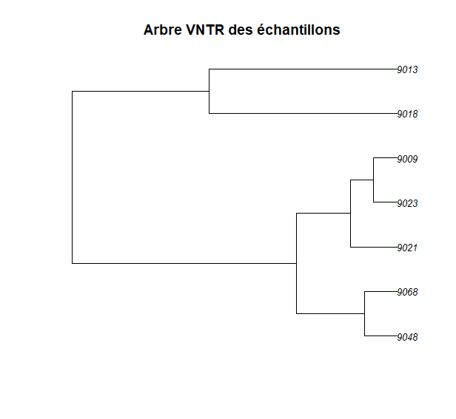
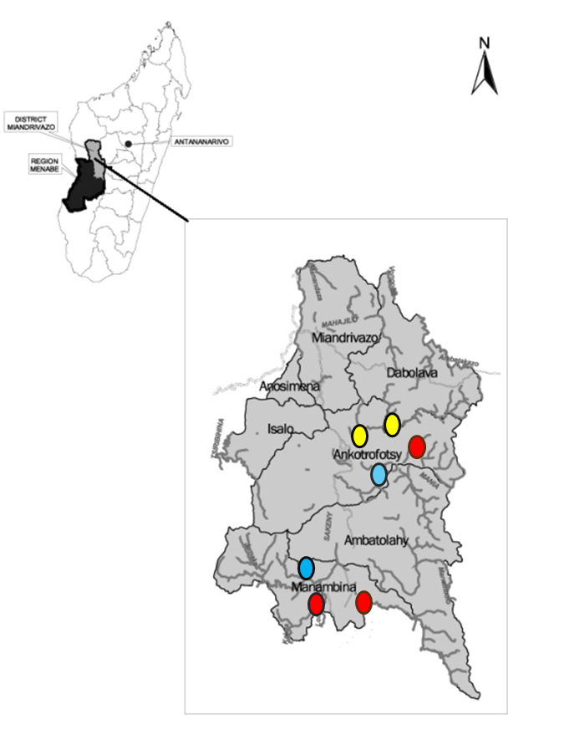
Figure 1A: Distribution of VNTR-based phylogenetic clusters across the Miandrivazo district (2018-2023)
Figure 1B: VNTR-based phylogenetic relationships between samples

Table S5: Biological sampling of the 80 leprosy patients detected from 2019 to 2021 in the PEOPLE study.
Clinicals signs |  | RLEP qPCR  skin biopsy  (n=33) |  |  | RLEP qPCR  nasal swab  (n=57) |  |  | anti-PGL I IgM  fingerstick blood  (n=47)
 |  | N_{Sampled} | pos | neg | N_{Sampled} | pos | neg | N_{Sampled} | Seropos | Seroneg
MB (41) | dMB (24) | 18 | 17 | 1 | 17 | 5 | 12 | 14 | 4 | 10
MB (41) | nMB (17) | 2* | 1 | 1 | 13 | 0 | 13 | 11 | 1 | 10
PB (39) | dPB (31) | 13 | 10 | 3 | 23 | 0 | 23 | 19 | 0 | 19
PB (39) | nPB (8) | 0 | 0 | 0 | 4 | 0 | 4 | 3 | 1 | 2
Total (80) |  | 33 | 28 | 5 | 57 | 5 | 52 | 47 | 6 | 41

neg: negative and pos: positive; d: dermatological; n: neural; MB: multibacillary; PB: paucibacillary /* For these two pure neural leprosy cases without skin lesions, nerve-level skin biopsies were performed at the top of the knee with patient consent, in line with national guidelines, although this procedure was not originally specified in the PEOPLE protocol.

