Evaluation of 5,6-cellulosene as a synthon for thiol–ene chemistry: NMR and computational study
Electronic supplementary material

Magdalena Dryś,^{[a,b]} Tetyana V. Koso,^{[c]} Tom Wirtanen,^{[c]} Katja T. Rinne-Garmston,^{[b]} Andrés Mollar-Cuni,^{[a]} Ilkka Kilpeläinen,^{[a]} Philipp Pracht,^{[d]} and Alistair W. T. King*^{[c]}

^{[a]} Department of Chemistry, Faculty of Science, University of Helsinki, A.I. Virtasen aukio 1, Helsinki, 00560 Finland
^{[b]} Stable Isotope Laboratory of Luke (SILL), Natural Resources Institute Finland (Luke), Latokartanonkaari 9, Helsinki, 00790 Finland
^{[c]} VTT Technical Research Centre of Finland Ltd, FutureHub 3, Tekniikantie 21, Espoo, 02150 Finland
^{[d]} Interdisciplinary Center for Scientific Computing (IWR), Heidelberg University, Im Neuenheimer Feld 205, 69120 Heidelberg, Germany

* Corresponding author: alistair.king@vtt.fi

Contents
1. Solubility of Eastman Cellulose Acetate CA320S 3
2. Chlorination vs formylation of CA with MsCl in DMF 3
Reaction mechanism of regioselective chlorination of CA with MsCl in DMF vs competitive formylation 3
Chlorination with MsCl and DMF performed in GVL as reaction medium 5
General procedure 5
Discussion 5
NMR spectra and assignments 7
3. Iodination in 2,5-hexanedione vs other dipolar aprotic solvents 10
General procedure 10
NMR spectra and assignments 10
4. Reactions of CA with DBU 11
Considering possible deacetylation mechanisms reported in the literature 11
Experimental details for the treatment of CA with DBU 12
Quantitative ¹³C NMR analysis 12
Comments on the previously-postulated DBU-induced deacetylation vs experimental results 13
Discussion regarding transacetylation/acetyl migration 14
NMR spectra and assignments 14
5. Degradation of 5,6-ene-CA in water at elevated temperatures 15
Computational details 15
Experimental NMR data 16
Calculated NMR data 17
Possible mechanisms for water additions at positions C1, C5 and C6 17
Speculative fragmentation mechanism 18
6. Radical-mediated thiol–ene reactions under different conditions 18
General procedure 18
NMR spectra, assignments and discussion 18
7. Estimating conversion to the thioether by quantitative ¹H-¹³C HSQC NMR 19
8. NMR pulse programs and parameters 20
9. NMR signal assignments for CA and CA-derivatives 21
Supplementary references 21

Solubility of Eastman Cellulose Acetate CA320S
The relation between structure and solubility of cellulose derivatives is extremely valuable for further processing and/or applications (Heinze, Koschella, and Liebert 2006). In this context, we compared solubilities of cellulose acetate with reduced hydroxyl content at C6 (CA) with the solubility of the obtained derivatives, synthesized from CA (Table S1). Compared with the starting material (CA), 6-Cl-CA and 6-I-CA are characterized by better solubility across different organic solvents. Likewise, 5,6-ene-CA exhibits similar solubility, except for acetone and acetonitrile; further, 5,6-ene-CA was partially soluble in water under prolonged stirring at 100 °C.
Table S1 Solubility of CA and synthesized CA derivatives in selected organic solvents and water, tested at 1% w/v concentration.
Solvent | bp (°C) | CA | 6-Cl-CA | 6-I-CA | 5,6-ene-CA
Water | 100 | - | - | - | †
Ethanol | 78 | - | - | - | -
Acetone | 56 | - | + | + | (-)
Acetonitrile | 81 | - | + | + | (-)
γ-Valerolactone (GVL) | 205 | + | + | + | +
Dimethyl sulfoxide (DMSO) | 189 | + | + | + | +
Cyrene (dihydrolevoglucosenone) | 226 | + | + | + | +
N,N-Dimethylacetamide (DMA) | 164 | + | + | + | +
N,N-Dimethylformamide (DMF) | 153 | + | + | + | +
Tetrahydrofuran (THF) | 66 | - | + | + | +
Pyridine | 115 | + | + | + | +
Chloroform | 61 | - | - | - | -
2,5-Hexanedione | 191 | + | + | + | +
+, soluble at RT; (-), partially soluble at 50 °C; †, partially soluble at 100 °C; -, insoluble. Colour coding adopted from GSK Solvent Sustainability Guide (Alder et al. 2016): red, major known issues; yellow, some known issues; green, few known issues; grey, no data.
In addition, CA was tested in the following ‘green’ solvents: anisole (bp 154 °C), cyclohexanone (bp 155 °C), ethyl acetate (bp 77 °C), methyl isobutylketone (MIBK) (bp 117 °C), and sulfolane (bp 285 °C). CA only dissolved in sulfolane, at 50 °C (sulfolane is solid at RT, mp 20-26 °C). We are currently investigating sulfolane a possible ‘green’ reaction medium for the preparation of 5,6-cellulosene from CA.

Chlorination vs formylation of CA with MsCl in DMF

Reaction mechanism of regioselective chlorination of CA with MsCl in DMF vs competitive formylation
Gao, Liu, and Edgar (2018) noted that the reaction of technical CA (with reduced 6-OH availability) with MsCl in DMF yields mainly 6-chlorinated species, with minor formation of 6-formate appendages, apparent in ¹H and ¹³C NMR data. Similarly, in our ME-HSQC data, the formation of the 6-formate species was also noted (Fig. S1b). Further, the diffusion-edited ¹H experiment confirmed that the formate appendages are covalently attached to the polymer backbone, rather than physisorbed due to insufficient purification.
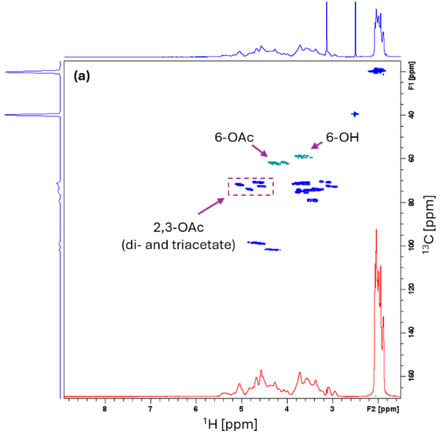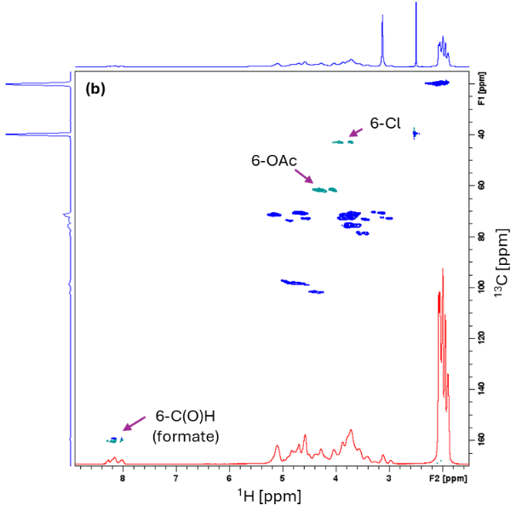
Fig. S1 ME-HSQC NMR spectra of (a) CA with reduced hydroxyl availability at C6, and (b) 6-Cl-CA. The standard ¹H spectrum is presented as the top horizontal projection, whereas the diffusion-edited ¹H spectrum is presented as the bottom horizontal projection.

The competitive formation of 6-chloro vs 6-formate species, in reactions involving alcohols, under the applied conditions (MsCl, DMF) is explained by the reaction mechanism, summarized as follows. The formylation/chlorination both involve the formation of a N,N-formiminium chloride (Vilsmeier intermediate) from DMF and MsCl (Scheme S1). The chlorination reaction follows the S_{N}2 pathway, which offers regioselectivity at position 6 bearing the primary hydroxyl group (displacement of the secondary 2- and 3-OH groups is restricted by the required inversion of the glucose ring). However, under alcoholytic conditions (where cellulose OH is the alcohol), the reactive Vilsmeier intermediate affords the formate ester (and ammonium salt byproduct), as occurs in the Vilsmeier-Haack formylation (Scheme S2).

Scheme S1 Chlorination of cellulose in MsCl/DMF, adapted from Gao, Liu, and Edgar (2018). Note that the cellulose intermediate under anhydrous conditions gives the corresponding alkyl chloride and under hydrolytic conditions yields the formate ester with ammonium salt (Khan and D'Souza 1994).

Scheme S2 Formylation mechanism, adapted from Khan and D'Souza (1994).

Chlorination with MsCl and DMF performed in GVL as reaction medium

General procedure
CA (1.00 g) was dissolved in GVL (40 mL), in a three-neck round-bottom flask (250 mL), at 75 or 120 °C, under magnetic stirring and argon flow. To the obtained clear solution, DMF and MsCl were added (MsCl added dropwise), and stirred for up to 20 hours (Table S2). The reaction mixture typically turned brown. The crude product was recovered by pouring the hot reaction mixture into distilled water (600 mL), filtration, washing with water until the filtrate was clear and finally washed with ethanol and dried in vacuo at 40 °C.
Table S2 Summary of tested reaction conditions for preliminary tests in GVL as reaction solvent.
Entry | MsCl  (mol eq /AGU) | DMF  (mol eq /AGU) | Temp (°C) | Time (h) | Workup
6-Cl-CA-GVL | 10 | 0 | 75 | 3 | water, ethanol
6-Cl-CA-GVL-a | 10 | 0.1 | 75 | 20 | water, ethanol
6-Cl-CA-GVL-b | 10 | 1.5 | 75 | 20 | water, ethanol
6-Cl-CA-GVL-c | 10 | 5 | 75 | 3 | water/methanol (1:1, v/v)
6-Cl-CA-GVL-d | 5 | 2.5 | 120 | 5 | water, ethanol

Discussion
Our screenings began by fully replacing DMF with GVL as reaction medium, under otherwise identical conditions, in order to confirm the reaction mechanism. 2D NMR data of the recovered product reveals that CA remained unreacted, with no 6-CH₂-Cl or 6-CHO (formate) correlations detected in ME-HSQC. Clearly, DMF is necessary for the reaction to proceed according to the Vilsmeier-Haack mechanism (Scheme S1).
Subsequently, in a follow-up reaction, we added sub-stoichiometric DMF (10 mol%/AGU), which only resulted in minor formylation, as the recovered product was almost identical to the starting material, based on ME-HSQC (Fig. S2a). The results suggest that a straightforward catalytic reaction is challenging, as DMF is consumed without regeneration in the side reaction (formylation), consequently preventing a catalytic cycle (Scheme S2). However, with slight excess of DMF (1.5 mol eq/AGU), we obtained the targeted chlorinated CA derivative, with only minimal gem cross-peaks for the unreacted 6-CH₂-OH present in ME-HSQC, and 6-acetate preserved (Fig. S2b). On the other hand, the yield did not improve with 5 mol eq of DMF—instead, we observe an almost fully deacetylated product, already apparent in ¹H NMR, where the CH₃ acetate signals were lost. ME-HSQC (Fig. S2c) confirms that all 6-CH₂-OC(O)CH₃ (acetate) was converted to 6-CH₂-OH; the characteristic cross-peaks of 2- and 3-CH acetate ({4.59,71.0} and {5.11,71.7} ppm, respectively (Kono, Hashimoto, and Shimizu 2015)) were also diminished. The data also indicate possible depolymerization of cellulose, with some unknown correlations. In addition, no chlorination product was observed, as evidenced by the absence of 6-CH₂-Cl correlations. In the final screening test with GVL, we aimed to maximize chlorination and prevent formylation with less DMF and at increased temperature. Contrary to our expectations, complete conversion of 6-OH-CA to 6-Cl-CA was not achieved (Fig. S2d); moreover, higher temperature was detrimental, as ME-HSQC reveals several new small cross-peaks, indicative of degradation. The observation is consistent with Vigo, Daigle, and Welch (1972), who note that temperature-promoted chlorination occurs at the expense of excessive degradation. However, based on ME-HSQC and broad signals in the proton spectrum, the hypothesized degradation under the applied reaction conditions seems to occur only to a rather minor extent, with 2-, 3- and 6-acetate groups preserved. Thus, excess of DMF seems to induce more significant degradation, even at lower temperature.
Finally, across all ME-HSQC spectra discussed in this section, we noted several new cross-peaks present in the upfield region (1.7-2.7 ppm in the ¹H dimension). The correlations are somewhat consistent with methylene shifts observed in GVL (Fig. S3a, Table S3) but the corresponding signals in ¹H spectra are rather low abundance. The residues were difficult to remove from the crude products with excess washing, and given that these experiments were only meant as quick screenings, we did not purify the obtained materials further. However, from examination of the HMBC and HSQC-TOCSY spectra, there seems to be an extended spin system that would correspond with esterified GVL, rather than corresponding to GVL itself (Fig. S3a-d, Table S3). Based on literature, this is a plausible explanation, as GVL is reportedly capable of undergoing ring-opening copolymerization (Gagliardi et al. 2015; Gagliardi and Bifone 2018). Nonetheless, the observed side reaction with GVL appears to be nonsignificant, consistent with low reactivity and/or slow reaction kinetics associated with GVL in ring-opening copolymerization reactions. Gagliardi and Bifone (2018) also conclude that there is a thermodynamic upper limit in GVL concentration, which suggests why in our experiments, the incorporation of GVL was minimal, despite the fact that GVL was used in excess (as reaction solvent). Partial loss of the appended GVL-side chains is also occurring during aqueous workup, as evidenced the presence of the 6-CH₂-OH gem correlations in ME-HSQC. Additional peaks in higher field in the proton spectra are present (0.75-1.4 ppm) but their origin is unknown.
Importantly, the reaction yielded 6-chlorocellulose acetate, with full conversion at position 6, using 1.5 molar equivalents of DMF. Normally, excess DMF is required (in order to generate the iminium intermediate) to achieve a satisfactory degree of chlorination (Vigo, Daigle, and Welch 1972)); consequently, the reprotoxic DMF becomes the solvent of choice for chlorination, as well as in many other reactions (Yang, Sheng, and Huang 2020). In the course of our experiments, we were able to demonstrate that only slight excess of DMF is may be sufficient to completely furnish position 6 with chloride. This is perhaps a modest improvement to the original preparation by Gao, Liu, and Edgar (2018); therefore, more work is needed to optimize reaction conditions. Alternatively, non-reprotoxic higher homologous amides, e.g., N-butylpyrrolidinone (Sherwood et al. 2016), N,N-diethylformamide and N-formylmorpholine (Carrera et al. 2020) may be used in a stoichiometric fashion, potentially also eliminating side reactions such as acyl transfer.

NMR spectra and assignments
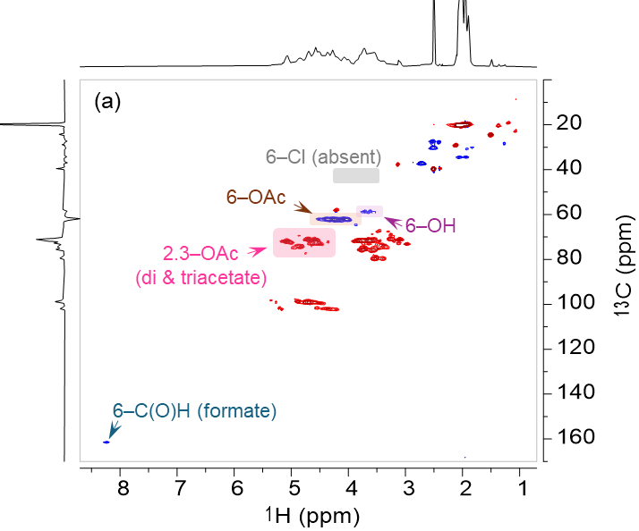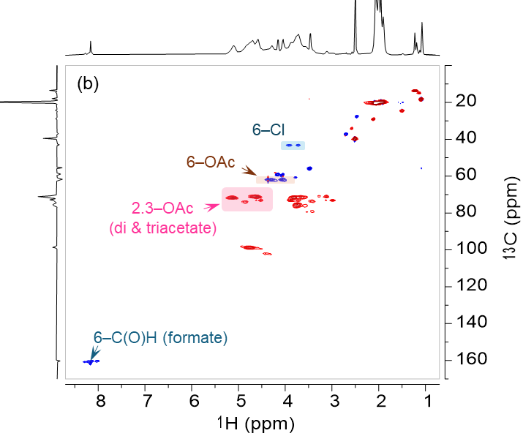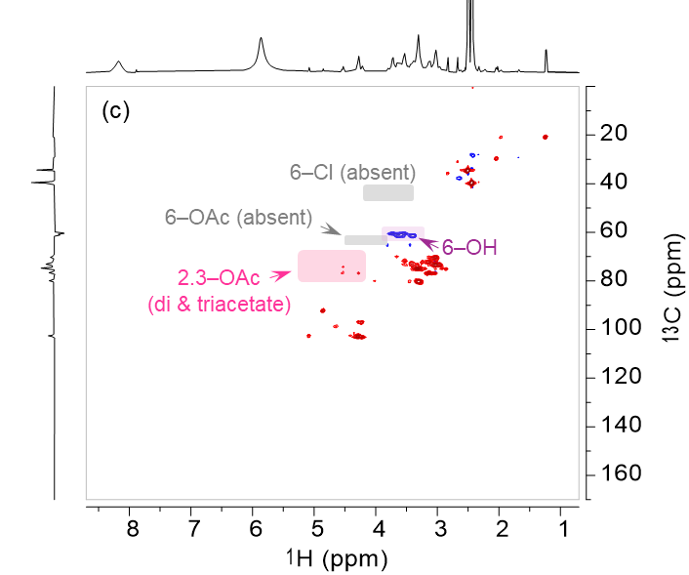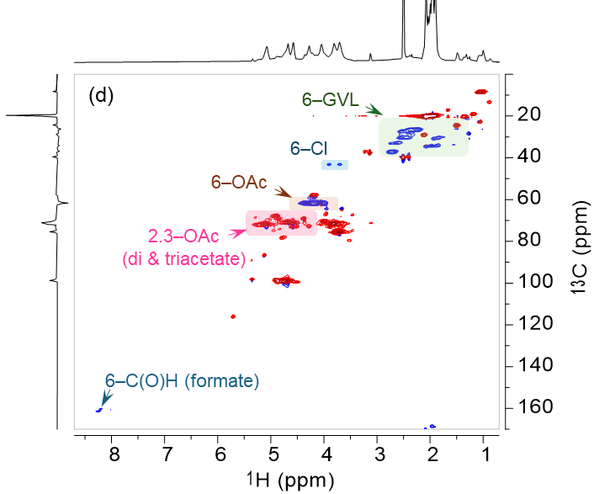
Fig. S2 ME-HSQC spectra of products isolated in screening reactions for chlorination with MsCl in GVL (600 MHz, DMSO-d₆, 65 °C). Reaction conditions are given in Table S3. Note that in the preliminary screening study, the crude products were typically not purified prior to NMR analysis.
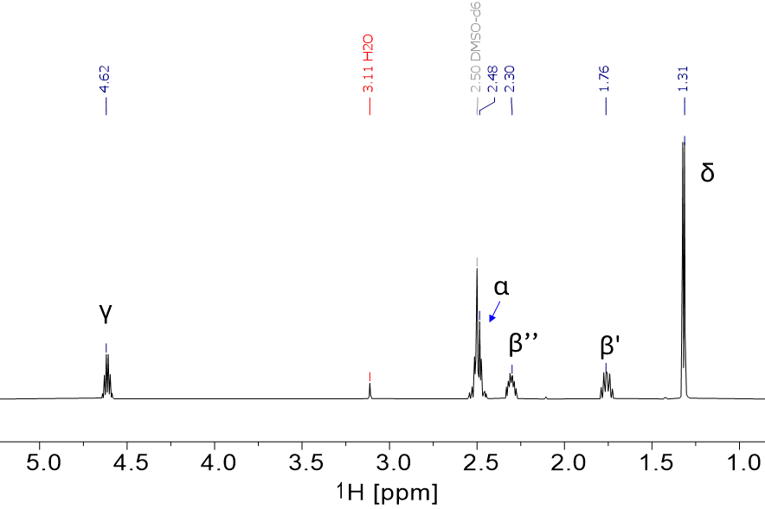
Fig. S3a Annotated ¹H NMR spectrum of GVL (600 MHz, DMSO-d₆, 65 °C).

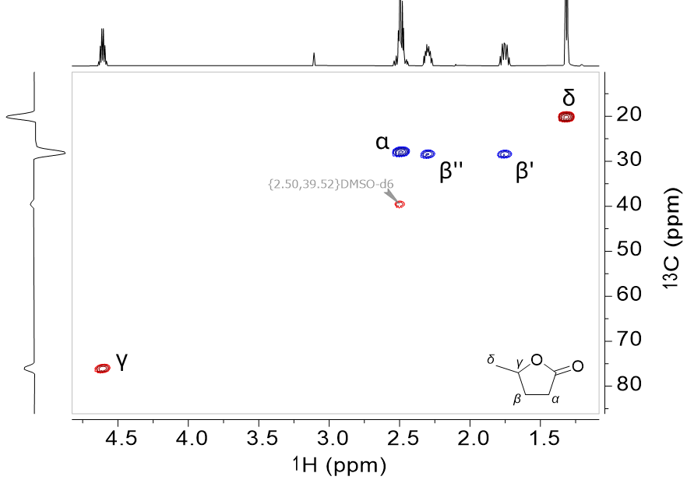
Fig. S3b Annotated ME-HSQC spectrum of GVL (600 MHz, DMSO-d₆, 65 °C).

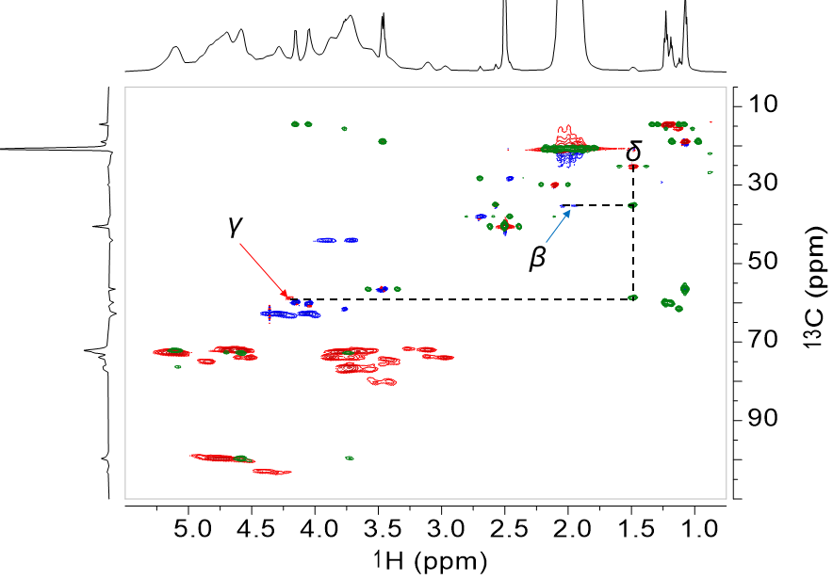
Fig. S3c Annotated HMBC spectrum of CA esterified with GVL (600 MHz, DMSO-d₆, 65 °C).

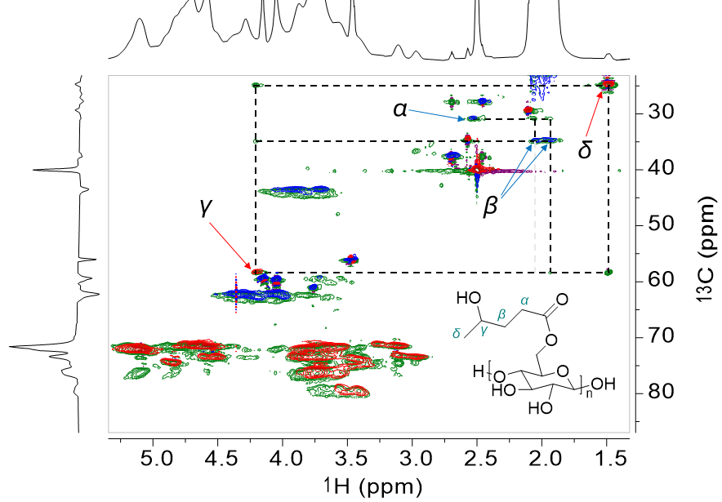
Fig. S3d Annotated HSQC-TOCSY spectrum of CA esterified with GVL (600 MHz, DMSO-d₆, 65 °C).

Table S3 Tabulated assignments for ¹H and ¹³C chemical shifts of GVL (600 MHz, DMSO-d₆, 65 °C).
 | α (2H) | β (2H) | γ (1H) | δ (3H)
GVL
¹H | 2.48 | 1.76;2.30 | 4.59 | 1.29
¹³C | 27.6 | 28.3 | 75.2 | 19.8
6-GVL-CA
¹H | 2.51 | 1.94;2.05 | 4.18 | 1.50
¹³C | 30.1 | 34.1 | 57.6 | 24.0

Iodination in 2,5-hexanedione vs other dipolar aprotic solvents

General procedure
6-Cl-CA (0.30 g) was dissolved in 2,5-hexanedione, DMF, DMA or DMSO (15 mL), in a round-bottom flask (100 mL), at 120 °C, under magnetic stirring. To the obtained clear solution, NaI (0.75 g) was added, and the reaction mixture was stirred for 5 hours at 120 °C. The reaction solution remained clear in dipolar aprotic solvents, and precipitation of NaCl was only observed in 2,5-hexanedione. The products were precipitated from water, filtered, washed with aqueous Na₂S₂O₃ (0.1 M) and ethanol. The obtained solids were dried in vacuo prior to NMR analysis.

NMR spectra and assignments
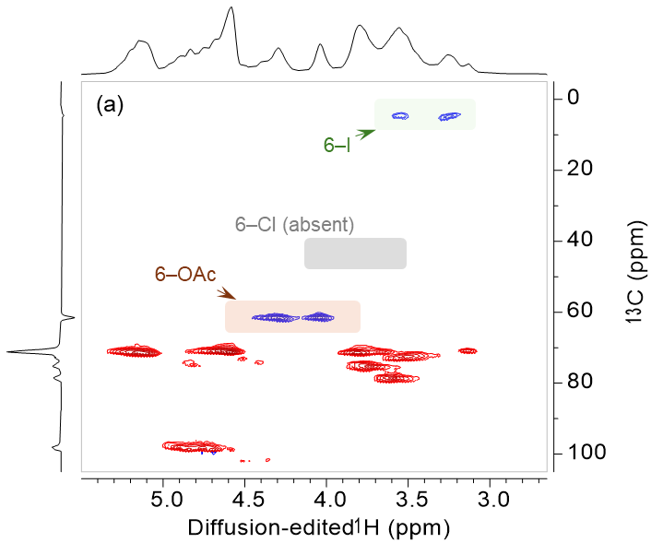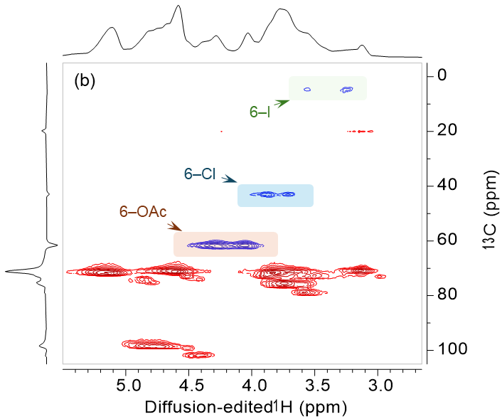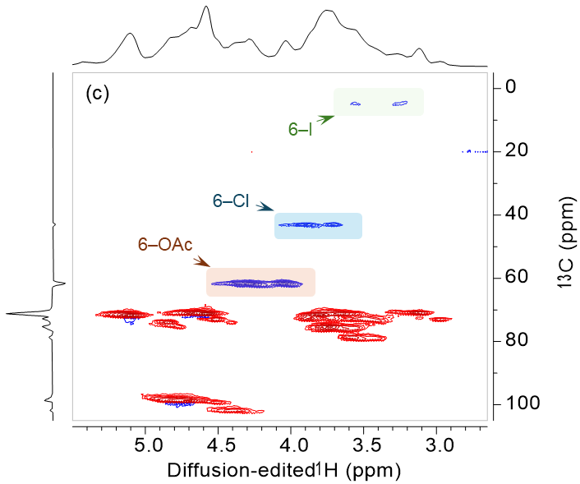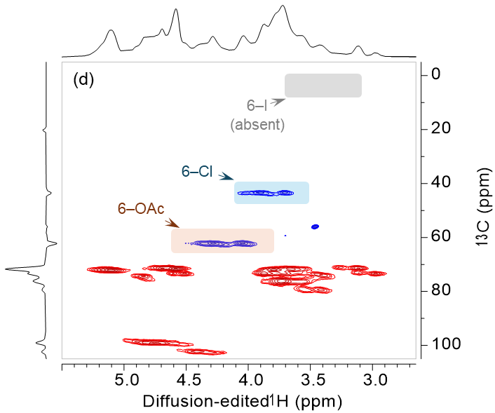
Fig. S4 ME-HSQC spectra of products isolated in screening reactions for iodination performed in 2,5-hexanedione (a) vs. three dipolar aprotic solvents: DMF (b), DMA (c) and DMSO (d). Only reaction in 2,5-hexanedione resulted in complete displacement of the chloride by iodide moiety at position 6, as evidenced by the absence of gem correlations corresponding to 6-CH₂-Cl at {3.71,42.8} and {3.88,42.8} ppm and presence of gem correlations corresponding to 6-CH₂-I at {3.22,4.32} and {3.56,4.32} ppm.

Reactions of CA with DBU

Considering possible deacetylation mechanisms reported in the literature
The possibility of DBU-catalysed chemoselective cleavage of acetyl groups (e.g., in the presence of benzoate groups) in aprotic solvents first came to our attention in Baptistella et al. (1989), who proposed a mechanism involving a transient ketene (or diketene) intermediate (Scheme S3).
Scheme S3 Proposed mechanism for non-hydrolytic acetyl cleavage in non-protic solvents, with a ketene intermediate (Baptistella et al. 1989).

However, Baptistella et al. (1989) do not provide any direct evidence in support of the proposed mechanism, apparently due to the high reactivity of the ketene (diketene) intermediate in the reaction medium (benzene or methanol). Incidentally, a better proposal for the reported deacetylation, at least in the reactions carried out in methanol, is the formation of methoxide anion, which also acts as a nucleophile in transacetylation, generating acetic acid methyl ester as a side product (Scheme S4).
Scheme S4 Mechanism of DBU-catalysed cleavage of acetyl groups (transacetylation) in methanol.

Our best guess is that, at least in our case, the observed minimal loss of the acetyl groups is occurring due to adventitious water, present in trace amounts in the reaction system, either from the moisture uptake by the solvent (DMF is hygroscopic), or from the CA intermediate, which is also prone to moisture uptake from ambient air (Scheme S5).
Scheme S5 Mechanism of DBU-catalysed hydrolysis of acetyl groups.

There is also another possibility of selective deacetylation, following a pathway analogous to that studied by Xu and Edgar (2012) of selective diacylation of CA by TBAF, who also put forward the ketene intermediate mechanism (Scheme S6). The proposed mechanism involves the deprotonation of the acyl moieties in the α position relative to the carbonyl group, with subsequent elimination of a transient ketene, which is captured by water, affording the carboxylic acid.
Scheme S6 Proposed mechanism for regioselective deacylation of CA via a ketene intermediate, adapted from Xu and Edgar (2012).

Interestingly, Xu and Edgar (2012) observe regioselective deacetylation at positions 2 and 3, with 6-acetate retained. On the other hand, Baptistella et al. (1989) who studied the DBU-catalysed deacetylation on small molecular weight sugars observes the opposite, trend, i.e., the primary acetyl cleaving faster than secondary or tertiary groups. The kinetics of deacetylation is faster at the primary C6 position (Baptistella et al. 1989); therefore, a more plausible mechanism would be deacetylation of the primary position C6, followed by transacetylation from position C2 across the glycosidic bond, and from position C3 to C2 within a single monomeric unit (Lassfolk et al. 2019). In order to test our intuitions, we set out to evaluate the (unlikely) deacetylation, by reacting CA with DBU (in the absence of other reagents), and analysing the recovered material (CA-DBU) against the starting material (CA), using the perpropionylation protocol (Tezuka and Tsuchiya 1995).

Experimental details for the treatment of CA with DBU
CA (2.00 g) and anhydrous DMF (20 mL) were placed in a 100 mL round-bottom flask. The solid was dissolved under stirring at room temperature to give a clear colourless solution. Stoichiometric amount of DBU (2.0 mL, ≈1.5 mol eq/sugar unit) was added dropwise at RT, and the reaction mixture was immersed in an oil bath preheated to 50 °C. Stirring was continued under heating for 2 h; afterwards. the reaction mixture was allowed to cool down for 30 min. The product was recovered from cold ethanol filtered and dried in vacuo.
CA (starting material) and the DBU-treated CA (CA-DBU) were perpropionylated, based on a published procedure (Tezuka and Tsuchiya 1995; Kono, Hashimoto, and Shimizu 2015). In summary, in a 50 mL round-bottom flask, CA or CA-DBU (300 mg) was dissolved in pyridine (5 mL), followed by addition of 4-dimethylaminopyridine (20 mg) and propionic anhydride (5 mL). The reaction mixture was subsequently heated to 80 ˚C and stirred at that temperature for 24 h. The perpropionylated crude product was recovered by precipitation from water (100 mL) and collected by filtration, then purified by dissolving in chloroform (10 mL), re-precipitating in ethanol (300 mL) and drying in vacuo at 65 °C.

Quantitative ¹³C NMR analysis
The individual DS at positions 2, 3 and 6 of CA and CA-derivatives can be determined from quantitative ¹³C NMR spectra of the corresponding perpropionylated derivatives, based on the following line of reasoning (Tezuka and Tsuchiya 1995). The acetyl carbonyl triplet (169–170.5 ppm) is separated from the propionyl carbonyl triplet (172.5–174 ppm). The three peaks at 170.3, 169.8, and 169.3 ppm can be assigned to the acetyl carbonyl carbons at the 6-, 3-, and 2-positions, respectively, while the resonances at 173.7, 173.2, and 172.8 ppm are attributed to the propionyl carbonyl carbons at the 6-, 3-, and 2-positions, respectively. The maximum total DS for the residual sugar unit of cellulose (or ‘anhydroglucose,’ AGU) is 3. Thus, by integrating the acetyl and propionyl carbonyl regions, and by normalizing the sum of all integrals to 3, it is possible to recover individual DS_{2-Ac}, DS_{3-Ac} and DS_{6-Ac} values for the acetyl substitution directly from the integral values obtained for the corresponding resonances in ¹³C NMR spectra. It follows that the sum of the integral values of the carbonyl carbons is equal to the total DS_{Ac}.
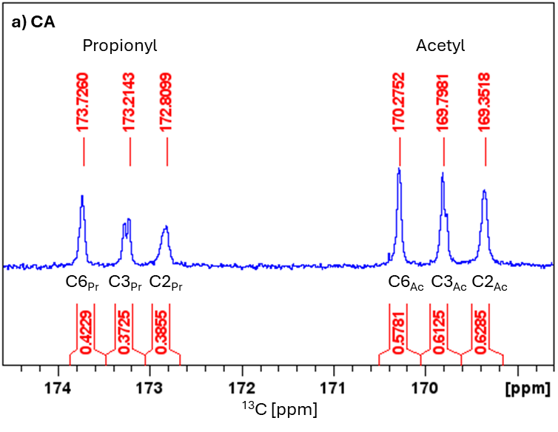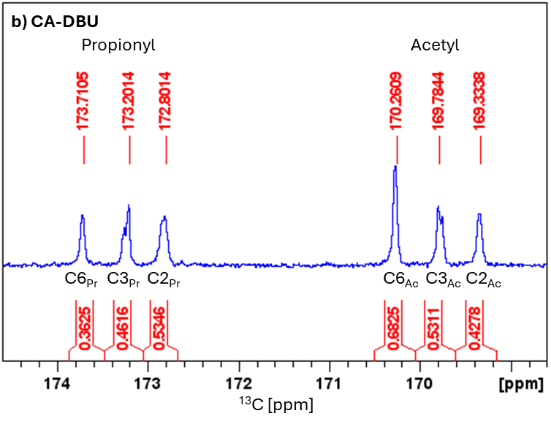
Fig. S5 Expansion of the carbonyl region of the quantitative ¹³C NMR spectra (600 MHz, 40 °C, CDCl₃) of perpropionylated samples: (a) CA, (b) CA treated with DBU.

Table S4 Total and position-specific DS_{Ac} and DS_{Pr} for raw/untreated CA vs CA treated with DBU.
 |  | DS_{i-Ac} |  |  | DS_{i-Pr}
 | Total DS_{Ac} | i = 2 | i = 3 | i = 6 | i = 2 | i = 3 | i = 6
CA | 1.82 | 0.63 | 0.61 | 0.58 | 0.39 | 0.37 | 0.43
CA-DBU | 1.64 | 0.43 | 0.53 | 0.68 | 0.53 | 0.46 | 0.36

Comments on the previously-postulated DBU-induced deacetylation vs experimental results
The results presented in Fig. S5 and Table S4 indicate that the overall loss of the acetyl groups is negligible, with the value dropping from 1.82 to 1.64. This constitutes approximately 10% loss, but the difference may be within the error typical for ¹³C NMR. Therefore, we concluded that DBU does not act as a deacetylating agent by elimination of a ketene, contrary to earlier claims by Baptistella et al. (1989). Rather, a more plausible explanation is that our system contains traces of water, which is deprotonated in the presence of DBU, and the resulting hydroxide ions act as a nucleophile in the deacetylation reaction (Scheme S5).
Irrespective of the congruent total DS_{Ac} for CA and CA-DBU, by comparing position specific values (Table S4), we observed a slight change in the distribution of the substituents between the primary 6 position and the secondary 2 and 3 positions. The acetate appendages are partially cleaved from the secondary 2 and 3 positions, and position 2 seems to be more affected by the deacetylation, given that the initial position-specific DS values are almost identical for 2 and 3. On the other hand, there is an apparent increase in DS₆ from 0.58 to 0.68. The observed acetyl migration/redistribution from the secondary 2 and 3 positions towards the primary 6 position is in alignment with results from the Lassfolk group (Lassfolk et al. 2019; Lassfolk et al. 2022). This is also consistent with the potential mechanism involving deprotonation of 6-OH with DBU (Scheme S5) and intermolecular reaction with the acetate on adjacent molecules.

Discussion regarding transacetylation/acetyl migration
In connection to the possible acetyl migration discussed in the preceding section, we considered the possibility that the acetyl redistribution may be occurring at any (or all) of the three reaction steps towards 5,6-cellulosene. In an attempt to retrieve more detailed mechanistic insights, we compared the acetate region (1.8-2.2 ppm) in diffusion-edited ¹H NMR of the starting material, CA, as well as the synthesized products, 6-Cl-CA, 6-I-CA and 5,6-ene-CA. From Fig. S7, it is apparent that CH₃ signals are markedly reduced when 6-I-CA is converted to 5,6-ene-CA. There is a noticeable loss of 2-, 3- and 6-acetate peaks associated with cellulose triacetate (CTA) (King et al. 2025). Concurrently, we observe increased intensity (peak volume) of 6-acetate present in the region characteristic for mono- and diacetate, consistent with the acetyl group migration (Lassfolk et al. 2019; Lassfolk et al. 2022). Interestingly, 5,6-ene-CA is characterized by smaller relative fraction of CTA units and higher fraction of mono- and diacetate units along the polymeric chain. There are subtle changes of the 2,3,6-OAc regioselectivity pattern between the remaining CA derivatives as well, albeit relatively small compared to changes occurring during the dehydroiodination to 5,6-cellulosene. However, due to the complexity in peak positioning, afforded by the adoption of different conformers and regioisomers, one should be careful not to overanalyse these spectra

NMR spectra and assignments
(a)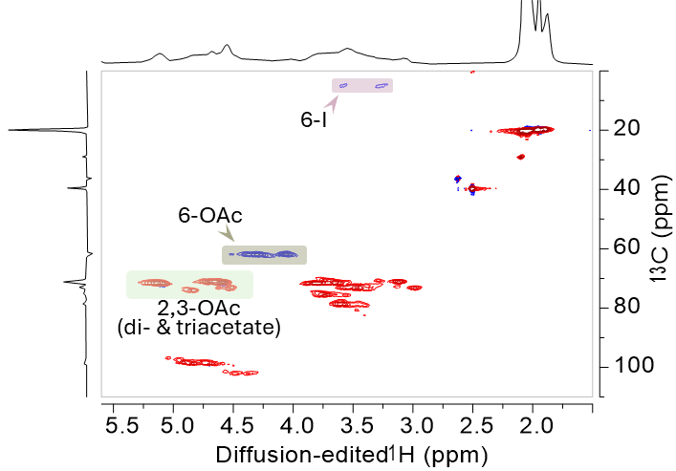
(b)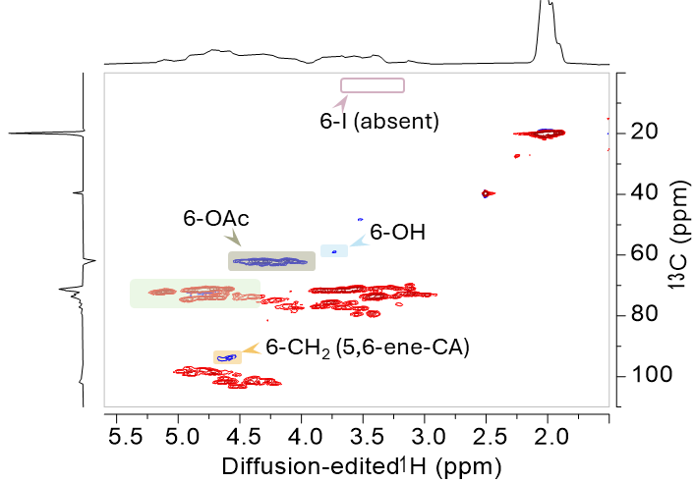
Fig. S6 ME-HSQC NMR spectrum of 6-I-CA (a) vs 5,6-ene-CA (b) (600 MHz, DMSO-d₆, 65 °C). Key correlations, indicating complete elimination of the 6-iodate species, are annotated.

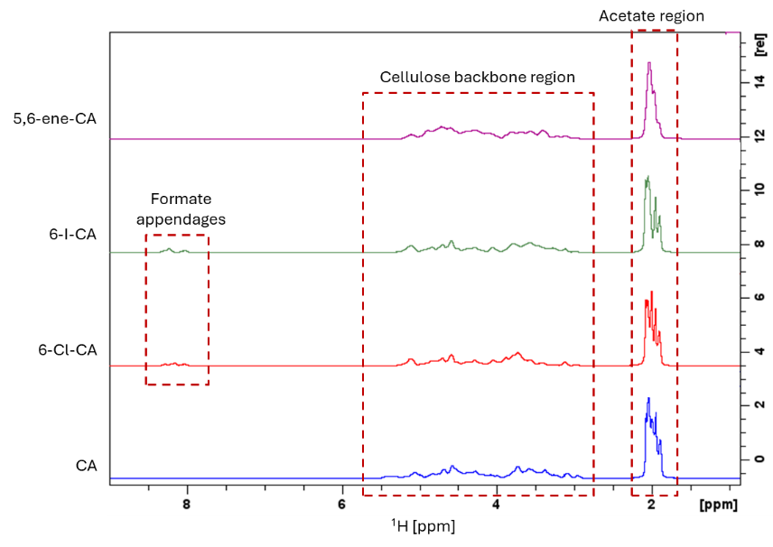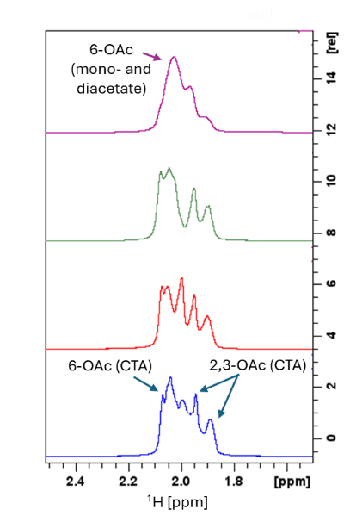
Fig. S7 Stacked diffusion-edited ¹H NMR spectra of CA, 6-Cl-CA, 6-I-CA and 5,6-ene-CA, showing the full ¹H spectral region on the left-hand side and the acetate region on the right-hand side (600 MHz, DMSO-d6, 65 °C).

Degradation of 5,6-ene-CA in water at elevated temperatures

Computational details
The computation of reaction Gibbs free energies via a supramolecular approach follows best DFT practices (Bursch et al. 2022). First, due to the expected flexibility of reactants and products, molecular conformations were sampled using the CREST program (Pracht et al. 2024), utilising the GFN2-xTB level for final energy sorting. To avoid additional computational effort, structures were deduplicated using a permutation invariant root-mean-square-deviation of atomic positions (Pracht 2025). Conformational energies for sugar-like systems are prone to larger errors at this semiempirical level of theory and require postprocessing (Bannwarth et al. 2021; Pracht et al. 2024). Therefore, energies for all conformational ensembles were recomputed using the novel g-xTB method (Froitzheim et al. 2025). Boltzmann weights were calculated for all structures, and conformations with a population of >0.5% were selected for subsequent DFT refinement using the ORCA 6 program package (Neese et al. 2020; Neese 2025). The selected geometries were optimized at the r²SCAN-3c level of theory (Grimme et al. 2021). The same level of theory was employed for calculating harmonic frequencies, using the modified and scaled rigid-rotor harmonic-oscillator scheme (${∆G}_{msRRHO}^{T}$) (Grimme 2012; Pracht and Grimme 2021). Finally, higher level electronic energies were computed at the ωB97X-V/def-QZVPP level of theory (Weigend and Ahlrichs 2005; Mardirossian and Head-Gordon 2014). The final free energy for all relevant conformers was obtained by adding the ${∆G}_{msRRHO}^{T}$ from r²SCAN-3c to the ωB97X-V electronic energies. A single average free energy ⟨G^{(T)}⟩ for each reactant and product was obtained as the Boltzmann-weighted average over the respective ensembles. The conformational free energy contributions ${∂G}_{conf}^{(T)}$ were then estimated using GFN2-xTB/ALPB(water) at 278.15 K, using the procedure described in Pracht and Grimme (2021). Currently conformational free energy contributions are only available, using CREST, at the GFNn-xTB or GFN-FF level of theory due to the unfeasible computational scaling of higher level (DFT) methods.

Table S5 Absolute Gibbs free energies in Hartree at 298.15 K (RT) and 373.15 k (100 °C), for the reactants of the hydrolysis reactions at two levels of theory.
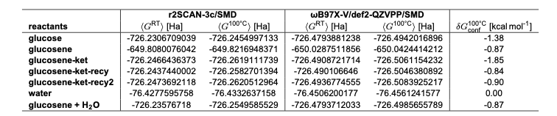
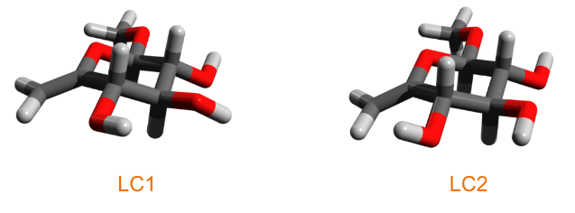
Fig. S8 Glucosene glycoside LC1 and LC2 (based on ωB97X-V energies).

Experimental NMR data
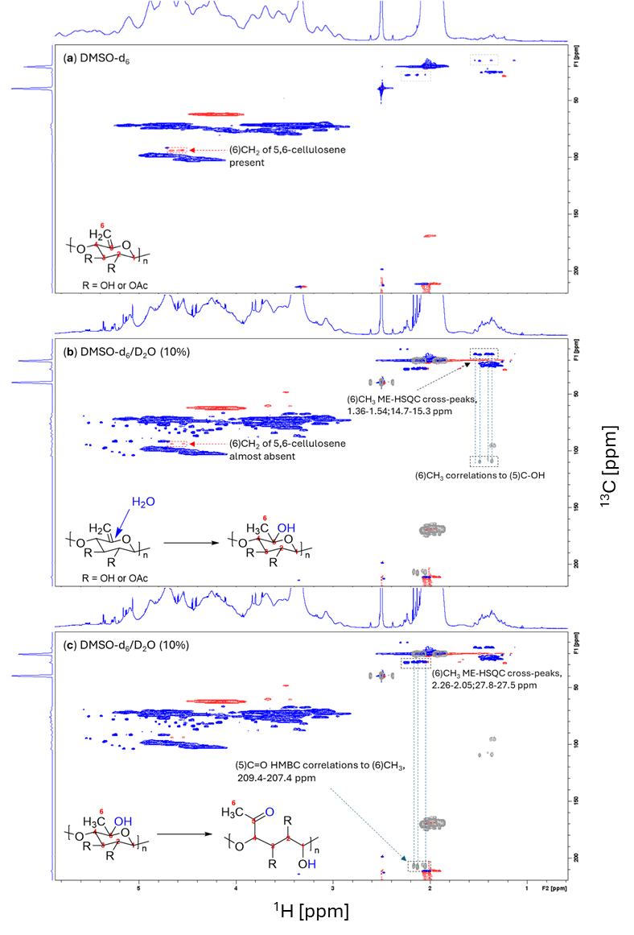
Fig. S9 ME-HSQC spectra of 5,6-ene-CA, dissolved in DMSO-d₆ (a), and after adding 10% D₂O, with HMBC data as overlay (b & c) (600 MHz, DMSO-d₆, 65 °C).

Calculated NMR data
Table S6 NMR chemical shifts for observed and calculated species resulting from water addition to C5 of 5,6-cellulosene.
Experimental
 | Open ring |  | Closed ring
Position | ¹H | ¹³C | ¹H | ¹³C
5 | - | 207.4-209.4 | - | 107.4-109.2
6 | 2.05-2.26 | 27.5-27.8 | 1.36-1.54 | 14.7-15.3

Calculated (calibrated against experimental HSQC data for β-methylglucopyranose in DMSO-d₆)
 | Open chain ketose |  | Closed chain ketose 1 |  |  | Closed chain ketose 2
Position | ¹H | ¹³C |  | ¹H | ¹³C |  | ¹H | ¹³C
1 | 4.35 | 98.57 |  | 4.12 | 102.34 |  | 4.35 | 101.34
2 | 3.34 | 74.99 |  | 3.03 | 72.88 |  | 2.99 | 73.74
3 | 3.83 | 73.15 |  | 3.36 | 72.16 |  | 3.38 | 72.84
4 | 4.16 | 77.30 |  | 3.11 | 75.45 |  | 3.01 | 74.63
5 | - | 223.39 |  | - | 100.16 |  | - | 98.97
6 | 2.01 | 19.17 |  | 1.62 | 12.38 |  | 1.29 | 18.90

Calculated (calibrated against experimental HSQC data for β-methylglucopyranose in DMSO-d₆)
 | Glucosene glycoside |  | Glucoside
Position | ¹H | ¹³C |  | ¹H | ¹³C
1 | 3.98 | 107.87 |  | 3.95 | 106.12
2 | 3.21 | 72.23 |  | 2.91 | 73.87
3 | 3.21 | 73.72 |  | 3.24 | 76.25
4 | 3.89 | 70.57 |  | 3.27 | 68.62
5 | - | 166.31 |  | 3.08 | 74.95
6 | 4.67 | 92.69 |  | 3.42 | 61.20

Possible mechanisms for water additions at positions C1, C5 and C6
Scheme S7 Possible reaction pathways for the hydrolysis of acetylated 5,6-cellulosene (5,6-ene-CA). R = OAc or OH; * = polymeric chain. Note that the presented structures include only one of the potential cyclic ketose anomers, arising from C5 and C1 addition of water.

Speculative fragmentation mechanism
Scheme S8 Possible fragmentation mechanism, induced by water addition to C5 of acetylated 5,6-cellulosene (5,6-ene-CA), and formation of ketone species. R = OAc or OH; * = polymeric chain. The keto group in the α position with respect to the glycosidic linkage induces hydrolysis of adjacent glycosidic linkage. The phenomenon had been demonstrated for a model compound by Kuznetsova, Kaverzneva, and Ivanov (1957): the glycosidic bond is hydrolytically unstable under both acidic and basic conditions (‘somewhat unstable in acidic medium and almost completely hydrolysed in basic medium’).

Radical-mediated thiol–ene reactions under different conditions
The screening experiments included different radical initiation and photoinitiation reaction conditions. The thermal reactions were performed using azobisisobutyronitrile (AIBN), as radical initiator, with variation in temperature and quantity of cysteamine, as summarized in Table S7. Conversely, the photoinitiated screening reactions were performed at RT, using two different photoinitiators; 1,2,3,5-tetrakis(carbazol-9-yl)-4,6-dicyanobenzene (4CzIPN) and 2,2-dimethoxy-2-phenylacetophenone (DMPA). The obtained thiol–ene conjugates were isolated and analysed by NMR as crude products dissolved in DMSO-d₆ (Fig. S10).

General procedure
In a typical procedure where azobisisobutyronitrile (AIBN) was used to generate the thiyl radical from 2-aminoethanethiol (2-AET), DMF was degassed for 15 min by bubbling argon gas. Following degassing, 5,6-ene-CA (100 mg) was dissolved in DMF (5 mL) under inert atmosphere, in a septum vial. Specified amounts of 2-AET (Table S7) and AIBN (15 mol%/thiol) were subsequently added, and the reaction vial was heated to 65 or 90 °C to start the reaction. After 16 h, the product was precipitated from ethanol and analysed by ¹H NMR without purification.
Photochemically-induced thiol–ene coupling with the photocatalyst 1,2,3,5-tetrakis(carbazol-9-yl)-4,6-dicyanobenzene (4CzIPN) was carried out using blue LED light source (450 nm), under otherwise identical conditions to those used in the corresponding photocoupling using DMPA as the photoinitiator.
Table S7 Summary of tested reaction conditions for radical-mediated thiol–ene syntheses with 2-AET.
Entry | 2-AET (mol eq /AGU) | Temp (°C) | Time (h) | Workup
AIBN-1 | 2 | 65 | 16 | ethanol
AIBN-2 | 8 | 65 | 16 | ethanol
AIBN-3 | 8 | 90 | 16 | ethanol
AIBN-4 | 4 | 65 | 16 | ethanol
4CzIPN | 8 | RT | 16 | ethanol
DMPA | 8 | RT | 16 | ethanol, water

NMR spectra, assignments and discussion
The relative efficiencies of conversions for all radical thiol–ene reactions were retrieved directly from ¹H NMR spectra, thanks to two new proton resonances at ≈2.6 and 2.8 ppm, consistent with methylene groups of thioether side chain (Gao, Liu, and Edgar 2018). Conveniently, the gem signals associated with the formation of a thioether are located between cellulose backbone and acetyl regions. However, standard ¹H NMR analysis may be hampered by solvent impurities and/or water, often present in the same region. On the other hand, diffusion-edited ¹H NMR allows for editing out fast-diffusing species, effectively showing only functionalities that are covalently bound to the polymer (King et al. 2018; Fliri et al. 2023). Thus, diffusion-editing provided evidence for successful incorporation of 2-AET via C6-S linkage. Note that diffusion-edited ¹H NMR experiments cannot be used for quantitation due to differences in signal relaxation in the different chemical species. Consequently, disproportionate signal losses during the pulse sequence, prior to acquisition, prevents direct quantitation (Koso et al. 2020; Fliri et al. 2023). Nevertheless, for our purposes, semi-quantitative and qualitative diffusion-edited ¹H NMR analysis enables quick screening for best conversion efficiencies under different reaction conditions, by comparing peak intensities in the methylene region (≈2.6-2.8 ppm).
In summary, the NMR data (Fig. S10) show that the highest conversion was achieved under photoinitiation with DMPA. One interesting initial observation was the formation of a new acetyl resonance, clearly visible in the ¹H NMR spectrum at 1.83 ppm, which led to further characterization work with 2D NMR to confirm the source of this resonance.
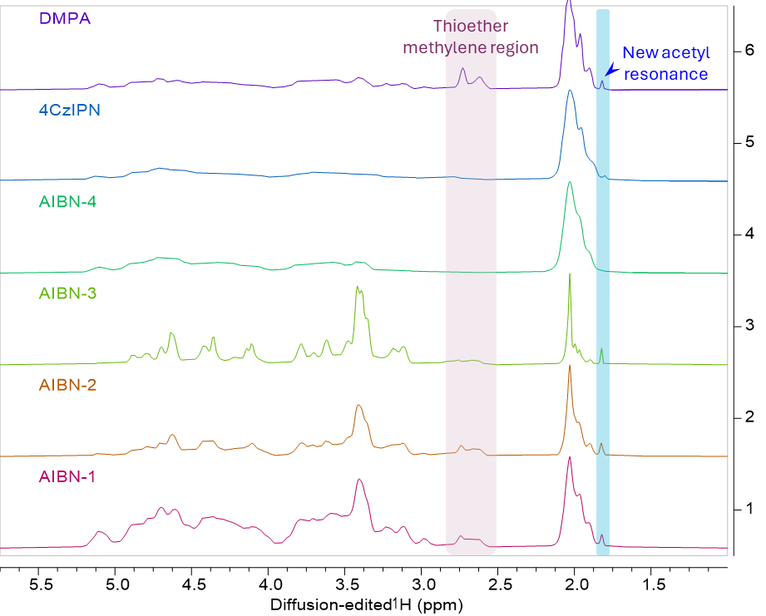
Fig. S10 Stacked array of diffusion-edited ¹H NMR spectra of crude products obtained via radical thiol–ene chemistry under thermal and photoinitiation (600 MHz, DMSO-d₆, 65 °C).

Estimating conversion to the thioether by quantitative ¹H-¹³C HSQC NMR
Conversion of 5,6-ene-CA to the thioether, achieved in the thiol–ene coupling with 2-AET under photocatalytic conditions with DMPA, was estimated based on ¹H-¹³C Q-HSQC NMR (Heikkinen et al. 2003; Koskela, Kilpeläinen, and Heikkinen 2005). Two gem correlations present in the ¹H-¹³C Q-HSQC NMR spectrum (Fig. S7), at {2.63,34.6} and {2.76,40.7} ppm, were used, since these correlations are assumed to correspond to the 6-CH₂-S thioether linkage
Table S8 ¹H-¹³C Q-HSQC correlations used for estimating conversion of 5,6-ene-CA to the CA thioether, along with the corresponding integral values.
Assignment | ¹H chemical shift [ppm] | ¹³C chemical shift [ppm] | Relative integral | Normalized integral*
6-CH₂ | 4.65 | 94.3 | 0.2252 | 11%
6-CH₂-S- | 2.63 | 34.6 | 0.8794 | 42%
6-CH₂-S- | 2.76 | 40.7 | 1.0000 | 48%
* Equivalent to conversion, expressed as percentage.

The assumption is based on complementary non-quantitative ¹H-¹³C ME-HSQC NMR and ¹H-¹³C HSQC-TOCSY NMR data. ME-HSQC was used to confirm the multiplicity of these correlations (CH₂ groups are in opposite phase to CH or CH₃ groups), whereas HSQC-TOCSY showed no additional correlations for the two gem cross peaks. The presence of additional cross peaks in HSQC-TOCSY would indicate an extended spin system, consistent with the two CH₂ groups present in the thiol chain (i.e., away from the cellulose backbone). Instead, we observed HSQC-TOCSY correlations at {2.65,31.6} and {3.22,31.6} ppm and {3.23(gem),38.5} ppm, which can thus be assigned to 7/7’- and 8/8’-CH₂ (of the amine and amide forms, as we were unable to identify separate gem pairs that could be unambiguously attributed to the amine and amide thioethers).
In order to estimate the conversion achieved in the thiol–ene transformation, the sum of the two peak volumes of 6-S linkage were compared with the gem peak volume at {4.65,94.3} ppm, attributable to the residual 6-CH₂ of 5,6-ene-CA. The estimation for the unreacted 5,6-cellulosene is approximately 11%, while the amine and amide forms are present in roughly equal amounts, as indicated by the normalized integral values in Table S8.

NMR pulse programs and parameters
Standard quantitative ¹H NMR used Bruker pulse program ‘zg30’ with the following parameters: 4 dummy scans (ds), 16 transient scans (ns), sweep-width (sw) of 12 ppm, acquisition time (aq) of 4.59 s, transmitter offset on 6.0 ppm (o1p), relaxation delay (d1) of 10 s.
Diffusion-edited ¹H NMR used a 1D bipolar-pulse pair with stimulated echo (BPPSTE) diffusion-ordered spectroscopy (DOSY) pulse sequence (Wu, Chen, and Johnson 1995) (Bruker pulse program ‘ledbpgp2s1d’), with the following parameters: 4 dummy scans (ds), minimum 32 transient scans (ns), a sweep-width (sw) of 12 ppm, acquisition time (aq) of 0.83 s, transmitter offset on 6.175 ppm (o1p), diffusion gradient pulse duration (p30) of 2.5 ms, relaxation delay (d1) of 3 s, gradient recovery delay (d16) of 0.2 ms, diffusion time (d20) of 200 ms, eddy current delay (d21) of 5 ms, and a z-gradient strength (gpz6) of 90% at 50 G cm-1 (probe z-gradient strength).
Multiplicity-edited ¹H-¹³C HSQC (ME-HSQC) NMR used a sensitivity-improved multiplicity-edited phase-sensitive HSQC sequence with echo/antiecho-TPPI gradient selection and adiabatic pulses (Willker et al. 1993) (Bruker pulse program ‘hsqcedetgpsisp2.2’). Typical parameters are as follows: spectral widths (sw) of 12 and 240 ppm, transmitter offsets (o1p) of 6.00 and 100 ppm, for ¹H and ¹³C dimensions, respectively, time-domain size (td1) in the indirectly detected ¹³C-dimension (f1) of 512, 16 dummy scans (ds), 64 transient scans (ns), acquisition time (aq) of 0.14 s for f2, and relaxation delay (d1) of 1.5 s.
Quantitative ¹³C (Q-¹³C NMR) used the ‘zgig30’ sequence with inverse gated decoupling. Typical acquisition parameters were: 4 dummy scans (ds), 15 000 transient scans (ns), sweep-width (sw) of 240 ppm, acquisition time (aq) of 0.917 s, transmitter offset on 100 ppm (o1p), relaxation delay (d1) of 5 s.
Quantitative ¹H-¹³C HSQC (Q-HSQC) NMR used the quantitative Carr-Purcell-Meiboom-Gill (CPMG) adjusted HSQC (Q-CAHSQC) experiments (Koskela, Kilpeläinen, and Heikkinen 2005) (Bruker pulse program ‘qcahsqc’), with the following parameters: spectral widths (sw) 13.0 and 165 ppm, transmitter offsets (o1p) 6.175 and 75 ppm, for ¹H and ¹³C dimensions, respectively. The time-domain size (td1) in the indirectly detected ¹³C-dimension (f1) was 320. There were 16 dummy scans (ds), 16 scans (ns), acquisition time (aq) was 0.065 s for f2, relaxation delay (d1) was 12.5 s. Window functions were typically sine squared (90 °) in F1 and F2, with no linear prediction.
¹H-¹³C HSQC-TOCSY NMR used a phase sensitive HSQC-TOCSY pulse program with the DIPSI-2 isotropic mixing sequence and echo/antiecho-TPPI gradient selection (Willker et al. 1993) (Bruker pulse program ‘hsqcdietgpsisp.2’). Typical parameters are as follows: spectral widths (sw) 16.0 and 165 ppm, transmitter offsets (o1p) 4.700 and 75 ppm, for ¹H and ¹³C dimensions, respectively. The time-domain size (td1) in the indirectly detected ¹³C-dimension (f1) was 512. There were 32 dummy scans (ds), 100 scans (ns), acquisition time (aq) was 0.106 s for f2, relaxation delay (d1) was 1.5 s. The TOCSY mixing delay (d9) was 0.015 s to yield a short-range (COSY-like) TOCSY experiment or 0.120 s to yield a long-range TOCSY experiment, where the full spin-system was typically observed. Window functions were typically sine squared (90 °) in f1 and f2.
¹H-¹³C HMBC NMR used a magnitude-mode gradient-enhanced HMBC sequence using a low-pass J-filter (Bax and Summers 1986) (Bruker pulse program ‘hmbcgplpndqf’), with the following parameters: spectral widths (sw) 13.0 and 220 ppm, transmitter offsets (o1p) 6.300 and 100 ppm, for ¹H and ¹³C dimensions, respectively. The time-domain size (td1) in the indirectly detected ¹³C-dimension (f1) was 512. There were 16 dummy scans (ds), 256 scans (ns), acquisition time (aq) was 0.131 s for f2, relaxation delay (d1) was 1.5 s. A ¹J_{CH} coupling constant value (cnst2) of 145 Hz was used, for setting up the low-pass filter. The polarization transfer delay was optimized for a ^{n}J_{CH} long-range coupling constant value of 10 Hz (cnst13). Window functions were typically sine bell (0 °) in f1 and f2.
¹H-¹⁵N HSQC NMR used Bruker’s ‘hsqcetgpsi2’ pulse program and the following parameters: spectral widths (sw) 13 and 400 ppm, transmitter offsets (o1p) 6.5 and 150 ppm, for ¹H and ¹⁵N dimensions, respectively. The time-domain size (td1) in the indirectly detected ¹⁵N-dimension (f1) was 256. There were 16 dummy scans (ds), 64 scans (ns), acquisition time (aq) was 0.125 s for f2, relaxation delay (d1) was 2 s.
¹H-¹⁵N HMBC NMR used Bruker’s ‘hmbcgpndqf’ pulse program and the following parameters: spectral widths (sw) 13 and 400 ppm, transmitter offsets (o1p) 6.0 and 150 ppm, for ¹H and ¹⁵N dimensions, respectively. The time-domain size (td1) in the indirectly detected ¹⁵N-dimension (f1) was 256. There were 16 dummy scans (ds), 64 scans (ns), acquisition time (aq) was 0.131 s for f2, relaxation delay (d1) was 2 s.

NMR signal assignments for CA and CA-derivatives
Table S9 NMR chemical shifts for key correlations, for CA and CA derivatives, referenced to DMSO-d₆ (¹H: δ = 2.50 ppm, ¹³C: δ = 39.52 ppm).
 | (O)CH₃ (acetate) | C(O)H (formate) | 1 | 2, 3, 4, 5 | 6 | 6'
CA
¹H | 2.2-1.8 | - | 4.84-4.14 | 5.15-2.95 | 3.71;3.55 | 4.42;4.08
¹³C | 20.3 | - | 101.9-98.7 | 81.7-69.6 | 59.2 | 62.1
6-Cl-CA
¹H | 2.2-1.8 | 8.4-7.9 | 5.00-4.23 | 5.13-3.00 | 3.92;3.70 | 4.35;4.05
¹³C | 20.0 | 161.1 | 102.7-97.0 | 78.2-70.3 | 43.6 | 62.2
6-I-CA
¹H | 2.2-1.8 | 8.3-8.0 | 5.0-4.23 | 5.26-2.91 | 3.58;3.26 | 4.28;4.05
¹³C | 20.0 | 161.0 | 102.2-97.0 | 82.7-69.8 | 5.03 | 62.1
5,6-ene-CA
¹H | 2.2-1.8 | - | 4.98-4.23 | 5.25-2.90 | 4.64;4.57 | 4.28;4.11
¹³C | 20.0 | - | 103.3-98.4 | 79.4-69.8 | 94.0 | 62.1
6-AET-CA
¹H | 2.1-1.86(1.81) | - | 4.90-4.22 | 5.20-2.92 | 2.72;(2.62) | 4.28;4.08
¹³C | 20.0(22.2) | - | 103.3-98.9 | 81.8-69.5 | 40.93(35.5) | 62.1
6' = 6-acetate, ( ) = acetamide moiety

Supplementary references
Alder, Catherine M., John D. Hayler, Richard K. Henderson, Anikó M. Redman, Lena Shukla, Leanna E. Shuster, and Helen F. Sneddon. 2016. 'Updating and further expanding GSK's solvent sustainability guide', Green Chemistry, 18: 3879–90.
Bannwarth, Christoph, Eike Caldeweyher, Sebastian Ehlert, Andreas Hansen, Philipp Pracht, Jakob Seibert, Sebastian Spicher, and Stefan Grimme. 2021. 'Extended tight-binding quantum chemistry methods', WIREs Computational Molecular Science, 11: e1493.
Baptistella, Lucia Helena B., José Fernando Dos Santos, Karin Cristina Ballabio, and Anita Jocelyne Marsaioli. 1989. '1,8-Diazabicyclo[5.4.0]undec-7-ene as a Mild Deprotective Agent for Acetyl Groups', Synthesis, 21: 436–39.
Bax, Ad, and Michael F. Summers. 1986. 'Proton and carbon-13 assignments from sensitivity-enhanced detection of heteronuclear multiple-bond connectivity by 2D multiple quantum NMR', Journal of the American Chemical Society, 108: 2093–94.
Bursch, Markus, Jan-Michael Mewes, Andreas Hansen, and Stefan Grimme. 2022. 'Best-Practice DFT Protocols for Basic Molecular Computational Chemistry', Angewandte Chemie International Edition, 61: e202205735.
Carrera, Manuel, Laurens De Coen, Michelle Coppens, Wim Dermaut, and Christian V. Stevens. 2020. 'A Vilsmeier Chloroformylation by Continuous Flow Chemistry', Organic Process Research & Development, 24: 2260–65.
Fliri, Lukas, Katja Heise, Tetyana Koso, Aleksandar R. Todorov, Daniel Rico del Cerro, Sami Hietala, Juha Fiskari, Ilkka Kilpeläinen, Michael Hummel, and Alistair W. T. King. 2023. 'Solution-state nuclear magnetic resonance spectroscopy of crystalline cellulosic materials using a direct dissolution ionic liquid electrolyte', Nature Protocols, 18: 2084–123.
Froitzheim, Thomas, Marcel Müller, Andreas Hansen, and Stefan Grimme. 2025. 'g-xTB: A General-Purpose Extended Tight-Binding Electronic Structure Method For the Elements H to Lr (Z=1–103)', ChemRxiv, 2025.
Gagliardi, Mariacristina, and Angelo Bifone. 2018. 'Ring-opening copolymerization thermodynamics and kinetics of γ-valerolactone/ϵ-caprolactone', PLOS ONE, 13: e0199231.
Gagliardi, Mariacristina, Federica Di Michele, Barbara Mazzolai, and Angelo Bifone. 2015. 'Chemical synthesis of a biodegradable PEGylated copolymer from ε-caprolactone and γ-valerolactone: evaluation of reaction and functional properties', Journal of Polymer Research, 22: 17.
Gao, Chengzhe, Shu Liu, and Kevin J. Edgar. 2018. 'Regioselective chlorination of cellulose esters by methanesulfonyl chloride', Carbohydrate Polymers, 193: 108–18.
Grimme, Stefan. 2012. 'Supramolecular Binding Thermodynamics by Dispersion-Corrected Density Functional Theory', Chemistry – A European Journal, 18: 9955–64.
Grimme, Stefan, Andreas Hansen, Sebastian Ehlert, and Jan-Michael Mewes. 2021. 'r²SCAN-3c: A “Swiss army knife” composite electronic-structure method', The Journal of Chemical Physics, 154.
Heikkinen, Sami, Merja M. Toikka, Pirkko T. Karhunen, and Ilkka A. Kilpeläinen. 2003. 'Quantitative 2D HSQC (Q-HSQC) via Suppression of J-Dependence of Polarization Transfer in NMR Spectroscopy: Application to Wood Lignin', Journal of the American Chemical Society, 125: 4362–67.
Heinze, Thomas, Andreas Koschella, and Tim Liebert. 2006. Esterification of polysaccharides (Springer: Berlin).
Khan, Abdul Rauf, and Valerian T. D'Souza. 1994. 'Synthesis of 6-Deoxychlorocyclodextrin via Vilsmeier-Haack-Type Complexes', The Journal of Organic Chemistry, 59: 7492–95.
King, Alistair W. T., Valtteri Mäkelä, Stephanie A. Kedzior, Tiina Laaksonen, Gabriel J. Partl, Sami Heikkinen, Harri Koskela, Harri A. Heikkinen, Ashley J. Holding, Emily D. Cranston, and Ilkka Kilpeläinen. 2018. 'Liquid-State NMR Analysis of Nanocelluloses', Biomacromolecules, 19: 2708–20.
King, Alistair W. T., Antti Paajanen, Ella Mahlamäki, Mikko Mäkelä, Paavo Penttilä, Michael Cordin, Avinash Manian, Mari Leino, Elisa Spönla, Maritta Svanberg, Tetyana Koso, Atsushi Tanaka, Vuokko Liukkonen, Amalie Solberg, Anniina Savolainen, Hannes Orelma, Antti Korpela, Kristin Syverud, and Ali Harlin. 2025. 'Controlled surface acetylation of cellulosics to tune biodegradability – expanding their use towards conventional plastics', RSC Sustainability, 3: 5356–66.
Kono, Hiroyuki, Hisaho Hashimoto, and Yuuichi Shimizu. 2015. 'NMR characterization of cellulose acetate: Chemical shift assignments, substituent effects, and chemical shift additivity', Carbohydrate Polymers, 118: 91–100.
Koskela, Harri, Ilkka Kilpeläinen, and Sami Heikkinen. 2005. 'Some aspects of quantitative 2D NMR', Journal of Magnetic Resonance, 174: 237–44.
Koso, Tetyana, Daniel Rico del Cerro, Sami Heikkinen, Tiina Nypelö, Jean Buffiere, Jesus E. Perea-Buceta, Antje Potthast, Thomas Rosenau, Harri Heikkinen, Hannu Maaheimo, Akira Isogai, Ilkka Kilpeläinen, and Alistair W. T. King. 2020. '2D Assignment and quantitative analysis of cellulose and oxidized celluloses using solution-state NMR spectroscopy', Cellulose, 27: 7929–53.
Kuznetsova, Z. I., E. D. Kaverzneva, and V. I. Ivanov. 1957. 'Effect of keto groups on the stability of the glucosidic linkage', Bulletin of the Academy of Sciences of the USSR, Division of chemical science, 6: 671–73.
Lassfolk, Robert, Manuel Pedrón, Tomás Tejero, Pedro Merino, Johan Wärnå, and Reko Leino. 2022. 'Acetyl Group Migration in Xylan and Glucan Model Compounds as Studied by Experimental and Computational Methods', Journal of organic chemistry, 87: 14544–54.
Lassfolk, Robert, Jani Rahkila, Mikael P. Johansson, Filip S. Ekholm, Johan Wärnå, and Reko Leino. 2019. 'Acetyl Group Migration across the Saccharide Units in Oligomannoside Model Compound', Journal of the American Chemical Society, 141: 1646–54.
Mardirossian, Narbe, and Martin Head-Gordon. 2014. 'ωB97X-V: A 10-parameter, range-separated hybrid, generalized gradient approximation density functional with nonlocal correlation, designed by a survival-of-the-fittest strategy', Physical Chemistry Chemical Physics, 16: 9904–24.
Neese, Frank. 2025. 'Software Update: The ORCA Program System—Version 6.0', WIREs Computational Molecular Science, 15: e70019.
Neese, Frank, Frank Wennmohs, Ute Becker, and Christoph Riplinger. 2020. 'The ORCA quantum chemistry program package', The Journal of Chemical Physics, 152.
Pracht, Philipp. 2025. 'Conformational Pruning via the Permutation Invariant Root-Mean-Square Deviation of Atomic Positions', Journal of Chemical Information and Modeling, 65: 4501–11.
Pracht, Philipp, and Stefan Grimme. 2021. 'Calculation of absolute molecular entropies and heat capacities made simple', Chemical Science, 12: 6551–68.
Pracht, Philipp, Stefan Grimme, Christoph Bannwarth, Fabian Bohle, Sebastian Ehlert, Gereon Feldmann, Johannes Gorges, Marcel Müller, Tim Neudecker, Christoph Plett, Sebastian Spicher, Pit Steinbach, Patryk A. Wesołowski, and Felix Zeller. 2024. 'CREST—A program for the exploration of low-energy molecular chemical space', The Journal of Chemical Physics, 160.
Sherwood, James, Helen L. Parker, Kristof Moonen, Thomas J. Farmer, and Andrew J. Hunt. 2016. 'N-Butylpyrrolidinone as a dipolar aprotic solvent for organic synthesis', Green Chemistry, 18: 3990–96.
Tezuka, Yasuyuki, and Yoshikazu Tsuchiya. 1995. 'Determination of substituent distribution in cellulose acetate by means of a 13C NMR study on its propanoated derivative', Carbohydrate Research, 273: 83–91.
Vigo, Tyrone L., Donald J. Daigle, and Clark M. Welch. 1972. 'Reaction of cellulose with chlorodimethylformiminium chloride and subsequent reaction with halide ions', Journal of Polymer Science Part B: Polymer Letters, 10: 397–406.
Weigend, Florian, and Reinhart Ahlrichs. 2005. 'Balanced basis sets of split valence, triple zeta valence and quadruple zeta valence quality for H to Rn: Design and assessment of accuracy', Physical Chemistry Chemical Physics, 7: 3297–305.
Willker, Wieland, Dieter Leibfritz, Rainer Kerssebaum, and Wolfgang Bermel. 1993. 'Gradient selection in inverse heteronuclear correlation spectroscopy', Magnetic Resonance in Chemistry, 31: 287–92.
Wu, D. H., A. D. Chen, and C. S. Johnson. 1995. 'An Improved Diffusion-Ordered Spectroscopy Experiment Incorporating Bipolar-Gradient Pulses', Journal of Magnetic Resonance, Series A, 115: 260–64.
Xu, Daiqiang, and Kevin J. Edgar. 2012. 'TBAF and Cellulose Esters: Unexpected Deacylation with Unexpected Regioselectivity', Biomacromolecules, 13: 299–303.
Yang, Qiang, Min Sheng, and Yongliang Huang. 2020. 'Potential Safety Hazards Associated with Using N,N-Dimethylformamide in Chemical Reactions', Organic Process Research & Development, 24: 1586–601.

