A deformylase inhibitor expands therapeutic options for Lyme disease.
Supplementary information

Supplementary Table 1. Differential screening of peptide deformylase inhibitors against bacteria and human cell lines. MIC, minimum inhibitory concentration; CC₅₀, cytotoxic concentration leading to 50% killing of cell lines.
Inhibitors | Staphylococcus aureus HG003 | Escherichia coli MG1655 | Borrelia burgdorferi B31 | HEK293
 | MIC (µg ml⁻¹) |  |  | CC₅₀ (µg ml⁻¹)
Actinonin | 16 | >32 | 2 | 32-64
GSK 1322322 | 0.5-1 | >32 | 1 | >64
LBM-415 | 0.125 | >32 | 2 | >64
3AP-2 | 2 | >32 | 8 | 4
NA-2 | 4 | >32 | 16 | 8
BB-3497 | 2 | 16 | 4 | 32
BB-83698 | 8 | >32 | 0.5 | >32
GI254023X | 16 | >32 | 32 | 32
GW280264X | 8 | >32 | 32 | 32
KP-457 | 8 | 32 | 16 | 32
BB-81384 | 8 | >32 | 0.5 | >32

Supplementary Table 2. Minimum inhibitory concentration (MIC) of forazemin and doxycycline against human commensal bacteria.
Commensal bacteria | Forazemin (µg ml⁻¹) | Doxycycline (µg ml⁻¹)
Lactobacillus gasseri | 64 | 4
Lactobacillus vaginalis | 32 | 2
Lactobacillus rhamnosus | 64 | 4
Lactobacillus acidophilus | 128 | 4
Lactococcus lactis | 64 | 4
Sporolactobacillus inulinus | 64 | 1
Bacillus cereus var. toyoi | 8 | 1
Bifidobacterium breve | 8 | 0.5
Bifidobacterium bifidum | 8 | 0.5
Bifidobacterium animalis subsp. lactis | 8 | 0.5
Bifidobacterium longum subsp. infantis | 4 | 0.25
Bifidobacterium faecale | 8 | 0.25
Blautia obeum | 4 | 0.125
Phocaeicola vulgatus | 8 | 0.25

Supplementary Table 3. Docking scores (standard-precision) of peptide deformylase (PDF) inhibitors to spirochete PDFs (kcal/mol).
Inhibitors | Borrelia burgdorferi | Leptospira interrogans
Actinonin | -11.86 | -12.46
GSK 1322322 | -11.56 | -12.04
LBM-415 | -11.05 | -11.20
3AP-2 | -9.49 | -9.43
NA-2 | -9.46 | -10.81
BB-3497 | -11.57 | -11.53
BB-83698 (Forazemin) | -12.53 | -12.70
GI254023X | -12.29 | -12.05
GW280264X | -8.63 | -6.80
KP-457 | -9.44 | -9.81
BB-81384 | -11.82 | -11.95

Supplementary Table 4. Cytotoxicity of forazemin against human cell lines.
Human cell lines | CC₅₀ (µg ml⁻¹)
HepG2 (Liver) | >512
HEK293 (Embryonic kidney) | >512
FaDu (hypopharynx) | >512
A549 (Lung epithelium) | >512
Caco-2 (Large intestine) | >512

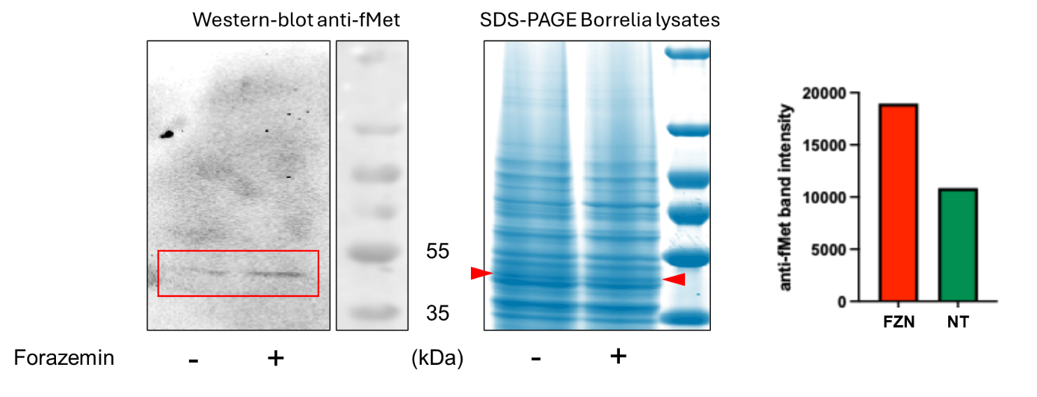
Supplementary Information Figure 1 Detection of Nt-formylated native proteins in Borrelia burgdorferi. Immunoblotting with anti-fMet (mouse monoclonal antibody that specifically detects N-terminal formylmethionine-bearing proteins) and Borrelia burgdorferi Bb1286 cells with or without 1 µg ml⁻¹ forazemin treatment. The gel with Coomassie brilliant blue staining indicates equal amounts of loaded samples.
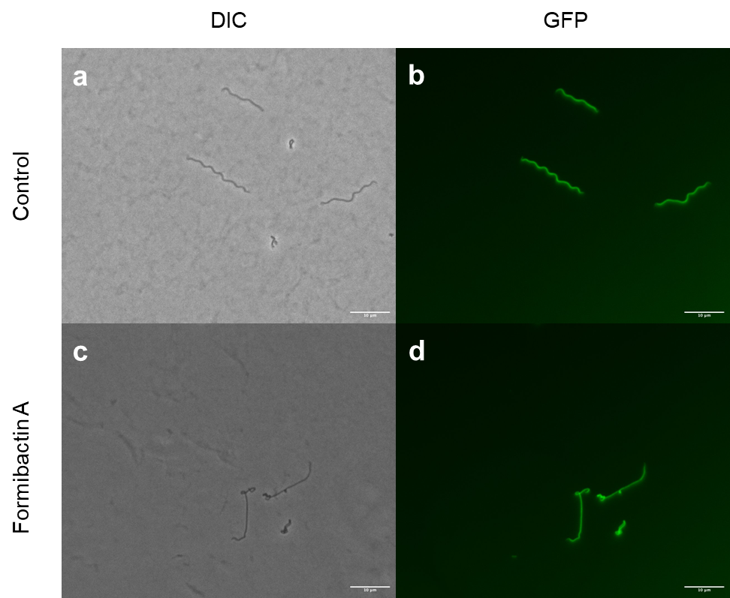
Supplementary Information Figure 2 Epifluorescence microscopy of forazemin-treated Borrelia burgdorferi. GFP-expressing B. burgdorferi Bb1286 (flaB-GFP) was treated overnight with forazemin at 10×MIC (5 µg ml⁻¹) in BSK-II medium (35 °C, 3% O₂, 5% CO₂). Cells were fixed in 2.5% glutaraldehyde on poly-L-lysine-coated coverslips. a, b, Untreated cells displaying characteristic corkscrew morphology. c, d, forazemin-treated cells exhibiting surface blebbing and loss of helical architecture. No cyst-like or pleomorphic forms were observed. Scale bars, 10 µm.
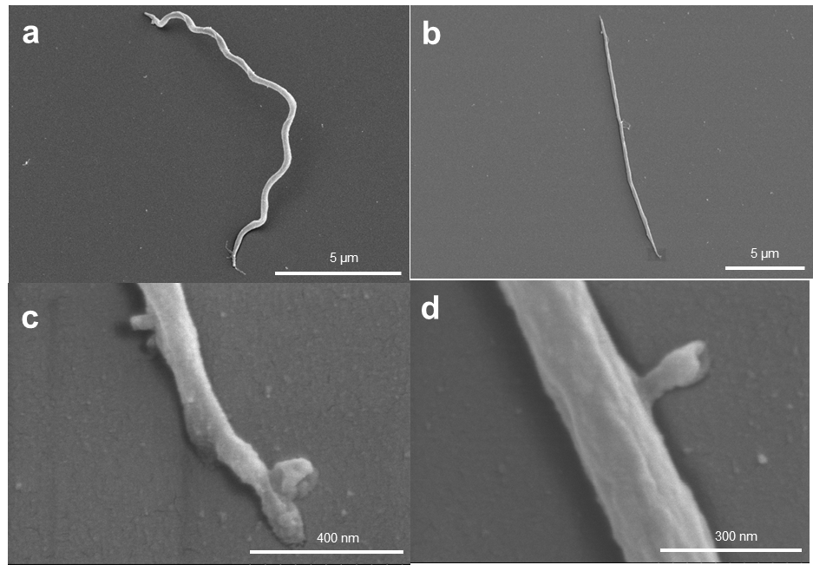
Supplementary Information Figure 3 Scanning electron microscopy of forazemin-treated Borrelia burgdorferi. B. burgdorferi Bb1286 was treated overnight with forazemin at 10×MIC (5 µg ml⁻¹) in BSK-II medium (35 °C, 3% O₂, 5% CO₂). Cells were fixed in 2.5% glutaraldehyde, post-fixed in 0.1% osmium tetroxide, dehydrated through a graded ethanol series, critical-point dried, and sputter-coated with platinum prior to imaging on a Hitachi S-4800 field-emission SEM. a, Untreated cells with intact spiral morphology. b–d, Forazemin-treated cells showing extensive surface blebbing and structural disruption. No cyst-like forms were detected. Respective scale bars is noted on each figure.

