Extended Data
Extended Data Table 1 | Minimum inhibitory concentration (MIC) of forazemin and doxycycline against Borrelia species.
Borrelia | Forazemin (µg ml⁻¹) | Doxycycline (µg ml⁻¹)
Borrelia garinii DSM 10534 | 1 | 0.5
Borrelia spielmanii DSM 16813 | 0.5 | 0.5
Borrelia californiensis DSM 17989 | 0.25 | 1
Borrelia bissettiae DSM 17990 | 1 | 1
Borrelia burgdorferi DSM 4681 | 1 | 1
Borrelia genomospecies DSM 17991 | 1 | 1
Borrelia lanei DSM 17992 | 0.25 | 2
Borrelia sinica DSM 23262 | 2 | 1
Borrelia mayonii DSM 102811 | 0.5 | 2
Borrelia lusitaniae DSM 107168 | 0.125 | 1
Borrelia kurtenbachii ATCC BAA-2495 | 0.25 | 0.5
Borrelia andersonii ATCC 700555 | 0.5 | 1
Borrelia coriaceae ATCC 43381 | 0.5 | 1
Borrelia nietonii TSD-355 | 1 | 1
Borrelia japonica ATCC 51557 | 1 | 0.5

Extended Data Fig. 1 | Time-kill kinetics of forazemin and doxycycline against Borrelia burgdorferi. Mid-logarithmic-phase B. burgdorferi B31 cultures were treated with forazemin or doxycycline at 10× MIC. Viable spirochetes were enumerated at the indicated time points by colony forming units (CFU). Data are presented as mean CFU ml⁻¹ ± s.e.m. (n = 2 biological replicates).
Extended Data Fig. 2 | Plasma pharmacokinetics of forazemin following single-dose oral administration in mice. Mice received a single oral dose of forazemin (50 mg kg⁻¹), and plasma samples were collected at the indicated time points and quantified by LC-MS/MS. Data are presented as mean plasma concentration ± s.e.m. (n = 3 mice).
Extended Data Fig. 3 | Blood-brain barrier (BBB) permeability of forazemin and comparator antibiotics assessed in a human in vitro model. An hCMEC/D3–astrocyte coculture system was used to model the BBB. Antibiotics or caffeine were added apically at 10 µg ml⁻¹ and basolateral drug accumulation was measured at the indicated time points, expressed as a percentage of the initial apical concentration. Data are presented as mean ± s.e.m. (n = 3 independent experiments). Statistical significance was determined by one-way ANOVA. P values are shown above relevant datasets.
Extended Data Fig. 4 | Fecal short-chain fatty acid levels in mice following antibiotic treatment. Fecal samples collected from mice treated with vehicle, forazemin (FZN) or doxycycline (DOX) were analyzed for total short-chain fatty acids (SCFA) content by competitive ELISA and normalized to fecal weight. Data are presented as mean ± s.e.m. Statistical significance was determined by one-way ANOVA. P values are shown above relevant datasets.
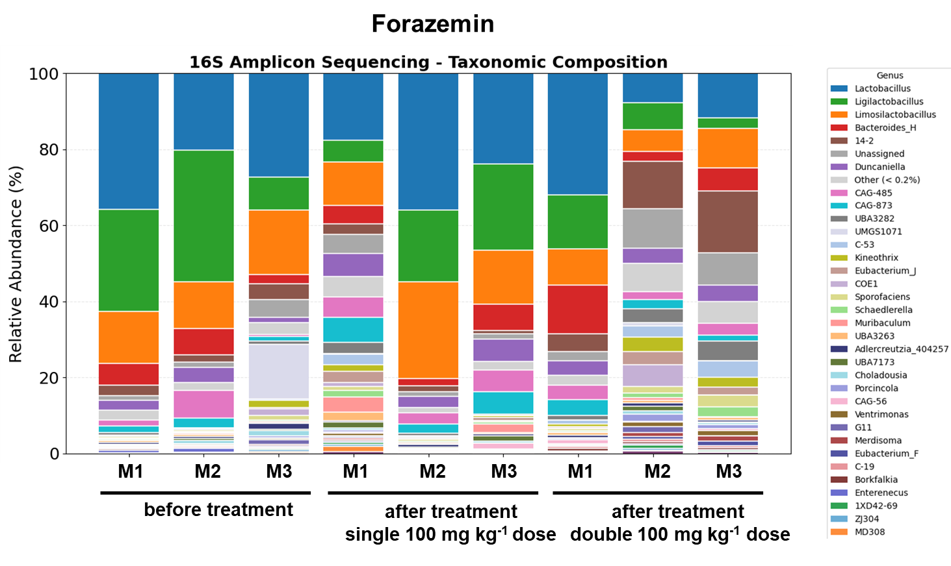
Extended Data Fig. 5 | Impact of forazemin on the murine fecal microbiome at the genus level. Fecal samples were collected from mice (n = 3) before and after treatment with a single or double dose of forazemin (100 mg kg⁻¹). Taxonomic relative abundance at the genus level is shown for each individual mouse.

