Supplementary Material

eTable 1. General Search Strategies for PubMed, Embase and Cochrane Library.

eTable 2. List of Included and Excluded Studies.

eTable 3. Sensitivity analysis for different methods of Unilateral biportal endoscopic technique for the treatment of recurrent lumbar disc herniation associated with different results.

eTable 4. Egger’s test and the trim and fill method for outcomes.

eTable 5. Complications of studies included in meta-analysis.

eFigure 1. Funnel plots for VAS-BP.

eFigure 2. Funnel plots for VAS-LP.

eFigure 3. Funnel plots for ODI scores.

eFigure 4. Funnel plots for Complications.

eTable 1. General Search Strategies for PubMed, Embase and Cochrane Library.
Text S1 Search strategy
Database: PubMed from inception to Present> (Search date: November 29, 2025)
Search Strategy:
--------------------------------------------------------------------------------
Recurrent Lumbar Disc Herniation terms (P):
#1 " Intervertebral Disc Displacement/surgery "[Mesh]
#2 (Recurrent Lumbar Disc Herniation OR rLDH OR Intervertebral Disc Displacement* OR Intervertebral Disk Displacement* OR Protruded Disc* OR Protruded Disk* OR Herniated Disc* OR Herniated Disk* OR Slipped Disc* OR Slipped Disk* OR Prolapsed Disc OR Prolapsed Disk* OR Disk Prolapse*) [Title/Abstract]
#3 #1-2/or (13,892)

Unilateral Biportal Endoscopy terms (I):
#4 " Endoscopy "[Mesh]
#5 (UBE OR Unilateral Biportal Endoscopy OR BESS OR Biportal Endoscopic Spine Surgery OR Endoscopic Surgical OR Endoscopy, Surgical) [Title/Abstract]
#6 #4-5/or (439,003)
Final search results: Combining Recurrent Lumbar Disc Herniation and Unilateral Biportal Endoscopy:
#7 #3 and #6 (1,291)

Text S2 Search strategy
Database: EMBASE from inception to Present> (Search date: November 29, 2025)
Search Strategy:
--------------------------------------------------------------------------------
Recurrent Lumbar Disc Herniation terms (P):
#1' Intervertebral Disc Hernia '/exp
#2(‘Recurrent Lumbar Disc Herniation’ OR ‘rLDH’ OR ‘Intervertebral Disc Displacement*’ OR ‘Intervertebral Disk Displacement*’ OR ‘Protruded Disc*’ OR ‘Protruded Disk*’ OR ‘Herniated Disc*’ OR ‘Herniated Disk*’ OR ‘Slipped Disc*’ OR ‘Slipped Disk*’ OR ‘Prolapsed Disc’ OR ‘Prolapsed Disk*’ OR ‘Disk Prolapse*’): ab,ti
#3 #1-2/or (35,740)

Unilateral Biportal Endoscopy terms (I):
#4 ' Endoscopy '/exp
#5(‘UBE’ OR ‘Unilateral Biportal Endoscopy’ OR ‘BESS’ OR ‘Biportal Endoscopic Spine Surgery’ OR ‘Endoscopic Surgical’ OR ‘Endoscopy, Surgical’): ab,ti
#6 #4-5/or (985,827)
Final search results: Combining Recurrent Lumbar Disc Herniation and Unilateral Biportal Endoscopy:
#7 #3 and #6 (1,408)

Text S3 Search strategy
Database: Cochrane Library from inception to Present> (Search date: November 29, 2025)
Search Strategy:
--------------------------------------------------------------------------------
Recurrent Lumbar Disc Herniation terms (P):
#1 MeSH descriptor: [Intervertebral Disc Displacement] explode all trees
#2 ((Recurrent Lumbar Disc Herniation OR rLDH OR Intervertebral Disc Displacement* OR Intervertebral Disk Displacement* OR Protruded Disc* OR Protruded Disk* OR Herniated Disc* OR Herniated Disk* OR Slipped Disc* OR Slipped Disk* OR Prolapsed Disc OR Prolapsed Disk* OR Disk Prolapse*)): ti,ab,kw (Word variations have been searched)
#3 #1-2/or (4,056)

Unilateral Biportal Endoscopy terms (I):
#4 MeSH descriptor: [Endoscopy] explode all trees
#5 ((UBE OR Unilateral Biportal Endoscopy OR BESS OR Biportal Endoscopic Spine Surgery OR Endoscopic Surgical OR Endoscopy, Surgical)): ti,ab,kw
#6 #4-5/or (31,460)
Final search results: Combining Recurrent Lumbar Disc Herniation and Unilateral Biportal Endoscopy:
#7 #3 and #6 (216)

eTable 2. List of Included and Excluded Studies.
Included and excluded reasons | No. studies | References.
Included studies | 7 | (1-7)
Review or Meta-analysis | 1 | (8)
Inadequate outcome data | 4 | (9-12)
The literature is not English | 1 | (13)
Not relevant | 17 | (14-30)
REFERENCE
1. Gao, X., et al., Case series of unilateral biportal endoscopic-assisted transforaminal lumbar interbody fusion in the treatment of recurrent lumbar disc herniation. Am J Transl Res, 2022. 14(4): p. 2383-2392.
2. Kang, M.S., et al., Clinical outcome of biportal endoscopic revisional lumbar discectomy for recurrent lumbar disc herniation. J Orthop Surg Res, 2020. 15(1): p. 557.
3. Guo, C., et al., Early Clinical and Radiologic Evaluation of Unilateral Biportal Spinal Endoscopy for Recurrent Lumbar Disc Herniation: A Retrospective Study. World Neurosurg, 2025. 203: p. 124499.
4. Gong, S., et al., Endoscopic Discectomy and Annulus Suture in Recurrent Lumbar Herniation: A Retrospective Analysis. Med Sci Monit, 2025. 31: p. e947282.
5. Zhang, Y., et al., Risk factors for recurrent lumbar disc herniation after unilateral biportal endoscopy: a retrospective study. Int Orthop, 2025. 49(8): p. 1963-1971.
6. Kang, M.S., et al., Comparison of Primary Versus Revision Lumbar Discectomy Using a Biportal Endoscopic Technique. Global Spine J, 2023. 13(7): p. 1918-1925.
7. Han, S.Y., et al., Feasibility of Recurrent Herniation Surgery with Biportal Endoscopic Discectomy : A Comparison of Biportal Endoscopic Discectomy and Microscopic Discectomy for Recurrent Disc Herniation. J Korean Neurosurg Soc, 2026.
8. Xie, X., G. Zhang, and N. Liu, Clinical effect of unilateral biportal endoscopy in the treatment of lumbar diseases: a systematic review and meta-analysis. Wideochirurgia I Inne Techniki Maloinwazyjne, 2022. 17(1): p. 61-68.
9. Zhu, X., et al., Clinical observation of unilateral biportal endoscopy surgery for highly free type lumbar disc herniation. Chinese Journal of Anatomy and Clinics, 2023. 28(5): p. 313-319.
10. Byval'tsev, V.A., et al., [Comparative analysis of effectiveness of endoscopic, microsurgical and endoscopic-assisted diskectomy in treatment of patients with lumbar intervertebral disk herniations]. Zh Vopr Neirokhir Im N N Burdenko, 2010(4): p. 20-6; discussion 26.
11. Arestov, S.O., A.V. Vershinin, and A.O. Gushcha, A comparative analysis of the effectiveness and potential of endoscopic and microsurgical resection of disc herniations in the lumbosacral spine. Zh Vopr Neirokhir Im N N Burdenko, 2014. 78(6): p. 9-14.
12. Wei, H., et al., Comparative Study of Three Minimally Invasive Surgical Approaches for the Treatment of L5/S1 Lumbar Intervertebral Disc Herniation. Turk Neurosurg, 2021. 31(3): p. 324-332.
13. Tang, Q., et al., [A comparative study on the clinical efficacy and safety of unilateral biportal endoscopy versus percutaneous transforaminal endoscopic discectomy in the treatment of recurrent lumbar disc herniation]. Zhonghua Wai Ke Za Zhi, 2025. 63(9): p. 814-820.
14. Do, H.M., H.T.N. Doan, and L.H. Nguyen, 1 Year-follow-up of transforaminal surgical approach in the management of migrated disc herniation: a cross-sectional study. Annals of Medicine and Surgery, 2023. 85(8): p. 3827-3832.
15. Li, Y., et al., Adjuvant surgical decision-making system for lumbar intervertebral disc herniation after percutaneous endoscopic lumber discectomy: a retrospective nonlinear multiple logistic regression prediction model based on a large sample. Spine J, 2021. 21(12): p. 2035-2048.
16. Yue, L., et al., [Analysis of surgical strategy of percutaneous endoscopic lumbar discectomy in young and middle-aged double-segment patients with lumbar disc herniation]. Beijing Da Xue Xue Bao Yi Xue Ban, 2021. 53(4): p. 734-739.
17. Zhang, B., et al., Analysis of the Causes and Treatment of Surgical Site Infection in Unilateral Biportal Endoscopy for Lumbar Disc Herniation. World Neurosurgery, 2025. 200.
18. Zhang, B., et al., Analysis of the Causes and Treatment of Surgical Site Infection in Unilateral Biportal Endoscopy for Lumbar Disc Herniation. World Neurosurg, 2025. 200: p. 124229.
19. Jiang, Y., et al., [Analysis on clinical effects of two surgical approaches in percutaneous spinal endoscopy for L(5)S(1) disc herniation]. Zhongguo Gu Shang, 2020. 33(5): p. 406-13.
20. Zhang, X., et al., Biomechanical changes in lumbar intervertebral discs after percutaneous endoscopic transforaminal discectomy surgery at different Body Mass Index (BMI) categories. J Orthop Surg Res, 2024. 19(1): p. 875.
21. Yuan, C., B. Wen, and H. Lin, Clinical Analysis of Minimally Invasive Percutaneous Treatment of Severe Lumbar Disc Herniation with UBE Two-Channel Endoscopy and Foraminal Single-Channel Endoscopy Technique. Oxid Med Cell Longev, 2022. 2022: p. 9264852.
22. Yan, T.Z., et al., [Comparision of surgical outcomes between percuteneous endoscopic interlaminar discectomy and fenestration discectomy for L₅S₁ lumbar disc herniation]. Zhongguo Gu Shang, 2019. 32(10): p. 933-936.
23. Zuo, R., et al., [Comparison of effectiveness of unilateral biportal endoscopy technique and the interlaminar uniportal endoscop technique for treatment of L (5), S (1) lumbar disc herniation]. Zhongguo Xiu Fu Chong Jian Wai Ke Za Zhi, 2022. 36(10): p. 1192-1199.
24. Chang, H., et al., Comparison of full-endoscopic foraminoplasty and lumbar discectomy (FEFLD), unilateral biportal endoscopic (UBE) discectomy, and microdiscectomy (MD) for symptomatic lumbar disc herniation. Eur Spine J, 2023. 32(2): p. 542-554.
25. Li, L., et al., Comparison of percutaneous endoscopic lumbar discectomy (PELD) and unilateral biportal endoscopic (UBE) discectomy in the treatment of far lateral lumbar disc herniation (FLLDH): a retrospective study. J Orthop Surg Res, 2025. 20(1): p. 510.
26. Yu, P., et al., Comparison of Percutaneous Transforaminal Endoscopic Discectomy and Microendoscopic Discectomy for the Surgical Management of Symptomatic Lumbar Disc Herniation: A Multicenter Retrospective Cohort Study with a Minimum of 2 Years' Follow-Up. Pain Physician, 2021. 24(1): p. E117-e125.
27. Choi, K.C., et al., Comparison of Surgical Invasiveness Between Microdiscectomy and 3 Different Endoscopic Discectomy Techniques for Lumbar Disc Herniation. World Neurosurg, 2018. 116: p. e750-e758.
28. Katayama, Y., et al., Comparison of surgical outcomes between macro discectomy and micro discectomy for lumbar disc herniation: a prospective randomized study with surgery performed by the same spine surgeon. Journal of spinal disorders & techniques, 2006. 19(5): p. 344‐347.
29. Yao, Y., et al., Comparison of Three Minimally Invasive Spine Surgery Methods for Revision Surgery for Recurrent Herniation After Percutaneous Endoscopic Lumbar Discectomy. World Neurosurg, 2017. 100: p. 641-647.e1.
30. Li, H., et al., Computed Tomography- (CT-) Based Virtual Surgery Planning for Spinal Intervertebral Foraminal Assisted Clinical Treatment. J Healthc Eng, 2021. 2021: p. 5521916.

eTable 3. Sensitivity analysis for different methods of Unilateral biportal endoscopic technique for the treatment of recurrent lumbar disc herniation associated with different results.

Study omitted | Pooled relative risk (95% CI) | Heterogeneity estimate (P value)
Complication
Min-Seok Kang (2020) (a) | 0.036 (0.015, 0.057) | 0.000
Min-Seok Kang (2020) (b) | 0.036 (0.015, 0.056) | 0.000
Min-Seok Kang (2023) (a) | 0.036 (0.015, 0.058) | 0.000
Min-Seok Kang (2023) (b) | 0.036 (0.015, 0.058) | 0.000
Sang Youp Han (2025) (a) | 0.034 (0.013, 0.056) | 0.000
Sang Youp Han (2025) (b) | 0.036 (0.014, 0.058) | 0.000
Xiangcheng Gao (2022) | 0.036 (0.014, 0.058) | 0.000
Chunliang Guo (2025) (a) | 0.037 (0.015, 0.060) | 0.000
Chunliang Guo (2025) (b) | 0.048 (0.022, 0.074) | 0.000
VAS-BP
Immediate Postoperation
Min-Seok Kang (2020) | -3.59 (-4.81, -2.37) | 0.000
Min-Seok Kang (2023) | -3.60 (-4.86, -2.34) | 0.000
Sang Youp Han (2025) | -3.85 (-5.28, -2.41) | 0.000
Yaoshen Zhang (2025) | -4.31 (-5.34, -3.28) | 0.000
Xiangcheng Gao (2022) | -4.09 (-5.48, -2.71) | 0.000
Shuangquan Gong (2025) | -3.78 (-5.17, -2.38) | 0.000
Chunliang Guo (2025) | -4.05 (-5.46, -2.63) | 0.000
Last Postoperation
Min-Seok Kang (2020) | -5.01 (-7.24, -2.78) | 0.000
Min-Seok Kang (2023) | -4.99 (-7.24, -2.75) | 0.000
Sang Youp Han (2025) | -4.23 (-5.49, -2.96) | 0.000
Yaoshen Zhang (2025) | -5.68 (-7.39, -3.97) | 0.000
Xiangcheng Gao (2022) | -5.22 (-7.45, -2.98) | 0.000
Shuangquan Gong (2025) | -5.14 (-7.38, -2.90) | 0.000
Chunliang Guo (2025) | -5.21 (-7.45, -2.98) | 0.000
VAS-LP
Immediate Postoperation
Min-Seok Kang (2023) | -3.40 (-5.70, -1.10) | 0.004
Sang Youp Han (2025) | -4.49 (-6.10, -2.87) | 0.000
Yaoshen Zhang (2025) | -3.95 (-6.41, -1.49) | 0.002
Xiangcheng Gao (2022) | -3.77 (-6.25, -1.29) | 0.003
Shuangquan Gong (2025) | -3.07 (-4.84, -1.30) | 0.001
Chunliang Guo (2025) | -3.91 (-6.38, -1.45) | 0.002
Last Postoperation
Min-Seok Kang (2023) | -5.77 (-8.15, -3.39) | 0.000
Sang Youp Han (2025) | -4.88 (-6.23, -3.53) | 0.000
Yaoshen Zhang (2025) | -6.26 (-8.26, -4.25) | 0.000
Xiangcheng Gao (2022) | -5.99 (-8.29, -3.68) | 0.000
Shuangquan Gong (2025) | -5.39 (-7.56, -3.21) | 0.000
Chunliang Guo (2025) | -6.03 (-8.31, -3.76) | 0.000
ODI
Immediate Postoperation
Min-Seok Kang (2023) | -3.42 (-5.26, -1.57) | 0.000
Xiangcheng Gao (2022) | -4.72 (-8.44, -1.00) | 0.013
Shuangquan Gong (2025) | -3.46 (-5.78, -1.14) | 0.003
Chunliang Guo (2025) | -5.12 (-7.83, -2.41) | 0.000
Last Postoperation
Min-Seok Kang (2023) | -3.85 (-6.30, -1.40) | 0.002
Xiangcheng Gao (2022) | -5.04 (-7.59, -2.49) | 0.000
Shuangquan Gong (2025) | -3.81 (-6.11, -1.51) | 0.001
Chunliang Guo (2025) | -5.10 (-7.52, -2.68) | 0.000

eTable 4. Egger’s test and the trim and fill method for outcomes.
Outcome | Effect Size (95% CI) | T-F adjusted Effect Size (95% CI) | Number of Filled Studies
ODI
Immediate postoperation | -4.20 (-6.64, -1.75) | -1.99 (-5.11, 1.13) | 2
Last postoperation | -4.44 (-6.55, -2.34) | -3.55 (-5.89, -1.21) | 1
VAS-BP
Immediate postoperation | -3.59 (-4.81, -2.37) | -1.97 (-3.75, -0.19) | 3
Last postoperation | -5.01 (-7.24, -2.78) | -2.37 (-5.47, 0.73) | 3
VAS-LP
Immediate postoperation | -3.76 (-5.78, -1.75) | -2.38 (-4.69, -0.07) | 2
Last postoperation | -5.72 (-7.65, -3.79) | -3.60 (-6.11, -1.09) | 3
OT | 99.59 (72.15, 127.03) | 99.59 (72.15, 127.03) | 0
BL | 66.59 (44.14, 89.03) | 66.59 (44.14, 89.03) | 0
LOS | 4.54 (3.22, 5.86) | 4.54 (3.22, 5.86) | 0
Complications | 0.04 (0.02, 0.05) | 0.03 (0.01, 0.05) | 5
Abbreviations: ODI = Oswestry Disability Index; VAS-BP = Visual Analog Scale for Back Pain; VAS-LP = Visual Analog Scale for Leg Pain; OT = Operation Time; BL = Blood Loss; LOS= Length of Stay; CI = Confidence Interval; SMD = Standardized Mean Difference; WMD = Weighted Mean Difference; T-F = Trim and Fill.
Note: The Trim and Fill method (Duval and Tweedie, 2000) was used to assess and adjust for potential publication bias. The method estimates the number of missing studies due to publication bias and recalculates the effect size after imputing these hypothetical studies. SMD was used for ODI, VAS-BP, and VAS-LP outcomes; WMD was used for OT, BL, and LOS outcomes.

eTable 5. Complications of studies included in meta-analysis.
First author (Year) | Sample size | Type of Complications | Number of complications | Rate of Complications
Kang, M. S. (2020) | 16 | Incidental durotomy | 1 | 6.25%
 |  | Local recurrence | 2 | 12.50%
Min-Seok Kang (2023) | 22 | Incidental durotomy | 1 | 4.55%
 |  | Epidural hematoma | 1 | 4.55%
Sang Youp Han (2025) | 44 | Dural tear | 3 | 6.82%
 |  | Wound dehiscence | 2 | 4.55%
Yaoshen Zhang (2025) | 205 | NR
Xiangcheng Gao (2022) | 44 | Dural rupture | 2 | 4.55%
Shuangquan Gong (2025) | 21 | NR
Chunliang Guo (2025) | 57 | Dural tear | 2 | 3.51%
 |  | Iatrogenic spinal instability | 1 | 1.75%

eFigure 1. Funnel plots for VAS-BP.
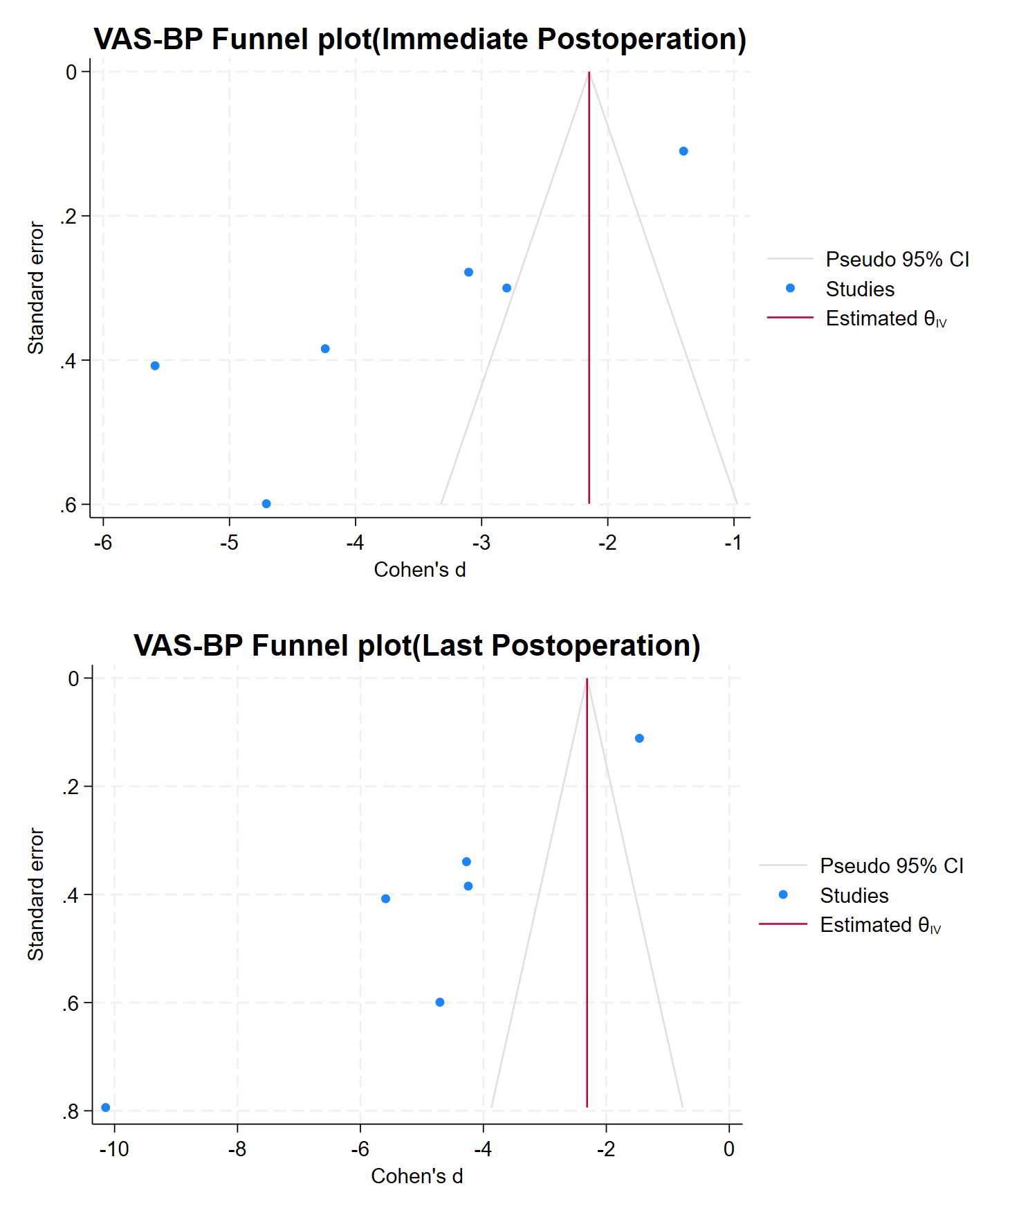
eFigure 2. Funnel plots for VAS-LP.
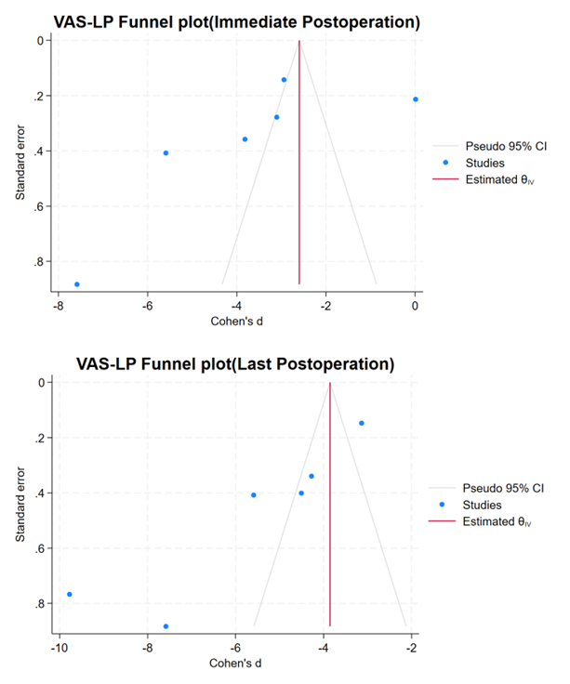
eFigure 3. Funnel plots for ODI scores
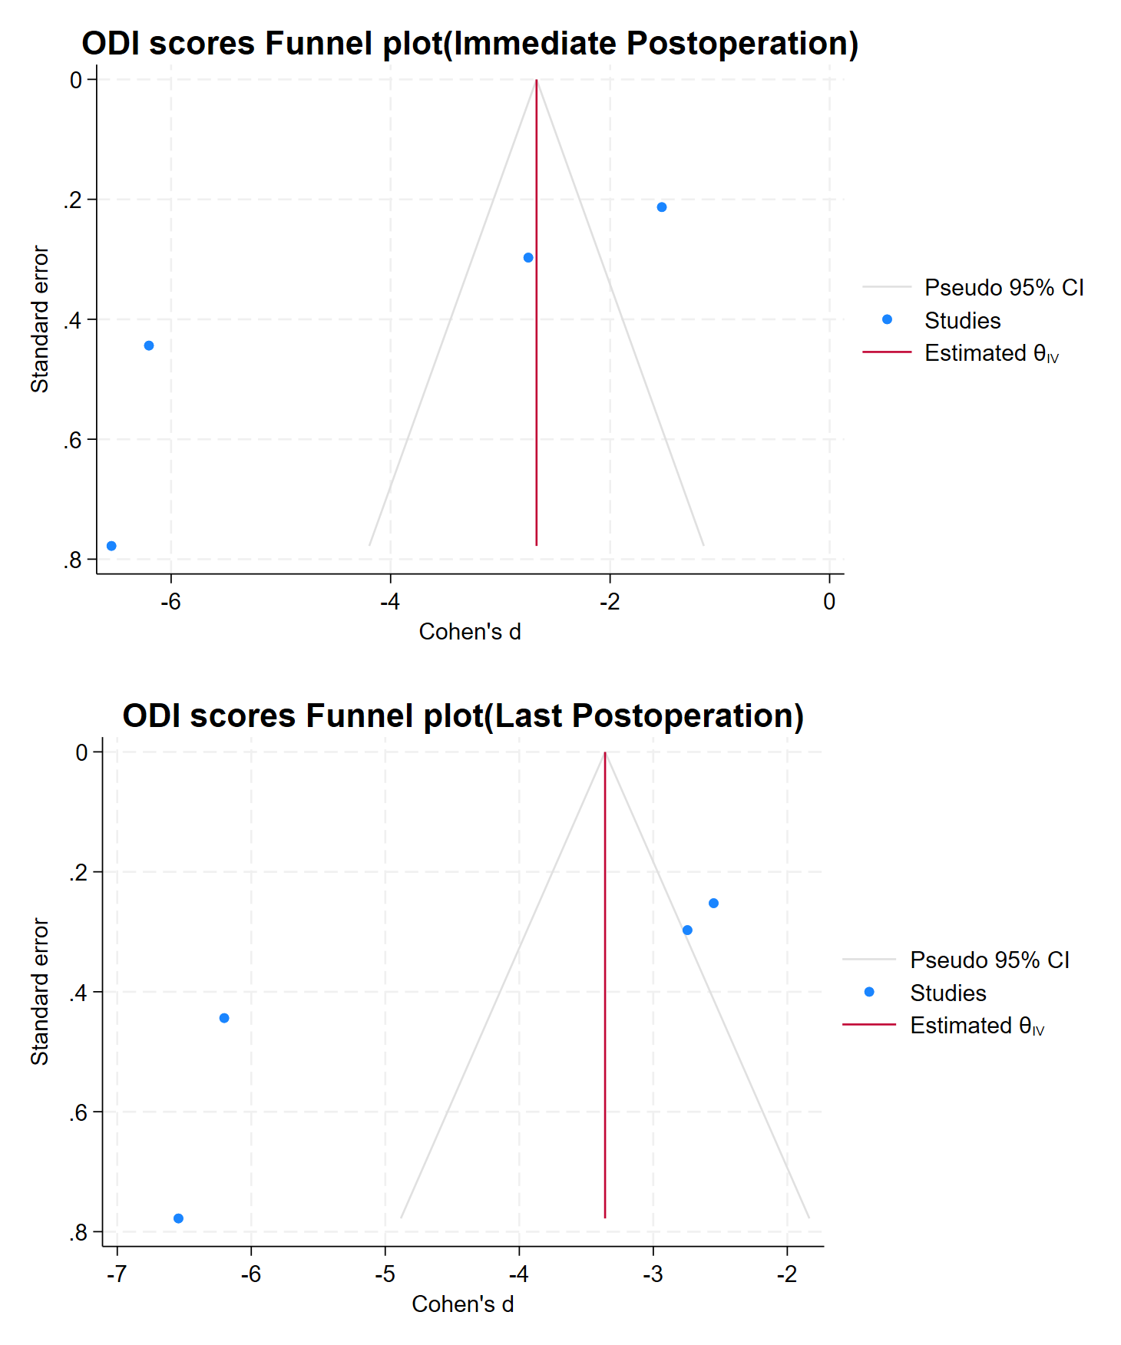
eFigure 4. Funnel plots for Complications.
