Fig.S3 Sensitivity Analysis: Odds Ratios for Network Meta-Analysis Comparisons in Pediatric Populations
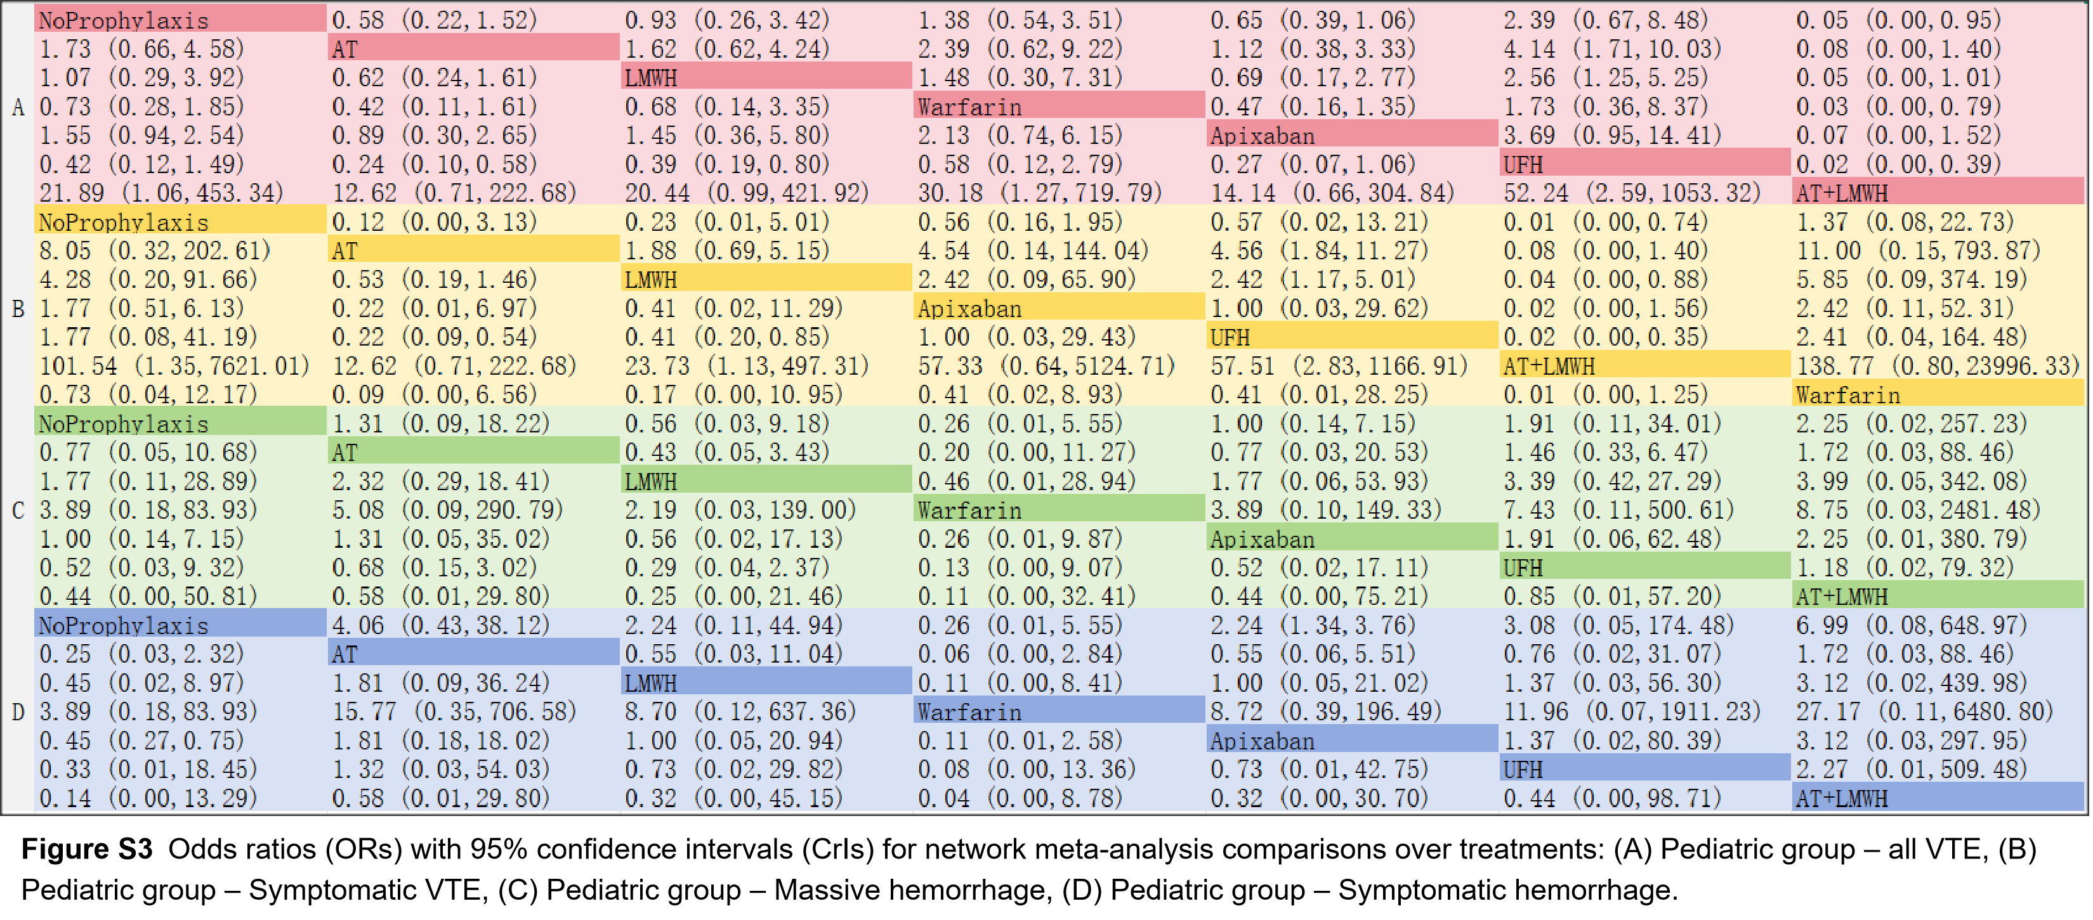

Fig.S4 Sensitivity Analysis: Ranking Probabilities (SUCRA) for Outcomes in Pediatric Populations
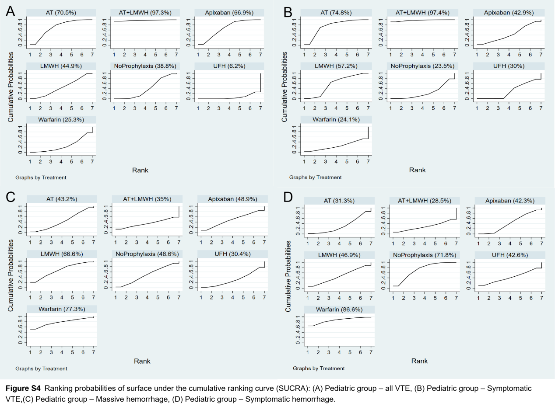

Fig. S5 Sensitivity Analysis: Forest Plots of Network Meta-Analysis in Adult Populations
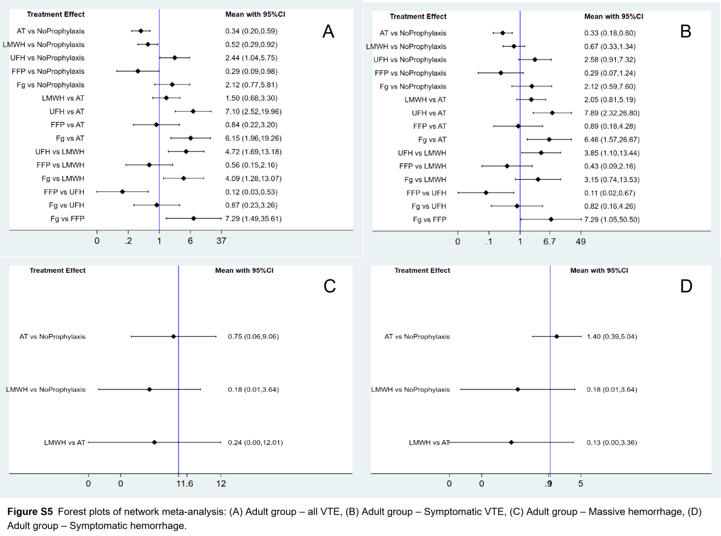

Fig. S7 Funnel Plot for Publication Bias in the Pediatric Group
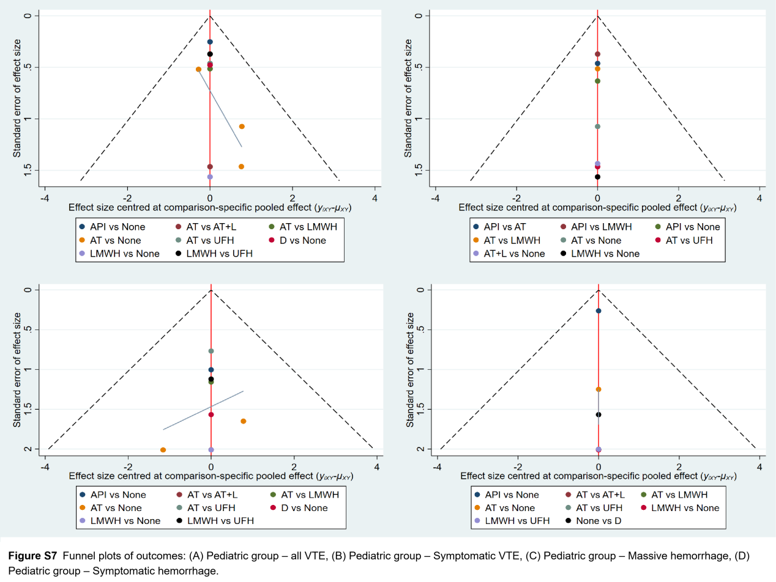

Fig. S8 Funnel Plot for Publication Bias in the Adult Group
