Circadian Rhythm Disruption Aggravates Periodontitis by Promoting M1 Polarization via BMAL1 / IGF-1 signaling axis
Supplementary Materials and Methods
Animals
Periodontitis models with circadian disturbance: 6-week-old male C57BL/6J mice were randomly assigned to standard LD12:12 (8 a.m. - 8 p.m.) or jet lag conditions (each n = 16). Mice in the jet lag group were housed in an environment with a varying light cycle, with the start of lighting being advanced by 8 h every 2–3 days for eight weeks (1) ( Appendix Fig.1). Eight weeks later, eight mice were randomly selected from the LD12: 12 and jet lag groups. A 5-0 silk ligature was tied around mice's bilateral maxillary second molars for a week to induce ligature-induced periodontitis.
Bmal1-/- periodontitis model: Homozygous BMAL1 deficient (Bmal1-/-) rats on an SD background were generated by mating heterozygous BMAL1-deficient mating pairs (Bmal1+/-). BMAL1 deficiency was confirmed by multiplex PCR as described by Bunger and Ye ((2,3)) (Appendix Fig.2). Eight Bmal1-/-rats and eight wild-type rats were selected randomly. Periodontitis was induced by ligating maxillary second molars with 3-0 ligature for four weeks.
Chronotherapy: 6-week-old C57BL/6J male mice were randomly assigned to control and treatment groups (each n = 8). Periodontitis was induced for one week, as previously described. SR1078 agonist (20 µM, 100 µL) was administered intraperitoneally to the treatment group, whereas comparable normal saline was administered to the control group. Injections started on the day of ligation.
In this study, a single mouse was defined as the experimental unit. The sample size was determined with reference to previous animal studies on periodontitis (4–6). All animals were subjected to weight-based block randomization using a computer-generated random sequence prior to the experiment and allocated to either the control group or experimental group. Strict blinding was implemented during both the model establishment phase (silk ligation surgery) and the assessment of primary outcomes (e.g., micro-CT analysis, histology, immunohistochemistry and immunofluorescence staining): both the surgical operator and outcome assessors were blinded to group allocation until all data collection and analysis were completed. Animals were housed in a specific pathogen-free (SPF) facility, and the experimental protocol was approved by the Animal Ethics Committee of Huazhong University of Science and Technology (Approval No.: [3448]). Predefined exclusion criteria stipulated that data from any mouse in the model group whose ligature was shed before the planned observation endpoint would be excluded; in this study, all ligatures remained intact at the time of specimen collection in the model group.
Animals were euthanized with an overdose of pentobarbital sodium when the endpoint was reached. The maxilla and surrounding tissue were carefully excised and fixed for 24 h in a 4% paraformaldehyde solution.
Histology, Immunohistochemistry and immunofluorescence staining
The maxillary samples of murine were fixed, decalcified, and paraffin-embedded. Paraffin-embedded sections were sequentially deparaffinized in xylene, dehydrated in ethanol and incubated in citrate buffer for 10 minutes at 90°C to unmask antigens. Hematoxylin and eosin staining was performed for histological and histomorphometric analysis. For immunohistochemistry analysis, Tissue Staining Kits (R&D systems) were used to detect the antigens in the specimens according to the manufacturer’s standard procedure. The primary antibodies used was an anti-IL-1β antibody (1:100; 26048-1-AP; Proteintech) or anti-IL-10 antibody (1:100; 60269-1-Ig; Proteintech).
For immunofluorescence, paraffin-embedded sections were blocked with 3% (w/v) bovine serum albumin (BSA) then incubated with primary antibodies and fluorescent secondary antibodies, finally counterstained with DAPI (62248, Thermo Scientific). The anti-fluorescence quencher was used to seal the sections. Primary antibodies used in the Immunofluorescence were: anti-BMAL1 (1:200, ab93806; Abcam), anti-CD68 (1:200, ab955; Abcam), anti-CD86 (1:200, 13395-1-AP; Proteintech), anti-CD206 (1:200, 18704-1-AP; Proteintech).
Protein extraction and Western blotting Assay
Protein was extracted with RIPA lysis buffer containing protease and phosphatase inhibitors (Beyotime Biotechnology, Wuhan, China). Protein concentrations were determined using the BCA protein assay kit (Beyotime Biotechnology, Wuhan, China). An equal amount of protein from each specimen was subjected to electrophoresis on a 10% (w/v) sodium dodecyl sulfate-polyacrylamide gel and subsequently transferred onto nitrocellulose membrane. The membranes were incubated overnight with primary antibodies, including anti-IGF-1 (1:2000, ab9572; Abcam), or anti-β-actin (1:10000, 20536-1-AP; Proteintech) at 4 °C. The membranes were next incubated with biotinylated secondary antibodies (Proteintech). ECL enhanced chemiluminescence substrate kit (Millipore) was used for imaging and quantitation by the Image J software.
Cell immunofluorescence staining
Raw264.7 cells were plated at a density of 1×10⁵ cells per well in 6-well plates with cell slides, and the cell confluent was about 30%-50%, prior to treatment with compression. Cells were fixed and stained with antibodies of anti-INOS (1:200, 18985-1-AP; Proteintech) or anti-CD206 antibody (1:200, 18704-1-AP; Proteintech) to detect the protein expression in Raw264.7 cells. Then, the slides were incubated with fluorescein isothiocyanate-conjugated secondary antibodies (1:200, SA00013-2; Proteintech). Cell nuclei were counterstained with 4′, 6-diamidino-2-phenylindole (DAPI; Beyotime Biotech., Wuhan, China).
Cell transfection
Viral packaging was purchased from Genechem Co., Ltd. (Shanghai, China). For viral inoculation, Raw264.7 cells were incubated with the viral supernatants (MOI = 50) in complete medium for 48-hr. Medium was changed to standard culture media 48-hr post infection. For BMAL1 overexpression, cells were infected with recombinant lentivirus particle pLV-CMV-mARNTL-Puro. For BMAL1 knockdown, cells were infected with recombinant lentivirus particles pLentiCRISPRV2-U6-ARNTL(mouse)-sgRNA-Cas9-Puro.
Flow Cytometry
After treatment, the Raw264.7 cells were washed and stained for 30 min at 4°C with CD86-PE (BioLegend) antibodies to characterize the M1 polarization of macrophages, CD206-APC (BioLegend) antibodies to characterize the M2 polarization of macrophages, Labeling was quantified using a BD Accuri C6 Flow Cytometer, and data were analyzed with the FlowJo software packages (TreeStar).
Quantitative real-time PCR
Total RNA was isolated from cells or tissues with TRIZOL (Vazyme, Nanjing, China) according to the manufacturer’s instructions and was reverse-transcribed with the HiScript II Q RT SuperMix for qPCR kit (Vazyme, Nanjing, China) to synthesize complementary DNA (cDNA). Real-time polymerase chain reaction (PCR) assays were performed using SYBR Green PCR Master Mix (Vazyme, Nanjing, China) in PCR Thermocycle Instrument (Applied Biosystems). The relative expression level was analyzed by the 2^{−ΔΔCt} method, normalized to expression of GAPDH. The primer sequences are listed below:
Gene (Human) | Forward（5，-3，） | Reverse（5，-3，）
BMAL1 | GGATGTGACCGAGGGAAGAT | CGTCGTGCTCCAGAACATAAT
CLOCK | AGGGCACCACCCATAATAGG | TTGCCCCTTAGTCAGGAACC
GAPDH | ATCCCATCACCATCTTCC | ATGACCCTTTTGGCTCCC
PER1 | AGCAGCAAGAGCACAAAC | GCTCCGAAATGTAGACGA
PER2 | ACTATTCTCCCATTCGGTT | AGGTCTGGCTCATAAGGT
CRY1 | AAGCACTTACTCGTTTGG | AAGCGTGGATTATTTGTT
CRY2 | TGTTCCCAAGGCTGTTCA | AGGTCTCGTCGTGGTTCT
Gene (Mouse) | Forward（5，-3，） | Reverse（5，-3，）
IGF-1 | GGACCGAGGGGCTTTTAC | TAGAGCGGGCTGCTTTTG
IL-6 | TTGGGACTGATGCTGGTGAC | GTGGTATAGACAGGTCTGTT
GAPDH | GGTGAAGGTCGGTGTGACCG | CTCGCTCCTGGAAGATGGTG
CD206 | ACCCAAGGGCTCTTCTAA | TGGCCTCTTGAGGTATGT
IL-1β | AAGAAGAGCCCATCCTCTGTG | TGTTCATCTCGGAGCCTGTAG
TNF-α | CGTCGTAGCAAACCACCAAG | GACAAGGTACAACCCATCGG
INOS | GAGCGAGTTGTGGATTGT | GCAGCCTCTTGTCTTTGA
TGF-β | CGAAGCGGACTACTATGC | TGTGAGATGTCTTTGGTTTT
Chromatin immunoprecipitation assay
Chromatin immunoprecipitation assays were performed using Chromatin Immunoprecipitation Kit (Millipore) according to the procedures provided by the manufacturer. Chromatin solutions were precipitated using normal rabbit IgG as negative control, anti-BMAL1 (1:200, ab93806; Abcam) at 4 ℃ overnight. Precipitates were detected by real-time quantitative polymerase chain reaction (qPCR). The primer sequences used for detecting BMAL1 binding to the IGF-1 promoter region are shown below:
5’-GATTCGCTGTGTTGGCACTGATG-3’ (forward) / 5’-CAGCACGGCACAGCATAACTAT-3’ (reverse).
Luciferase reporter assay
293T cells were co-transfected with firefly and pRL-SV40 renilla luciferase reporter vectors (Promega) using lipofectamine 3000 (Thermo Fisher Scientific). Cells extracts were harvested post 48-hr transfection. The luminescence intensity induced by firefly and renilla luciferase was detected by the dual luciferase reporter assay system (Promega). For IGF-1 promoter activity, the luciferase signal was standardized according to the firefly/renilla ratio.
Supplementary Figures and Figure Legends
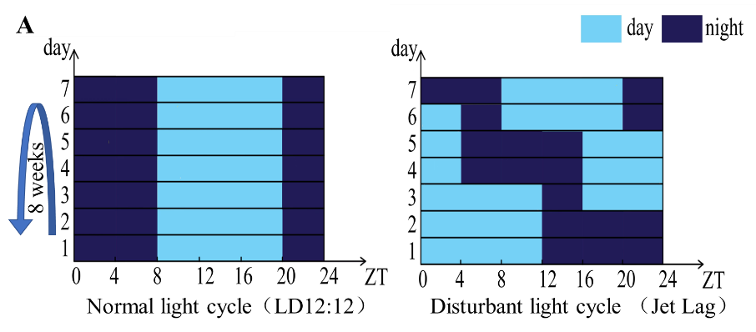
Appendix Figure 1. (A) Construction of the model for circadian rhythm disorder.
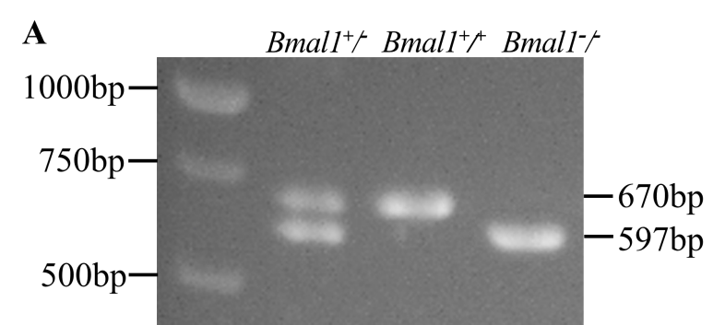
Appendix Figure 2. (A) Genotype identification of Bmal1^{-/-} rats.
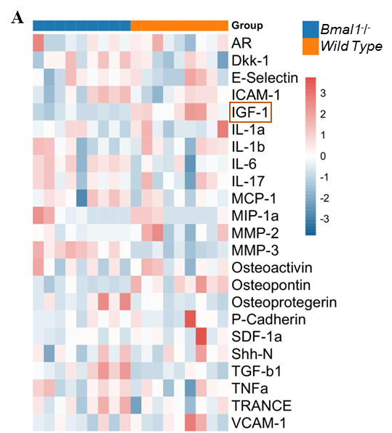
Appendix Figure 3. (A) Heat map of protein chip in periodontal tissue of Bmal 1^{-/-} mice aged 8-10 weeks (n=9)
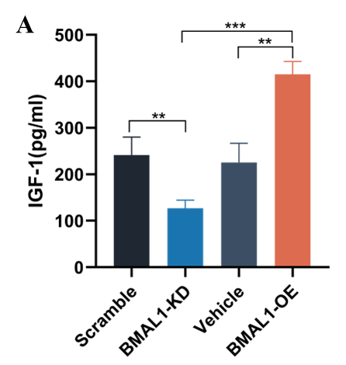
Appendix Figure 4. (A) Elisa detected the concentration of IGF-1 in the supernatant of macrophages with BMAL1 knockdown/overexpression.

References
1. Zhao J, Zhou X, Tang Q, Yu R, Yu S, Long Y, et al. BMAL1 Deficiency Contributes to Mandibular Dysplasia by Upregulating MMP3. Stem Cell Reports. 2018 Jan;10(1):180–95. doi:10.1016/j.stemcr.2017.11.017
2. Ye L, Mei G, Liu H, Zhong R, Tang Q, Yuan Z. Circadian rhythm disruption aggravates alveolar bone loss in rat apical periodontitis. Int Endod J. 2025 May;58(5):744–56. doi:10.1111/iej.14201 PubMed PMID: 39871453.
3. Bunger MK, Wilsbacher LD, Moran SM, Clendenin C, Radcliffe LA, Hogenesch JB, et al. Mop3 Is an Essential Component of the Master Circadian Pacemaker in Mammals. Cell. 2000 Dec 22;103(7):1009–17. PubMed PMID: 11163178; PubMed Central PMCID: PMC3779439.
4. Wu X, Chen H, Wang Y, Gu Y. Akt2 Affects Periodontal Inflammation via Altering the M1/M2 Ratio. J Dent Res. 2020 May;99(5):577–87. doi:10.1177/0022034520910127
5. Han Y, Huang Y, Gao P, Yang Q, Jia L, Zheng Y, et al. Leptin Aggravates Periodontitis by Promoting M1 Polarization via NLRP3. J Dent Res. 2022 Jun;101(6):675–85. doi:10.1177/00220345211059418
6. Ma XX, Meng XQ, Wang YL, Liu Y, Shi XR, Shao S, et al. Ncor1 Deficiency Promotes Osteoclastogenesis and Exacerbates Periodontitis. J Dent Res. 2023 Jan;102(1):72–81. doi:10.1177/00220345221116927

