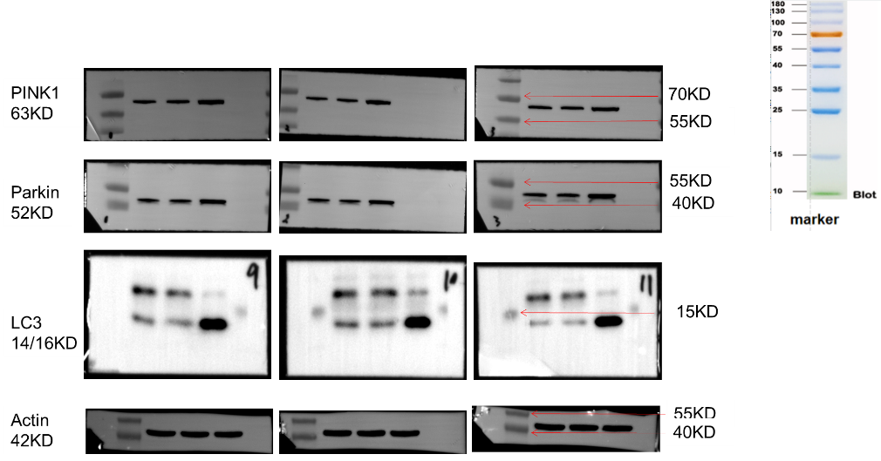
Fig.1. LC3Ⅱ/Ⅰ, PINK1, and Parkin protein levels assessed using Western blotting (in vitro), with Actin protein serving as a loading control.
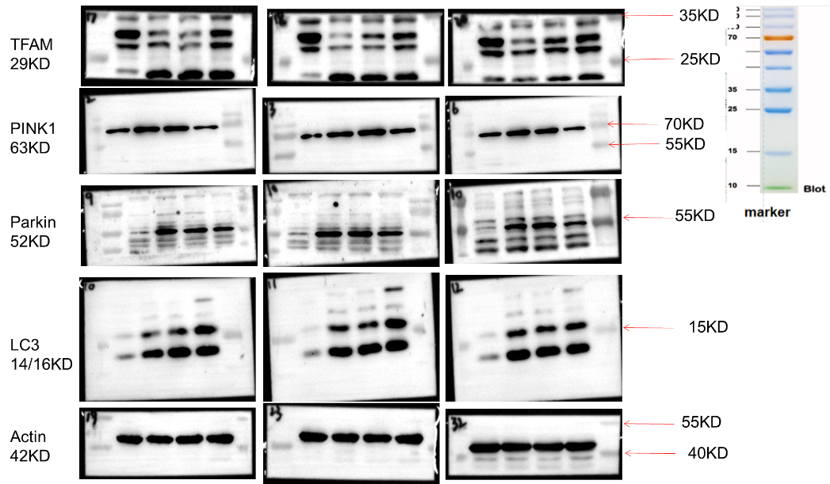
Fig.2. TFAM, LC3Ⅱ/Ⅰ, PINK1, and Parkin protein levels assessed using Western blotting (in vivo), with Actin protein serving as a loading control.

