Supplementary Information
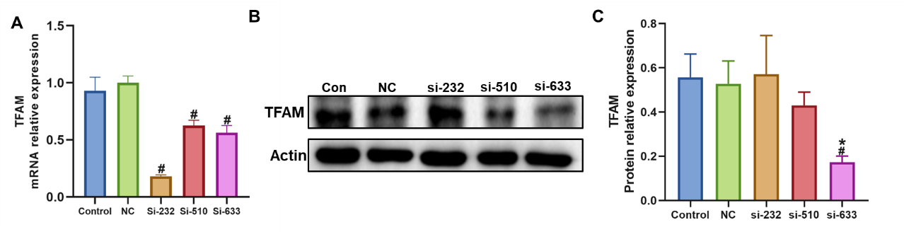
Supplementary Figure 1
Establishment of the cellular interference model. (A) Expression levels of TFAM mRNA in each cell group. (B) TFAM protein expression assessed using Western Blotting (WB), with Actin protein serving as a loading control. (C) Statistical analysis of the protein expression levels of TFAM. According to WB and RT-qPCR, the interference sequence si-633 has a better effect.
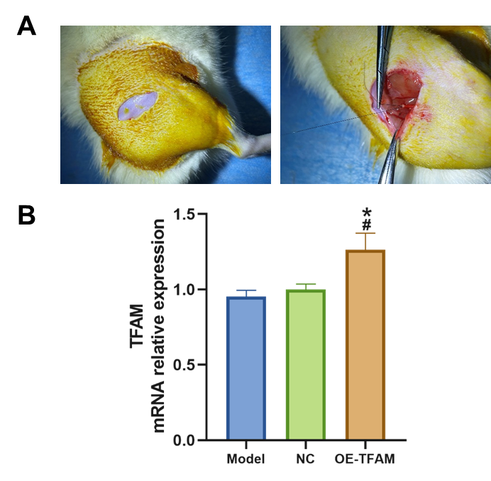
Supplementary Figure 2
Establishment of Animal Models. A. Establishment of skin incision and denervation models; B. Expression levels of TFAM mRNA in each group.

