Supplementary Figures
Age-dependent normative centile curves for different indices and ratios across all 19 electrodes of the 10–20 system. Each panel corresponds to one electrode, arranged in approximate anatomical order from anterior (top) to posterior (bottom). Individual observations from the HarMNqEEG normative database (n = 1,564; ages 5–97 years) are shown as grey circles. The solid red line indicates the normative mean (μ) estimated by GAMLSS with P-spline smoothers on log(age). The shaded grey band represents the ±1.96σ normative interval, corresponding to the 2.5th–97.5th centile range under the fitted conditional distribution. Dashed lines mark the outer ±1.96σ bounds. The x-axis is displayed on a logarithmic scale.

Sup. Figure 1. Theta/Beta Ratio (TBR), defined as ln[θ(ch)] − ln[β(ch)] at each electrode ch. The consistent age-dependent decrease observed across all electrodes — most pronounced at frontal and central sites — reflects progressive cortical maturation and reduction of slow oscillatory dominance from childhood through adulthood (Arns et al. 2013; Ogrim et al. 2012).

Sup. Figure 2. Theta/Alpha Ratio (TAR), defined as ln[θ(ch)] − ln[α(ch)] at each electrode ch. The age-dependent decrease is consistent across all electrodes, reflecting the progressive strengthening of alpha relative to theta activity during cortical maturation. The trajectory is less steep than for TBR, and the normative band is narrower in posterior regions — where alpha dominance is more consistent across individuals — compared to frontal sites, where greater inter-individual variability in vigilance-related theta modulation broadens the normative interval (Klimesch 1999).
Sup. Figure 3. Alpha/Beta Ratio (ABR), defined as ln[α(ch)] − ln[β(ch)] at each electrode ch. In contrast to TBR and TAR, ABR shows a non-monotonic developmental trajectory in several electrodes: values increase during childhood and adolescence — reflecting the well-documented strengthening of alpha oscillations during cortical maturation — before stabilizing or modestly declining in adulthood. This pattern is most pronounced at posterior and parietal sites (P3, Pz, P4, O1, O2), where alpha dominance is strongest, and attenuated at frontal sites where beta activity contributes more substantially to the ratio. The normative band is notably wider at frontal electrodes, reflecting greater inter-individual variability in the alpha/beta balance in prefrontal regions.
Sup. Figure 4. Engagement Index (EI), defined as EI = ln[β̄] − ln[ᾱ + θ̄], where the overbar denotes the mean over all 19 electrodes; the log-ratio formulation yields the negative values observed, as alpha and theta power jointly exceed beta power across the lifespan under resting eyes-closed conditions. The normative trajectory shows a gradual increase with age across all electrodes, consistent with a progressive shift toward relatively greater beta activity — reflecting increasing cortical activation efficiency and reduced slow-wave dominance — from childhood through adulthood (Pope et al. 1995). Inter-individual variability is largest in childhood and decreases progressively with age, resulting in a narrowing normative band in adults and older adults.
Sup. Figure 5. Theta/High-Beta Ratio, defined as ln[θ(ch)] − ln[β_Hi(ch)], where β_Hi denotes power in the high-beta sub-band (~15–30 Hz). The developmental trajectory closely parallels that of the broadband TBR (Supplementary Figure 1), with a pronounced age-dependent decrease from childhood to early adulthood across all electrodes. Values are systematically higher than broadband TBR at comparable ages, reflecting the lower absolute power in the high-beta sub-band relative to the full beta band. The frontal predominance of the ratio and its sensitivity to attentional regulation are preserved, making this index a complementary marker of cortical arousal with particular relevance for neurofeedback protocols targeting the high-beta range (Arns et al. 2013; Ogrim et al. 2012).
Sup. Figure 6. Delta/High-Beta Ratio, defined as ln[δ(ch)] − ln[β_Hi(ch)], where β_Hi denotes power in the high-beta sub-band (~15–30 Hz). The index captures the balance between infra-slow delta oscillations and fast cortical activity, and shows a pronounced age-dependent decrease across all electrodes, most marked in frontal and central regions. The steeper descent compared to TBR reflects the combined contribution of both delta reduction and high-beta maturation during development. Notably, values at temporal electrodes (T3, T4, T5, T6) show greater inter-individual variability and a wider normative band relative to midline sites, consistent with the higher variability of delta activity in lateral temporal regions. Elevated Delta/Beta(Hi) has been associated with cortical hypoactivation and is sensitive to disorders of consciousness and severe attentional dysregulation.
Sup. Figure 7. Age-dependent normative centile curves for hemispheric ratio asymmetry indices based on Delta/Beta(Hi) and Theta/Beta(Hi) at four homologous electrode pairs. Each panel displays the normative trajectory for one asymmetry index at one electrode pair.
Top row — Delta/Beta(Hi) asymmetry: computed at four homologous pairs: F3–F4 (dorsolateral prefrontal), F7–F8 (lateral prefrontal), T3–T4 (temporal), and T5–T6 (posterior temporal). Bottom row — Theta/Beta(Hi) asymmetry: computed at the same four pairs.
A normative mean near zero reflects hemispheric symmetry, consistent with the healthy population. The ±1.96σ normative band widens with age, particularly at frontal pairs, reflecting increased inter-individual variability in hemispheric lateralization in adulthood and older age. Delta/Beta(Hi) asymmetry indices show a modest age-dependent decrease in normative dispersion at temporal sites, whereas Theta/Beta(Hi) asymmetry at F3–F4 shows a slight increase in the normative band width with age, consistent with the known developmental increase in frontal alpha asymmetry variability. Positive values indicate left-hemisphere dominance of the respective ratio; negative values indicate right-hemisphere dominance.

Sup. Figure 8. Age-dependent normative centile curves for global functional state indices and frontocentral spectral ratios. (Top left) Arousal Index (AI): defined as β̄_F / (δ̄_F + θ̄_F), where the overbar denotes the mean over the frontal cluster F3, F4, Cz. The normative trajectory increases monotonically with age, reflecting progressive frontal fast-wave dominance across the lifespan, with the largest inter-individual variability in childhood and early adolescence.
(Top right) Valence Index (FAA): defined as ln[α(F4)] − ln[α(F3)]. The normative mean remains near zero across the lifespan, consistent with hemispheric alpha symmetry in the healthy population. The normative band is wide and nearly constant across ages, reflecting high inter-individual variability in frontal alpha lateralization that is independent of age — a well-known property of FAA in healthy samples (Allen et al. 2018; Davidson 1998). The vertical clustering of observations around ages 15–20 reflects the higher density of adolescent subjects in the normative database.
(Bottom left) FrontoCentral Theta/Beta(Hi) [FC-TBR(Hi)]: defined as ln[θ̄_{F3,F4,Cz}] − ln[β_Hi̅_{F3,F4,Cz}]. The trajectory shows a pronounced age-dependent decrease from childhood to adulthood, with a wide normative band in childhood that narrows progressively, consistent with the maturation of frontocentral attentional regulation networks.
(Bottom right) FrontoCentral Delta/Beta(Hi) [FC-DBR(Hi)]: defined as ln[δ̄_{F3,F4,Cz}] − ln[β_Hi̅_{F3,F4,Cz}]. The developmental pattern parallels FC-TBR(Hi) but shows a steeper descent and wider normative band, particularly in childhood, reflecting the additional contribution of delta reduction to frontocentral maturational change.

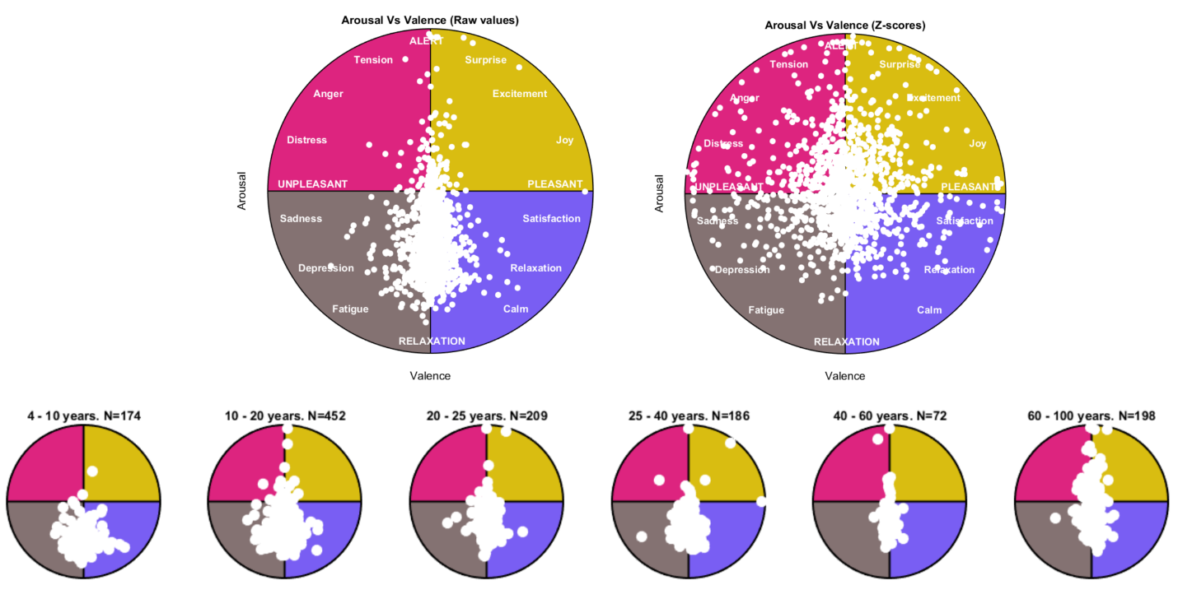
Sup. Figure 9. Arousal–Valence distribution of the normative sample mapped onto the circumplex model of affect. Each white dot represents one individual. The circular space is partitioned into four quadrants according to the two-dimensional valence–arousal framework (Russell, 1980): high arousal / pleasant (yellow, upper right), high arousal / unpleasant (pink, upper left), low arousal / pleasant (blue, lower right), and low arousal / unpleasant (grey, lower left). Emotional states labelled within each quadrant correspond to prototypical affect categories. Top row: full-sample distributions plotted using raw index values (left) and age-corrected Z-scores (right; N = 1,564). The shift toward the center observed in the Z-score panel reflects the removal of age-related variance in both indices. Bottom row: raw-value distributions stratified by age group (4–10 yr, N = 174; 10–20 yr, N = 452; 20–25 yr, N = 209; 25–40 yr, N = 186; 40–60 yr, N = 72; 60–100 yr, N = 198), illustrating the developmental trajectory of resting-state affective tone. Younger participants cluster preferentially in the low-arousal quadrants, whereas the distribution broadens and shifts toward higher arousal in adolescence and early adulthood.

Sup. Figure 10: GAMLSS normalized residuals stratified by recording device. Normalized quantile residuals from GAMLSS models for three representative indices (TBR, Arousal Index, Valence/FAA; n = 1,564; 9 recording devices). Panels A, C, E: per-device residual distributions (violin plots); black dot = median, bar = IQR; dashed red line = Z = 0; dotted lines = ±1.96. Panels B, D, F: mean residual ± 1.96 SE per device; green band indicates the |Z| < 0.5 region. Panel G: Q–Q plot of all pooled residuals against the standard normal (n = 8,000 random subsample). Panel H: cross-index summary of mean device residuals. Although Kruskal–Wallis tests detect statistically significant inter-device differences (driven by the large sample size), all mean deviations remain within |Z| < 0.5 — well below any clinically meaningful threshold — confirming that ESN normalization adequately removes equipment-related amplitude variability before normative modeling. The overall residual distribution is approximately normal (Mean ≈ 0, SD ≈ 1.0), consistent with a well-calibrated normative model.

Supplementary Table 1. Empirical calibration of GAMLSS normative models
Percentage of normative sample with normalized quantile residuals |Z| > 1.96, evaluated per index using R's internal residual diagnostics. Under a perfectly calibrated model, the expected rate is 5.0%.
Index | n | Scope | Family | Transform | % |Z| > 1.96 | Δ from 5%
TBR | 1,564 | 19 electrodes (pooled) | NO | — | 4.95% (range: 4.0–5.7%) | -0.05 pp
Arousal Index | 1,564 | Global | BCT | log† | 5.03% | +0.03 pp
Valence (FAA) | 1,564 | Global | NO | — | 5.11% | +0.11 pp
pp = percentage points. NO = Normal; BCT = Box-Cox t distribution. † Transform was specified, but BCT was fitted on raw data (values > 0); the ν parameter of BCT absorbs asymmetry, making the log pre-transform redundant. TBR range reflects variability across the 19 individual electrode models. All three indices show adequate calibration, with deviations from the nominal 5% rate below 0.2 pp.
Supplementary Table 2. Empirical centile coverage of GAMLSS normative models
Empirical percentage of the normative sample falling below each centile threshold, derived by comparing each subject's observed index value against the age-interpolated centile curve. Values in parentheses indicate the deviation (Δ) from the nominal level. Under perfect calibration, all deviations are equal to 0.
Index | Scope | Family | Transf | p2.5 | p10 | p25 | p50 | p75 | p90 | p97.5
 |  |  |  | (exp. 2.5%) | (exp. 10%) | (exp. 25%) | (exp. 50%) | (exp. 75%) | (exp. 90%) | (exp. 97.5%)
TBR | 19 elec. | NO | — | 2.5 (-0.0) | 9.2 (-0.8) | 23.7 (-1.3) | 49.9 (-0.1) | 75.7 (+0.7) | 91.0 (+1.0) | 97.5 (+0.0)
Arousal | global | BCT | log† | 2.6 (+0.1) | 10.4 (+0.4) | 25.9 (+0.9) | 49.0 (-1.0) | 74.8 (-0.2) | 90.3 (+0.3) | 97.6 (+0.1)
Valence | global | NO | — | 3.1 (+0.6) | 6.7 (-3.3) ‡ | 15.0 (-10.0) ‡ | 50.3 (+0.3) | 84.9 (+9.9) ‡ | 93.6 (+3.6) ‡ | 97.9 (+0.4)
pp = percentage points. NO = Normal; BCT = Box-Cox t distribution. TBR was pooled across 19 electrode models. ‡ |Δ| > 3 pp. † BCT fitted on raw data; log-transform redundant (absorbed by BCT's ν parameter).
TBR and Arousal show excellent calibration across all centiles (max |Δ| < 1.4 pp and < 1.0 pp, respectively). Valence (NO) shows systematic underdispersion in the central quantiles (p25: -10.0 pp; p75: +9.9 pp), consistent with leptokurtic residuals not captured by the Normal family; a BCT refit is recommended for future versions.

Supplementary Table 3. Adaptive distributional family selection criteria in GAMLSS normative modeling
Condition | Criteria met (out of 3) | Family sequence | Rationale
Raw data strictly positive (y > 0) | ≥ 2 | BCT → BCPE → NO | BCT handles asymmetry and heavy tails via shape parameters ν and τ; log pre-transform is redundant
Raw data includes negative values | ≥ 2 | NO directly | Empirically verified: JSU/SHASHo overestimate σ for spike-and-slab distributions (e.g. Valence/FAA)
Raw data strictly positive (y > 0) | 1 | BCPE → NO | Moderate departure from normality; conservative family
Any sign | 0 | NO + requested transform | Near-normal distribution; apply log/sqrt pre-transform if specified
Three diagnostic criteria evaluated on raw (pre-transformation) data: (1) excess kurtosis > 1 (i.e. kurtosis > 4); (2) |skewness| > 0.5; (3) Shapiro–Wilk test p < 0.05 on a subsample of up to 2,000 observations. BCT = Box-Cox t; BCPE = Box-Cox Power Exponential; NO = Normal. Arrows indicate fallback order if the primary family fails to converge. The criterion is evaluated on raw data regardless of any pre-transformation specified in gamlss_meta.csv*, because BCT and BCPE require y > 0, which holds in the original scale for positive indices such as the Arousal Index.*

