Supplemental Materials

Refer to the Major Resources Table in the Supplemental Materials for details.

Supplemental Methods

Total RNA Sequencing and Data Analysis
Total RNA was isolated from HUVECs using TRIzol reagent (Invitrogen). RNA concentration was quantified using the Quant-iT RiboGreen RNA Assay Kit (Invitrogen) on a Victor Nivo Multimode Microplate Reader (PerkinElmer). The integrity of total RNA was assessed using an Agilent 2100 Bioanalyzer (Agilent Technologies).
The cDNA libraries were prepared using the TruSeq Stranded mRNA Library Prep Kit (Illumina) according to the manufacturer's protocol. High-throughput sequencing was performed as paired-end reads on an Illumina platform by Macrogen Inc. (Seoul, Republic of Korea).
For data analysis, quality control of raw sequencing reads was performed using FastQC (v0.11.7). Low-quality reads and adapter sequences were removed using Trimmomatic (v0.38) with the following parameters: ILLUMINACLIP, SLIDINGWINDOW, LEADING, TRAILING, and MINLEN. The trimmed reads were then aligned to the human reference genome (hg19) using HISAT2 (v2.1.0). Transcript assembly and abundance estimation were conducted using StringTie (v2.1.3b). Subsequent differential gene expression analysis and data visualization were performed using the Macrogen DEG Viewer (https://degviewer.macrogen.com). Genes with a P-value < 0.05 and fold change > 1.5 were considered significantly differentially expressed.

Proximity Ligation in situ Assay (PLA)
HUVECs were fixed (4% PFA, 10 min, RT), blocked (DuoLink, 1 h, 37°C), and incubated overnight (4°C) with anti-AC3 and anti-CAV1 (Santa Cruz). Oligonucleotide-conjugated secondary antibodies (Sigma-Aldrich) were used for PLA, and images were acquired using a Leica-TCS-SP8 confocal microscope.

Transwell Migration Assay
HUVECs transfected with CAP1 siRNA were seeded onto fibronectin-coated Transwells (Corning) and cultured for 48 h. After resistin treatment (12 h), THP-1 cells were added to the upper chamber and incubated for 6–12 h. Migrated cells were counted under light microscopy.

Cell Culture and Transfection
Pooled human umbilical vein endothelial cells (HUVECs) were purchased from Lonza and cultured in Endothelial Cell Growth Medium MV2 Kit (C-22121, PromoCell) containing the SupplementMix and 10% fetal bovine serum (FBS). HUVECs were used at passages 5 to 6. For transfection, the plasmid cloned with mFc-conjugated hResistin was transfected into HUVECs using Lipofectamine (Thermo Fisher Scientific) or polyethylenimine (PEI) according to the manufacturer's protocol.

Cytosol, Nuclear, and Membrane Fractionation
To prepare cytosolic extracts, cells were carefully collected using cytosol lysis buffer (10 mM HEPES [pH 7.9], 10 mM KCl, 0.1 mM EDTA, 0.1 mM EGTA, 0.1 mM DTT, 1 mM Na₃VO₄). The samples were lysed by adding 0.6% NP40 for one minute and quickly centrifuged at 13,000 rpm. Cytosolic extracts were obtained in supernatants and the remaining pellets were lysed in nuclear lysis buffer (25 mM HEPES [pH 7.9], 0.4 M NaCl, 0.5 mM EDTA, 0.5 mM EGTA, 0.1 mM DTT, 1 mM Na₃VO₄) for 30 minutes at 4°C. Membrane extracts were obtained using the Qproteome Cell Compartment Kit (QIAGEN, #37502).

Immunofluorescence Staining
Cells seeded on coverslips were fixed with 4% paraformaldehyde (PFA) for 15 min at room temperature and permeabilized with 0.05% Triton X-100 in PBS for 10 min. After blocking with 1% bovine serum albumin (BSA) for 30 min, cells were incubated overnight at 4°C with primary antibodies. Subsequently, cells were washed three times with PBS and incubated with secondary antibodies for 1 h at room temperature in the dark. Nuclei were counterstained with DAPI (4′,6-diamidino-2-phenylindole) for 5–10 min in the dark. Fluorescence images, including Z-stacks for 3D reconstruction, were acquired using a Leica STED CW inverted confocal microscope. Confocal Z-stack images were processed and analyzed using Imaris software (Version 9.5, Bitplane, Oxford Instruments).

Collagen Gel Invasion Assay
A collagen mixture was prepared by mixing rat tail type I collagen, 10× PBS, and 1 M NaOH. The mixture was polymerized in Transwell inserts for 30 min at 37°C. Bone marrow-derived monocytes were seeded on top of the collagen gel, and rhResistin (100 ng/mL) or LPS was added to the lower chamber as a chemoattractant. After incubation, the invasion depth was analyzed by focusing through the gel using a microscope, and the distance of infiltrating cells from the top surface was quantified.

Antibodies and Reagents
The following primary antibodies were used: anti-CAP1 (SantaCruz, sc-100917, sc-134637, 52kDa), anti-human Resistin (Adipogen, cat#AG-25A-0013, ~10kDa), anti NF-κB p50 (SantaCruz, sc-114, 50kDa), anti NF-κB p65 (SantaCruz, sc-109, 65kDa), anti-phospho-VASP (Ser157) (Cell Signaling, cat#3111, 50kDa), anti-His tag (Cell Signaling, cat#2365), anti-lamin A/C (SantaCruz, sc-6215, 69/62 kDa), anti-α-tubulin (Sigma-Aldrich, T6199, 50kDa), anti-phospho-CREB (SantaCruz, sc-101663, 43kDa), anti-ADCY3 (SantaCruz, sc-518064, 170/180kDa), anti-ADCY4 (Abcam, ab103484, 120 kDa), anti-ADCY5/6 (SantaCruz, sc-590, 132 kDa), anti-ACDY7 (Abcam, ab102751, 120 kDa), anti-ADCY9 (Abcam, ab110159, 151 kDa), anti-caveolin1 (SantaCruz, sc-894, 22 kDa), anti-caveolin2 (SantaCruz, sc-7942, 25 kDa), anti-caveolin3 (SantaCruz, sc-5310, 20-25 kDa), anti-ICAM-1 (SantaCruz, sc-7891, sc-8439, 85-110 kDa), anti-VCAM-1 antibody (SantaCruz, sc-13160, 110kDa), anti-VE-cadherin (Santa Cruz Biotechnology, sc-6458, eBioscience, clone 16B1, 130 kDa), anti-p-VE-cadherin (Tyr658) (Invitrogen, 44-1144G, 130 kDa), anti-ZO-1 (Invitrogen, 61-7300, 33-9100, 220 kDa), anti-Connexin-37 (HUABIO, ER1901-85, 37 kDa), anti-PECAM-1 (Cell Signaling Technology, 3528, 130 kDa), anti-TOMM20 (GeneTex, GTX133756, Santa Cruz Biotechnology, sc-17764, 20 kDa), anti-DRP1 (Santa Cruz Biotechnology, sc-32898, Cell Signaling Technology, 14647, 80 kDa), anti-p-DRP1 (Ser616) (Cell Signaling Technology, 3455, 80 kDa), and anti-GAPDH (Sigma Aldrich, G9545, Cell Signaling Technology, 11908, 36 kDa).
The following reagents were used: methyl-β-cyclodextrin (Sigma Aldrich, C4555), OptiPrep™ Density Gradient Medium (Sigma Aldrich, D15556), recombinant CAP1 (Abnova, H00010487-P01), recombinant human resistin (Peprotech, #450-19), polyethylenimine (Polysciences, #23966), and HiPerFect Transfection Reagent (QIAGEN, #301704).
Supplemental Table I. List of primer sequences used for qRT-PCR.

A. Human Primers
Target Gene | Forward Primer (5' → 3') | Reverse Primer (5' → 3')
CAP1 | CAGTCTCTACCAGTTCAGGCTC | ACTGGACCACTCTGAGCCTTCA
ICAM1 | GGCACCCCAGCGGCTGACGT | CCCCATTCAGCGTCACCTTG
ICAM2 | ATGACACGGTCCTCCAATGCCA | GCACTCAATGGTGAAGGACTTGC
VCAM1 | AAGATGGTCGTGATCCTTGG | GGTGCTGCAAGTCAATGAGA
SELP (P-selectin) | TCCGCTGCATTGACTCTGGACA | CTGAAACGCTCTCAAGGATGGAG
SELL (L-selectin) | TCACAGTGTGCCTTCAGCTGCT | TCTGGTGCTGATAGAGGCTCAC
SELPLG (PSGL-1) | GAACCTGTCCACGGATTCAGCA | GTCAGTCGAGTTGTCTGTGCCT
GJA1 (Cx43) | GGAGATGAGCAGTCTGCCTTTC | TGAGCCAGGTACAAGAGTGTGG
GJA4 (Cx37) | ATCTGGCTGACGGTGCTCTTCA | GGTCATAGCAGACGTTGGTGCA
GJA5 (Cx40) | TAGGCAAGGTCTGGCTCACTGT | GAAAGCCTGGTCGTAGCAGACA
CCL2 (MCP-1) | AGAATCACCAGCAGCAAGTGTCC | TCCTGAACCCACTTCTGCTTGG
CCL5 (RANTES) | CCTGCTGCTTTGCCTACATTGC | ACACACTTGGCGGTTCTTTCGG
CXCL10 (IP-10) | GGTGAGAAGAGATGTCTGAATCC | GTCCATCCTTGGAAGCACTGCA
CXCL11 (I-TAC) | AAGGACAACGATGCCTAAATCCC | CAGATGCCCTTTTCCAGGACTTC
RSAD2 (Viperin) | CCAGTGCAACTACAAATGCGGC | CGGTCTTGAAGAAATGGCTCTCC
CMPK2 | CCAGGTTGTTGCCATCGAAGGA | GGTGGTGACTTTAAGAGGACAGC
OPTN | ACTCTGACCAGCAGGCTTACCT | CTATGTCAGGCAGAACCTCTCC
ACP5 | CATGACCACCTTGGCAATGTCTC | CTGTGGGATCTTGAAGTGCAGG
CTSK | GAGGCTTCTCTTGGTGTCCATAC | TTACTGCGGGAATGAGACAGGG
18S rRNA | ACACGGACAGGATTGACAGA | GCCAGAGTCTCGTTCGTTAT
GAPDH | GTCTCCTCTGACTTCAACAGCG | ACCACCCTGTTGCTGTAGCCAA

B. Mouse Primers
Target Gene | Forward Primer (5' → 3') | Reverse Primer (5' → 3')
Cap1 | TTGACTCGCTGCTTGCCAATCC | CACTGAGAAGCTGTAGCCAGGA
Il1b (IL-1β) | TGGGCCTCAAAGGAAAGAAT | CAGGCTTGTGCTCTGCTTGT
Il4 (IL-4) | ATCATCGGCATTTTGAACGAGGTC | ACCTTGGAAGCCCTACAGACGA
Il6 (IL-6) | TACCACTTCACAAGTCGGAGGC | CTGCAAGTGCATCATCGTTGTTC
Ifng (IFN-γ) | CAGCAACAGCAAGGCGAAAAAGG | TTTCCGCTTCCTGAGGCTGGAT
Tnf (TNF-α) | GATCTCAAAGACAACCAACATGTG | CTCCAGCTGGAAGACTCCTCCCAG
Tlr4 | AGCTTCTCCAATTTTTCAGAACTTC | TGAGAGGTGGTGTAAGCCATGC
Gapdh | CATCACTGCCACCCAGAAGACTG | ATGCCAGTGAGCTTCCCGTTCAG

Supplemental Table II. Sequences of siRNAs used for gene silencing.
Target Gene | Type | Sequence (5' → 3')
CAV1 (Caveolin-1) | Sense | AAAAGAGCUUCCUGAUUGAGAUU
 | Antisense | AAUCUCAAUCAGGAAGCUCUUUU
CAP1 | Sense | ACCGAGUCCUCAAAGAGUA
 | Antisense | UACUCUUUGAGGACUCGGU
Negative Control | - | AccuTarget™ Negative Control siRNA

Supplemental Figure 1
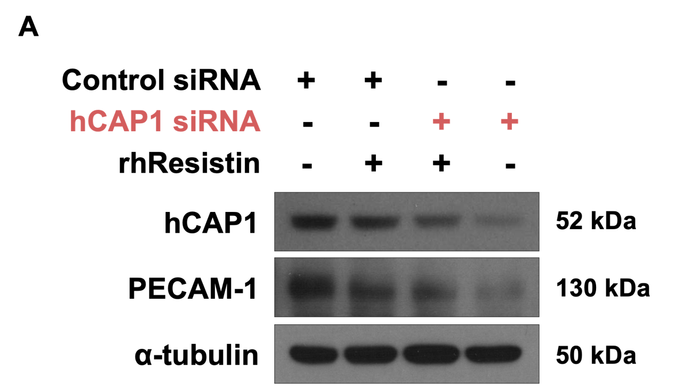

Supplemental Figure 1. CAP1 deficiency or resistin treatment compromises endothelial junctional integrity by downregulating PECAM-1 expression.
(A) Western blot analysis of whole-cell lysates from HUVECs transfected with control or CAP1 siRNA in the presence or absence of recombinant human resistin (rhResistin, 100 ng/mL). The immunoblot demonstrates that both the genetic depletion of CAP1 and resistin treatment result in a marked reduction in the protein levels of Platelet Endothelial Cell Adhesion Molecule-1 (PECAM-1), a critical component of endothelial cell-to-cell junctions. Efficient knockdown of CAP1 is confirmed in the top panel. α-tubulin served as a loading control. These findings provide additional evidence that the resistin-CAP1 axis destabilizes endothelial barrier function.

Supplemental Figure 2
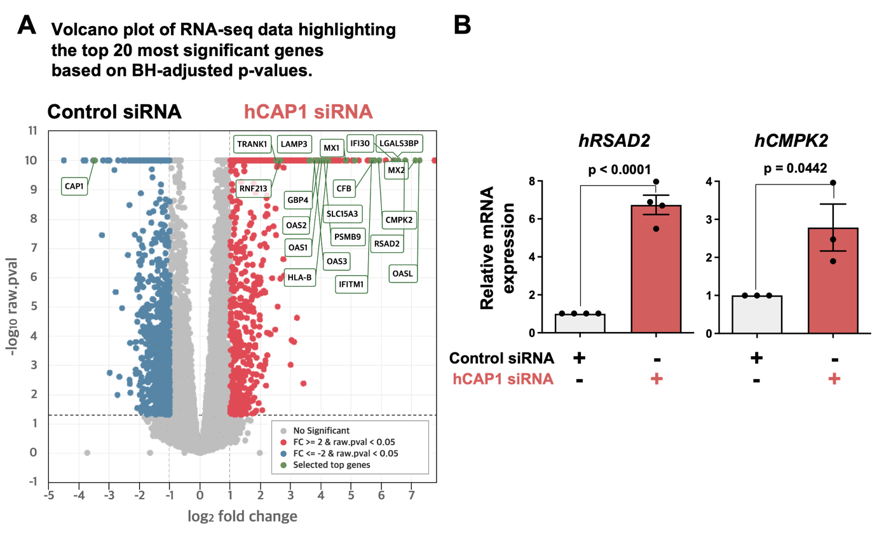
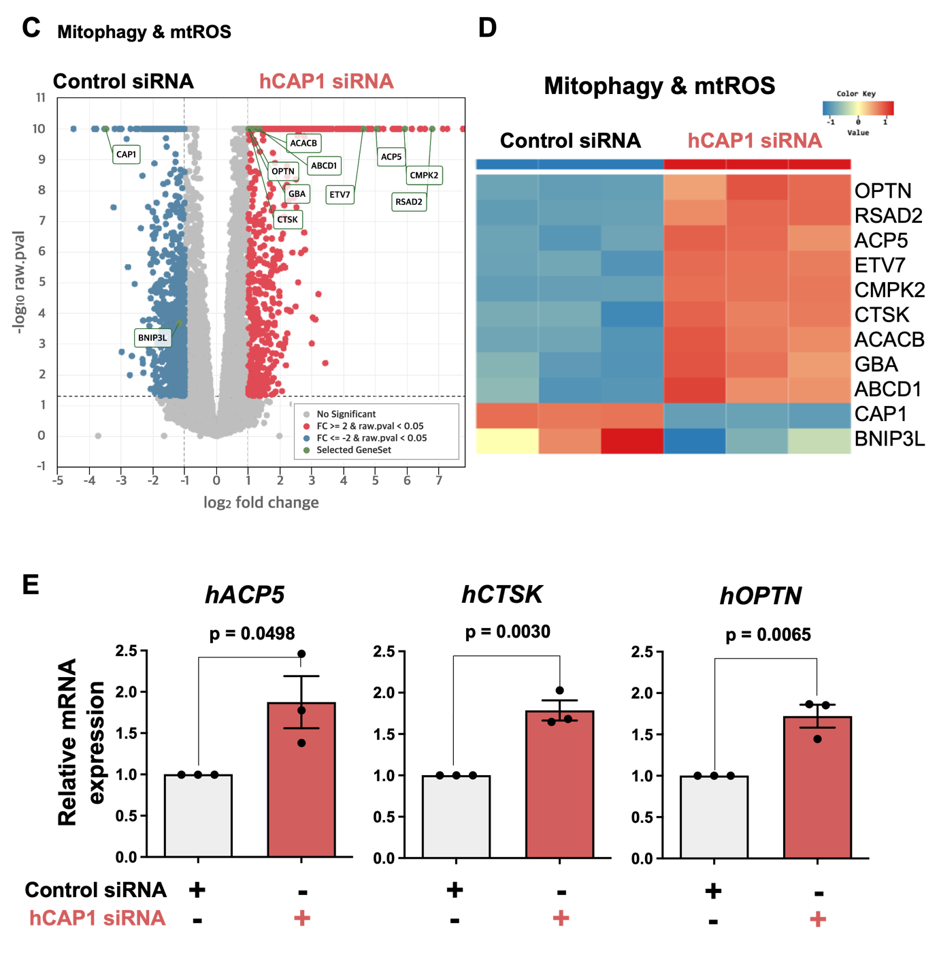
Supplemental Figure 2. Transcriptomic analysis reveals that CAP1 deficiency induces a pro-inflammatory phenotype and upregulation of interferon-stimulated genes linked to mitochondrial stress.
(A) Volcano plot visualizing global gene expression changes between siControl and siCAP1 groups. The x-axis represents the log2 fold change, and the y-axis represents the -log10 adjusted P-value. Red dots indicate significantly upregulated genes (Fold change > 2, P < 0.05), and blue dots indicate downregulated genes. The plot highlights the marked induction of interferon-stimulated genes (ISGs), such as RSAD2, CMPK2, MX1, and OAS family genes, upon CAP1 knockdown. (B) qRT-PCR confirmation of representative ISGs (hRSAD2 and hCMPK2) identified from the volcano plot. Both genes showed robust upregulation in CAP1-deficient HUVECs. Notably, the upregulation of RSAD2 and CMPK2 is known to facilitate the accumulation of mitochondrial reactive oxygen species (mtROS), thereby contributing to mitochondrial dysfunction and oxidative stress. Data are presented as mean ± SEM from three independent experiments. P-values were determined using an unpaired two-tailed Student’s t-test and are indicated in the graphs. (C) Volcano plot focusing on mitophagy- and mtROS-related genes. In addition to mitochondrial stress markers (RSAD2, CMPK2), the plot reveals a distinct upregulation of the mitophagy receptor OPTN and lysosomal enzymes (CTSK, GBA, ACPS). (D) Heatmap visualization of the differentially expressed genes related to mitophagy and mtROS shown in (C). The color scale represents relative gene expression levels (red: high; blue: low). (E) qRT-PCR confirmation of mitophagy receptor OPTN and lysosomal enzymes (CTSK, ACPS). Data are presented as mean ± SEM from three independent experiments. P-values were determined using an unpaired two-tailed Student’s t-test and are indicated in the graphs.

Supplemental Figure 3
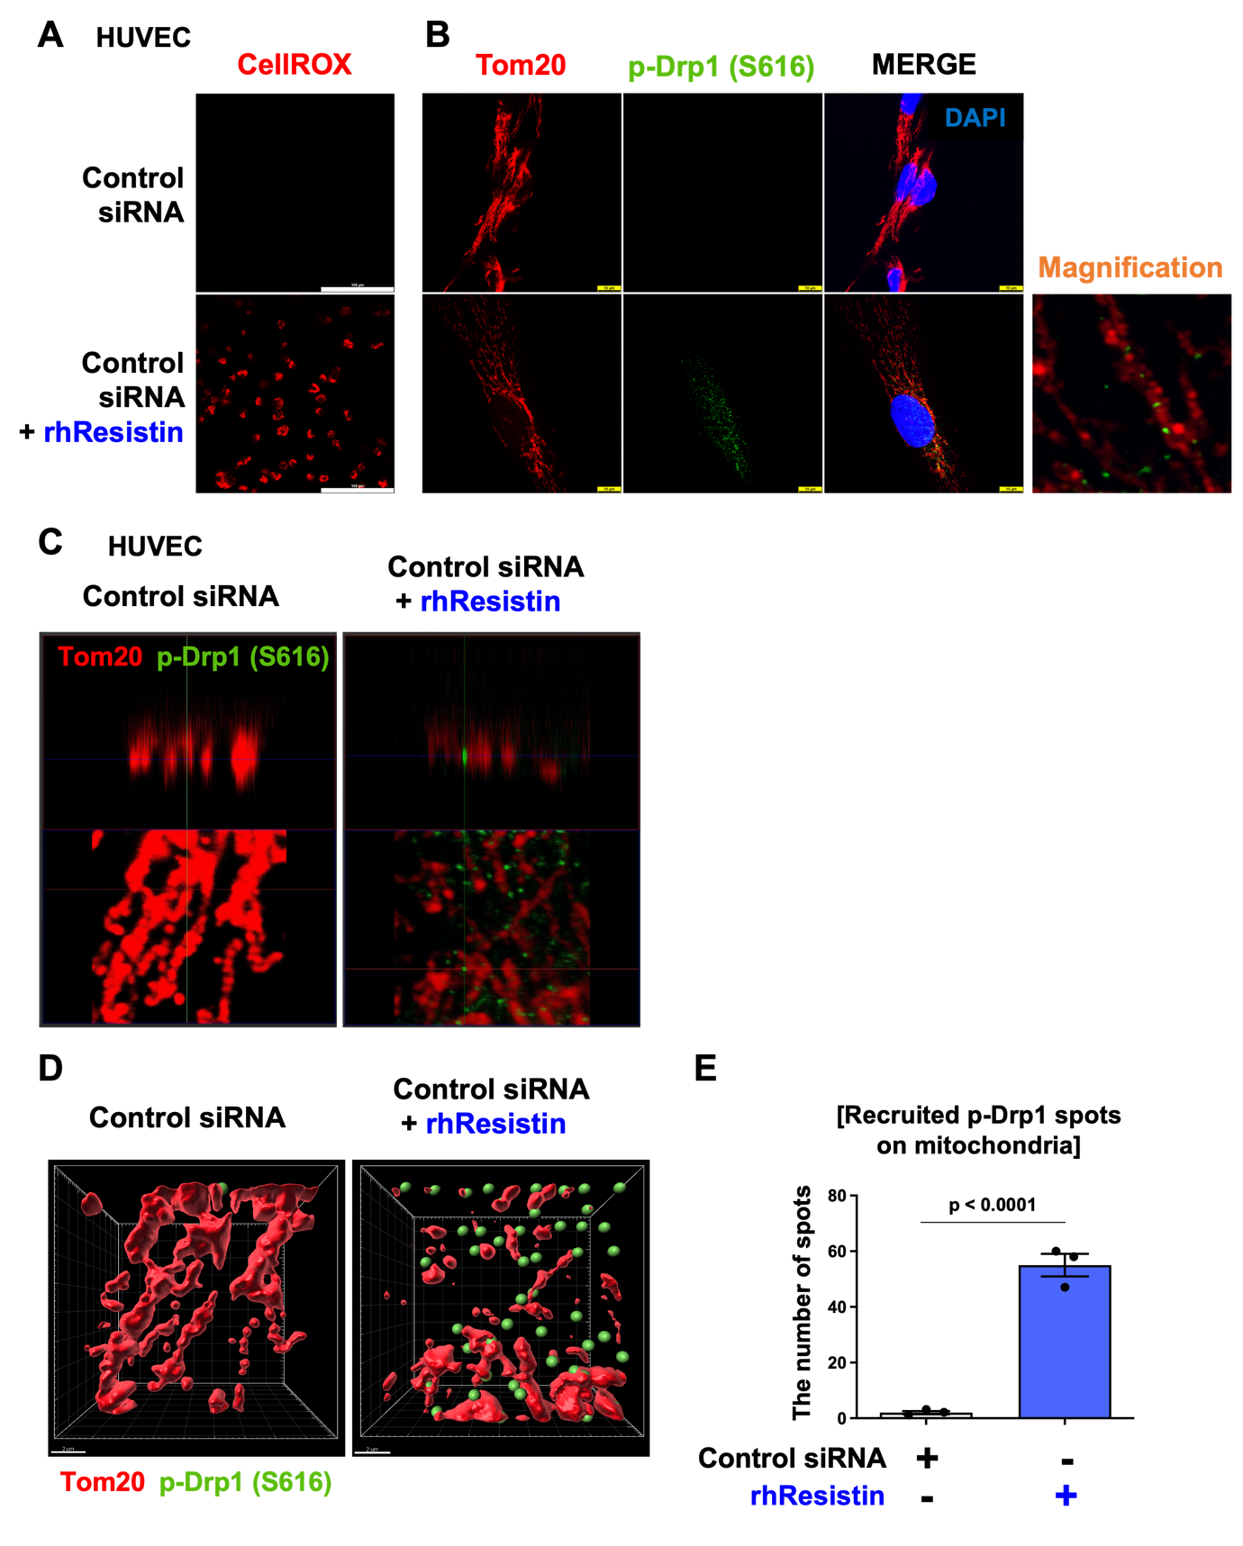

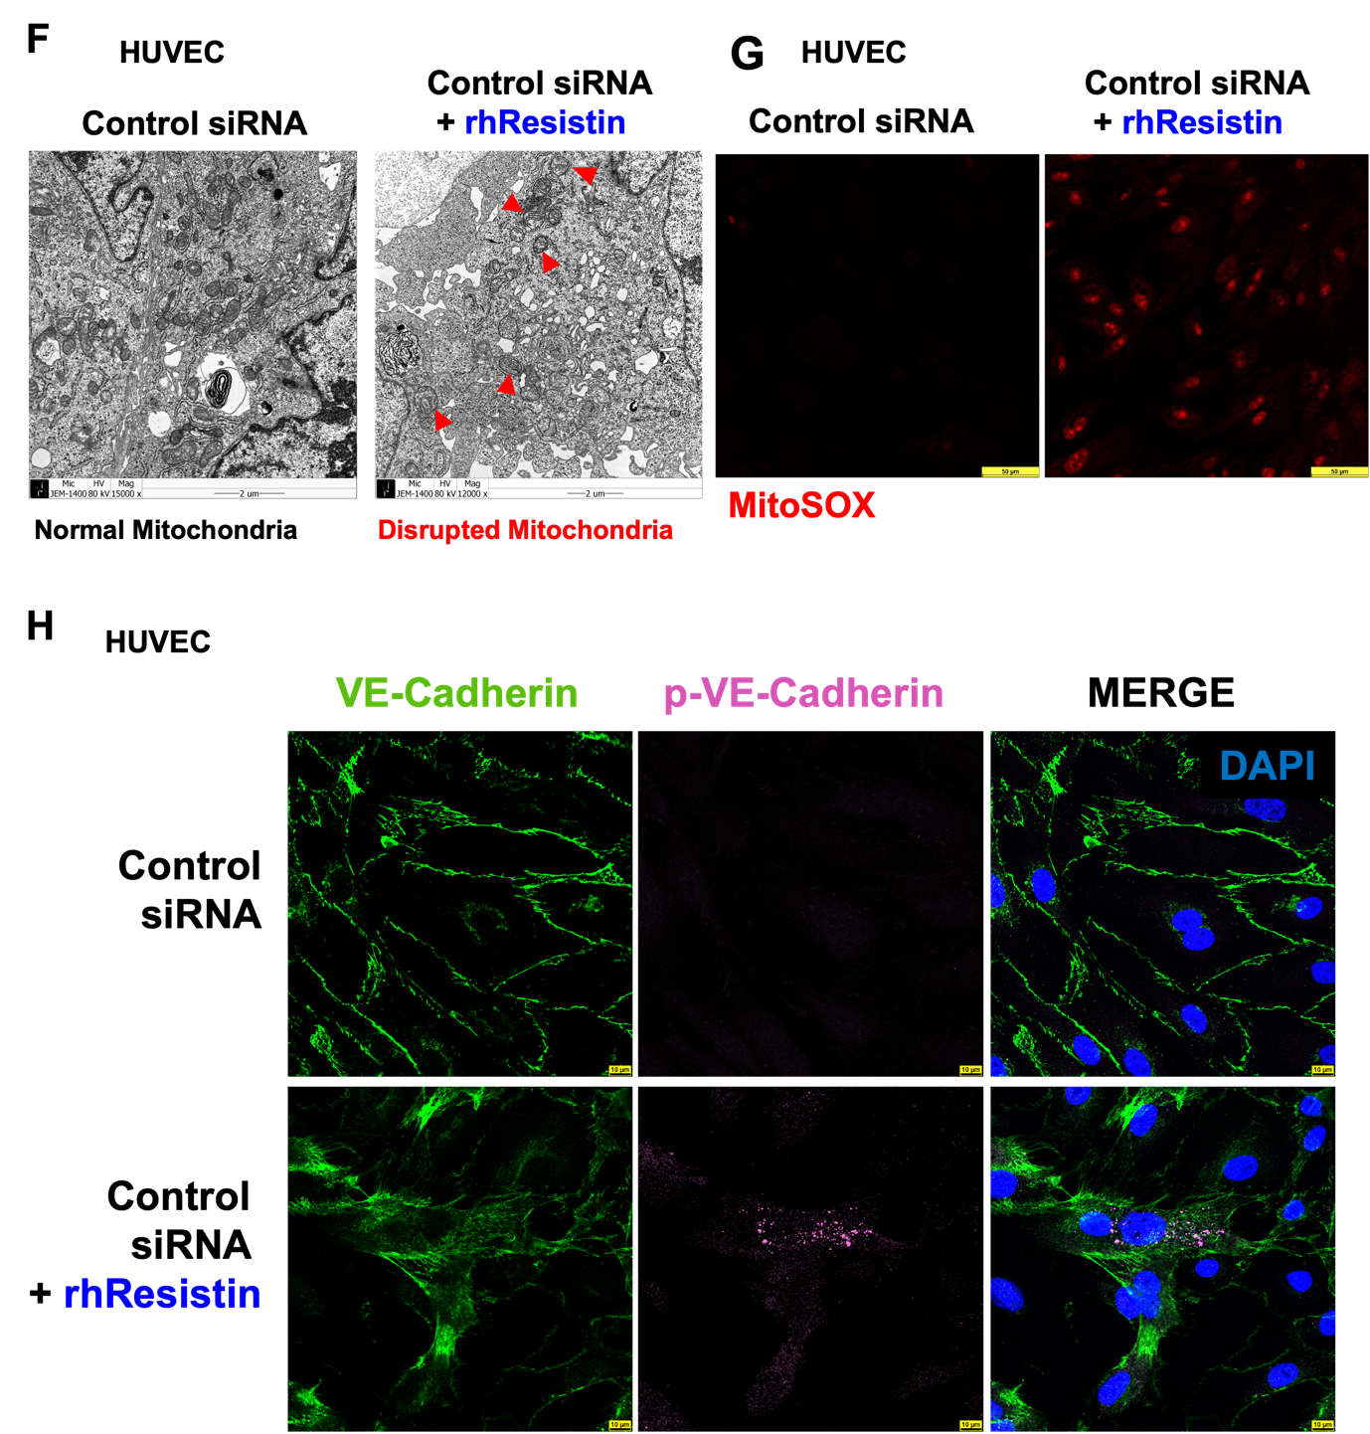

Supplemental Figure 3. Resistin induces mitochondrial structural collapse and endothelial junctional destabilization.
(A-G) Mitochondrial oxidative stress and structural collapse induced by rhResistin. (A) Detection of cellular ROS using CellROX (red) in HUVECs treated with or without rhResistin. (B, C) Confocal microscopy analysis (B) and 3D reconstruction (C) showing the recruitment of phosphorylated Drp1 (S616, green) to mitochondria (Tom20, red), indicating active fission upon rhResistin treatment. (D) IMARIS 3D surface rendering visualizing the spatial distribution and recruitment of p-Drp1 (S616, green spheres) on mitochondria (Tom20, red surface). (E) Quantification of the number of recruited p-Drp1 spots on mitochondria. (F) Ultrastructural analysis by transmission electron microscopy (TEM) revealing mitochondrial swelling and cristolysis (red arrowheads) in rhResistin-treated cells. (G) Evaluation of mitochondrial-specific superoxide (ROS) production using MitoSOX Red indicator.
(H) Junctional destabilization via VE-Cadherin phosphorylation. Immunofluorescence staining for total VE-Cadherin (green) and phosphorylated VE-Cadherin (magenta), a marker of junction disassembly, in response to rhResistin treatment.

Supplemental Figure 4
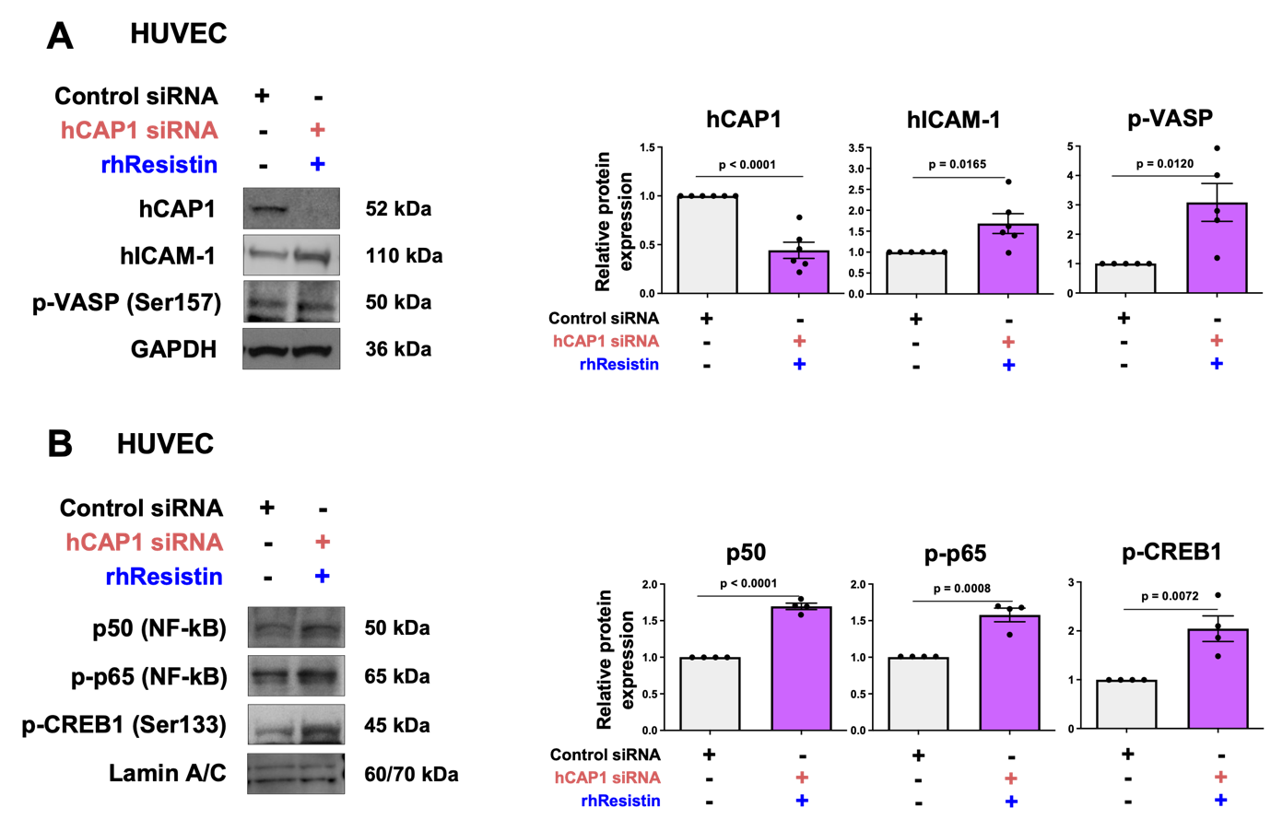
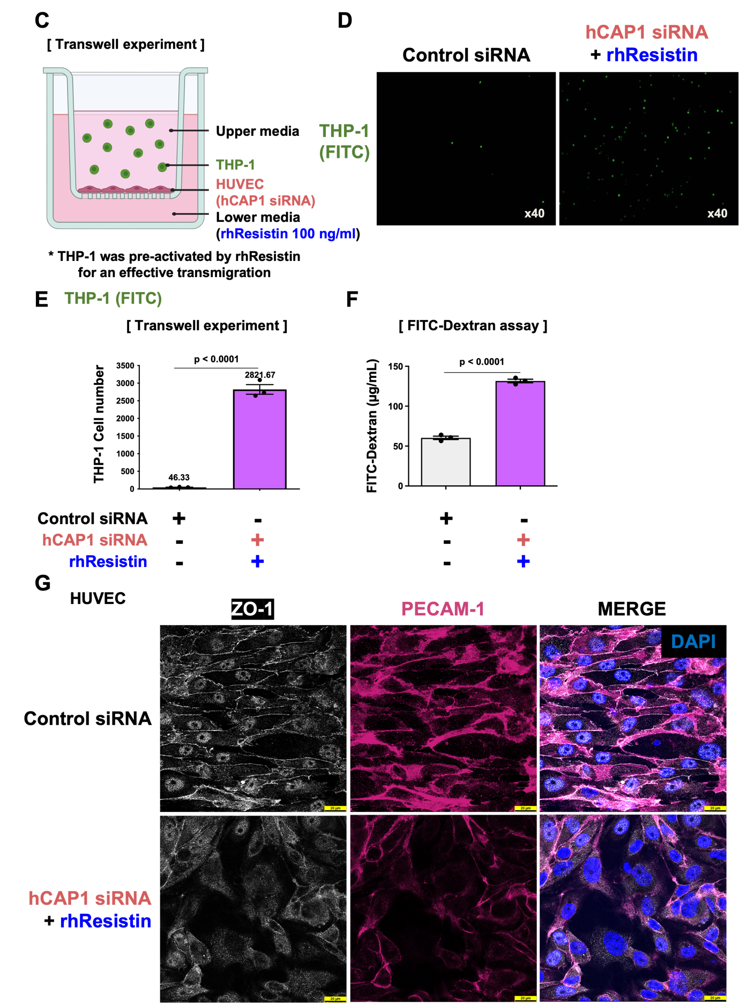

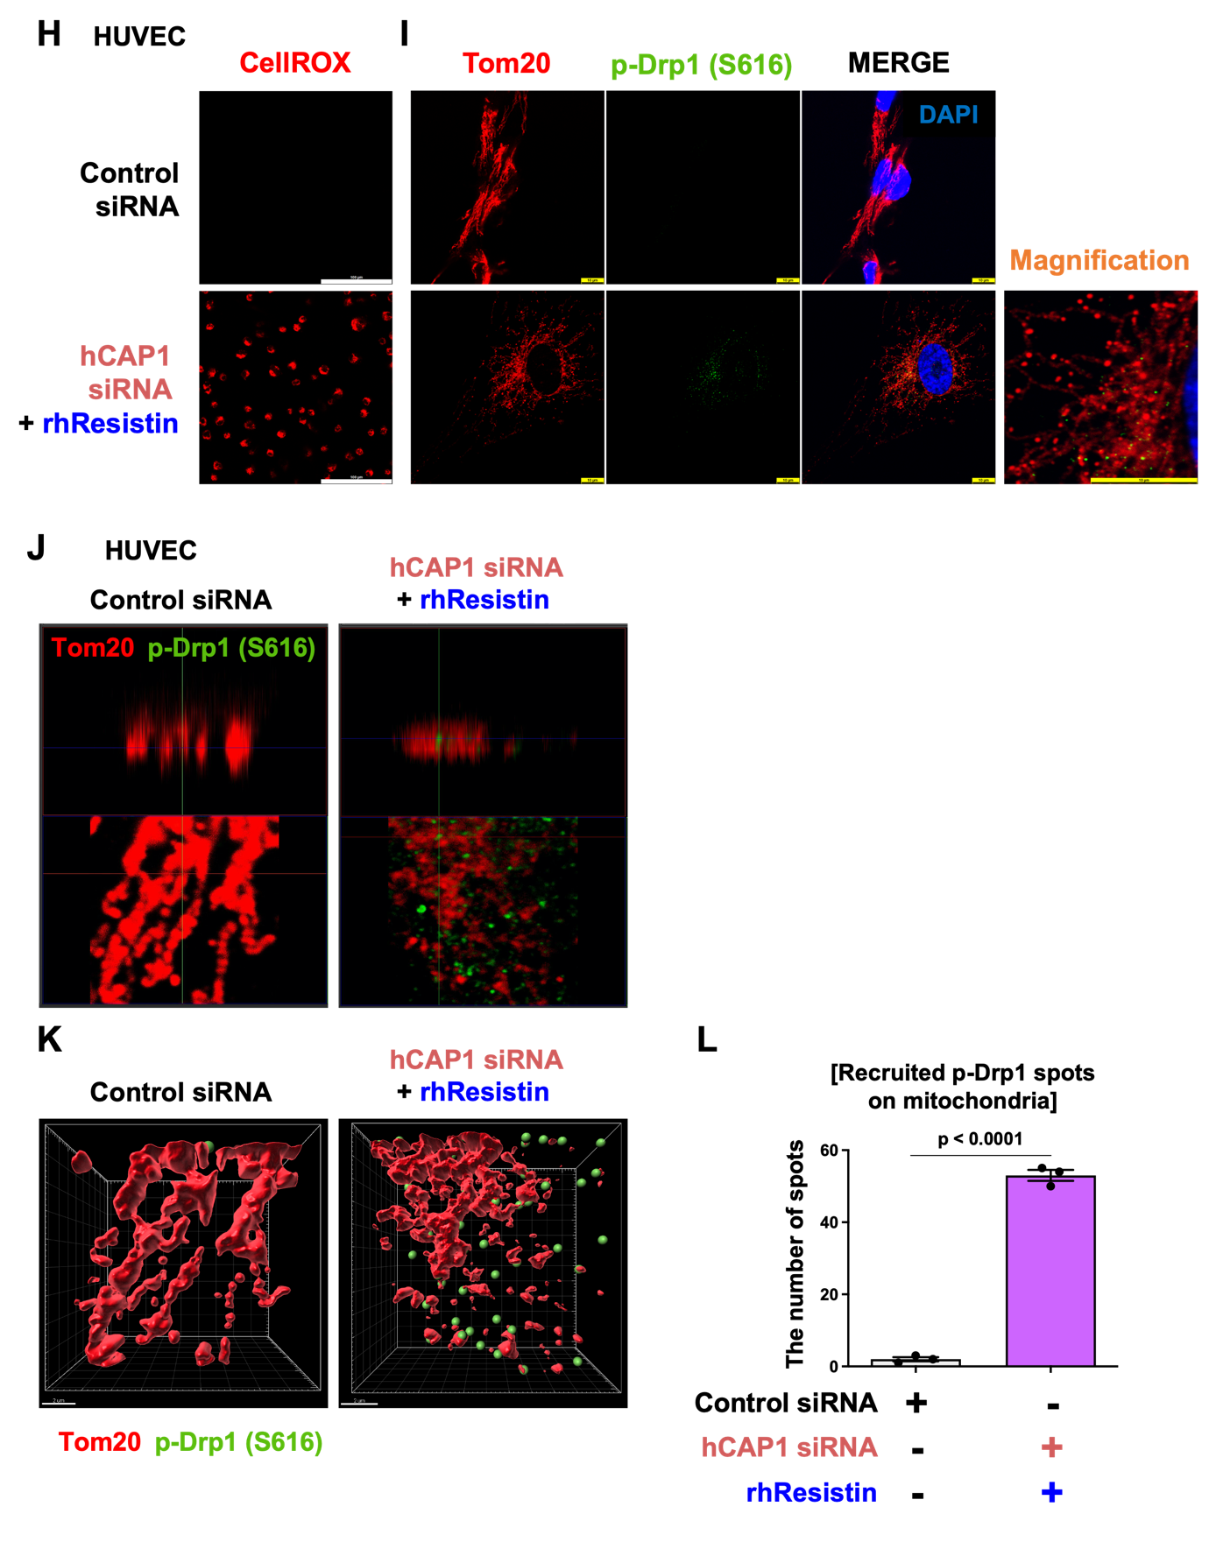
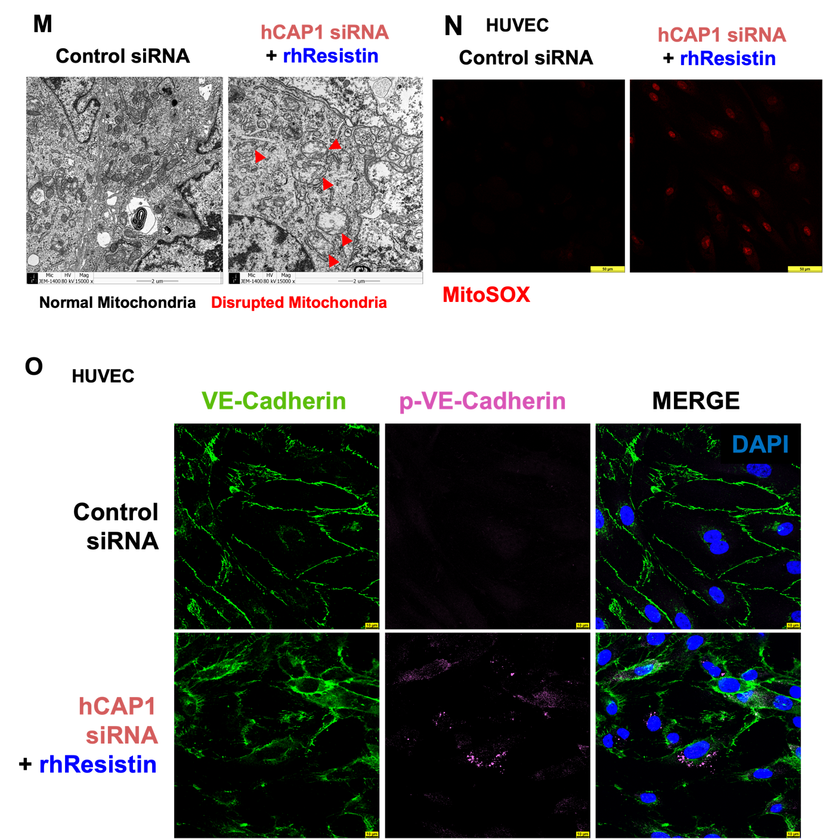

Supplementary Figure 4. Combined effects of CAP1 knockdown and rhResistin treatment on endothelial barrier dysfunction, and mitochondrial structural collapse in HUVECs.
(A, B) Protein expression and nuclear transcription factor activation. (A) Western blot analysis and quantification of hCAP1, hICAM-1, and p-VASP (Ser157) in whole-cell lysates of HUVECs transfected with control siRNA or hCAP1 siRNA combined with rhResistin treatment. (B) Western blot analysis and quantification of nuclear NF-κB subunits (p50 and p-p65) and p-CREB1 (Ser133).
(C-F) Monocyte transendothelial migration and endothelial hyperpermeability. (C) Schematic illustration of the transwell assay. (D) Representative fluorescence images of migrated FITC-labeled THP-1 cells. (E) Quantification of the transmigrated THP-1 cell number. (F) Evaluation of endothelial permeability by measuring FITC-Dextran leakage across the HUVEC monolayer. (G) Tight junction disruption. Immunofluorescence staining for ZO-1 (white) and PECAM-1 (magenta), demonstrating the disruption of tight junctions and endothelial cell borders. DAPI (blue) was used to stain nuclei.
(H-N) Mitochondrial oxidative stress, Drp1 recruitment, and ultrastructural collapse. (H) Detection of cellular ROS production using CellROX indicator (red). (I, J) Confocal microscopy analysis (I) and 3D reconstruction (J) showing the active recruitment of phosphorylated Drp1 (S616, green) to the mitochondrial network (Tom20, red). (K) IMARIS 3D surface rendering visualizing the spatial distribution of p-Drp1 (S616, green spheres) on mitochondria (Tom20, red surface). (L) Quantification of the number of recruited p-Drp1 spots on mitochondria. (M) Representative transmission electron microscopy (TEM) images revealing severe mitochondrial swelling and cristolysis (red arrowheads) in the hCAP1 siRNA + rhResistin group. (N) Evaluation of mitochondrial-specific superoxide production using MitoSOX Red indicator.
(O) Adherens junction destabilization. Immunofluorescence staining for total VE-Cadherin (green) and phosphorylated VE-Cadherin (magenta), indicating the disassembly of adherens junctions.

