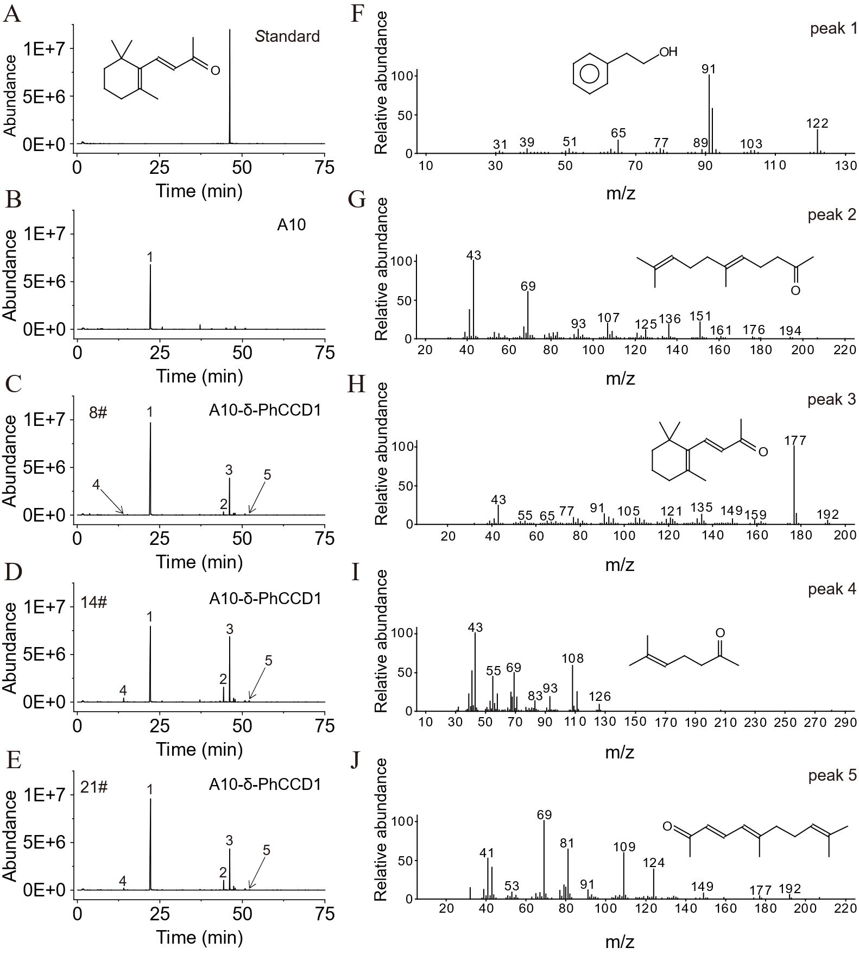
Fig. S1 SPME-GC-MS analysis of β-ionone in its authentic standard (A), and that of 2-phenylethanol and volatile apocarotenoid products in the strain A10 (B) and 8# (C), 14# (D) and 21# (E) recombinant strains of A10-δ-PhCCD1. The peaks of the targeted compounds are marked with number 1, 2, 3, 4 and 5. The mass spectrum of peak 1 detected in the samples was identical to that of 2-phenylethanol (F), the mass spectrum of peak 2 was identical to that of geranylacetone (G), the mass spectrum of peak 3 detected in the samples was identical to that of β-ionone (H), the mass spectrum of peak 4 detected in the samples was identical to that of 6-methyl-5-heptene-2-one (I), and the mass spectrum of peak 5 detected in the samples was identical to that of pseudoionone (J). The retention time of peak 3 was consistent with that of β-ionone standard.
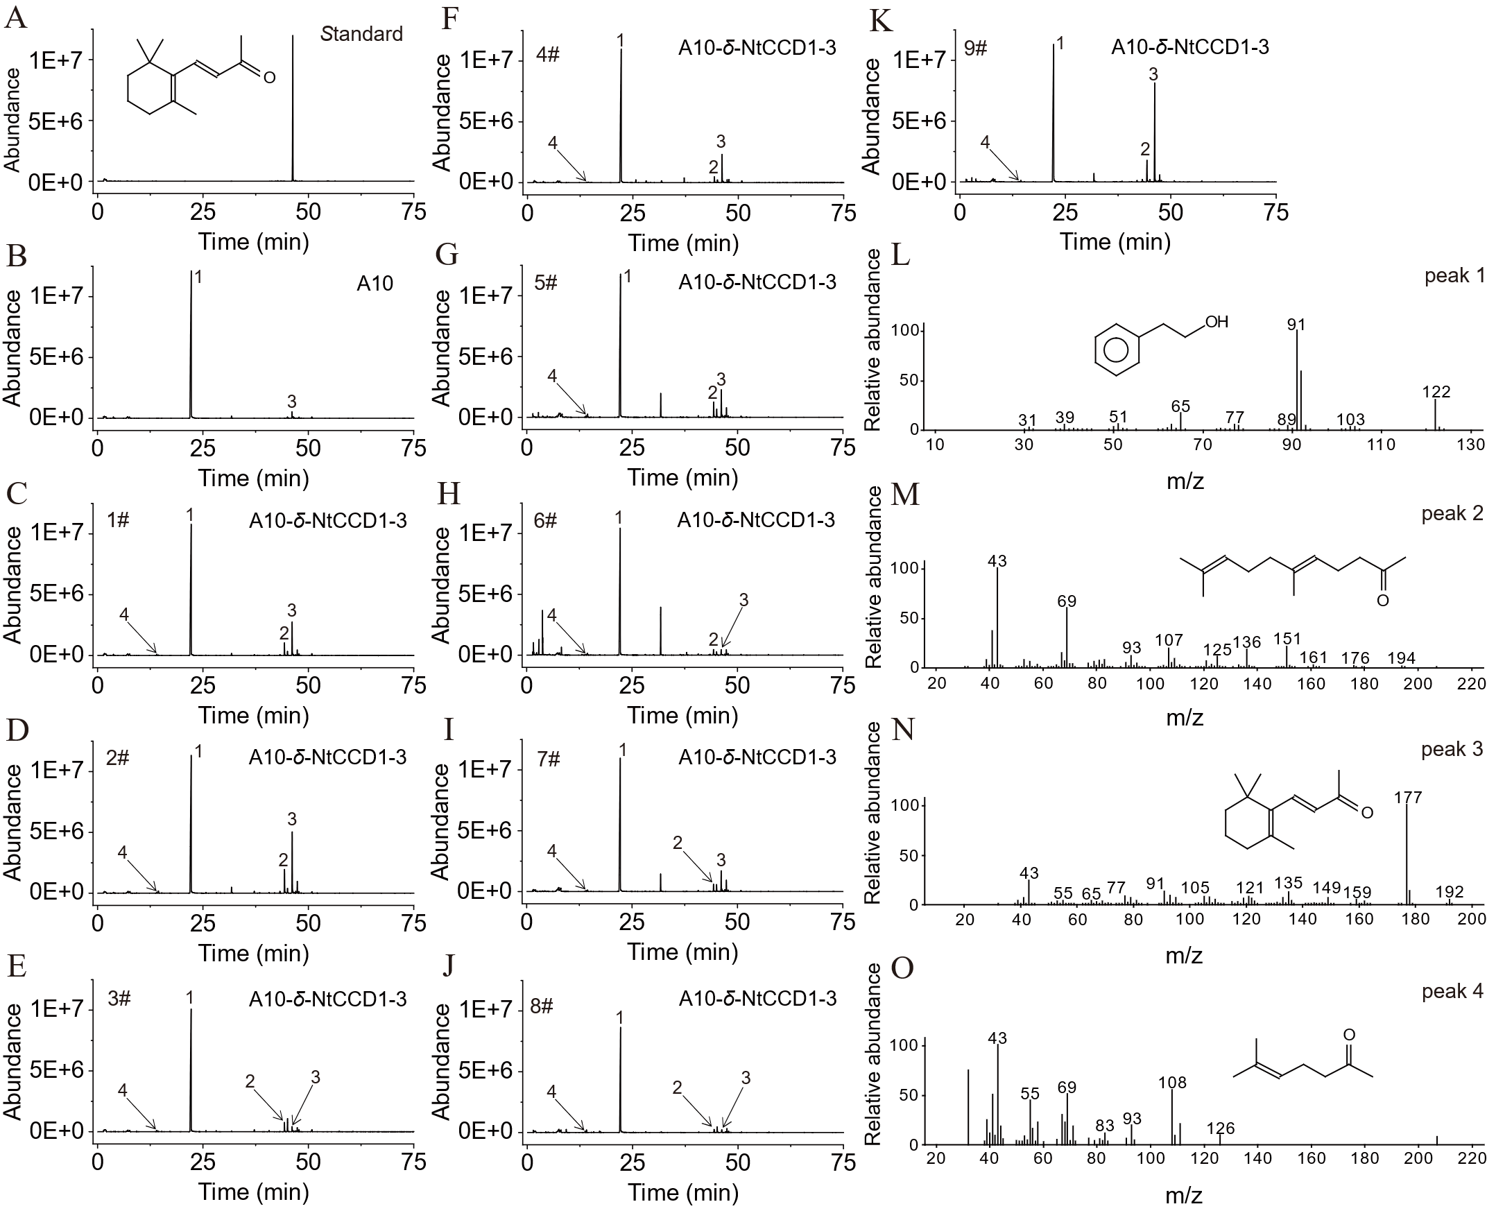
Fig. S2 SPME-GC-MS analysis of β-ionone in its authentic standard (A), and that of 2-phenylethanol and volatile apocarotenoid products in the strain A10 (B) and 1# (C), 2# (D), 3# (E), 4# (F), 5# (G), 6# (H), 7# (I), 8# (J) and 9# (K) recombinant strains of A10-δ-NtCCD1-3. The peaks of the targeted compounds are marked with number 1, 2, 3, 4 and 5. The mass spectrum of peak 1 detected in the samples was identical to that of 2-phenylethanol (L), the mass spectrum of peak 2 was identical to that of geranylacetone (M), the mass spectrum of peak 3 detected in the samples was identical to that of β-ionone (N), and the mass spectrum of peak 4 detected in the samples was identical to that of 6-methyl-5-heptene-2-one (O). The retention time of peak 3 was consistent with that of β-ionone standard.
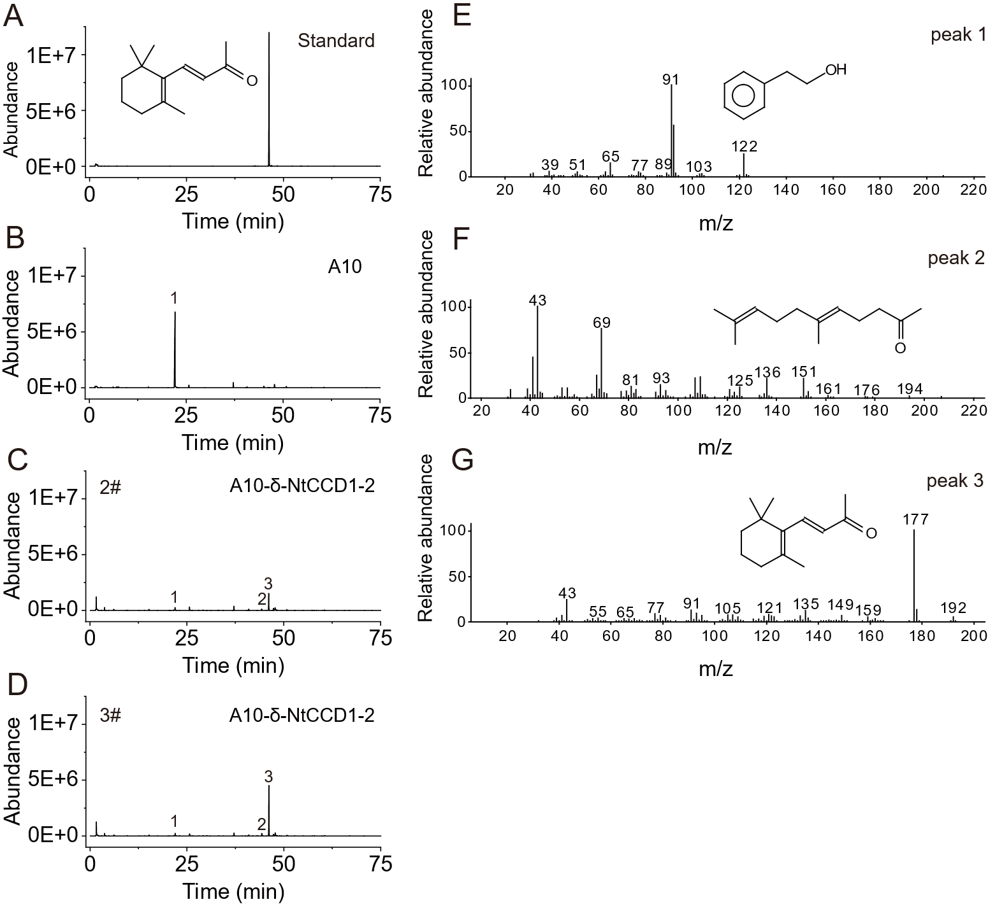
Fig. S3 SPME-GC-MS analysis of β-ionone in its authentic standard (A), and that of 2-phenylethanol and volatile apocarotenoid products in the strain A10 (B) and 2# (C) and 3# (D) recombinant strains of A10-δ-NtCCD1-2. The peaks of the targeted compounds are marked with number 1, 2 and 3. The mass spectrum of peak 1 detected in the samples was identical to that of 2-phenylethanol (E), the mass spectrum of peak 2 was identical to that of geranylacetone (F), and the mass spectrum of peak 3 detected in the samples was identical to that of β-ionone (G). The retention time of peak 3 was consistent with that of β-ionone standard.
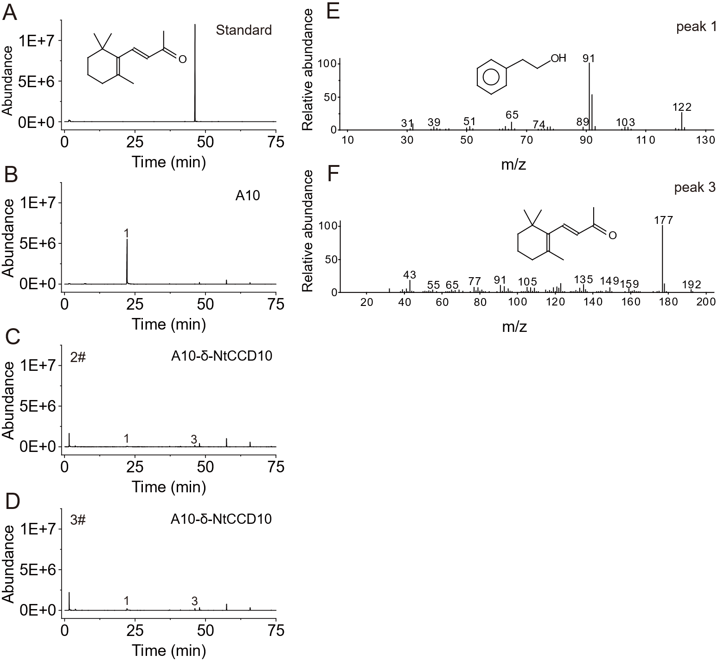
Fig. S4 SPME-GC-MS analysis of β-ionone in its authentic standard (A), and that of 2-phenylethanol and volatile apocarotenoid products in the strain A10 (B) and 2# (C) and 3# (D) recombinant strains of A10-δ-NtCCD10. The peaks of the targeted compounds are marked with number 1 and 3. The mass spectrum of peak 1 detected in the samples was identical to that of 2-phenylethanol (E), and the mass spectrum of peak 3 detected in the samples was identical to that of β-ionone (F). The retention time of peak 3 was consistent with that of β-ionone standard.
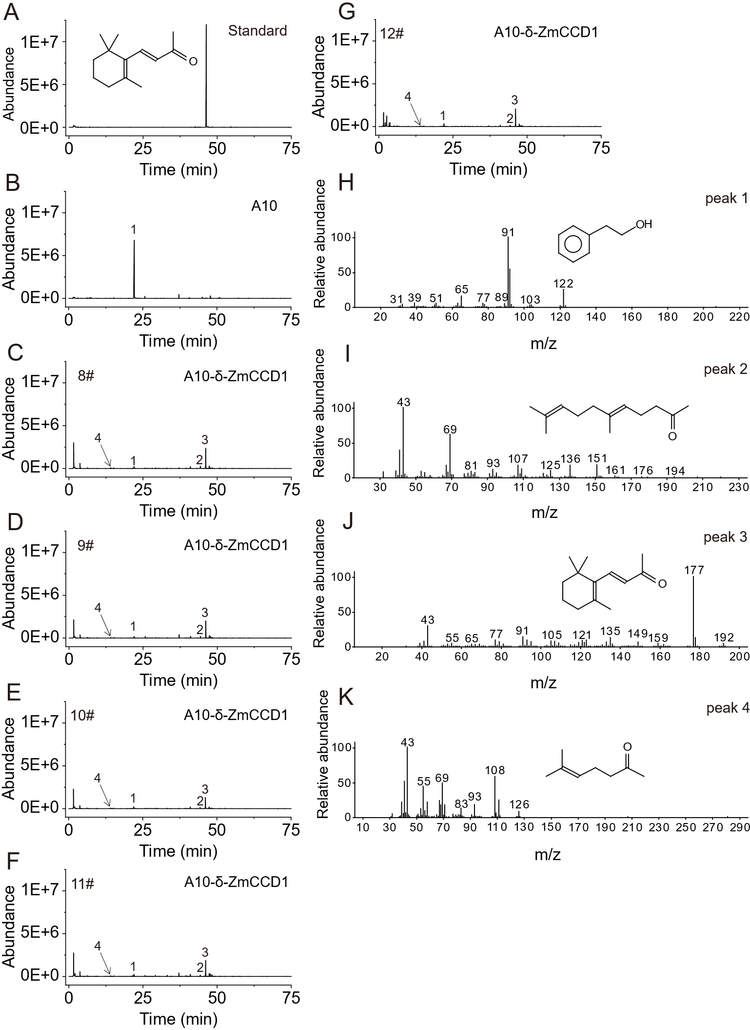
Fig. S5 SPME-GC-MS analysis of β-ionone in its authentic standard (A), and that of 2-phenylethanol and volatile apocarotenoid products in the strain A10 (B) and 8# (C), 9# (D), 10# (E), 11# (F) and 12# (G) recombinant strains of A10-δ-ZmCCD1. The peaks of the targeted compounds are marked with number 1, 2, 3 and 4. The mass spectrum of peak 1 detected in the samples was identical to that of 2-phenylethanol (H), the mass spectrum of peak 2 was identical to that of geranylacetone (I), the mass spectrum of peak 3 detected in the samples was identical to that of β-ionone (J), and the mass spectrum of peak 4 detected in the samples was identical to that of 6-methyl-5-heptene-2-one (K). The retention time of peak 3 was consistent with that of β-ionone standard.
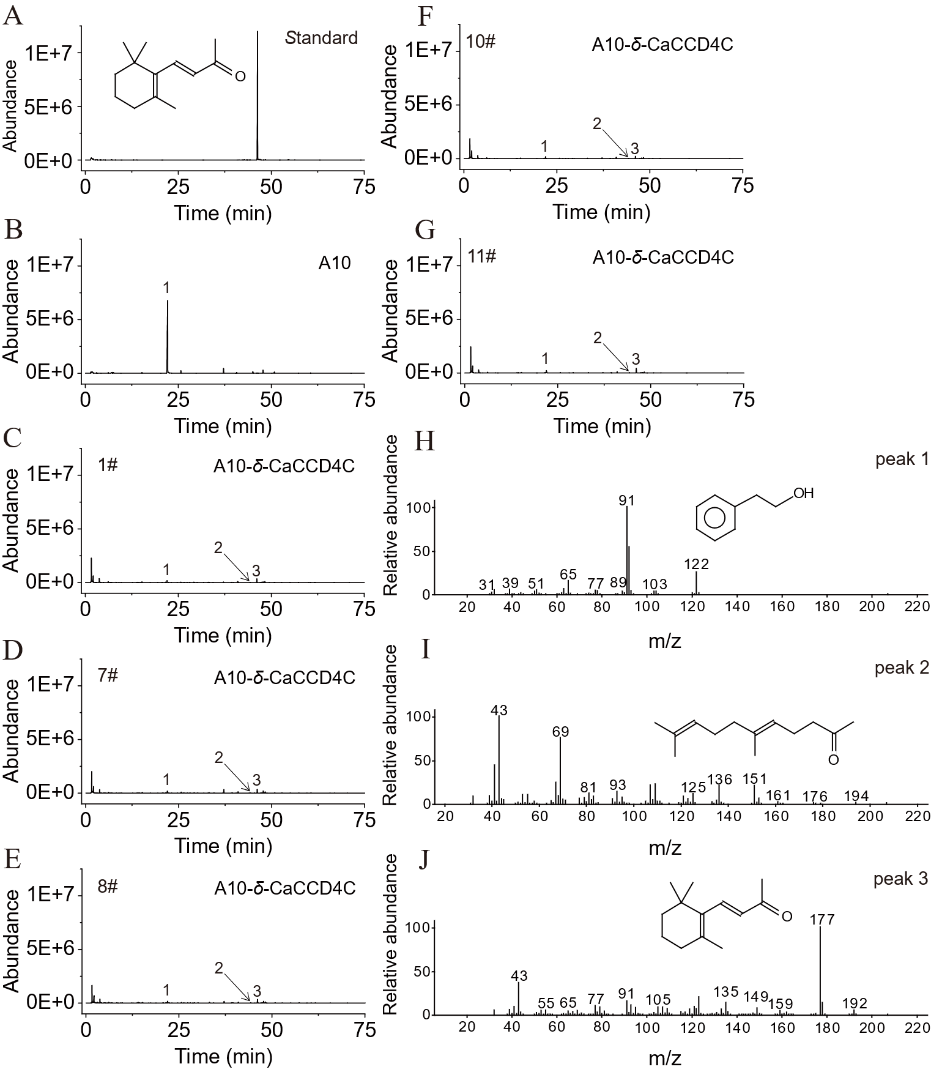
Fig. S6 SPME-GC-MS analysis of β-ionone in its authentic standard (A), and that of 2-phenylethanol and volatile apocarotenoid products in the strain A10 (B) and 1# (C), 7# (D), 8# (E), 10# (F) and 11# (G) recombinant strains of A10-δ-CaCCD4C. The peaks of the targeted compounds are marked with number 1, 2 and 3. The mass spectrum of peak 1 detected in the samples was identical to that of 2-phenylethanol (H), the mass spectrum of peak 2 was identical to that of geranylacetone (I), and the mass spectrum of peak 3 detected in the samples was identical to that of β-ionone (J). The retention time of peak 3 was consistent with that of β-ionone standard.

Fig. S7 Heat map analysis of the upregulated and downregulated genes in Ph1 (A), N3 (B), N1 (C), N10 (D), Zm1 (E) and Ca4 (F), compared to A10, respectively.
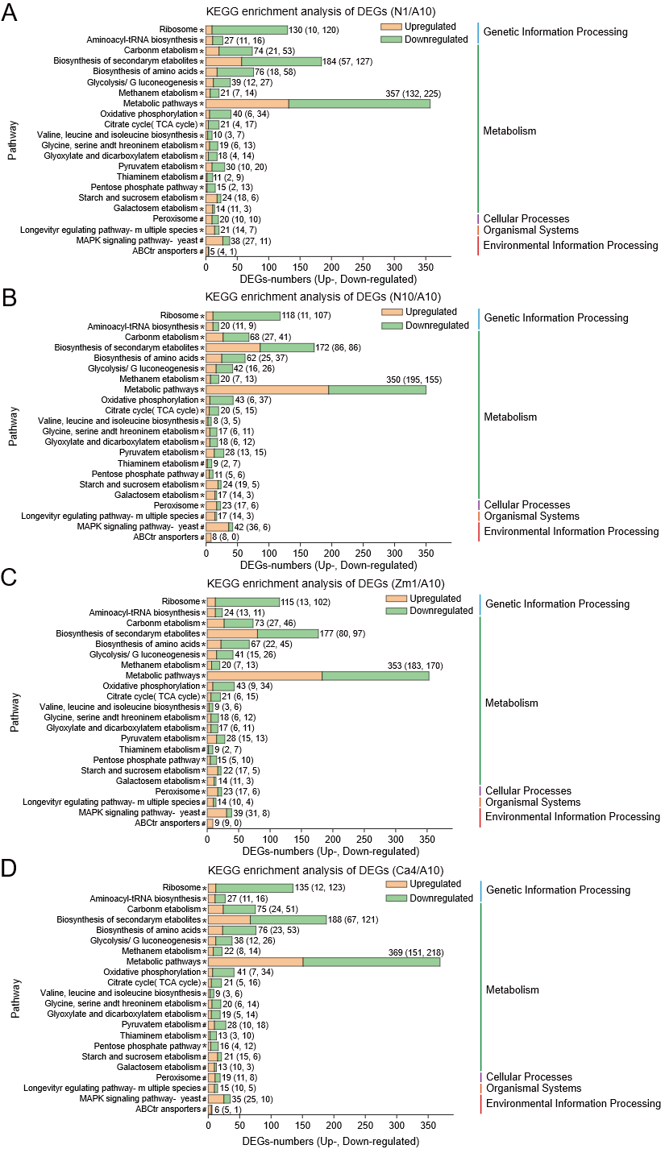
Fig. S8 KEGG enrichment analysis of DEGs between N1 and A10 (A), N10 and A10 (B), Zm1 and A10 (C), as well as Ca4 and A10 (D), respectively.
Table S1 Primers used in this study.
Primers | Sequence (5’ to 3’)
CCDs-F | ccattttgaggattcctatatcctatccttttgttgtttccgggtgtac
CCDs-R | cgatacctgagtattcccacagttggatccgcaaattaaagccttcgag
Leu-δ-F | ctcgaaggctttaatttgcggatccaactgtgggaatactcaggtatcg
Leu-δ-R | ggctataatattaggtatacagaaatcgactacgtcgttaaggccg
δ-up-F | tcggtaccctcgagggatccgaatttgttggaatagaaatcaactatcatctactaac
δ-up-R | acaacaaaaggataggatataggaatcctcaaaatggaatctatatttctacatac
δ-down-F | gacgtagtcgatttctgtatacctaatattatagcctttatcaacaatggaatcc
δ-down-R | gactgcaggtcgacaagcttgaattatgggggttctctggaacagc
PhCCD1-qPCR-F | gatggtgacggtatgattcatgg
PhCCD1-qPCR-R | ccaaacaaacctttcaagtcacc
NtCCD1-3-qPCR-F | gatggtgacggtatgattcatgg
NtCCD1-3-qPCR-R | ccaaacaaacctttcaagtcacc
NtCCD1-2-qPCR-F | gatggtgacggtatgattcatgg
NtCCD1-2-qPCR-R | ccaaacaaacctttcaagtcacc
NtCCD10-qPCR-F | agatgattttccggaaggagttt
NtCCD10-qPCR-R | gaaggtagtccaagttcctctta
ZmCCD1-qPCR-F | gctggttatcattggtttgatgg
ZmCCD1-qPCR-R | ccaaagaaacctttcaagtcacc
CaCCD4C-qPCR-F | caatccgttcaagtcccttcatt
CaCCD4C-qPCR-R | ttggtggcaattcaccgact
Act1-qPCR-F | gaattgagagttgccccaga
Act1-qPCR-R | ggcttggatggaa acgtaga

Table S2 HP-SPME-GC-MS analysis of β-cyclocitral and dihydroactinidiolide in the strain A10 and different tranformants of A10-δ-CCDs.
Strains | Transformants | Area
Strains | Transformants | β-Cyclocitral | Dihydroactinidiolide
Control | A10 | N.D. | 0.78×10⁶
A10-δ-PhCCD1 | 8# | N.D. | N.D.
A10-δ-PhCCD1 | 14# | N.D. | N.D.
A10-δ-PhCCD1 | 21# | N.D. | N.D.
A10-δ-NtCCD1-3 | 3# | N.D. | N.D.
A10-δ-NtCCD1-3 | 6# | N.D. | N.D.
A10-δ-NtCCD1-3 | 9# | N.D. | N.D.
A10-δ-NtCCD1-2 | 2# | 1.45×10⁶ | 1.81×10⁶
A10-δ-NtCCD1-2 | 3# | 1.46×10⁶ | 2.14×10⁶
A10-δ-NtCCD10 | 2# | N.D. | 1.72×10⁶
A10-δ-NtCCD10 | 3# | N.D. | 1.18×10⁶
A10-δ-ZmCCD1 | 8# | 3.18×10⁶ | 4.16×10⁶
A10-δ-ZmCCD1 | 9# | 2.27×10⁶ | 5.06×10⁶
A10-δ-ZmCCD1 | 10# | 2.02×10⁶ | 3.30×10⁶
A10-δ-ZmCCD1 | 11# | 2.79×10⁶ | 6.59×10⁶
A10-δ-ZmCCD1 | 12# | 2.79×10⁶ | 6.59×10⁶
A10-δ-CaCCD4C | 1# | 1.81×10⁶ | 5.20×10⁶
A10-δ-CaCCD4C | 7# | 1.72×10⁶ | 6.07×10⁶
A10-δ-CaCCD4C | 8# | 1.48×10⁶ | 5.47×10⁶
A10-δ-CaCCD4C | 10# | 1.24×10⁶ | 5.10×10⁶
A10-δ-CaCCD4C | 11# | 1.67×10⁶ | 4.93×10⁶
N.D. not detected.

