Appendix

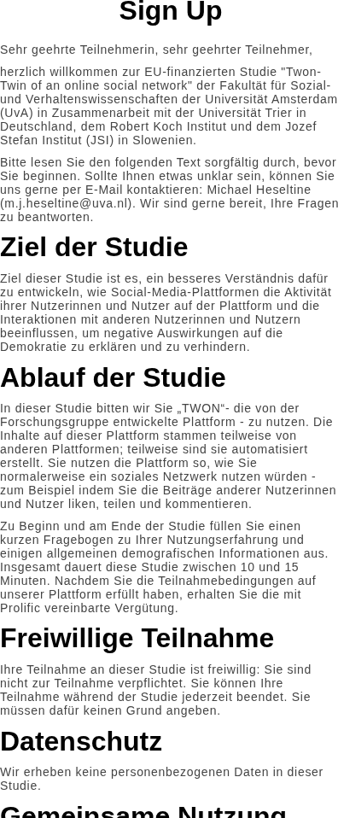
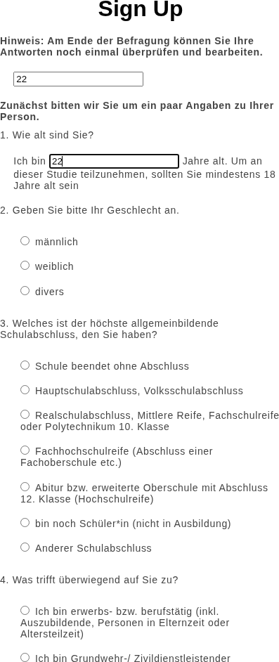
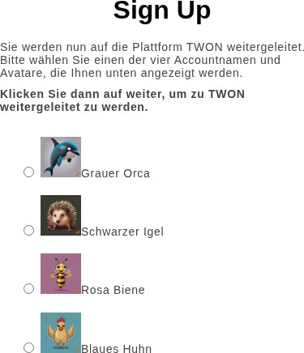
(a) Consent Form (b) Pre-survey (c) Username Selection
Fig. 3: User onboarding flow of the TWON platform.

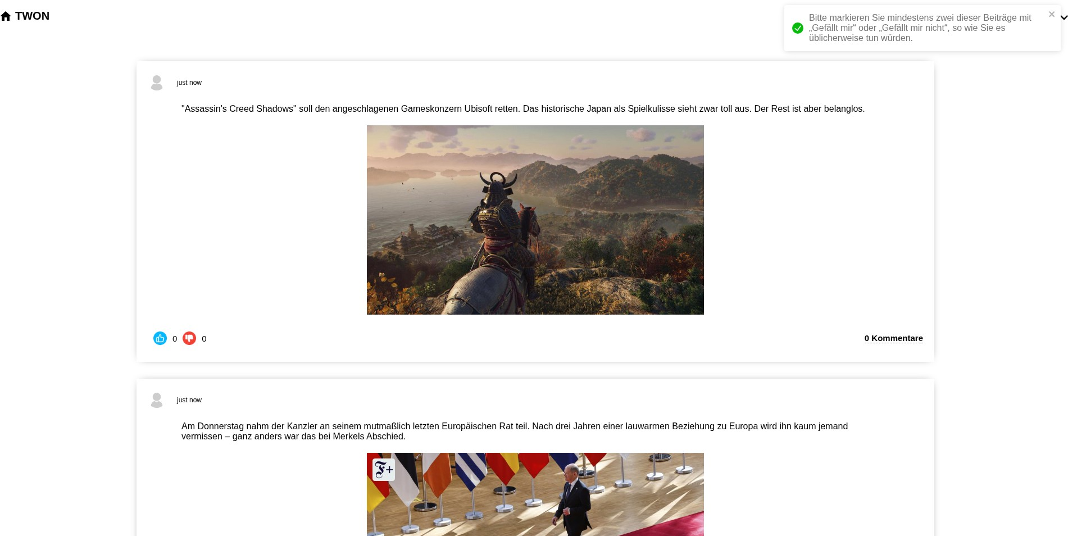
  - Feed
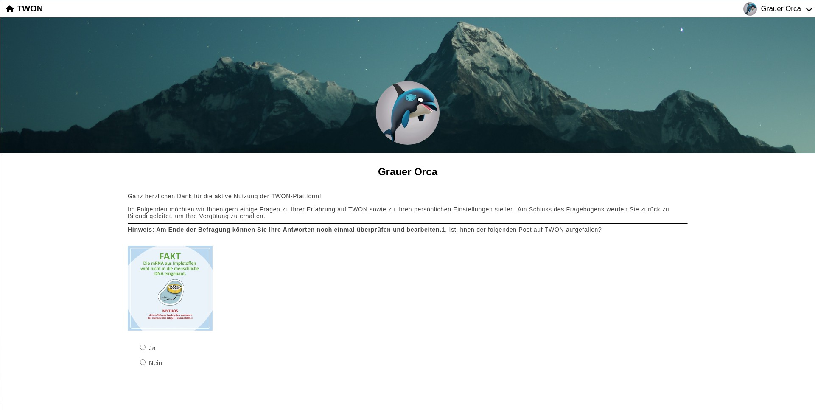
  - Post-survey

Fig. 4: User onboarding flow of the TWON platform.

