Supplementary Figures-

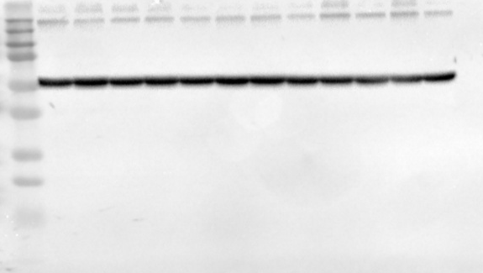
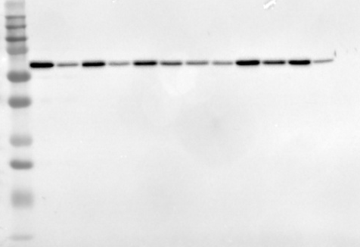
A B

C D
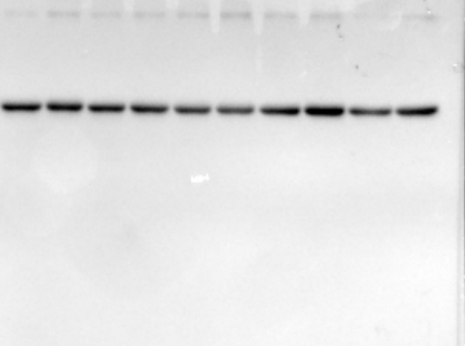
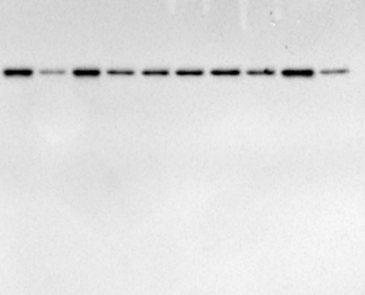

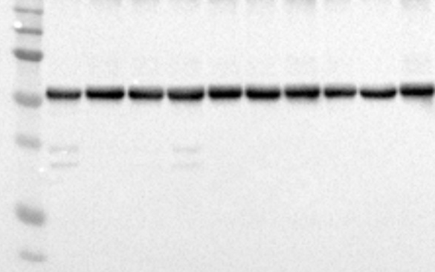
E F
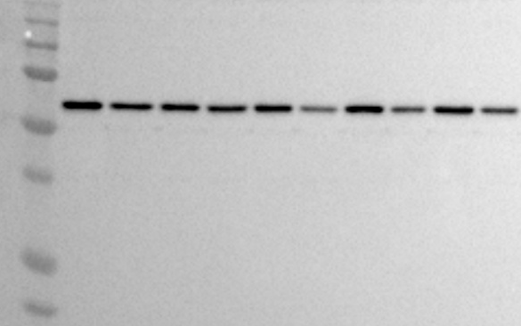

Supplementary Figure S1. Full western blots for expression of Tyrosine hydroxylase in striatum.
Panels A, C, and E show protein expression at 15, 30, and 60 days, respectively, with corresponding β-tubulin loading controls shown in panels B, D, and F.

A B
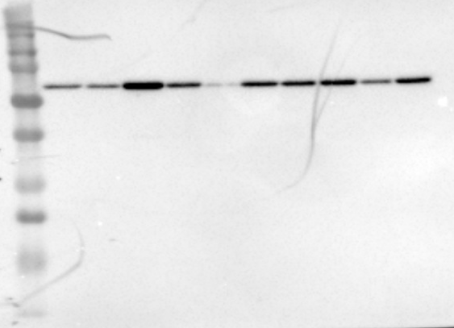
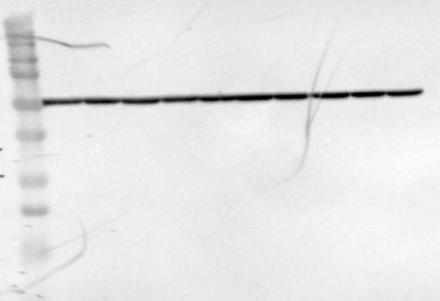

C D
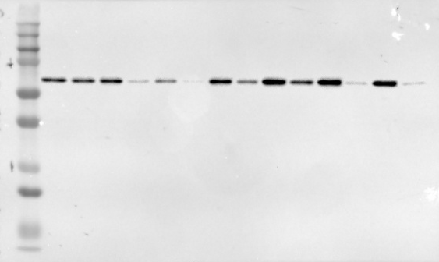
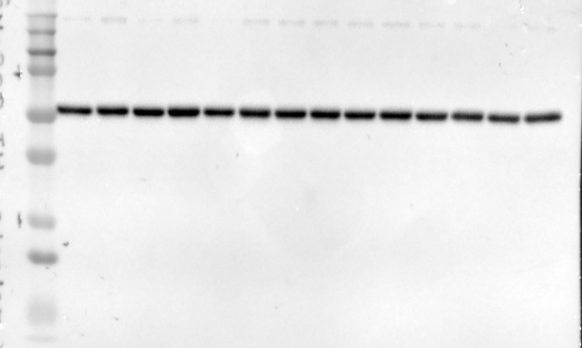

E F

Supplementary Figure S2. Full western blots for expression of Tyrosine hydroxylase in substantia nigra pars compacta.
Panels A, C, and E show protein expression at 15, 30, and 60 days, respectively, with corresponding β-tubulin loading controls shown in panels B, D, and F
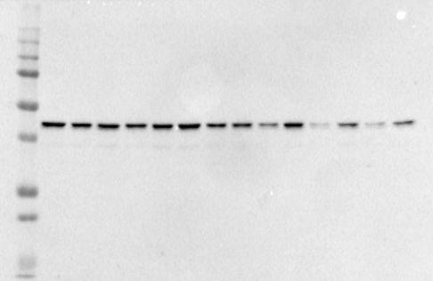
A B
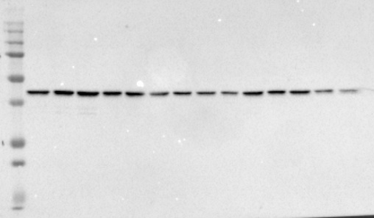

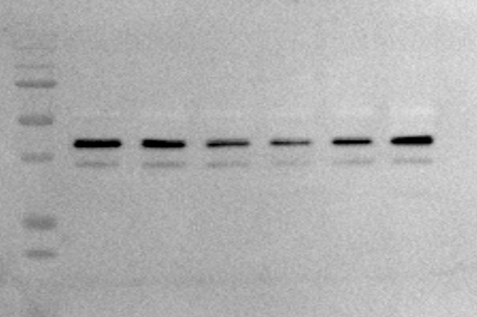
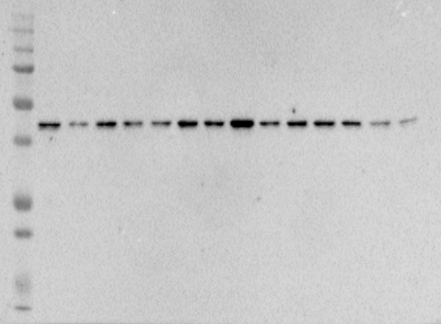
C D

E F
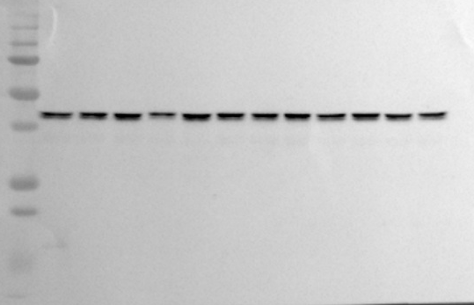
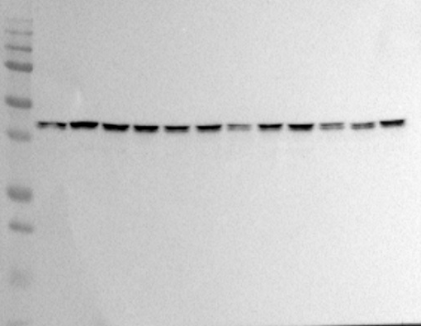

G H
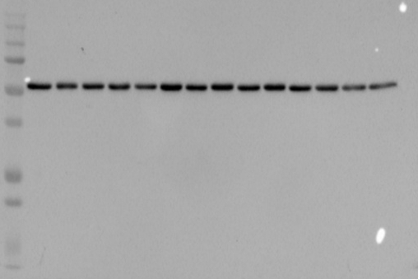
Supplementary Figure S3. Full western blots for expression of Dopamine D1 receptor in striatum and substantia nigra pars compacta.
Panels A, C, and E represent samples from the striatum at 15, 30, and 60 days, respectively, with the corresponding β-tubulin loading control shown in panel G. Panels B, D, and F represent samples from the substantia nigra at 15, 30, and 60 days, respectively, with the corresponding β-tubulin loading control shown in panel H.

A B
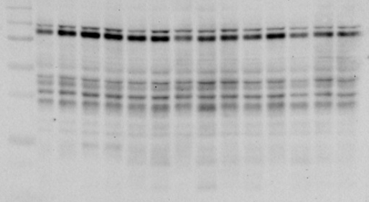
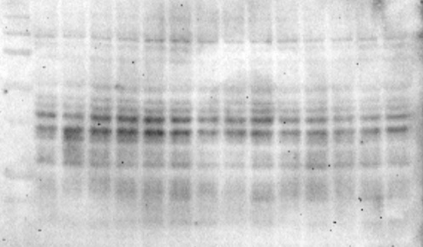

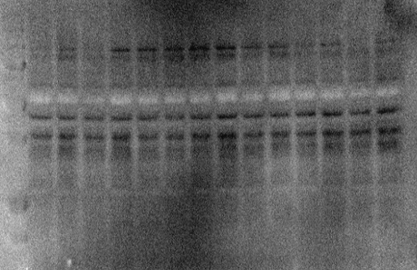
C D
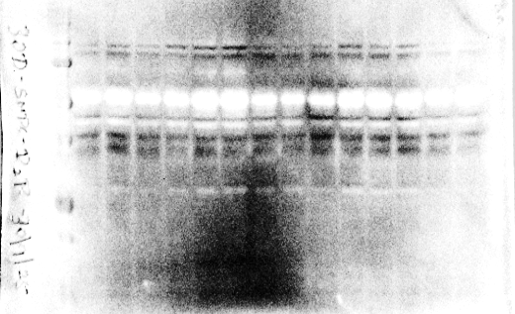

E F
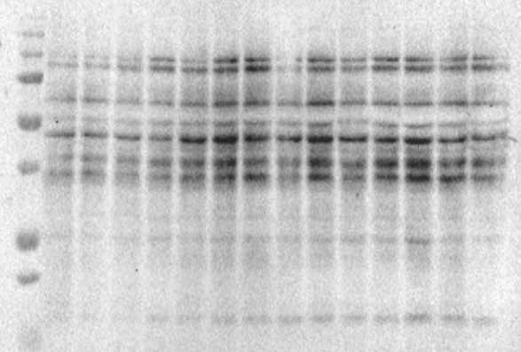
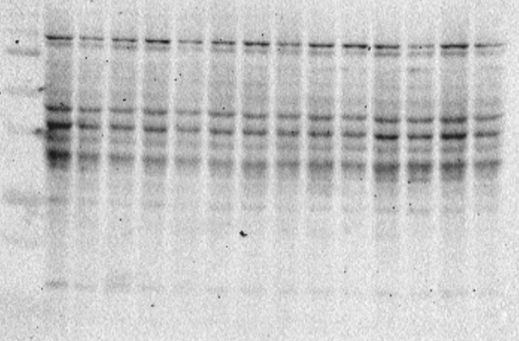

G H
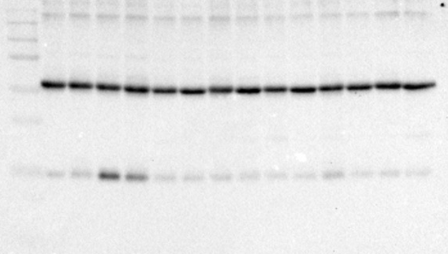
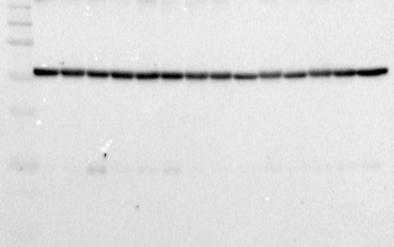

Supplementary Figure S4. Full western blots for expression of Dopamine D2 receptor in striatum and substantia nigra pars compacta.
Panels A, C, and E represent samples from the striatum at 15, 30, and 60 days, respectively, with the corresponding β-tubulin loading control shown in panel G. Panels B, D, and F represent samples from the substantia nigra at 15, 30, and 60 days, respectively, with the corresponding β-tubulin loading control shown in panel H.
A B
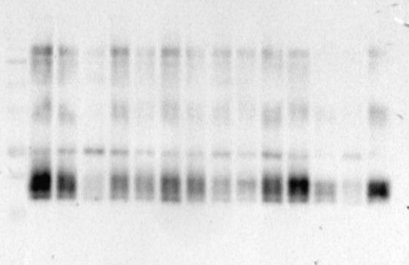
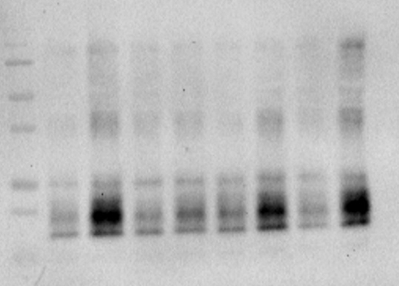

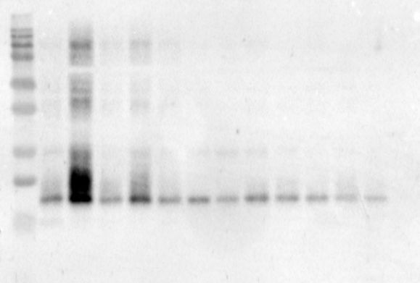
C D
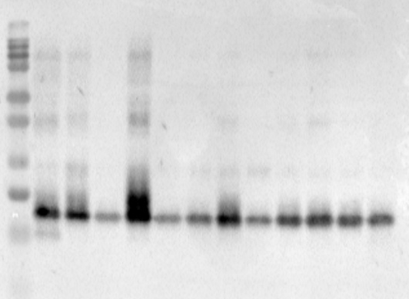

E F
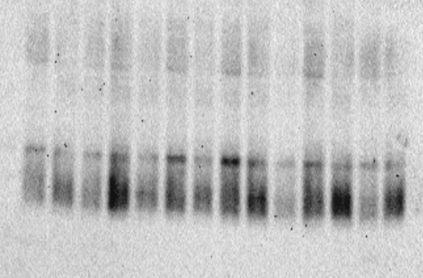

G H
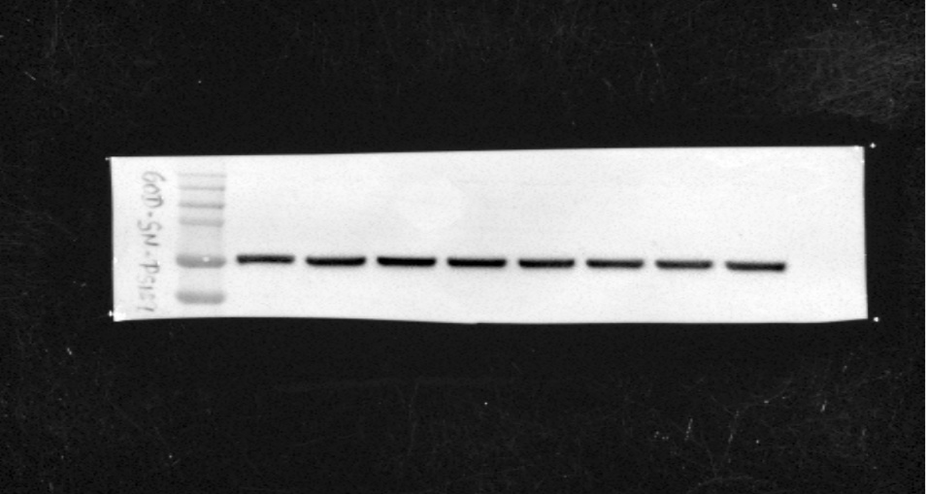

Supplementary Figure S5. Full western blots for expression Alpha-synuclein in striatum and substantia nigra pars compacta.
Panels A, C, and E represent samples from the striatum at 15, 30, and 60 days, respectively, with the corresponding β-tubulin loading control shown in panel G. Panels B, D, and F represent samples from the substantia nigra at 15, 30, and 60 days, respectively, with the corresponding β-tubulin loading control shown in panel H.

A B
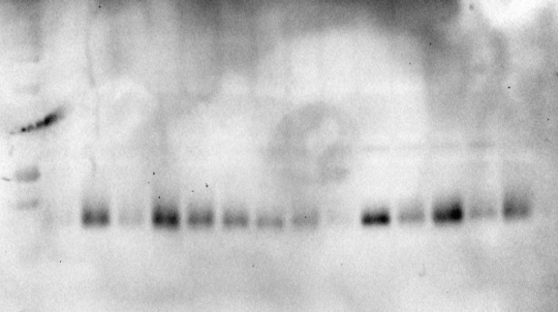
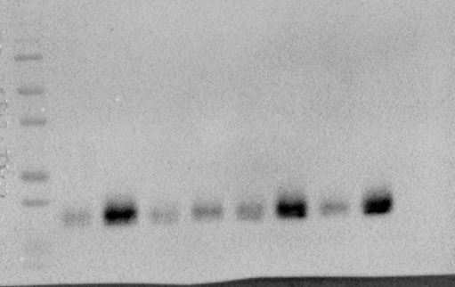

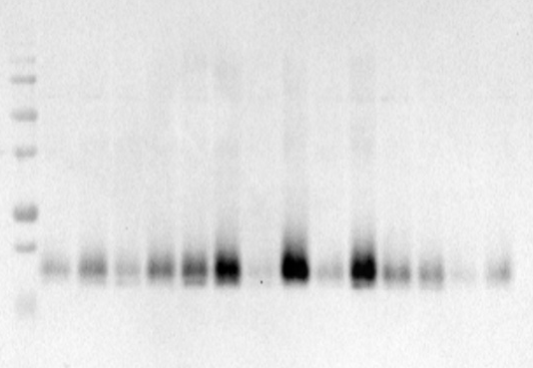
C D
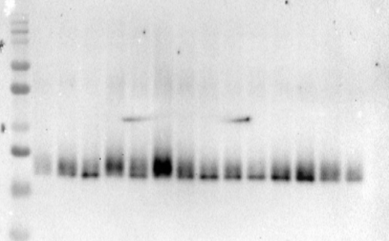

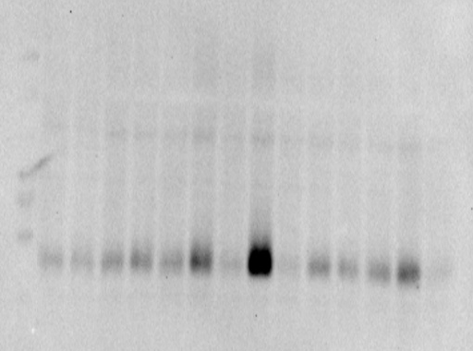
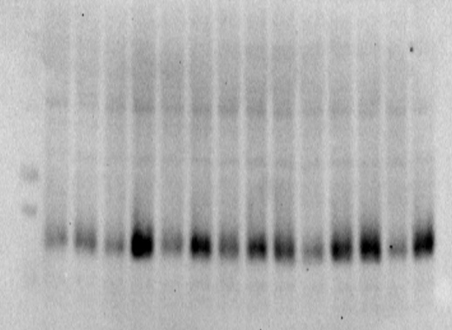
E F

G H
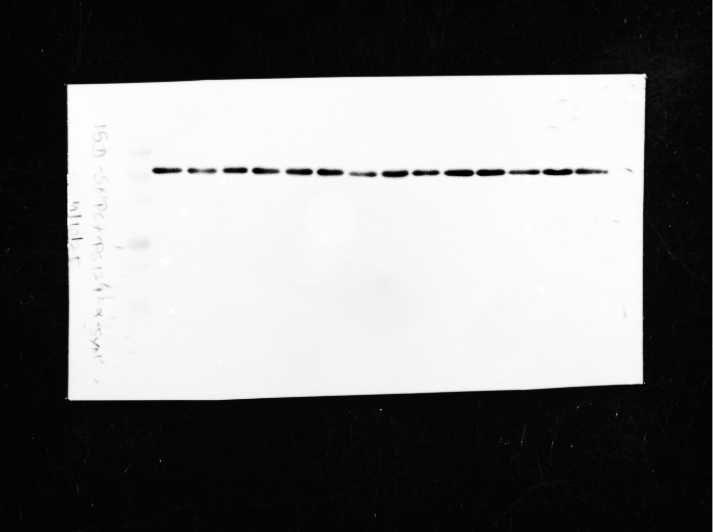
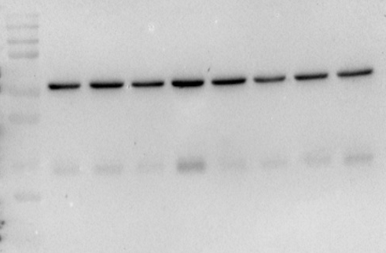

Supplementary Figure S6. Full western blots for expression pS129 in striatum and substantia nigra pars compacta.
Panels A, C, and E represent samples from the striatum at 15, 30, and 60 days, respectively, with the corresponding β-tubulin loading control shown in panel G. Panels B, D, and F represent samples from the substantia nigra at 15, 30, and 60 days, respectively, with the corresponding β-tubulin loading control shown in panel H.

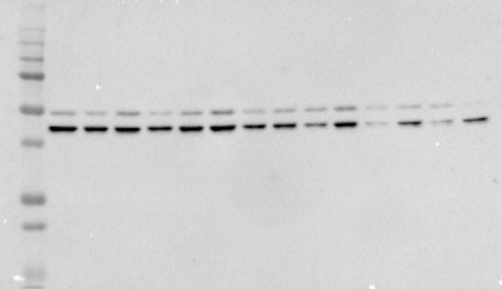
A B
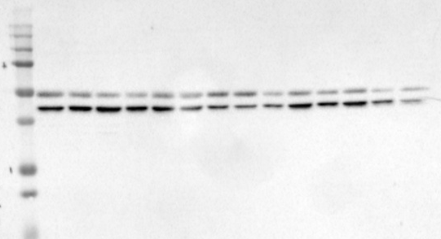

C D
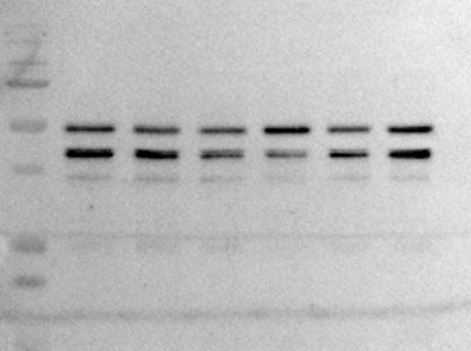
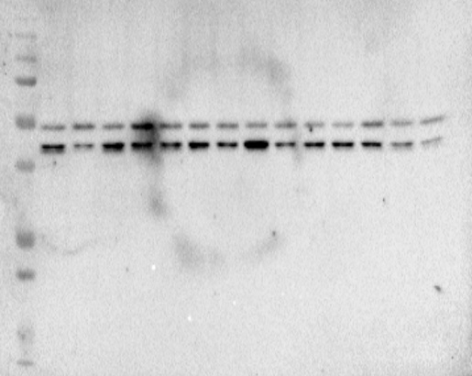

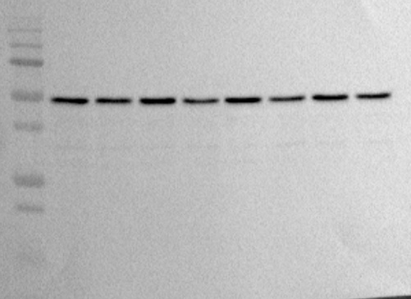
E F
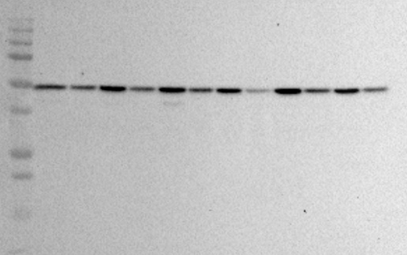

G H
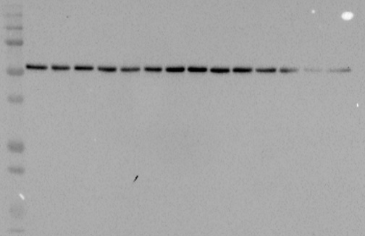
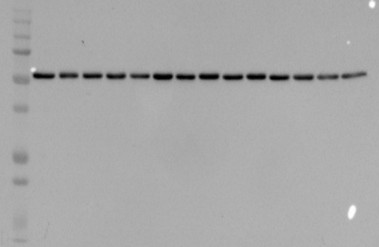

Supplementary Figure S7. Full western blots for expression GABA-A receptor in striatum and substantia nigra pars compacta.
Panels A, C, and E represent samples from the striatum at 15, 30, and 60 days, respectively, with the corresponding β-tubulin loading control shown in panel G. Panels B, D, and F represent samples from the substantia nigra at 15, 30, and 60 days, respectively, with the corresponding β-tubulin loading control shown in panel H.

