SUPLEMENT
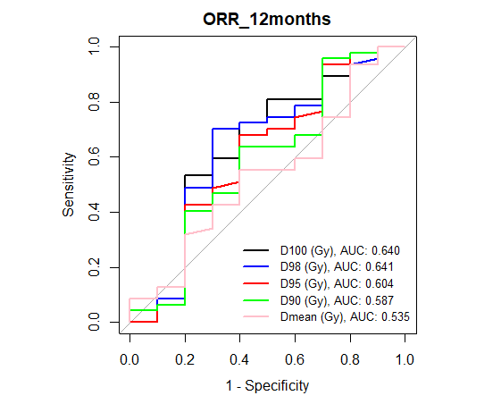
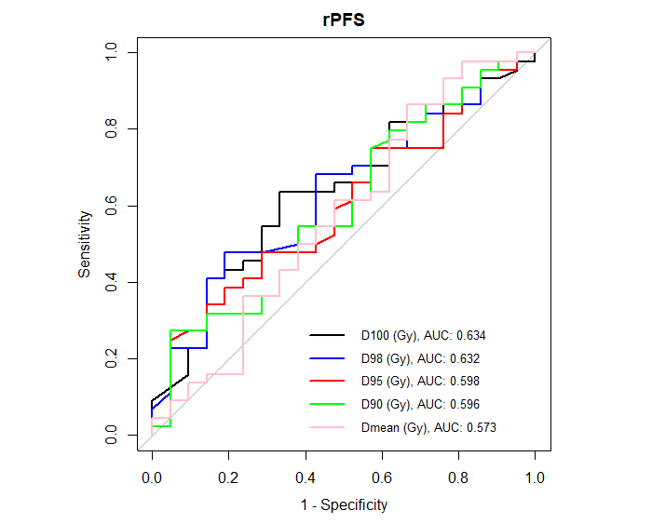
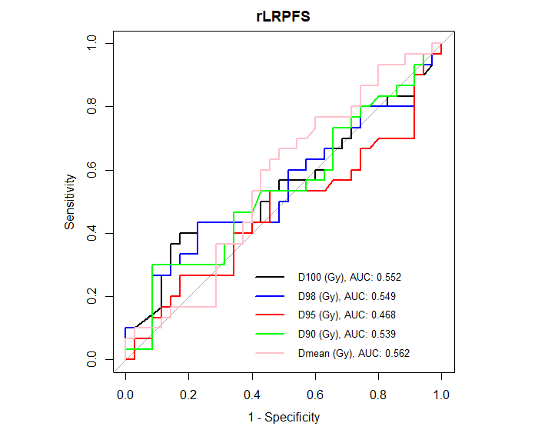
Figure S1. Receiver operating characteristic (ROC) curves for dose–volume parameters (D100, D98, D95, D90, Dmean) in relation to ORR at 12 months, rPFS and rLRPFS.
Supplementary Table S1. Association between dose–volume parameters and outcomes using the two-tailed Fisher’s exact test for 2 groups (above vs below dose threshold).
ORR_12m
Dose Factors | Dose Treshold [Gy] | 95% CI [Gy] | p-value for two-tailed Fisher's exact test
D100 | 14.9 | 12.8-20.1 | 0.14
D98 | 18.4 | 17.2-24.3 | 0.04
D95 | 21.1 | 18.8-31.2 | 0.15
D90 | 30.8 | 21.0-35.8 | 0.03
Dmean | 52.3 | 34.6-83.6 | 0.49

rPFS
Dose Factors | Dose Treshold [Gy] | 95% CI [Gy] | p-value for two-tailed Fisher's exact test
D100 | 12.7 | 10.7-15.5 | 0.07
D98 | 18.3 | 14.8-23.2 | 0.03
D95 | 21.1 | 14.4-25.3 | 0.27
D90 | 22.6 | 17.5-27.8 | 0.29
Dmean | 44.0 | 33.8-72.8 | 0.10

rLRPFS
Dose Factors | Dose Treshold [Gy] | 95% CI [Gy] | p-value for two-tailed Fisher's exact test
D100 | 16.3 | 10.7-20.2 | 0.05
D98 | 19.4 | 15.3-23.3 | 0.11
D95 | 21.7 | 15.1-25.0 | 0.59
D90 | 27.9 | 18.0-29.1 | 0.17
Dmean | 49.1 | 34.6-77.4 | 0.21

Supplementary Table S2. Differences in 12-month rPFS (log-rank test) and rLRPFS (Gray’s test) according to each dosimetric threshold.
rPFS
Dose Factors [Gy] | 12-months incidence [%] | 95% CI [%] | p-value
D100 |  |  |  | 0,3
≤12,7 | 37 | 18-56
>12,7 | 40 | 22-58
D98 |  |  |  | 0,3
≤18,3 | 35 | 19-51
>18,3 | 47 | 22-69
D95 |  |  |  | > 0,9
≤21,1 | 38 | 23-54
>21,1 | 40 | 16-64
D90 |  |  |  | 0,9
≤22,6 | 36 | 19-54
>22,6 | 42 | 22-61
Dmean |  |  |  | 0,7
≤44,0 | 39 | 10-67
>44,0 | 39 | 24-54
Liver-restricted progression
Dose Factors [Gy] | 12-month estimate [%] | 95% CI [%] | p-value
D100 |  |  | 0,1
≤16,3 | 22 | 10-37
>16,3 | 44 | 19-66
D98 |  |  | 0,3
≤19,4 | 24 | 11-40
>19,4 | 37 | 16-58
D95 |  |  | 0,9
≤21,7 | 31 | 17-46
>21,7 | 24 | 7-46
D90 |  |  | 0,6
≤27,9 | 29 | 17-43
>27,9 | 25 | 3-58
Dmean |  |  | 0,3
≤49,1 | 20 | 6-40
>49,1 | 35 | 19-51

