APPENDIX
This appendix reports the additional robustness evidence referenced in Section 4.2.
Appendix Table A1. HS10 Robustness Across Scored Subsamples
Dependent variable: ln(unit value)
Panel A. H1
Variables | S1 | S2 | S3 | S4 | S5
ln(dist) | 0.2849*** | 0.2962*** | 0.1897*** | 0.1979*** | 0.2060***
 | (0.0202) | (0.0204) | (0.0226) | (0.0225) | (0.0226)
Observations | 10,655,711 | 10,406,217 | 6,905,933 | 6,863,656 | 6,761,359
Within R² | 0.002 | 0.002 | 0.001 | 0.001 | 0.001

Panel B. H2
Variables | S1 | S2 | S3 | S4 | S5
ln(dist)_c | 0.1687*** | 0.1756*** | 0.2127*** | 0.2241*** | 0.2329***
 | (0.0273) | (0.0275) | (0.0303) | (0.0302) | (0.0303)
Air (dummy) | -0.2477*** | -0.2517*** | -0.3056*** | -0.3058*** | -0.3062***
 | (0.0094) | (0.0096) | (0.0111) | (0.0112) | (0.0113)
Air × ln(dist)_c | 0.2502*** | 0.2610*** | 0.0510 | 0.0444 | 0.0418
 | (0.0332) | (0.0334) | (0.0348) | (0.0349) | (0.0351)
Observations | 10,655,711 | 10,406,217 | 6,905,933 | 6,863,656 | 6,761,359
Within R² | 0.046 | 0.049 | 0.062 | 0.063 | 0.063
Notes: Standard errors are reported in parentheses. *** p<0.01, ** p<0.05, * p<0.10. All regressions include HS10 product fixed effects and year fixed effects; standard errors are clustered at the HS6 level.

Appendix Figure A1. HS2 Air-Transport Interaction Across Scored Subsamples
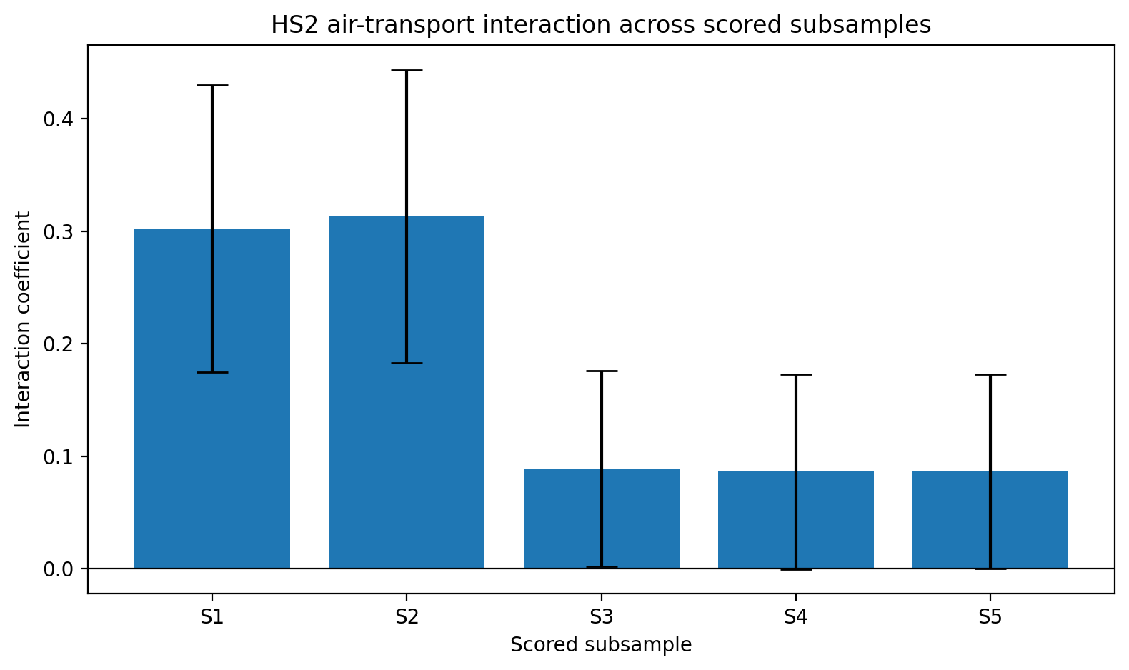
Notes: The figure plots the coefficient on Air × ln(dist)_c from the HS2 robustness specification across the five scored subsamples S1–S5. Error bars correspond to one standard error. The interaction is positive in every subsample and statistically significant in the two broadest samples, S1 and S2.

