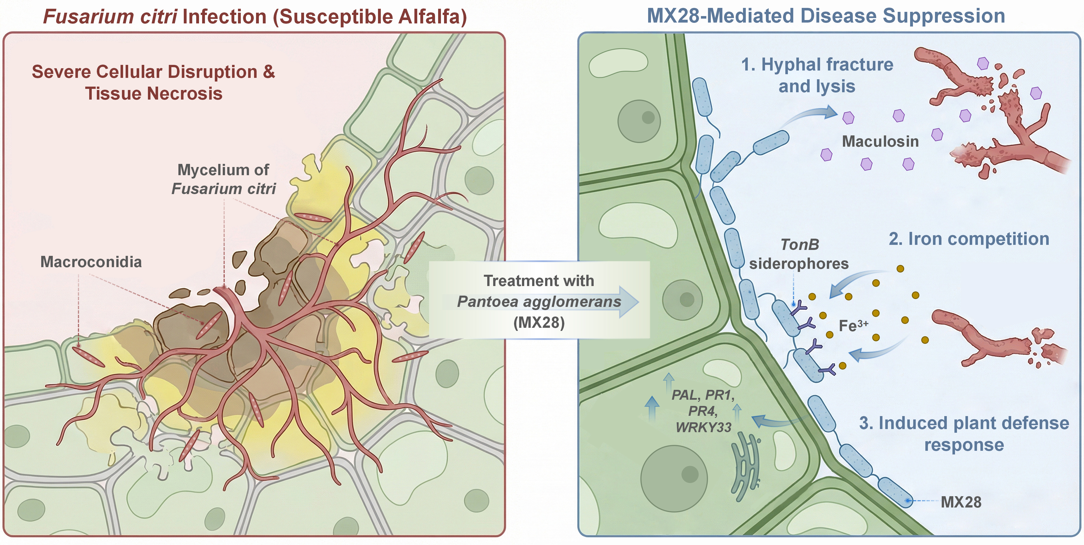
Schematic model of MX28-mediated suppression of alfalfa leaf blight. In susceptible alfalfa, Fusarium citri infection leads to fungal colonization, macroconidia accumulation, severe cellular disruption, and tissue necrosis. Treatment with Pantoea agglomerans MX28 suppresses disease through three coordinated mechanisms: maculosin-associated hyphal fracture and lysis, TonB siderophore-mediated iron competition, and induction of plant defense responses, including PAL, PR1, PR4, and WRKY33. Together, these processes restrict fungal growth and alleviate host tissue damage.

