Tables:
Table S1: Detailed information of the correction process for missing records in the daily rainfall data at 23 stations over Bangladesh.
Rainfall Station | Year | Data Missing  (Number of Days) | Neighbour Station from where Data Filled-up
Barisal | 1987 | 7 | Bhola
Bhola | 1987 | 7 | Barisal
Bogura | 1987 | 6 | Rangpur
Rajshahi | 1985 | 5 | Bogura
 | 1987 | 7
Rangpur | 1981 | 90 | Bogura
Cumilla | 1981 | 365 | Dhaka
Rangamati | 1981 | 59 | Sitakunda
Cox’s bazaar | 1980 | 61 | Tekhnaf
Feni | 1983 | 31 | Cumila
Feni | 2005 | 30 | Cumila
Sandwip | 1984 | 5 | Sitakunda
Sandwip | 1991 | 39 | Sitakunda
Sandwip | 2000 | 146 | Sitakunda
Sandwip | 2001 | 16 | Sitakunda
Sandwip | 2002 | 365 | Sitakunda
Sandwip | 2003 | 365 | Sitakunda
Sandwip | 2004 | 260 | Sitakunda
Sandwip | 2012 | 31 | Sitakunda
Teknaf | 1980 | 4 | Cox’s Bazar
Teknaf | 1982 | 3 | Cox’s Bazar
Teknaf | 1983 | 65 | Cox’s Bazar
Teknaf | 1984 | 93 | Cox’s Bazar
Teknaf | 1987 | 8 | Cox’s Bazar
Teknaf | 1991 | 5 | Cox’s Bazar
Teknaf | 1994 | 35 | Cox’s Bazar

Table S2. Detailed information of the missing data management of daily maximum temperature and minimum temperature at 20 stations of Bangladesh.
Stations | Year | Number of missing days |  | Neighbor station from where missing data filled-up
Stations | Year | Tmax | Tmin | Neighbor station from where missing data filled-up
Bogura | 1980 | 3 | - | Rajshahi
Bogura | 1981 | 2 | - | Rajshahi
Bogura | 1982 | 9 | 4 | Rajshahi
Bogura | 1983 | 2 | - | Rajshahi
Bogura | 1985 | 2 | - | Rajshahi
Bogura | 1987 | 12 | 8 | Rajshahi
Bogura | 2004 | 16 | - | Rajshahi
Bogura | 2013 | 30 | 30 | Rajshahi
Dhaka | 1980 | 2 | 2 | Mymensingh, Faridpur
 | 1981 | 8 | 3 | Mymensingh, Faridpur
 | 1982 | 4 | 2 | Mymensingh, Faridpur
Jashore | 1980 | 14 | 6
Jashore | 1985 | 3 | 10 | Khulna
Jashore | 1986 | 4 | 43
Mymensingh | 1980 | - | 5
Mymensingh | 1981 | 1 | 365 | Sylhet, Dhaka
Mymensingh | 1982 | 1 | 365 | Sylhet, Dhaka
Mymensingh | 1984 | 2 | 120 | Sylhet, Dhaka
Mymensingh | 1985 | 4 | 20 | Sylhet, Dhaka
Mymensingh | 1987 | - | 3 | Sylhet, Dhaka
Patuakhali | 1980 | 365 | 365 | Barishal, Bhola
Patuakhali | 1986 | 1 | 3 | Barishal, Bhola
Patuakhali | 1987 | 22 | 7 | Barishal, Bhola
Patuakhali | 1997 | 5 | 2 | Barishal, Bhola
Rajshahi | 1980 | 5 | 2 | Bogura
Rajshahi | 1981 | 113 | 12 | Bogura
Rajshahi | 1982 | 150 | 7 | Bogura
Rajshahi | 1985 | 8 | 6 | Bogura
Rangamati | 1980 | 16 | 3 | Sitakunda
Rangamati | 1981 | 91 | 91 | Sitakunda
Rangamati | 1987 | 6 | 6 | Sitakunda
Rangpur | 1980 | 24 | 3
Rangpur | 1981 | 112 | 104
Rangpur | 1983 | 5 | 3
Rangpur | 1984 | 2 | - | Dinajpur
Rangpur | 2006 | 3 | 3
Sylhet | 1980 | 5 | 5 | Srimangal
Sylhet | 1987 | 15 | 285 | Srimangal
Sylhet | 1995 | 6 | 2 | Srimangal
Faridpur | 1980 | 4 | -
Faridpur | 1981 | 3 | 3
Faridpur | 1982 | 6 | 1
Faridpur | 1983 | 6 | 6 | Madaripur
Faridpur | 2004 | - | 13
Faridpur | 2007 | 1 | -
Madaripur | 1980 | 7 | 1 | Faridpur
Madaripur | 1981 | 153 | 153 | Faridpur
Madaripur | 1984 | 2 | 2 | Faridpur
Madaripur | 1987 | 1 | 195 | Faridpur
Madaripur | 1988 | 6 | 184 | Faridpur
Madaripur | 1989 | 1 | 58 | Faridpur
Madaripur | 1990 | - | 60 | Faridpur
Madaripur | 1996 | - | 8 | Faridpur
Madaripur | 1998 | 3 | 3 | Faridpur
Madaripur | 1999 | 159 | - | Faridpur
Khulna | 1980 | 15 | 9 | Jashore, Satkhira
Khulna | 1982 | 3 | 3 | Jashore, Satkhira
Khulna | 1983 | 31 | 31 | Jashore, Satkhira
Barishal | 1980 | 8 | 3 | Patuakhali, Bhola
Barishal | 1986 | 2 | - | Patuakhali, Bhola
Barishal | 1987 | 6 | 6 | Patuakhali, Bhola
Bhola | 1987 | 6 | 6 | Patuakhali,Sandwip
 | 1992 | 16 | 16 | Patuakhali,Sandwip
 | 2002 | 199 | - | Patuakhali,Sandwip
 | 2004 | 3 | 8 | Patuakhali,Sandwip
Cumilla | 1980 | 4 | 2 | Feni, Dhaka
Cumilla | 1981 | 6 | 5 | Feni, Dhaka
Cumilla | 1983 | 47 | 7 | Feni, Dhaka
Cumilla | 1984 | 2 | 2 | Feni, Dhaka
Cumilla | 1987 | 7 | 7 | Feni, Dhaka
Cox’s Bazar | 1980 | 67 | 68 | Teknaf
Cox’s Bazar | 1984 | 26 | 7 | Teknaf
Cox’s Bazar | 1985 | 44 | 37 | Teknaf
Cox’s Bazar | 1986 | 21 | 21 | Teknaf
Cox’s Bazar | 1987 | 15 | 13 | Teknaf
Cox’s Bazar | 1988 | 8 | 3 | Teknaf
Feni | 1980 | 11 | 6
Feni | 1981 | 6 | 2
Feni | 1983 | 33 | 32 | Cumilla
Feni | 1984 | 7 | -
Feni | 2003 | 62 | 27
Feni | 2005 | 31 | 31
Sandwip | 1980 | 5 | 4
Sandwip | 1984 | 5 | - | Bhola
Sandwip | 1985 | 3 | 2 | Bhola
Sandwip | 1987 | 7 | 7 | Bhola
Sandwip | 1991 | 39 | 39 | Bhola
Sandwip | 2000 | 146 | 147 | Bhola
Sandwip | 2001 | 16 | 9 | Bhola
Sandwip | 2002 | 365 | 365 | Bhola
Sandwip | 2003 | 365 | 365 | Bhola
Sandwip | 2004 | 260 | 260 | Bhola
Sandwip | 2012 | 31 | 31
Teknaf | 1980 | 4 | 4
Teknaf | 1982 | 3 | 2 | Cox’s Bazar
Teknaf | 1983 | 60 | 31 | Cox’s Bazar
Teknaf | 1984 | 93 | - | Cox’s Bazar
Teknaf | 1987 | 8 | 7 | Cox’s Bazar
Teknaf | 1991 | 5 | 13 | Cox’s Bazar
Teknaf | 1994 | 28 | 150

List of Figures

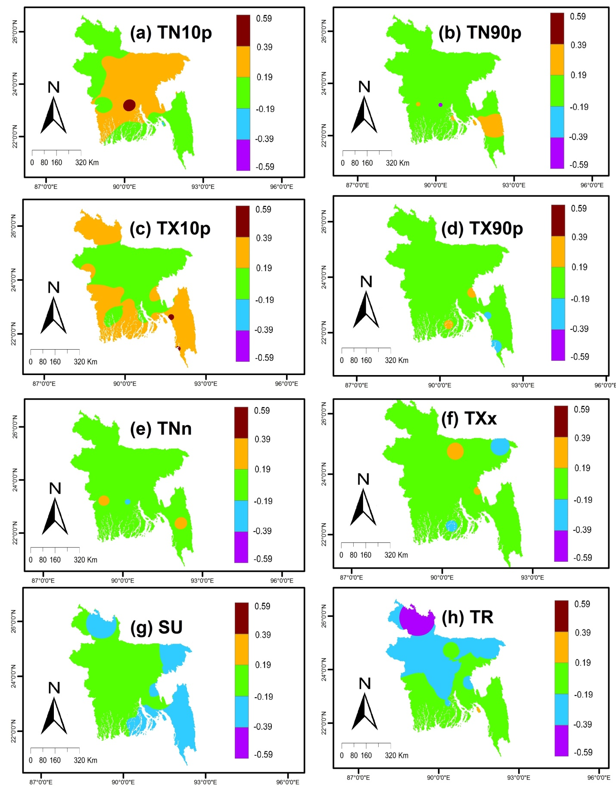
Fig. S1 Mapping of the association of extreme temperature indices with MEI
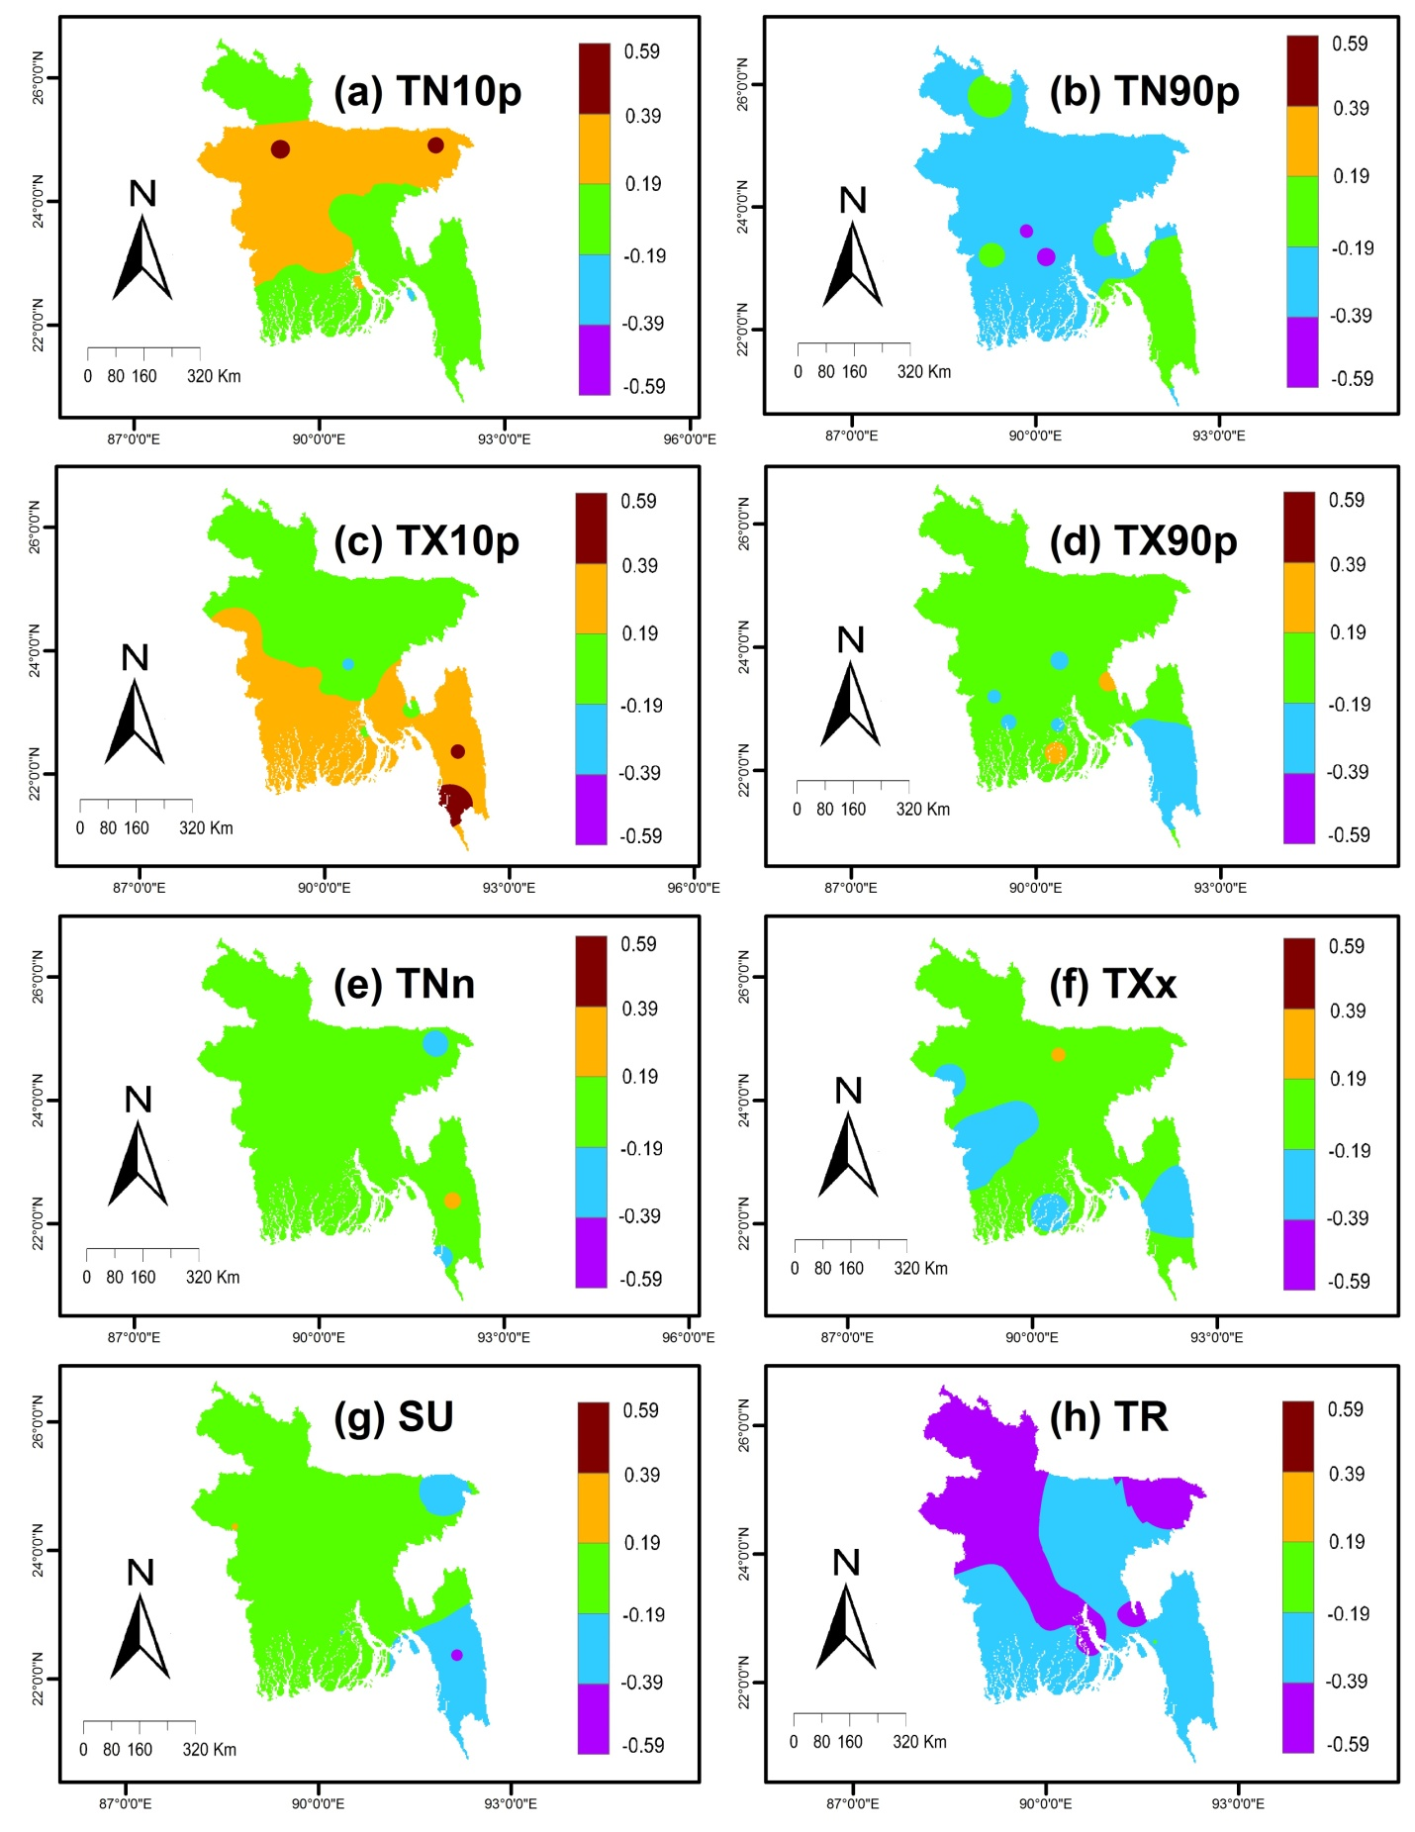
Fig. S2 Mapping of the association of extreme temperature indices with SOI
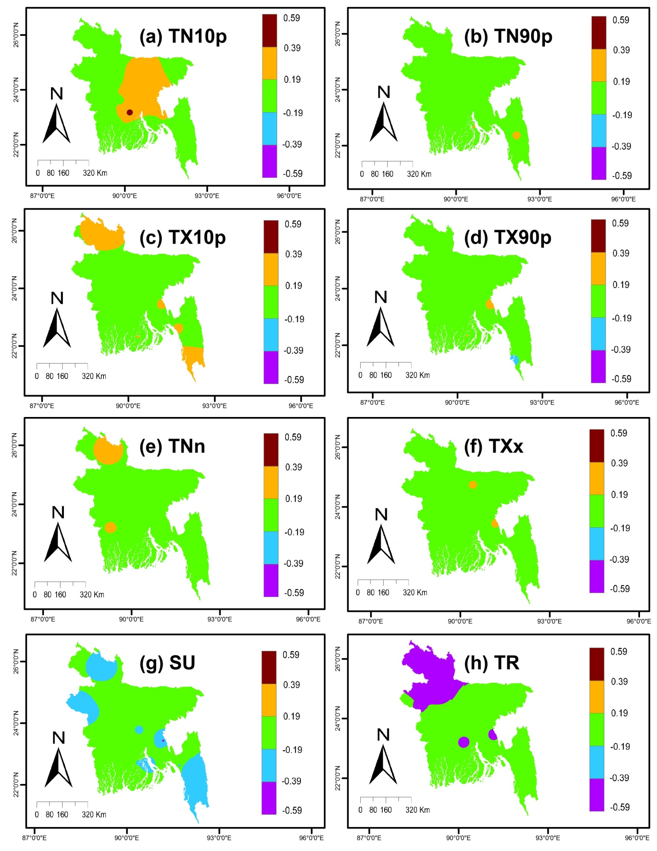
Fig. S3 Mapping of the association of extreme temperature indices with SST
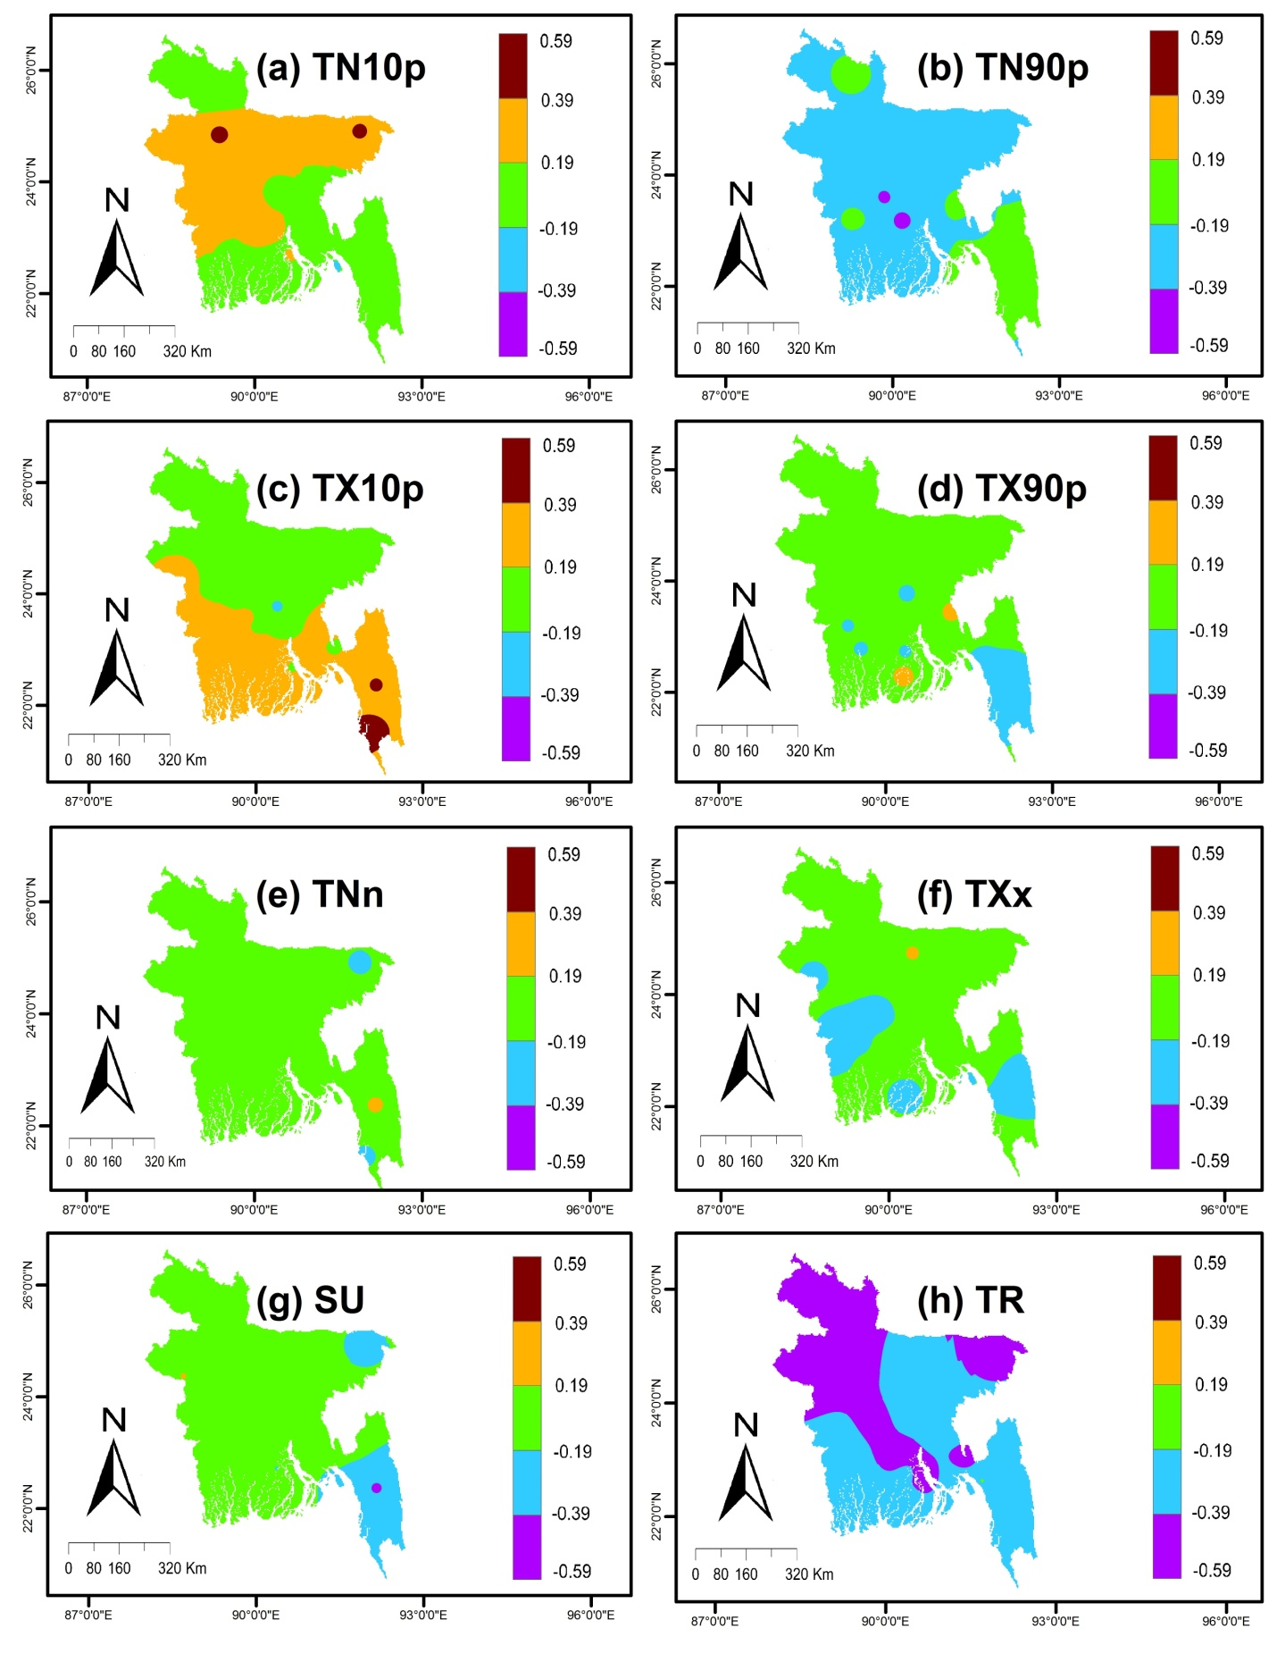
Fig S4 Mapping of the association of extreme temperature indices with NAO

