GRAPHICAL ABSTRACT

FOUR UNDERUTILIZED ETHNOMEDICINAL PLANTS
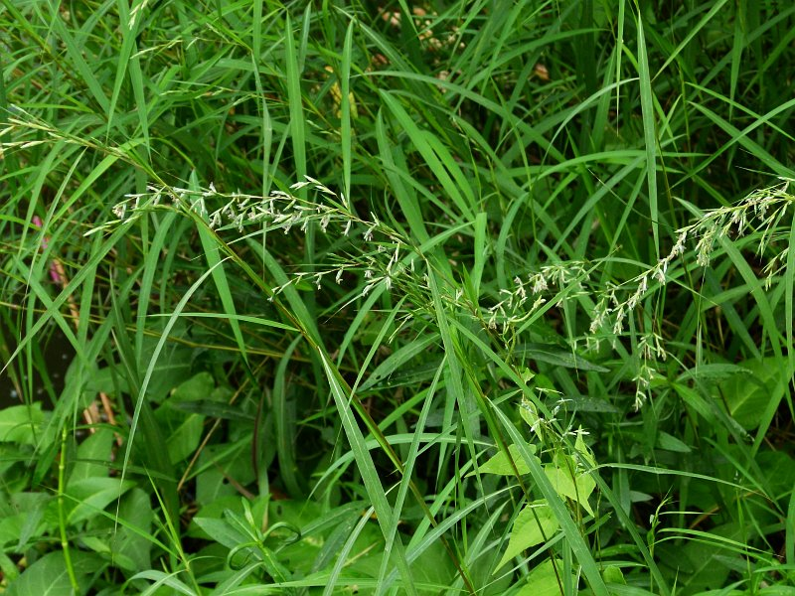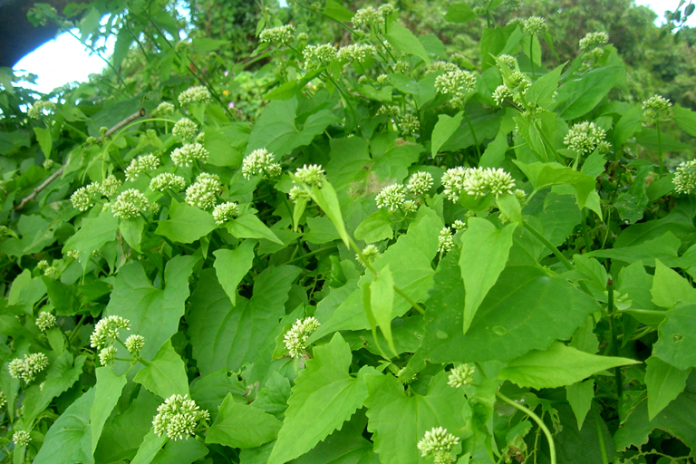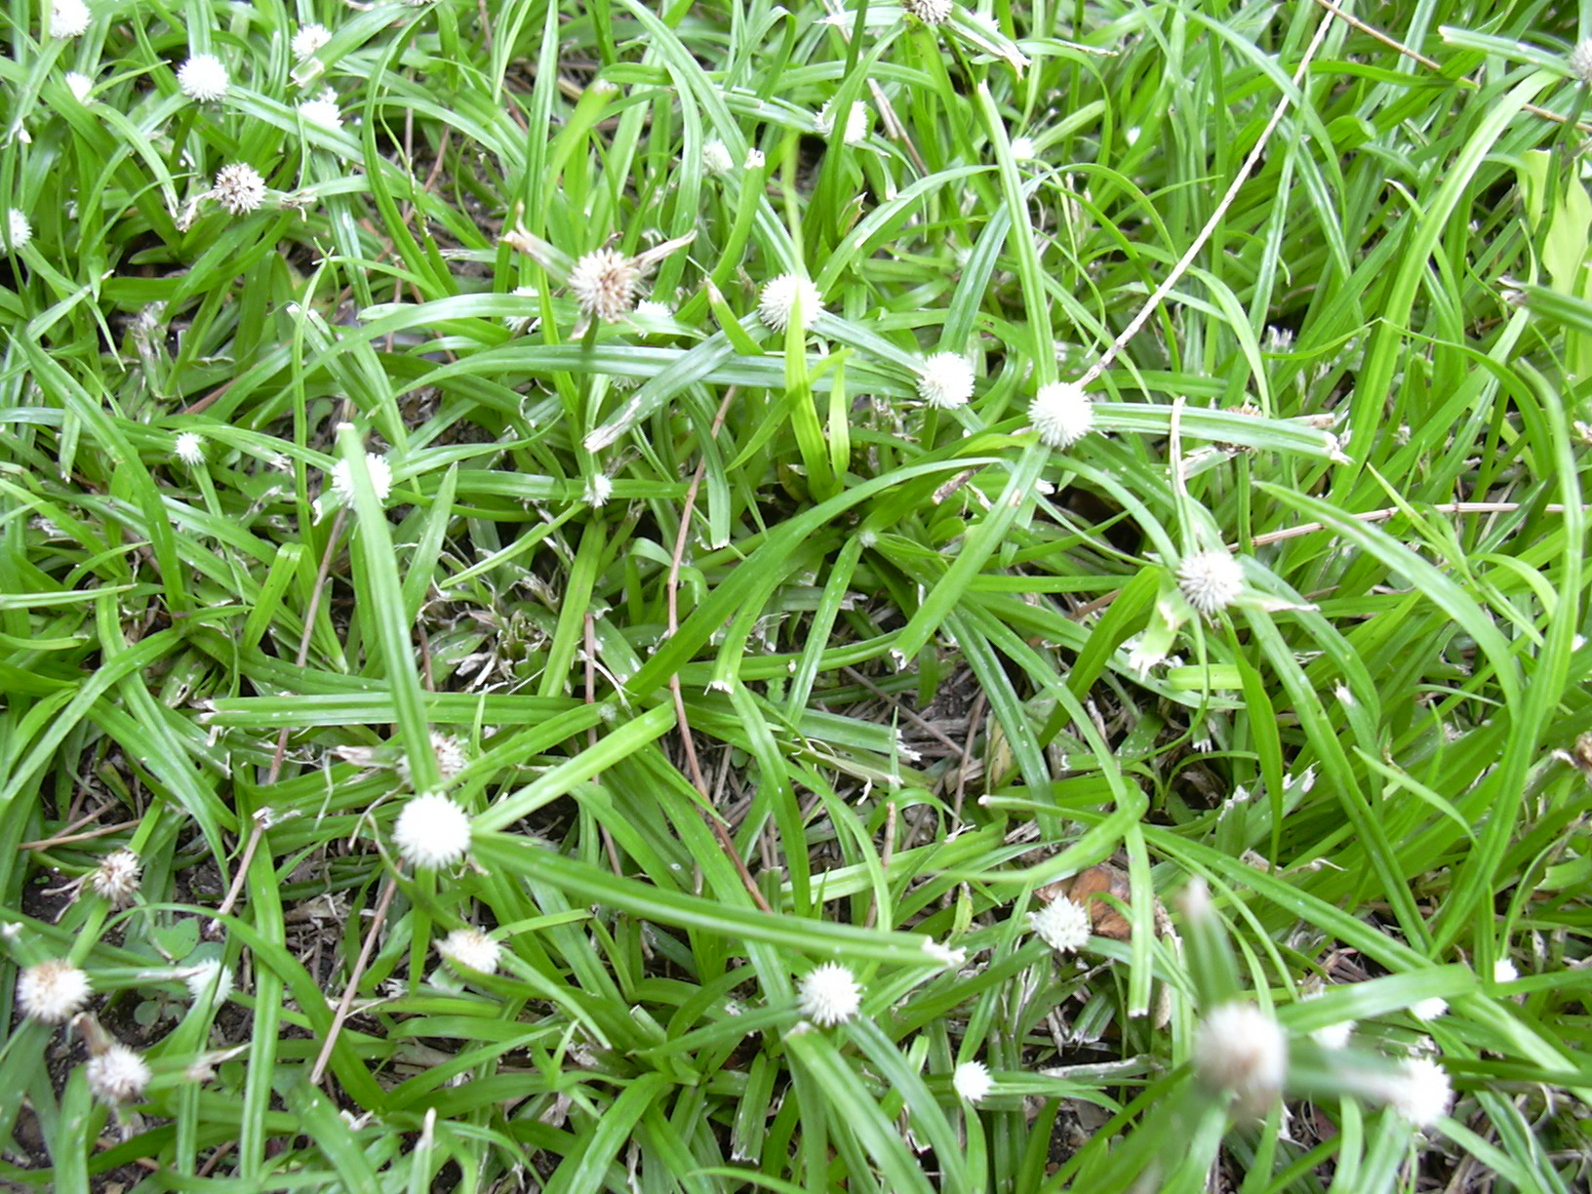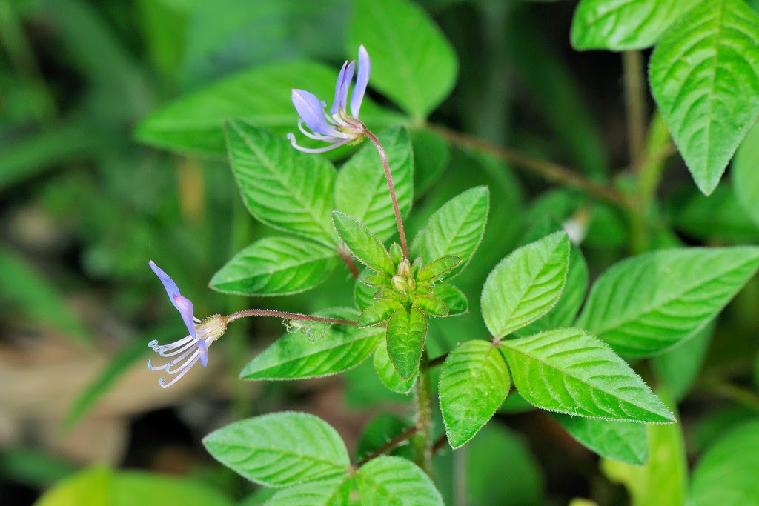
Apluda mutica Micania micrantha Kyllinga nemoralis Cleome rutidosperma

Potential sources of antioxidant, anti-diabetic and anti- inflammatory agent.
HPLC profiling of all plants different solvent system
Anti-oxidant activity in four different solvent system of all plants
Anti-diabetic activity of all plants

Anti-inflammatory activity of all plants

