Effects of pre-spawning heat-stress on the fecundity of Acropora aspera
Supplementary Information

SI.1 Summary of Model Results and Post-Hoc Comparisons for Coral Fecundity Traits

Table 1. Summary of model results for Acropora aspera coral fecundity traits under different heat-stress treatments. Two analyses were performed for each fecundity trait: (1) a 9-week treatment-only comparison (including Control, +1 °C, and +2 °C treatments for 9 weeks), and (2) a duration-inclusive model excluding controls to assess cumulative heat-stress effects. For each model, the fixed effect p-values are reported for treatment comparisons, along with the estimated coral genotypic variance (random effect) and AIC values.
Fecundity Trait | Treatments compared | Fixed Effect p-values | Coral  Genotypic Variance  (Random Effect) | AIC
Probability of finding a Gravid Polyp | Analysis 1:  9 weeks treatments only (Controls, +1C and +2 for 9 weeks) | Model: GLMM - Binomial (logit link)  Fecundity ~ Heat + (1|Coral Genotype)
Probability of finding a Gravid Polyp |  | +1C x 9 weeks = 0.352,  +2C x 9 weeks = 0.007 | 3.426 | 1034.2
Probability of finding a Gravid Polyp | Analysis 2:  Heat-stress treatments only (all treatments except Controls) | Model: GLMM - Binomial (logit link)  Fecundity ~ Heat + poly(Duration) + (1|Coral Genotype) (no interactive effect)
Probability of finding a Gravid Polyp |  | +2C = 0.832,  6 weeks = 0.158,  9 weeks = 0.001 | 2.688 | 1974.5
Egg Count Per Polyp | Analysis 1:  9 weeks treatments only (Controls, +1C and +2 for 9 weeks) | Model: GLMM – Truncated Poisson (log)  Fecundity ~ Heat + (1|Coral Genotype)
Egg Count Per Polyp |  | +1C x 9 weeks = 0.135,  +2C x 9 weeks = 0.084 | 0.003 | 489.2
Egg Count Per Polyp | Analysis 2:  Heat-stress treatments only (all treatments except Controls) | Model: GLMM – Truncated Poisson (log)  Fecundity ~ Heat + Duration + (1|Coral Genotype) (no interactive effect)
Egg Count Per Polyp |  | +2C = 0.094,  6 weeks = 0.092,  9 weeks = 0.325 | 0.019 | 1104.3
Egg volume | Analysis 1:  9 weeks treatments only (Controls, +1C and +2 for 9 weeks) | Model: LMM – Gaussian  Fecundity ~ Heat + (1|Coral Genotype)
Egg volume |  | +1C x 9 weeks < 0.001,  +2C x 9 weeks < 0.001 | <0.001 | -2633.6
Egg volume | Analysis 2:  Heat-stress treatments only (all treatments except Controls) | Model: LMM – Gaussian  Fecundity ~ Heat * Duration + (1|Coral Genotype) (significant interactive effect)
Egg volume |  | +2C = 0.693,  6 weeks = 0.071,  9 weeks < 0.001,  +2C x 6 weeks = 0.971  +2C x 9 weeks < 0.001 | <0.001 | -5721.7
Total Testis Volume per Polyp | Analysis 1:  9 weeks treatments only (Controls, +1C and +2 for 9 weeks) | Model: LMM – Gaussian  Fecundity ~ Heat + (1|Coral Genotype)
Total Testis Volume per Polyp |  | +1C x 9 weeks = 0.021,  +2C x 9 weeks < 0.001 | 0.001 | -304.2
Total Testis Volume per Polyp | Analysis 2:  Heat-stress treatments only (all treatments except Controls) | Model: LMM – Gaussian  Fecundity ~ Heat * Duration + (1|Coral Genotype) (significant interactive effect)
Total Testis Volume per Polyp |  | +2C = 0.117  6 weeks = 0.276  9 weeks = 0.035  +2C x 6 weeks < 0.001  +2C x 9 weeks = 0.002 | <0.001 | -748.2

Table 2. Predicted fecundity values from Analysis 1 models for each trait under 9-week treatments.
Models include only the Control, +1 °C, and +2 °C treatments applied for 9 weeks. Shown are the predicted values of each fecundity trait (from model estimates on the response scale), along with standard errors and 95% confidence intervals. These values represent the average predicted outcomes across coral genotypes for each treatment.

Fecundity trait | Treatment | Predicted  Fecundity | Standard Error | Lower 95%  Confidence Interval | Upper 95%  Confidence interval
Probability of finding a gravid polyp | Control | 0.026 | 0.023 | 0.007 | 0.095
Probability of finding a gravid polyp | +1°C x 9 weeks | 0.031 | 0.027 | 0.008 | 0.113
Probability of finding a gravid polyp | +2°C x 9 weeks | 0.015 | 0.0137 | 0.004 | 0.058
Egg Count Per Polyp | Control | 6.200 | 0.352 | 5.550 | 6.930
Egg Count Per Polyp | +1°C x 9 weeks | 5.250 | 0.528 | 4.310 | 6.390
Egg Count Per Polyp | +2°C x 9 weeks | 5.070 | 0.549 | 4.100 | 6.270
Egg Volume (mm³) | Control | 0.098 | 0.009 | 0.080 | 0.117
Egg Volume (mm³) | +1°C x 9 weeks | 0.176 | 0.010 | 0.156 | 0.195
Egg Volume (mm³) | +2°C x 9 weeks | 0.133 | 0.009 | 0.115 | 0.152
Total Testis Volume per polyp (mm³) | Control | 0.160 | 0.015 | 0.130 | 0.190
Total Testis Volume per polyp (mm³) | +1°C x 9 weeks | 0.111 | 0.021 | 0.071 | 0.152
Total Testis Volume per polyp (mm³) | +2°C x 9 weeks | 0.056 | 0.018 | 0.019 | 0.092

Table 3. Predicted fecundity values from Analysis 2 models for each trait across all heat-stress treatments. Analysis 2 excludes the Control group and assesses the independent and interactive effects of heat intensity and exposure duration on each fecundity trait. Shown are the predicted fecundity values for each heat-duration combination, along with standard errors and 95% confidence intervals. Predictions reflect the average modelled response across coral genotypes.

Fecundity trait | Treatment | Predicted  Fecundity | Standard Error | Lower 95%  Confidence Interval | Upper 95%  Confidence Interval
Probability of  finding a  gravid polyp in  a branch | +1°C x 3 weeks | 0.051 | 0.028 | 0.017 | 0.146
Probability of  finding a  gravid polyp in  a branch | +2°C x 3 weeks | 0.051 | 0.028 | 0.017 | 0.142
Probability of  finding a  gravid polyp in  a branch | +1°C x 6 weeks | 0.070 | 0.037 | 0.024 | 0.189
Probability of  finding a  gravid polyp in  a branch | +2°C x 6 weeks | 0.069 | 0.037 | 0.023 | 0.186
Probability of  finding a  gravid polyp in  a branch | +1°C x 9 weeks | 0.043 | 0.024 | 0.014 | 0.123
Probability of  finding a  gravid polyp in  a branch | +2°C x 9 weeks | 0.042 | 0.023 | 0.014 | 0.120
Egg Count  Per Polyp | +1°C x 3 weeks | 5.960 | 0.458 | 5.120 | 6.930
Egg Count  Per Polyp | +2°C x 3 weeks | 5.420 | 0.386 | 4.710 | 6.230
Egg Count  Per Polyp | +1°C x 6 weeks | 5.360 | 0.397 | 4.630 | 6.190
Egg Count  Per Polyp | +2°C x 6 weeks | 4.870 | 0.385 | 4.170 | 5.690
Egg Count  Per Polyp | +1°C x 9 weeks | 5.520 | 0.481 | 4.650 | 6.540
Egg Count  Per Polyp | +2°C x 9 weeks | 5.020 | 0.447 | 4.210 | 5.970
Egg Volume | +1°C x 3 weeks | 0.116 | 0.010 | 0.097 | 0.135
Egg Volume | +2°C x 3 weeks | 0.118 | 0.009 | 0.099 | 0.136
Egg Volume | +1°C x 6 weeks | 0.110 | 0.010 | 0.091 | 0.128
Egg Volume | +2°C x 6 weeks | 0.111 | 0.010 | 0.092 | 0.130
Egg Volume | +1°C x 9 weeks | 0.164 | 0.010 | 0.144 | 0.183
Egg Volume | +2°C x 9 weeks | 0.137 | 0.010 | 0.117 | 0.156
Total Testis  Volume per polyp | +1°C x 3 weeks | 0.070 | 0.013 | 0.044 | 0.096
Total Testis  Volume per polyp | +2°C x 3 weeks | 0.090 | 0.012 | 0.067 | 0.113
Total Testis  Volume per polyp | +1°C x 6 weeks | 0.085 | 0.012 | 0.061 | 0.109
Total Testis  Volume per polyp | +2°C x 6 weeks | 0.174 | 0.013 | 0.149 | 0.200
Total Testis  Volume per polyp | +1°C x 9 weeks | 0.104 | 0.016 | 0.073 | 0.135
Total Testis  Volume per polyp | +2°C x 9 weeks | 0.062 | 0.014 | 0.034 | 0.090

Table 4. Pairwise comparisons of predicted fecundity values from Analysis 1 models across 9-week treatments. This table presents treatment contrasts between Control, +1 °C, and +2 °C exposures for each fecundity trait. Shown are the percentage change in the predicted mean of Treatment B relative to Treatment A (Effect size [%]), ratio values (odds ratio for binomial GLMMs, z or t ratios for other models), and p-values for each comparison. Arrows (↑ / ↓) indicate the direction of the effect relative to the first treatment listed in the contrast. All comparisons are based on modelled averages across coral genotypes on the response scale.

Fecundity Trait | Contrast (Treatment A vs B) | Effect | Effect size (%) | Ratio value | p-value
Probability of finding a gravid polyp | Control vs +1°C x 9 weeks | = | +19.77 | 0.83 odds ratio | 0.620
Probability of finding a gravid polyp | Control vs +2°C x 9 weeks | ↓ | -42.97 | 1.77 odds ratio | 0.019
Probability of finding a gravid polyp | +1°C x 9 weeks vs +2°C x 9 weeks | ↓ | -52.38 | 2.13 odds ratio | 0.003
Egg count per polyp | Control vs +1°C x 9 weeks | = | -15.32 | 1.49 z ratio | 0.135
Egg count per polyp | Control vs +2°C x 9 weeks | = | -8.23 | 1.73 z ratio | 0.084
Egg count per polyp | +1°C x 9 weeks vs +2°C x 9 weeks | = | -3.42 | 0.27 z ratio | 0.600
Egg volume | Control vs +1°C x 9 weeks | ↑ | +78.48 | -13.78 t ratio | <0.001
Egg volume | Control vs +2°C x 9 weeks | ↑ | +35.53 | - 8.39 t ratio | <0.001
Egg volume | +1°C x 9 weeks vs +2°C x 9 weeks | ↓ | -24.06 | 7.46 t ratio | <0.001
Total Testis Volume per polyp | Control vs +1°C x 9 weeks | ↓ | -30.31 | 2.31 t ratio | 0.059
Total Testis Volume per polyp | Control vs +2°C x 9 weeks | ↓ | -65.06 | 6.15 t ratio | <0.001
Total Testis Volume per polyp | +1°C x 9 weeks vs +2°C x 9 weeks | ↓ | -49.87 | 2.56 t ratio | 0.031

Table 5. Pairwise comparisons of predicted probabilities of finding a gravid polyp from Analysis 2 model.
All heat-stress treatments (excluding controls) were compared to assess the effects of heat intensity and exposure duration. Shown are the percentage change in the predicted mean of Treatment B relative to Treatment A (Effect size [%]), z ratio values, and p-values for each contrast. Directional arrows (↓) indicate a significant decrease in predicted fecundity in the second treatment compared to the first. All comparisons are based on modelled averages across coral genotypes.
Contrast (Treatment A vs B) | Effect | Effect size (%) | Z Ratio value | p-value
+1°C x 3 weeks vs +2°C x 3 weeks | = | -2.50 | 0.21 | 0.999
+1°C x 3 weeks vs +1°C x 6 weeks | = | +34.93 | -2.18 | 0.246
+1°C x 3 weeks vs +2°C x 6 weeks | = | +31.67 | -1.44 | 0.702
+1°C x 3 weeks vs +1°C x 9 weeks | = | -17.27 | 1.28 | 0.797
+1°C x 3 weeks vs +2°C x 9 weeks | = | -19.19 | 1.11 | 0.876
+2°C x 3 weeks vs +1°C x 6 weeks | = | +38.39 | -1.92 | 0.391
+2°C x 3 weeks vs +2°C x 6 weeks | = | +35.04 | -2.18 | 0.246
+2°C x 3 weeks vs +1°C x 9 weeks | = | -15.16 | 0.87 | 0.953
+2°C x 3 weeks vs +2°C x 9 weeks | = | -17.13 | 1.28 | 0.797
+1°C x 6 weeks vs +2°C x 6 weeks | = | -2.42 | 0.21 | 0.999
+1°C x 6 weeks vs +1°C x 9 weeks | ↓ | -38.69 | 3.35 | 0.011
+1°C x 6 weeks vs +2°C x 9 weeks | ↓ | -40.11 | 2.86 | 0.048
+2°C x 6 weeks vs +1°C x 9 weeks | = | -37.17 | 2.37 | 0.166
+2°C x 6 weeks vs +2°C x 9 weeks | ↓ | -38.63 | 3.35 | 0.011
+1°C x 9 weeks vs +2°C x 9 weeks | = | -2.32 | 0.21 | 0.999

Table 6. Pairwise comparisons of predicted average egg counts per polyp from Analysis 2 model.
All heat-stress treatments (excluding controls) were compared to assess the effects of heat intensity and exposure duration. Shown are the percentage change in the predicted mean of Treatment B relative to Treatment A (Effect size [%]), z ratio values, and p-values. All comparisons are based on modelled averages across coral genotypes.

Contrast (Treatment A vs B) | Effect | Effect size (%) | Z ratio value | p-value
+1°C x 3 weeks vs +2°C x 3 weeks | = | -9.06 | 1.67 | 0.549
+1°C x 3 weeks vs +1°C x 6 weeks | = | -10.07 | 1.68 | 0.541
+1°C x 3 weeks vs +2°C x 6 weeks | = | -18.29 | 2.15 | 0.263
+1°C x 3 weeks vs +1°C x 9 weeks | = | -7.38 | 0.98 | 0.923
+1°C x 3 weeks vs +2°C x 9 weeks | = | -15.77 | 1.68 | 0.547
+2°C x 3 weeks vs +1°C x 6 weeks | = | -1.11 | 0.16 | 1.000
+2°C x 3 weeks vs +2°C x 6 weeks | = | -10.15 | 1.68 | 0.541
+2°C x 3 weeks vs +1°C x 9 weeks | = | -1.85 | -0.19 | 1.000
+2°C x 3 weeks vs +2°C x 9 weeks | = | -7.38 | 0.98 | 0.923
+1°C x 6 weeks vs +2°C x 6 weeks | = | -9.14 | 1.67 | 0.549
+1°C x 6 weeks vs +1°C x 9 weeks | = | +2.99 | -0.36 | 0.999
+1°C x 6 weeks vs +2°C x 9 weeks | = | -6.34 | 0.67 | 0.985
+2°C x 6 weeks vs +1°C x 9 weeks | = | 13.35 | -1.23 | 0.823
+2°C x 6 weeks vs +2°C x 9 weeks | = | 3.08 | -0.36 | 0.999
+1°C x 9 weeks vs +2°C x 9 weeks | = | -9.06 | 1.67 | 0.549

Table 7. Pairwise comparisons of predicted average egg volume from Analysis 2 model across all heat-stress treatments. All heat-stress treatments (excluding controls) were compared to assess the effects of heat intensity and exposure duration. Shown are the percentage change in the predicted mean of Treatment B relative to Treatment A (Effect size [%]), t ratio values, and p-values. Arrows (↑ / ↓) indicate the direction of the effect relative to the reference group. All comparisons are based on modelled averages across coral genotypes.
Contrast (Treatment A vs B) | Effect | Effect size (%) | t ratio values | p-value
+1°C x 3 weeks vs +2°C x 3 weeks | = | +1.20 | -0.39 | 0.999
+1°C x 3 weeks vs +1°C x 6 weeks | = | -5.84 | 1.80 | 0.465
+1°C x 3 weeks vs +2°C x 6 weeks | = | -4.55 | 1.37 | 0.746
+1°C x 3 weeks vs +1°C x 9 weeks | ↑ | +40.55 | -10.51 | <0.001
+1°C x 3 weeks vs +2°C x 9 weeks | ↑ | +17.44 | -4.57 | <0.001
+2°C x 3 weeks vs +1°C x 6 weeks | = | -6.96 | 2.68 | 0.079
+2°C x 3 weeks vs +2°C x 6 weeks | = | -5.69 | 1.99 | 0.351
+2°C x 3 weeks vs +1°C x 9 weeks | ↑ | +38.88 | -11.36 | <0.001
+2°C x 3 weeks vs +2°C x 9 weeks | ↑ | +16.04 | -4.96 | <0.001
+1°C x 6 weeks vs +2°C x 6 weeks | = | +1.37 | -0.43 | 0.998
+1°C x 6 weeks vs +1°C x 9 weeks | ↑ | +49.27 | -11.98 | <0.001
+1°C x 6 weeks vs +2°C x 9 weeks | ↑ | +24.73 | -6.69 | <0.001
+2°C x 6 weeks vs +1°C x 9 weeks | ↑ | +47.25 | -11.70 | <0.001
+2°C x 6 weeks vs +2°C x 9 weeks | ↑ | +23.04 | -6.59 | <0.001
+1°C x 9 weeks vs +2°C x 9 weeks | ↓ | -16.44 | 5.74 | <0.001

Table 8. Pairwise comparisons of predicted Total Testis Volume ver polyp from Analysis 2 model across all heat-stress treatments. All heat-stress treatments (excluding controls) were compared to assess the effects of heat intensity and exposure duration. Shown are the percentage change in the predicted mean of Treatment B relative to Treatment A (Effect size [%]), t ratio values, and p-values. Arrows (↑ / ↓) indicate the direction of the effect relative to the reference group. All comparisons are based on modelled averages across coral genotypes.

Contrast (Treatment A vs B) | Effect | Effect size (%) | t ratio value | p-value
+1°C x 3 weeks vs +2°C x 3 weeks | = | +28.71 | -1.57 | 0.621
+1°C x 3 weeks vs +1°C x 6 weeks | = | +21.14 | -1.09 | 0.885
+1°C x 3 weeks vs +2°C x 6 weeks | ↑ | +149.14 | -7.54 | <0.001
+1°C x 3 weeks vs +1°C x 9 weeks | = | +48.57 | -2.11 | 0.286
+1°C x 3 weeks vs +2°C x 9 weeks | = | -11.29 | 0.50 | 0.996
+2°C x 3 weeks vs +1°C x 6 weeks | = | -5.88 | 0.49 | 0.996
+2°C x 3 weeks vs +2°C x 6 weeks | ↑ | +93.56 | -7.32 | <0.001
+2°C x 3 weeks vs +1°C x 9 weeks | = | +15.43 | -0.94 | 0.934
+2°C x 3 weeks vs +2°C x 9 weeks | = | -31.08 | 2.15 | 0.267
+1°C x 6 weeks vs +2°C x 6 weeks | ↑ | +105.66 | -7.70 | <0.001
+1°C x 6 weeks vs +1°C x 9 weeks | = | +22.64 | -1.21 | 0.830
+1°C x 6 weeks vs +2°C x 9 weeks | = | -26.77 | 1.63 | 0.576
+2°C x 6 weeks vs +1°C x 9 weeks | ↓ | -40.37 | 4.49 | <0.001
+2°C x 6 weeks vs +2°C x 9 weeks | ↓ | -64.39 | 8.40 | <0.001
+1°C x 9 weeks vs +2°C x 9 weeks | = | -40.29 | 2.56 | 0.110

SI.2 Spearman’s Rank Correlation Results: Egg Volume and Egg Count Relationships

Table 9. Spearman’s rank correlation between average egg volume and egg count per polyp across all samples. Shown are the correlation coefficient (Spearman’s ρ) and associated p-value for the full dataset, combining all treatments and genotypes. Shown are the correlation coefficient (Spearman’s ρ) and associated p-value for the full dataset, combining all treatments and genotypes. The test was based on Spearman’s rho to account for potential non-parametric relationship

Method | Correlation Coefficient | p-value
Spearman (rho) | -0.250 | 3.36 × 10⁻⁶

Table 10. Spearman’s rank correlation between average egg volume and egg count per polyp within each treatment. For each treatment combination (heat intensity and duration), Spearman’s ρ and the corresponding p-value are reported. All tests were performed using Spearman’s rho to account for non-parametric relationships within each treatment group.

Heat (°C above ambient) | Duration (weeks) | Spearman ρ | p-value (Spearman)
0 | 9 | -0.189 | 0.135
+1 | 3 | -0.111 | 0.484
+1 | 6 | -0.514 | < 0.001
+1 | 9 | 0.102 | 0.620
+2 | 3 | -0.001 | 0.100
+2 | 6 | -0.139 | 0.353
+2 | 9 | -0.432 | 0.012

SI.3 Genotype-Level Variation in Testis Volume and Probability of finding a gravid polyp under Experimental Heat Stress

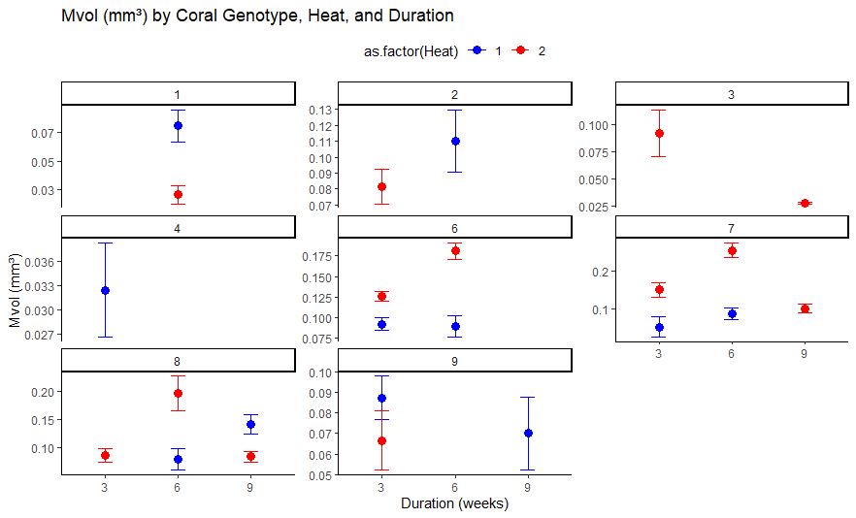

Fig.1 Predicted total testis volume (Mvol, mm³) per polyp across coral genotypes under experimental heat stress.
Each panel represents a distinct donor colony (genotype). Points show model-predicted mean total testis volume per polyp (± SE) for each combination of heat treatment (+1 °C in blue, +2 °C in red) and exposure duration (3, 6, or 9 weeks; x-axis). Predictions are derived from the generalized linear mixed-effects model described in the main text.

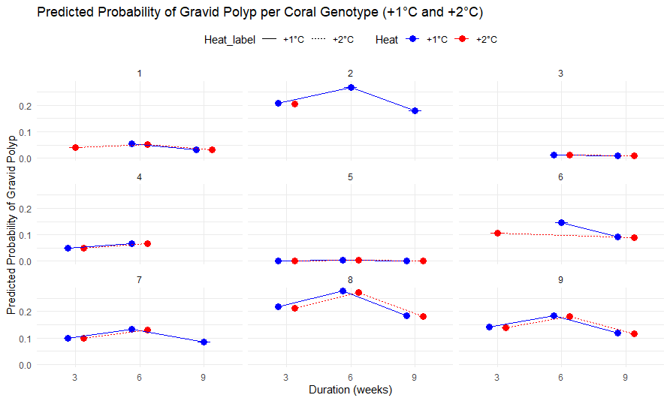

Fig.2 Predicted probability of a polyp being gravid across coral genotypes under experimental heat stress.
Each panel represents a distinct donor colony (genotype). Points show model-predicted mean probability (± SE) of a polyp being gravid for each combination of heat treatment (+1 °C in blue, +2 °C in red) and exposure duration (3, 6, or 9 weeks; x-axis). Predictions are derived from the binomial generalized linear mixed-effects model described in the main text.

SI.4 Relationship Between Egg Volume and Egg Count in Gravid Polyps

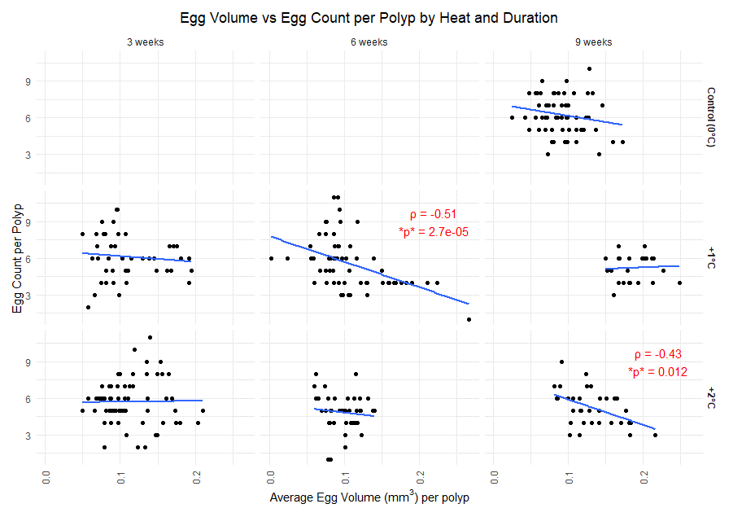

Fig.3 Relationship between egg volume and egg count per polyp in Acropora aspera across heat treatments and exposure durations. Panels are faceted by heat treatment (rows: Control, +1 °C, +2 °C) and exposure duration (columns: 3, 6, and 9 weeks). Each point represents an individual gravid polyp. The x-axis shows mean egg volume per polyp (mm³), and the y-axis shows total egg count within that polyp. Blue lines indicate fitted linear regressions for visualization.Spearman’s rank correlation tests were used to assess associations between egg volume and egg count within each treatment-duration combination. Only statistically significant correlations (p < 0.05) are annotated in red, with Spearman’s ρ and corresponding p-values shown.
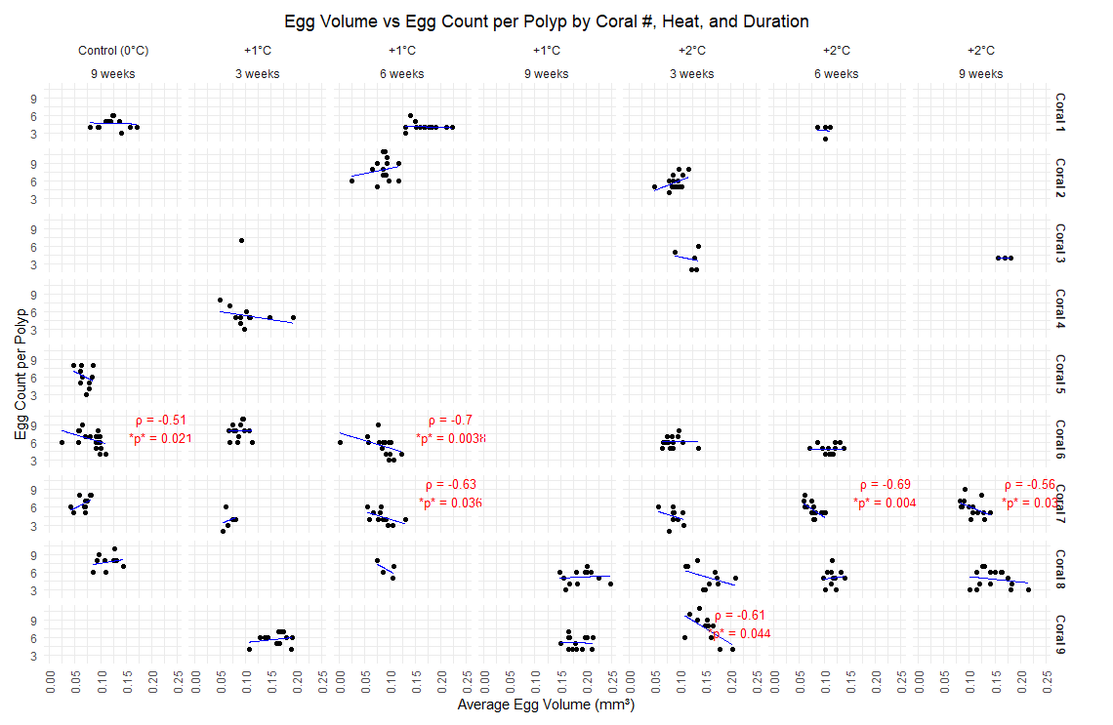

Fig.4 Relationship between egg volume and egg count per polyp in Acropora aspera, separated by coral genotype, heat treatment, and exposure duration. Panels are faceted by genotype (rows; Coral 1–9) and treatment-duration combinations (columns: Control 9 weeks, +1 °C at 3, 6, and 9 weeks; +2 °C at 3, 6, and 9 weeks). Each point represents an individual gravid polyp. The x-axis shows mean egg volume per polyp (mm³), and the y-axis shows total egg count within that polyp. Blue lines indicate fitted linear regressions for visualization within each treatment group. Spearman’s rank correlation tests were used to assess associations between egg volume and egg count within each genotype × treatment combination. Only statistically significant correlations (p < 0.05) are annotated in red, with Spearman’s ρ and corresponding p-values shown.

SI.5 Temperature Data Tables and Treatment Comparisons

Details / Date | Treatment | Recorded Temperature (Daily Mean T°C ± SD) | Nominal Temperature  (Daily Mean T°C ± SD) | Time points (n) | Tanks (n)
Collection dates: 31/08/2022 – 02/09/2022
Coldest Day –  pre heating: 13/09/2022 | Untreated ambient water (reflects in-situ temperatures) | 20.3 ± 0.6 | 21.8 ± 0.2 | 4 | 27
Pre-heating:  22/09/2022 | All tanks follow nominal control temperature profile | 21.8 ± 0.4 | 22.1 ± 0.2 | 4 | 27
All 9x weeks treatments reached +1°C and +2°C: 03/10/2022  Measurement date: 04/10/2022 | +1°C for 9 weeks | 23.1 ± 0.3 | 23.4 ± 0.4 | 2 | 3
 | +2°C for 9 weeks | 23.9 ± 0.3 | 24.4 ± 0.4 | 2 | 3
 | Controls, +1°C and +2°C for 3 and 6 weeks | 22.2 ± 0.2 | 22.4 ± 0.4 | 2 | 21
All 9x weeks and 6x weeks treatments reached +1°C and +2°C: 19/10/2022  Measurement date 23/10/2022 | +1°C for 9 weeks and 6 weeks | 24.1 ± 0.2 | 24.4 ± 0.0 | 2 | 6
 | +2°C for 9 weeks and 6 weeks | 25.3 ± 0.1 | 25.4 ± 0.0 | 2 | 6
 | Controls, +1°C and +2°C for 3 weeks | 23.4 ± 0.4 | 23.4 ± 0.0 | 2 | 15
All 9x, 6x, and 3x weeks treatments reached +1°C and +2°C: 04/11/2022  Measurement date: 10/11/2022  End of Experiment | +1°C for 9, 6, and 3 weeks | 24.9 ± 0.1 | 25.0 ± 0.2 | 2 | 9
 | +2°C for 9, 6, and 3 weeks | 25.9 ± 0.3 | 26.0 ± 0.2 | 2 | 9
 | Controls | 24.0 ± 0.2 | 24.0 ± 0.2 | 2 | 9
Table 11. Summary of key temperature data recorded during the experiment. This table presents selected daily mean temperatures (in °C, ± standard deviation) recorded at key time points across the experiment, alongside the corresponding nominal target temperatures. Temperature values are grouped by treatment, measurement date, and experimental milestone. The number of temperature sampling time points (n) and number of tanks sampled for each treatment are also indicated.

Table 12. ANOVA results comparing recorded mean temperatures across treatments within each experimental period. To confirm that experimental heat-stress treatments produced distinct thermal conditions, one-way ANOVAs were conducted on manually recorded tank temperatures within each exposure period: Long-Term (temperatures records from 3 October 2022 comparing Control, +1 °C and +2 °C for 9 weeks), Medium-Term (temperatures records from 23 October 2022 comparing Control, +1 °C and +2 °C for 6 and 9 weeks), and Short-Term (temperatures records from 10 November 2022 comparing all seven treatments, which included Control, +1 °C and +2 °C for 3, 6, and 9 weeks). Treatment was included as a fixed factor, and Tukey HSD post-hoc tests and estimated marginal means (EMMeans) were used to assess pairwise differences between treatments. Shown are the ANOVA F-statistics with associated degrees of freedom, p-values, and a summary of post-hoc comparisons indicating the relative ranking of recorded temperatures among treatments.

Period | Treatments compared | ANOVA F(df) | p-value | Post-hoc Summary
Long-Term  (9 weeks) | Control, +1°C and +2°C for 9 weeks | F(2, 492)=133.4 | <0.001 | +2°C for 9 weeks > +1°C for 9 weeks > Control
Medium-Term (6 weeks) | Control, +1°C and +2°C for 6 and 9 weeks | F(4, 331)=23.5 | <0.001 | +2°C for 6 and 9 weeks > +1°C for 6 and 9 weeks > Control
Short-Term  (3 weeks) | All treatments | F(6, 101)=272.6 | <0.001 | +2°C for all durations > +1°C for all durations > Control

SI.6 Manually Recorded Temperature Profiles and Donor Colony Thermal History

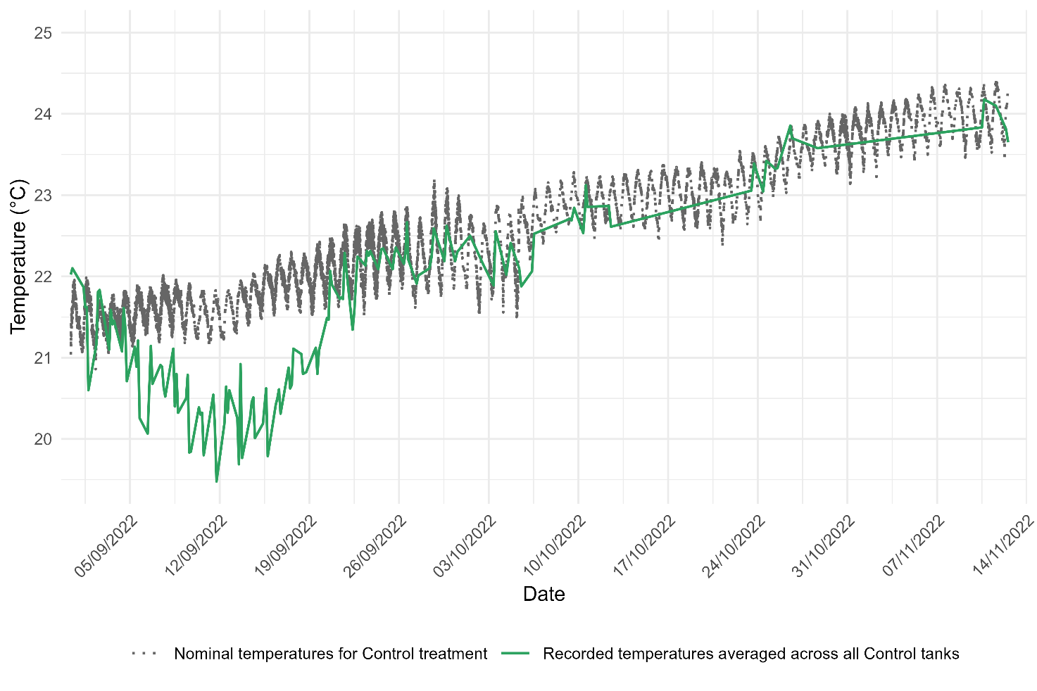

Fig.5 Recorded temperatures in Control tanks during the experimental period. The green line shows daily mean temperatures recorded in Control tanks, averaged across replicate tanks. The grey dotted line represents the nominal (programmed) target temperatures for the Control treatment. Gaps in the recorded series correspond to periods when manual measurements were unavailable.

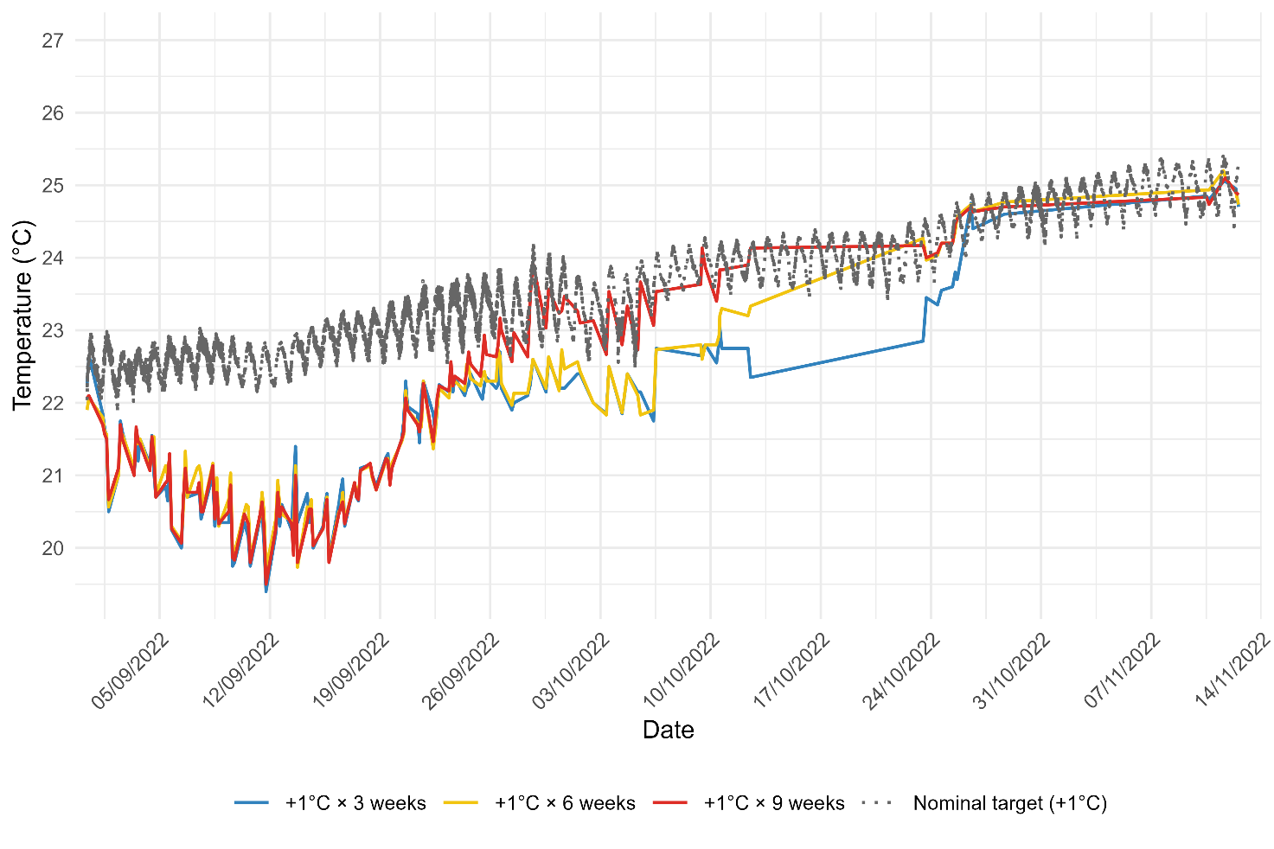

Fig.6 Recorded temperatures for +1 °C heat-stress treatments during the experimental period.
Coloured lines show daily mean temperatures recorded in tanks assigned to +1 °C treatments, averaged across replicate tanks within each exposure duration: 3 weeks (blue), 6 weeks (yellow), and 9 weeks (red). The grey dotted line represents the nominal (programmed) +1 °C target temperature. Gaps in the recorded series correspond to periods when manual measurements were unavailable

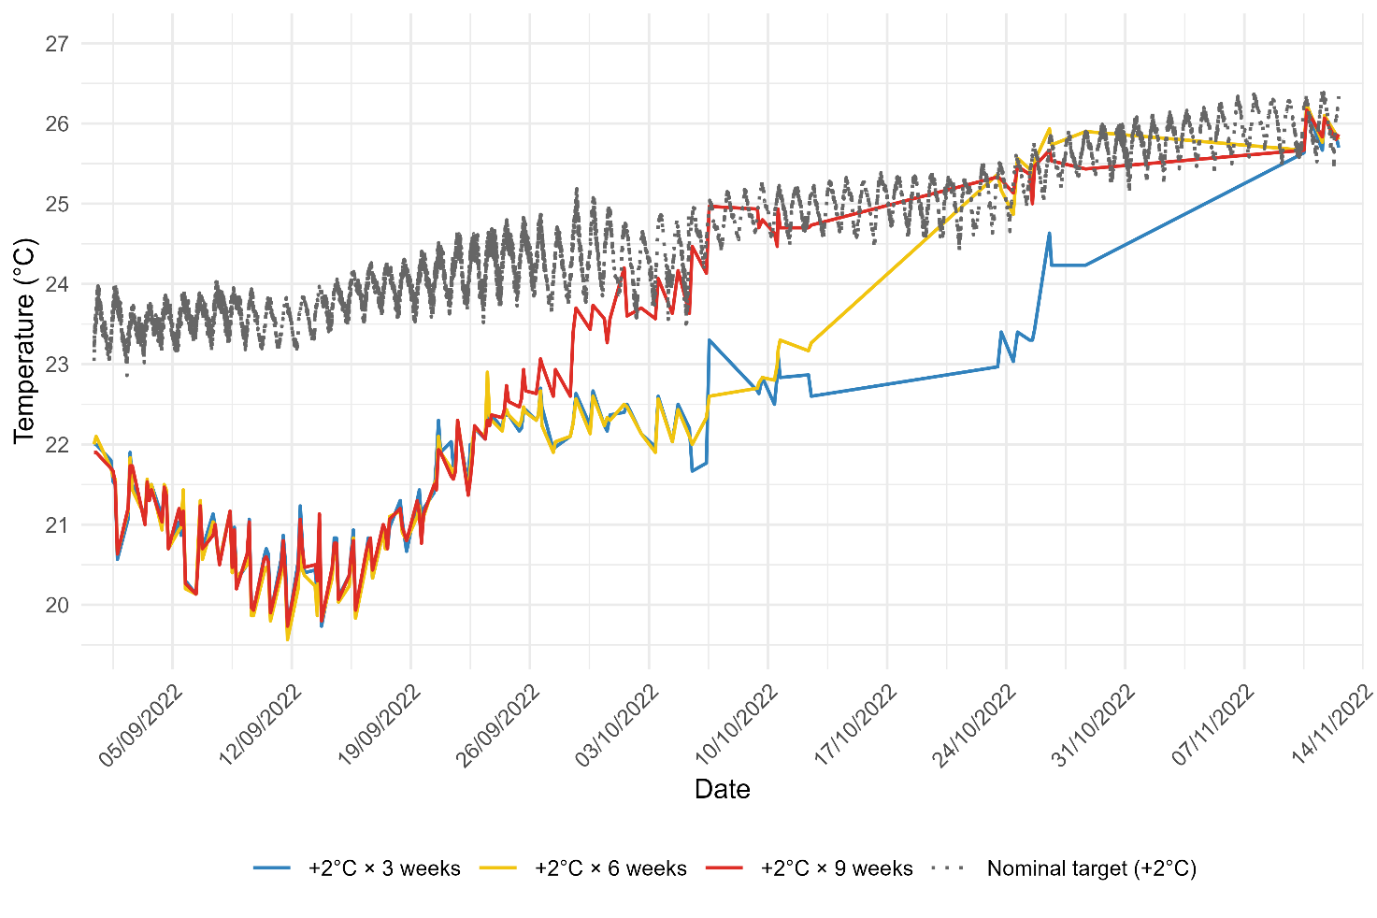

Fig.7 Recorded temperatures for +2 °C heat-stress treatments during the experimental period.
Coloured lines show daily mean temperatures recorded in tanks assigned to +2 °C treatments, averaged across replicate tanks within each exposure duration: 3 weeks (blue), 6 weeks (yellow), and 9 weeks (red). The grey dotted line represents the nominal (programmed) +2 °C target temperature. Gaps in the recorded series correspond to periods when manual measurements were unavailable.

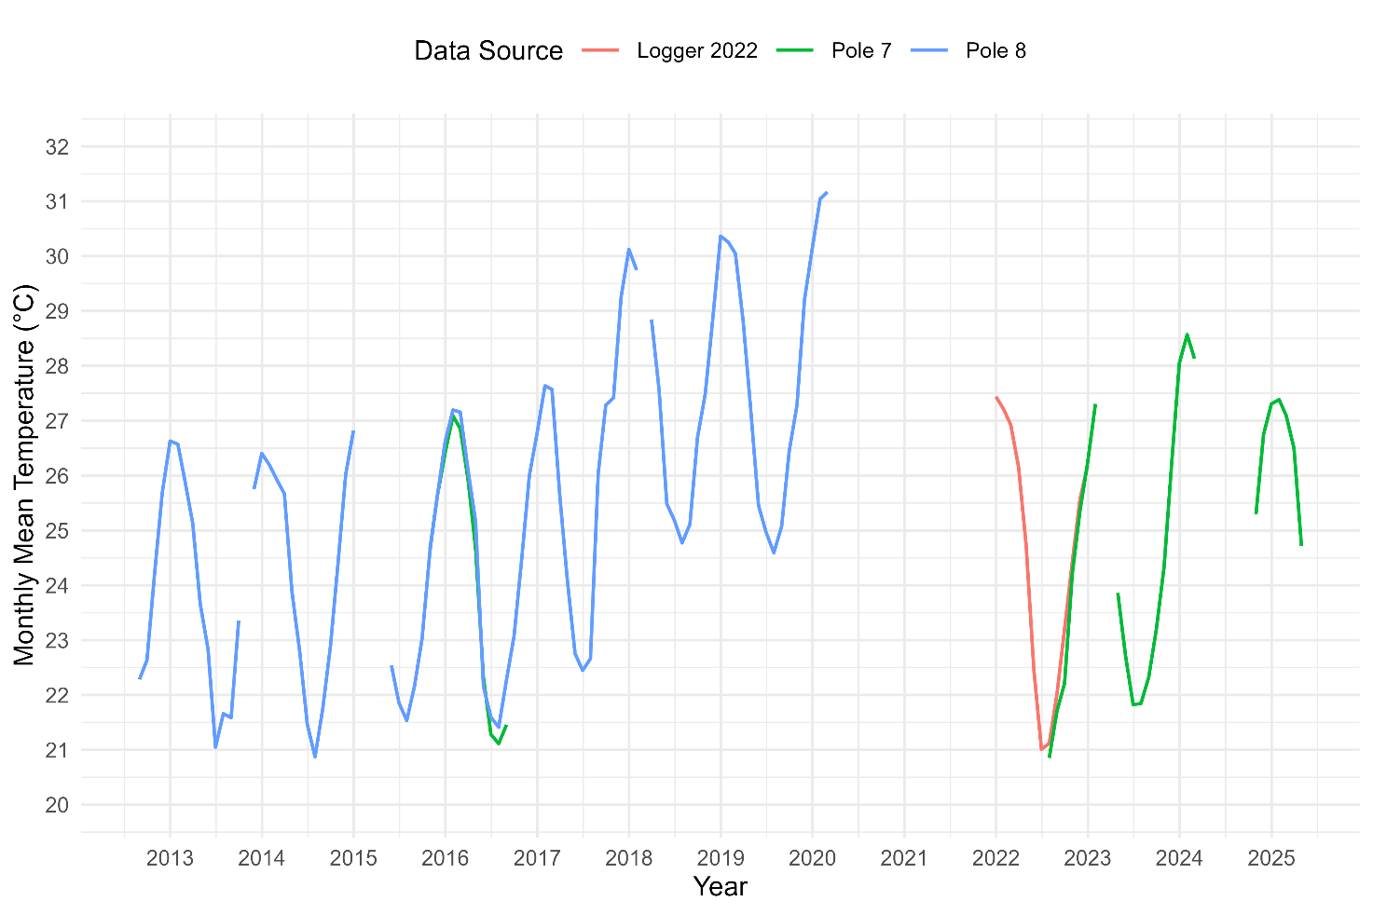

Fig.8 Monthly mean seawater temperatures from long-term AIMS monitoring sites and in situ logger data from 2022. Blue and green lines show monthly mean temperatures from AIMS loggers at Pole 8 (North Heron Island reef slope, 5.4 m depth, 2000–2020) and Pole 7 (South Heron Island reef slope, Wistari Channel, 5 m depth, 2016), respectively. The red line represents monthly mean temperatures from an in-situ logger deployed near the experimental site in 2022 (Heron Reef slope, Wistari Channel, 5 m depth; data provided by S. Jurriaans, AIMS, unpublished). The Pole 7 and Pole 8 datasets were used to calculate the seasonal average temperature profile for the Control treatment. The 2022 in situ logger data provide contextual validation of thermal conditions experienced by donor colonies during the experimental year.

