Attachment 3. Critical appraisal checklist
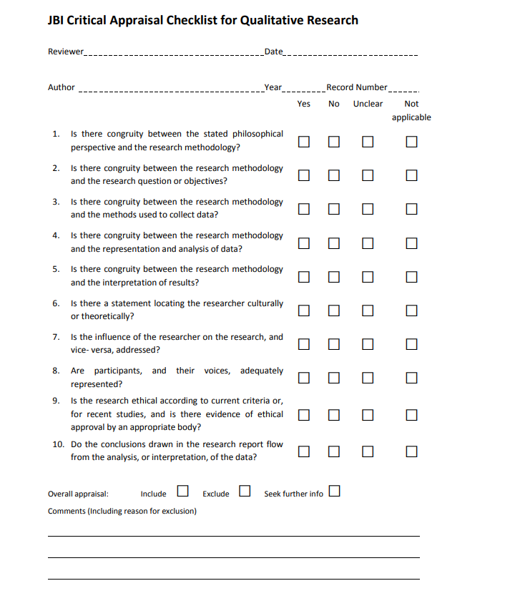
Copyright © The Joanna Briggs Institute 2014

