Supplementary Information

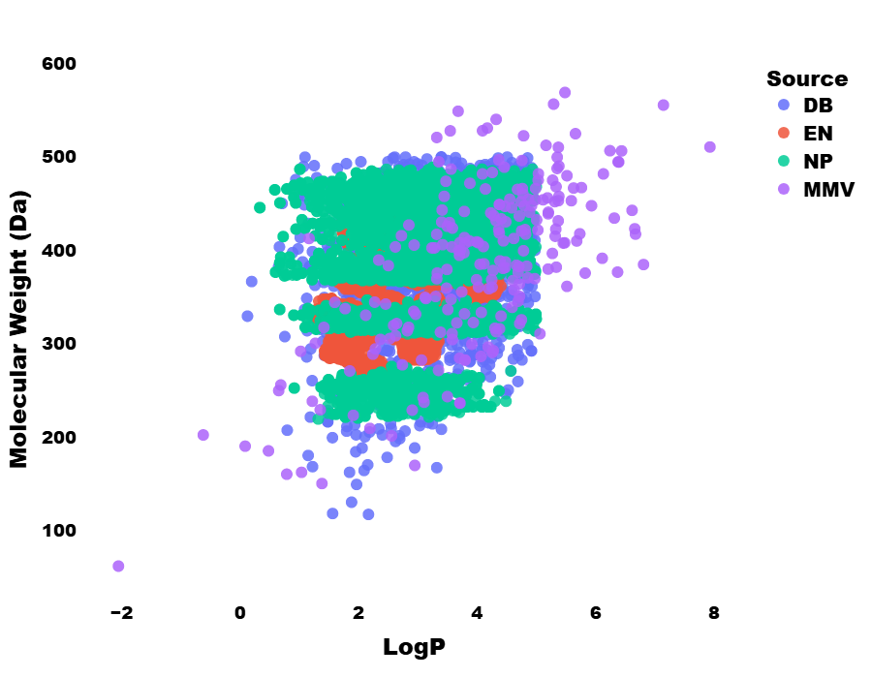
Fig S1. Chemical Landscape of Dataset applied to the model used in this study compared to the publicly available dataset in MMV website

Fig. S2. Docking score distribution among the four proteins in this study. (A) F/GGPPS (B) PfPKG (C) 3EBH (D) 3165 (E) Average docking scores of top ten (10) ligands in each protein among the three class of datasets used.

Table S1. Summary of datasets used for ML-based screening in this study
S/N | Library | Compounds Retrieved | Compounds applied to model | Compounds predicted Active | Compounds post Lipinski filter
 | Natural Products |  | 1,909,411 | 343,875 | 139,743
 | Coconut | 695,199
 | Super-Nat 3.0 | 1,205,199
 | Natur-Ar | 1,538
 | Afro-Database | 6,511
 | In-house | 1,044
 | Enamine Library |  | 585,600 | 181,136 | 180,467
 | HLL-460 | 460,160
 | DDS-50 | 50,240
 | DDS-10 | 10240
 | KNS-64960 | 64960
 | Drug Bank | 12,309 | 12,309 | 2,044 | 1245

Table S2. Results of Prime-mmgbsa for compound selection for MD
 | PfPKG |  |  | F/GGPPS
Ligands | Prime-MMGBSA (kcal/mol) | Initial Docking Scores | Ligands | Prime-MMGBSA (kcal/mol) | Initial Docking Scores
EN528030 | -68.991 | -11.6 | NP83747 | -81.522 | -12.3
NP68949 | -59.572 | -11.4 | EN517399 | -69.655 | -12.3
NP134058 | -50.081 | -11.4 | EN048157 | -68.285 | -12.1
NP107354 | -49.532 | -11.4 | NP87379 | -60.894 | -12.9
NP91613 | -41.583 | -11.6 | EN252070 | -58.852 | -12.1
NP16205 | -40.001 | -11.5 | NP16901 | -54.831 | -12.1
NP99632 | -40.001 | -11.5 | NP60415 | -54.065 | -12.2
NP34114 | -31.390 | -11.5 | NP24278 | -50.079 | -12.5
NP88935 | -29.592 | -11.7 | NP21949 | -49.479 | -12.3
NP22077 | -15.489 | -11.8 | NP5450 | -48.181 | -12.3

Table S3. Smile notations and information about the compounds used for MD in this study
 | Smiles | Reported activity
 | PfPKG
EN52 | O=C(N)N1CC(NC(=O)c2c3CCC\C(=C/c4ccc(F)cc4)\c3nc3ccccc23)C=C1 | Not reported for any bioactivity
NP10 | N1([C@H]2N(C(=O)c3c2cccc3)c2ccccc2C1=O)CCC(=O)N1CCc2c3ccccc3[nH]c2C1 | Not reported for any bioactivity
NP13 | N1(C)c2ccccc2C(=O)[C@H]2[C@H]3[C@@]4(C)CC[C@H](c5c(c6ccccc6n(C)c5=O)O4)[C@H]3C(C)(C)O[C@H]12 | Not reported for any bioactivity
NP68 | n1(C)c2c3cc4c(cc3ccc2c2cc3c5c(ccc3cc2c1=O)OCO5)OCO4 | Fused or dimeric coumarins https://doi.org/10.1016/S0031-9422(96)00724-8
WLK | N([C@@H]1NCC=C(N1)N1C=C(N[C@@H]1c1ccccc1)C1CC1)[C@@H]1CCN(C(=O)[C@@H]2NC=CS2)C1 | Standard
 | F/GGPPS
EN04 | N(C(=O)Cn1ncc2c(c1=O)cccc2)c1ncc(Cc2ccc(cc2)C(F)(F)F)s1 | Identified as a hit in qHTS screening of human lactate dehydrogenase (https://pubchem.ncbi.nlm.nih.gov/bioassay/1347041)
EN25 | n1c(NC(=O)Cc2noc3c2cccc3)scc1c1cc2CCC(=O)Nc2cc1 | No report
EN51 | N(C(=O)N1C[C@@H](CCC1)c1nc(no1)c1ccc(cc1)F)Cc1cc2C(=O)NCCc2cc1 | No report
NP83 | N([C@H]1CO[C@@H]2[C@@H](NC(=O)c3ccccc3)CO[C@H]12)c1nc(ccn1)c1ccc(cc1)c1ccccc1 | Hits in many assays like Malaria etc https://pubchem.ncbi.nlm.nih.gov/bioassay/1347417
NP87 | n12c(=O)c(NC(=O)C3CCCCC3)ccc2[C@H]2CN(C[C@@H](C1)C2)C(=O)c1cc2ccccc2cc1 | No report
MMV | n1(C)c2c(cccc2)c2sc(C(=O)NCCCN3CCCCCC3)cc2c1=O | Standard

Fig. S3. Cartoon representation of PfPKG with the active site coloured in yellow (A) and zoomed in to see the loop (lid) over the active site and important residue Phe525 (B). (C) Protein F/GGPPS showing the loop9-10, loop4-5 and Ser230. (D) The different regions of active sites of F/GGPPS, site A: allylic substrate site (binding to FPP), site B: allylic/product site (binding to FPP/GGPP), site C: product site (binding to IPP).

Fig. S4. Model performance for the docking score regression models. 3EBH, 8EM8, 3I65, and 9NSR are the proteins used in the molecular docking studies.

Fig. S5. (A) RMSD of ligand in the active site; evolution of distances (B) D1 and (C) D3 throughout the simulation for F/GGPPS

Fig. S6. Cluster analysis for PfPKG. (A) Fractions of population in each cluster ID; (B) Residence of population fractions over the simulation time; (C) Representativeness of cluster IDs over the simulation time. Here, only the top ten (10) clusters were used.

Fig. S7. Cluster analysis for F/GGPPS. (A) Fractions of population in each cluster ID; (B) Residence of population fractions over the simulation time; (C) Representativeness of cluster IDs over the simulation time. Here, only the top ten (10) clusters were used.

Fig. S8. Residue-by-residue correlation matrix for PfPKG. (A) Apo; (B) EN52. (C) NP10 ; (D) NP13 ; (E) NP68 (F) WLK

Fig. S9. Residue-by-residue correlation matrix for F/GGPPS. (A) Apo; (B) EN04; (C) EN25; (D) EN51; (E) MMV; (F) NP83; (G) NP87.

Table S4. Summary averages of RMSD of ligand in the active site, RMSF of active site residue, RMSF of lid (p-loop), distances D1 and D2 of PfPKG
System | Ligand RMSD (Å) | RMSF Active Site (Å) | RMSF Lid (Å) | D1 (Å) | D2 (Å)
EN52 | 1.63±0.35 | 0.77±0.3 | 0.72±0.32 | 16.75±2.11 | 18.21±1.88
NP10 | 2.19±0.3 | 0.81±0.3 | 0.48±0.1 | 10.67±1.01 | 12.47±1.06
NP13 | 1.10±0.24 | 0.79±0.34 | 0.53±0.16 | 10.64±1.31 | 12.69±1.23
NP68 | 0.50±0.15 | 0.92±0.43 | 0.74±0.29 | 13.63±2.97 | 16.28±2.68
WLK | 2.68±0.31 | 0.71±0.24 | 0.51±0.16 | 17.68±1.67 | 18.67±1.35
APO | ------ | 0.73±0.2 | 0.51±0.13 | 14.76±1.26 | 16.82±1.11

Table S5. Summary averages of RMSD of ligand in the active site, RMSF of active site residue, RMSF of lid (p-loop), distances D1, D2 and D3, theta and RMSF of loops 45 and 910 for F/GGPPS
System | Ligand RMSD (Å) | RMSF Active Site (Å) | D1 (Å) | D2 (Å) | D3 (Å) | Theta (°) | RMSF_loop45 (Å) | RMSF_loop910 (Å)
EN04 | 1.89±0.31 | 0.79±0.41 | 12.21±4.17 | 17.06±0.96 | 24.23±1.15 | 26.94±13.66 | 0.74±0.17 | 1.57±0.80
EN25 | 1.97±0.16 | 0.71±0.31 | 10.61±1.5 | 17.06±1.11 | 23.75±0.53 | 23.46±4.83 | 0.63±0.12 | 0.81±0.30
EN51 | 1.05±0.33 | 0.59±0.24 | 10.41±1.36 | 18.89±0.87 | 22.90±0.75 | 26.53±4.83 | 0.47±0.1 | 1.07±0.58
MMV | 1.58±0.21 | 0.76±0.40 | 12.05±1.63 | 18.69±1.48 | 25.20±0.81 | 26.32±6.06 | 1.00±0.29 | 0.93±0.46
NP83 | 1.42±0.36 | 0.72±0.33 | 15.78±2.32 | 18.21±1.10 | 25.29±1.19 | 38.29±6.28 | 0.48±0.08 | 1.30±0.80
NP87 | 1.50±0.30 | 0.82±0.43 | 15.45±2.03 | 14.62±1.97 | 26.43±1.54 | 28.04±5.72 | 0.93±0.21 | 1.64±0.72
APO | ------ | 0.67±0.32 | 10.84±2.09 | 17.67±1.42 | 25.15±0.59 | 21.26±6.21 | 0.61±0.14 | 1.01±0.56

Fig. S10. PRED and Interaction diagram of WLK bound to PfPKG

Fig. S11. PRED and Interaction diagram of ligands EN04 and MMV bound to F/GGPPS

Fig. S12 . Snapshots of interactions between ligands (A) NP10 (B) NP13 and (C) WLK for PfPKG system; (D) EN25 (E) NP83 and (F) MMV for the F/GGPPS system

Fig. S13. Hydrogen bond occupancy ((A) ligand as the donor; (B) protein as donor); and probability density of the hydrogen bond counts ((C) ligand as the donor; (D) protein as donor) for PfPKG
Fig. S14. Hydrogen bond occupancy ((A) ligand as the donor; (B) protein as donor); and probability density of the hydrogen bond counts ((C) ligand as the donor; (D) protein as donor) for F/GGPPS

Web server application
To facilitate broad and interactive access to the models developed in this study, we implemented a web server application named Mal-Predict. The app serves as a user-friendly interface through which researchers and chemists can rapidly obtain predictions of antimalarial activity and estimated docking scores for new chemical compounds.
The Mal-Predict application is publicly accessible here
Functionality and User Interaction
Mal-Predict provides two primary modes of input:
- Single-Compound Prediction
  - Users can enter the SMILES string of any small molecule into a text field.
  - Upon submission, the app processes the input through the trained classification and regression models.
  - The user receives:
    - A prediction of antimalarial activity (active vs inactive) based on the optimized classification model selected in Section 2.4.
    - Predicted docking scores for each of the four protein targets used in this study, derived from the multi-target regression model.
  - This mode is particularly useful for rapid evaluation of individual compounds during lead prioritization or virtual screening workflows.
- Batch Prediction via CSV Upload
  - Users can upload a CSV file containing a column of canonical SMILES strings.
  - After uploading, the app featurizes each compound, applies the classification and regression models, and produces a results table.
  - The output can be downloaded as a CSV file containing:
    - Input SMILES
    - Predicted activity class (0 or 1)
    - Predicted docking scores for each protein target
  - This feature supports high-throughput screening of large compound libraries without the need for local programming expertise.
Technical Architecture
Mal-Predict was developed using Stream-lit, a lightweight Python web application framework that streamlines deployment of data science and machine learning interfaces. The backend of the app loads pre-trained models for activity prediction and docking score regression, along with any necessary preprocessing components (e.g., imputer and scaler objects).
The input SMILES are processed as follows:
- Each SMILES string is converted to molecular features using the established featurization pipeline (Morgan fingerprints plus calculated descriptors).
- The processed feature vectors are passed to:
  - The best-performing classification model (as determined in Section 2.4) to compute probability-based predictions of antimalarial activity.
  - The docking score regression model to compute estimated affinity scores for each protein target.
- Results are presented on-screen and made available for download in tabular format.

