Supplementary Information
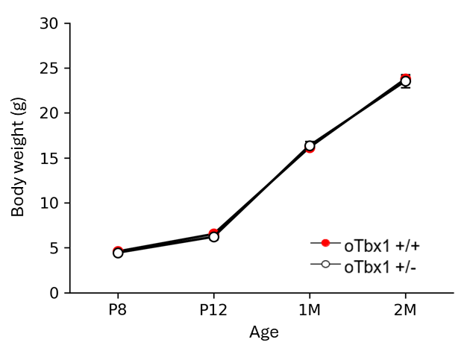
Figure S1. Body weights oTbx1^{+/+} and oTbx1^{+/−} mice. oTbx1^{+/+} and oTbx1^{+/−} mice had indistinguishable body weight increases from P8 to 2 months of age (P8, U = 140, p = 0.800; P12, U = 153, p = 0.466; 1 month, U = 135.5, p = 0.7035; 2 months, U = 102, p = 0.917). oTbx1^{+/+} P8, N = 27, P12; N = 30; 1M, 1 month, N = 27; 2M, 2 months, N = 21: oTbx1^{+/−}: P8, N = 11, P12, N = 12; 1M, N = 11; 2M, N = 10.

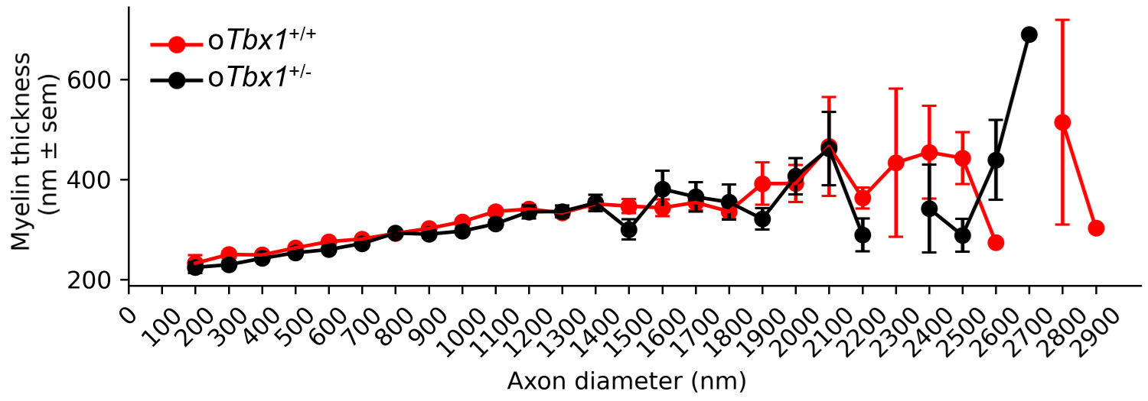Supplementary Figure S2. The myelin thickness of axons for oTbx1^{+/−} versus oTbx1^{+/+} mice versus axon diameter was similar along the axon diameter range (genotype, p = 0.931; genotype × axon diameter, p = 0.814).

