model | auroc | ci_lo | ci_hi | auprc | brier | n_pos | n_total | analysis | scenario
Model1_Static | 0.65 | 0.578 | 0.717 | 0.002 | 0.235 | 72 | 81623 | Outcome Definition | CAM-ICU Only
Model3_XGBoost | 0.563 | 0.484 | 0.635 | 0.002 | 0.088 | 72 | 81623 | Outcome Definition | CAM-ICU Only
Model1_Static | 0.65 | 0.578 | 0.717 | 0.002 | 0.235 | 72 | 81623 | Outcome Definition | CAM-ICU + ICD
Model3_XGBoost | 0.563 | 0.484 | 0.635 | 0.002 | 0.088 | 72 | 81623 | Outcome Definition | CAM-ICU + ICD
Model1_Static | 0.584 | 0.574 | 0.593 | 0.05 | 0.242 | 3105 | 81623 | Outcome Definition | Composite (incl. medication proxy)
Model3_XGBoost | 0.631 | 0.622 | 0.641 | 0.059 | 0.219 | 3105 | 81623 | Outcome Definition | Composite (incl. medication proxy)
Model1_Static | 0.568 | 0.552 | 0.584 | 0.016 | 0.245 | 1032 | 81623 | Prediction Horizon | 8h Horizon
Model3_XGBoost | 0.616 | 0.596 | 0.631 | 0.02 | 0.211 | 1032 | 81623 | Prediction Horizon | 8h Horizon
Model1_Static | 0.576 | 0.564 | 0.588 | 0.033 | 0.244 | 2091 | 81623 | Prediction Horizon | 16h Horizon
Model3_XGBoost | 0.629 | 0.615 | 0.64 | 0.041 | 0.219 | 2091 | 81623 | Prediction Horizon | 16h Horizon
Model1_Static | 0.584 | 0.574 | 0.593 | 0.05 | 0.242 | 3105 | 81623 | Prediction Horizon | 24h Horizon
Model3_XGBoost | 0.631 | 0.622 | 0.641 | 0.059 | 0.219 | 3105 | 81623 | Prediction Horizon | 24h Horizon
Table S1: Sensitivity analyses across outcome definitions and prediction horizons

AUROC, area under the receiver-operating characteristic curve; AUPRC, area under the
precision-recall curve; CI, confidence interval; LR, logistic regression; CAM-ICU,
Confusion Assessment Method for the ICU; ICD, International Classification of Diseases.
Bootstrap 95% confidence intervals based on 500 resampling iterations.
Model 1: Static logistic regression; Model 3: XGBoost classifier.
n_pos, number of positive windows in the test set; n_total, total number of windows in the test set.

Figure S1: Cumulative incidence functions (CIF) for delirium and ICU death as a competing event, estimated using the Aalen-Johansen estimator.
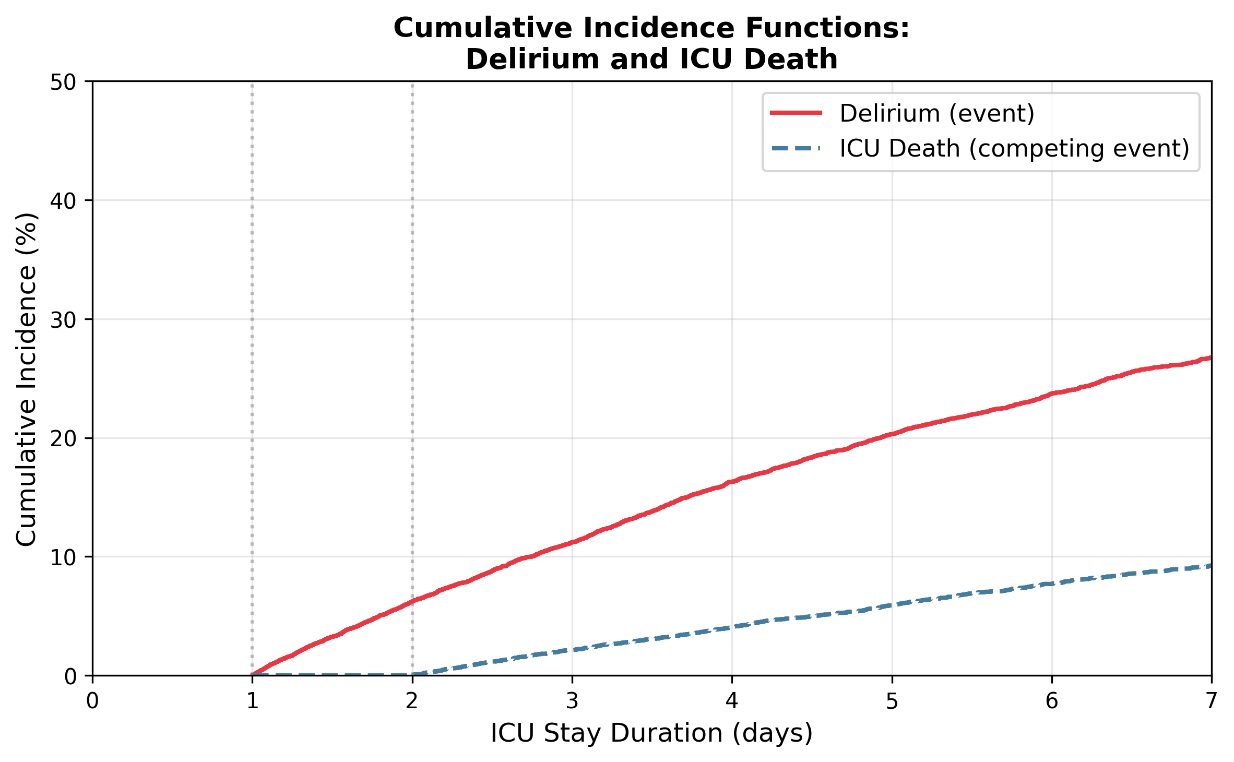
CIF, cumulative incidence function; ICU, intensive care unit.
The competing event was defined as ICU death occurring without prior delirium.
Patients discharged or transferred without delirium or death were classified as censored.
Time zero represents ICU admission.

