Table 2. Synthesis of pyrano]2, 3-d[pyrimidine derivatives ª

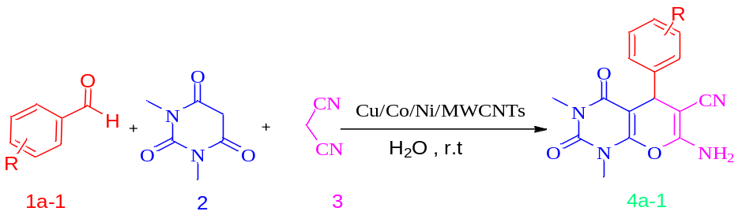
Entry R product Time (min) Yield (%)
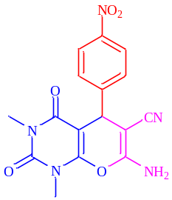
4-NO₂
98
10
1
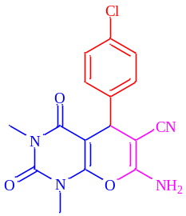
4-Cl
85
20
2
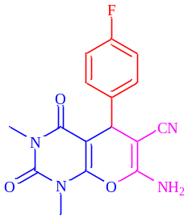
4-F
12
89
3
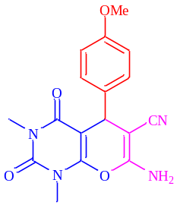
4-OMe
60
25
4
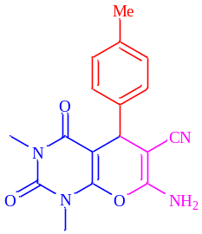
5
16
79
4-Me
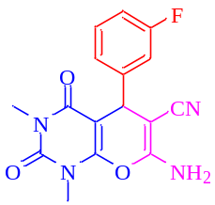
89
20
3-F
6
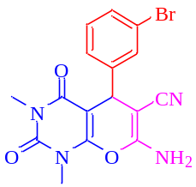
80
15
3-Br
7
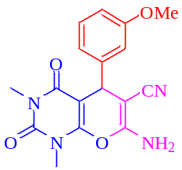
8
30
52
3-OMe
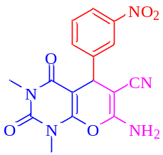
14
89
3-NO₂
9
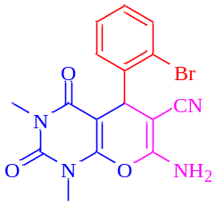
68
15
2-Br
10
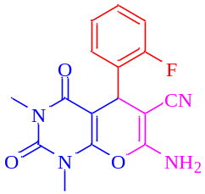
15
70
2-F
11
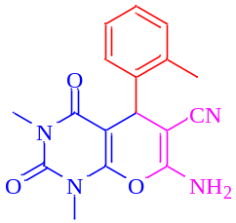
20
63
2-Me
12
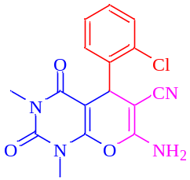
12
69
2-Cl
13
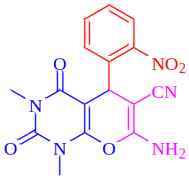
12
80
2-NO₂
14
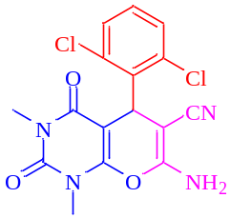
75
20
2, 6-Cl
15
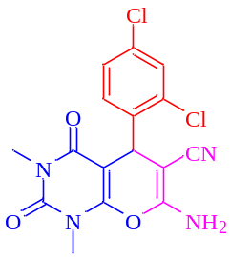
79
15
2, 4-Cl
16
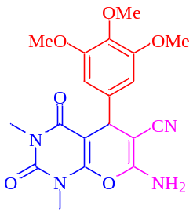
73
38
3, 4, 5-OMe
17
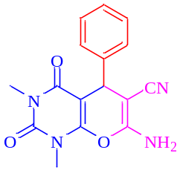
79
12
-
18
ª Reaction conditions: Aromatic aldehyde (1mmol), malononitrile (1.2 mmol), 1,3-dimethylbarbituric acid (1 mmol), catalyst (0.005 mg), and H₂O (5 ml) solvent at 25°C

