Supplementary figures and tables
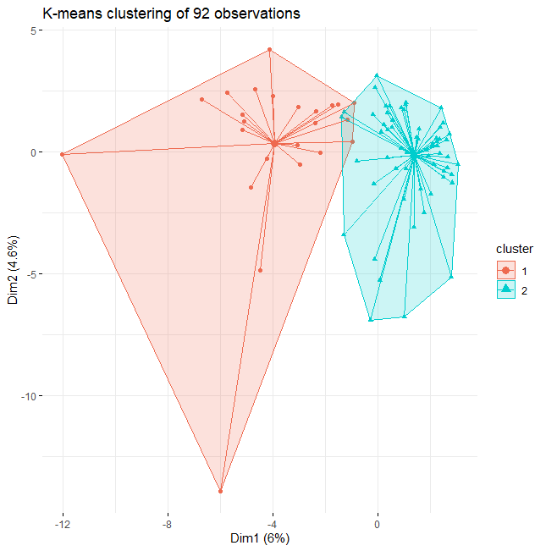
Figure S1. Graphical representation of K-means clustering results for 92 observations. Cluster 2 includes mainly patients with SOCS1 mutations.
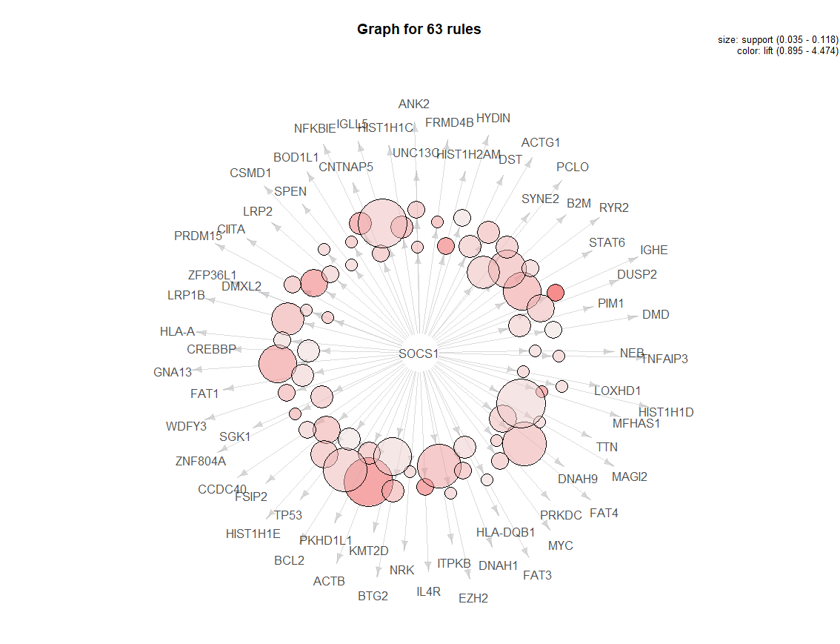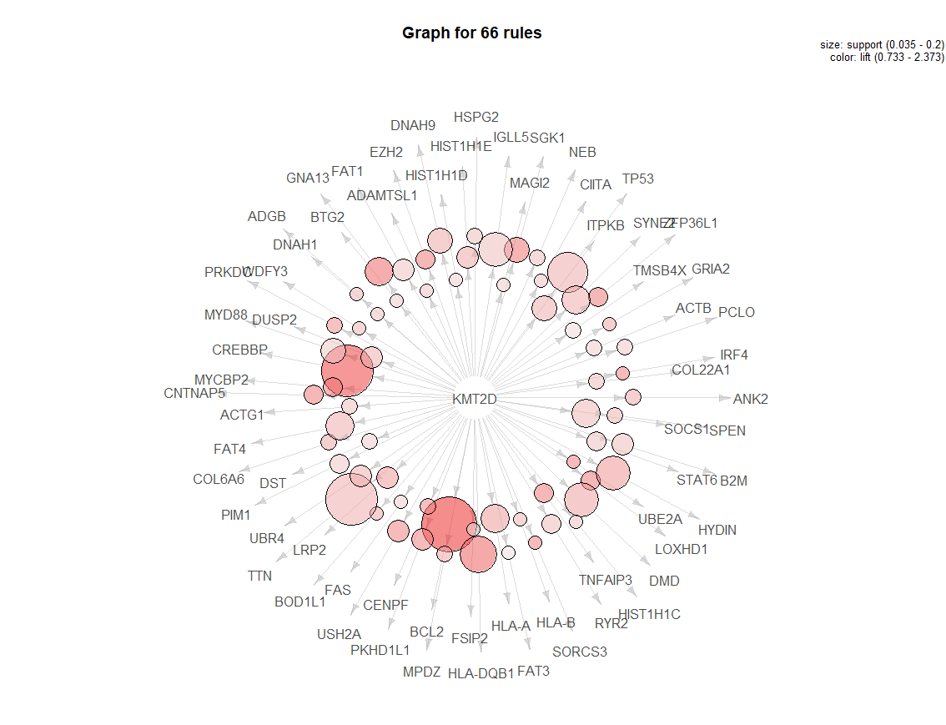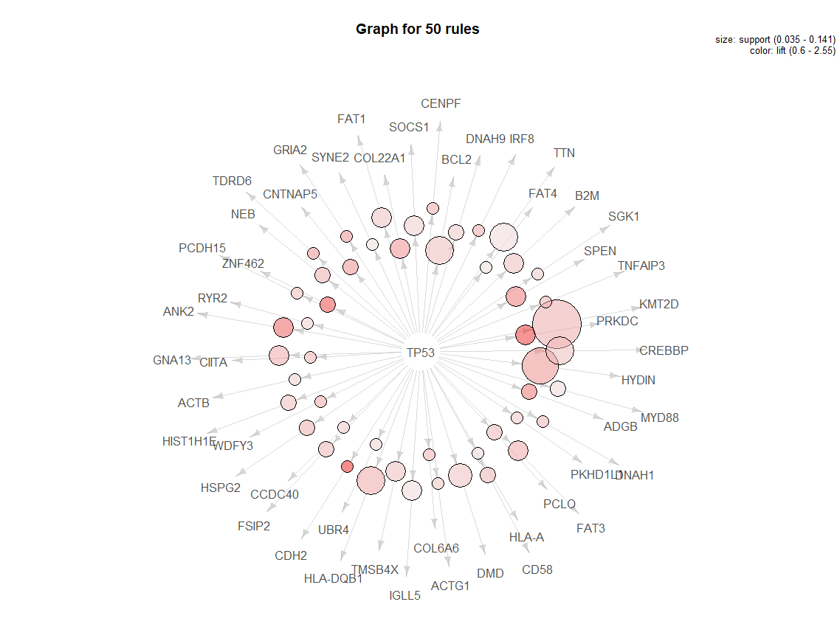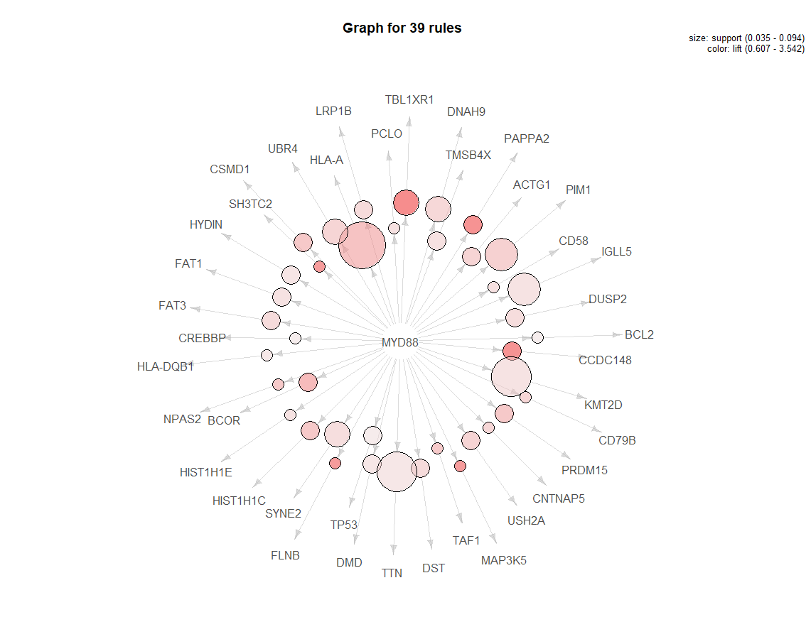
Figure S2. Visualization of association rules for SOCS1, KMT2D, MYD88, and TP53.
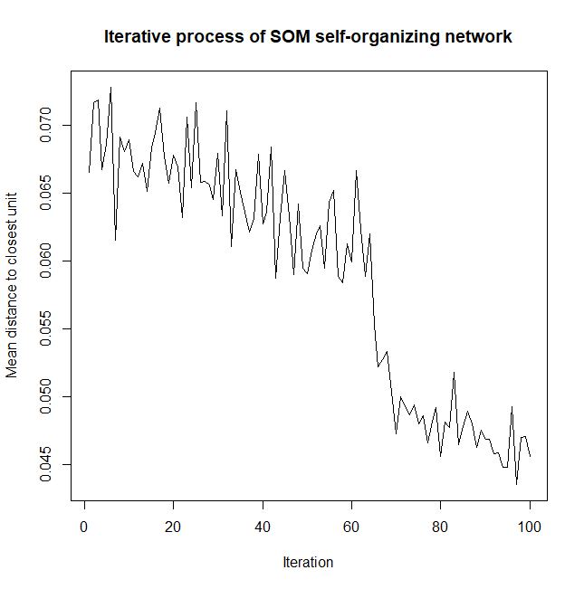
Figure S3. Iterative process of SOM self-organizing network. The vertical axis shows mean distance to the closest unit, and the horizontal axis shows the number of iterations.

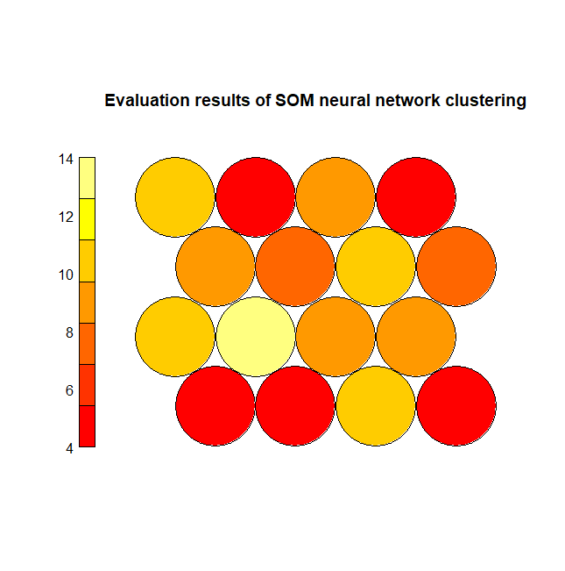
Figure S4. Evaluation results of SOM neural network clustering. The clusters are numbered 1-16 from left to right and from bottom to top. The color depth represents the mean distance of various observation samples from the center.

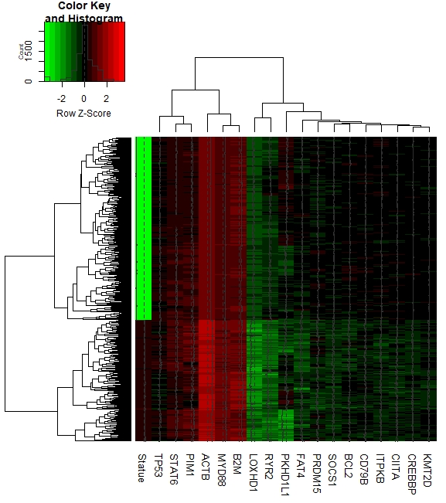
Figure S5. Clustering heat map of 18 RRDLBCL common mutant gene expression levels according to survival status. For each gene, red indicates that the gene expression level is up-regulated, and green indicates that the gene expression level is down-regulated. For survival, green indicates survival and black indicates death. The data were normalized.

Table S1.SOM self-organizing network cluster analysis results
Gene | Num* | SOCS1 | STAT6 | MYD88 | CREBBP | KMT2D | TP53 | cluster
BCL2 | 21 | 1.917293 | 2.179487 | 0.607143 | 2.698413 | 2.372742 | 1.133333 | 1
CREBBP | 21 | 1.065163 | 2.179487 | 0.607143 | 4.047619 | 2.233169 | 1.133333 | 1
EZH2 | 8 | 1.677632 | 2.451923 | 0.53125 | 3.035714 | 1.831897 | 0.85 | 1
KMT2D | 29 | 1.23412 | 1.127321 | 1.025862 | 2.233169 | 2.931035 | 1.406897 | 1
GNA13 | 12 | 2.982456 | 2.179487 | 0.354167 | 1.349206 | 1.954023 | 1.416667 | 2
LOXHD1 | 8 | 1.677632 | 2.451923 | 1.0625 | 1.517857 | 1.831897 | 0.85 | 2
PKHD1L1 | 10 | 2.236842 | 2.615385 | 0.425 | 2.02381 | 1.758621 | 1.02 | 2
STAT6 | 13 | 2.753036 | 6.538462 | 0.326923 | 2.179487 | 1.127321 | 0.523077 | 2
UBE2A | 5 | 1.789473 | 2.615385 | 0.85 | 1.619048 | 1.758621 | 0.68 | 2
ACTB | 12 | 3.72807 | 2.179487 | 0.708333 | 0.674603 | 0.977012 | 0.85 | 3
B2M | 15 | 2.385965 | 1.74359 | 0.566667 | 0.809524 | 1.172414 | 1.133333 | 3
CIITA | 8 | 3.355263 | 1.634615 | 0.53125 | 1.011905 | 1.099138 | 1.275 | 3
DNAH1 | 8 | 2.236842 | 1.634615 | 0 | 0.505952 | 1.099138 | 1.275 | 3
FRMD4B | 5 | 2.684211 | 2.615385 | 0.85 | 0.809524 | 0 | 1.36 | 3
FSIP2 | 11 | 2.440191 | 2.377622 | 0.386364 | 0.735931 | 0.799373 | 1.236364 | 3
HIST1H2AM | 5 | 3.578947 | 3.923077 | 0 | 0 | 0 | 0.68 | 3
MFHAS1 | 4 | 3.355263 | 3.269231 | 0 | 1.011904 | 0 | 0 | 3
SOCS1 | 19 | 4.473684 | 2.753036 | 0.223684 | 1.065163 | 1.23412 | 0.894737 | 3
ZNF423 | 5 | 1.789474 | 2.615385 | 0 | 0.809524 | 0 | 0.68 | 3
IGHE | 4 | 4.473684 | 3.269231 | 0 | 0 | 0 | 0.85 | 4
IL4R | 5 | 3.578947 | 0 | 0 | 0.809524 | 0 | 1.36 | 4
NFKBIE | 7 | 3.195489 | 0 | 0 | 0 | 0 | 0.485714 | 4
ZNF804A | 5 | 2.684211 | 0 | 0 | 0 | 0 | 1.36 | 4
ADAMTSL1 | 8 | 1.118421 | 0 | 1.0625 | 1.517857 | 1.099138 | 0.85 | 5
DMD | 19 | 0.941828 | 0.688259 | 0.894737 | 1.278195 | 1.54265 | 1.073684 | 5
HLA-A | 15 | 1.192983 | 1.74359 | 2.266667 | 1.619048 | 1.563218 | 0.68 | 5
HLA-DQB1 | 16 | 1.398026 | 1.634615 | 0.796875 | 1.264881 | 2.015086 | 1.4875 | 5
HYDIN | 18 | 0.994152 | 1.089744 | 0.944444 | 1.574074 | 1.628353 | 1.7 | 5
IRF4 | 5 | 0.894737 | 0 | 0.85 | 1.619048 | 1.758621 | 0.68 | 5
MYCBP2 | 8 | 1.118421 | 0 | 1.0625 | 2.02381 | 1.831897 | 0.425 | 5
SORCS3 | 5 | 0 | 0 | 1.7 | 0.809524 | 1.758621 | 1.36 | 5
UBR4 | 13 | 0.68825 | 1.005917 | 1.634615 | 1.556777 | 1.352785 | 0.784615 | 5
USH2A | 10 | 0.44736 | 0 | 1.7 | 1.214286 | 1.758621 | 0.68 | 5
ACTG1 | 10 | 2.236842 | 1.307692 | 1.7 | 0.809523 | 1.172414 | 1.02 | 6
DNAH9 | 14 | 1.917293 | 1.868132 | 1.517857 | 0.578231 | 1.465517 | 0.971428 | 6
DST | 12 | 1.864035 | 1.089744 | 1.416667 | 1.349206 | 0.977012 | 0.283333 | 6
FAT4 | 17 | 2.368421 | 1.538462 | 0 | 1.190476 | 1.37931 | 0.6 | 6
HIST1H1C | 8 | 2.796053 | 1.634615 | 2.125 | 1.011905 | 1.099138 | 1.275 | 6
HIST1H1E | 12 | 2.236842 | 1.089744 | 1.0625 | 1.011905 | 1.465517 | 1.133333 | 6
IGLL5 | 25 | 1.789474 | 0.523077 | 1.02 | 1.133333 | 1.172414 | 0.68 | 6
ITPKB | 15 | 2.684211 | 0.871795 | 0.566667 | 1.079365 | 1.367816 | 0.226667 | 6
LRP2 | 11 | 1.626794 | 1.188811 | 0.772727 | 1.103896 | 1.598746 | 0.309091 | 6
PIM1 | 14 | 1.597744 | 1.401099 | 1.821429 | 0.867347 | 1.046798 | 0.242857 | 6
RYR2 | 12 | 1.491228 | 1.634615 | 0.708333 | 1.349206 | 1.221264 | 0.85 | 6
SGK1 | 11 | 2.033493 | 1.188811 | 0.386364 | 1.471862 | 1.865204 | 0.927273 | 6
SYNE2 | 17 | 1.842105 | 1.538462 | 1.25 | 0.952381 | 1.37931 | 0.6 | 6
TTN | 34 | 1.31579 | 1.153846 | 0.875 | 1.190476 | 1.37931 | 0.7 | 6
CD79B | 8 | 1.118421 | 1.634615 | 1.59375 | 1.011905 | 0 | 0 | 7
CSMD1 | 8 | 1.677632 | 1.634615 | 2.125 | 1.011905 | 0 | 0.85 | 7
GPR98 | 4 | 1.118421 | 3.269231 | 1.0625 | 1.011905 | 0 | 0 | 7
GREB1 | 4 | 1.118421 | 3.269231 | 1.0625 | 0 | 0 | 0 | 7
MYC | 9 | 1.988304 | 1.452992 | 0.944444 | 1.349206 | 0 | 0.755556 | 7
NPAS2 | 6 | 1.491228 | 2.179487 | 2.125 | 1.349206 | 0 | 1.133333 | 7
NRK | 8 | 1.677632 | 1.634615 | 1.0625 | 0.505952 | 0 | 0.425 | 7
PRDM15 | 8 | 2.236842 | 3.269231 | 2.125 | 1.011905 | 0 | 0 | 7
PTPRB | 5 | 0 | 2.615385 | 0.85 | 0.809524 | 0 | 0.68 | 7
AASS | 4 | 2.236842 | 0 | 1.0625 | 1.011905 | 0 | 0 | 8
BTG2 | 9 | 2.48538 | 0 | 0.944444 | 0.449735 | 0.977012 | 0.377778 | 8
DMXL2 | 6 | 2.236842 | 0 | 0.708333 | 0.674603 | 0 | 0 | 8
ETV1 | 4 | 2.236842 | 0 | 1.0625 | 1.011905 | 0 | 0 | 8
FNBP4 | 5 | 1.789474 | 0 | 0 | 0.809524 | 0 | 0 | 8
GRM8 | 5 | 1.789474 | 0 | 0.85 | 0.809524 | 0 | 0.68 | 8
HIST1H3I | 4 | 2.236842 | 0 | 2.125 | 0 | 0 | 0 | 8
LRP1B | 12 | 2.609649 | 1.089744 | 1.416667 | 0.674603 | 0 | 0.566666 | 8
RFX7 | 4 | 2.236842 | 0 | 1.0625 | 0 | 0 | 0 | 8
BOD1L1 | 6 | 2.236842 | 0 | 0 | 1.349206 | 1.465517 | 0.566667 | 9
COL6A6 | 8 | 1.118421 | 0 | 0.53125 | 1.011904 | 1.465517 | 1.275 | 9
HLA-B | 7 | 0.639098 | 0 | 0.607143 | 1.156463 | 1.256158 | 0.971428 | 9
HSPG2 | 10 | 0.894737 | 0 | 0.85 | 1.214286 | 1.172414 | 1.36 | 9
MAGI2 | 9 | 1.491228 | 0 | 0.472222 | 0.899471 | 0.977012 | 0.755555 | 9
NEB | 10 | 1.342105 | 0 | 0.425 | 0.404762 | 1.172414 | 1.36 | 9
PCLO | 11 | 2.033493 | 0 | 1.159091 | 1.103896 | 1.065831 | 1.236364 | 9
TNFAIP3 | 8 | 1.677632 | 0 | 0.53125 | 1.517857 | 1.83189 | 1.275 | 9
ZFP36L1 | 8 | 1.677632 | 0 | 0 | 0.505952 | 1.831897 | 0.85 | 9
DUSP2 | 13 | 2.064777 | 0 | 1.307692 | 0.622711 | 1.352785 | 0.523077 | 10
FAS | 9 | 0.994152 | 0 | 0.944444 | 0.899471 | 0.977012 | 0.755556 | 10
FAT1 | 16 | 1.398026 | 0.817308 | 1.0625 | 0.505952 | 1.099138 | 1.0625 | 10
FAT3 | 12 | 1.118421 | 0 | 1.416667 | 0.674603 | 0.732759 | 1.416667 | 10
HIST1H1D | 9 | 1.491228 | 0 | 0.944444 | 0.449735 | 0.977012 | 0.755556 | 10
MPDZ | 8 | 0.559211 | 0 | 1.0625 | 1.011905 | 1.465517 | 0 | 10
TMSB4X | 15 | 0.596491 | 0 | 1.133333 | 0.269841 | 0.781609 | 1.133333 | 10
ARHGEF1 | 4 | 2.236842 | 0 | 0 | 0 | 0 | 1.7 | 11
BSN | 5 | 0.894737 | 0 | 0.85 | 0 | 0 | 0.68 | 11
CCDC40 | 11 | 1.626794 | 0 | 0.772727 | 0.367965 | 0 | 0.927272 | 11
CD58 | 11 | 0.813397 | 0 | 1.159091 | 0.367965 | 0 | 1.236363 | 11
GRIN2B | 5 | 1.789474 | 0 | 1.7 | 0 | 0 | 1.36 | 11
KIAA0430 | 5 | 1.789474 | 0 | 0.85 | 0 | 0 | 0.68 | 11
MLL3 | 6 | 0.745614 | 0 | 0.708333 | 0 | 0 | 1.133333 | 11
PCDH15 | 9 | 0.994152 | 0 | 0.472222 | 0.449735 | 0 | 1.133333 | 11
PRKCB | 5 | 0.894737 | 0 | 1.7 | 0 | 0 | 0.68 | 11
SRRM2 | 6 | 2.236842 | 0 | 1.0625 | 0 | 0 | 0.85 | 11
UNC13C | 6 | 2.236842 | 0 | 1.416667 | 0 | 0 | 1.133333 | 11
BCOR | 7 | 0 | 0 | 2.428571 | 0.578231 | 0 | 0 | 12
CCDC148 | 5 | 0 | 0 | 3.4 | 0.809524 | 0 | 0 | 12
FLNB | 4 | 0 | 0 | 3.1875 | 0 | 0 | 0 | 12
MYD88 | 20 | 0.223684 | 0 | 4.25 | 0.607143 | 1.025862 | 0.68 | 12
PAPPA2 | 5 | 0.894737 | 0 | 3.4 | 0.809524 | 0 | 0.68 | 12
ROBO1 | 4 | 1.118421 | 0 | 2.125 | 0 | 0 | 0 | 12
TBL1XR1 | 6 | 0 | 0 | 3.541667 | 0 | 0 | 0.566667 | 12
ADGB | 7 | 0 | 0 | 0 | 1.156463 | 1.256158 | 1.942857 | 13
ANK2 | 8 | 2.236842 | 0 | 1.0625 | 1.0119 | 1.465517 | 2.125 | 13
CENPF | 7 | 1.278196 | 0 | 0.607143 | 0 | 1.674877 | 1.457143 | 13
CNTNAP5 | 8 | 2.236842 | 0 | 1.59375 | 1.011905 | 1.831897 | 1.7 | 13
COL22A1 | 10 | 0.894737 | 1.307692 | 0.85 | 0.404762 | 1.172414 | 1.7 | 13
GRIA2 | 6 | 1.491228 | 0 | 0.708333 | 0.674603 | 1.465517 | 1.7 | 13
PRKDC | 7 | 1.917293 | 1.868132 | 0.607143 | 1.734694 | 1.674877 | 2.428571 | 13
SPEN | 9 | 1.491228 | 0 | 0.944444 | 0.449735 | 1.30268 | 1.888889 | 13
TP53 | 25 | 0.894737 | 0.523077 | 0.68 | 1.133333 | 1.406897 | 3.4 | 13
WDFY3 | 7 | 2.556391 | 0 | 0.607143 | 0 | 1.256158 | 1.457143 | 13
CDH2 | 4 | 1.118421 | 0 | 1.0625 | 1.011905 | 0 | 2.55 | 14
DCC | 4 | 1.118421 | 0 | 0 | 1.011905 | 0 | 1.7 | 14
IRF8 | 7 | 1.278196 | 1.868132 | 0 | 1.156463 | 0 | 1.457143 | 14
TDRD6 | 6 | 0.745614 | 0 | 0.708333 | 1.349206 | 0 | 1.7 | 14
ZNF462 | 6 | 1.491228 | 0 | 1.416667 | 1.349206 | 0 | 2.266667 | 14
ABLIM3 | 5 | 0 | 0 | 0.85 | 0.809524 | 0 | 0.68 | 15
AC096579.13-001 | 4 | 0 | 0 | 1.0625 | 1.011905 | 0 | 0.85 | 15
ADAMTS16 | 4 | 0 | 0 | 1.0625 | 1.011905 | 0 | 0 | 15
ANK3 | 5 | 0.89473 | 0 | 0.85 | 0.809524 | 0 | 0.68 | 15
CCND3 | 7 | 0 | 0 | 1.214285 | 0.578231 | 0 | 0 | 15
FGA | 4 | 1.118421 | 0 | 1.0625 | 1.011905 | 0 | 0.85 | 15
MPEG1 | 6 | 0.745614 | 0 | 1.416667 | 0.674603 | 0 | 1.133333 | 15
PTPN14 | 6 | 0.745614 | 0 | 0.708333 | 1.349206 | 0 | 1.133333 | 15
SLITRK5 | 5 | 0 | 0 | 0.85 | 0.809524 | 0 | 0.68 | 15
CNTNAP3 | 4 | 1.118421 | 0 | 2.125 | 0 | 0 | 0.85 | 16
FRG1B | 4 | 0 | 0 | 2.125 | 1.011905 | 0 | 0.85 | 16
MAP3K5 | 4 | 0 | 0 | 3.1875 | 1.011905 | 0 | 1.7 | 16
SH3TC2 | 4 | 1.118421 | 0 | 3.1875 | 1.011905 | 0 | 0.85 | 16
TAF1 | 6 | 1.491228 | 0 | 2.125 | 0.674603 | 0 | 1.133333 | 16
*Num：Number of occurrences in 92 observed data sets.
The lightness of the color indicates the frequency of gene mutations in the data set, and the darker color represents the higher frequency.

