Ext. Data Figure | 31 | 71 | 168 | Cofactors | Metal | pH | Log k DP*A to DPA | Log k DP*A to DP⁺A⁻ | Log k DP⁺A⁻ to DPA | Log k DP⁺A⁻ to D⁺PA⁻ | Log k D⁺PA⁻ to DPA (Lifetime) | Yield% | Significance
1a | L | L | C | ZnP |  | 7.5 | 2.5 |  |  |  |  | 0 | Monad provides P* decay rate
1b | L | L | L | ZnP Heme |  | 7.5 | 2.5 | 4.2 | not resolved |  |  | ~0 | Dyad provides P* to heme ET rate
2a | L | L | C | Fc ZnP Heme |  | 7.5 | 2.5 | 4.0 | 4.9 | 3.7 | 0.45  (350 ms) | 4.3% | Triad with H+ independent donor
2b | L | L | C | Fc ZnP DADPIX |  | 7.5 | 2.5 | 4.1 | 4.5 | 4.1 | 1.7  (20 ms) | 31% | Triad with DADPIX acceptor high yield
3a | D | H | Y | Y ZnP Heme |  | 9.5 | 2.5 | 4.3 | 5.4 | 4.5 | 2.5  (3.2 ms) | 11% | Tyrosinate donor
3b | D | H | Y | Y ZnP Heme |  | 7.5 | 2.5 | 4.5 | 5.9 | 4.3 | 4.0  (0.1 ms) | 2.4% | Tyrosine donor yield, lifetime drop at pH 7.5
4 | L | L | Y | Y ZnP Heme |  | 9.5 | 2.5 | 4.3 | 4.0 | 2.3 | 1.4  (40 ms) | 2.3% | Without Asp and His Tyrosinate yield drops but lifetime increases
5a | L | H | Y | Y ZnP Heme |  | 9.5 | 2.5 | 4.4 | 4.5 | 3.0 | 1.5  (32 ms) | 2.9% | His has little effect on Tyrosinate yield or lifetime
5b | L | H | Y | Y ZnP Heme |  | 7.5 | 2.5 | 4.2 | 5.0 | 3.5 | 2.7  (2.0 ms) | 6% | Asp removal has less effect at neutral pH
6 | L | H | Y | Mn Y ZnP Heme | 10 μM MnCl₂ | 7.5 | 2.5 | 4.1 | not resolved | not resolved | 2.5  (3.2 ms) | ~0 | Adding Mn shortens lifetime dramatically
7a | L | H | Y | Fe Y ZnP Heme | 10 μM FeCl₂ | 7.5 | 2.5 | 4.2 | 7.5 | 6.4 | 0.6  (250 ms) | 6.4% | Fe donor increases yield and lengthens lifetime dramatically
7b | L | L | L | Fe ZnP Heme | 10 μM FeCl₂ | 7.5 | 2.5 | 4.2 | not resolved |  |  | ~0 | Removing Tyr disables Fe as donor
8 | L | L | Y | Fe Y ZnP CoP | 10 μM FeCl₂ | 7.5 | 2.5 | 4.0 | not resolved |  |  | <4% | CoP lower yield acceptor than heme

Extended Data Table 1 | Summary of SVD kinetic model analysis of Extended Data Figures 1-8. Full visible light-induced difference spectra captured at multiple time points from 1 μs to ~1 s. Each data set was collected on a single sample. Transient absorption measurements before and after data collection revealed negligible photodegradation over the course of an experiment. Each data set was analyzed by singular value decomposition (SVD) to fit a simple kinetics model connecting transient spectral species by single exponential rates. SVD analysis extracts the most significant spectral and temporal changes in the 3-D data set.
Extended Data Figures 1-8 show 8 panels for each analysis: the fit log rates, upper left; the log of the SVD singular values showing the most important components above the background noise, upper right; the light induced difference spectra, upper middle left; the kinetics model fit to the first two SVD component amplitudes for a 3 state model, upper middle right; the difference spectra associated with the two or three model kinetic species (the reference ground state being spectrally silent), lower middle left; the model state populations as a function of log time, lower middle right. The bottom two panels show a fit of raw absorbance data to P* and iron or cobalt porphyrin redox reference spectra for charge-separation yield estimates.
The kinetics model fit uses a fixed P* to P log rate of 2.5 s⁻¹, as calibrated by the simple exponential decay of the excited Zn porphyrin the absence of a heme electron acceptor and when the heme is pre-reduced before light excitation (Extended Data Fig. 1a). For triads, charge separation from DP*A to DP⁺A⁻ takes place over the same edge-to-edge distance as charge recombination from DP⁺A⁻ to DPA ground state. By using a typical intraprotein electron-tunneling reorganization energy around 0.8 eV, the rate of charge recombination is expected to be about 1.1 log units faster than the rate of charge separation (Moser et al., Nature 1992). The difference spectrum of intermediate electron-transfer species such as D⁺PA⁻ are expected to be dominated by the heme redox difference spectrum (the spectrum of oxidized heme minus reduced heme) (see Extended Data Figure 9).

Extended Data Figure 1 | Transient absorption kinetics of Monad and Dyad. a. ZnP monad construct at pH 7.5 allows characterization of the spectrum and dynamics of the ZnP* excited triplet state. SVD is dominated by a single component (upper right, red). The time variation of this component (upper middle right) is well described by a single exponential decay with a log rate of 2.5 s⁻¹ (3 ms lifetime). The SVD kinetics model fit (upper middle right) with time dependent state populations (lower middle right) generates a spectrum of this component (lower middle left) with Soret band ground state bleach and the broad absorbance from 450 to 600 nm expected for the triplet state. A non-SVD fit to the raw absorbance data to a P* spectrum is shown at lower left and right. b. A dyad construct with ZnP and heme B is assembled in the Y168L mutant at pH 7.5. A 2 state kinetic model of the SVD data in which k A⁻ to P⁺ is much faster than k P* to A gives log k P* to A of 4.2 s⁻¹. Sub-panels as described in figure 1a. Log k A⁻ to P⁺ cannot be estimated independently as the data set is dominated by P* signal and even small deviations from single exponential log k P* to A behavior compromises 3 state kinetic model fits. The relatively short lifetime of the charge-separated state prevents an accurate yield estimated.

Extended Data Figure 2 | Transient absorption kinetics of Ferrocene Triads. a. Ferrocene-ZnP-Heme Triad in Y168C mutant at pH 7.5. SVD indicates a second kinetic species above the background noise (upper right). A 3 state kinetic model fit to the SVD in which k A⁻ to P⁺ is much faster than k P* to A gives log k P* to A of 4.0 s⁻¹ and a D⁺PA⁻ spectrum with a clear heme redox signal (blue). Decay of this state back to the ground state DPA has a log rate of 0.45 s⁻¹. The yield of heme reduction of ~4% is estimated by fitting P* and heme redox difference spectra to each time trace (lower left and right). A 4-state SVD model fit using this yield gives the log rates in parentheses (upper right). b. Ferrocene-ZnP-DADPIX Triad in Y168C mutant at pH 7.5. SVD indicates a second kinetic species above the background noise (upper right). A 3 state kinetic model in which k A⁻ to P⁺ is much faster than k P* to A gives log k P* to A of 4.1 s⁻¹ and a D⁺PA⁻ spectrum with a clear heme redox signal (blue). Decay of this state back to the ground state DPA has a log rate of 1.7 s⁻¹. The larger yield of DADPIX reduction of ~31% is estimated by fitting P* and heme redox difference spectra to each time trace (lower left and right). A 4-state SVD model fit using this yield gives the log rates in parentheses (upper right).
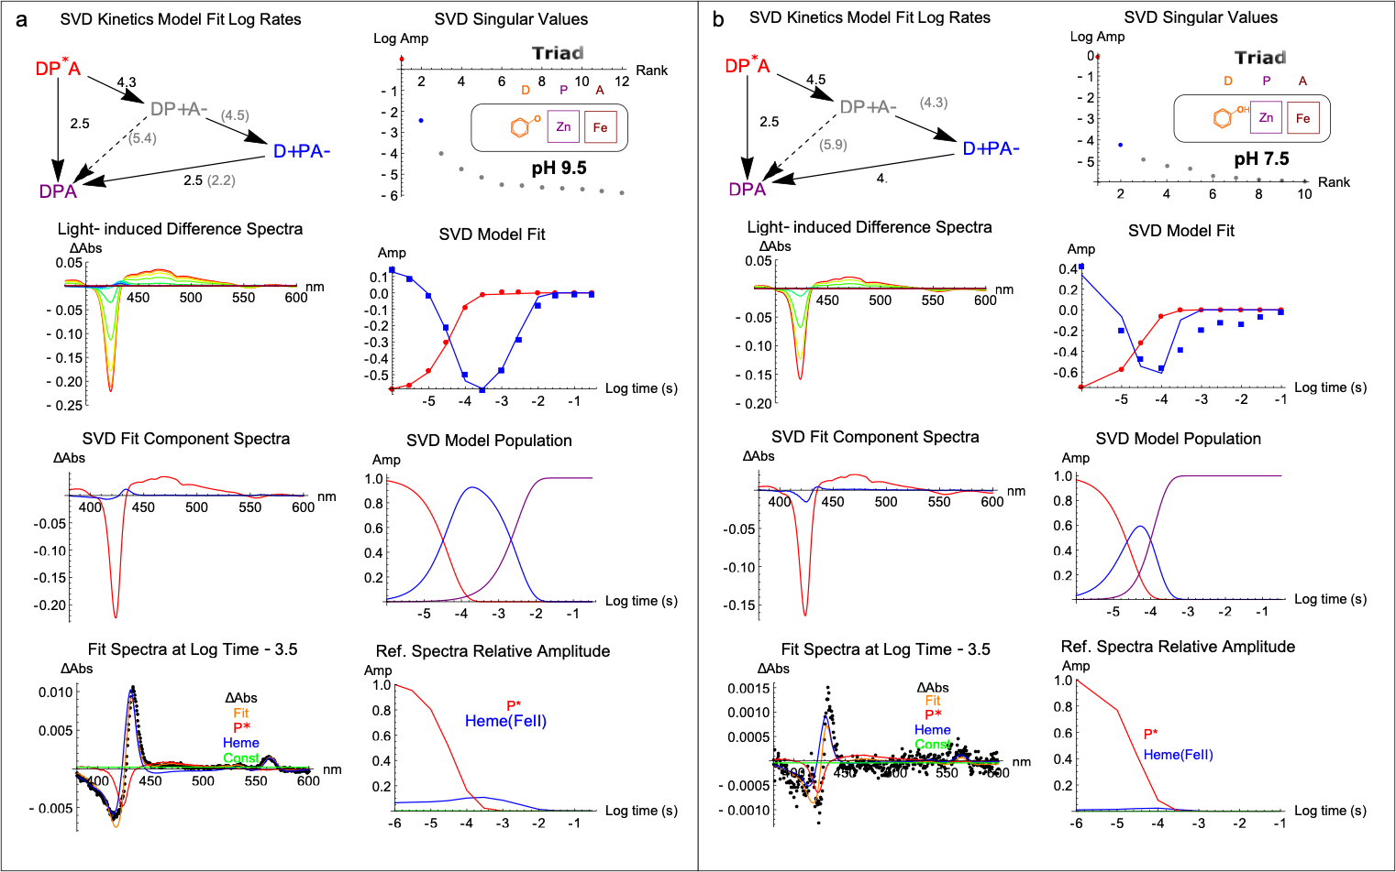

Extended Data Figure 3 | Transient absorption kinetics of Tyrosine-ZnP-Heme Triad in L31D/L71H mutant. a. pH 9.5. SVD indicates a second kinetic species above the background noise. A 3 state kinetic model in which k A⁻ to P⁺ >> k P to A gives log k P to A of 4.3 s⁻¹ and a D⁺PA⁻ spectrum with a clear heme redox signal (blue). Introducing an aspartic acid at L31D dramatically improves the quantum yield of charge separation to 11% compared to Extended Data Fig. 4a. Using this yield in a 4 state SVD model gives log rates shown in parentheses. Decay of this state back to the ground state DPA has a log rate of 2.5 s⁻¹ (a 3 ms lifetime of charge separation). b. At pH 7.5. SVD indicates a small second kinetic species above the background noise. A 3 state kinetic model in which k A⁻ to P⁺ >> k P to A gives log k P to A of 4.5 s⁻¹ and a D⁺PA⁻ spectrum with a heme redox signal (blue) with some contamination from the ZnP triplet bleach. Decay of this state back to the ground state DPA has a log rate of 4.0 s⁻¹. Fit to reference P* and heme redox spectra estimates yield at 2.4%. Using this yield in a 4 state SVD model gives log rates shown in parentheses. Dropping the pH from 9.5 to 7.5 lowers the charge separation yield and shortens the lifetime.

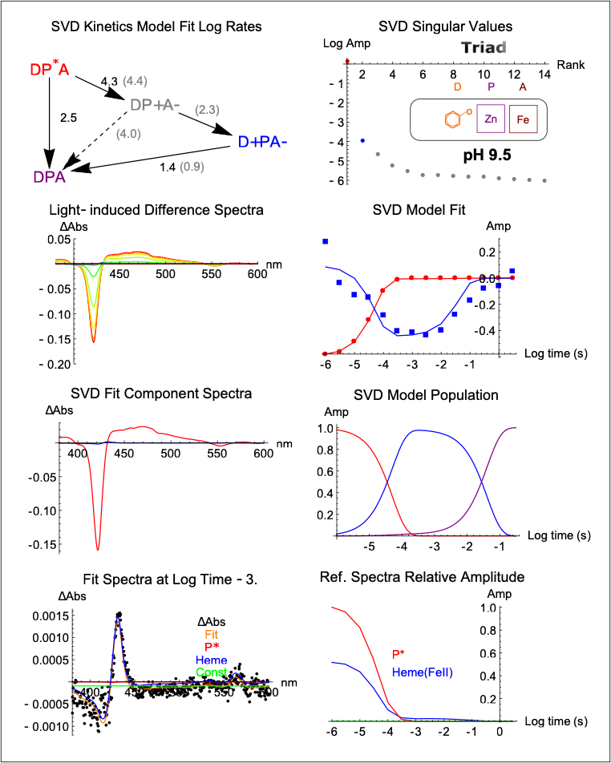

Extended Data Figure 4 | Transient absorption kinetics of Tyrosine-ZnP-Heme Triad in RC maquette (original design). a. At pH 9.5, SVD indicates a second kinetic species above the background noise. A 3 state kinetic model in which k A⁻ to P⁺ >> k P to A gives log k P to A of 4.3 s⁻¹ and a D⁺PA⁻ spectrum with a clear heme redox signal (blue). Fit of the raw absorbance data with P* and heme redox reference spectra estimates yield at 2.3%. Using this yield in a 4 state SVD model gives log rates shown in parentheses. Without Asp31 and His71, the yield of tyrosinate oxidation drops but lifetime increases compared to Extended Data Fig. 3a. Decay of the charge separated state back to ground DPA has a log rate of 1.4 s⁻¹.

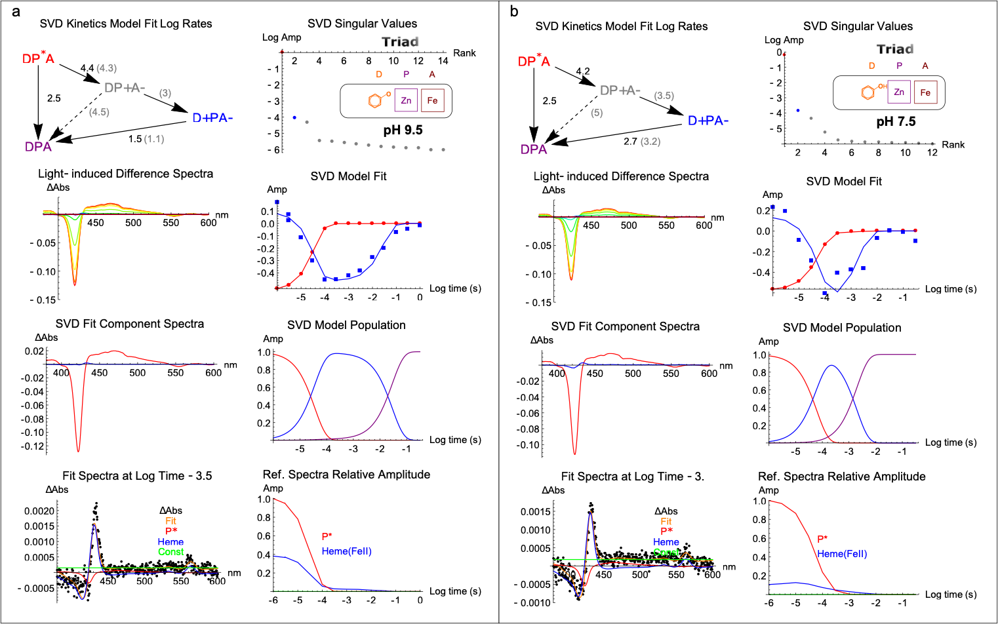

Extended Data Figure 5 | Transient absorption kinetics of Tyrosine-ZnP-Heme Triad in L71H variant. a. At pH 9.5, SVD indicates a second kinetic species above the background noise. A 3 state kinetic model in which k A⁻ to P⁺ is much faster than k P to A gives log k P to A of 4.4 s⁻¹ and a D⁺PA⁻ spectrum with a clear heme redox signal (blue). Fits to P* and heme redox reference spectra estimate the charge-separation yield at ~2.9%. This yield is used to calculate the rates given in parentheses of a 4 state kinetic model. The log rate of charge recombination from the D⁺PA⁻ state to DPA ground state is 1.5 s⁻¹. b. At pH 7.5, a 3 state kinetic model in which k A⁻ to P⁺ is much faster than k P to A gives log k P to A of 4.2 s⁻¹ and a D⁺PA⁻ spectrum with a clear heme redox signal (blue). Decay of this state back to the ground state DPA has a log rate of 2.7 s⁻¹. The yield of heme reduction relative to the initial P* triplet state is ~6%.

Extended Data Figure 6 | Transient absorption kinetics of Mn-Tyr-ZnP-Heme Tetrad in L71H mutant at pH 7.5. With 10 μM MnCl₂ present, SVD indicates a second kinetic species barely above the background noise. A 3 state kinetic model in which k A⁻ to P⁺ is much faster than k P to A gives log k P to A of 4.1 s⁻¹ and a D⁺PA⁻ spectrum without a clear heme redox signal. A charge separation quantum yield estimate is not possible. With low yield, an estimate of the decay of the charge separated state back to the ground state DPA of 2.5 s⁻¹ is not well determined.

Extended Data Figure 7 | Transient absorption kinetics of Fe-Tyrosine-ZnP-Heme Tetrad and Tyrosine knock-out. a. L71H variant at pH 7.5 with ZnP, heme B, and 10 μM Fe(II)Cl₂. SVD indicates a second kinetic species well above the background noise. A 3 state kinetic model in which k A⁻ to P⁺ is much faster than k P to A gives log k P to A of 4.2 s⁻¹ and a D⁺PA⁻ spectrum with a clear heme redox signal (blue). Decay of the D⁺PA⁻ charge separated state to the ground state has a log rate of 0.6 s⁻¹, significantly slower than the metal-free Extended Data Fig. 5b. The yield of heme reduction relative to the initial P* triplet state (red spectrum) is 6.4%. Using this yield, a 4 state model gives log rates in parentheses. b. Y168L mutant was prepared with ZnP, heme B, and 10 μM Fe(II)Cl₂ at pH 7.5. Knocking out the tyrosine donor decouples electron transfer from Fe(II). SVD indicates a second kinetic species close to the background noise. A 3 state kinetic model in which k A⁻ to P⁺ >> k P to A, giving log k P to A of 4.2 s⁻¹. The D⁺PA⁻ spectrum does not have a clear heme redox signal and decay of this state back to the ground state DPA is uncertain, but has a log rate significantly faster than Tyr containing maquette in panel (a), indicating that Tyr facilitates electron transfer from Fe(II).

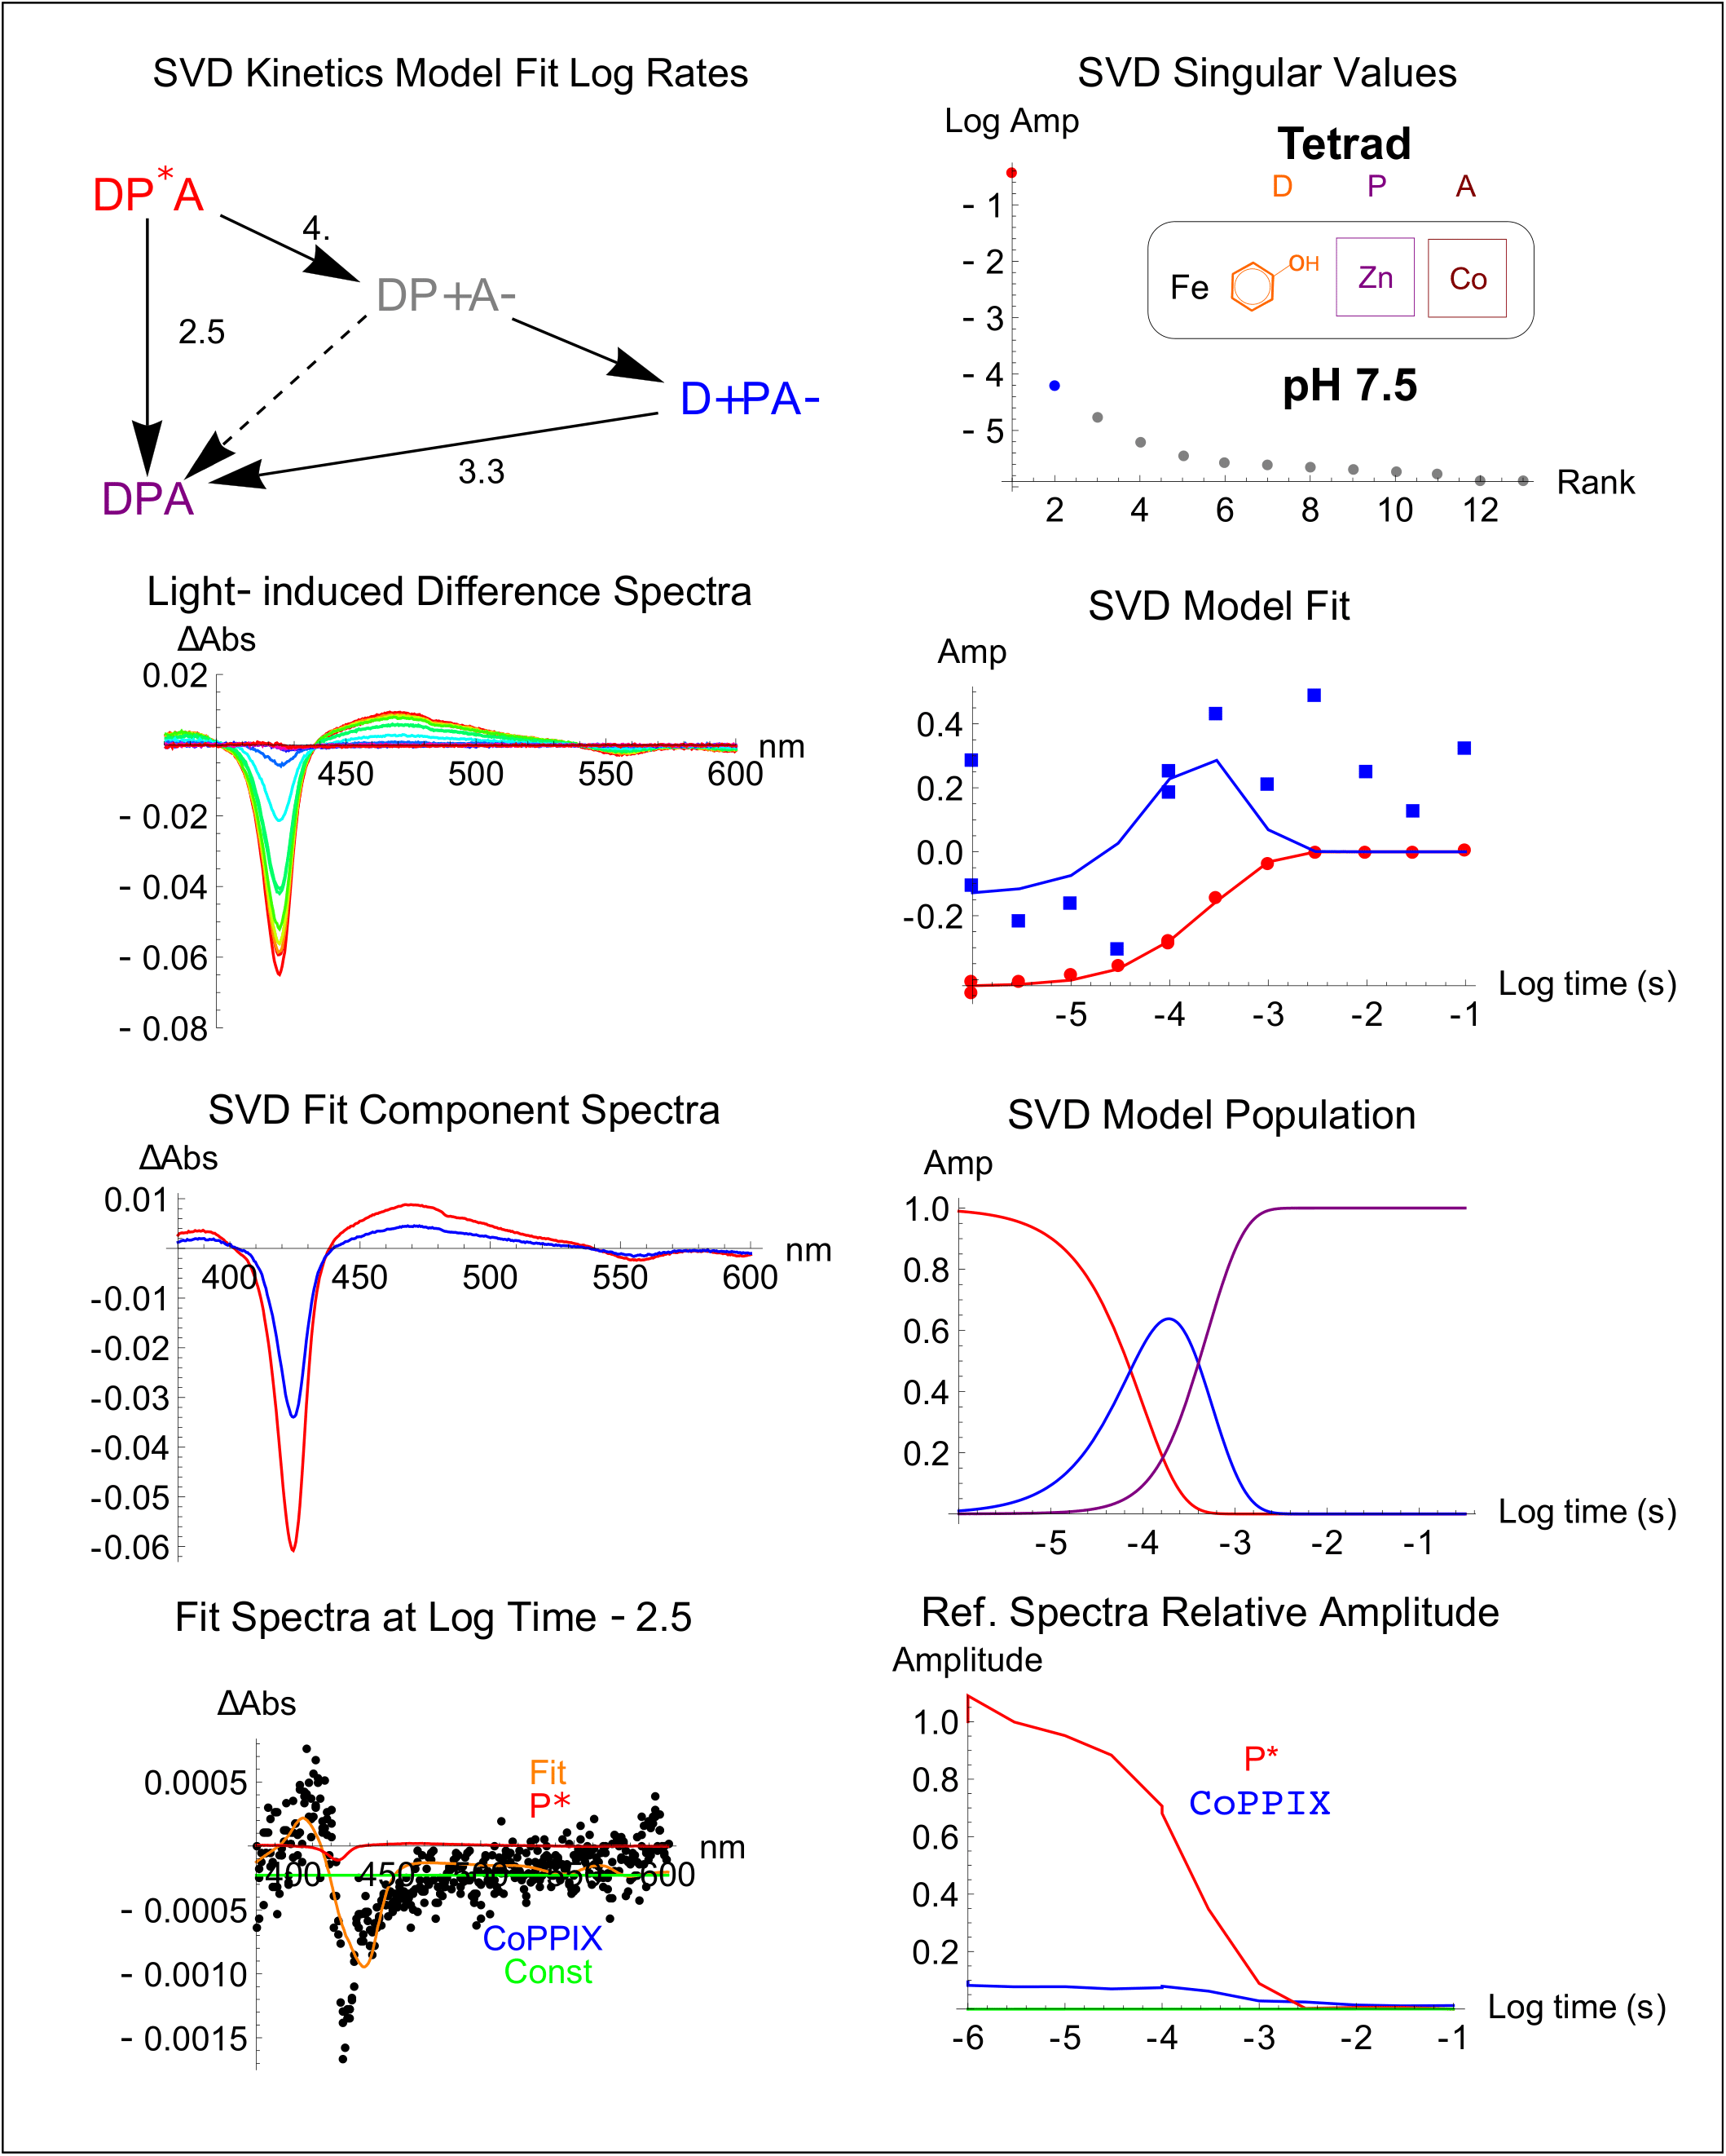

Extended Data Figure 8 | Transient absorption kinetics of Fe-Tyrosine-ZnP-CoPPIX Tetrad. At pH 7.5 with 10 μM Fe(II)Cl₂, using the monad ³ZnP* decay rate of 2.5 s⁻¹ with a 3 state system gives log k P to A of 4.0 s⁻¹. At long delay times an absorbance blue-shift is evident, as expected for Co(III)PPIX photoreduction to Co(II)PPIX, but the signal is small. An accurate yield estimate is not possible, but spectral fits indicate a yield of a few percent. Final charge recombination of D⁺PA⁻ to the ground state is not well determined. CoPPIX significantly increases the rate of P* quenching compared to the monad (Extended Data Fig. 1a).

Extended Data Figure 9 | Redox midpoint potentials of cofactors. a. Spectra for electrochemical determination of E_{m} values of heme B in reaction center maquette. Buffer conditions: 15 mM NaCl, 10 mM phosphate buffer, pH 7. b. SVD fit of the spectra in panel (a) to a single n=1 Nernst redox transition give a midpoint potential of -0.192 V vs. SHE. c. Spectro-electrochemical determination of E_{m} value of Fe porphyrin DADPIX in reaction center maquette. Buffer conditions: 50 mM phosphate, 200 mM NaCl, pH 7. d. Spectro-electrochemical determination of E_{m} value of ZnP in reaction center maquette. Buffer conditions: 50 mM phosphate, 200 mM NaCl, pH 7.

