Supplementary Table 1 | Sequences of Reaction Center Maquette and mutants
RC maquette variant  and description | Amino acid sequence (not including N-terminal His₆-tag and  TEV protease cleavage sequence)
Reaction Center Maquette  (original design) | GSPELRQEHQQLAQEFQQLLQEIQQLGRELLKGELQGIKQLREASEKARNPEKKSVLQKILEDEEKHIELLETLQQTGQEAQQLLQELQQTGQELWQLGGSGGPELRQKHQQLAQKIQQLLQKHQQLGAKILEDEEKHIELLETILGGSGGDELRELLKGELQGIKQYRELQQLGQKAQQLVQKLQQTGQKLWQLG
L71H mutant  (H71-Y168 hydrogen-bonded pair) | GSPELRQEHQQLAQEFQQLLQEIQQLGRELLKGELQGIKQLREASEKARNPEKKSVLQKILEDEEKHIELHETLQQTGQEAQQLLQELQQTGQELWQLGGSGGPELRQKHQQLAQKIQQLLQKHQQLGAKILEDEEKHIELLETILGGSGGDELRELLKGELQGIKQYRELQQLGQKAQQLVQKLQQTGQKLWQLG
L31D/L71H mutant  (Increased solvent accessibility to H71-Y168 hydrogen-bonded pair) | GSPELRQEHQQLAQEFQQLLQEIQQLGRELDKGELQGIKQLREASEKARNPEKKSVLQKILEDEEKHIELHETLQQTGQEAQQLLQELQQTGQELWQLGGSGGPELRQKHQQLAQKIQQLLQKHQQLGAKILEDEEKHIELLETILGGSGGDELRELLKGELQGIKQYRELQQLGQKAQQLVQKLQQTGQKLWQLG
Y168L mutant  (Tyr-free control) | GSPELRQEHQQLAQEFQQLLQEIQQLGRELLKGELQGIKQLREASEKARNPEKKSVLQKILEDEEKHIELLETLQQTGQEAQQLLQELQQTGQELWQLGGSGGPELRQKHQQLAQKIQQLLQKHQQLGAKILEDEEKHIELLETILGGSGGDELRELLKGELQGIKQLRELQQLGQKAQQLVQKLQQTGQKLWQLG
Y168L/G164C mutant  (for crosslinking C164-ferrocene to make Fc164) | GSPELRQEHQQLAQEFQQLLQEIQQLGRELLKGELQGIKQLREASEKARNPEKKSVLQKILEDEEKHIELLETLQQTGQEAQQLLQELQQTGQELWQLGGSGGPELRQKHQQLAQKIQQLLQKHQQLGAKILEDEEKHIELLETILGGSGGDELRELLKGELQCIKQLRELQQLGQKAQQLVQKLQQTGQKLWQLG
Y168C mutant  (for crosslinking C168-ferrocene to make Fc168) | GSPELRQEHQQLAQEFQQLLQEIQQLGRELLKGELQGIKQLREASEKARNPEKKSVLQKILEDEEKHIELLETLQQTGQEAQQLLQELQQTGQELWQLGGSGGPELRQKHQQLAQKIQQLLQKHQQLGAKILEDEEKHIELLETILGGSGGDELRELLKGELQGIKQCRELQQLGQKAQQLVQKLQQTGQKLWQLG

Supplementary Table 2 | Crystallization conditions used to obtain RC maquette crystal structures
Crystal Structure | RC maquette stock concentration | Cofactors in stock solution* | Well solution | Drop volumes  (well solution: protein stock) | Cryoprotectant†
RC maquette,  Original design  (PDB ID: 5VJS) | 12.4 mg/mL  (550 μM) | Heme B, ZnP, 1.5 mM ZnCl₂ | 3.6 M NaCl, 100 mM NaAc‡, pH 4.5 | 1 μL:1 μL | 30% glycerol, 3.5 M NaCl, 100 mM NaAc pH 4.4
RC maquette,  Original design  (PDB ID: 5VJT) | 14.2 mg/mL  (630 μM) | Heme B, 1.5 mM ZnCl₂ | 2.7 M NaCl, 100 mM NaAc, pH 4.5 | 1 μL:1 μL | 30% glycerol, 3.5 M NaCl, 100 mM NaAc pH 4.4
RC maquette,  L71H mutant (PDB ID: 5VJU) | 14.2 mg/mL  (630 μM) | Heme B | 24% w/v PEG§ 1500, 70 mM CdCl₂, 100 mM NaAc pH 4.6 | 5 μL: 1 μL, seeds|| | 40% v/v glycerol, 70 mM CdCl₂, 100 mM NaAc pH 4.6
* Porphyrin cofactors in stock solution had same molar concentration as protein.
† Crystals were dipped in the indicated cryoprotectant immediately prior to flash freezing in liquid nitrogen or a nitrogen gas stream at 100 K.
‡ NaAc stands for sodium acetate.
§ PEG stands for polyethylene glycol.
|| Streak seeded with cat whisker from crystals grown with the same protein stock solution hanging over 25% PEG 1500, 80 mM CdCl₂, 100 mM NaAc, pH 4.6

Supplementary Table 3 | Multiwavelength anomalous dispersion (MAD) statistics for crystal structure 5VJS
Measurement | Zn K edge | Zn K inflection point | Remote energy
Wavelength (Å) | 1.2824 | 1.2831 | 1.0781
Resolution (Å) | 2.1 | 2.1 | 2.0
Completeness (%) | 99.1 | 99.1 | 99.4
I/σ(I) | 18.2 | 19.5 | 16.8
R_{merge} (%) | 6.6 | 6.3 | 8.5

Supplementary Table 4 | X-ray crystallographic data collection and refinement statistics
Protein | RC maquette  (original design) | RC maquette  (original design) | RC maquette  (L71H mutant)
PDB ID | 5VJS | 5VJT | 5VJU
Cofactors | Heme B  ZnP  Tyr  Zn(II) | Heme B  --  Tyr  Zn(II) | Heme B  --  H-bonded His-Tyr  Cd(II)
Data Collection

Space group | P4₁2₁2 | P4₁2₁2 | P2₁
X-ray source | NSLS  X6A Beamline | NSLS  X6A Beamline | Rotating Anode Cu K_{α}
Wavelength (Å) | 1.0781 | 1.0781 | 1.54178
Unit cell dimensions
a (Å) | 43.749 | 43.747 | 44.48
b (Å) | 43.749 | 43.747 | 25.88
c (Å) | 245.74 | 245.52 | 73.71
α (°) | 90 | 90 | 90
β (°) | 90 | 90 | 103.64
γ (°) | 90 | 90 | 90
Resolution (Å) | 61.43 - 2.00  (2.05 – 2.00)* | 61.38 - 1.45  (1.49 – 1.45) | 71.54 - 2.02  (2.07 – 2.02)
R_{merge} (%) | 8.5 (97.0) | 9.9 (133.7) | 5.1 (10.1)
I/σ(I) | 16.80 (2.52) | 15.30 (1.26) | 25.98 (9.46)
Completeness (%) | 99.4 (98.8) | 99.7 (96.1) | 97.3 (71.0)
Redundancy | 7.6 (7.4) | 8.8 (5.2) | 6.7 (3.3)
Refinement

Resolution | 61.43 – 2.00 (2.05 – 2.00) | 41.21 – 1.45 (1.49 – 1.45) | 71.63 – 2.08 (2.13 – 2.08)
Unique reflections | 16,280 (1,131) | 41,378 (2,848) | 9,587 (643)
R_{work}/R_{free} | 0.235/0.278 | 0.202/0.236 | 0.183/0.243
No. of non-H atoms
Protein | 1585 | 1585 | 1587
Ligand | 88 | 48 | 50
Water | 39 | 172 | 88
Mean B factor (Å²) | 40.77 | 23.27 | 31.83
R.m.s. deviations
Bonds (Å²) | 0.018 | 0.031 | 0.015
Angles (°) | 1.829 | 2.236 | 1.782
* Values in parentheses represent statistics from the highest resolution shell.

 | a Heme (PDB ID: 5VJT) | b Heme (PDB ID: 5VJU) |  | c Heme (PDB ID: 5VJS) |  | d Zn porphyrin (PDB ID: 5VJS)
1.0 σ contouring | 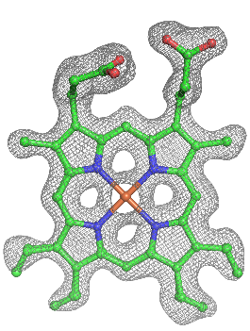 | 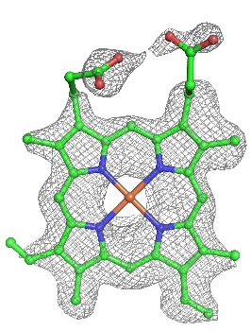 |  | 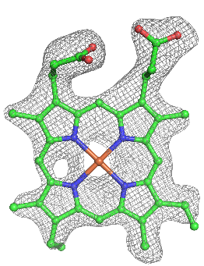 |  | 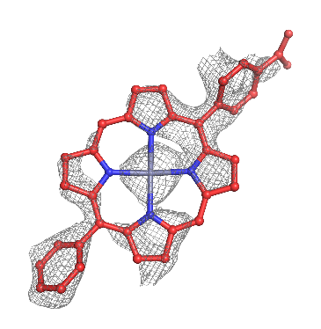
3.0 σ contouring | 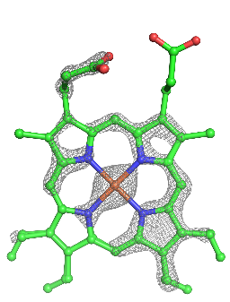 | 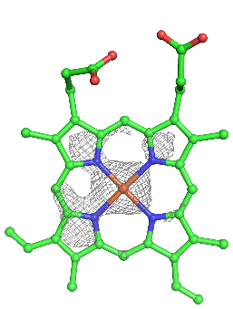 |  | 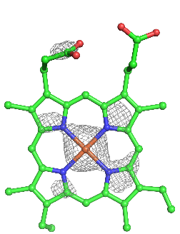 |  | 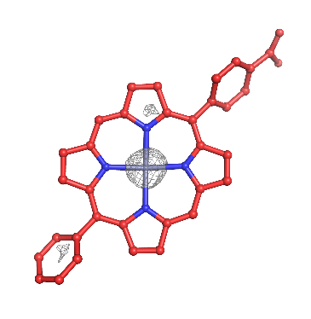
 | e Tyr and Zn(II) ion (PDB ID: 5VJT) |  | f His-Tyr and Cd(II) ions (PDB ID: 5VJU) |  | g Tyr and Zn(II) ion (PDB ID: 5VJS)
1.0 σ contouring | 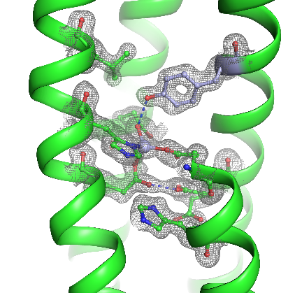 |  | 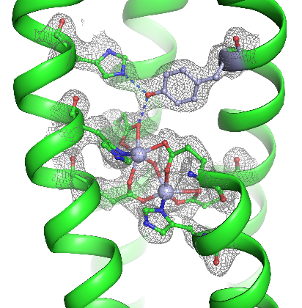 |  | 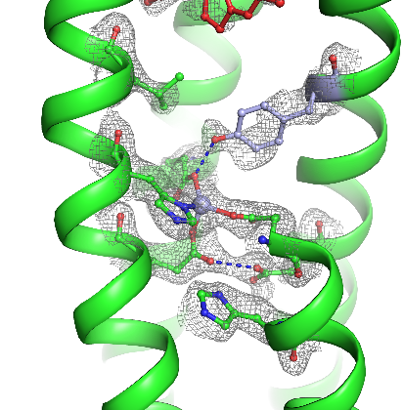
3.0 σ contouring | 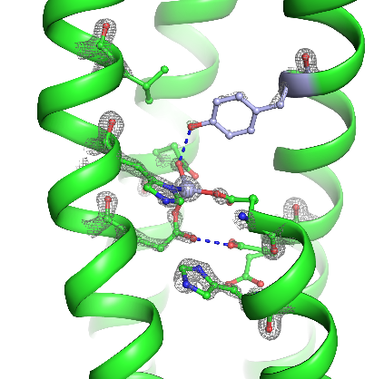 |  | 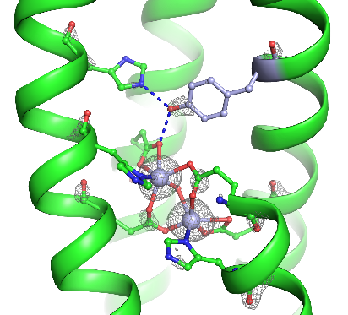 |  | 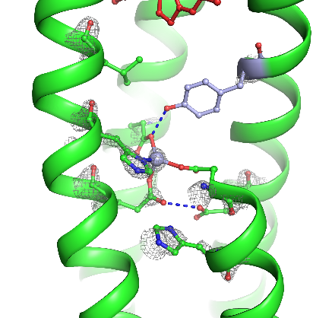

Supplementary Figure 1 | 2Fo-Fc omit maps of cofactors. Omit maps of cofactors at 1.0 σ and 3.0 σ contouring levels (grey mesh) were created in PHENIX using simulated annealing to remove model bias. a-c. Omit maps of heme B electron acceptor in each of the three crystal structures (PDB IDs: 5VJT, 5VJU, and 5VJS). Heme B in structure 5VJT is modeled in two superposed conformations, giving 4 vinyl groups in the model. d. ZnP pigment omit map in structure 5VJS. e-g. Omit maps of electron donor sites. Structures 5VJT and 5VJS (panels (e) and (g)), contain only the Zn(II) ion in the metal site nearest the pigment site, but 5VJU (panel (f)) has two Cd(II) ions bound, as designed. Blue dashes indicate hydrogen bonds.

