Jiella semarangensis sp. nov., a novel bacterium isolated from mangrove sediment in Semarang city, Indonesia

Mada Triandala Sibero^{1,2,3,4}, Zhou-Qing Zheng⁵, Fei-Na Li⁶, Shao-Wei Liu^{1,2}, Chengshao Zan⁵, Xin Xiang⁷, Li Tuo^{5*}, Cheng-Hang Sun^{1,2*}

¹ State Key Laboratory of Bioactive Substances and Functions of Natural Medicines, Institute of Medicinal Biotechnology, Peking Union Medical College and Chinese Academy of Medical Sciences, Beijing 100050, China
² Department of Microbial Chemistry, Institute of Medicinal Biotechnology, Chinese Academy of Medical Sciences & Peking Union Medical College, Beijing 100050, P. R. China
³ Department of Marine Science, Faculty of Fisheries and Marine Science, Universitas Diponegoro, Semarang, Indonesia
⁴ Department of Microbiology & Immunology, University of Otago, Dunedin, New Zealand
⁵ School of Basic Medical Sciences, Zunyi Medical University, Zunyi 563006, P. R. China
⁶ Laboratory of Respiratory Diseases, Beijing Pediatric Research Institute, Beijing Children’s Hospital, Capital Medical University, National Center for Children’s Health, Beijing 100045, P. R. China
⁷ School of Eco-Environmental Engineering, Qinghai University, Xining, Qinghai 810016, P. R. China

*Correspondence: Cheng-Hang Sun，E-Mail: chenghangsun@hotmail.com or sunchenghang@imb.pumc.edu.cn; Li Tuo, E-Mail: tuoli25@163.com

Supplementary Fig. S1 The maximum-likelihood phylogenetic tree based on 16S rRNA gene sequences exhibiting the phylogenetic position of strain M17.18^{T} and related species. Rhodospirillum rubrum ATCC 11170^{T} was used as the outgroup (based on 1000 replicates; only values > 50% are shown). Bar, 0.02 substitutions per nucleotide position.
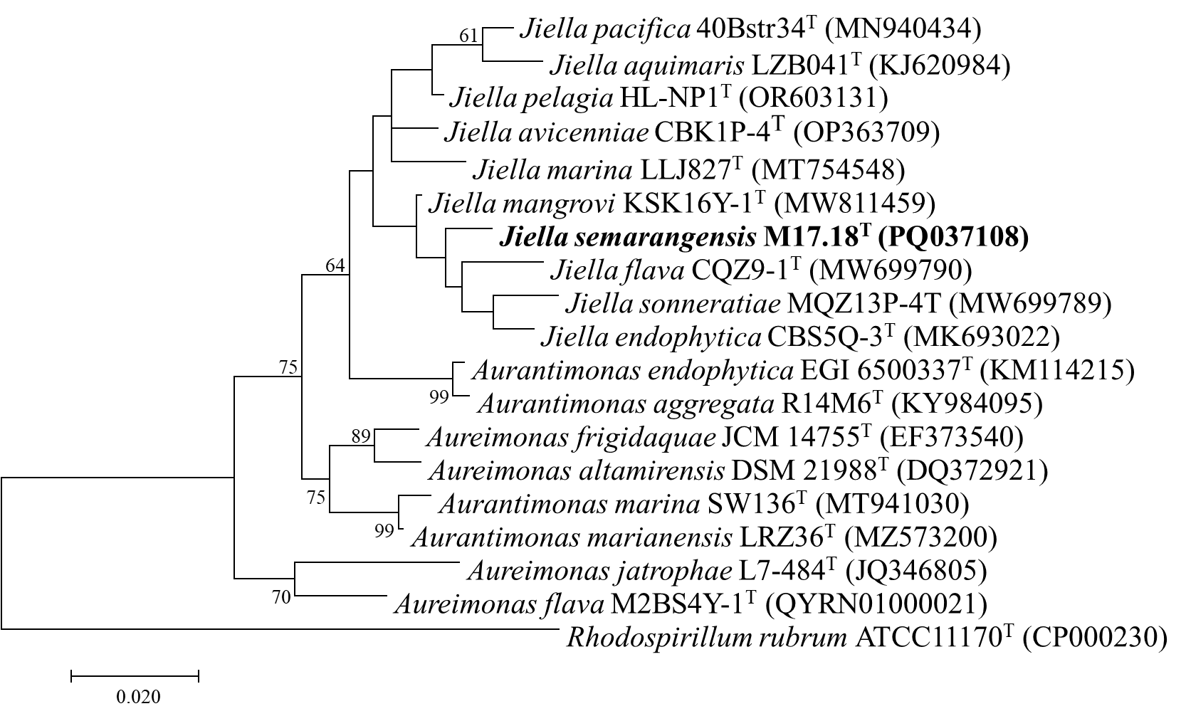
Supplementary Fig. S2. The maximum-parsimony phylogenetic tree based on the 16S rRNA gene sequence exhibits the phylogenetic position of strain M17.18^{T} and related species. Rhodospirillum rubrum ATCC 11170^{T} was used as the outgroup (based on 1000 replicates; only values > 50% are shown).
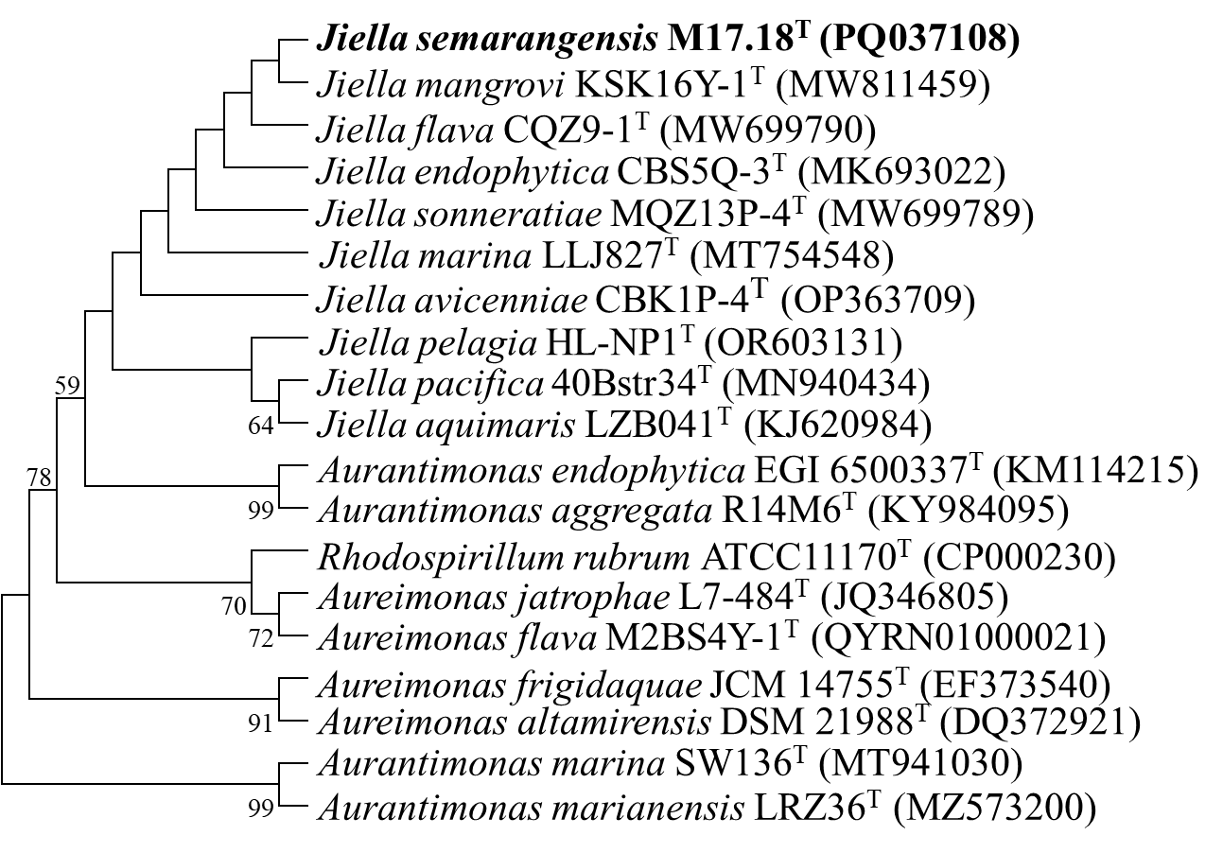
Supplementary Fig. S3 The circular genomic map of strain M17.18^{T}. The rings from the outer to the inner were arranged as the contigs, CDS on the forward strand, CDS on the reverse strand, RNA genes, CDS with homology to known antimicrobial resistance genes, CDS with homology to known virulence factors, GC content, and GC skew. The colors of the CDS on the forward and reverse strands indicate the subsystem that these genes belong to.
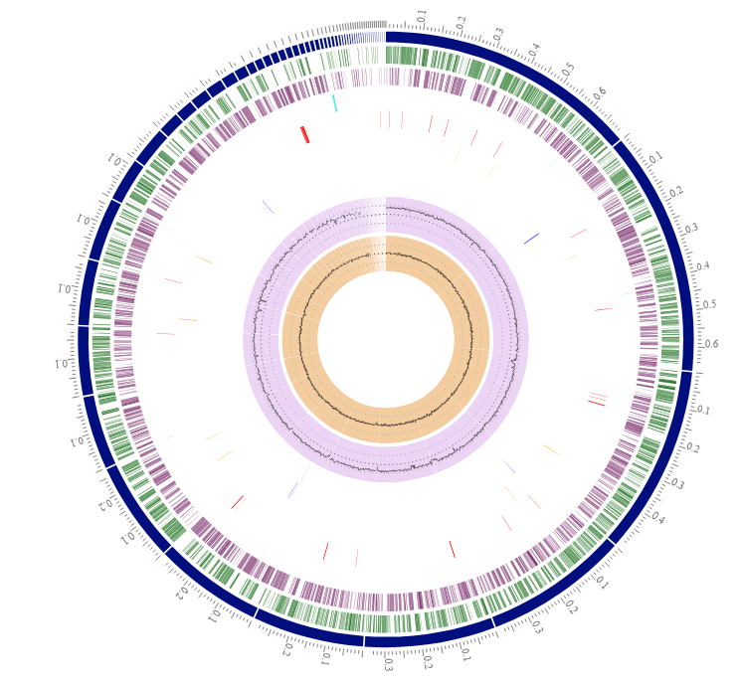
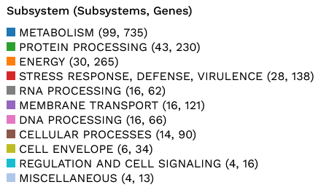
Supplementary Fig. S4 The heatmap of ANI values from the OAT software between strain M17.18^{T} and its related species.
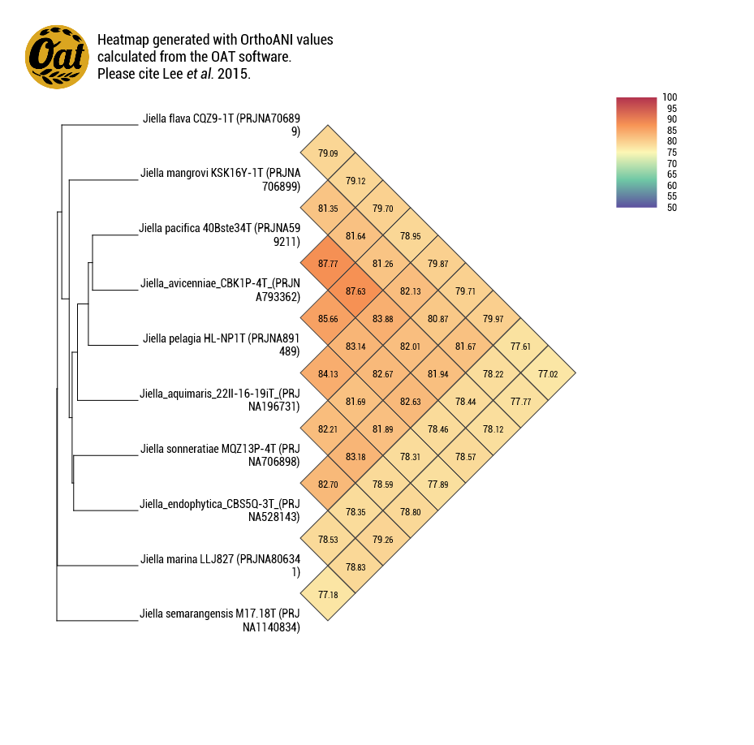

Supplementary Fig. S5 The Venn diagram and bar chart show the number of shared and unique orthologous clusters among strain M17.18^{T} (1), J. mangrovi KSK16Y-1^{T} (2), J. flava CQZ9-1^{T} (3), and J. aquimaris 22II-16-19i (4).
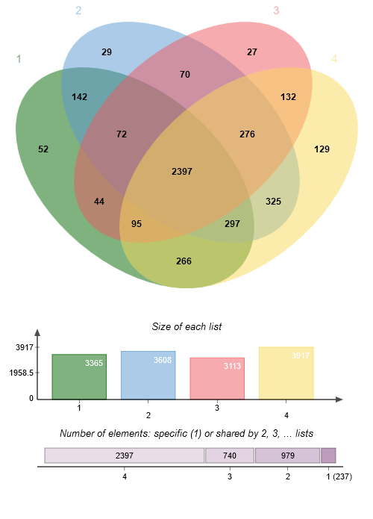

Supplementary Fig. S6. The visualization of two-dimensional thin-layer chromatography of lipids extracted from strain M17.18^{T}. The first dimension was developed in CHCl₃:CH₃OH:H₂O (64:27:5 by volume) then the second dimension was developed in CHCl₃:CH₃COOH: CH₃OH:H₂O (80:18:12:5 by volume). The plates were sprayed with molybdatophosphoric acid reagent (a), molybdenum blue reagent (b), ninhydrin reagent (c), and anisaldehyde reagent (d).
DPG: diphosphatidylglycerol, PG: phosphatidylglycerol, PC: phosphatidylcholine, PME: phosphatidylmonomethylethanolamine, PE: phosphatidylethanolamine, L: unknown lipid, PL: unknown phospholipid, AL: unknown aminolipid, APL: unknown aminophospholipid (APL).

