Supplementary Information
Self-assembled polysaccharide nanoparticles enable M cell–mediated oral immune entry and enhance systemic antitumor immunity
Zheming Hu¹, Qin Zhang¹, Haojie Wang, Wulong Wen, Lingfan Fan, Jinxuan Yang, Shuhui Geng, Lan Qin, Fengyi Ma, Yang Lu*

Affiliations:
Department of Pharmacy, School of Chinese Materia Medica, Beijing University of Chinese Medicine, Beijing 100029, China.

Corresponding authors:
(Yang Lu) luyang@bucm.edu.cn

¹ The two authors contributed equally to this paper.

Keywords: Ginseng polysaccharide, Chito-oligosaccharide, self-assembly, Oral delivery, M-cell targeting, Radio-immunotherapy

Fig. S1 Monosaccharide Composition Analysis by PMP.

Table S1 Peak Table (Detector A: 250 nm)
Peak No. | Retention Time (min) | Compound | Area | Height | Area%
1 | 13.939 | Mannose | 102,788 | 6,081 | 0.529
2 | 17.271 | Ribose | 28,628 | 1,268 | 0.147
3 | 17.946 | Rhamnose | 4,966 | 261 | 0.026
4 | 21.606 | Glucuronic acid | 113,881 | 3,771 | 0.587
5 | 24.506 | Galacturonic acid | 141,977 | 4,855 | 0.731
6 | 28.742 | Glucose | 18,705,432 | 516,159 | 96.358
7 | 33.127 | Galactose | 69,484 | 1,688 | 0.358
8 | 34.877 | Xylose | 40,708 | 790 | 0.21
9 | 36.179 | Arabinose | 192,904 | 4,176 | 0.994
10 | 42.398 | Fucose | 11,581 | 236 | 0.06
Total | - | - | 19,412,349 | 539,286 | 100
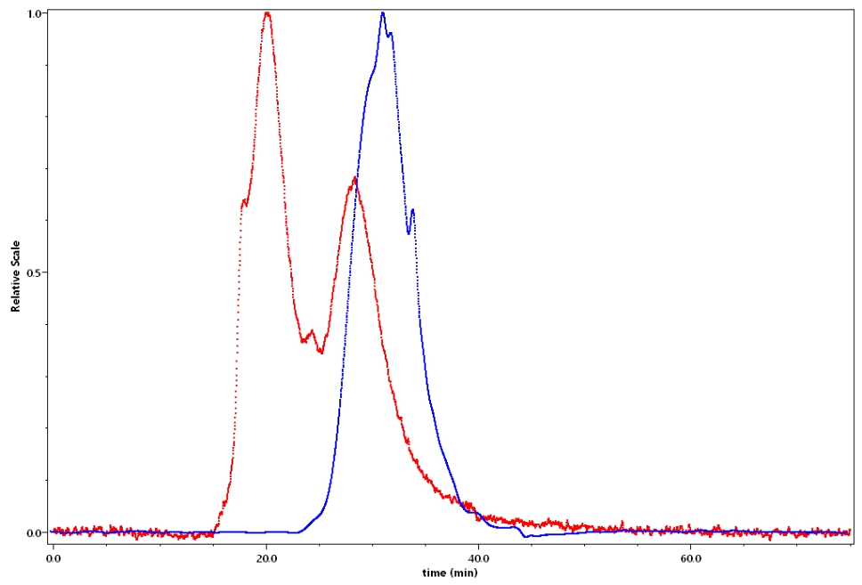
Fig. S2 Molecular Weight Distribution Profile.
Table S2 Comprehensive Molecular Characterization of GP.
Parameter Type | ​Key Metrics​ | Value ± Unc.​​
Molecular Weight  ​(kDa) | Number-average (Mn) | 15.393 ± 0.062
Molecular Weight  ​(kDa) | Peak (Mp) | 11.479 ± 0.078
Molecular Weight  ​(kDa) | ​Weight-average (Mw)​​ | ​23.275 ± 0.058​
Molecular Weight  ​(kDa) | Z-average (Mz) | 41.312 ± 0.113
​Dispersion​ | ​PDI (Mw/Mn)​​ | 1.512 ± 0.085
​Hydrodynamic Size  (nm) | Radius (Rn) | 27.12 ± 0.30
​Hydrodynamic Size  (nm) | Radius (Rw) | 27.85 ± 0.29
​Hydrodynamic Size  (nm) | Radius (Rz) | 28.48 ± 0.26
Chromatography | Peak range | 26.0 - 33.0
Table S3 Plackett-Burman Design Matrix and Responses.
Run | COS(%) | GP(%) | TPP(%) | Size (nm) | PDI | Zeta (mV)
1 | 4 (+1) | 3 (+1) | 0.5 (-1) | 208.6 | 0.259 | +14.8
2 | 4 (+1) | 2 (-1) | 1 (+1) | 227.3 | 0.355 | +18.3
3 | 4 (+1) | 3 (+1) | 1 (+1) | 447.0 | 0.416 | +12.9
4 | 4 (+1) | 2 (-1) | 0.5 (-1) | 313.3 | 0.651 | +17.5
5 | 2 (-1) | 3 (+1) | 0.5 (-1) | 549.6 | 0.100 | -4.8
6 | 2 (-1) | 3 (+1) | 1 (+1) | 745.5 | 0.347 | -3.2
7 | 4 (+1) | 2 (-1) | 0.5 (-1) | 355.2 | 0.381 | +18.9
8 | 2 (-1) | 2 (-1) | 1 (+1) | 232.2 | 0.475 | +2.3
9 | 2 (-1) | 2 (-1) | 1 (+1) | 277.1 | 0.351 | +1.2
10 | 2 (-1) | 3 (+1) | 0.5 (-1) | 488.7 | 0.398 | -5.7
11 | 2 (-1) | 2 (-1) | 0.5 (-1) | 297.6 | 0.591 | +5.6
12 | 4 (+1) | 3 (+1) | 1 (+1) | 253.0 | 0.281 | +12.4

Tab. S4 Storage Stability and Lyophilization-Reconstitution Stability of GP-NPs $\left(x±s,n=3\right)$
Group | Size (nm) | PDI | Zeta (mV)
0 d | 234.9 ± 13.8 | 0.309 ± 0.10 | 12.0 ± 1.1
1 d | 275.5 ± 12.9 | 0.297 ± 0.15 | 13.8 ± 1.3
2 d | 217.7 ± 14.2 | 0.312 ± 0.17 | 14.1 ± 1.7
4 d | 280.9 ± 22.3 | 0.273 ± 0.13 | 11.7 ± 1.2
7 d | 317.5 ± 15.9 | 0.325 ± 0.18 | 13.3 ± 2.1
Lyophilization-Reconstitution | 0.309 ± 0.14 | 0.396 ± 0.23 | 13.4 ± 1.4

Fig. S3 Transcriptomic analysis of intestinal tissues in healthy mice. (a) PCA plot; (b) Pearson correlation heatmap; (c) Volcano plot of differentially expressed genes (DEGs); (d) GO enrichment analysis of total DEGs; (e) GO enrichment analysis of upregulated DEGs; (f) GO enrichment analysis of downregulated DEGs; (g) Gene set enrichment analysis (GSEA) of response to bacterium; (h) GSEA of innate immune response in mucosa; (i) Heatmap of genes involved in innate immune response in mucosa.
Fig. S4. In vitro cytotoxicity evaluation of GP and COS@GP. Cell viability of (a) 4T1 cells, (b) DC2.4, (c) RAW 264.7 macrophages, and (d) Caco-2 cells after 24 h incubation with varying concentrations of free GP or COS@GP. Data are presented as mean ± SD (n = 6).

Fig. S5 Cellular uptake evaluation in Caco-2. (a) CLSM images of Caco-2 cells incubated with GP, COS/GP, or COS@GP; (b) MFI of Caco-2 cells measured by flow cytometry; (c) Flow cytometry histograms (count) of FITC-labeled formulations in Caco-2.

Fig. S6 Standard curve of FITC fluorescence intensity. The linear regression equation is y = 4420.4x - 43.727 (R² = 0.9990), where x represents the concentration of FITC (mg/mL) and y represents the fluorescence intensity.

Fig. S7. Standard curve of RhB fluorescence intensity. The linear regression equation is y = 1236.5x - 220.56 (R² = 0.9995), where x represents the concentration of RhB (mg/mL) and y represents the fluorescence intensity.
Fig. S8. In vivo fluorescence imaging and biodistribution of different GP formulations.
Fig. S9. H&E staining of major organs (heart, liver, spleen, kidney, and lung) in different treatment groups.
Fig. S10. Gating strategy for identification of DC in TDLN.
Fig. S11. Gating strategy for analysis of tumor-infiltrating CD4⁺ and CD8⁺ T cells..
Fig. S12. Gating strategy for characterization of tumor-associated macrophage polarization.
Fig. S13. Additional transcriptomic analyses. (a) PCA plot of RNA-seq samples. (b) GO enrichment analysis of all differentially expressed genes. (c) GO enrichment analysis of upregulated genes. (d) GO enrichment analysis of downregulated genes. (e) KEGG pathway enrichment analysis.

